When Round 1 opens, you'll choose 1 of 4–5 problem statements and build an OpenEnv environment around it.
Problem statements will be revealed on 1 April. You pick one, build it, and submit within the 7-day window.
Example of what a problem statement looks like
"Build a mini-game RL environment with clearly defined tasks, automated graders, and reward logic using the OpenEnv framework."
→ Create a mini-game that an AI agent can play
→ Define tasks with increasing difficulty
→ Write graders that verify task completion
→ Define reward logic for scoring
→ Package using OpenEnv for automated evaluation
Evaluation Criteria
Runtime correctness
Runs without errors
Interface compliance
Follows OpenEnv standard
Task design
Clear, realistic, testable
Grading logic
The reward system makes sense

Prerequisites:
python --version
git --version
pip install huggingface_hub --version
huggingface-cli login
pip install openenv-core
pip install openenv-core
→ colab.research.google.com
docker --version’

VS Code
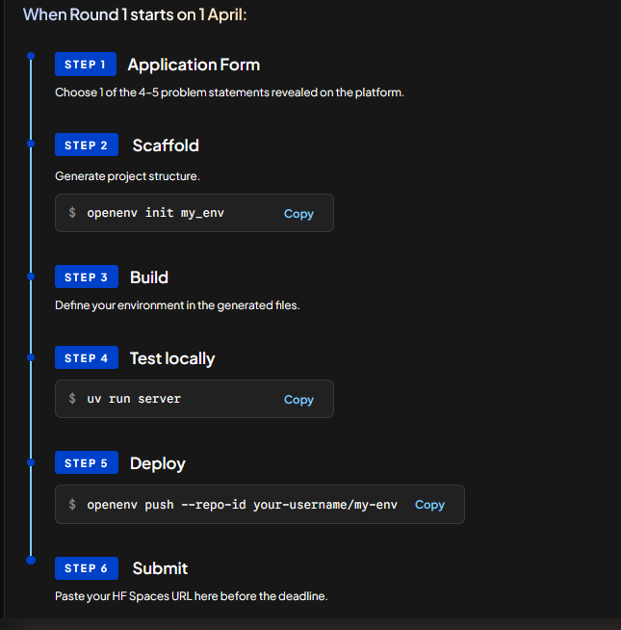

PROBLEM STATEMENT Round 1 —

Problem Statement
The Task: Build a complete, real-world OpenEnv environment that an AI agent can learn from through the standard step() / reset() / state() API.

Key Requirements at a Glance:

Must simulate a real-world task (not games or toys).
Implement full OpenEnv spec: typed models, step()/reset()/state(), openenv.yaml

Minimum 3 tasks with agent graders (easy → medium → hard, scores 0.0–1.0) Meaningful reward function with partial progress signals
Baseline inference script with reproducible scores
Deploy to Hugging Face Spaces + working Dockerfile
README with environment description, action/observation spaces, setup instructions
Functional Requirements:
Real-world task simulation: The environment must simulate a task humans actually do. Not games, not toys. Examples: email triage, code review, data cleaning, scheduling, customer support, content moderation.
OpenEnv spec compliance: Implement the full OpenEnv interface: typed Observation, Action, and Reward Pydantic models. step(action) → returns observation, reward, done, info. reset() → returns initial observation. state() → returns current state. openenv.yaml with metadata.
Tested via openenv validate.
Minimum 3 tasks with agent graders.
Each task defines a concrete objective an agent must accomplish, with a programmatic grader that scores performance (0.0–1.0). Tasks should range: easy → medium → hard.
Graders must have clear, deterministic success/failure criteria.
Meaningful reward function: Provides signal over the full trajectory (not just binary end-of-episode).
Rewards partial progress toward task completion.
Penalizes clearly undesirable behavior (e.g. infinite loops, destructive actions). Baseline inference script : Uses the OpenAI API client to run a model against the environment.
Reads API credentials from environment variables (OPENAI_API_KEY). Produces a reproducible baseline score on all 3 tasks.

Detailed Requirements :

Non-Functional Requirements :
Deploys to a Hugging Face Space Environment must run as a containerized HF Space tagged with openenv.
Containerized execution: Must include a working Dockerfile.
The environment should start cleanly with docker build + docker run. Documentation README must include: environment description and motivation, action and observation space definitions, task descriptions with expected difficulty, setup and usage instructions, baseline scores.
Parameter Weight Description: Real-world utility 30%
Does the environment model a genuine task? Would someone actually use this to train or evaluate agents? Task & grader quality 25% Are tasks well-defined with clear objectives? Do graders accurately and fairly measure success? Meaningful difficulty progression?
Environment design 20% Clean state management, sensible action/observation spaces, good reward shaping, proper episode boundaries.
Code quality & spec compliance 15% Follows OpenEnv spec, clean project structure, typed models, documented, tested, Dockerfile works.
Creativity & novelty: 10% Novel problem domain, interesting mechanics, clever reward design, original approach.

Scoring Breakdown
Real-world utility (30%) • 0–5: Toy/artificial problem with no practical application
• 6–15: Valid domain but shallow modeling of the real task
• 16–25: Good domain modeling, would be useful for agent evaluation
• 26–30: Excellent — fills a real gap, immediate value for the RL/agent community
Task & grader quality (25%)
• 3+ tasks with difficulty range?
• Graders produce scores between 0.0–1.0?
• Graders deterministic and reproducible?
• Hard task genuinely challenges frontier models?
Environment design (20%)
• reset() produces clean state?
• Action/observation types well-designed and documented?
• Reward function provides useful varying signal (not just sparse)?
• Episode boundaries sensible? Code quality & spec compliance (15%)
• openenv validate passes?
• docker build && docker run works?
• HF Space deploys and responds?
• Baseline script runs and reproduces scores?
Creativity & novelty (10%)
• Domain we haven’t seen in OpenEnv before?
• Reward design has interesting properties?
• Clever mechanics that make the environment engaging?

Evaluation Criteria Phase 1:
Automated Validation Pass/fail gate — HF Space deploys, OpenEnv spec compliance, Dockerfile builds, baseline reproduces, 3+ tasks with graders.

Phase 2: Agentic Evaluation Scored — baseline agent re-run, standard Open LLM agent (e.g., Nemotron 3 Super) run against all environments, score variance check.

Phase 3: Human Review Top submissions reviewed by Meta and Hugging Face engineers for real-world utility, creativity, and exploit checks.

Disqualification Criteria: Environment does not deploy or respond. Plagiarized or trivially modified existing environments. Graders that always return the same score. No baseline inference script.

How Judging works: Pre-Submission Checklist — all must pass, or you're disqualified. HF Space deploys Automated ping to the Space URL — must return 200 and respond to reset() OpenEnv spec compliance Validate openenv.yaml, typed models, step()/reset()/state() endpoints
Dockerfile builds Automated docker build on the submitted repo Baseline reproduces
Run the submitted inference script — must complete without error and produce scores 3+ tasks with graders Enumerate tasks, run each grader, verify scores in 0.0–1.0 range Additional Endpoints to Expose /baseline - Trigger inference script and returns baseline score for all 3 tasks /grader - Returns grader score after an episode is completed /tasks - Returns list of tasks and the action schema (fields required for an action in a step) Validator

Run the pre-submission validation script before submitting

