DASHBOARD DESIGN REPORT
Team ID | MCA
Project Name | Smartphone Addiction & Digital Wellbeing Analytics
Maximum Marks | 5 Marks

1. Introduction
The Smartphone Addiction & Digital Wellbeing Analytics dashboard is designed to understand how people use smartphones and how smartphone habits may be related to digital wellbeing. The dashboard presents important information such as screen time, social media use, gaming, sleep, app opens, notifications, stress level and addiction level in a simple visual form.

2. Activity 1: Interactive and Visually Appealing Dashboard
The dashboard follows these important design principles:
- Clear and Intuitive Layout – Important KPIs and charts are arranged in an easy-to-read order.
- Appropriate Visualizations – Cards, bar charts, pie/donut charts, line charts and scatter charts are used for different types of information.
- Colour and Theming – A consistent theme makes the dashboard clean and easy to understand.
- Interactive Filters and Slicers – Users can filter information using fields such as age group, gender, stress level and addiction level.
- Drill-Down and Detailed Analysis – Different report pages allow the user to study smartphone usage from different angles.
- Responsive and Simple Design – The dashboard keeps the main information visible without unnecessary content.
- Custom Visuals and Icons – Visual elements help users understand the information quickly.
- Infographics and KPI Cards – Key measures are shown at the top so important information can be understood at a glance.

3. Dashboard Preview
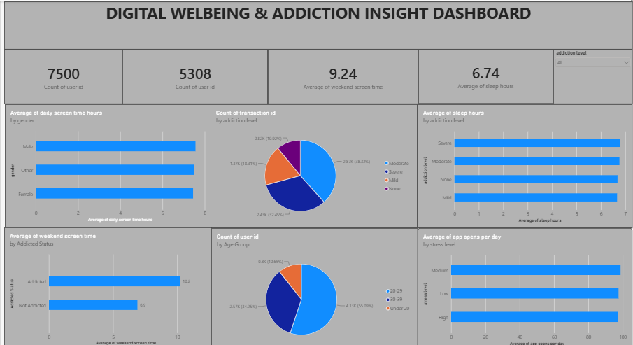
Figure 1: Illustrative preview of the dashboard structure from the supplied Power BI report.

4. Main Dashboard Sections
KPI Section: Shows important measures such as number of users, average age, daily screen time, social media hours, gaming hours, sleep hours, notifications, app opens, weekend screen time and work/study hours.
Usage Analysis: Compares screen time and smartphone activities across gender and age groups.
Addiction Analysis: Shows addiction level and addicted/non-addicted status using charts.
Digital Wellbeing Analysis: Examines relationships between screen time, sleep, stress, social media use and gaming.
Academic/Work Impact: Shows how smartphone use and work/study time are related to reported academic or work impact.
Interactive Analysis: Slicers allow the user to select categories and view the dashboard from different perspectives.

5. Major Outcomes from the Dashboard
- The dashboard gives a clear overall view of smartphone usage patterns among the users in the dataset.
- Daily screen time is treated as an important measure for studying smartphone usage and digital wellbeing.
- Social media and gaming usage can be compared to understand different types of smartphone activity.
- Sleep hours can be compared with screen time and addiction level to study possible relationships in the dataset.
- Age group and gender filters help users identify differences in smartphone usage between groups.
- Stress level and app-open frequency provide additional indicators for understanding digital habits.
- Addiction level and addicted status help divide users into categories for easier analysis.
- The dashboard supports interactive exploration, so users can change filters and study specific groups instead of looking only at overall results.

6. Conclusion
The Smartphone Addiction & Digital Wellbeing Analytics dashboard converts smartphone usage data into simple visual information. It helps users understand screen time, smartphone activities, sleep, stress and addiction-related patterns. The interactive design makes the dashboard easy to explore and useful for identifying important patterns in the available data.

7. Technologies / Tools Used
Power BI was used to create the interactive dashboard, visualizations, KPI cards, slicers and analytical report pages.

