Link: <https://www.youtube.com/watch?v=89yWXXIOisk&list=PLhW3qG5bs-L_ZCOA4zNPSoGbnVQ-rp_dG&index=1&fbclid=IwAR1o1Nomr9OgoG0ixPwyukrfT-Cw9ZN_I32tIjUl-KSnYIMaPiGbfkek5bs>

Username: sunena

Password:gwachha

**Tutorial 1**

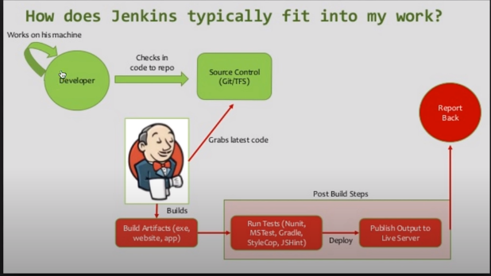

Go to Chrome localhost:8080

Myfile is on C:\Program Files (x86)\Jenkins

1st time

Go to terminal

run command java -jar jenkins.war

Do this---

java -jar"C:\Program Files (x86)\Jenkins\jenkins.war"

It will give password copy that and paste in installation process

Then go to localhost:8080

make setup and create user

We can stop jenkins by going to taskmanagar and do end task to Java...running

software and when we go to localhost:8080 it will show error

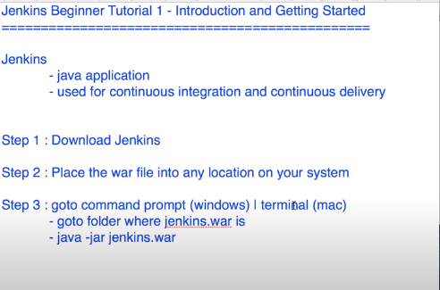

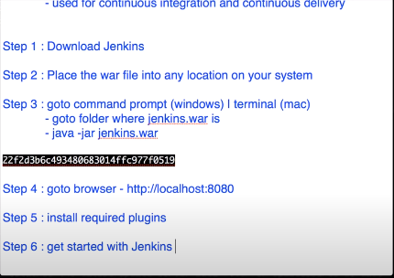

**Tutorial 2:**

**Why tomcat? Or Running Jenkins standalone(jetty/winstone) vs Running Jenkins on Tomcat**

We can start all our application on a single server.

We can also deploy on Glassfish, Jboss, Jetty. Weblogic,Tomcat,etc

Copy place the Jenkins.war file inside tomcat/webapps folder

C:\apache-tomcat-9.0.30\webapps

Goto commandprompt and go to C:\apache-tomcat-9.0.30\bin

Do dir to see list

cls to clear

make any file .sh executible

do this chmod +x *.sh

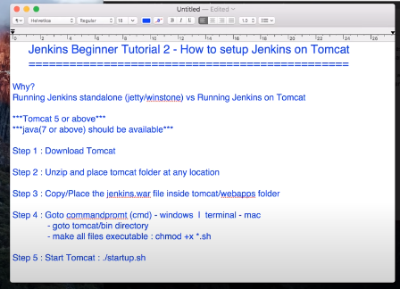

<http://localhost:8080/> …..tomcat

[http://localhost:8080/jenkins ....jenkins](http://localhost:8080/jenkins%20....jenkins)

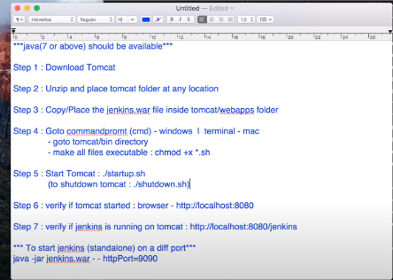

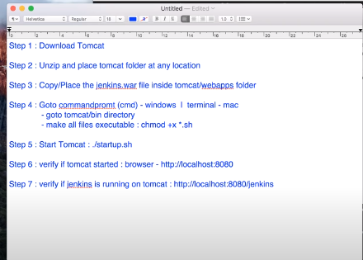

Now goto Jenkins folder

Cd C:\Program Files (x86)\Jenkins\

Change port of Jenkins because tomcat is also running on 8080

java -jar jenkins.war –httpPort=9090

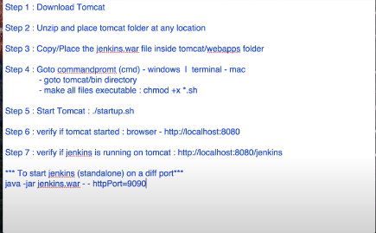

<http://localhost:9090/>

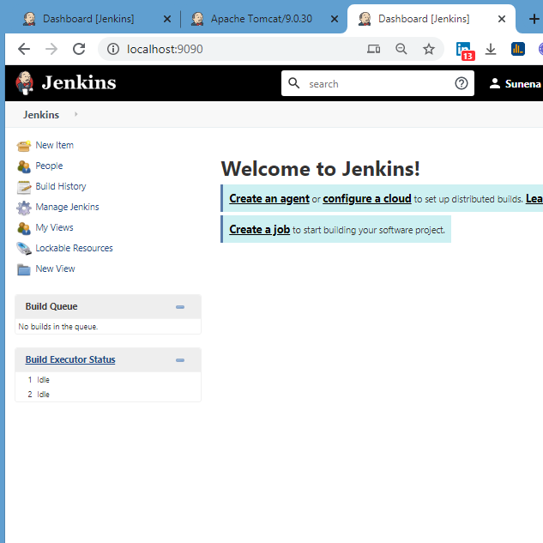

<http://localhost:8080/jenkins/>

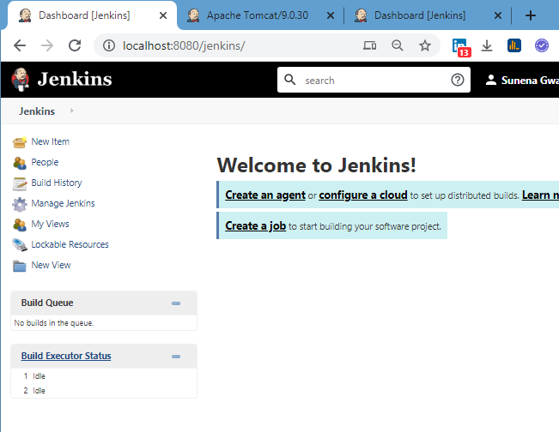

Create a project name TestJob1 in 8080 and TestJob2 in 9090

In command terminal shutdown.sh again startup.sh



Now we can use Jenkins standalone or inside tomcat

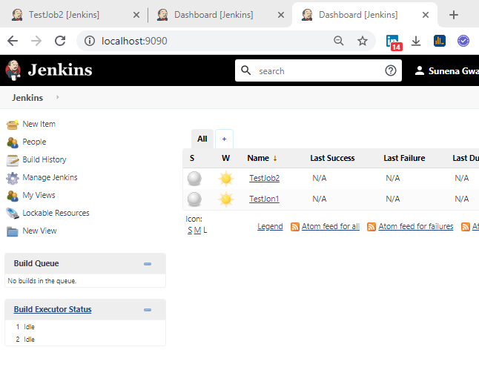

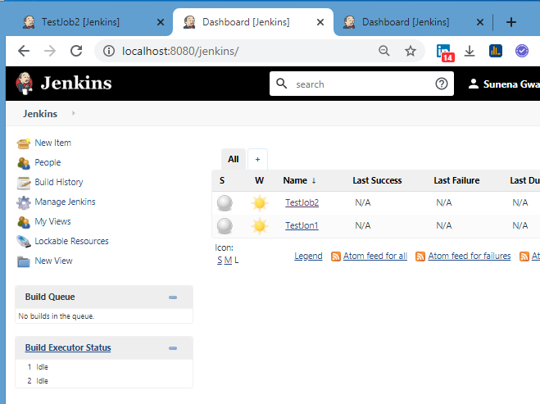

**Tutorial 3(I haven’t used this tutorial)**

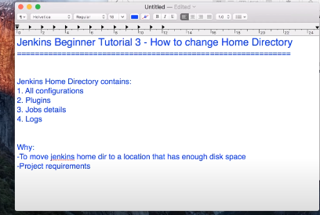

To restart Jenkins

Got to chrome type

Localhost:8080/restart then press enter

**Tutorial 4**

**Tutorial 5**

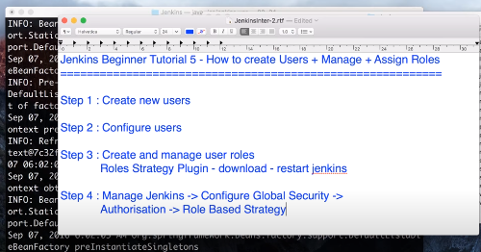

**Tutorial 7**

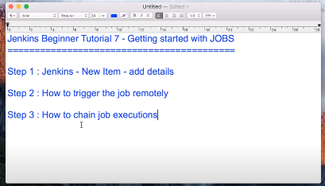

**Tutorial 8**

