**KAFKA**

<https://grokonez.com/spring-framework/spring-boot/start-spring-apache-kafka-application-springboot>

<https://grokonez.com/java-integration/start-apache-kafka>

<https://www.loginradius.com/blog/async/quick-kafka-installation/>

C:\kafka_2.12-0.10.2.1(In my PC)

**According to this link I modify these two file.**

modify the config/*zookeeper.properties* file 🡪 dataDir=C:\kafka\zookeeper

modify the config/server.properties file 🡪 log.dirs=C:\kafka\kafka-logs

**Change Environment variable (otherwise ‘wpic’ is not recognized as internal or external command bhan6)**

Variable name: Path

Variable value: C:\Windows\System32\wbem;%SystemRoot%\System32\;SystemRoot%;%PATH%;

**Commands**

**Start a ZooKeeper:**

C:\kafka_2.12-0.10.2.1>.\bin\windows\zookeeper-server-start.bat .\config\zookeeper.properties

-> Logs:

[2017-06-06 17:59:52,636] INFO Reading configuration from: .\config\zookeeper.properties

...

– **Start the Apache Kafka server**:

C:\kafka_2.12-0.10.2.1>.\bin\windows\kafka-server-start.bat .\config\server.properties

-> Logs:

[2017-06-06 18:06:53,365] INFO starting (kafka.server.KafkaServer)

[2017-06-06 18:06:53,367] INFO Connecting to zookeeper on localhost:2181 (kafka.server.KafkaServer)

[2017-06-06 18:06:53,379] INFO Starting ZkClient event thread. (org.I0Itec.zkclient.ZkEventThread)

...

**-Run Spring boot project**

**Make a producer request**: http://localhost:8080/jsa/kafka/producer?data=Hello World

**Make a consumer request**: http://localhost:8080/jsa/kafka/consumer

<http://localhost:8080/jsa/kafka/producer?data=praja>

<http://localhost:8080/jsa/kafka/consumer>

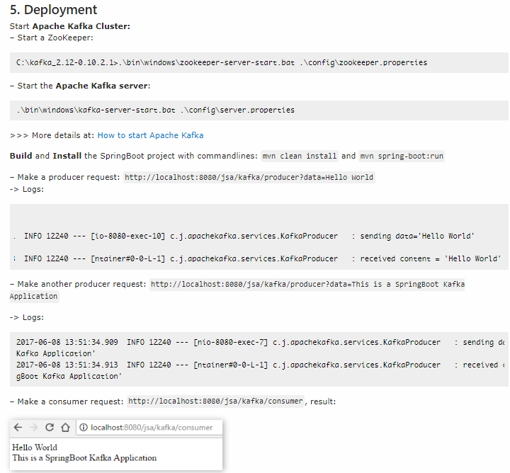

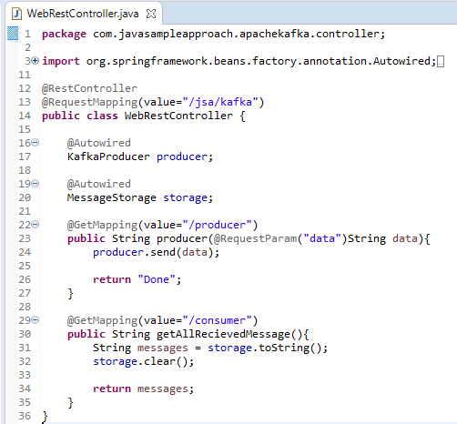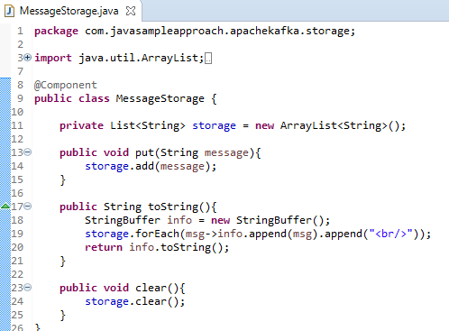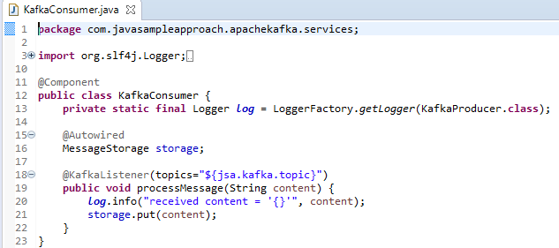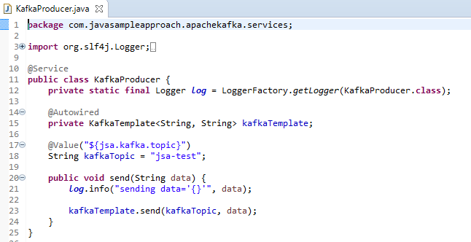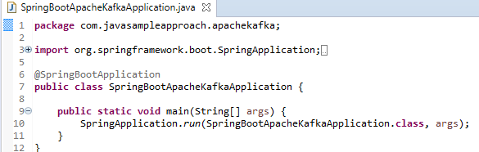**Code**

