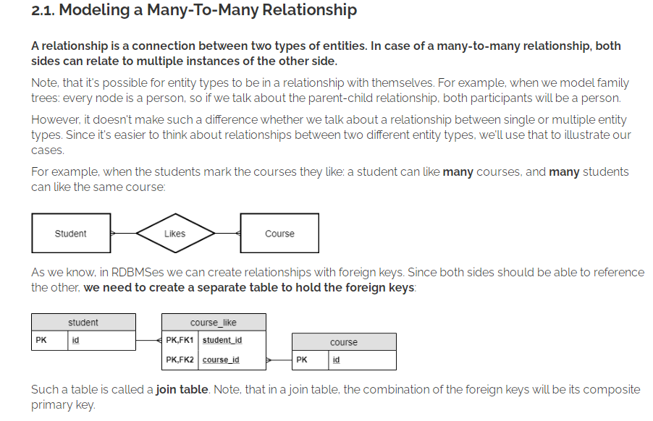

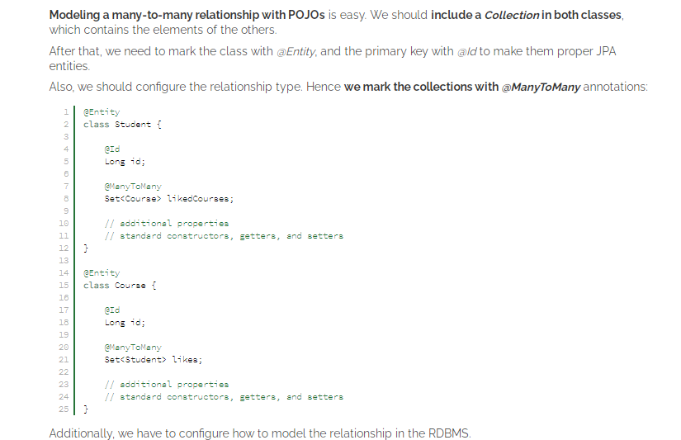

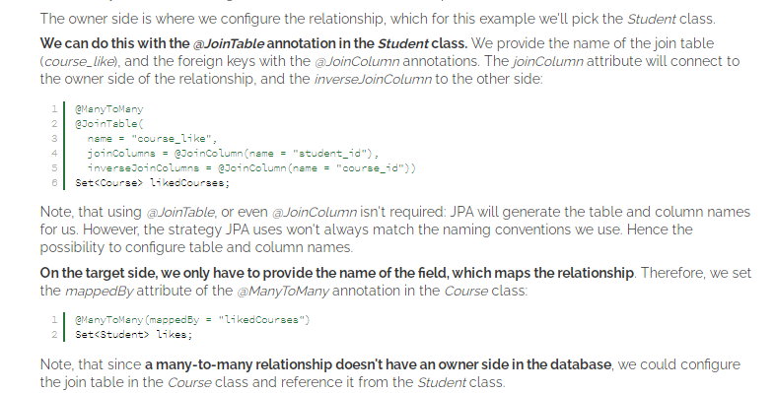

**OneToOneRelationship**

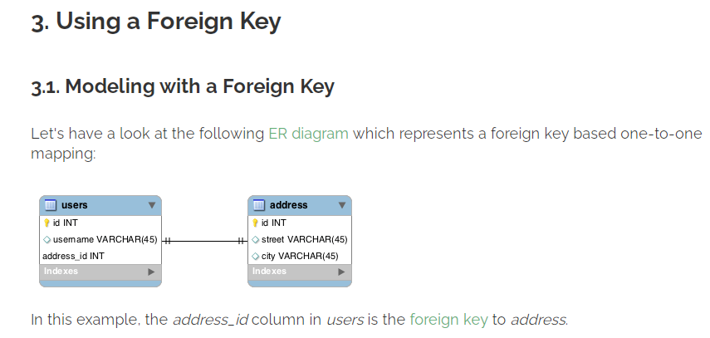

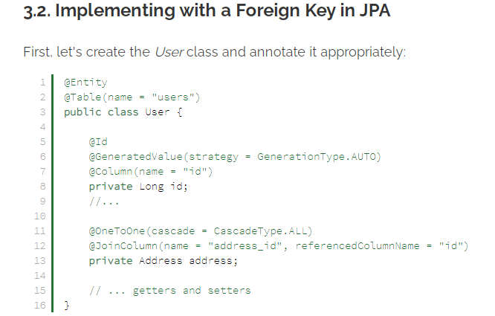

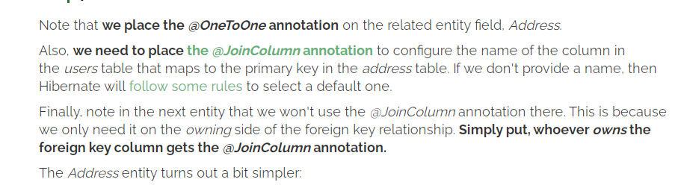

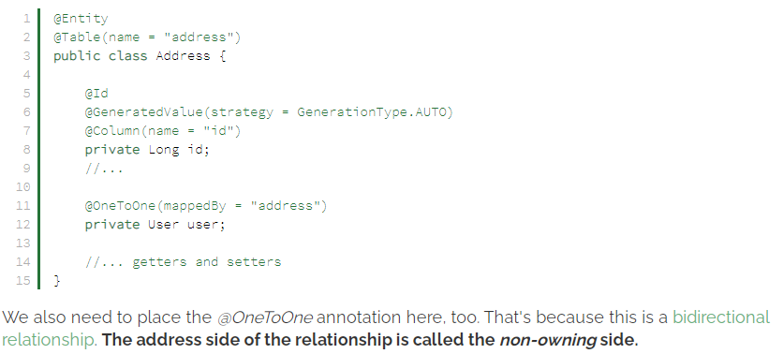

**ManyToMany Bidirectional**

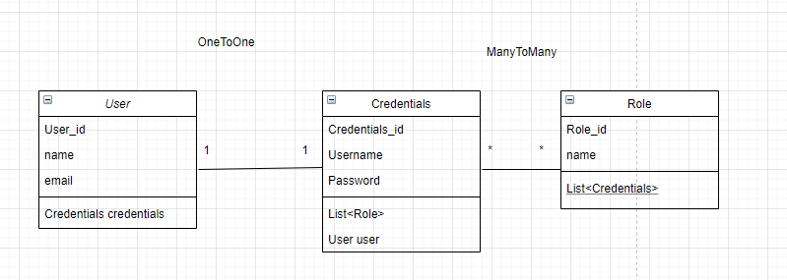

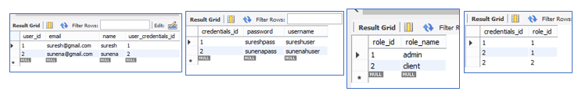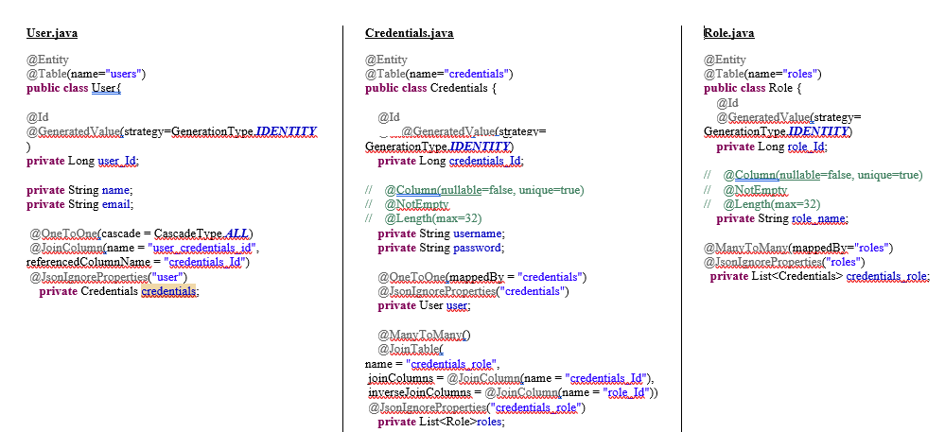

**Note:**

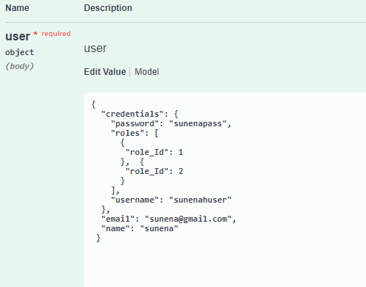

**Use this to remove Hibernate Sequence table in database**

@Id

**@GeneratedValue(strategy=GenerationType.*IDENTITY*)**

**private** Long user_Id;

**Note:**

**Use this to to save from infinite loop**

@OneToOne(cascade = CascadeType.***ALL***)

@JoinColumn(name = "user_credentials_id", referencedColumnName = "credentials_Id")

**@JsonIgnoreProperties("user")**

**private** Credentials credentials;

**OneToMany Bidirectional**

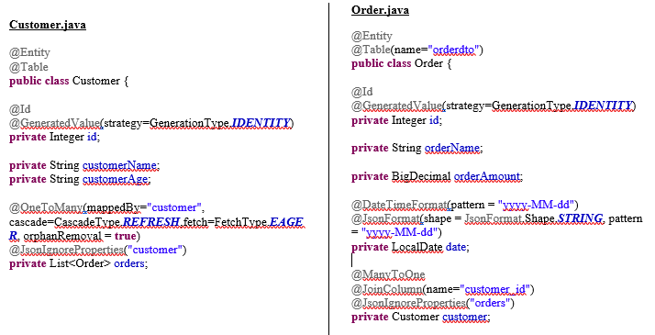

**CustomerTable OrderTable**

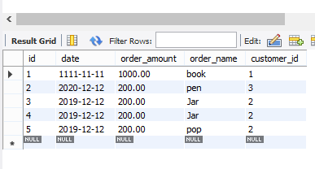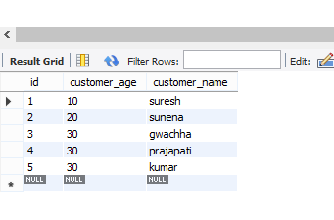

**Application.propertiesfile**

spring.datasource.url=jdbc:mysql://localhost:3306/orderdto1?**createDatabaseIfNotExist=true**

**spring.datasource.username=root**

spring.datasource.password=root

spring.jpa.hibernate.ddl-auto=**update**

server.port=8181

spring.jpa.show-sql=true