**CustomerTable**

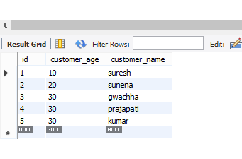

**OrderTable**

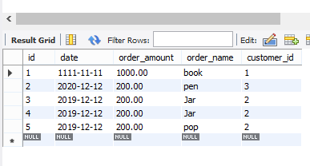

**Application.propertiesfile**

spring.datasource.url=jdbc:mysql://localhost:3306/orderdto1?**createDatabaseIfNotExist=true**

**spring.datasource.username=root**

spring.datasource.password=root

spring.jpa.hibernate.ddl-auto=**update**

server.port=8181

spring.jpa.show-sql=true

**OrderController**

@RestController

**public** **class** OrderController {

@Autowired

**private** OrderService orderService;

@PostMapping(value = "/addOrder")

**public** Order addAddress(@RequestBody Order order){

**return** orderService.addOrder(order);

}

@GetMapping(value = "/getOrder")

**public** List<Order> getOrder(){

**return** orderService.getOrder();

}

**@DeleteMapping("/deleteOrderById/{orderId}")**

**public ResponseEntity<?> deleteOrderById( @PathVariable Integer orderId ) {**

**orderService.deleteOrderById(orderId);**

**return ResponseEntity.*ok*("DELETED");**

}

@GetMapping("/getOrderId/{orderId}")

**public** Order getOrderById( @PathVariable Integer orderId ) {

**return** orderService.findOrderById(orderId);

}

}

**CustomerServiceImpl**

@Service

**public** **class** CustomerServiceImpl **implements** CustomerService{

@Autowired

CustomerRepository customerRepository;

@Override

**public** Customer addCustomer(Customer customer) {

// **TODO** Auto-generated method stub

**return** customerRepository.save(customer);

}

@Override

**public** List<Customer> getCustomer() {

// **TODO** Auto-generated method stub

**return** customerRepository.findAll();

}

@Override

**public** Customer findCustomerById(Integer customerId) {

// **TODO** Auto-generated method stub

**return** **customerRepository.findById(customerId).orElse(null);**

}

}

**For implementing deteleByID in JPA repository we have to make the mapping like this**



**In side repository**

@DeleteMapping("/deleteOrderById/{orderId}")

**public** ResponseEntity<?> deleteOrderById( @PathVariable Integer orderId ) {

orderService.deleteOrderById(orderId);

**return** ResponseEntity.*ok*("DELETED");

}

**Application.properties ma show sql=true garda spring boot ko console ma**

spring.jpa.show-sql=true

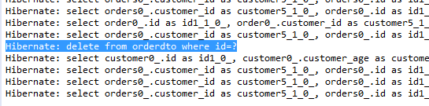

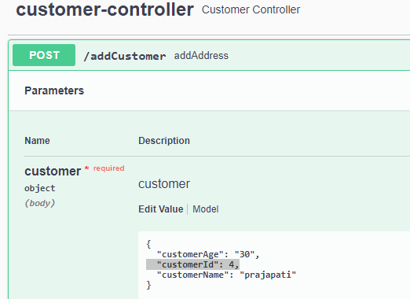

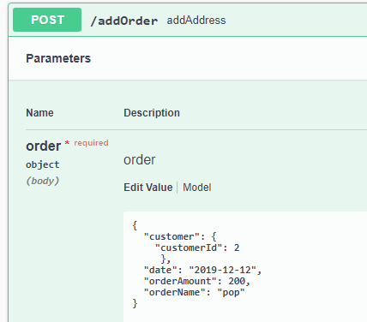

**@Id**

**@GeneratedValue(strategy=GenerationType.*IDENTITY*)**

**private Integer id;**

**So no need to give CustomerId and above orderId**

