**Team members:**

Efrem Tekle (109623)

Daniel Abraha (109548 )

Lwam Tesfamariam (109410)

Suresh Prajapati (109524)

Sunena Gwachha (109578)

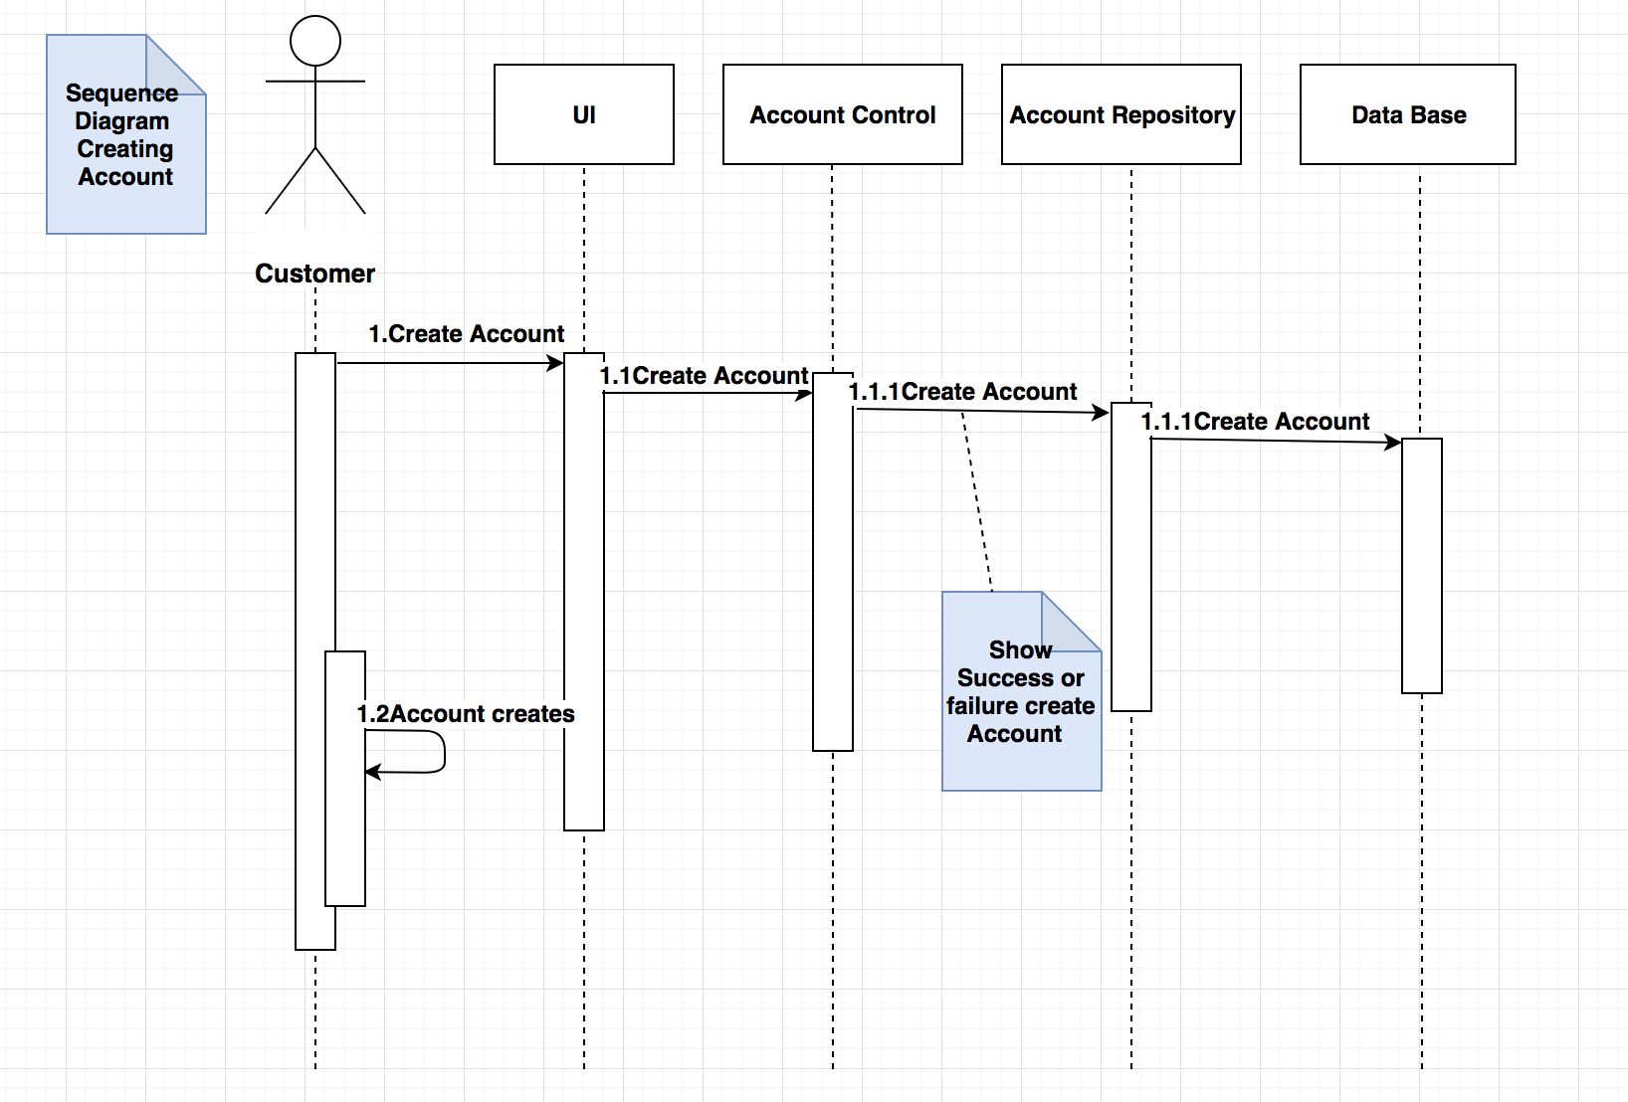

Fig.1 Sequence diagram for creating account

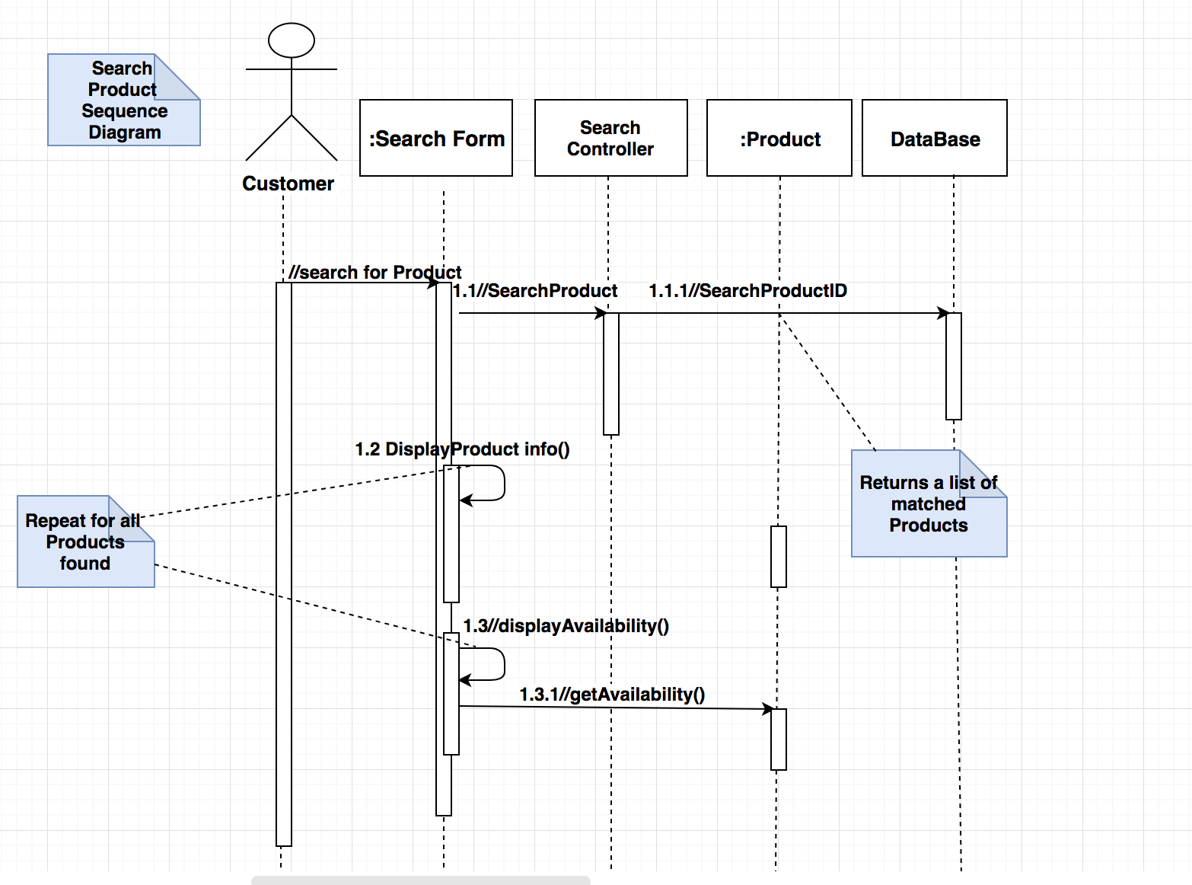

Fig 2. Sequence diagram of Searching Products

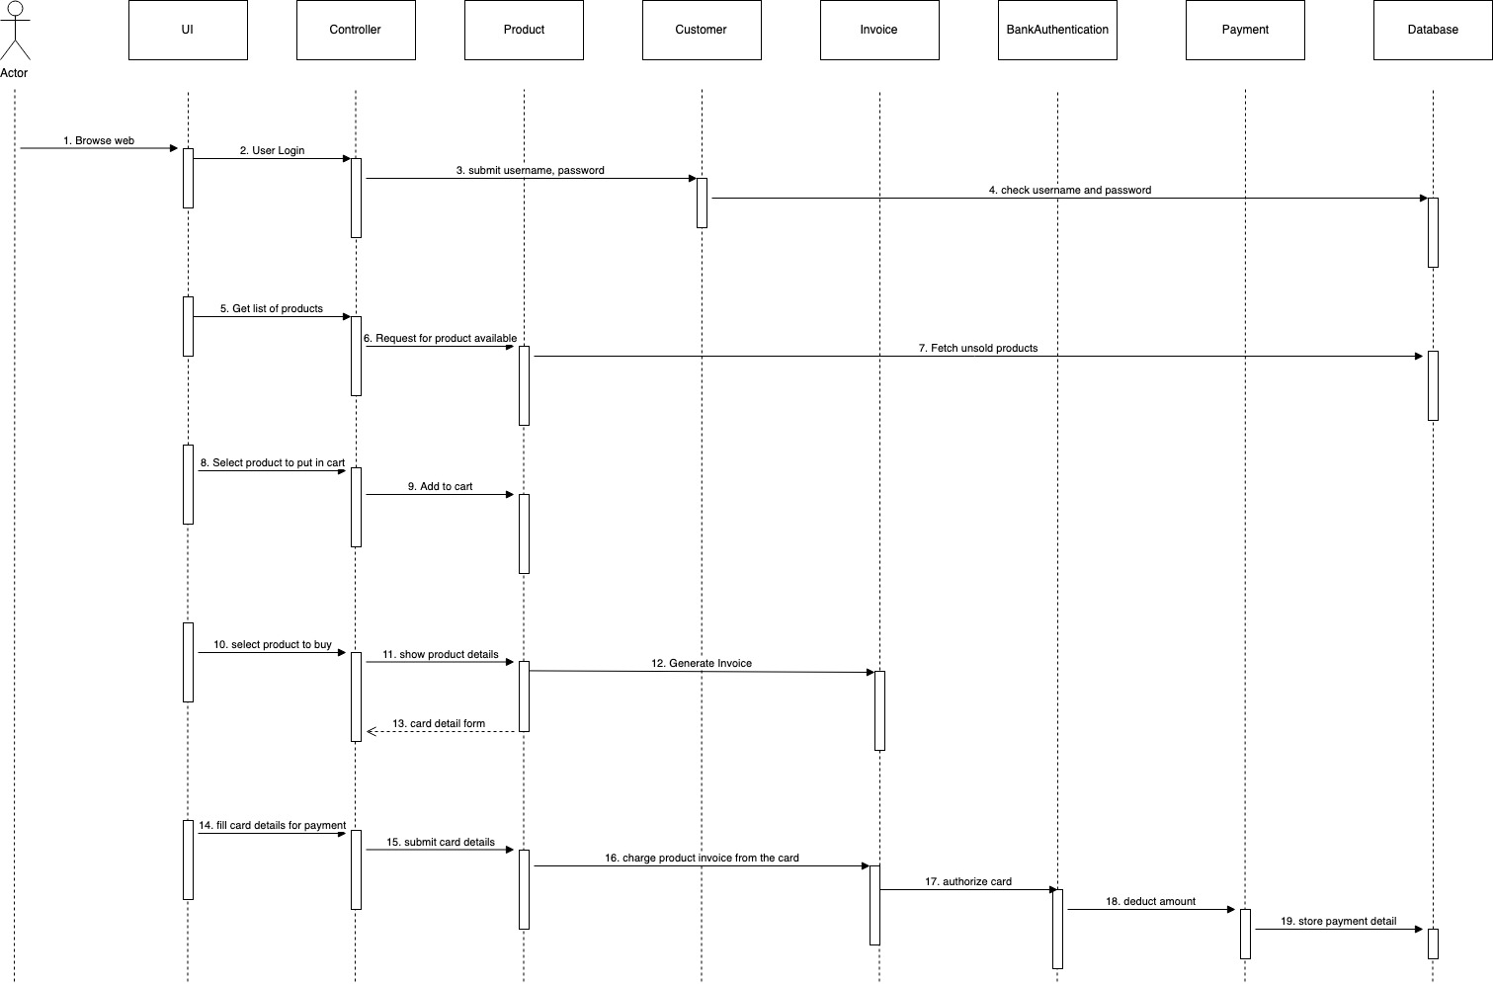

Fig 3. Sequence diagram for Product Purchase