GenMap.py

# Class Map

A class represents all important information of a map:

* The size:
* N (int): width.
* M (int): length.
* The map details (2D list): the whole maze.
* Obstacles (2D list): the positions of obstacles on the map.

# Important functions

## generate_map_randomly

Just like its name, the main idea of this function is to generate a map randomly.

There are 2 types of a random map:

1. Map with discrete walls.
2. We defined the number of walls (each wall is represented by one cell) as equal to the production of the length and width of the map divided by 10.

To ensure the randomness, we stochastically add one or two to the final result.

1. Then we place all of the walls scattered on the map according to that result.
2. In this process, we also maintain that there will not be any invalid wall like this:

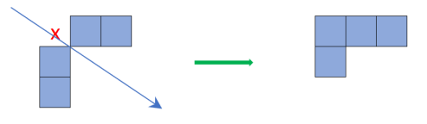

1. Besides, the function just allows a limited number of continuous walls on this type of map. That number is defined as the sum of the length and width then divided by 10.
2. Map with L-shaped walls.
3. With this type of map, we defined the number of L-shaped walls (the walls which are combined create

The user can choose one of the above types. Besides, the number of hiders on the map can be given, too.

However, this function cannot construct obstacles that can be moved by agents.

Therefore, we just use this function to create some test cases in our project.

## generate_map_selectively

In contrast, this function is used to export fixed maps which are initially defined.

We use these maps as the main maps in our project.

There are five maps representing five difficulty levels:

1. Map 1:

* Size: 10 x 10.
* Number of hiders: 1.
* Number of obstacles: 1.

1. Map 2:

* Size: 10 x 20.
* Number of hiders: 2.
* Number of obstacles: 1.

1. Map 3:

* Size: 30 x 30.
* Number of hiders: 4.
* Number of obstacles: 2.

*(chụp hình map)*

1. Map 4:

* Size: 40 x 40.
* Number of hiders: 6.
* Number of obstacles: 3.

*(chụp hình map)*

1. Map 5:

* Size: 50 x 50.
* Number of hiders: 8.
* Number of obstacles: 3.

*(chụp hình map)*

The user can select one of the above maps.