2.4 Liu Wei (TP085412)

2.4.1 Objectives
The objectives of this project are:
- To examine if the website extension (Top Level Domain) in the URL affects the amount of financial Loss from an attack.
- To analyze the impact of the WebServer version on the server DownTime to determine which types of server remain unavailable for the longest duration.

2.4.2 Analysis Questions
The following analysis questions guide the investigation for each research objective. All questions are formulated as testable hypotheses to enable rigorous statistical evaluation.
RO1: To examine if the website extension (TLD) affects financial Loss
Q1: Is there a significant difference in financial Loss across different TLD groups?
Q2: Do government websites (.gov) suffer significantly higher financial Loss per incident compared to commercial websites (.com)?

RO2: To analyze the impact of WebServer type on server DownTime
Q1: Does Apache have significantly longer DownTime compared to modern web servers (Nginx, LiteSpeed, OpenResty)?
Q2: Is there a significant difference in DownTime across different WebServer types?

RO1-Q1 and RO2-Q2 involve multi-group comparisons (>2 groups) and are addressed using the Kruskal-Wallis rank sum test, a non-parametric alternative to one-way ANOVA appropriate for non-normal data. RO1-Q2 and RO2-Q1 involve targeted two-group comparisons and are addressed using the Wilcoxon Rank-Sum test (Mann-Whitney U), suitable for directional hypotheses with non-normal data.

2.4.3 Data Preparation
The data preparation for this individual analysis builds upon the group's completed data cleaning pipeline. The final imputed dataset (mice_imputed_data.RData) containing 592,765 records was loaded, and the relevant variables for each research objective were selected.
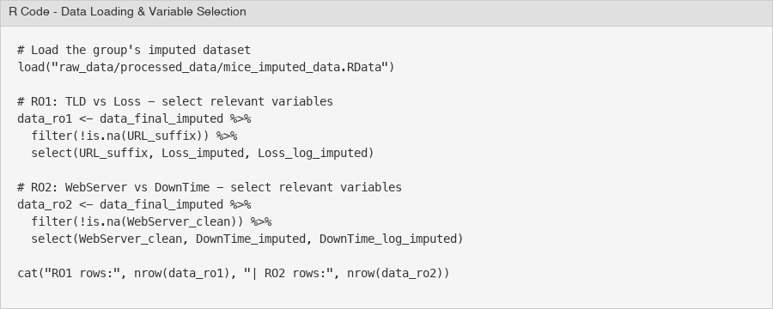
Figure 35 - R Code: Data Loading and Variable Selection
For RO1 (TLD vs Financial Loss), the variables URL_suffix, Loss_imputed, and Loss_log_imputed were selected. After removing rows where URL_suffix was NA, the RO1 dataset contained 571,570 records (21,195 rows removed). For RO2 (WebServer vs DownTime), the variables WebServer_clean, DownTime_imputed, and DownTime_log_imputed were selected, resulting in 532,470 records after removing 60,295 rows with NA in WebServer_clean. Both Loss_imputed and DownTime_imputed had zero missing values after the group's MICE imputation.
Before selecting a statistical test, the normality of the dependent variables was assessed using Shapiro-Wilk tests on random samples of 5,000 observations (the full dataset exceeds the Shapiro-Wilk limit), along with skewness and kurtosis calculations.
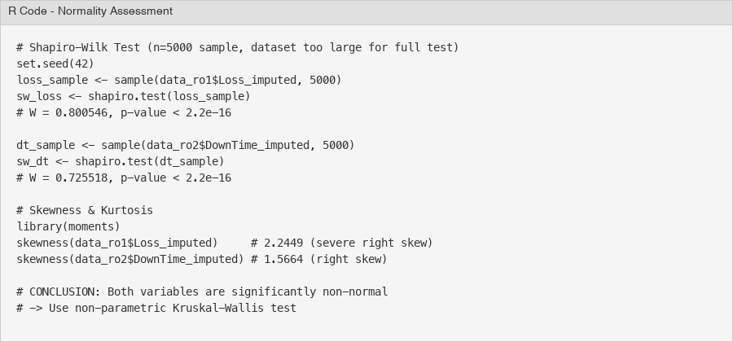
Figure 36 - R Code: Normality Assessment (Shapiro-Wilk & Skewness)
The Shapiro-Wilk test for Loss_imputed yielded W = 0.8005, p < 2.2e-16, and for DownTime_imputed W = 0.7255, p < 2.2e-16. Both p-values are far below the 0.05 significance level, providing strong evidence against normality. The skewness values further confirm this: Loss_imputed has a skewness of 2.2449 and kurtosis of 15.70 (leptokurtic), while DownTime_imputed has a skewness of 1.5664 and kurtosis of 4.18. Even the log-transformed versions show non-negligible skewness (Loss_log: -1.18, DownTime_log: 0.56).
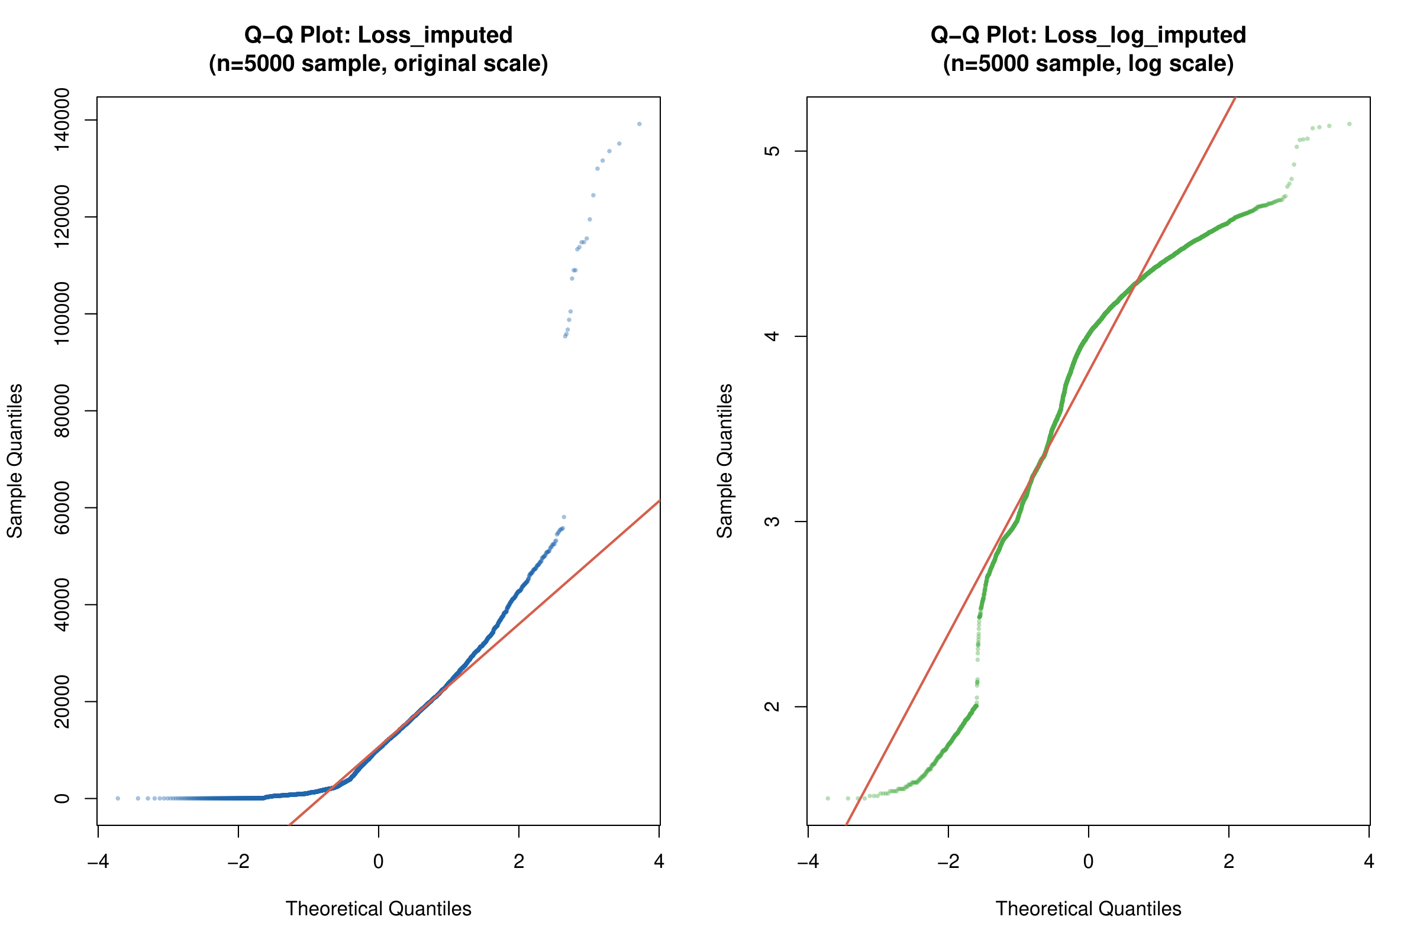
Figure 37 - Q-Q Plots for Loss_imputed: Original Scale (left) and Log Scale (right)
The Q-Q plots for Loss_imputed visually confirm the non-normality. On the original scale (left), the sample quantiles curve sharply upward from the theoretical line, indicating severe right skew and heavy tails. On the log scale (right), the data fits the theoretical line more closely in the middle range but still deviates at both tails, showing residual left skew.
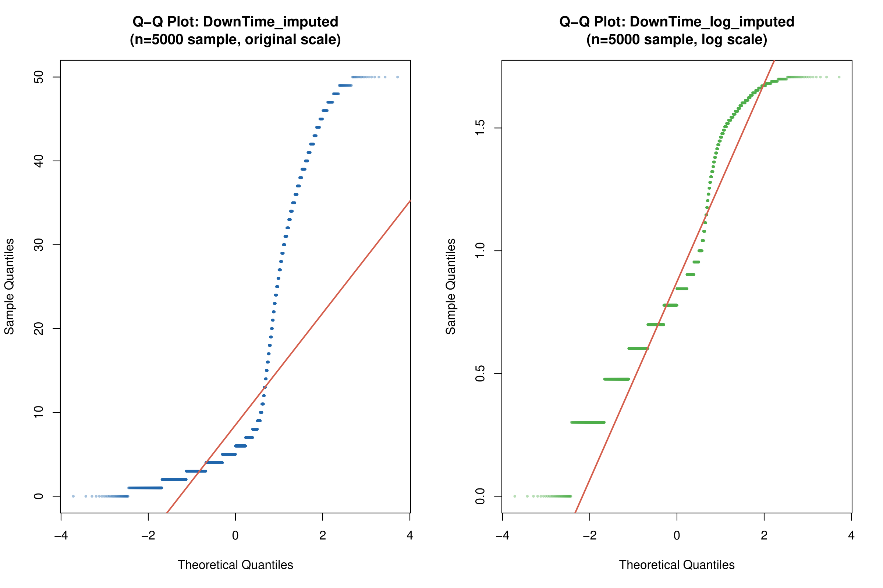
Figure 38 - Q-Q Plots for DownTime_imputed: Original Scale (left) and Log Scale (right)
The Q-Q plots for DownTime_imputed show a step-like pattern on the original scale due to the discrete nature of downtime values (integer days). The deviation from the theoretical line is pronounced at both extremes. On the log scale, the discrete stepping is even more visible. These patterns conclusively demonstrate that neither variable follows a normal distribution, justifying the use of the non-parametric Kruskal-Wallis test for hypothesis testing.
Regarding group balance, the RO1 analysis comprises 11 TLD groups with sizes ranging from 2,889 (.ch) to 410,471 (.com). All groups exceed the minimum threshold of 30 observations. The RO2 analysis contains 6 WebServer categories, with sizes from 747 (Other) to 190,333 (Apache). While there is substantial imbalance between groups, the Kruskal-Wallis test is robust to unequal group sizes.

2.4.4 Data Analysis
RO1: Does TLD Affect Financial Loss?
To address the first research objective, exploratory data analysis was conducted to examine how financial loss varies across different Top-Level Domains (TLDs). The analysis used the cleaned and imputed dataset containing 571,570 records with 11 TLD categories.
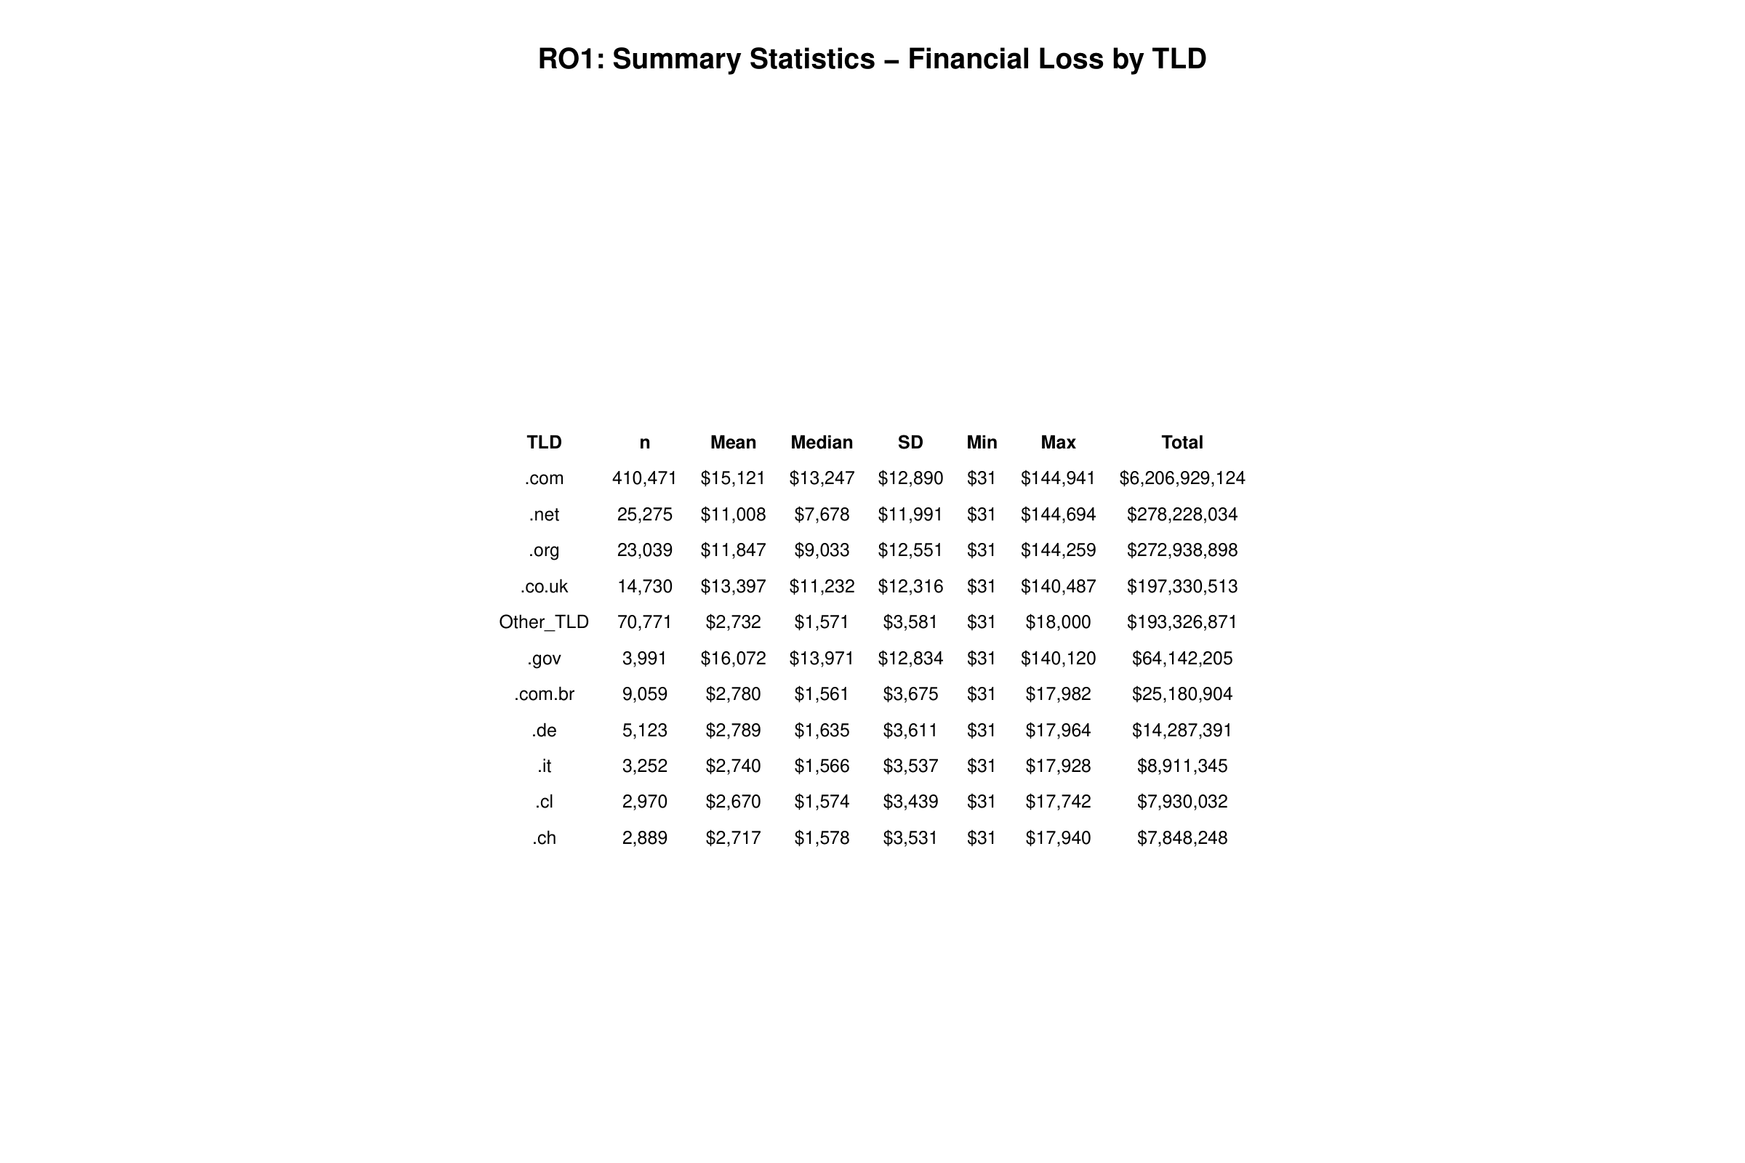
Figure 39 - RO1 Summary Statistics: Financial Loss by TLD
The summary statistics table reveals a clear two-tier pattern in financial losses. The first tier consists of generic TLDs (.gov, .com, .co.uk, .org, .net) with mean losses ranging from $11,008 to $16,072. The second tier contains country-code TLDs (.de, .com.br, .it, .cl, .ch) and the Other_TLD category, all clustering around $2,670 to $2,789 in mean loss. Notably, .gov websites have the highest mean loss ($16,072) despite having only 3,991 records, suggesting that government websites suffer more severe financial consequences per attack. Meanwhile, .com dominates in total loss ($6.2 billion) due to its overwhelming volume of 410,471 incidents.
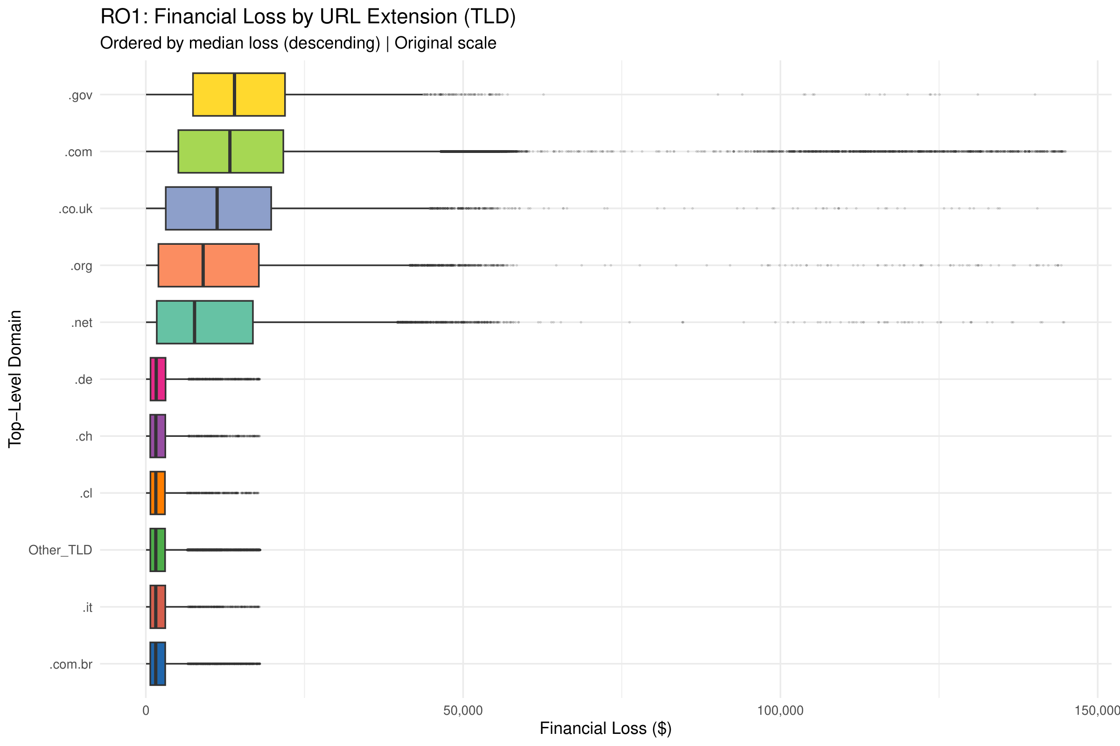
Figure 40 - RO1 Boxplot: Financial Loss by TLD (Original Scale)
The boxplot on the original scale shows that .gov and .com have the widest interquartile ranges (IQR), indicating high variability in their financial losses. Both TLDs also exhibit extreme outliers reaching up to $140,000–$145,000. Country-code TLDs (.de, .ch, .cl, .it, .com.br) display narrow boxes clustered near the lower end, confirming their relatively low and consistent loss amounts.
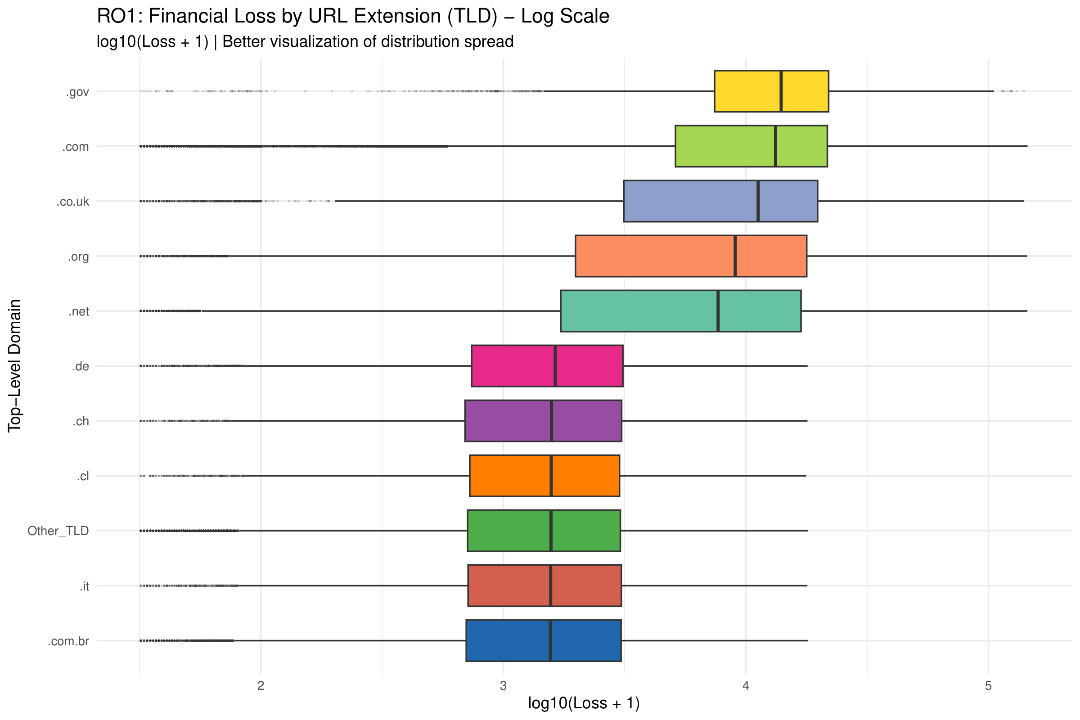
Figure 41 - RO1 Boxplot: Financial Loss by TLD (Log Scale)
The log-transformed boxplot provides better visibility of the distribution spread across all TLD groups. On this scale, the separation between the two tiers becomes more apparent. The generic TLDs (.gov, .com, .co.uk, .org, .net) cluster in the log10 range of 3.5–4.5, while the country-code TLDs occupy the 2.8–3.5 range. This transformation also reveals that .net has the widest IQR among all groups on the log scale, indicating the most heterogeneous loss distribution.
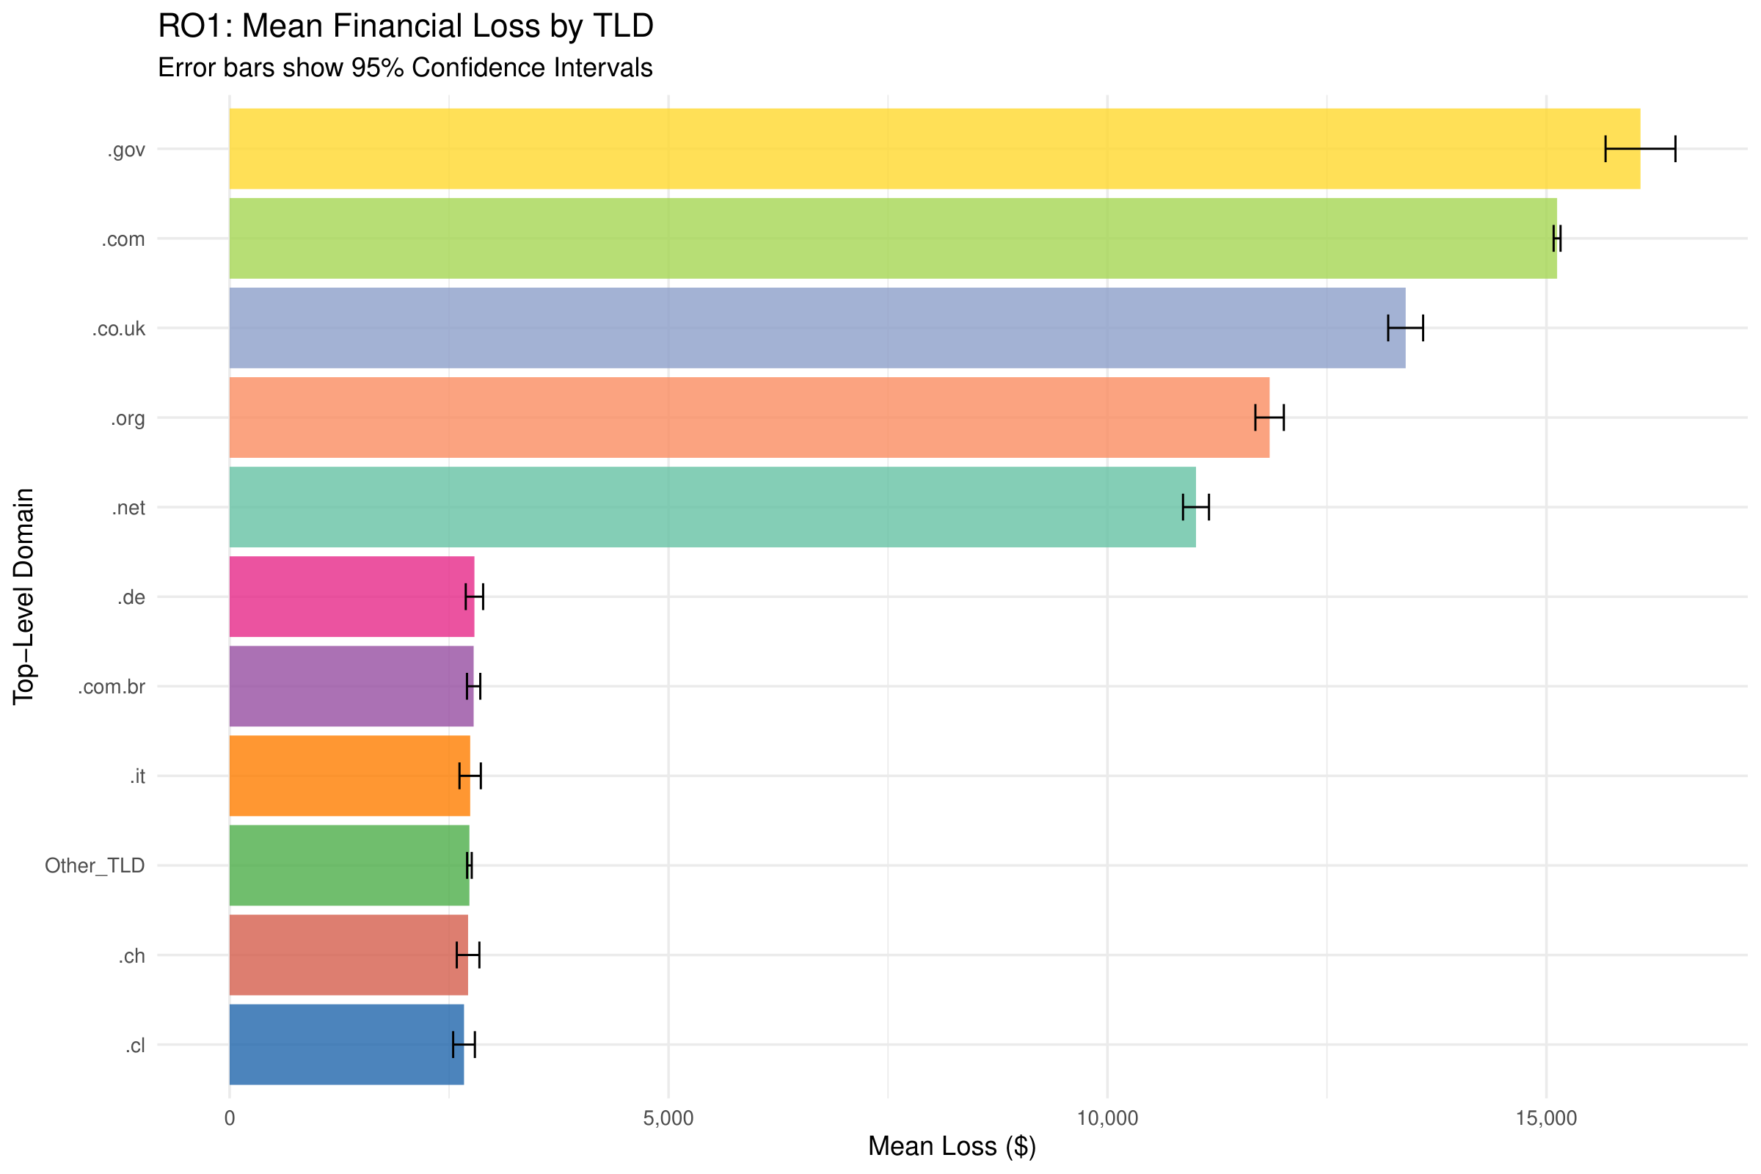
Figure 42 - RO1 Mean Financial Loss by TLD with 95% CI
The mean loss bar chart with 95% confidence intervals shows the ranking clearly: .gov ($16,072) > .com ($15,121) > .co.uk ($13,397) > .org ($11,847) > .net ($11,008). The confidence intervals are narrow due to the large sample sizes, confirming that these differences are reliable. The gap between the top 5 generic TLDs and the bottom 6 country-code/Other TLDs is dramatic, with the latter all falling below $3,000.
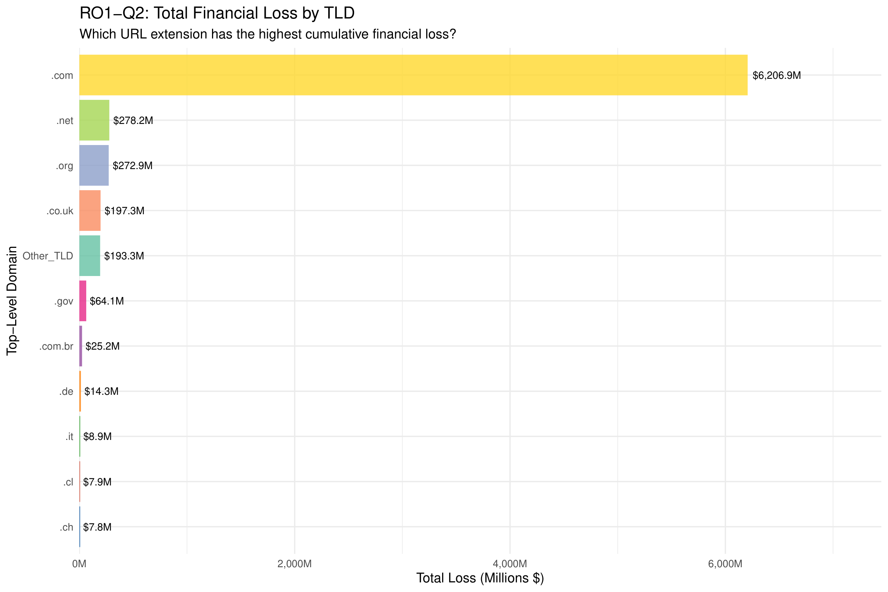
Figure 43 - RO1 Total Financial Loss by TLD (Descriptive Context for Q2)
The total loss bar chart provides descriptive context for RO1-Q2. While .com dominates overwhelmingly with $6,206.9 million in cumulative losses (approximately 85% of all financial losses), the formal statistical comparison between .gov and .com is presented in Section 2.4.5 using the Wilcoxon Rank-Sum test. The dominance of .com in total loss is primarily driven by its sheer volume (410,471 incidents out of 571,570 total), rather than higher per-incident severity.
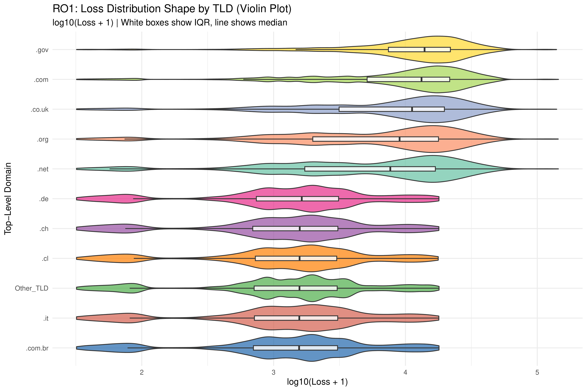
Figure 44 - RO1 Violin Plot: Loss Distribution by TLD
The violin plot reveals the full distributional shape of losses within each TLD group. The .gov and .com groups show a unimodal, right-skewed distribution concentrated at higher values. In contrast, several country-code TLDs (.de, .ch, .cl, .it, .com.br) display a bimodal pattern with density peaks at both low and moderate loss values. The Other_TLD group shows the most concentrated distribution around low loss values, reflecting the heterogeneous nature of this catch-all category.
RO2: Does WebServer Type Affect DownTime?
The second research objective investigates how server downtime varies across different WebServer types. The analysis used 532,470 records classified into 6 WebServer categories.
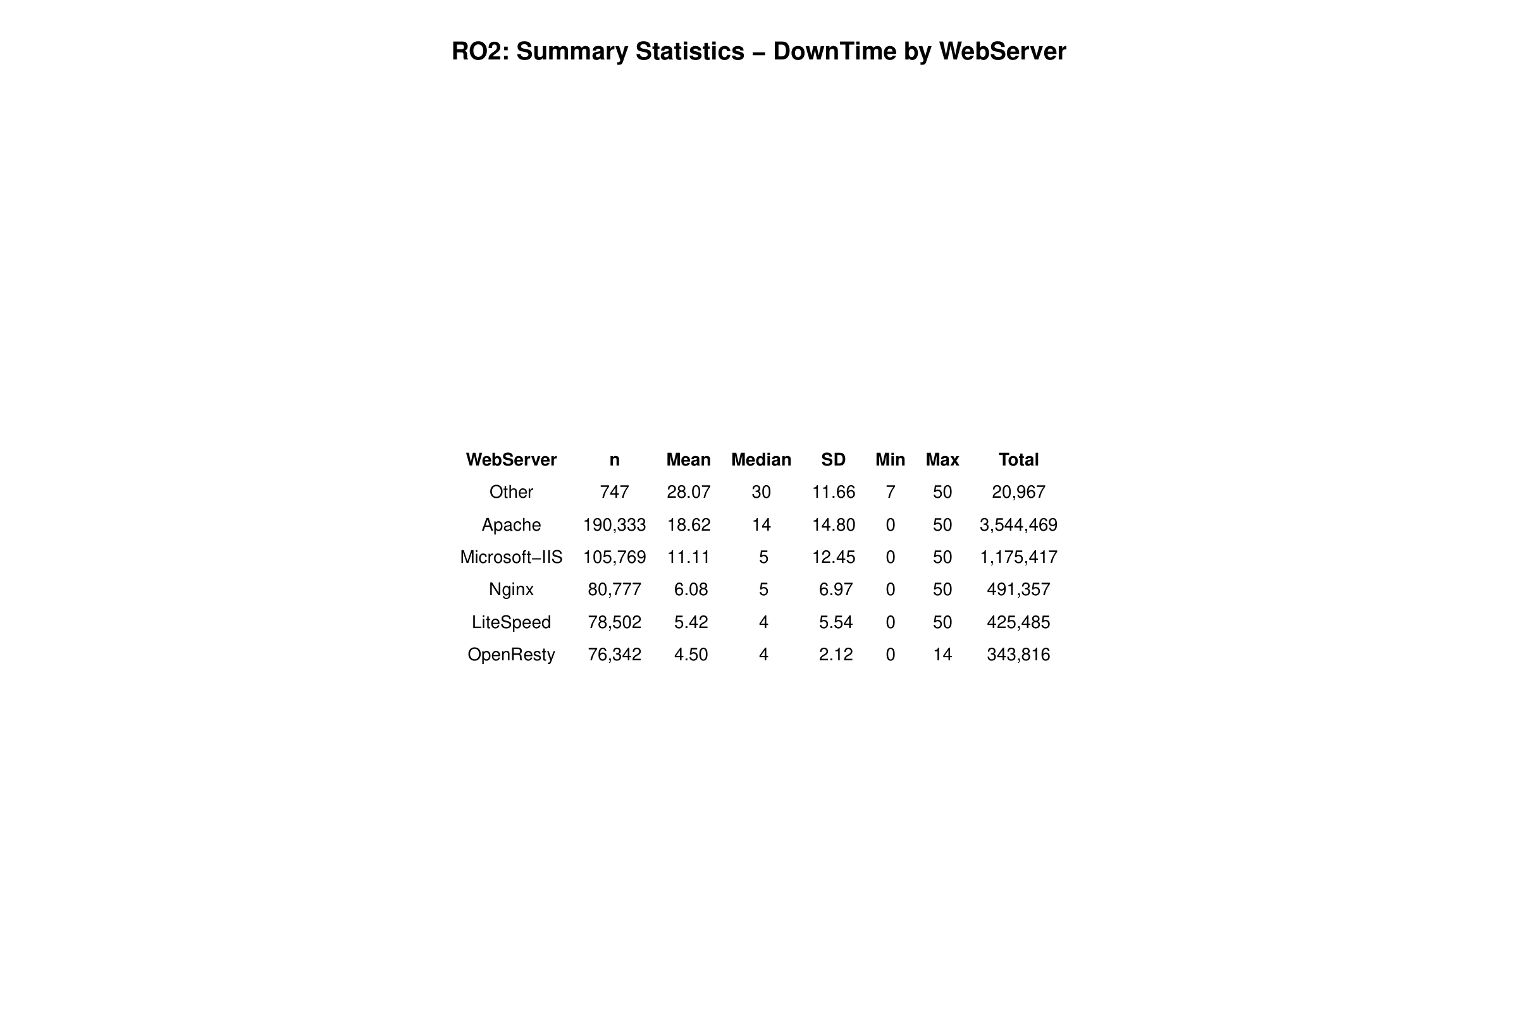
Figure 45 - RO2 Summary Statistics: DownTime by WebServer
The summary statistics table reveals a clear hierarchy in mean downtime. The "Other" category has the highest mean (28.07 days) but with only 747 records, it represents miscellaneous or rare server types. Among mainstream servers, Apache leads with a mean of 18.62 days and median of 14 days, followed by Microsoft-IIS (mean 11.11, median 5), Nginx (mean 6.08, median 5), LiteSpeed (mean 5.42, median 4), and OpenResty (mean 4.50, median 4). OpenResty also shows the lowest standard deviation (2.12), indicating the most consistent recovery times.
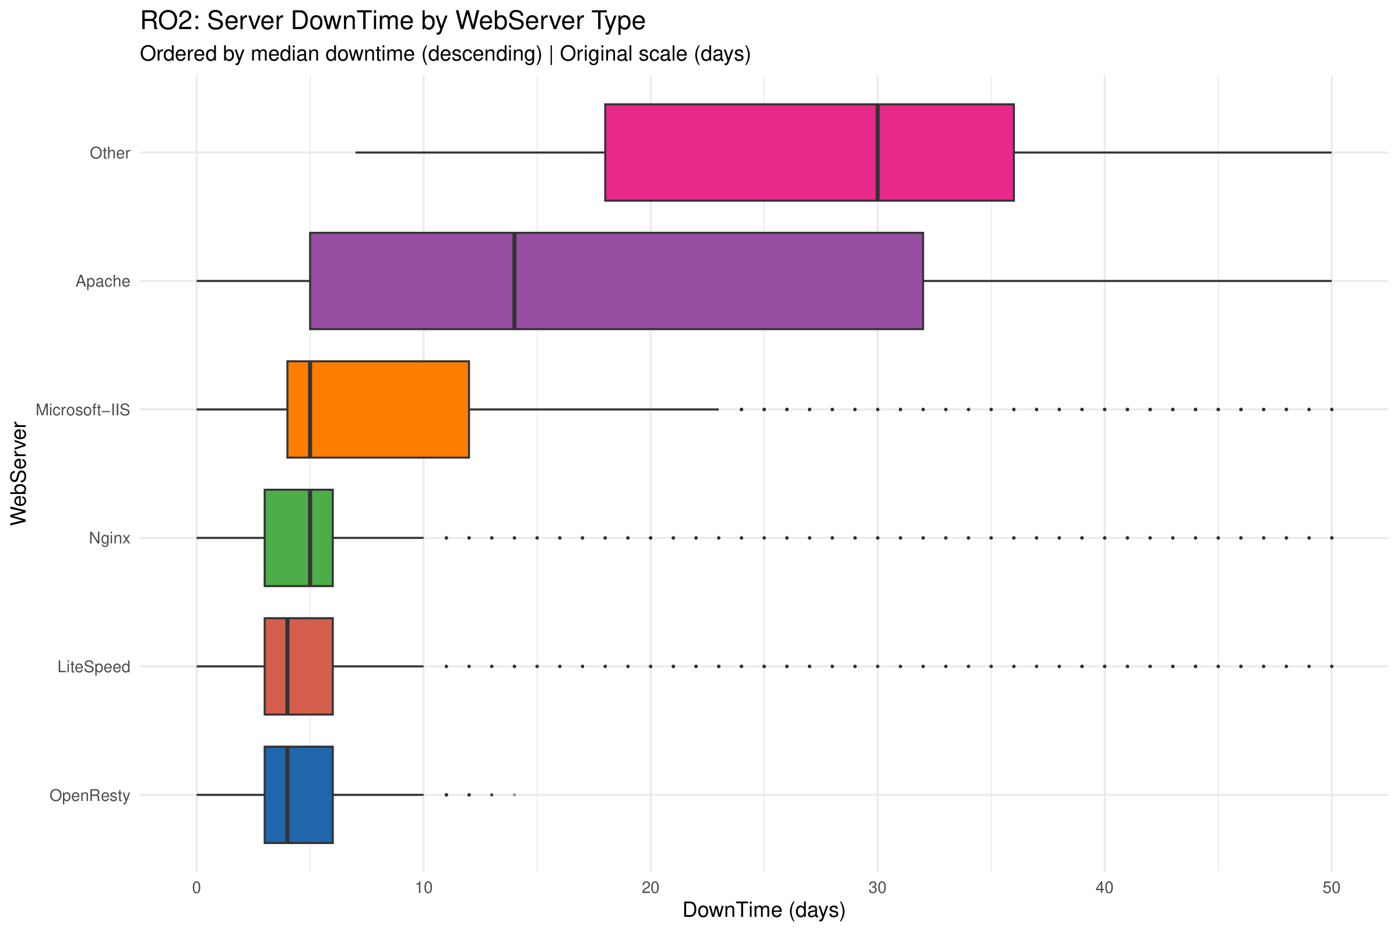
Figure 46 - RO2 Boxplot: DownTime by WebServer (Original Scale)
The boxplot on the original scale dramatically illustrates the differences. The "Other" category shows the widest box (IQR spanning roughly 15–37 days), while Apache displays a very wide distribution from 0 to 50 days. In contrast, the modern web servers (Nginx, LiteSpeed, OpenResty) have compact boxes concentrated in the 0–10 day range. OpenResty has the tightest distribution with a maximum of only 14 days.
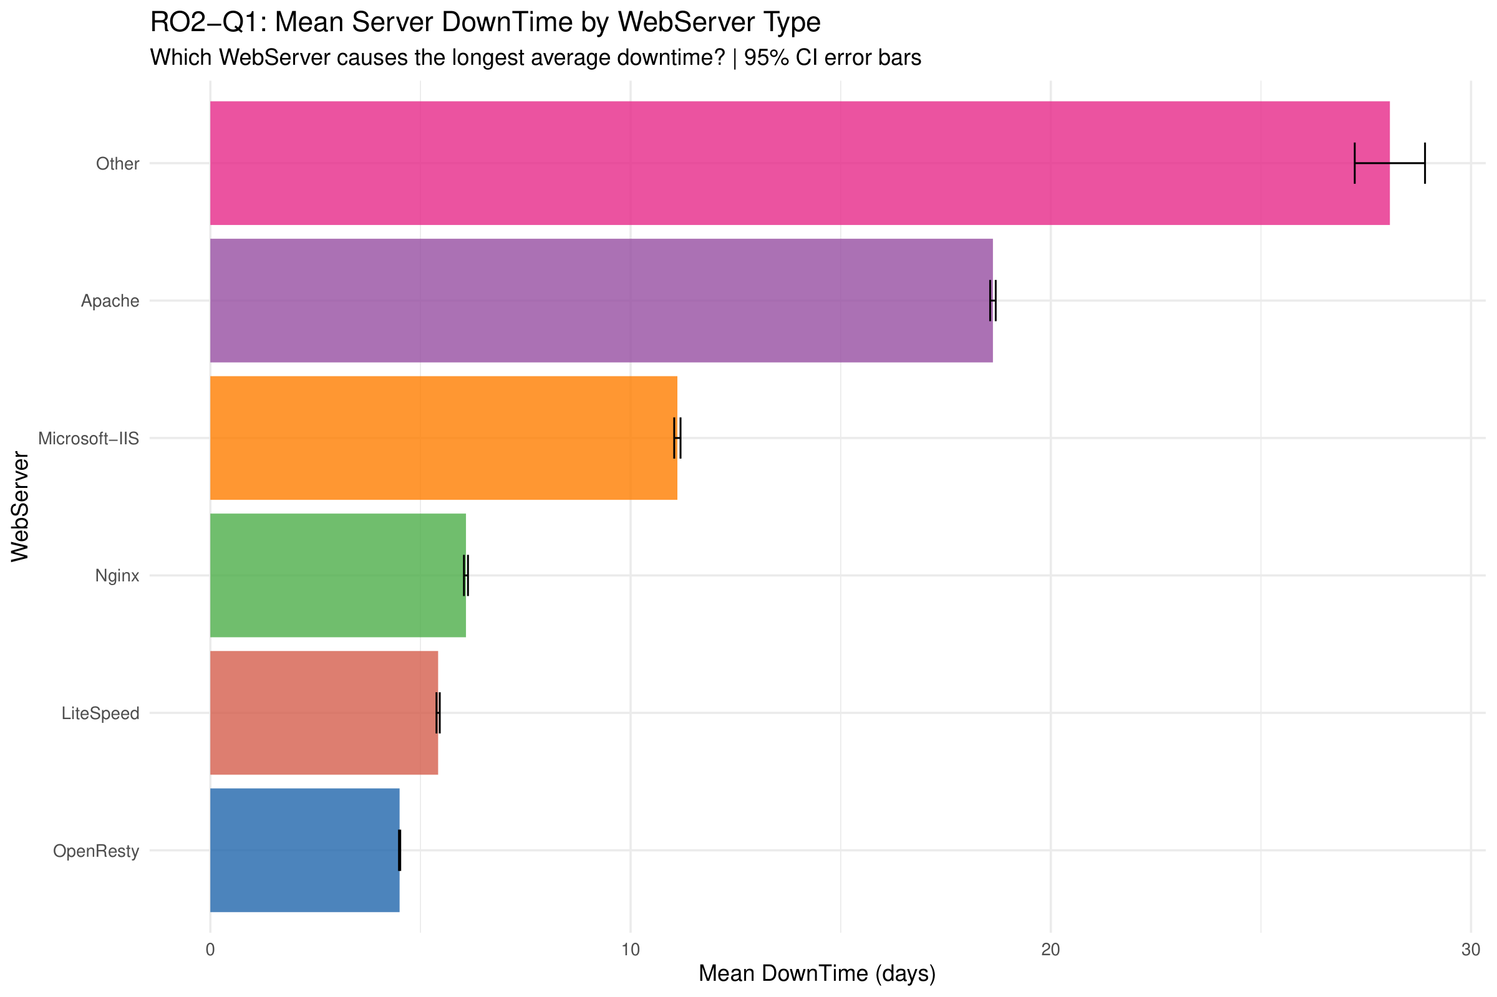
Figure 47 - RO2 Mean DownTime by WebServer (Descriptive Context for Q1)
The mean downtime bar chart provides descriptive context for RO2-Q1. Among mainstream servers, Apache has the longest average downtime at 18.62 days, followed by Microsoft-IIS at 11.11 days, Nginx at 6.08 days, LiteSpeed at 5.42 days, and OpenResty at 4.50 days. The formal hypothesis test comparing Apache against modern servers (Nginx, LiteSpeed, OpenResty) is presented in Section 2.4.5 using the Wilcoxon Rank-Sum test. The 95% confidence intervals are extremely narrow due to the large sample sizes, confirming the reliability of these rankings.
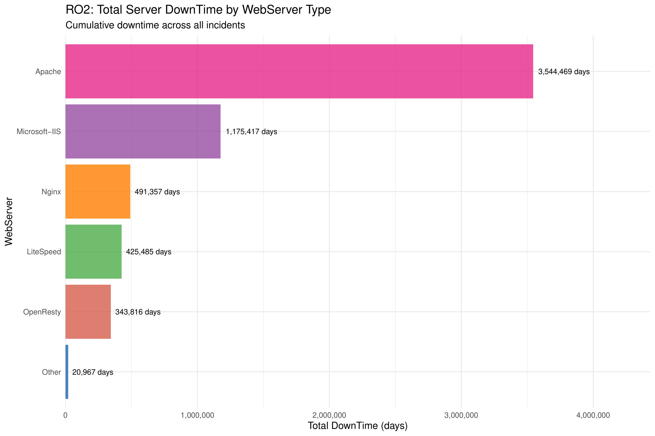
Figure 48 - RO2 Total DownTime by WebServer
The total downtime bar chart shows Apache accumulating 3,544,469 days of downtime across all incidents, far exceeding Microsoft-IIS (1,175,417 days), Nginx (491,357 days), LiteSpeed (425,485 days), and OpenResty (343,816 days). Apache's dominance in total downtime reflects both its higher per-incident downtime and its large market share (190,333 incidents).
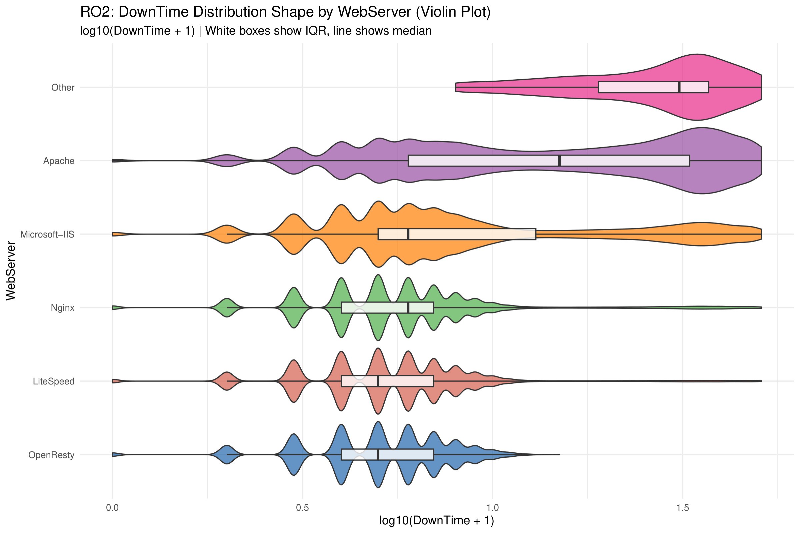
Figure 49 - RO2 Violin Plot: DownTime Distribution by WebServer
The violin plot reveals distinct distributional shapes across server types. Apache shows a bimodal distribution with a density peak at low values and another at high values, suggesting two populations of Apache servers with very different recovery characteristics. Microsoft-IIS displays a multi-modal pattern. In contrast, OpenResty shows a concentrated, unimodal distribution, indicating highly consistent and predictable downtime. This pattern suggests that modern web server technologies not only have shorter average downtimes but also more reliable and predictable recovery times.

2.4.5 Hypothesis Formulation and Testing
RO1: Does TLD Affect Financial Loss?
To determine whether the type of Top-Level Domain (TLD) in the URL significantly affects the financial loss from a cyber-attack, the following hypotheses were formulated:
H₀: The distribution of financial loss (Loss) has the same location parameter across all TLD groups. In other words, there is no significant difference in median Loss ranks among TLD groups.
H₁: At least one TLD group has a significantly different loss distribution location compared to the others.
Since the data is significantly non-normal (as demonstrated in section 2.4.3 with Shapiro-Wilk p < 2.2e-16 and skewness = 2.24), and the comparison involves more than two independent groups (11 TLD categories), the Kruskal-Wallis rank sum test was selected as the appropriate non-parametric alternative to one-way ANOVA.
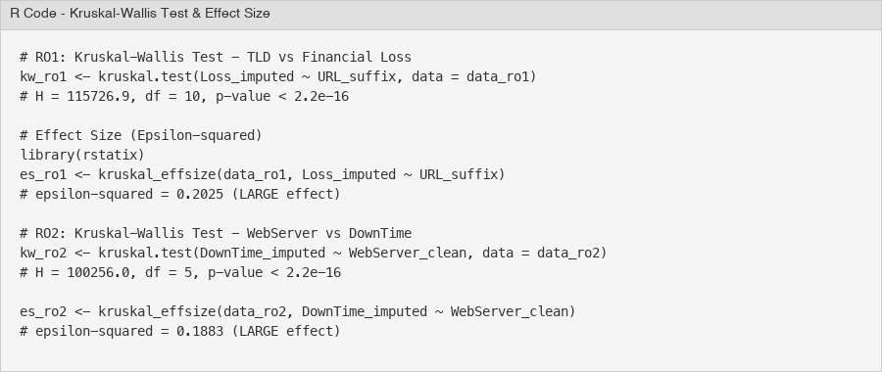
Figure 50 - Kruskal-Wallis Test and Effect Size Calculation
The Kruskal-Wallis test yielded a test statistic of H = 115,726.9 with 10 degrees of freedom and a p-value < 2.2e-16. This result is highly significant, leading to the rejection of H₀. There is strong statistical evidence that the distribution of financial loss differs across TLD groups.
The effect size was measured using epsilon-squared (ε²), calculated via the rstatix::kruskal_effsize() function. The result was ε² = 0.2025, which is classified as a large effect according to standard interpretation guidelines (ε² < 0.01 = negligible, 0.01–0.06 = small, 0.06–0.14 = medium, > 0.14 = large). This confirms that the TLD difference is not merely statistically significant due to the large sample size (n = 571,570), but is also practically meaningful.
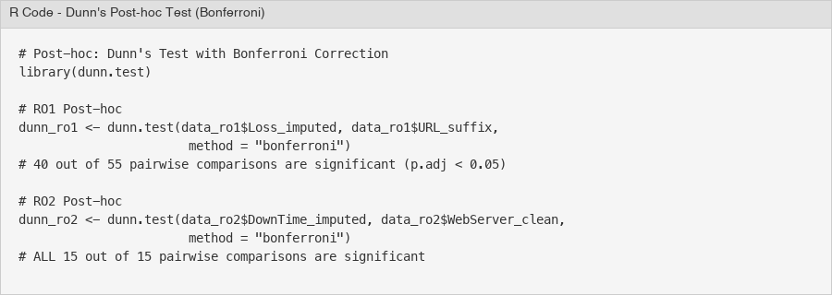
Figure 51 - Dunn's Post-hoc Test with Bonferroni Correction
To identify which specific TLD pairs differ significantly, Dunn's test with Bonferroni correction was performed. Out of 55 pairwise comparisons, 40 were statistically significant (adjusted p < 0.05). Notably, all comparisons involving .gov, .com, .co.uk, .org, and .net against the country-code TLDs (.de, .it, .cl, .ch, .com.br) were significant, confirming the two-tier pattern observed in the exploratory analysis.
RO1 Conclusion: The TLD in a website URL is significantly associated with the financial loss from a cyber-attack. Government websites (.gov) suffer the highest per-incident loss ($16,072 mean), while commercial websites (.com) accumulate the highest total loss ($6.2 billion) due to their dominant presence in the dataset. Country-code TLDs consistently show lower financial losses.

RO1-Q2: Do .gov Websites Suffer Higher Financial Loss Than .com?
Following the omnibus Kruskal-Wallis test which established that TLD groups differ significantly in financial loss, a targeted comparison between government (.gov) and commercial (.com) websites was conducted to address RO1-Q2. This focused analysis tests whether the observed mean difference ($16,072 for .gov vs $15,121 for .com) is statistically significant.
H₀: The distribution of financial loss for .gov websites has the same location parameter as .com websites (no difference in median ranks).
H₁: Government websites (.gov) suffer significantly higher financial loss per incident than commercial websites (.com).
Since this is a two-group comparison with non-normal data and a directional hypothesis, the Wilcoxon Rank-Sum test (also known as the Mann-Whitney U test) was selected. The one-sided alternative tests whether .gov losses are stochastically greater than .com losses.
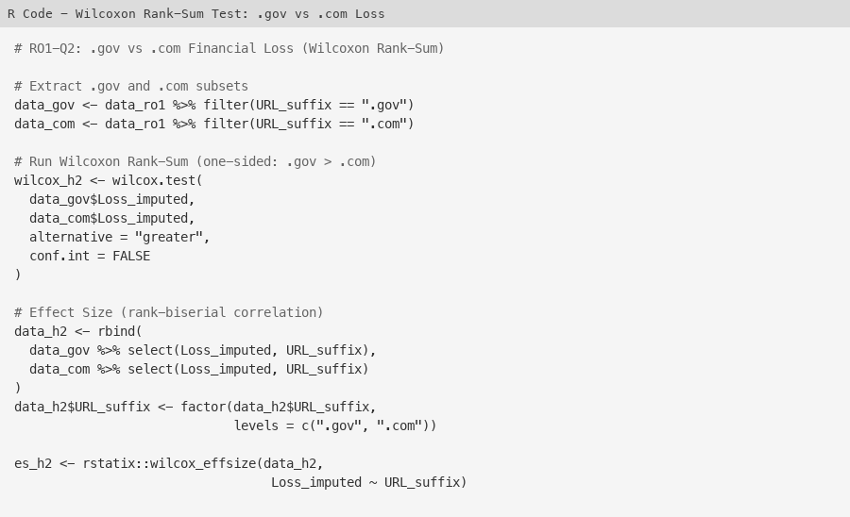
Figure 52 - R Code: Wilcoxon Rank-Sum Test for .gov vs .com Loss
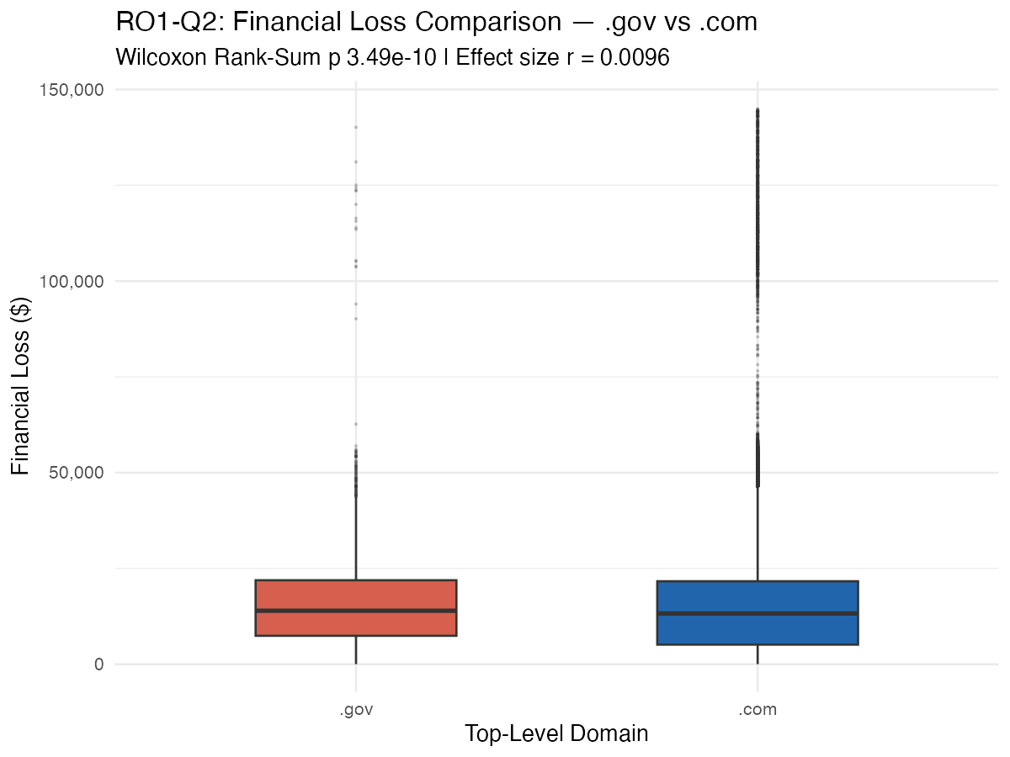
Figure 53 - Boxplot: Financial Loss Distribution for .gov vs .com
The Wilcoxon Rank-Sum test yielded W = 865,478,982 with p = 3.49e-10 (one-sided). This result is highly significant at the 0.05 level, leading to the rejection of H₀. Government websites (.gov) suffer statistically significantly higher financial loss per incident than commercial websites (.com).
The effect size was measured using the rank-biserial correlation (r), calculated via rstatix::wilcox_effsize(). The result was r = 0.0096, classified as a small effect. Interpretation guidelines for the rank-biserial correlation: r < 0.1 = negligible, 0.1–0.3 = small, 0.3–0.5 = medium, r > 0.5 = large. While statistically significant, the small effect size indicates that the practical difference between .gov and .com per-incident losses, though real, is modest. This is consistent with the observation that .gov's mean advantage ($16,072 vs $15,121, a 6.3% difference) is relatively small compared to the massive gap between the generic TLD tier and country-code TLD tier revealed by the Kruskal-Wallis test.
RO1-Q2 Conclusion: Government websites (.gov) do suffer significantly higher financial loss per incident than commercial websites (.com), as confirmed by the Wilcoxon Rank-Sum test (W = 865,478,982, p = 3.49e-10). However, the small effect size (r = 0.0096) suggests that the practical magnitude of this difference is modest. The Kruskal-Wallis omnibus test (Section 3.1) provides stronger evidence of meaningful group differences across all TLDs.
RO2: Does WebServer Type Affect DownTime?
To determine whether the type of web server affects the duration of server downtime following a cyber-attack, the following hypotheses were formulated:
H₀: The distribution of downtime (DownTime) has the same location parameter across all WebServer types. There is no significant difference in median DownTime ranks.
H₁: At least one WebServer type has a significantly different downtime distribution location compared to the others.
The same justification for non-parametric testing applies: DownTime is significantly non-normal (Shapiro-Wilk W = 0.73, p < 2.2e-16, skewness = 1.57), and the comparison involves 6 independent WebServer groups. The Kruskal-Wallis test was used.
The Kruskal-Wallis test produced H = 100,256.0 with 5 degrees of freedom and p < 2.2e-16, leading to the rejection of H₀. There is strong statistical evidence that server downtime differs significantly across WebServer types.
The effect size was ε² = 0.1883, classified as a large effect. This confirms that the WebServer type has a substantial practical impact on downtime duration, not just a statistical artifact of the large sample.
Dunn's post-hoc test with Bonferroni correction revealed that all 15 out of 15 pairwise comparisons were statistically significant (adjusted p < 0.05). This means every WebServer type has a significantly different downtime profile from every other type. The most notable contrasts are Apache vs. OpenResty (Z = 240.13) and Apache vs. Nginx (Z = 217.95), reflecting the massive gap between legacy and modern server technologies.
RO2 Conclusion: The WebServer type is significantly associated with server downtime. Among mainstream servers, Apache exhibits the longest average downtime (18.62 days), while modern servers such as OpenResty (4.50 days), LiteSpeed (5.42 days), and Nginx (6.08 days) recover substantially faster. This suggests that newer web server technologies have improved resilience and faster recovery mechanisms.

RO2-Q1: Does Apache Have Significantly Longer DownTime Than Modern Servers?
Following the omnibus Kruskal-Wallis test which established that WebServer types differ significantly in downtime, a targeted comparison was conducted to address RO2-Q1. Modern web servers (Nginx, LiteSpeed, and OpenResty) were combined into a single "Modern" group and compared against Apache. This binary grouping allows a direct test of whether legacy server technology (Apache) is associated with longer recovery times than current-generation alternatives.
H₀: The distribution of downtime for Apache servers has the same location parameter as modern servers (Nginx, LiteSpeed, OpenResty combined).
H₁: Apache servers have significantly longer downtime compared to modern servers.
The Wilcoxon Rank-Sum test was used with a one-sided alternative, testing whether Apache downtime is stochastically greater than modern server downtime. This is appropriate for the binary grouping with non-normal data and a clear directional expectation based on the exploratory analysis.
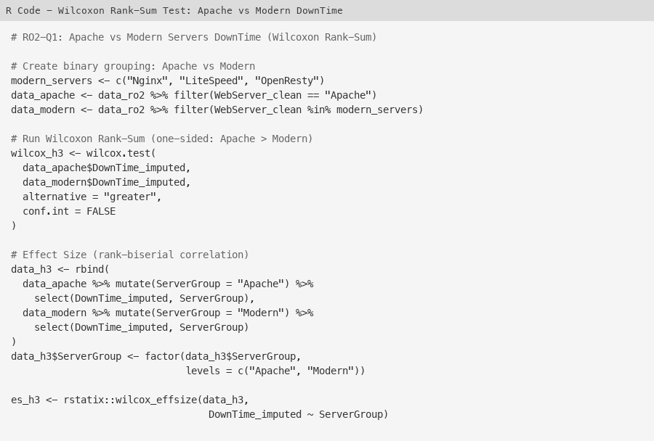
Figure 54 - R Code: Wilcoxon Rank-Sum Test for Apache vs Modern Servers
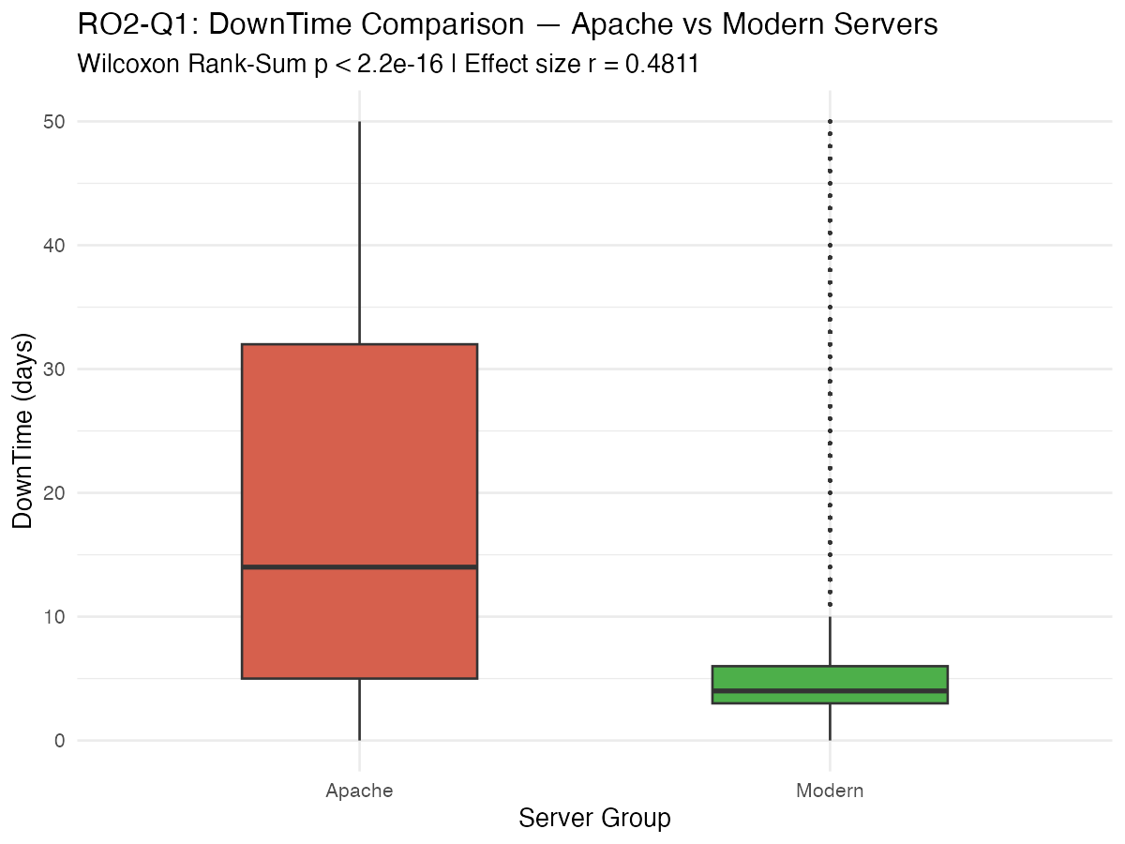
Figure 55 - Boxplot: DownTime Distribution for Apache vs Modern Servers
The Wilcoxon Rank-Sum test produced W = 34,904,993,978 with p < 2.2e-16 (one-sided), leading to the rejection of H₀. Apache servers have statistically significantly longer downtime than modern web servers. The sample sizes were 190,333 (Apache) and 235,621 (Modern).
The effect size (rank-biserial correlation) was r = 0.4811, classified as a moderate effect. This is a substantially larger effect than the .gov vs .com comparison (r = 0.0096), confirming that the Apache vs Modern server difference has genuine practical significance. Apache's mean downtime of 18.62 days is approximately 3.5 times longer than the modern servers' combined mean of 5.35 days, representing a substantial operational difference.
RO2-Q1 Conclusion: Apache servers suffer significantly longer downtime compared to modern web servers (Nginx, LiteSpeed, OpenResty). The Wilcoxon Rank-Sum test provides overwhelming statistical evidence (W = 34,904,993,978, p < 2.2e-16) with a moderate effect size (r = 0.4811). This confirms that the architectural and performance advantages of modern web server technologies translate into meaningfully faster incident recovery times.
Limitations: (1) The Loss and DownTime values include MICE-imputed data (6.3% of Loss and 0.4% of DownTime were imputed), which may introduce minor distributional changes. (2) With a sample size exceeding 500,000, virtually any difference becomes statistically significant; therefore, effect sizes (ε²) were emphasized over p-values for practical interpretation. (3) This is an observational study; the associations between TLD/WebServer and outcomes do not imply causation. (4) The "Other" category in both analyses is a catch-all group containing heterogeneous entries and should be interpreted with caution.

