2.4 Liu Wei (TP085412)

2.4.1 Objectives
This project sets out to accomplish two main goals. The first objective seeks to determine whether the website extension—commonly referred to as the Top Level Domain or TLD—in a URL has any bearing on how much money gets lost when an attack happens. The second objective aims to examine how different WebServer versions relate to server DownTime, specifically figuring out which server types stay offline the longest after incidents occur.

2.4.2 Analysis Questions
The questions below guided this investigation. Each one was written as a testable hypothesis so that proper statistical evaluation could be carried out.
RO1: Examining whether TLD affects financial Loss
Q1: Is there any real difference in financial Loss when comparing different TLD groups against each other?
Q2: When stacking government websites (.gov) against commercial ones (.com), do the .gov sites actually suffer worse financial Loss per incident?
RO2: Analyzing WebServer type impact on DownTime
Q1: Does Apache really have longer DownTime than the newer web servers like Nginx, LiteSpeed, and OpenResty?
Q2: Across all the different WebServer types, is there a meaningful difference in how long they stay down?
Test selection rationale: RO1-Q1 and RO2-Q2 both involve comparing more than two groups, so the Kruskal-Wallis rank sum test was employed here. It serves as a non-parametric stand-in for one-way ANOVA when data doesn't follow a normal distribution. For RO1-Q2 and RO2-Q1, which pit just two groups against each other with a directional prediction, the Wilcoxon Rank-Sum test (what some call the Mann-Whitney U) was selected. This works well for non-normal data when there's a specific direction in mind.

2.4.3 Data Preparation
This individual analysis builds on top of what the group already accomplished with data cleaning. The final imputed dataset (mice_imputed_data.RData), which held 592,765 records, was loaded, and just the variables needed for each research objective were pulled out.
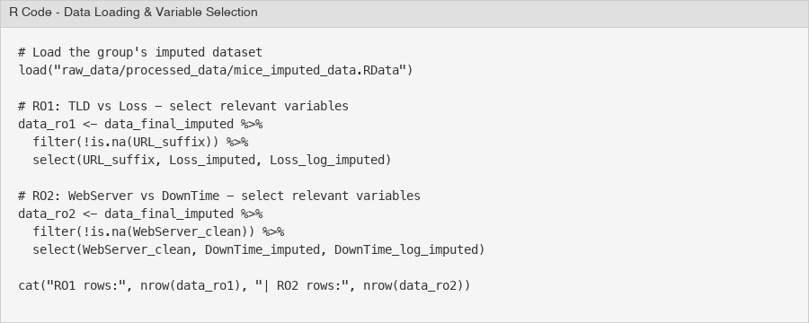
Figure 35 - R Code: Data Loading and Variable Selection
For the TLD versus Financial Loss question (RO1), the variables URL_suffix, Loss_imputed, and Loss_log_imputed were selected. Once rows where URL_suffix was NA got thrown out, the dataset ended up with 571,570 records—meaning 21,195 rows got cut. For the WebServer versus DownTime question (RO2), WebServer_clean, DownTime_imputed, and DownTime_log_imputed were selected. After dropping 60,295 rows that had NA in WebServer_clean, this left 532,470 records. Worth noting: both Loss_imputed and DownTime_imputed came out with zero missing values thanks to the MICE imputation the group ran earlier.
Before jumping into which statistical test to use, the normality of the dependent variables was assessed. Shapiro-Wilk tests were run on random samples of 5,000 observations each—the full dataset is too big for Shapiro-Wilk to handle—and skewness and kurtosis values were calculated too.
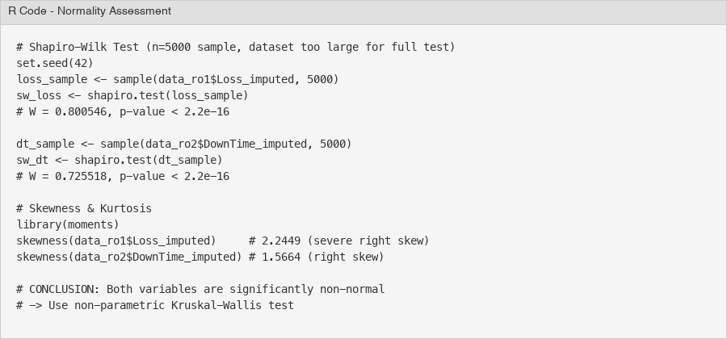
Figure 36 - R Code: Normality Assessment (Shapiro-Wilk & Skewness)
The results were pretty definitive. Loss_imputed came back with W = 0.8005 and p < 2.2e-16. DownTime_imputed gave W = 0.7255, also with p < 2.2e-16. Both of those p-values sit way below 0.05, so there's strong evidence these variables aren't normally distributed. The skewness numbers back this up: Loss_imputed shows 2.2449 with kurtosis at 15.70 (quite leptokurtic), while DownTime_imputed has skewness of 1.5664 and kurtosis of 4.18. Log-transformation was attempted, but even then the skewness didn't go away completely—Loss_log still showed -1.18 and DownTime_log came out at 0.56.
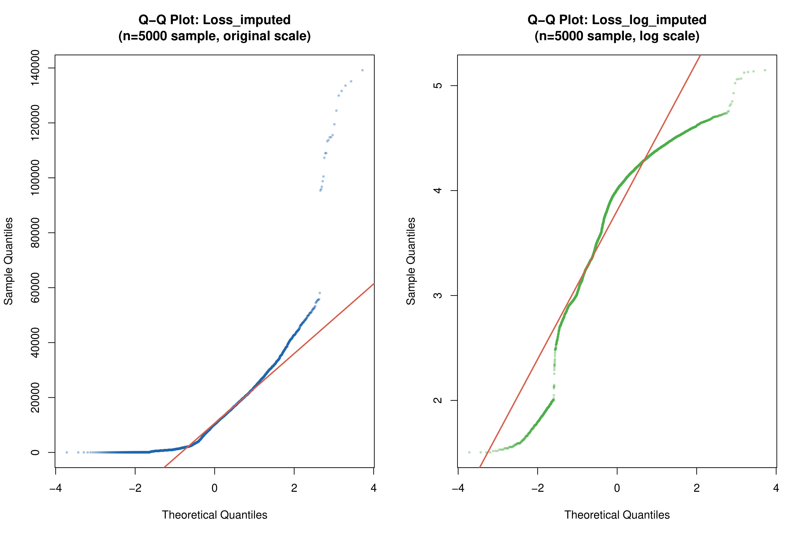
Figure 37 - Q-Q Plots for Loss_imputed: Original Scale (left) and Log Scale (right)
Looking at the Q-Q plots for Loss_imputed really drives home how non-normal this data is. On the original scale, the sample quantiles curve sharply upward away from where the theoretical line sits—classic signs of severe right skew and heavy tails. The log scale version fits the theoretical line better in the middle portion, but the tails still wander off, showing some leftover left skew.
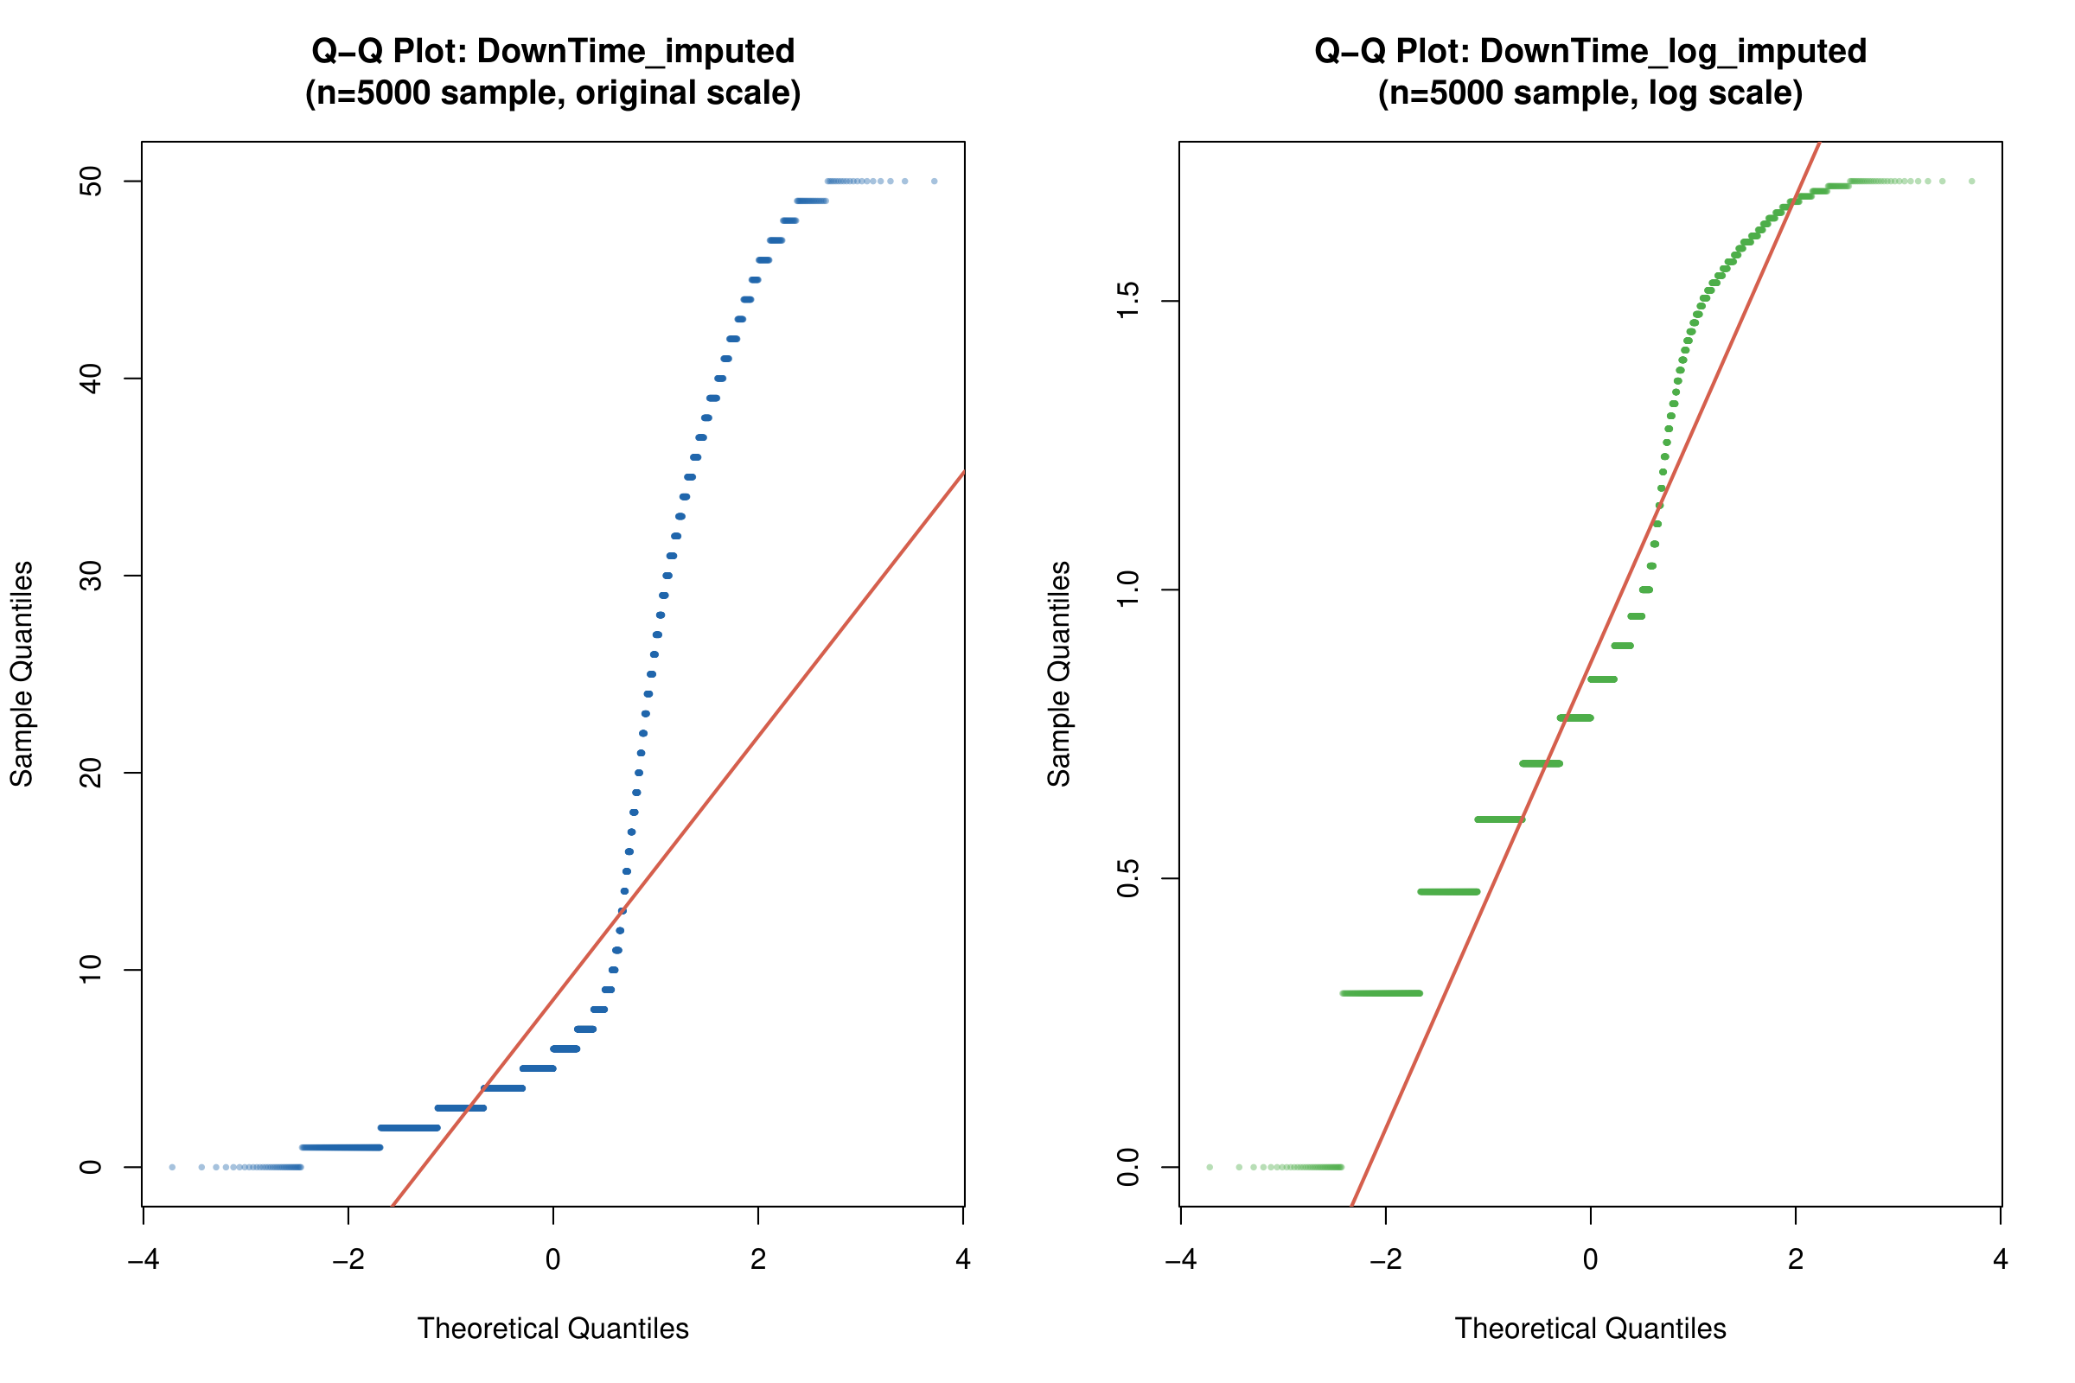
Figure 38 - Q-Q Plots for DownTime_imputed: Original Scale (left) and Log Scale (right)
The DownTime Q-Q plots tell a different story but reach the same conclusion. There's this step-like pattern on the original scale because downtime values are discrete (whole days, basically). Both tails deviate noticeably from where they should be. Go to log scale and that discrete stepping becomes even more obvious. Bottom line: neither variable is normal, which is why the non-parametric Kruskal-Wallis test was selected.
A quick note on group sizes: RO1 involves 11 TLD groups ranging from 2,889 records (.ch) up to 410,471 (.com). Every group clears the 30-observation minimum that's generally recommended. RO2 has 6 WebServer categories, with sizes spanning from 747 (Other) to 190,333 (Apache). Yes, there's substantial imbalance here, but Kruskal-Wallis handles unequal group sizes just fine.

2.4.4 Data Analysis

RO1: Does TLD Affect Financial Loss?
To tackle the first research objective, exploratory data analysis was conducted looking at how financial loss varies by Top-Level Domain. The analysis worked with the cleaned, imputed dataset: 571,570 records spread across 11 TLD categories.
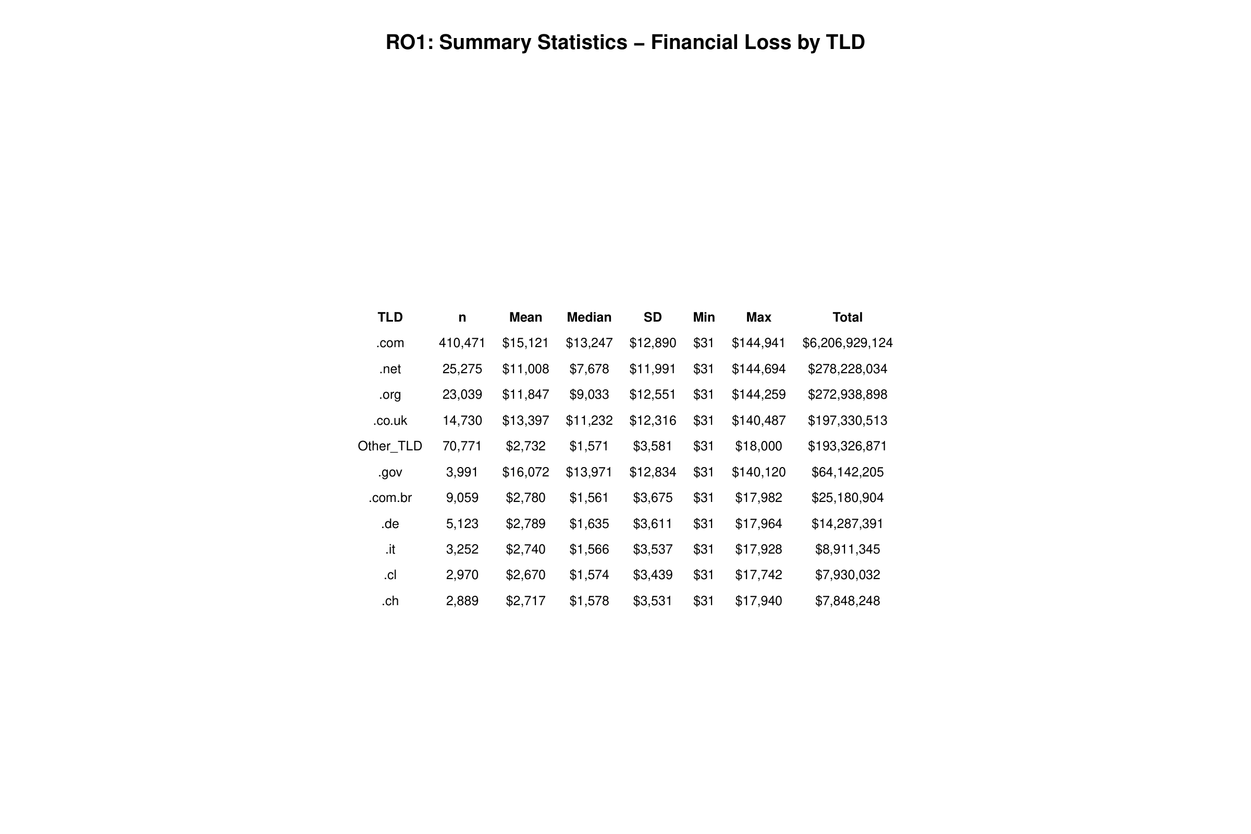
Figure 39 - RO1 Summary Statistics: Financial Loss by TLD
What jumped out from the summary statistics was a clear two-tier pattern. Tier one includes the generic TLDs—.gov, .com, .co.uk, .org, .net—where mean losses range from $11,008 to $16,072. Tier two contains country-code TLDs (.de, .com.br, .it, .cl, .ch) plus the Other_TLD catch-all, all bunched together between $2,670 and $2,789 in mean loss. Here's what stands out: .gov websites show the highest mean loss at $16,072 even though they only account for 3,991 records. Government sites seem to take a harder financial hit when attacks succeed. Meanwhile, .com racks up the biggest total loss—$6.2 billion—but that's mainly because there are so many of them (410,471 incidents).
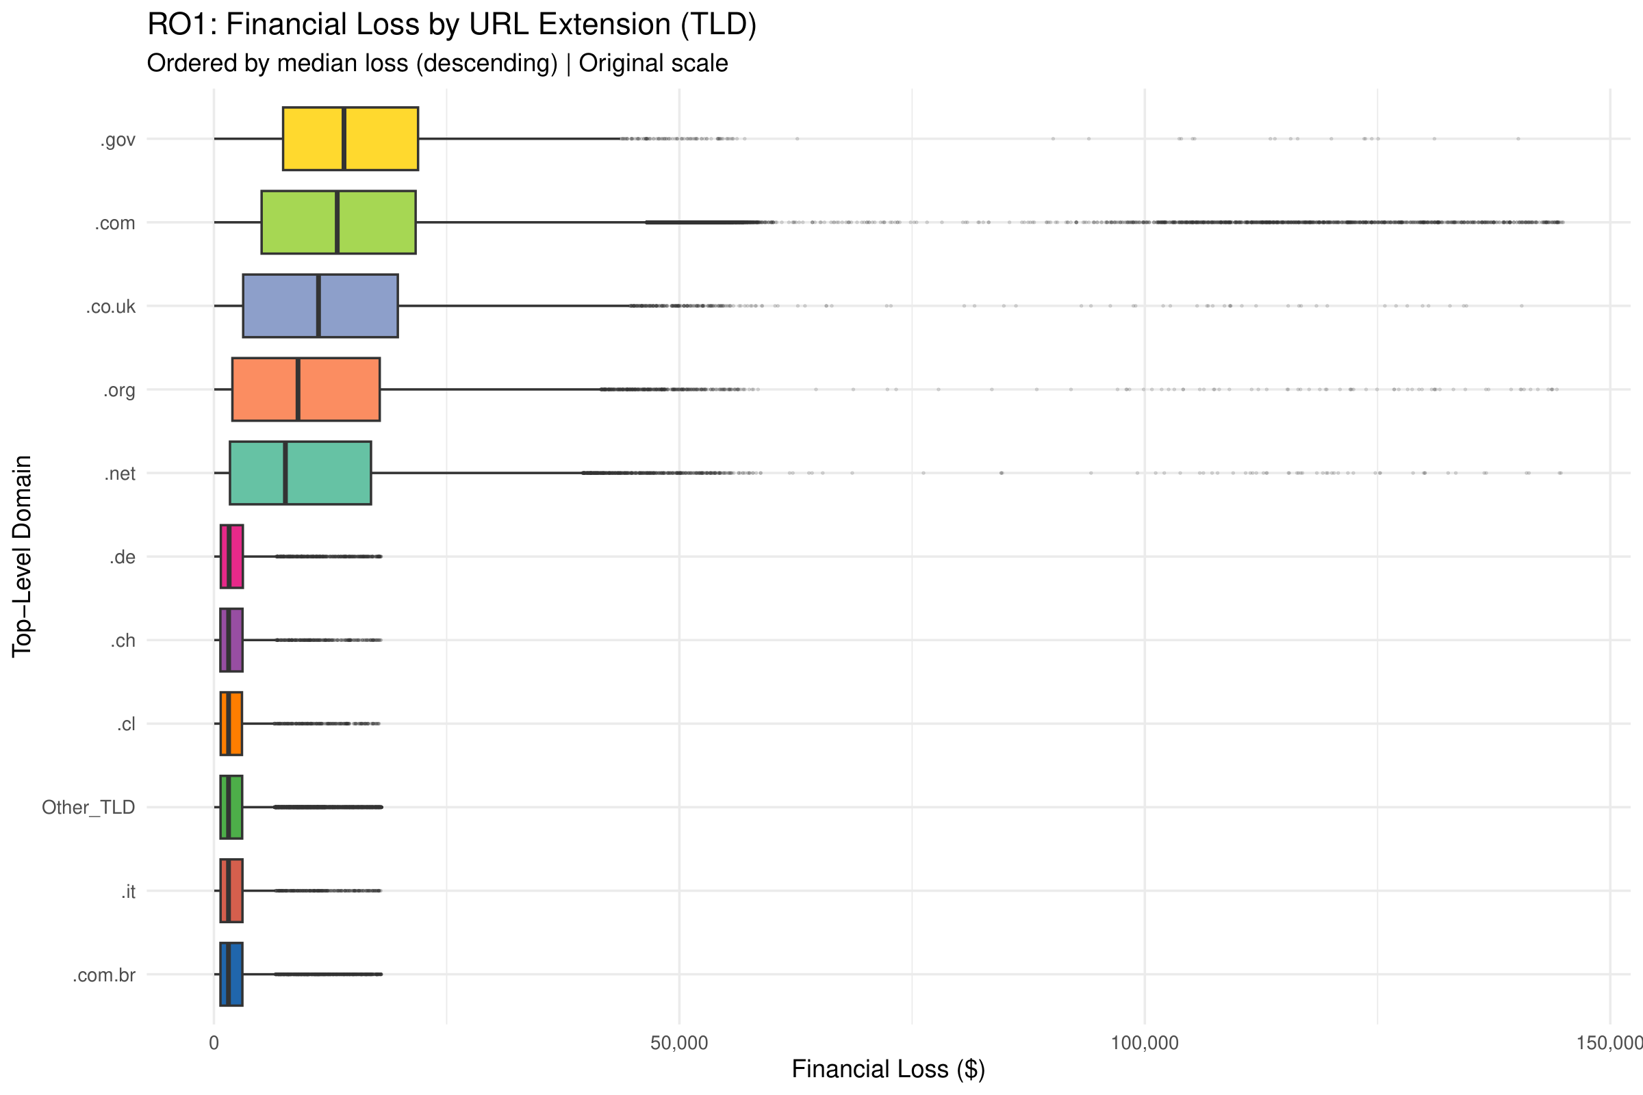
Figure 40 - RO1 Boxplot: Financial Loss by TLD (Original Scale)
The boxplot on original scale tells an interesting story. Both .gov and .com have the widest interquartile ranges, which means their financial losses are all over the map. These two also show extreme outliers going up to $140,000–$145,000. Compare that to the country-code TLDs (.de, .ch, .cl, .it, .com.br) and their narrow boxes hugging the lower end—losses there are relatively low and consistent.
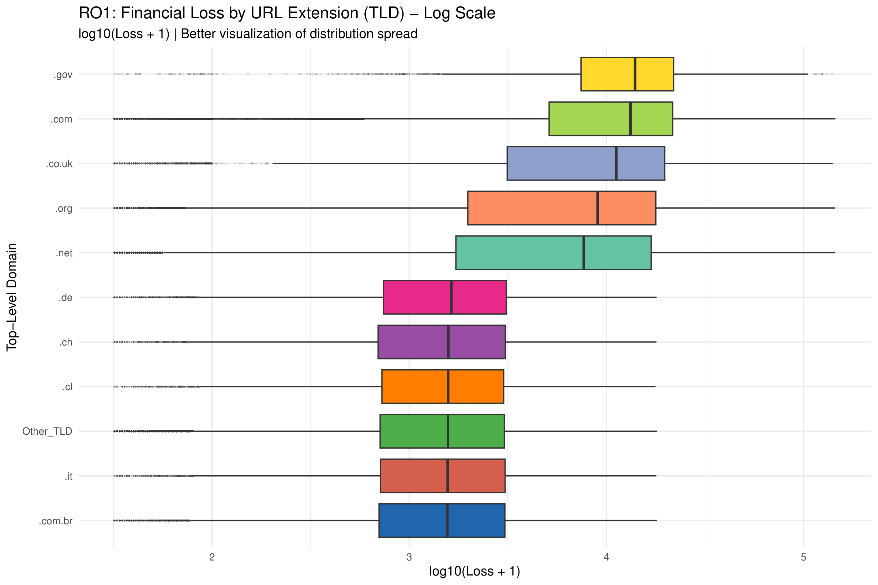
Figure 41 - RO1 Boxplot: Financial Loss by TLD (Log Scale)
Switching to log scale makes the spread across all groups easier to see. Now the two-tier separation really stands out. Generic TLDs cluster in the log10 range of 3.5–4.5; country-code TLDs sit lower at 2.8–3.5. One notable observation: .net actually has the widest IQR on the log scale, suggesting its loss distribution is the most heterogeneous of the bunch.
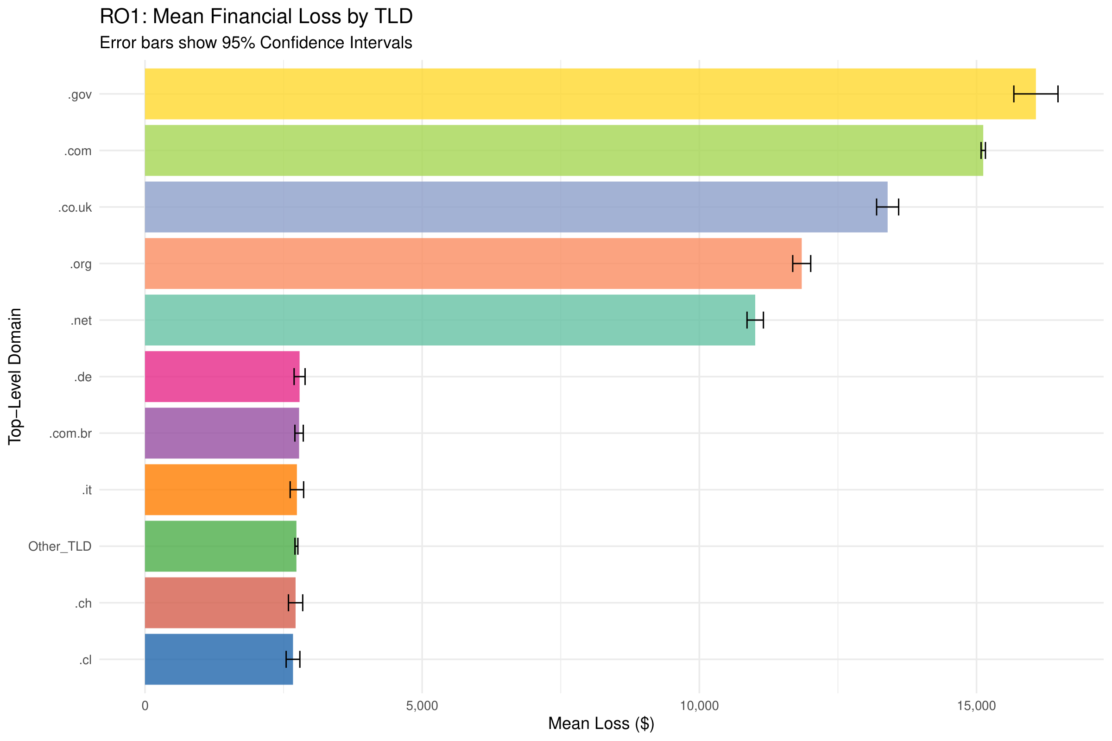
Figure 42 - RO1 Mean Financial Loss by TLD with 95% CI
The bar chart with 95% confidence intervals lays out the ranking: .gov ($16,072) > .com ($15,121) > .co.uk ($13,397) > .org ($11,847) > .net ($11,008). Those confidence intervals are quite narrow because of the large sample sizes, so these differences are reliable. The drop-off from the top 5 generic TLDs to the bottom 6 country-code/Other TLDs is dramatic—everything in that second group falls below $3,000.
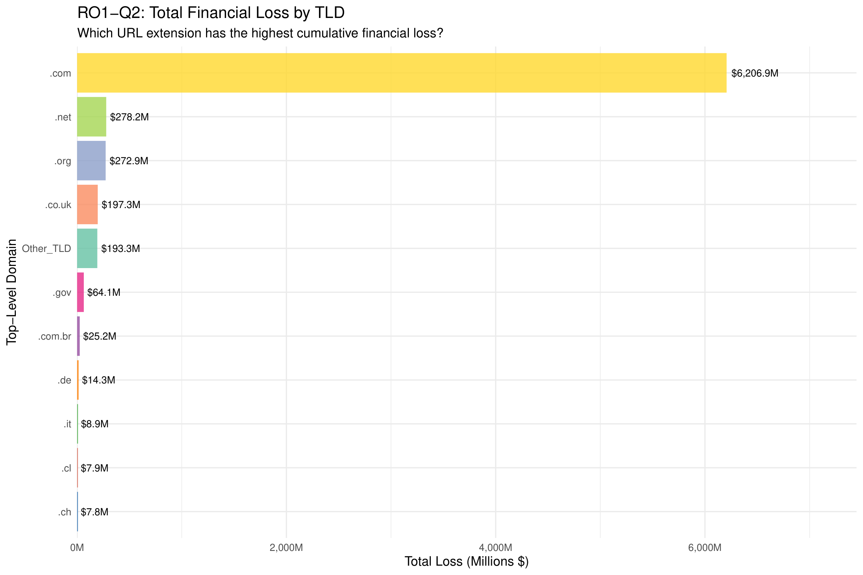
Figure 43 - RO1 Total Financial Loss by TLD (Descriptive Context for Q2)
For some context on RO1-Q2, look at total loss. The .com domain absolutely dominates at $6,206.9 million in cumulative losses—roughly 85% of all financial losses in the dataset. The formal statistical comparison between .gov and .com comes later in Section 2.4.5 with the Wilcoxon Rank-Sum test. What drives .com's total loss dominance is sheer volume: 410,471 incidents out of 571,570 total. It's not that each .com attack is necessarily worse.
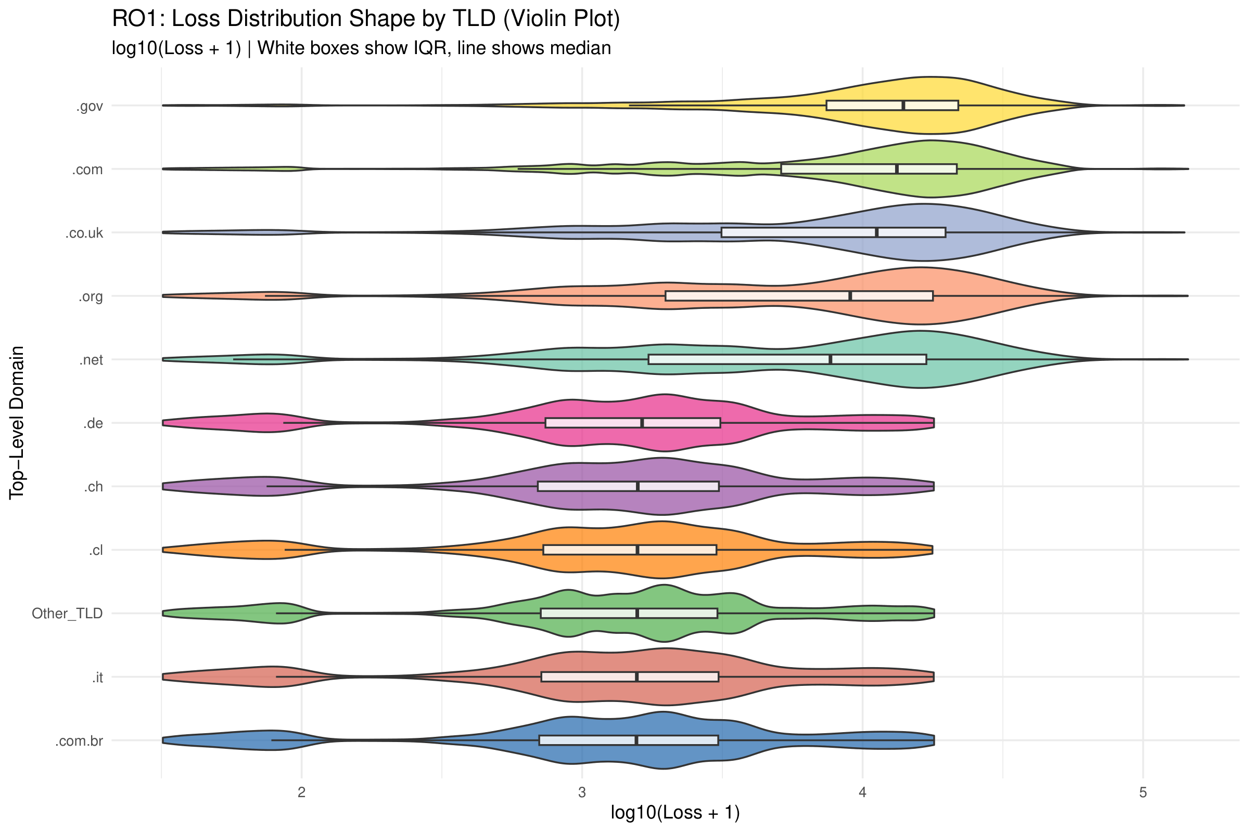
Figure 44 - RO1 Violin Plot: Loss Distribution by TLD
The violin plot shows the full shape of each distribution. Both .gov and .com display unimodal distributions that skew right, with density concentrated at higher values. Several country-code TLDs (.de, .ch, .cl, .it, .com.br) show something different: a bimodal pattern with peaks at both low and moderate loss values. The Other_TLD group has the most concentrated distribution, bunched up around low loss values—probably reflecting how heterogeneous that catch-all category really is.

RO2: Does WebServer Type Affect DownTime?
The second research objective looks at how server downtime changes depending on which WebServer type got hit. The analysis covered 532,470 records split across 6 WebServer categories.
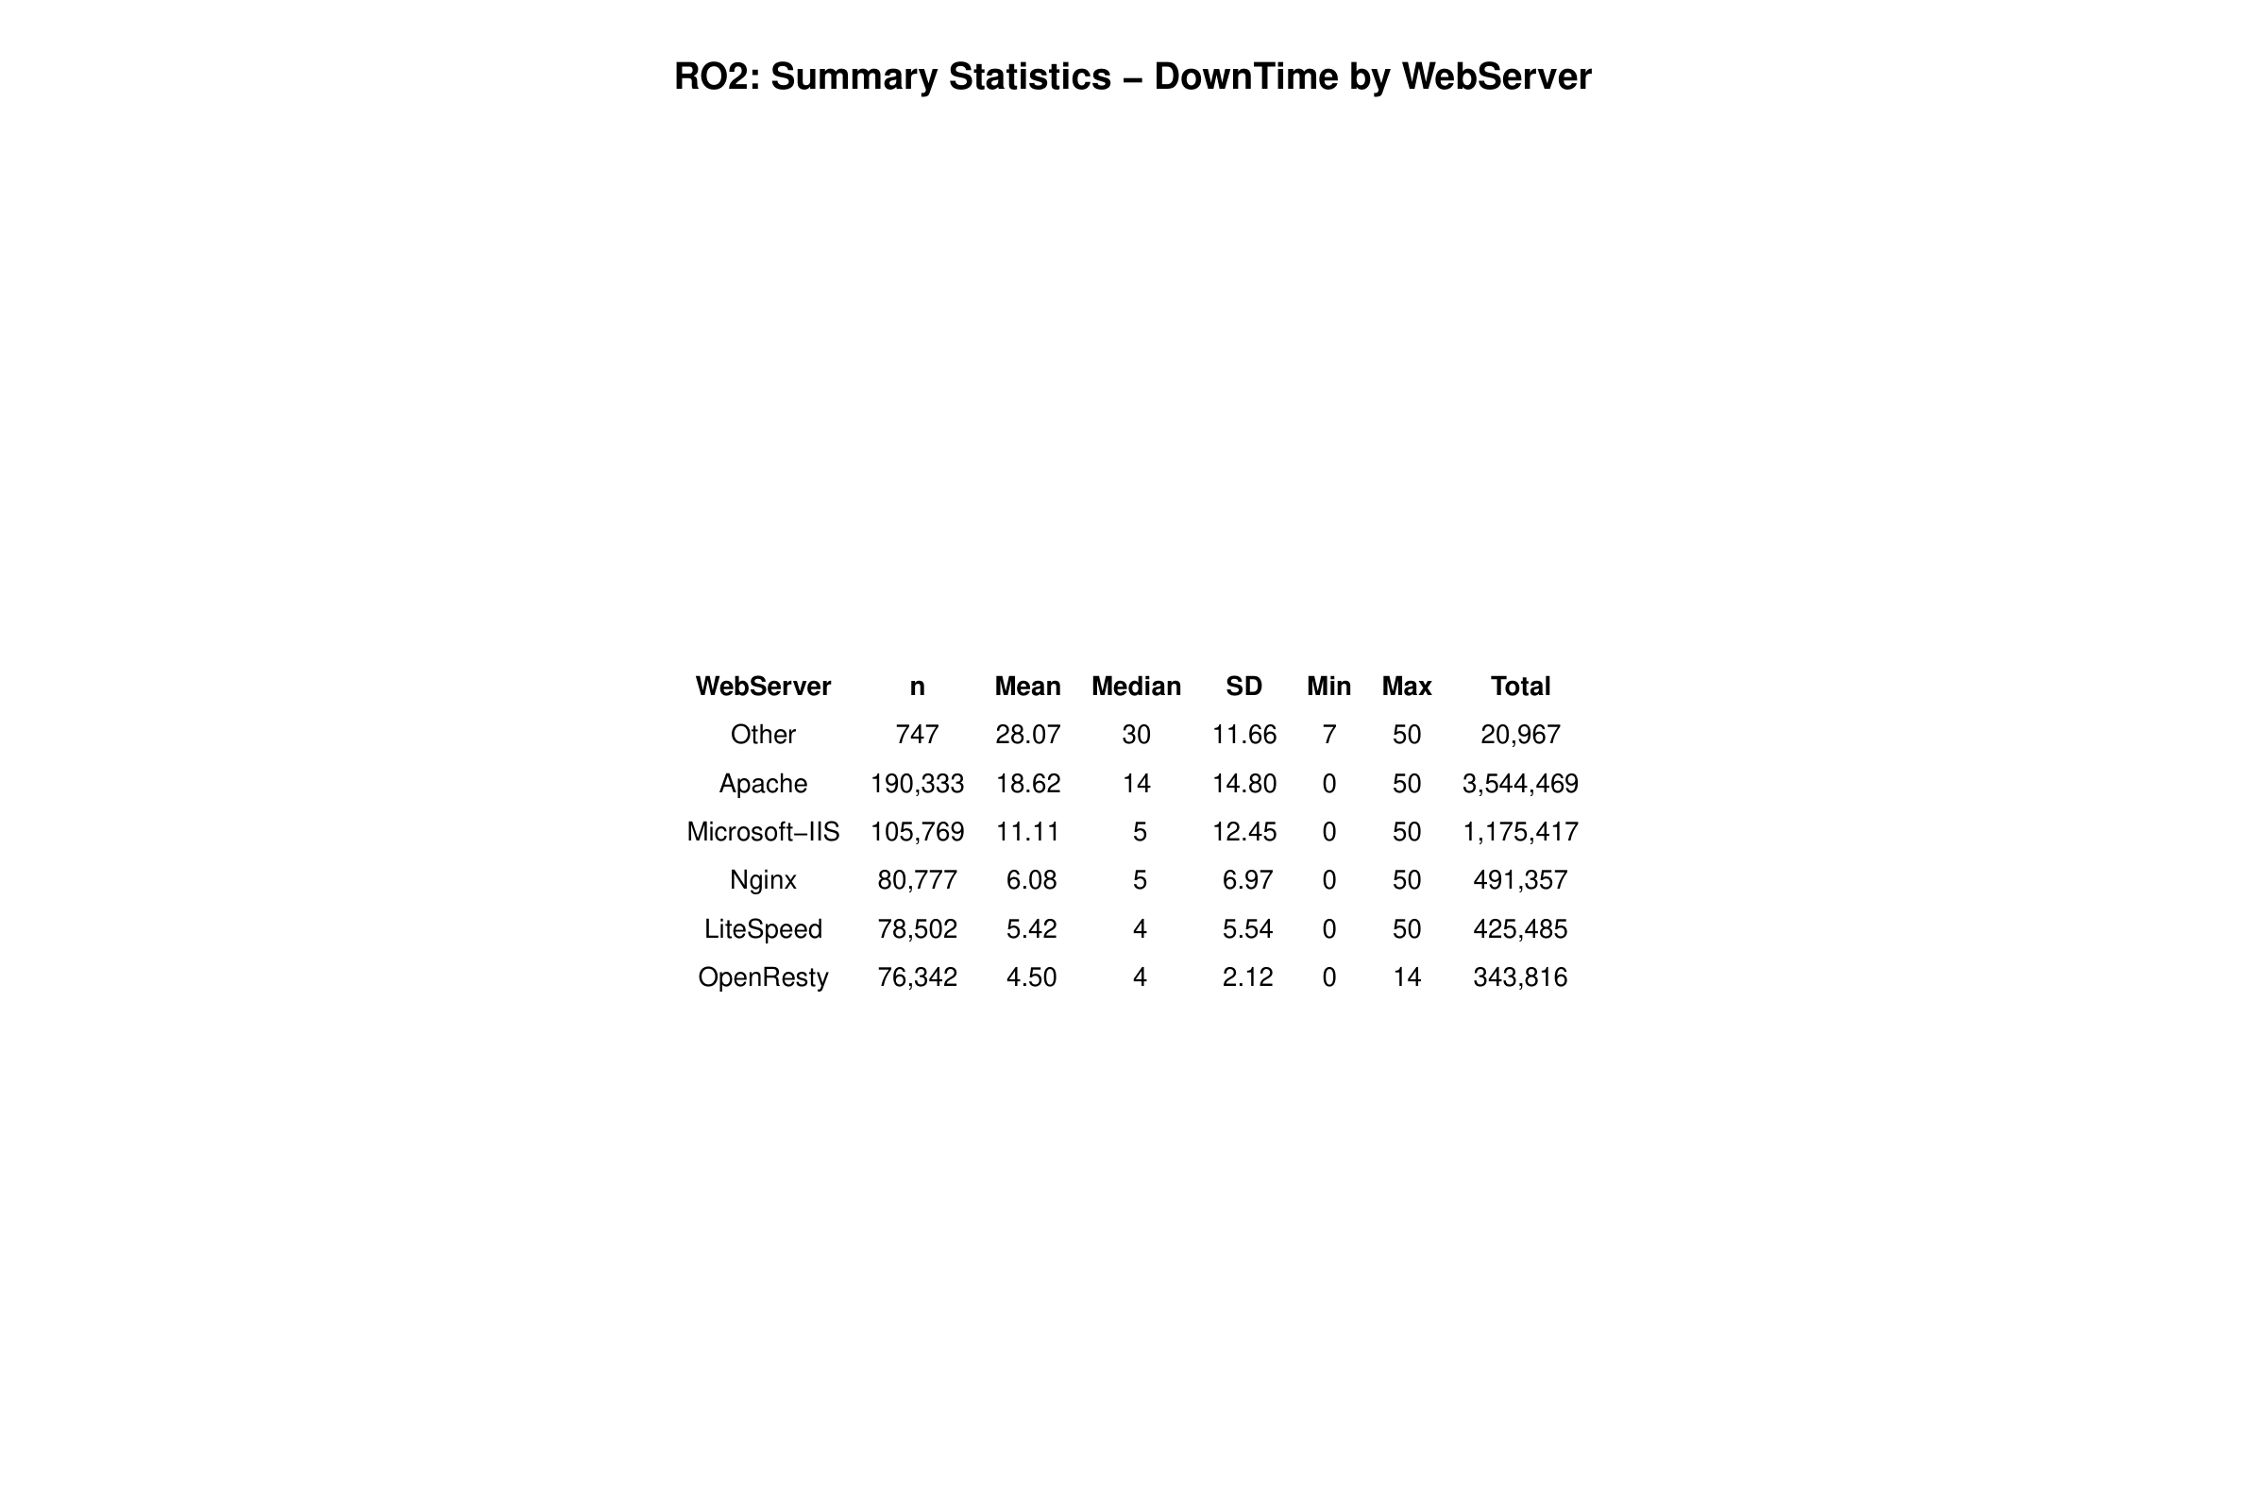
Figure 45 - RO2 Summary Statistics: DownTime by WebServer
A clear hierarchy emerges from the summary statistics. The "Other" category tops the list at 28.07 days mean downtime, but with only 747 records it's really just a collection of miscellaneous or rare server types. Among the mainstream servers, Apache sits at the top with 18.62 days mean and 14 days median. Then comes Microsoft-IIS (mean 11.11, median 5), Nginx (mean 6.08, median 5), LiteSpeed (mean 5.42, median 4), and finally OpenResty (mean 4.50, median 4). OpenResty also has the lowest standard deviation at 2.12—these servers recover the most consistently.

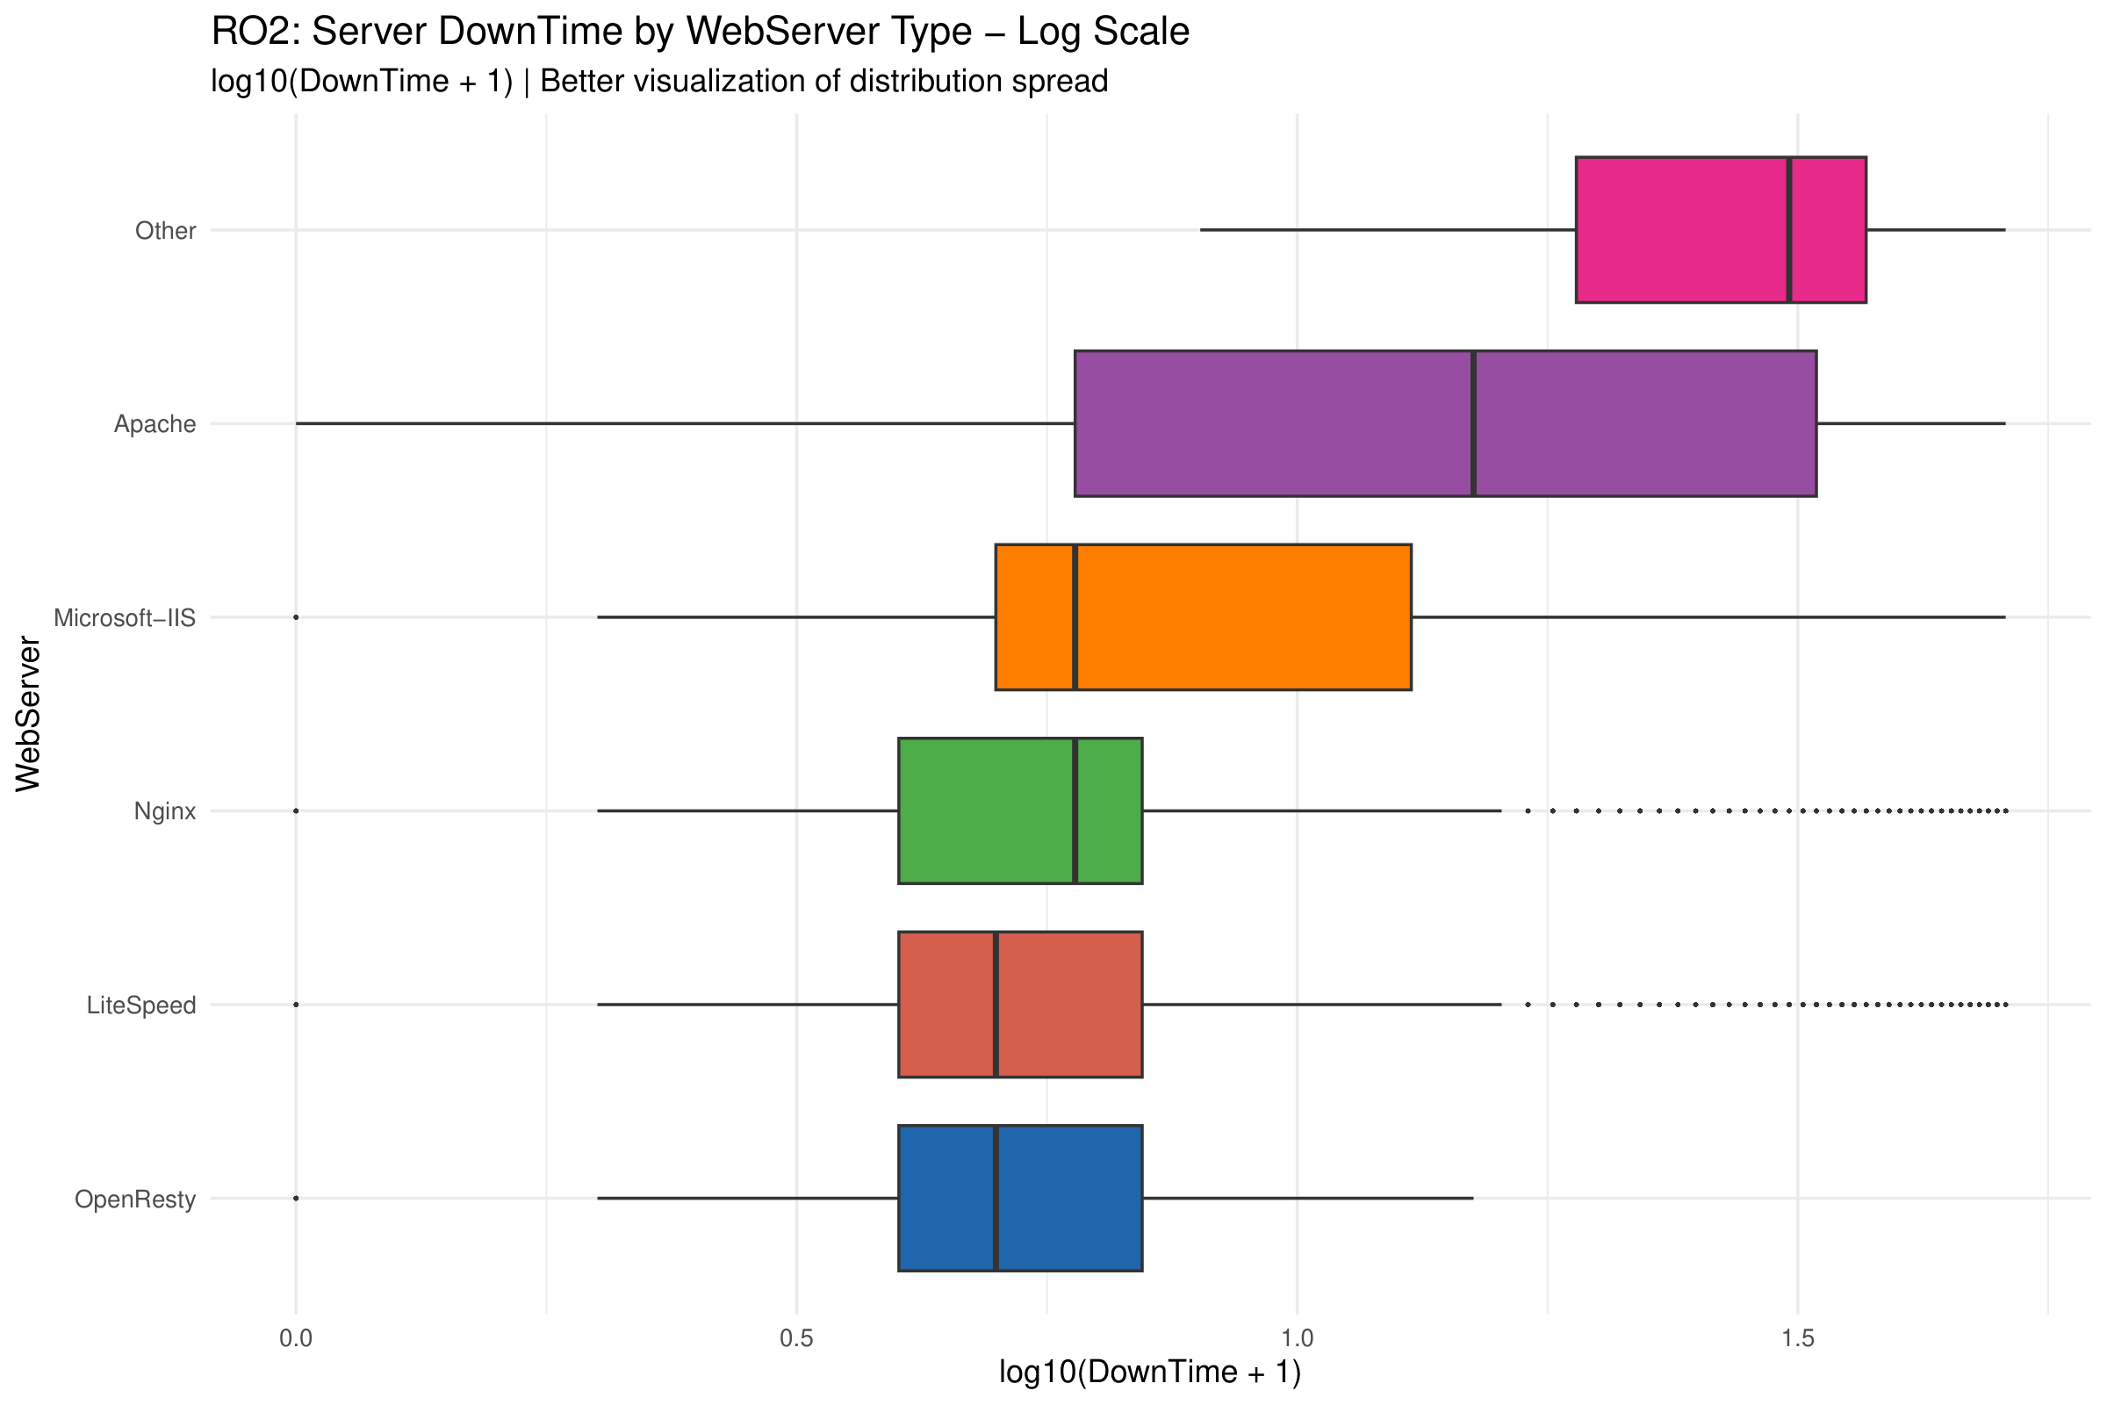
Figure 46 - RO2 Boxplot: DownTime by WebServer (Log Scale)
The boxplot really shows these differences dramatically. That "Other" category has a massive box—IQR spanning roughly 15–37 days. Apache spreads wide too, running from 0 all the way to 50 days. The modern servers (Nginx, LiteSpeed, OpenResty) look completely different: tight little boxes concentrated in the 0–10 day range. OpenResty is particularly compact, maxing out at just 14 days.
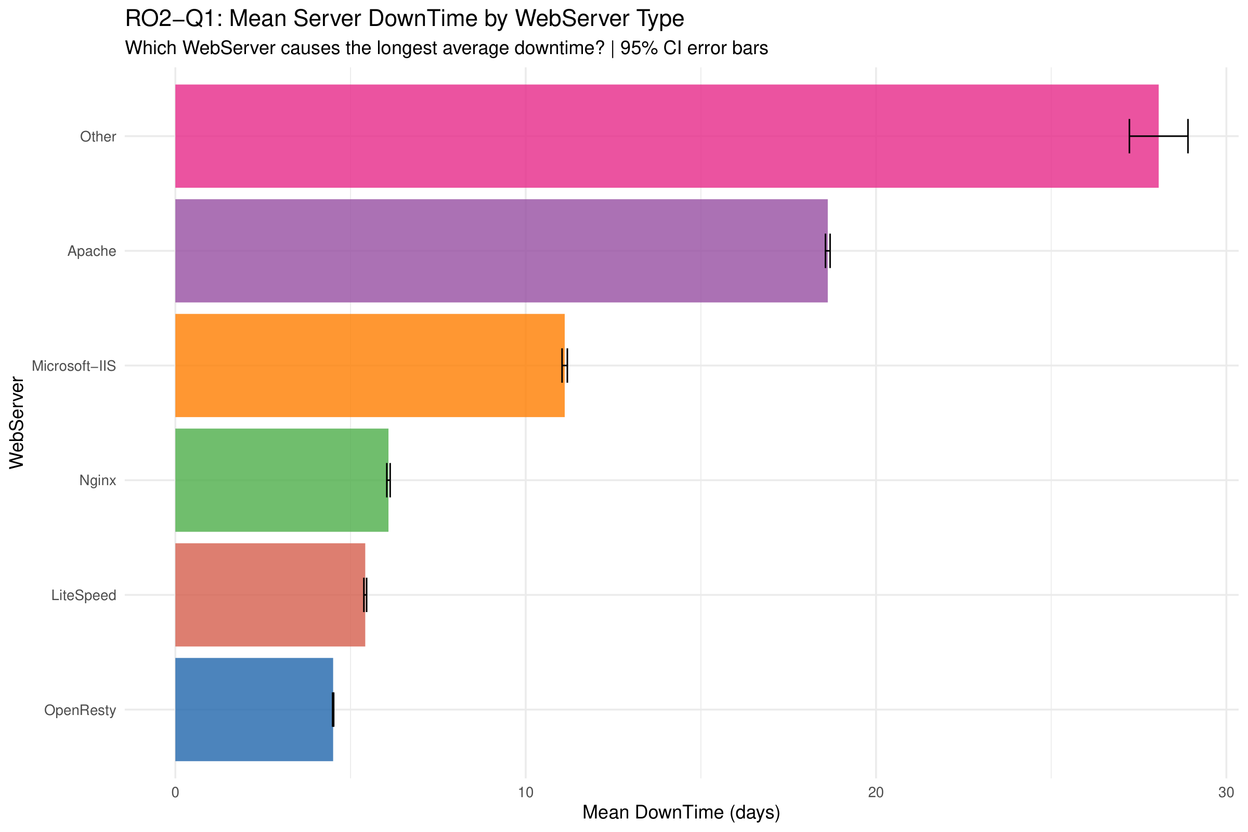
Figure 47 - RO2 Mean DownTime by WebServer (Descriptive Context for Q1)
For context on RO2-Q1, the mean downtime bar chart paints a clear picture. Among mainstream servers: Apache leads at 18.62 days, Microsoft-IIS follows at 11.11 days, Nginx at 6.08 days, LiteSpeed at 5.42 days, and OpenResty at 4.50 days. The formal hypothesis test that compares Apache against the modern servers shows up in Section 2.4.5. Those 95% confidence intervals look super narrow because of the sample sizes, which tells us these rankings are solid.
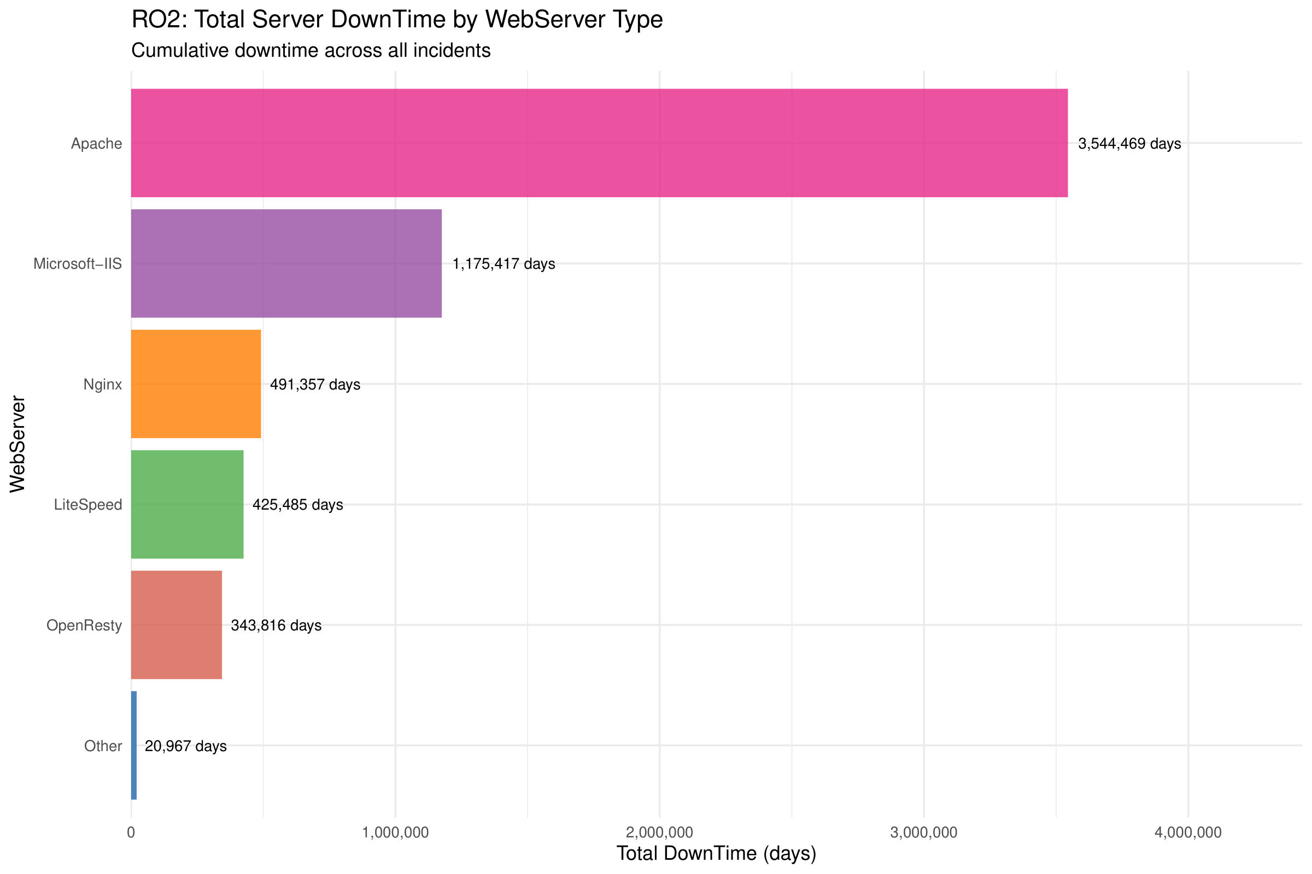
Figure 48 - RO2 Total DownTime by WebServer
Looking at total downtime, Apache piles up 3,544,469 days across all incidents. That dwarfs Microsoft-IIS (1,175,417 days), Nginx (491,357 days), LiteSpeed (425,485 days), and OpenResty (343,816 days). Apache's dominance here reflects two things working together: longer per-incident downtime AND its large market share (190,333 incidents).
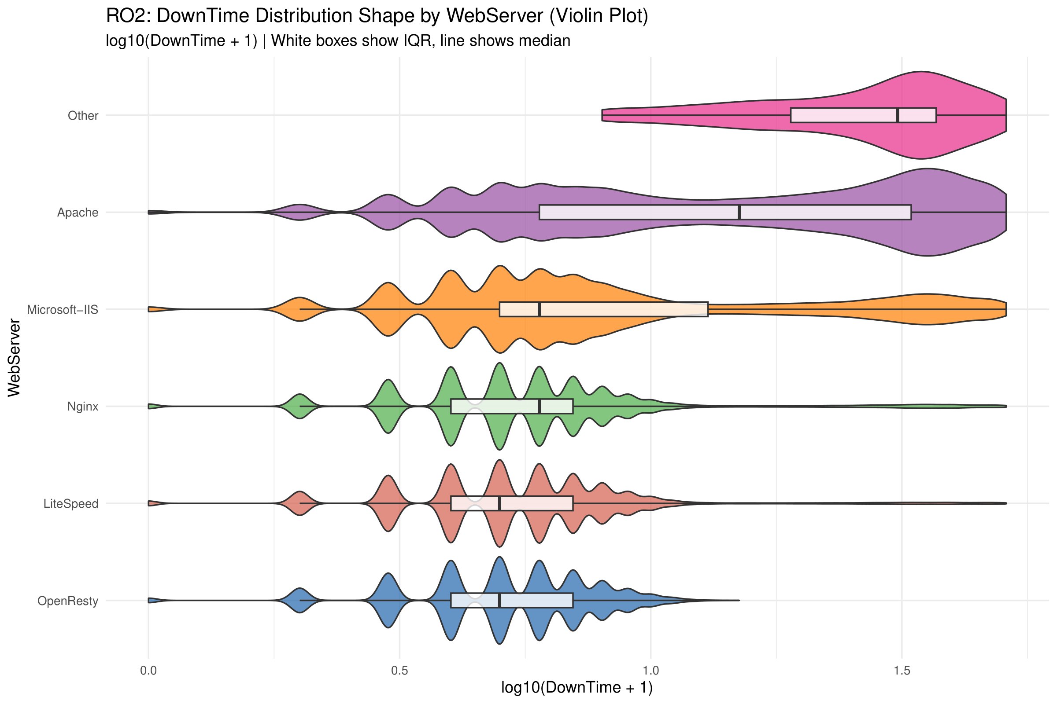
Figure 49 - RO2 Violin Plot: DownTime Distribution by WebServer
The violin plot uncovers some interesting distribution shapes. Apache shows a bimodal pattern—one density peak at low values, another at high values. This suggests there might be two distinct populations of Apache servers with very different recovery profiles. Microsoft-IIS displays multiple modes. OpenResty, by contrast, has a tight unimodal distribution, indicating predictable and consistent downtime. What this pattern suggests is that modern web servers aren't just faster to recover on average; they're also more reliable and predictable in how long recovery takes.

2.4.5 Hypothesis Formulation and Testing

RO1: Does TLD Affect Financial Loss?
To figure out whether TLD type genuinely affects financial loss from cyber-attacks, the following hypotheses were set up:
H₀: Financial loss distribution has the same location parameter across all TLD groups. Put simply, there's no real difference in median Loss ranks between the groups.
H₁: At least one TLD group has a loss distribution that sits at a different location than the others.
Given that the data clearly isn't normal (Section 2.4.3 showed Shapiro-Wilk p < 2.2e-16 with skewness = 2.24) and the comparison involves 11 independent groups, the Kruskal-Wallis rank sum test was the right choice. It's the non-parametric alternative to one-way ANOVA.
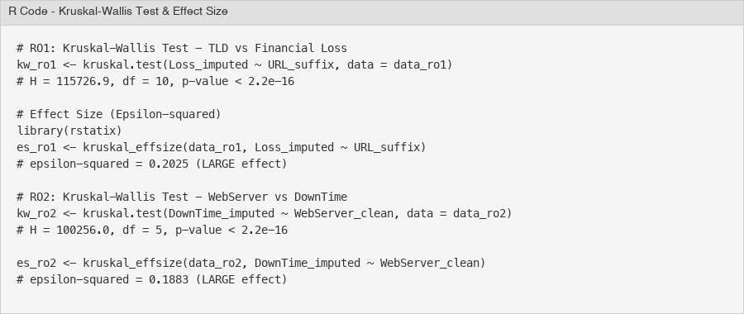
Figure 50 - Kruskal-Wallis Test and Effect Size Calculation
The test returned H = 115,726.9 with 10 degrees of freedom and p < 2.2e-16. That's highly significant—H₀ is rejected. There's strong evidence that financial loss distributions differ across TLD groups.
But with 571,570 observations, pretty much anything would be statistically significant. So effect size was calculated using epsilon-squared (ε²) via rstatix::kruskal_effsize(). The result: ε² = 0.2025. That's classified as a large effect using standard guidelines (ε² < 0.01 = negligible, 0.01–0.06 = small, 0.06–0.14 = medium, > 0.14 = large). So the TLD difference isn't just a statistical artifact of the massive sample—it's actually meaningful in practice.
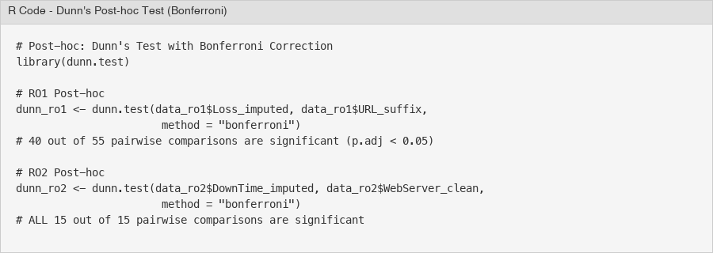
Figure 51 - Dunn's Post-hoc Test with Bonferroni Correction
To pin down which specific TLD pairs differ, Dunn's test with Bonferroni correction was performed. Out of 55 pairwise comparisons, 40 came back statistically significant (adjusted p < 0.05). Every single comparison of a generic TLD (.gov, .com, .co.uk, .org, .net) against a country-code TLD (.de, .it, .cl, .ch, .com.br) was significant. This confirms the two-tier pattern spotted in the exploratory analysis.
RO1 Conclusion: TLD does have a significant association with financial loss. Government websites (.gov) suffer the highest per-incident loss at $16,072 mean, while commercial websites (.com) rack up the highest total loss ($6.2 billion) simply because there are so many of them. Country-code TLDs consistently show lower financial losses.

RO1-Q2: Do .gov Websites Suffer Higher Financial Loss Than .com?
After the Kruskal-Wallis test established that TLD groups differ in financial loss, a targeted comparison between .gov and .com was conducted to address RO1-Q2. The question: is that observed mean difference ($16,072 for .gov versus $15,121 for .com) statistically significant?
H₀: Financial loss distribution for .gov has the same location as .com—no difference in median ranks.
H₁: Government websites (.gov) suffer higher financial loss per incident than commercial ones (.com).
This is a two-group comparison with non-normal data and a directional hypothesis, so the Wilcoxon Rank-Sum test (Mann-Whitney U) was employed. The one-sided alternative tests whether .gov losses are stochastically greater than .com losses.
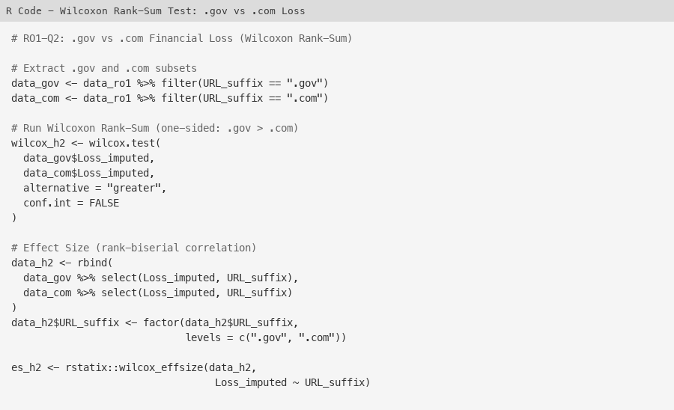
Figure 52 - R Code: Wilcoxon Rank-Sum Test for .gov vs .com Loss
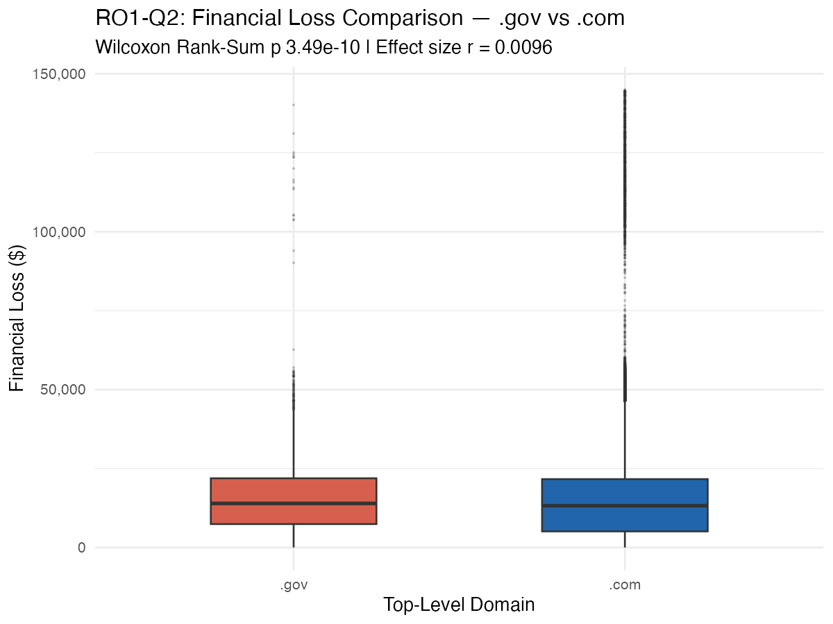
Figure 53 - Boxplot: Financial Loss Distribution for .gov vs .com
Results: W = 865,478,982 with p = 3.49e-10 (one-sided). That's significant at 0.05, so H₀ is rejected. Government websites do suffer statistically significantly higher financial loss per incident.
For effect size, rank-biserial correlation (r) was calculated via rstatix::wilcox_effsize(). The result was r = 0.0096—that's classified as small (guidelines: r < 0.1 = negligible, 0.1–0.3 = small, 0.3–0.5 = medium, r > 0.5 = large). So yes, it's statistically significant, but the practical difference between .gov and .com per-incident losses is modest. Makes sense when considering that .gov's mean advantage ($16,072 vs $15,121) is only 6.3%—nothing compared to the gap between generic TLDs and country-code TLDs that the Kruskal-Wallis test revealed.
RO1-Q2 Conclusion: Government websites (.gov) do suffer significantly higher financial loss per incident than commercial websites (.com), confirmed by the Wilcoxon Rank-Sum test (W = 865,478,982, p = 3.49e-10). However, the small effect size (r = 0.0096) tells us the practical magnitude is modest. The Kruskal-Wallis omnibus test from Section 3.1 actually provides stronger evidence of meaningful group differences.

RO2: Does WebServer Type Affect DownTime?
To determine if web server type affects how long servers stay down after an attack, the following hypotheses were formulated:
H₀: Downtime distribution has the same location parameter across all WebServer types—no difference in median DownTime ranks.
H₁: At least one WebServer type has a significantly different downtime distribution.
Same reasoning for non-parametric testing applies here: DownTime is non-normal (Shapiro-Wilk W = 0.73, p < 2.2e-16, skewness = 1.57), and the comparison involves 6 independent WebServer groups. Kruskal-Wallis it is.
The test produced H = 100,256.0 with 5 degrees of freedom and p < 2.2e-16. H₀ is rejected. Server downtime differs significantly across WebServer types.
Effect size came out to ε² = 0.1883—that's a large effect. WebServer type has substantial practical impact on downtime duration; this isn't just the massive sample size talking.
Dunn's post-hoc test with Bonferroni correction showed all 15 out of 15 pairwise comparisons were statistically significant (adjusted p < 0.05). Every WebServer type has a significantly different downtime profile from every other type. The biggest contrasts: Apache vs. OpenResty (Z = 240.13) and Apache vs. Nginx (Z = 217.95)—really showing the gap between older and newer server tech.
RO2 Conclusion: WebServer type is significantly associated with server downtime. Among mainstream servers, Apache has the longest average downtime (18.62 days), while modern servers recover much faster—OpenResty at 4.50 days, LiteSpeed at 5.42 days, and Nginx at 6.08 days. Newer web server technologies seem to have better resilience and faster recovery mechanisms.

RO2-Q1: Does Apache Have Significantly Longer DownTime Than Modern Servers?
After the Kruskal-Wallis test showed WebServer types differ in downtime, a targeted comparison for RO2-Q1 was conducted. Nginx, LiteSpeed, and OpenResty were combined into a single "Modern" group and compared against Apache. This binary setup directly tests whether the older server technology is associated with longer recovery times.
H₀: Apache's downtime distribution has the same location as modern servers (Nginx, LiteSpeed, OpenResty combined).
H₁: Apache servers have significantly longer downtime than modern servers.
The Wilcoxon Rank-Sum test was employed with a one-sided alternative, testing if Apache downtime is stochastically greater. This fits the binary grouping, non-normal data, and the clear directional expectation based on what the exploratory analysis showed.
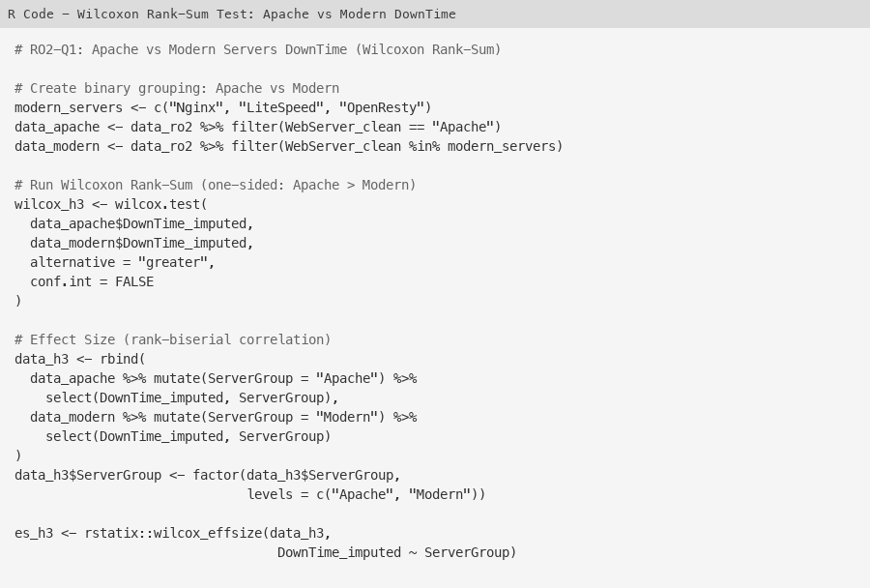
Figure 54 - R Code: Wilcoxon Rank-Sum Test for Apache vs Modern Servers
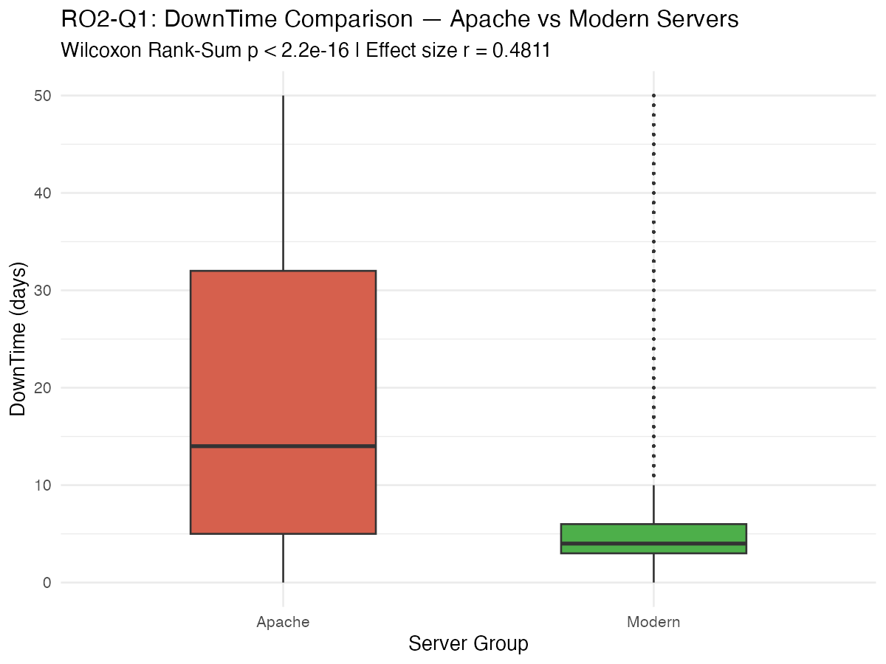
Figure 55 - Boxplot: DownTime Distribution for Apache vs Modern Servers
Results: W = 34,904,993,978 with p < 2.2e-16 (one-sided). H₀ is rejected. Apache servers have statistically significantly longer downtime. The sample sizes: 190,333 for Apache and 235,621 for Modern.
Effect size (rank-biserial correlation) was r = 0.4811—a moderate effect. This is much larger than the .gov vs .com comparison (r = 0.0096), confirming that the Apache vs Modern server difference has real practical significance. Apache's mean of 18.62 days is about 3.5 times the modern servers' combined mean of 5.35 days. That's a substantial operational difference.
RO2-Q1 Conclusion: Apache servers do suffer significantly longer downtime compared to modern web servers (Nginx, LiteSpeed, OpenResty). The Wilcoxon Rank-Sum test gives overwhelming evidence (W = 34,904,993,978, p < 2.2e-16) with a moderate effect size (r = 0.4811). The architectural and performance advantages of modern web server technologies translate into meaningfully faster incident recovery.
Limitations: (1) Loss and DownTime values include MICE-imputed data (6.3% of Loss and 0.4% of DownTime were imputed), which might introduce minor distributional changes. (2) With sample sizes over 500,000, virtually any difference becomes statistically significant; therefore, effect sizes (ε²) were emphasized over p-values for practical interpretation. (3) This is observational; the associations between TLD/WebServer and outcomes don't prove causation. (4) The "Other" category in both analyses is a catch-all containing heterogeneous entries and should be interpreted carefully.

