Instruction Manual
----- CSF JET Multi Megasonic Generator -----
LCD Panel User Operation Manual / v4.0-EN / 2026-05-19
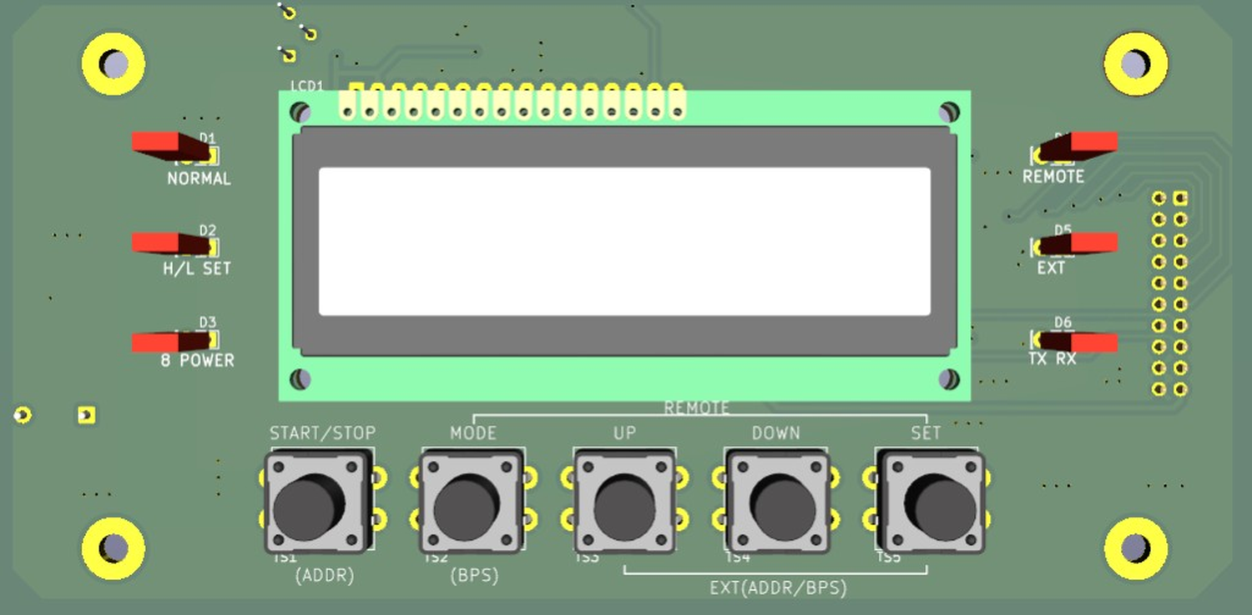
Actual LCD operation panel

< OPERATING SUMMARY >
Item | Operation
Run/Stop | Press START/STOP on the SELECT screen
Move item | Short press MODE: MODE -> FREQ CH -> 8 POWER
Enter setting | Long press MODE on the SELECT screen
Change value | UP/DOWN; long press repeats quickly
Save | Short press SET; two beeps indicate success
Return to select screen | Long press SET for about 2 seconds in setting screens
Auto Tuning | Long press START/STOP for about 3 seconds in FREQ SET
Clear alarm | Remove cause, then press SET on the alarm screen

1. Specification
No. | Item | Specification
1 | Model name | CSF JET Multi Megasonic Generator
2 | Display | LCD1602, 2 lines x 16 characters
3 | Buttons | START/STOP, MODE, UP, DOWN, SET
4 | Indicators | NORMAL, H/L SET, 8 POWER, REMOTE, EXT, TX/RX LEDs
5 | Operating frequency | 10CH, 400kHz to 2200kHz
6 | Frequency setting | Manual setting and Auto Tuning
7 | LC BIT | 16 steps, BIT 0000 to 1111
8 | Output setting | 8 POWER profiles, LOW/HIGH/DEF
9 | Output range | 0.20W to 5.00W
10 | Control connector | 25-pin D-SUB
11 | Communication | RS-485 Half-Duplex, Modbus RTU
12 | Setting storage | Internal FLASH, retained after power-off

2. Caution on Product Use

2.1 Caution on Installation
- Install the generator on a stable support where vibration does not affect the unit.
- Avoid acidic/alkaline gas, conductive dust, oil mist and high-temperature environments.
- Secure ventilation space around the unit.
- Connect protective earth before applying power.
- Use the assigned nozzle/transducer and cable.
- Do not change output cable type or length without confirmation.
- Turn off power before wiring work.

2.2 Caution on Use
- Do not operate while the output connector is disconnected.
- If SENSOR is open, oscillation is inhibited or stopped.
- Do not repeatedly restart after an alarm without checking the cause.
- After installation or nozzle replacement, start at low output and increase gradually.
- Keep sufficient interval between REMOTE ON and OFF.
- For communication operation, match address, baudrate and parity with the master.

3. Name and Function of Each Part
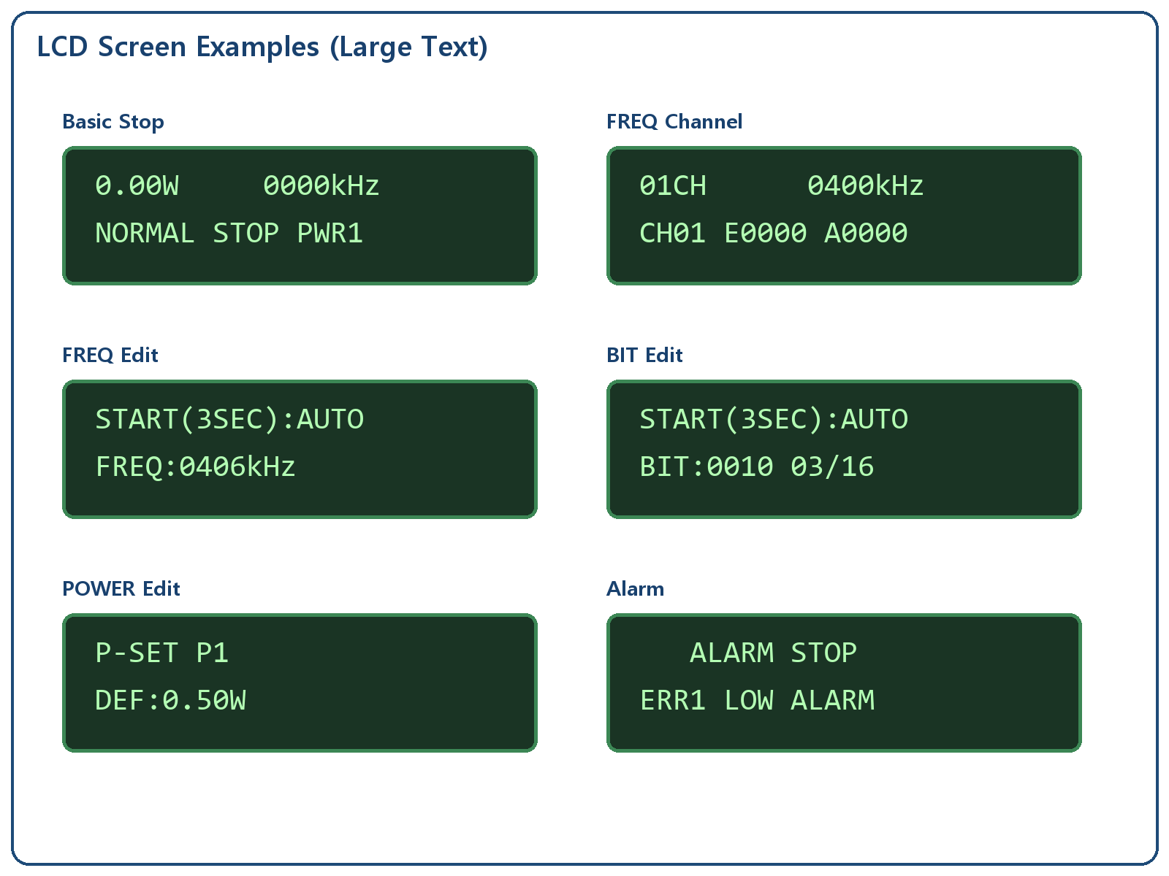
LCD screen examples
Part | Function
LCD | Displays output, frequency, operation mode, setting menu and alarms
NORMAL LED | Indicates NORMAL operation mode
H/L SET LED | Indicates high/low alarm setting related status
8 POWER LED | Indicates 8 POWER selection/setting
REMOTE LED | Indicates REMOTE mode
EXT LED | Indicates EXT communication mode
TX/RX LED | Indicates RS-485 transmit/receive activity
START/STOP | Starts/stops oscillation; long press in FREQ SET starts Auto Tuning
MODE | Moves selected item/edit field; long press enters setting or returns to upper menu
UP/DOWN | Increases/decreases values; long press repeats quickly
SET | Saves/confirms values; long press returns to SELECT screen in setting screens

4. Connecting Method
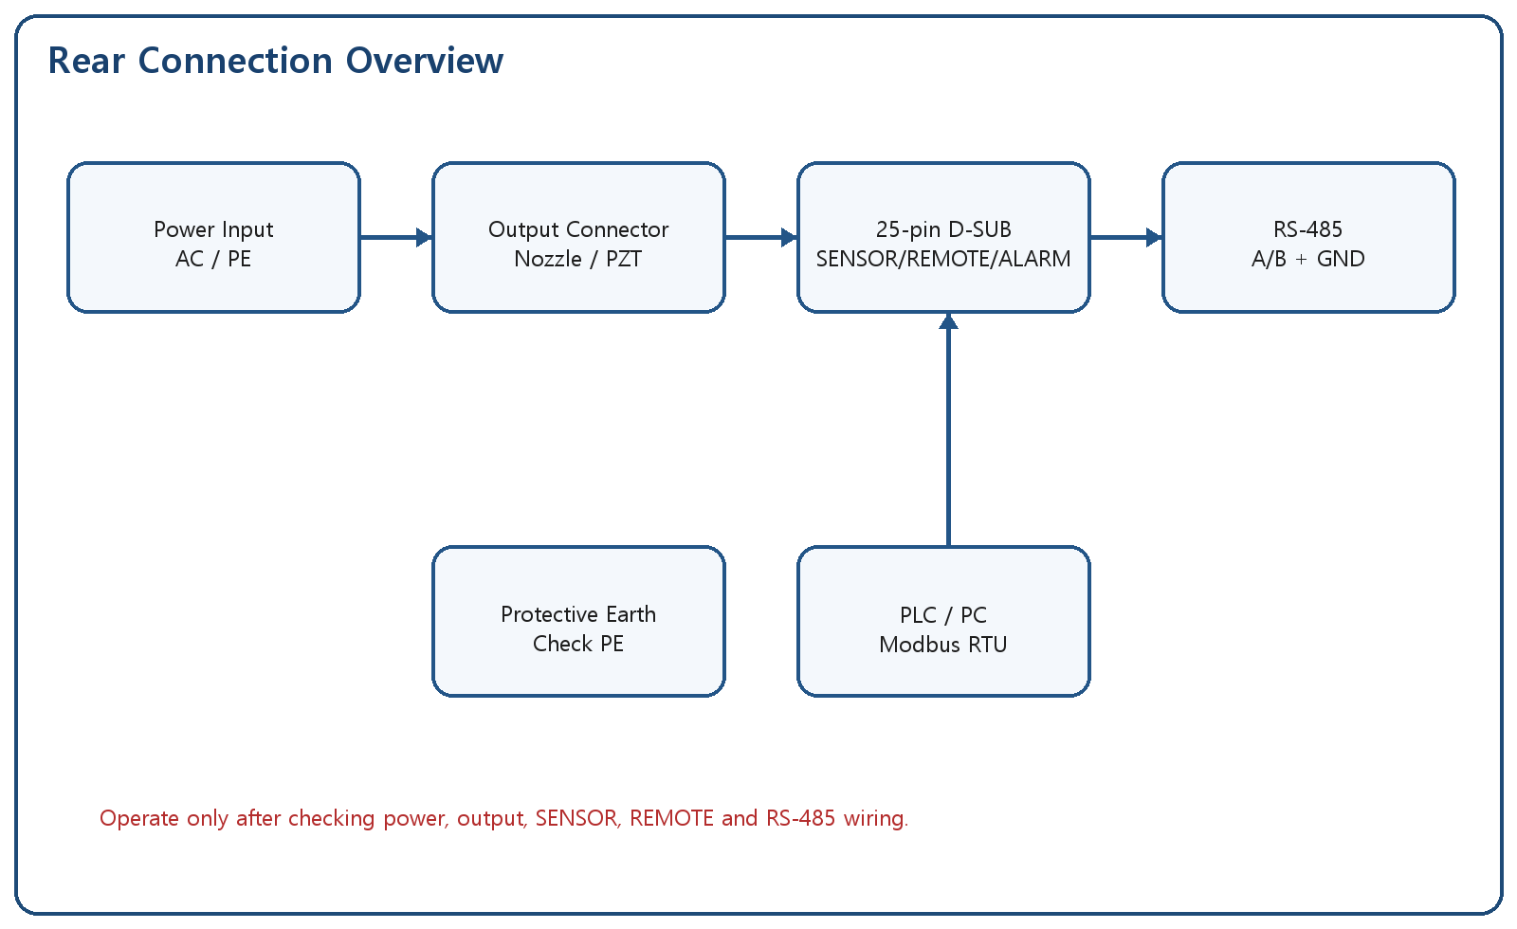
Rear connection overview

4.1 25-pin D-SUB Control Connector
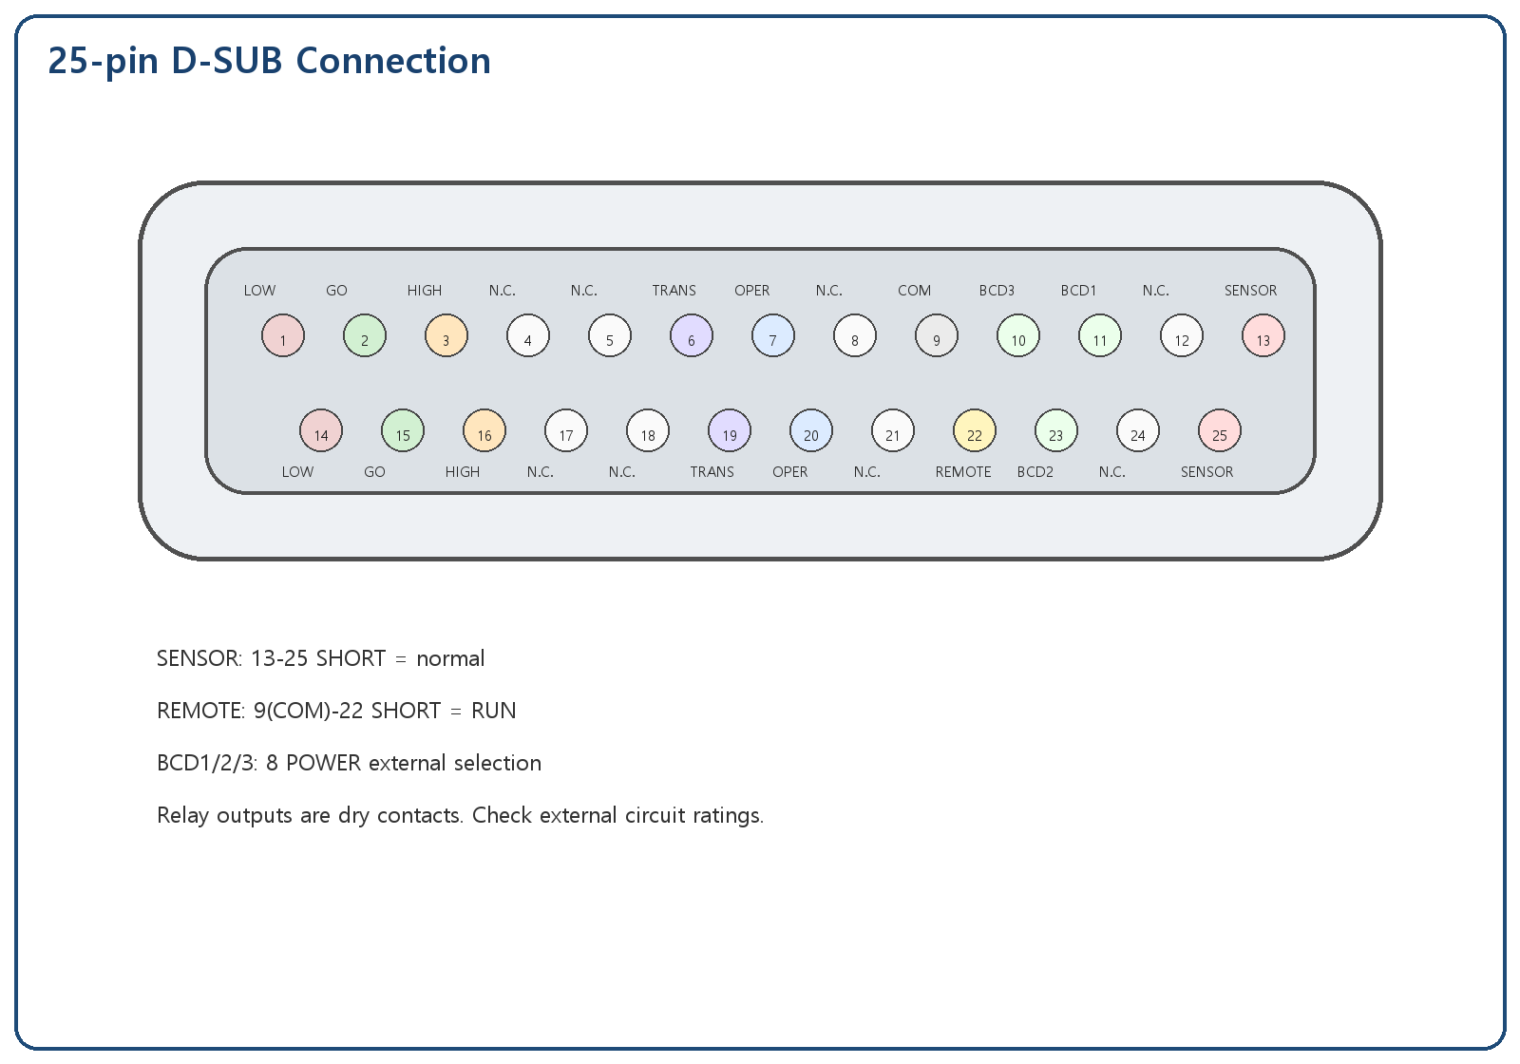
25-pin D-SUB connection
Pin | Signal | Type | Description
1 | LOW ALARM A | Relay contact | SHORT to pin 14 when Err1 occurs
14 | LOW ALARM B | Relay contact | Err1 LOW ALARM
2 | GO A | Relay contact | SHORT to pin 15 in normal output range
15 | GO B | Relay contact | Normal output range
3 | HIGH ALARM A | Relay contact | SHORT to pin 16 when Err2 occurs
16 | HIGH ALARM B | Relay contact | Err2 HIGH ALARM
6 | TRANSDUCER ALARM A | Relay contact | SHORT to pin 19 when Err5 occurs
19 | TRANSDUCER ALARM B | Relay contact | Transducer/load alarm
7 | OPERATE A | Fail-safe relay | SHORT to pin 20 in normal state; OPEN at alarm/power-off
20 | OPERATE B | Fail-safe relay | Integrated operation/alarm contact
9 | COM | Input common | Common for REMOTE/BCD inputs
22 | REMOTE | Contact input | SHORT to pin 9 = RUN, OPEN = STOP
11 | BCD1 | Contact input | 8 POWER external select bit1
23 | BCD2 | Contact input | 8 POWER external select bit2
10 | BCD3 | Contact input | 8 POWER external select bit3
13 | SENSOR A | Safety input | SHORT to pin 25 is normal
25 | SENSOR B | Safety input | OPEN causes Err7/Err8
4,5,8,12,17,18,21,24 | N.C. | Reserved | Do not use
SHIELD | Connector shell | Shield | Connector body shield/ground

4.2 8 POWER External Selection
BCD3 | BCD2 | BCD1 | Selected POWER
0 | 0 | 0 | PWR1
0 | 0 | 1 | PWR2
0 | 1 | 0 | PWR3
0 | 1 | 1 | PWR4
1 | 0 | 0 | PWR5
1 | 0 | 1 | PWR6
1 | 1 | 0 | PWR7
1 | 1 | 1 | PWR8

5. Operation Ready
- Confirm DI water or process liquid is supplied to the nozzle when required.
- Check output cable and 25-pin D-SUB wiring.
- Confirm SENSOR is in normal SHORT state.
- Turn on power and check LCD/LED indication.
- Start the first operation at low output.

6. Operating Method
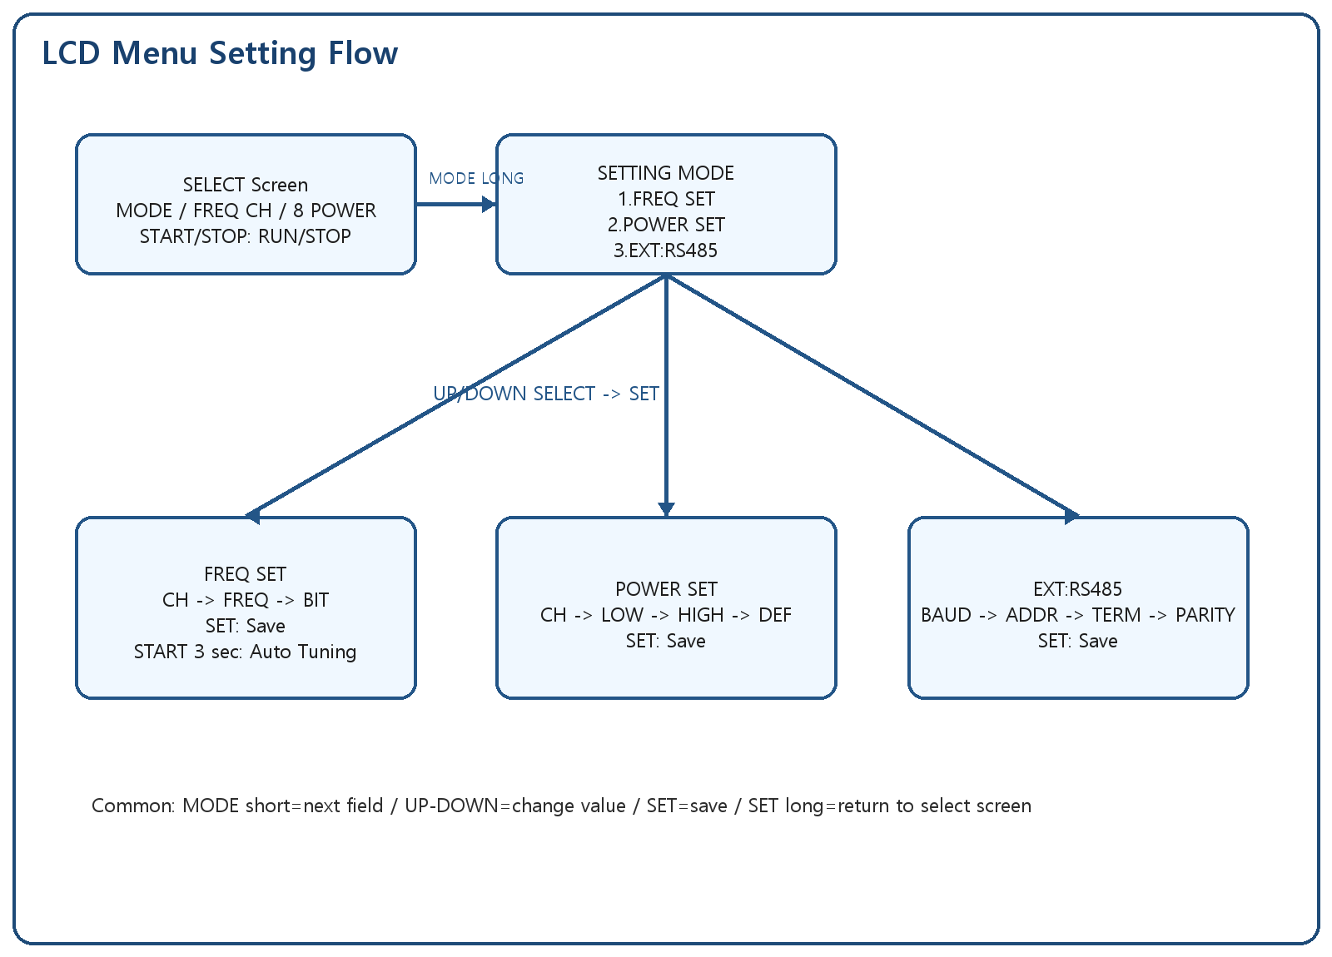
LCD menu setting flow

6.1 FREQ Channel
Channel | Default Frequency | Description
CH01 | 400kHz | Frequency profile 1
CH02 | 600kHz | Frequency profile 2
CH03 | 800kHz | Frequency profile 3
CH04 | 1000kHz | Frequency profile 4
CH05 | 1200kHz | Frequency profile 5
CH06 | 1400kHz | Frequency profile 6
CH07 | 1600kHz | Frequency profile 7
CH08 | 1800kHz | Frequency profile 8
CH09 | 2000kHz | Frequency profile 9
CH10 | 2200kHz | Frequency profile 10

6.2 POWER SET
Field | Meaning | Range
CH | POWER profile number | PWR1~PWR8
LOW | Low alarm threshold | 0.10W~0.95W
HIGH | High alarm threshold | 0.20W~5.00W
DEF | Default output | 0.20W~5.00W

6.3 EXT:RS485
Field | Setting | Description
BAUD | 9600/19200/38400/115200 | Communication speed
ADDR | 1~247 | Slave address
TERM | OFF/ON | Termination setting record; hardware control reserved
PARITY | NONE-8-1/EVEN-8-1 | Panel parity setting

- MODE long -> SETTING MODE -> select item -> SET enter -> MODE next field -> UP/DOWN change -> SET save
- START/STOP for about 3 seconds in FREQ SET: Auto Tuning
- Save success: 2 beeps, save failure: 3 beeps

7. ERROR Display
Code | Contents | Condition | Output | Action
Err1 | LOW ALARM | Output remains below LOW setting | Stop | Check load/cable/LOW setting, then press SET
Err2 | HIGH ALARM | Output remains above HIGH setting | Stop | Check output setting/load/HIGH setting, then press SET
Err5 | TRANSDUCER ALARM | Transducer or load abnormal | Stop | Check nozzle/transducer/cable
Err6 | SETTING ERROR | Setting outside allowed range | Conditional | Enter a value within the allowed range
Err7 | SENSOR OFF | SENSOR open while stopped | Output inhibited | Power OFF -> check SENSOR short -> power ON
Err8 | SENSOR RUN | SENSOR open while running | Stop | Power OFF -> check SENSOR short -> power ON

8. Communication Specification
Item | Specification
Interface | RS-485 Half-Duplex
Protocol | Modbus RTU
Default setting | ADDR 1, 9600bps, NONE-8-1
Supported baudrates | 9600/19200/38400/115200
Setting menu | SETTING MODE -> 3.EXT:RS485
Function codes | 0x03 / 0x06 / 0x10

Address | R/W | Name | Value
0x0000 | R/W | RUN control | 0=STOP, 1=RUN
0x0001 | R/W | Frequency | x0.1kHz
0x0002 | R/W | Duty | x0.1%
0x0006 | R/W | Operation mode | 0=NORMAL,1=REMOTE,2=EXT
0x0010 | R/W | Slave address | 1~247
0x0011 | R/W | Baud index | 0~3
0x0012 | R/W | Parity | 0=None,1=Even,2=Odd

9. Initial Setting Value
Item | Initial Value
MODE | NORMAL
FREQ CH | CH01 / 400kHz
POWER | PWR1 / DEF 0.50W
LOW ALARM | 0.10W
HIGH ALARM | 5.00W
RS-485 | ADDR1 / 9600bps / NONE-8-1

10. Setting Storage
Operating mode, FREQ channel/frequency/BIT, POWER channel/LOW/HIGH/DEF and RS-485 settings saved by SET are stored in internal FLASH and retained after power-off.

11. Troubleshooting
Symptom | Possible Cause | Action
No output | STOP/alarm/SENSOR open | Check LCD, alarm and SENSOR
Err7 at power ON | SENSOR OPEN | Power OFF and check pin 13-25 SHORT
REMOTE does not work | Pin 9-22 contact or mode setting error | Check REMOTE wiring and mode
No RS-485 response | A/B, address, baudrate or parity mismatch | Check EXT:RS485 setting

12. Maintenance
- Daily: check cables/connectors, LCD/LEDs and alarm history
- Weekly: check output repeatability, REMOTE contact and RS-485 response
- Monthly: check transducer/cable insulation, alarm thresholds and setting backup

13. A/S
When requesting service, provide model name, serial number, alarm code, operating condition, installation photos and reproduction steps.

14. Revision History
Version | Date | Description
v4.0-EN | 2026-05-19 | Full LCD panel user manual with 25-pin D-SUB, actual panel image, detailed menu settings, REMOTE/EXT operation and bilingual output

