**Electronic Voting machines and their security - notes**

**Opportunities:**

**Efficiency:** electronic voting machines are known to provide a clearer presentation of who you’re voting for. This helps reduce the probability of someone voting for the wrong or picking too many candidates, thus improving the general integrity of voting. An example of this going horribly wrong was during the 2000 US presidential election recount. In Florida, during this election they chose a punch-card voting machine method. This had many problems with design and “chads” (hanging paper) that caused confusion as it failed to distinguish votes. The rise of scan technology in newly adopted machines has organizers hoping the voter's choice is secure.

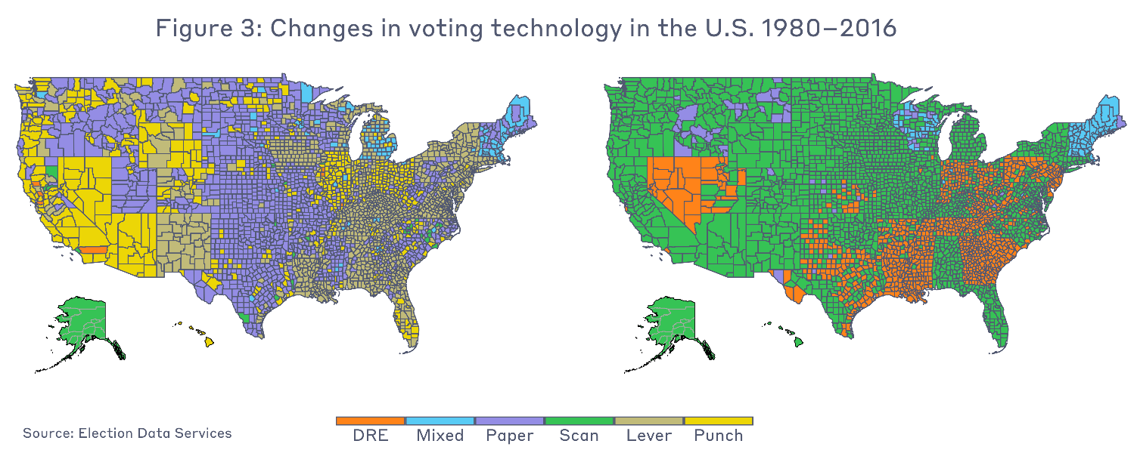

Figure (Voting Technology, 2022)

There are also fewer steps involved. This can encourage people who might not have previously voted but will as the process is simpler.

Electronic voting machines can also usually add up votes themselves. This can prevent human errors from occurring due to miscount/misplacement etc.

**Rural votes:** many voters may feel a level of dissonance with the methods of election and feel unheard. This is due to the difficulty it can be for them to get to a voting booth. A more modern approach through electronic methods (email perhaps) could lead to these people's votes being counted and therefore have a renewed sense of involvement.

**Fraud reduction:** in the past ballots have been known to be tampered with. Although there is a chance electronic voting machines could be compromised some would argue ballots are less secure. Michael Shamos of Carnegie Mellon University who favors electronic voting argues that “Paper voting records have shown themselves for the past 250 years to be horribly insecure and easy to manipulate. In practice they have so many flaws that they are as bad as punched card voting at its worst.”

**Accessibility:** electronic voting/machines also give the opportunity to people with disabilities/impairments the chance to vote. For example, people with visual impairments could have the ability to vote with audio ballets.

**Cost:** the clear reduction in cost from electronic machines are a big opportunity. With the automation of voting machines can take the voters input and add it to a total. Machines can also keep track of the total, which reduces the need for employees to count.

**Waste Reduction:** machines as a replacement for ballots could hugely reduce the amount of paper required for elections thus benefiting the environment.

Smartmatic (27 September 2019). *What is electronic voting*

[*https://elections.smartmatic.com/electronic-voting-advantages/*](https://elections.smartmatic.com/electronic-voting-advantages/)

Election Data – Science Lab. Massachusetts Institute of Technology (2022) *Voting Technology*

<https://electionlab.mit.edu/research/voting-technology>

Ace – The electoral knowledge network.(n.d) *E-Voting*

<https://aceproject.org/ace-en/focus/e-voting/default>

Election Buddy (April 20, 2022). *The Advantages and Disadvantages of Online Voting Systems*

<https://electionbuddy.com/blog/2022/04/20/the-advantages-and-disadvantages-of-online-voting-systems/>

Lin, G. Espinoza, N (2007)Stanford University. *Arguments in Favor*.

<https://cs.stanford.edu/people/eroberts/cs201/projects/2006-07/electronic-voting/index_files/page0001.html>