電腦輔助檢測與診斷作業

1. B10521130 宋沂芸

B10521131 徐梓翔

B10521135 林宥嫻

B10521138 洪宜君

B10521141 蔡昕頤

1. 於不同強度光源所攝取之影像

|  |  |
| --- | --- |
| 圖一 | 圖二 |
|  |  |

1. 以視覺畫呈現
2. RGB影像之R,G,B矩陣具變異性

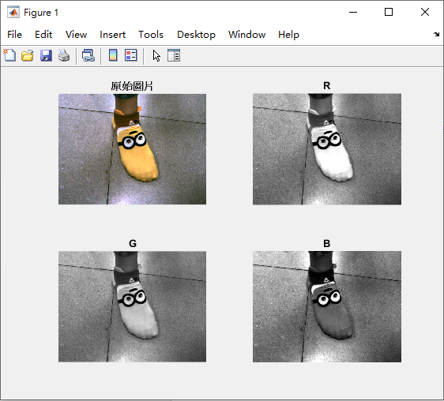

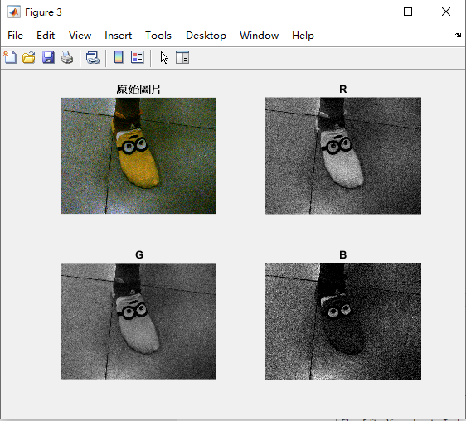

1. 轉至HSV表示時，Hue與Saturation仍保持相似性, Value(Intensity)具變異性

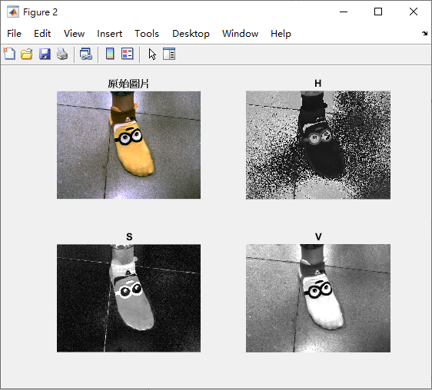

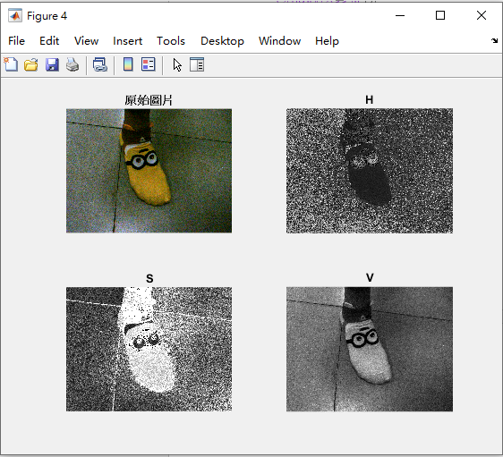

1. Matlab程式碼

%第一張圖

RGB1 = imread('C:\Users\Tepao_Sung\Desktop\雲科大108-1\電腦輔助檢測與診斷\20191002\33.tif');

R1 = RGB1(:,:,1);

G1 = RGB1(:,:,2);

B1 = RGB1(:,:,3);

subplot(2,2,1);imshow(RGB1);title('原始圖片');

subplot(2,2,2);imshow(R1);title('R');

subplot(2,2,3);imshow(G1);title('G');

subplot(2,2,4);imshow(B1);title('B');

figure;

HSV1 = rgb2hsv(RGB1);

H1 = HSV1(:,:,1);

S1 = HSV1(:,:,2);

V1 = HSV1(:,:,3);

subplot(2,2,1);imshow(RGB1);title('原始圖片');

subplot(2,2,2);imshow(H1);title('H');

subplot(2,2,3);imshow(S1);title('S');

subplot(2,2,4);imshow(V1);title('V');

figure;

%第二張圖

RGB2 = imread('C:\Users\Tepao_Sung\Desktop\雲科大108-1\電腦輔助檢測與診斷\20191002\44.tif');

R2 = RGB2(:,:,1);

G2 = RGB2(:,:,2);

B2 = RGB2(:,:,3);

subplot(2,2,1);imshow(RGB2);title('原始圖片');

subplot(2,2,2);imshow(R2);title('R');

subplot(2,2,3);imshow(G2);title('G');

subplot(2,2,4);imshow(B2);title('B');

figure;

HSV2 = rgb2hsv(RGB2);

H2 = HSV2(:,:,1);

S2 = HSV2(:,:,2);

V2 = HSV2(:,:,3);

subplot(2,2,1);imshow(RGB2);title('原始圖片');

subplot(2,2,2);imshow(H2);title('H');

subplot(2,2,3);imshow(S2);title('S');

subplot(2,2,4);imshow(V2);title('V');