電腦輔助檢測與診斷作業

1. B10521130 宋沂芸

B10521131 徐梓翔

B10521138 洪宜君

B10521141 蔡昕頤

1. 灰階影像

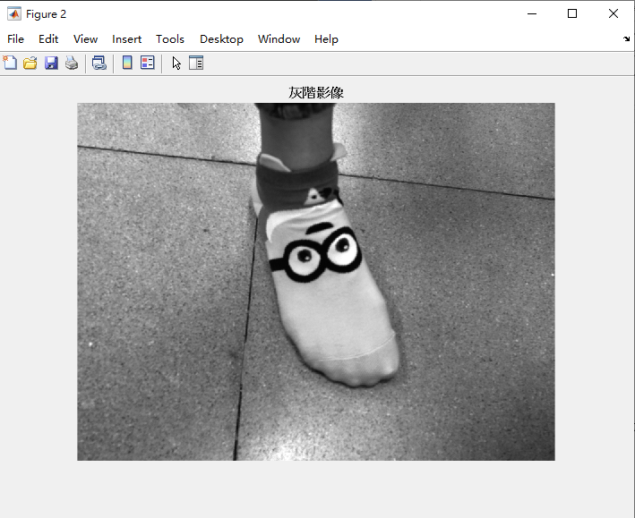

1. Watershed影像切割

|  |  |
| --- | --- |
|  |  |
|  |  |
|  |  |

1. 兩類Mask影像強化輸出

|  |  |
| --- | --- |
|  |  |

Otsu 及 k-means切割前述影像強化之二值化輸出

|  |  |
| --- | --- |
|  |  |

1. 設計驗算法測試上述三演算法
2. Matlab 程式碼

A = imread('C:\Users\Tepao_Sung\Desktop\sock.jpg');

imshow(A);title('原始影像');

%灰階影像

B=rgb2gray(A);

figure;imshow(B);title('灰階影像');

[y,x]=imhist(B);

%figure;bar(x,y);title('灰階影像直方圖');

%Watershed-影像切割

[m,n]=size(B);

Bdb=double(B);%圖片轉成double精度類型(0~1)

%figure;imshow(Bdb/255);title('灰階影像轉成double');

hy=fspecial('sobel');%利用sobel算子計算梯度影像

hx=hy';

Iy = imfilter(Bdb, hy, 'replicate');

Ix = imfilter(Bdb, hx, 'replicate');

[Ix, Iy]=gradient(Bdb);

gradmag = sqrt(Ix.^2 + Iy.^2);

%figure;imshow(gradmag,[]);title('Sobel算子-梯度影像');

level=graythresh(B);%Otsu切割影像

plabel=imbinarize(B,level);

%figure;imshow(plabel);title('影像強化之二值化');

plabel1=imfill(plabel,'holes');

figure;imshow(plabel1);title('影像填滿');

plabel2=imerode(plabel1, ones(5));%前景骨架化

plabel3=bwmorph(plabel2,'skel',Inf);

figure;imshow(plabel3);title('骨架化前景');

back=1-plabel1;%背景骨架化

back1=imerode(back,ones(5));

back2=bwmorph(back1,'skel',Inf);

figure;imshow(back2),title('骨架化背景');

figure;imshow(plabel3|back2);title('前後景標記物作為分水嶺起始點');

gradmag2=imimposemin(gradmag, plabel3|back2);%

%figure;imshow(gradmag2);title('分水嶺分割');

L2 = watershed(gradmag2);

rgb=label2rgb(L2);

figure;imshow(rgb);title('轉換標記矩陣到RGB圖像');

XX=L2==0;

figure;imshow(XX),title('影像切割1-分水嶺線');

%兩類Mask-影像強化

M=fspecial('sobel');%Mask1

Gx=filter2(M,B,'valid');

Gy=filter2(M,B,'valid');

G=(Gx.^2+Gy.^2).^0.5;

figure;imshow(G,[]);title('Mask1-影像強化1');

N=[0 1 2;-1 0 1;-2 -1 0];%Mask2

Hx=filter2(N,B,'valid');

Hy=filter2(N,B,'valid');

H=(Hx.^2+Hy.^2).^0.5;

figure;imshow(H,[]);title('Mask2-影像強化2');

%K=(G.^2+H.^2).^0.5;

%Final=imbinarize(K);

%figure;imshow(Final);title('Mask2-影像強化2');

%應用 Otsu 及 k-means,切割前述影像強化之二值化

C1=graythresh(B);%Otsu

BW1=imbinarize(B,C1);

figure;imshow(BW1);title('影像切割2-Otsu之二值化');

J=double(B);%k-means

[m,n]=size(B);

X=reshape(J,m*n,1);

[cidx,ctrs]=kmeans(X,2);

rergb=reshape(cidx,m,n);

figure;imshow(rergb,[]);title('影像切割3-k-means之二值化');

1. 輸入及輸出影像，及步驟e之結果

|  |  |
| --- | --- |
|  |  |
|  |  |