電腦輔助檢測與診斷作業

1. B10521130 宋沂芸

B10521131 徐梓翔

B10521138 洪宜君

B10521141 蔡昕頤

1. i灰階影像

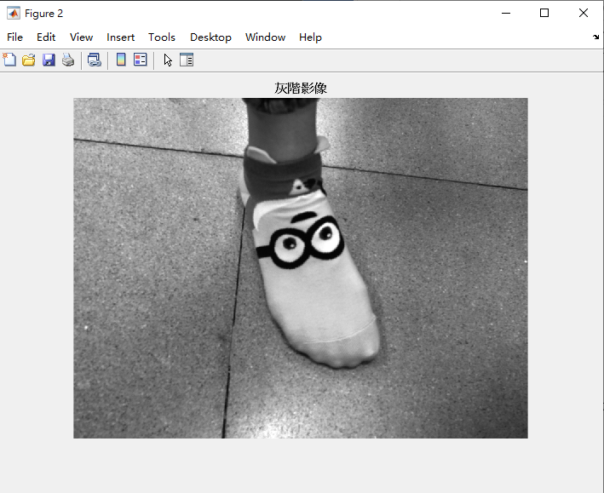

ii Otsu, k-means 及 Mark-controlled Watershed切割前述影像，並以二值化輸出

|  |  |
| --- | --- |
| Otsu | k-means |
|  |  |

|  |  |
| --- | --- |
| Watershed | |
|  |  |
|  |  |
|  |  |

iii應用ginput擷取關注區域及roipoly計算黃金標準之二值化影像

|  |  |
| --- | --- |
|  |  |

iv測試上述三演算法相似度之相異性

Watershed=0.0212

Otsu=0.2301

k-means=0.1205

v Matlab 程式碼

A = imread('C:\Users\Tepao_Sung\Desktop\sock.jpg');

%imshow(A);title('原始影像');

%灰階影像

B=rgb2gray(A);

figure;imshow(B);title('灰階影像');

%[y,x]=imhist(B);

%figure;bar(x,y);title('灰階影像直方圖');

%Watershed-影像切割

[m,n]=size(B);

Bdb=double(B);%圖片轉成double精度類型(0~1)

%figure;imshow(Bdb/255);title('灰階影像轉成double');

hy=fspecial('sobel');%利用sobel算子計算梯度影像

hx=hy';

Iy = imfilter(Bdb, hy, 'replicate');

Ix = imfilter(Bdb, hx, 'replicate');

[Ix, Iy]=gradient(Bdb);

gradmag = sqrt(Ix.^2 + Iy.^2);

%figure;imshow(gradmag,[]);title('Sobel算子-梯度影像');

level=graythresh(B);%Otsu切割影像

plabel=imbinarize(B,level);

%figure;imshow(plabel);title('影像強化之二值化');

plabel1=imfill(plabel,'holes');

%figure;imshow(plabel1);title('影像填滿');

plabel2=imerode(plabel1, ones(5));%前景骨架化

plabel3=bwmorph(plabel2,'skel',Inf);

%figure;imshow(plabel3);title('骨架化前景');

back=1-plabel1;%背景骨架化

back1=imerode(back,ones(5));

back2=bwmorph(back1,'skel',Inf);

%figure;imshow(back2),title('骨架化背景');

%figure;imshow(plabel3|back2);title('前後景標記物作為分水嶺起始點');

gradmag2=imimposemin(gradmag, plabel3|back2);%

%figure;imshow(gradmag2);title('分水嶺分割');

L2 = watershed(gradmag2);

rgb=label2rgb(L2);

%figure;imshow(rgb);title('轉換標記矩陣到RGB圖像');

XX=L2==0;

%figure;imshow(XX),title('影像切割1-分水嶺線');

%應用 Otsu 及 k-means,切割前述影像強化之二值化

C1=graythresh(B);%Otsu

BW1=imbinarize(B,C1);

%figure;imshow(BW1);title('影像切割2-Otsu之二值化');

J=double(B);%k-means

[m,n]=size(B);

X=reshape(J,m*n,1);

[cidx,ctrs]=kmeans(X,2);

rergb=reshape(cidx,m,n);

%figure;imshow(rergb,[]);title('影像切割3-k-means之二值化');

%應用ginput 擷取關注區域

figure;imshow(B);title('ginput 擷取關注區域影像');

[r, c]=ginput;

K=roipoly(B,r,c);

[R,C]=size(K);

for i=1:R

for j=1:C

if K(i,j)==1;

Out(i,j)=B(i,j);

else

Out(i,j)=0;

end

end

end

figure;imshow(Out,[]);title('輸出擷取影像');

%L = imread('C:\Users\Tepao_Sung\Desktop\sock_ginput.jpg');

L=uint8(Out);

M = imbinarize(L);

figure;imshow(M);title('擷取影像之二值化');

%計算相似度

S1=sum(sum(M&XX))/sum(sum(M|XX));%Watershed

S2=sum(sum(M&BW1))/sum(sum(M|BW1));%Otsu

S3=sum(sum(M&rergb))/sum(sum(M|rergb));%K-means

1. 選擇兩類具代表性紋理分析之影像

