電腦輔助檢測與診斷作業

1. B10521130 宋沂芸

B10521131 徐梓翔

B10521138 洪宜君

B10521141 蔡昕頤

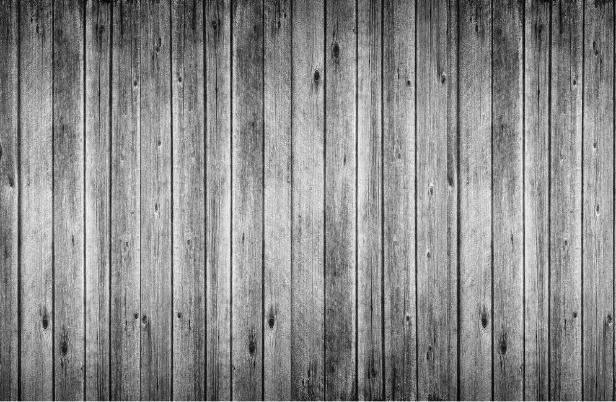

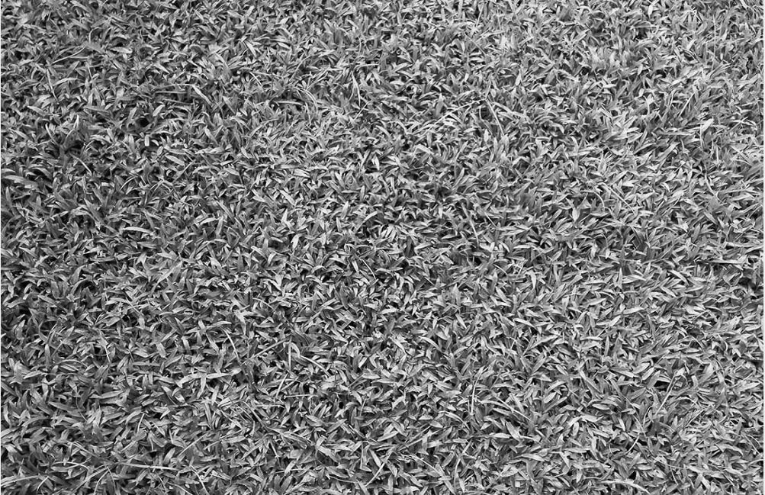

rand('seed', 2)

GRNN

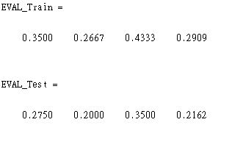

GRNN

clear all;close all;

tempa=imread('grass.bmp');

temp=tempa(:,:,1:3)

figure;imshow(temp);

temp1=double(rgb2gray(temp));

[m, n]=size(temp1);

figure;imshow(temp1,[]);

%%%%%%%%%%%%%%% Image Generation Parameters

width = 64; height=64;numberOfImage=200;

%%%%%%%%%%%%%%%%%%%%%%

Partition1=ceil(0.6*numberOfImage);

Partition2=ceil(0.2*numberOfImage);

Partition3=ceil(0.2*numberOfImage);

%%%%%%%%%%%%%%%%%%%%%%%

rand('seed', 2);

Feature1=[];

for i=1:numberOfImage

a=ceil(rand*(m-height));

b=ceil(rand*(n-width));

hold on; plot([b b b+width b+width b],[a a+height a+height a a],'r','LineWidth', 3);

temp2=temp1(a:a+height-1, b:b+width-1);

feature=gfeature(double(temp2),'0');

Feature1=[Feature1, feature];

end

%%%%%%%%%%%%%%%%%%%% Start the 2nd Image**********

tempa=imread('wood.bmp');

temp=tempa(:,:,1:3)

figure;imshow(temp);

temp1=double(rgb2gray(temp));

[m, n]=size(temp1);

figure;imshow(temp1,[]);

Feature2=[];

for i=1:numberOfImage

a=ceil(rand*(m-height));

b=ceil(rand*(n-width));

hold on; plot([b b b+width b+width b],[a a+height a+height a a],'b','LineWidth', 3);

temp2=temp1(a:a+height-1, b:b+width-1);

feature=gfeature(double(temp2),'0');

Feature2=[Feature2, feature];

end

% End Feature Extraction

P1=Feature1(:,1:Partition1);

P2=Feature2(:,1:Partition1);

P_Tr=[P1 P2];

T_Tr=[zeros(1,Partition1) ones(1, Partition1)];

P1=Feature1(:,Partition1+1:Partition1+Partition2);

P2=Feature2(:,Partition1+1:Partition1+Partition2);

P_Te=[P1 P2];

T_Te=[zeros(1,numberOfImage-(Partition1+Partition3)), ones(1,numberOfImage-(Partition1+Partition3))];

P1=Feature1(:,Partition1+Partition2+1:numberOfImage);

P2=Feature2(:,Partition1+Partition2+1:numberOfImage);

P_Vali=[P1 P2];

T_Vali=[zeros(1,numberOfImage-(Partition1+Partition2)), ones(1,numberOfImage-(Partition1+Partition2))];

%%%%%% Train GRNN

%

pause

%

A_Tr=[];

A_Te=[];

A_Vali=[];

x=[0.1:0.1:10];

for Sigma=0.1:0.1:10

net=newgrnn(P_Tr,T_Tr,Sigma);

out=sim(net,P_Tr);

accuracyTr=(length(T_Tr)-sum(abs(T_Tr-out)>0.5))/length(T_Tr);

A_Tr=[A_Tr accuracyTr];

out=sim(net,P_Te);

accuracyTe=(length(T_Te)-sum(abs(T_Te-out)>0.5))/length(T_Te);

A_Te=[A_Te accuracyTe];

out=sim(net,P_Vali);

accuracyVali=(length(T_Vali)-sum(abs(T_Vali-out)>0.5))/length(T_Vali);

A_Vali=[A_Vali accuracyVali];

end

figure;plot(x, A_Tr,'b-');hold on;plot(x, A_Te,'r');plot(x, A_Vali,'k');plot(x, A_Tr+A_Te+A_Vali,'g');

%%

pause

%%

%­pºâAccuracy, Sensitivity, Specificity, F-measure

Sigma=4;

net=newgrnn(P_Tr,T_Tr,Sigma);

save('ImageClassification.mat');

load('ImageClassification.mat', 'net','height','width');

out_Tr=sim(net,P_Tr);

out_Te=sim(net,P_Te);

out_Vali=sim(net,P_Vali);

EVAL_Train = Evaluate(T_Tr,out_Tr)

EVAL_Test = Evaluate(T_Te,out_Te)

EVAL_Vali = Evaluate(T_Te,out_Vali)

%%

pause

%%

%%Test Grnn

tempa=imread('grass.bmp');

temp=tempa(:,:,1:3)

temp1=double(rgb2gray(temp));

tempb=imread('wood.bmp');

temp=tempb(:,:,1:3)

temp2=double(rgb2gray(temp));

I=[temp1 temp1;temp1 temp1;temp2 temp2;temp2 temp2];

figure;imshow(I,[])

while pause

disp('Select a test point')

[b,a]=ginput(1);

b=round(b);a=round(a);

N1=I(a:a+height-1,b:b+width-1);

F=gfeature(double(N1),'0');

out1=sim(net,F);

hold on;

if out1 > 0.5

plot([b b b+width b+width b],[a a+height a+height a a], 'b:','LineWidth', 3)

else

plot([b b b+width b+width b],[a a+height a+height a a],'r:','LineWidth',3)

end

end

BPNN

rng(2)

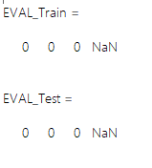

BPNN

clear all;close all;

temp=imread('grass.bmp');

figure;imshow(temp);

temp1=double(rgb2gray(temp));

[m, n]=size(temp1);

figure;imshow(temp1,[]);

%%%%%%%%%%%%%%% Image Generation Parameters

width = 64; height=64;numberOfImage=100;

%%%%%%%%%%%%%%%%%%%%%%

Partition1=ceil(0.6*numberOfImage);

Partition2=ceil(0.2*numberOfImage);

Partition3=ceil(0.2*numberOfImage);

%%%%%%%%%%%%%%%%%%%%%%%

rng(2);

Feature1=[];

for i=1:numberOfImage

a=ceil(rand*(m-height));

b=ceil(rand*(n-width));

hold on; plot([b b b+width b+width b],[a a+height a+height a a],'r','LineWidth', 3);

temp4=temp1(a:a+height-1, b:b+width-1);

feature=gfeature(double(temp4),'0');

Feature1=[Feature1, feature];

end

%%%%%%%%%%%%%%%%%%%% Start the 2nd Image**********

temp=imread('wood.bmp');

figure;imshow(temp);

temp1=double(rgb2gray(temp));

[m, n]=size(temp1);

figure;imshow(temp1,[]);

Feature2=[];

for i=1:numberOfImage

a=ceil(rand*(m-height));

b=ceil(rand*(n-width));

hold on; plot([b b b+width b+width b],[a a+height a+height a a],'b','LineWidth', 3);

temp4=temp1(a:a+height-1, b:b+width-1);

feature=gfeature(double(temp4),'0');

Feature2=[Feature2, feature];

end

% End Feature Extraction

P1=Feature1(:,1:Partition1);

P2=Feature2(:,1:Partition1);

P_Tr=[P1 P2];

T_Tr=[zeros(1,Partition1) ones(1, Partition1)];

P1=Feature1(:,Partition1+1:Partition1+Partition2);

P2=Feature2(:,Partition1+1:Partition1+Partition2);

P_Te=[P1 P2];

T_Te=[zeros(1,numberOfImage-(Partition1+Partition3)), ones(1,numberOfImage-(Partition1+Partition3))];

P1=Feature1(:,Partition1+Partition2+1:numberOfImage);

P2=Feature2(:,Partition1+Partition2+1:numberOfImage);

P_Vali=[P1 P2];

T_Vali=[zeros(1,numberOfImage-(Partition1+Partition2)), ones(1,numberOfImage-(Partition1+Partition2))];

%

pause

%

E_Tr=[];

E_Te=[];

E_Vali=[];

x=[1:1:40];

for node=1:1:40

net=newff(P_Tr,T_Tr,node);

out_Tr=sim(net,P_Tr);

err_Tr=immse(T_Tr,out_Tr);

E_Tr=[E_Tr err_Tr];

out_Te=sim(net,P_Te);

err_Te=immse(T_Te,out_Te);

E_Te=[E_Te err_Te];

out_Vali=sim(net,P_Vali);

err_Vail=immse(T_Te,out_Te);

E_Vali=[E_Vali err_Vail];

end

figure;plot(x, E_Tr,'b-');hold on;plot(x, E_Te,'r');plot(x, E_Vali,'k');plot(x, E_Tr+E_Te+E_Vali,'g');

%%

pause

%%

%node=2®É¡Aerror³Ì§C

node=2;

net=newff(P_Tr,T_Tr,node);

out_Tr=sim(net,P_Tr);

out_Te=sim(net,P_Te);

out_Vali=sim(net,P_Vali);

EVAL_Train = Evaluate(T_Tr,out_Tr)

EVAL_Test = Evaluate(T_Te,out_Te)

EVAL_Vali = Evaluate(T_Te,out_Vali)