Phonetics:
Pronunciation

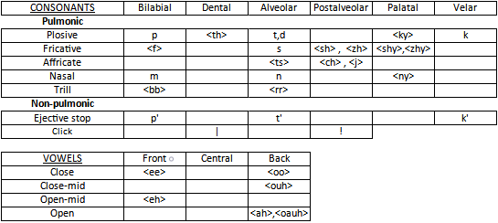

Basic Rules

Starting Rules:
- <sound> adapted from another character to be easier to read for English speakers.
- Only proper nouns capitalized.
- Ends of words will always be a vowel.
- All syllables end in a vowel. (Except for clicks and ejective stops, which each take a syllable.)
- Stresses always on first syllable (Not including clicks or ejective stops), unless otherwise specified with an acute accent. (í, ú, é, á, ó, ớ)
- Written right to left.

Letter Simplification. "()" Denotes Right-to-Left Written Form

- <ky> - ǩ
- <shy> - sȟ (ȟs)
- <zhy> - zȟ (ȟz)
- <ny> - ň
- <ee> - i
- <oo> - u
- <eh> - e
- <ah> - a
- <ouh> - o
- <oauh> - ơ
- <rr> - ṛ
- <bb> - ḅ
- "|" - ^
- "!" - *

Structure:
Syntax

Visual:
- Subject, Object, Verb. (Verb, Object, Subject as seen in written form.)
- Noun - Adjective. (Adjective - Noun as seen in written form.)
- Noun - Postposition. (Postposition - Noun as seen in written form.)
- Possessed - Possessor (Possessor - Possessed as seen in written form.)

Inceptual:
- Adjectives derived from nouns.
- Postposition derived from verbs.

Grammar

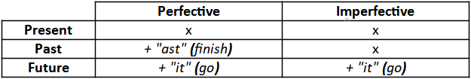

Visual:
- Verb - Auxiliary. (Auxiliary - Verb as seen in written form.)
- Plurals indicated by a succeeding adjective.

Permutative:
- "To come" changes valency of transitive verbs. (Passive)
- "To cause" changes valency of transitive verbs. (Causative)

Goals:
Concepts

- Music, art, technology, city life, flavours, colours, emotions/feelings, types of pain.

Communication

- Easy sounds and words to pronounce for me, personally, as well as portraying concepts I interact with and speak about in life.

Dictionary (Pronounce from Right to Left!):
Pronouns

Subject:
- "eǩ" - I
- "ahz" - You
- "a'k" - They
- "os" - We
- "í'pa" - You All
- "aň" - They All

Object:
- "ej" - Me
- "ip" - You
- "aṛik" - Them
- "os" - Us
- "í'pa" - You All
- "aň" - Them All

Possessive Adjective:
- "áhsej" - My
- "aiáhz" - Your
- "eṛik" - Their
- "is" - Our
- "aí'pa" - All Your
- "aíaň" - All Their

Possessive Pronoun:
- "ameǩ" - Mine
- "itip" - Yours
- "eṛe'k" - Theirs
- "is" - Ours
- "aí'pa" - You All's
- "aíaň" - Them All's

Words

Expressions:
- "a^" - Yes
- "^^" - No

Nouns:
- "e*a" - Person
- "áṛo" - Creature
- "éṛo" - Tree
- "atu" - Sky
- "i'k" - Fabric
- "á'ten" - Sound
- "ahce" - Ground
- "asam" - Object
- "ajut" - Rock, Stone
- "efu" - Place, Area
- "ama" - Sustenance, Consumable
- "a'te" - Bed
- "aput" - Solid
- "aňut" - Liquid
- "aoan" - Water
- "ameḅ" - Chair
- "ekáma" - Fire
- "a'p" - Light
- "íken" - Dark
- "aiahc" - Food
- "uhta'k" - Flesh
- "otak't" - Wood
- "aṛítu" - Word

"Traditional" Adjectives:
- "eǩot" - Green, Beautiful
- "otot" - Blue, Calm
- "upuṛ" - Red
- "aoast" - Reflective, Shiny
- "utihs" - Invisible, Unseen
- "ani^" - Gross
- "oast" - Many
- "uó" - All

Verbs:
- "aka*" - To Speak
- "e" - To Be
- "it" - To Go
- "ast" - To Finish
- "aňun" - To Sleep
- "ukam" - To Hear
- "eof" - To See
- "okap" - To Sit
- "atob" - To Make
- "afeň" - To Enjoy
- "aoahs" - To Come
- "iab" - To Feel

Compounds (Synonyms Beneath). Breakdown in "[]".

In Usage:
- "ekámatu" - [Sky + Fire] Sun
- "íkenefu" - [Dark + Place] Shade
- "ájutatu" - [Sky + Rock] Moon
- "atobufe" - [To Make + Place] Structure
- "atobasam" - [To Make + Object] Man-Made Object
  - "e*asam" - [Person + Object] Man-Made Object, Belonging of Person
- "aňuni'k" - [To Sleep + Fabric] Blanket
- "e*afu" - [Person + Place] Community
- "e*atobufe" - [Person + Structure] House
- "íaba'ten" - [To Feel + Sound] Music
- "oastaṛítu" - [Many + Word] Language
- "isáṛitu" - [Our + Word] Our Language (The Name of the Language)

Partially Invalidated by Base & Commonly Used:
- "e*á'ten" - [Person + Sound] Word, A Capella

Invalidated by Base & Commonly Used:
- "atupama" - [Solid + Sustenance] Food
- "aňutama" - [Liquid + Sustenance] Water
- "okapasam" - [To Sit + Object] Chair

Out of Common Usage:
- "a'téi'k" - [Bed + Fabric] Blanket

Invalidated by Base & Out of Common Usage:
- "aňunatobásam" - [To Sleep + To Make + Object] Bed
- "éṛohta'k" - [Tree + Flesh] Wood
- "okápatobasam" - [To Sit + To Make + Object] Chair
- "aka*a'ten" - [To Speak + Sound] Word

Sample Sentences. Breakdown in "[]"

- "e eǩot ahz" - [Be Beautiful You] You are beautiful.

