**Software Requirements Specification**

**for**

Packet Sniffer

**Version 1.0 approved**

**Sunil Baliganahalli NarayanMurthy**

**Nehal Kamat**

**Apoorva Bapat**

**University of Colorado, Boulder**

**Feb 17, 2016**

**Table of Contents**

**Table of Contents**

**Revision History**

**1. Introduction**

1.1 Purpose

1.2 Document Conventions

1.3 Intended Audience and Reading Suggestions

1.4 Product Scope

**2. System Requirements**

2.1 Business requirements

2.2 User requirements

2.3 Functional requirements

2.4 Non-Functional requirements

**3. Functional View**

3.1 Use case View

3.2 Logical View

3.2.1 Sequence diagrams

3.2.2 Activity diagrams

3.2.3 State chart diagrams

3.3 Deployment View

**4. Open points**

**Revision History**

|  |  |  |  |
| --- | --- | --- | --- |
| **Name** | **Date** | **Reason For Changes** | **Version** |
| Sunil Baliganahalli Narayana Murthy | 2/17/2016 | Initial draft | 1.0 |
| Sunil Baliganahalli Narayana Murthy | 2/21/2016 | Incorporated review comments from teammates | 1.1 |
| Sunil Baliganahalli Narayana Murthy | 3/4/2016 |  | 1.2 |
|  |  |  |  |

# **Introduction**

## **Purpose**

Packet sniffing is defined as a technique that is used to monitor every packet that crosses the network. A packet sniffer is a piece of hardware or software that monitors all network traffic. Using the information captured by the packet sniffers an administrator can identify erroneous packets and use the data to pinpoint bottlenecks and help to maintain efficient network data transmission. For most organizations packet sniffer is largely an internal threat.

Packet sniffers can be operated in both switched and non switched environment. Determination of packet sniffing in a non switched environment is a technology that can be understand by everyone. In this technology all hosts are connected to a hub. There are a large number of commercial and non commercial tools are available that makes possible eavesdropping of network traffic. Now a problem comes that how this network traffic can be eavesdrop; this problem can be solved by setting network card into a special “promiscuous mode”. Now businesses are updating their network infrastructure, replacing aging hubs with new switches. The replacement of hub with new switches that makes switched environment is widely used because “it increases security”. However, the thinking behind is somewhat flawed. It cannot be said that packet sniffing is not possible in switched environment. It is also possible in switched environment.

## **Intended Audience and Reading Suggestions**

This document is intended for User, Developer and tester.

## **Product Scope**

<Provide a short description of the software being specified and its purpose, including relevant benefits, objectives, and goals. Relate the software to corporate goals or business strategies. If a separate vision and scope document is available, refer to it rather than duplicating its contents here.>

# System Features

|  |  |  |  |  |
| --- | --- | --- | --- | --- |
| **Business Requirements - [Not Applicable]** | | | | |

|  |  |  |  |  |
| --- | --- | --- | --- | --- |
| **User Requirements** | | | | |
| **ID** | **Requirements** | **Topic Area** | **User** | **Priority** |
| UR-001 | Users should have the option of choosing the client machine to monitor packets from | Freedom | Any | High |
| UR-002 | Users should be able to deploy the application on any operating system/work environment | Deployment | Any | High |
| UR-003 | Users should have the option to run the application either using a graphical interface or via the command | Interaction | Any | Medium |
| UR-004 | Users should be able to extract required information and save it | Logging | Any | High |

|  |  |  |  |  |
| --- | --- | --- | --- | --- |
| **Functional Requirements** | | | | |
| **ID** | **Requirements** | **Topic Area** | **User** | **Priority** |
| FR-001 | The user shall we be able to select the client for which he wants to monitor the network traffic. |  | User | High |
| FR-002 | The user shall be able to capture live packet data from a selected network interface. |  | User | High |
| FR-003 | The user shall be able to save the captured packets or discard. |  | User | Low |
| FR-004 | The user shall be able to filter the packets like filter all TCP, ICMP etc. |  | User | Medium |
| FR-005 | The user shall be able to open the saved packets for analysis. |  | User | Medium |
| FR-006 | The user shall be import/export the saved packets. |  | User | Medium |
| FR-007 | The user shall be able to look at the header data or packet data of the captured packet. |  | User | High |
| FR-008 | The user shall be able to stop the capturing of the packets. |  | User | Medium |
| FR-009 | The user shall be able to see the basic stats about the monitored client like # of TCP packets captured, # of UDP packets captured, etc. |  | User | Low |
| FR-010 | The user shall be able to search for packets on many criteria |  | User | Low |
| FR-011 | Colorize packet display based on filters. |  | User | Low |
| FR-012 |  |  |  |  |

|  |  |  |  |  |
| --- | --- | --- | --- | --- |
| **Non-Functional Requirements** | | | | |
| **ID** | **Requirements** | **Topic Area** | **User** | **Priority** |
| NF001 | Sufficient network bandwidth |  |  | High |
| NF002 | The application should be reliable |  |  | High |
| NF003 | Application should be robust and handle at-least 5 clients |  |  | High |
| NF004 | Application should be responsive |  |  | High |
| NF005 | Application should have a reasonable performance (1sec) |  |  | Medium |
| NF006 |  |  |  |  |

**Use case documents:**

|  |  |
| --- | --- |
| **Use Case ID:** | UC-001 |
| **Use Case Name:** | Open Graphical User Interface |
| **Description:** | Click on GUI icon of application to open a graphical interface to the application’s functionality |

|  |  |  |  |
| --- | --- | --- | --- |
| **Actors:** | Any | | |
| **Pre-**  **conditions** | User should choose to use graphical interface to application in place of command line access to application | | |
| **Post**  **conditions** | User should understand the layout of the interface and should understand how the information is being displayed | | |
| **Frequency of Use:** | User might use the GUI as primary interaction with application | | |
| **Flow of Events:** |  | Actor Action | System Response |
| 1 | Double-click application shortcut on desktop | Application GUI opens |
| 2 | Click application entry in all programs menu | Application GUI opens |
| 3 |  |  |
| 4 |  |  |
| **Variations:** |  | | |
| **Notes and Issues:** |  | | |
| **Developer Notes:** |  | | |

|  |  |
| --- | --- |
| **Use Case ID:** |  |
| **Use Case Name:** |  |
| **Description:** |  |

|  |  |  |  |
| --- | --- | --- | --- |
| **Actors:** |  | | |
| **Pre**  **conditions** |  | | |
| **Post**  **conditions** |  | | |
| **Frequency of Use:** |  | | |
| **Flow of Events:** |  | Actor Action | System Response |
| 1 |  |  |
| 2 |  |  |
| 3 |  |  |
| 4 |  |  |
| **Variations:** |  | | |
| **Notes and Issues:** |  | | |
| **Developer Notes:** |  | | |

|  |  |
| --- | --- |
| **Use Case ID:** |  |
| **Use Case Name:** |  |
| **Description:** |  |

|  |  |  |  |
| --- | --- | --- | --- |
| **Actors:** |  | | |
| **Pre**  **conditions** |  | | |
| **Post**  **conditions** |  | | |
| **Frequency of Use:** |  | | |
| **Flow of Events:** |  | Actor Action | System Response |
| 1 |  |  |
| 2 |  |  |
| 3 |  |  |
| 4 |  |  |
| **Variations:** |  | | |
| **Notes and Issues:** |  | | |
| **Developer Notes:** |  | | |

|  |  |
| --- | --- |
| **Use Case ID:** |  |
| **Use Case Name:** |  |
| **Description:** |  |

|  |  |  |  |
| --- | --- | --- | --- |
| **Actors:** |  | | |
| **Pre**  **conditions** |  | | |
| **Post**  **conditions** |  | | |
| **Frequency of Use:** |  | | |
| **Flow of Events:** |  | Actor Action | System Response |
| 1 |  |  |
| 2 |  |  |
| 3 |  |  |
| 4 |  |  |
| **Variations:** |  | | |
| **Notes and Issues:** |  | | |
| **Developer Notes:** |  | | |

|  |  |
| --- | --- |
| **Use Case ID:** |  |
| **Use Case Name:** |  |
| **Description:** |  |

|  |  |  |  |
| --- | --- | --- | --- |
| **Actors:** |  | | |
| **Pre**  **conditions** |  | | |
| **Post**  **conditions** |  | | |
| **Frequency of Use:** |  | | |
| **Flow of Events:** |  | Actor Action | System Response |
| 1 |  |  |
| 2 |  |  |
| 3 |  |  |
| 4 |  |  |
| **Variations:** |  | | |
| **Notes and Issues:** |  | | |
| **Developer Notes:** |  | | |

|  |  |
| --- | --- |
| **Use Case ID:** |  |
| **Use Case Name:** |  |
| **Description:** |  |

|  |  |  |  |
| --- | --- | --- | --- |
| **Actors:** |  | | |
| **Pre**  **conditions** |  | | |
| **Post**  **conditions** |  | | |
| **Frequency of Use:** |  | | |
| **Flow of Events:** |  | Actor Action | System Response |
| 1 |  |  |
| 2 |  |  |
| 3 |  |  |
| 4 |  |  |
| **Variations:** |  | | |
| **Notes and Issues:** |  | | |
| **Developer Notes:** |  | | |

**6. Functional View**

**6.1 Use case view**

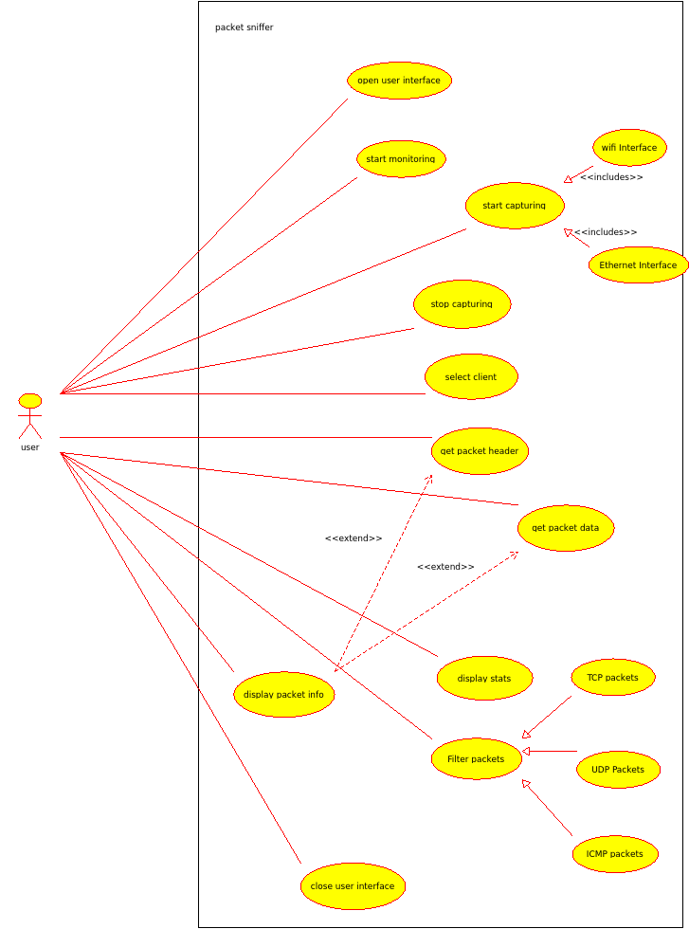

**6.2 Logical View**

**6.2.1 Sequence diagrams**

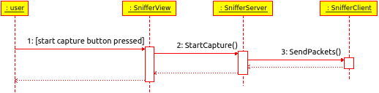

**6.2.2 Activity diagrams**

**6.2.3 State chart diagrams**

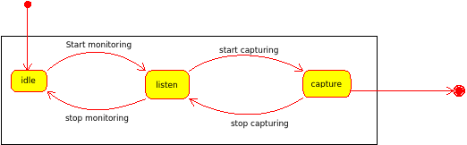

**6.2.4 Class diagrams**

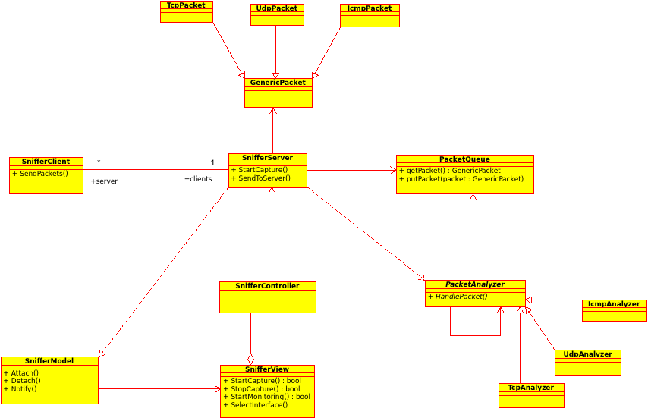

**6.3 Deployment View**

**6.3.1 Multi-client deployment**

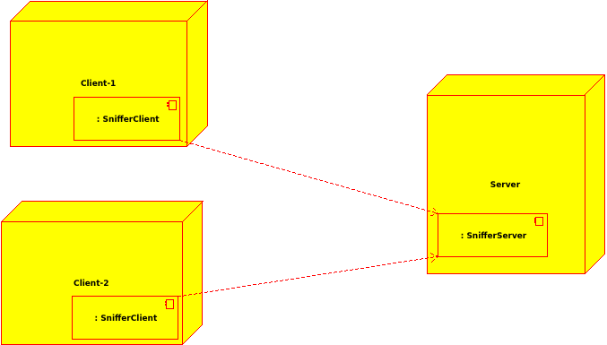

**6.3.2 Stand-Alone deployment**

