Software Requirements Specification

For

Packet Sniffer

**Version 1.0**

**Sunil Baliganahalli NarayanMurthy**

**Nehal Kamat**

**Apoorva Bapat**

**University of Colorado, Boulder**

**Mar 09, 2016**

**Table of Contents**

**Revision History**

**1. Introduction**

1.1 Purpose

1.2 Document Conventions

1.3 Intended Audience and Reading Suggestions

**2. System Requirements**

2.1 Business requirements

2.2 User requirements

2.3 Functional requirements

2.4 Non-Functional requirements

**3. Functional View**

3.1 Use case View

3.2 Use documents

3.2 Logical View

3.2.1 Activity diagrams

3.2.2 Class diagram

3.2.3 Sequence diagrams

**4. State Machine diagrams**

**5. Deployment View**

**4. UI Mock ups**

**Revision History**

|  |  |  |  |
| --- | --- | --- | --- |
| **Name** | **Date** | **Reason For Changes** | **Version** |
| Sunil Baliganahalli Narayana Murthy | 2/17/2016 | Initial draft | 0.0 |
| Sunil Baliganahalli Narayana Murthy | 2/21/2016 | Incorporated review comments from teammates | 0.1 |
| Sunil Baliganahalli Narayana Murthy | 3/4/2016 | Incorporated review comments from teammates | 0.2 |
| Apoorva Bapat | 3/5/2016 | Incorporated UI mockups | 0.3 |
| Nehal Kamat | 3/6/2016 | Incorporated updated use case | 0.5 |
| Apoorva Bapat | 3/7/2016 | Included Activity & Sequence diagrams | 0.6 |
| Nehal Kamat | 3/7/2016 | Included Activity & Sequence diagrams | 0.7 |
| Sunil Baliganahalli Narayana Murthy | 3/7/2016 | Included Activity & Sequence diagrams | 1.0 |

# Introduction

## Purpose

Packet sniffing is defined as a technique that is used to monitor every packet that crosses the network. A packet sniffer is a piece of hardware or software that monitors all network traffic. Using the information captured by the packet sniffers an administrator can identify erroneous packets and use the data to pinpoint bottlenecks and help to maintain efficient network data transmission. For most organizations packet sniffer is largely an internal threat.

Packet sniffers can be operated in both switched and non-switched environment. Determination of packet sniffing in a non-switched environment is technologies that can be understand by everyone. In this technology all hosts are connected to a hub. There are a large number of commercial and non-commercial tools are available that makes possible eavesdropping of network traffic. Now a problem comes that how this network traffic can be eavesdrop; this problem can be solved by setting network card into a special “promiscuous mode”. Now businesses are updating their network infrastructure, replacing aging hubs with new switches. The replacement of hub with new switches that makes switched environment is widely used because “it increases security”. However, the thinking behind is somewhat flawed. It cannot be said that packet sniffing is not possible in switched environment. It is also possible in switched environment.

## Intended Audience and Reading Suggestions

This document is intended for User, Developer and tester.

# System Features

|  |
| --- |
| **Business Requirements - [Not Applicable]** |

|  |  |  |  |  |
| --- | --- | --- | --- | --- |
| **User Requirements** | | | | |
| **ID** | **Requirements** | **Topic Area** | **User** | **Priority** |
| UR-001 | User should be able to launch application. | Interaction | Any | High |
| UR-002 | User should be able to close the application | Freedom | Any | Medium |
| UR-003 | User should be able to start capturing packets by selecting network interface |  | Any | High |
| UR-004 | User should be able to stop capturing packets. |  | Any | High |
| UR-005 | User should be able to mark packets for saving packet information. |  | Any | Medium |
| UR-006 | User should be able to save either all the captured packets or marked captured packets. |  | Any | High |
| UR-007 | User should be able to import/export the saved packets. |  | Any | High |
| UR-008 | User should be able to view types of protocols used in captured packets. |  | Any | High |
| UR-009 | Users should have the option of choosing the client machine to monitor packets from. | Freedom | Any | High |
| UR-010 | User should be able to filter packets according to detected protocols. |  | Any | Medium |
| UR-011 | User should be able to inspect the packet information for a selected packet |  | Any | Medium |
| UR-012 | User should be able to view only packet header |  | Any | Medium |
| UR-013 | User should have the option to view real time network statistics | Statistics | Any | High |
| UR-014 | User should be able to validate a selected packet for its integrity and authenticity | Validation | Any | High |

|  |  |  |  |  |
| --- | --- | --- | --- | --- |
| **Functional Requirements** | | | | |
| **ID** | **Requirements** | **Topic Area** | **User** | **Priority** |
| FR-001 | System should detect and display new clients in real time. |  | System | High |
| FR-002 | System should include timestamp for the captured packets. |  | System | Medium |
| FR-003 | System should remember user preference (export type, filter protocol) from last session. |  | System | Medium |
| FR-004 | System should be able to summarize the statistics about the packets captured |  | System | Medium |

|  |  |  |  |  |
| --- | --- | --- | --- | --- |
| **Non-Functional Requirements** | | | | |
| **ID** | **Requirements** | **Topic Area** | **User** | **Priority** |
| NF-001 | Application should work with sufficient network bandwidth. | Performance |  | High |
| NF-002 | The application should be reliable. | Reliability |  | High |
| NF-003 | Application should be robust and handle at-least 5 clients. | Scalability |  | High |
| NF-004 | Application should be responsive. | Usability |  | High |
| NF-005 | Application should respond to user action within 1sec. | Performance |  | Medium |

1. **Use Cases:**

**Actors:** All users

**Use Case Overview:**



**Use Case Documents:**

|  |  |
| --- | --- |
| **Use Case ID:** | UR-001 |
| **Use Case Name:** | Open User Interface |
| **Description:** | Select application icon on desktop/ in the start menu to open a graphical interface for running the application |

|  |  |  |  |
| --- | --- | --- | --- |
| **Actors:** | Any | | |
| **Pre-**  **conditions** | User should choose to use graphical interface to application | | |
| **Post**  **conditions** | User should understand the layout of the interface and should understand how the information is being displayed | | |
| **Frequency of Use:** | Moderate - High | | |
| **Flow of Events:** |  | Actor Action | System Response |
| 1 | Double-click application shortcut on desktop | Application GUI opens |

|  |  |
| --- | --- |
| **Use Case ID:** | UR-002 |
| **Use Case Name:** | Close User Interface |
| **Description:** | Display the network statistics on the command line instead of a graphical interface |

|  |  |  |  |
| --- | --- | --- | --- |
| **Actors:** | Advanced Users | | |
| **Pre**  **conditions** | User should have application running | | |
| **Post**  **conditions** | User Interface closes | | |
| **Frequency of Use:** | frequently | | |
| **Flow of Events:** |  | Actor Action | System Response |
| 1 | Close User Interface | Stop capturing packets.  Close UI |

|  |  |
| --- | --- |
| **Use Case ID:** | UR-003 |
| **Use Case Name:** | Enable Capturing |
| **Description:** | Allows the user to start capturing packets in the network |

|  |  |  |  |
| --- | --- | --- | --- |
| **Actors:** | All users | | |
| **Pre**  **conditions** | User should have | | |
| **Post**  **conditions** | Users should have opened either the graphical interface or command line interface | | |
| **Frequency of Use:** | Frequently | | |
| **Flow of Events:** |  | Actor Action | System Response |
| 1 | Open application | Application user interface is displayed |
| 2 | Click ‘Enable Capturing’ | Transmitted packet details are displayed on the UI |

|  |  |
| --- | --- |
| **Use Case ID:** | UR-004 |
| **Use Case Name:** | Disable Capturing |
| **Description:** | Allows user to stop capturing packets in network |

|  |  |  |  |
| --- | --- | --- | --- |
| **Actors:** | All users | | |
| **Pre**  **conditions** | Application should be running and packets are being monitored | | |
| **Post**  **conditions** | Capturing of packets is stopped and user can use this data to analyze network | | |
| **Frequency of Use:** | Very frequent | | |
| **Flow of Events:** |  | Actor Action | System Response |
| 1 | Start application | Application interface displayed to user |
| 2 | Click Enable monitoring | Packets start being monitored and their information displayed on the interface |
| 3 | Click Disable Capturing | Capturing of packets is stopped |

|  |  |
| --- | --- |
| **Use Case ID:** | UR-005 |
| **Use Case Name:** | Mark Packets |
| **Description:** | Enables the user to mark specific packets for saving information |

|  |  |  |  |
| --- | --- | --- | --- |
| **Actors:** | All users | | |
| **Pre**  **conditions** | Application should be running and packets being captured | | |
| **Post**  **conditions** | Packets are marked as per user’s requirements for saving | | |
| **Frequency of Use:** | Very frequent | | |
| **Flow of Events:** |  | Actor Action | System Response |
| 1 | Start application | Application interface displayed to user |
|  | 2 | Click Enable Capturing | Packets start being monitored and their information displayed on the interface |
|  | 3 | Select packet information to be saved by clicking check boxes against the packet names | Packet information is saved in a log file created in a pre-specified local directory |

|  |  |
| --- | --- |
| **Use Case ID:** | UR-006 |
| **Use Case Name:** | Save Packets |
| **Description:** | Enables the user to save packet information |

|  |  |  |  |
| --- | --- | --- | --- |
| **Actors:** | All users | | |
| **Pre**  **conditions** | Application should be running and packets being monitored | | |
| **Post**  **conditions** | Packets information is saved according to user preference: either all packets are saved or only marked packets are saved. | | |
| **Frequency of Use:** | Very frequent | | |
| **Primary Flow of Events:** |  | Actor Action | System Response |
| 1 | Click on file menu | Display file menu |
| 2 | Click on save packets | Display submenu giving user the choice of saving either all or only marked packets |
| 3 | Select ‘Save marked packets’ | Display checkboxes in front of packets for marking packets for saving. Open dialogue for user to select export type |
|  | 4 | Select text/xml/p-cap export format | Save packet information in user chosen format. |
| **Alternative Flow of Events:** | 1 | Click on file menu | Display file menu |
|  | 2 | Click on save packets | Display submenu giving user the choice of saving either all or only marked packets |
|  | 3 | Select ‘Save all packets’ | Open dialogue for user to select export type |
|  | 4 | Select text/xml/p-cap export format | Save packet information in user chosen format. |

|  |  |
| --- | --- |
| **Use Case ID:** | UR-007 |
| **Use Case Name:** | Display packet protocols |
| **Description:** | Gives user the list different protocols used in captured packets. |

|  |  |  |  |
| --- | --- | --- | --- |
| **Actors:** | All users | | |
| **Pre**  **conditions** | Users should start the application and click on display packet protocols. | | |
| **Post**  **conditions** | Users should be displayed a list of all protocols used in the captured packets | | |
| **Frequency of Use:** | High | | |
| **Flow of Events:** |  | Actor Action | System Response |
| 1 | Click on View menu | Display View Menu |
|  | 2 | Click Display packet protocols | A list of all protocols used in the captured packets |

|  |  |
| --- | --- |
| **Use Case ID:** | UR-008 |
| **Use Case Name:** | Select Client |
| **Description:** | User is able to select a client to capture packets |

|  |  |  |  |
| --- | --- | --- | --- |
| **Actors:** | All users | | |
| **Pre**  **conditions** | Users should start the application. | | |
| **Post**  **conditions** | User should be able to see packets captured only from selected clients | | |
| **Frequency of Use:** | High | | |
| **Flow of Events:** |  | Actor Action | System Response |
| 1 | Start the application | User interface displayed |
|  | 2 | Select client from a drop down list | Packets only from selected client are displayed |

|  |  |
| --- | --- |
| **Use Case ID:** | UR-009 |
| **Use Case Name:** | Filter packets |
| **Description:** | User should be able to display packets having a specific protocol |

|  |  |  |  |
| --- | --- | --- | --- |
| **Actors:** | All users | | |
| **Pre**  **conditions** | Users should start the application and select the type of packets of their preference | | |
| **Post**  **conditions** | |  | | --- | | Users should be displayed only those type of packets that have been filtered out by the user | | | |
| **Frequency of Use:** | High | | |
| **Flow of Events:** |  | Actor Action | System Response |
| 1 | Start application | Open User Interface |
| 2 | |  | | --- | | Click Filter Packets | | |  | | --- | | Display List of Protocols | |
| 3 | Double Click Protocol | Set condition to display packets with selected protocol only |
|  | - | Start Capturing Packets |

|  |  |
| --- | --- |
| **Use Case ID:** | UR-010 |
| **Use Case Name:** | Inspect Packets |
| **Description:** | Enable users to view packet info of selected packet |

|  |  |  |  |
| --- | --- | --- | --- |
| **Actors:** | All users | | |
| **Pre**  **conditions** | Users should start the applications and start capturing packets | | |
| **Post**  **conditions** | User should be displayed packet information | | |
| **Frequency of Use:** | Low | | |
| **Flow of Events:** |  | Actor Action | System Response |
| 1 | Start application | Open User Interface |
| 2 | Enable Capture Packets | Display captured packets |
| 3 | Select Packet | - |
| 4 | Click Inspect Packet | Display all packet information |

|  |  |
| --- | --- |
| **Use Case ID:** | UR-011 |
| **Use Case Name:** | Display Packet Header |
| **Description:** | Enables users to view only header of selected packet |

|  |  |  |  |
| --- | --- | --- | --- |
| **Actors:** | All users | | |
| **Pre**  **conditions** | Users should start the application, start monitoring packets and select the packet whose header is to be expanded | | |
| **Post**  **conditions** | Users should be displayed the entire packet header | | |
| **Frequency of Use:** | Low | | |
| **Flow of Events:** |  | Actor Action | System Response |
| 1 | Start application | Open User Interface |
| 2 | Enable Capture Packets | Display captured packets |
| 3 | Select Packet | - |
|  | 4 | Click Inspect Packet | Display all packet information |
|  | 4 | Right click packet | - |
|  | 5 | Select Display Packet Header | Display only packet header |

|  |  |
| --- | --- |
| **Use Case ID:** | UR-012 |
| **Use Case Name:** | Display Network Statistics |
| **Description:** | Enables user to view real time statistics of the information being transmitted along the network |

|  |  |  |  |
| --- | --- | --- | --- |
| **Actors:** | All users | | |
| **Pre**  **conditions** | Users should start the applications and start capturing packets | | |
| **Post**  **conditions** | Users should be displayed real-time statistics of packets in the form of pie charts or bar graphs | | |
| **Frequency of Use:** | High | | |
| **Flow of Events:** |  | Actor Action | System Response |
| 1 | Start application | Open User Interface |
| 2 | Enable Capture Packets | Display Captured Packets |
|  | 3 | Click Display Network Statistics | Display chooser with 2 options – Bar Graph and Pie Chart |
|  | 4 | Select Bar Graph/Pie Chart | Display Appropriate Plot |

|  |  |
| --- | --- |
| **Use Case ID:** | UR-013 |
| **Use Case Name:** | Validate Packet |
| **Description:** | Enables user to check authenticity of the packet and whether or not it is broken |

|  |  |  |  |
| --- | --- | --- | --- |
| **Actors:** | All users | | |
| **Pre**  **conditions** | Users should start the applications and start capturing packets | | |
| **Post**  **conditions** | User should be displayed with information regarding the checksum of the packet and whether or not it is broken/incomplete | | |
| **Frequency of Use:** | Moderate | | |
| **Flow of Events:** |  | Actor Action | System Response |
| 1 | Start application | Open User Interface |
| 2 | Enable Capture Packets | Display Captured Packets |
|  | 3 | Select Packet | - |
|  | 4 | Click Validate Packet | Display checksum and packet integrity information |

1. **Activity Diagrams:**

**+ Requirement ID : {UR-003} | Use Case ID : {UR-003} | Use Case Name : {Start Capture} | Group Member Name : Sunil Baliganahalli Naryana Murthy**



**+ Requirement ID : {UR-006} | Use Case ID : {UR-006} | Use Case Name : {Save Packets} | Group Member Name : Apoorva Bapat**

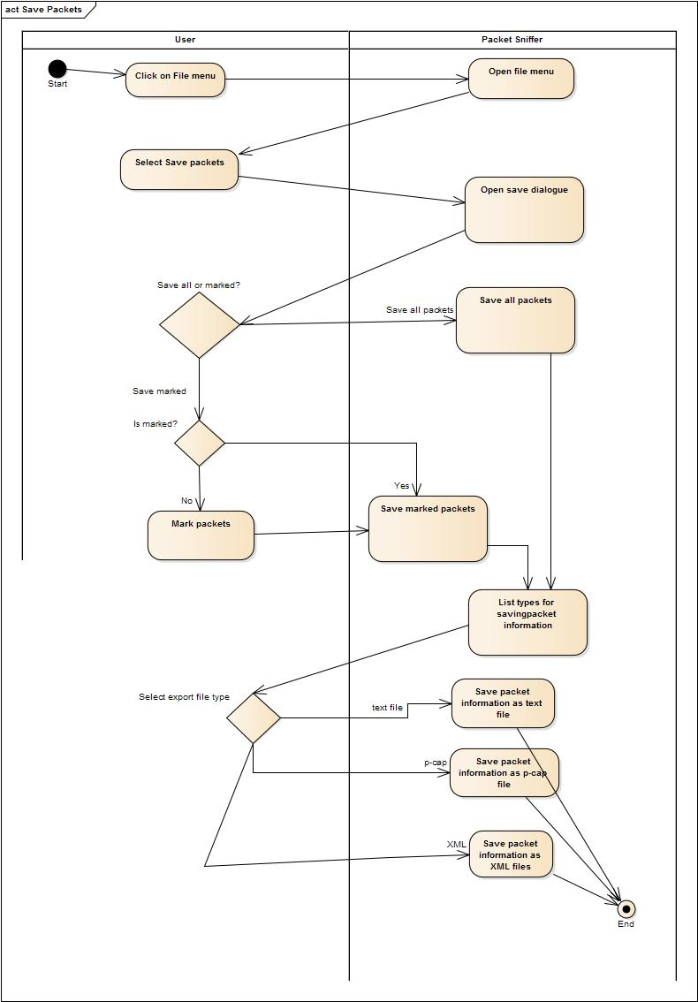

**Use Case Name:** {Save Packets}

**Description:** This diagram represents the activity of saving packets according to user preference of saving only the marked packets. The user clicks on file menu and then UI prompts the user to fill in its requirements. Once, the system gets its marked packets, it then prompts user to select file type or exporting and saves in the selected format.**+ Requirement ID : {UR-009, UR-010} | Use Case ID : { UR-009, UR-010} | Use Case Name : {Filter Packets, Inspect Packet} | Group Member Name : Nehal Kamat**

**[Note : 2 use cases combined]**



**Use Case Name**: {Filter Packet, Inspect Packet}

**Description**: This diagram represents the activity of the user filtering packets by protocol and then inspecting one packet from the filtered packets. The user first clicks filter packets which then gives the user the option of choosing one of the packet protocols. After choosing the protocol and the sniffer applying the filter to the captured packets, the user can select a packet and inspect its data.

**5 Data Storage:** PCAP format, Text format, Xml format

Classes:

* The application supports multiple formats like Pcap, Text, xml etc.
* All of these format implement a ImportExportData interface.
* The PcapImportExport supports impoting from Pcap and exporting in a Pcap format. Likewise for TextImportExportData, XmlImportExportData (shown in class diagram).

**6 UI Mockups:**

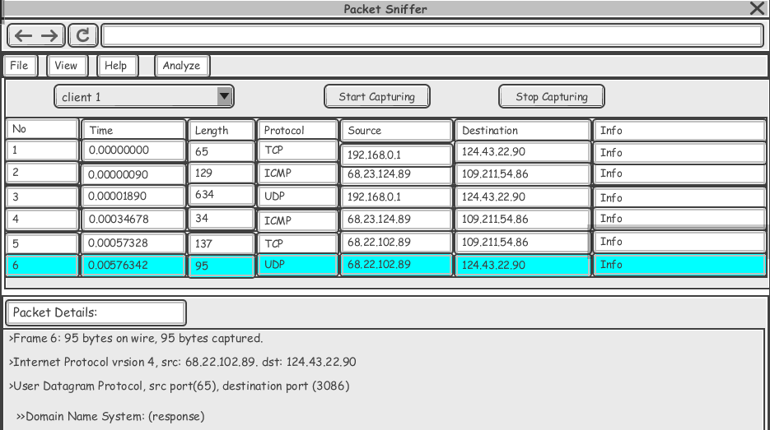

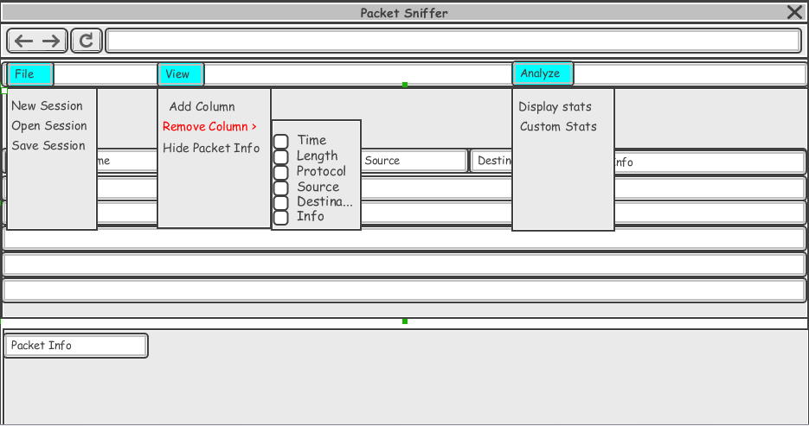

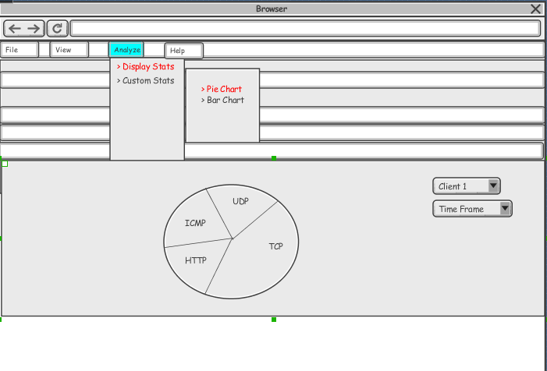

**7 User Interactions:**

**+ Requirement ID : {UR-001} | Use Case ID : {UR-001} | Use Case Name : {Start User Interface} | Group Member Name : Sunil Baliganahalli Naryana Murthy**



**Use case Name:** Start user Interface

**Description:** The above sequence diagram shows the application boot-up sequence and different classes that are created thereafter.

**+ Requirement ID : {UR-002} | Use Case ID : {UR-002} | Use Case Name : {Close User Interface} | Group Member Name : Sunil Baliganahalli Naryana Murthy**



**Use case Name:** Close user Interface

**Description:** The above sequence diagram shows the application shutdown sequence and different classes that are destroyed thereafter.

**+ Requirement ID : {UR-003} | Use Case ID : {UR-003} | Use Case Name : {Enable Capturing} | Group Member Name : Sunil Baliganahalli Naryana Murthy**



**Use case Name:** Enable capturing

**Description:** The start capture sequence starts with the user clicking on the enable capture. The packet sniffer server messages the sniffer server to start the listening to the incoming clients. Server then accepts any incoming client and adds the received packets to packet queue, which is then picked up by the packet analyzer to convert the byte stream of packets into object (Generic Packet).



**+ Requirement ID : {UR-004} | Use Case ID : {UR-004} | Use Case Name : {Disable Capturing} | Group Member Name : Sunil Baliganahalli Naryana Murthy**



**Use Case Name**: Disable Capturing

**Description:** The stop sequence of the packet sniffer is shown below. The user clicks on disable capture which signals the sniffer model to stop streaming to the packets.

**Requirement ID: {UR-006}, Use Case ID: {UC-006}, Use Case Name: {Save Packets}, Group Member Name: Apoorva Bapat**



**Use Case Name:** Save Packets

**Description:** User clicks on File menu, which then leads to sub menus and selects save packets. User selects save marked packets for which he/she ahs to mark packets which are to be saved. After marking these packets, user selects the file format for exporting files.

**+ Requirement ID : {UR-009} | Use Case ID : { UR-009} | Use Case Name : {Filter Packets} | Group Member Name : Nehal Kamat**



**Use case Name:** {Filter Packet}

**Description:** User clicks filter packet, which the system then processes to display the list of protocols. The user chooses the protocol and the system then filters the packet according to the chosen protocol. During the time when the filter is applied, the user can select and inspect a packet from the captured packets, which is described in the next sequence diagram.

**+ Requirement ID : {UR-010} | Use Case ID : { UR-010} | Use Case Name : {Inspect Packet} | Group Member Name : Nehal Kamat**



**Use case Name**:

{Inspect Packet}

**Description:** This sequence of actions happens when a filter has been applied by the user. The user selects the packet and clicks inspect packet which the system then processes to display all the details of the packet.

**7. Class Diagram:**



The packet sniffer is client-server architecture. We are using Model-View-Controller (MVC) for the User interface and interfacing with the backend. The packet analyzer uses a Chain of responsibility pattern for analyzing the packet, which gives you the flexibility of extending the analyzer for other types of packets later. For import and export we use a strategy pattern which supports multiple import/exports formats like PCAP, XML etc.

**Architectural Pattern:**

* Client-Server

**Design Patterns used:**

* Model-View-Model
* Observer pattern
* Strategy Pattern
* Chain of responsibility

**8. State Machine Diagram:**



**9. Deployment View:**

1. Multi-client deployment:
2. Standalone deployment:

