**ASSIGNMENT -1 – Data Science Program**

**Submitted by – SUNIDHI RAWAT**

**Ques 1. What is the basic difference and similarity between a vector and a matrix?**

**Ans1. Differences –**

1. Vector has single index , whereas matrix will has two indices .
2. Vectors are one dimensional , whereas matrices are two dimensional.

**Similarities –** Both vector and matrix are homogenous it contains same data types.

**Ques 2. What is the basic difference and similarities in data frame and matrix ?**

**Ans2. Differences –**

1. Matrix has fixed numbers of rows and columns , data frame has variable number of rows and columns.
2. The data stored in matrix can be only of same data type , whereas data stored in data frame can be numeric , logical , character type.
3. Matrix is homogeneous , whereas data frames is heterogeneous .

**Similarities -** Both are two dimensional data structure of R programming.

**Ques 3. Create a vector using (15, TRUE, “World”).**

**Ans3.** It will give the following result- x =

chr[1:3] “15”, “TRUE”, “World”

because of the explicit coercion the vector will convert the data type into character data type .

**Ques4 . John’s scores in the final semester for the three subjects are 95, 91 and 88. The subjects are Statistics , Linear Algebra and Calculus. Using these create a vector based on their subjects .**

**Ans4 .** Scores <- c(95,91,88)

names(Scores) <- c("Statistics","Linear Algebra","Calculus")

Scores

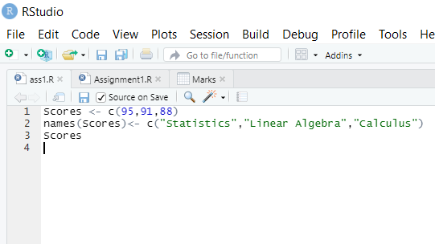

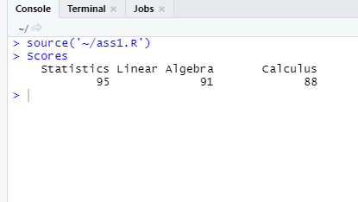

**Ques5. Please check the types (character or numeric) of the vector**

**you created.**

**Ans 5.** class(Scores) It is of numeric type .

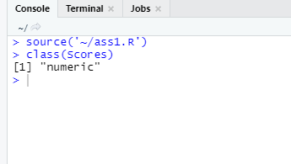

**Ques 6. You have three students in your class (choose any name you want).**

**You must create a matrix using their score in the above mentioned subjects**

**question 4 , Student 1 (95, 91, and 88), Student 2(96, 94, and 97),**

**Student 3(88, 98, and 85).**

**Create a matrix and label column and row names.**

**Ans 6 .**

Marks <- matrix(c(95, 91, 88 ,96, 94, 97 ,88, 98, 85 ) , nrow = 3 ,

ncol = 3 , byrow = TRUE)

rownames(Marks) <- c("Student 1" , "Student 2" , "Student 3")

colnames(Marks) <- c("Statistics", "Linear Algebra", "Calculus")

View(Marks)

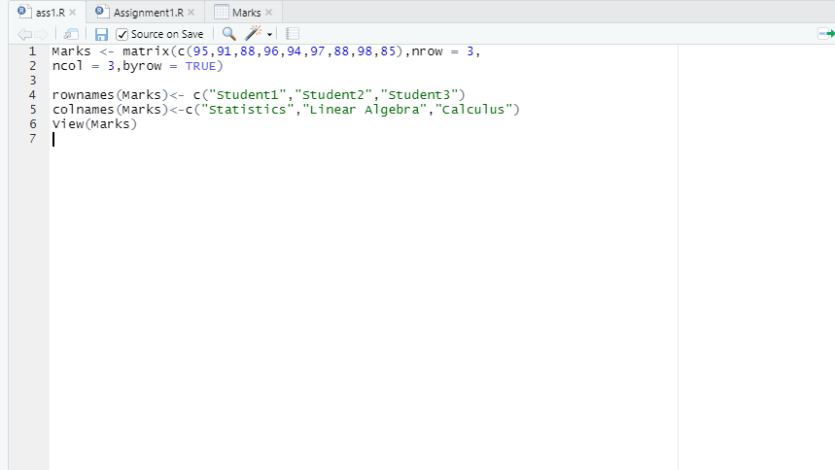

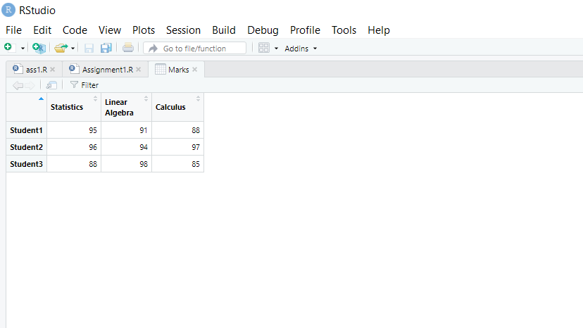

**Ques6 .**Convert the created matrix into a data frame**.**

**Ans 6.**

dataframe <- data.frame(Marks)

print(dataframe)

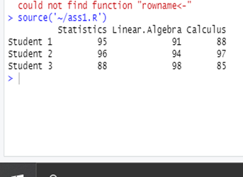

**Ques 7. Create three vectors using five countries (your choice) from the following**

**website. The first vector should be country names, the second vector should**

**be the total number of cases, and the third vector should contain the total**

**number of deaths. Create a data frame using these vectors.**

**Ans 7.** country<- c("USA","Brazil","India","Spain","Turkey")

tot_cases <- c(30521774 , 11998233 , 11646081 , 3228803 , 3035338)

tot_deaths <- c(555314, 294115 , 160003 , 73543 , 30178 )

D <- data.frame(country , tot_cases , tot_deaths)

print(D)

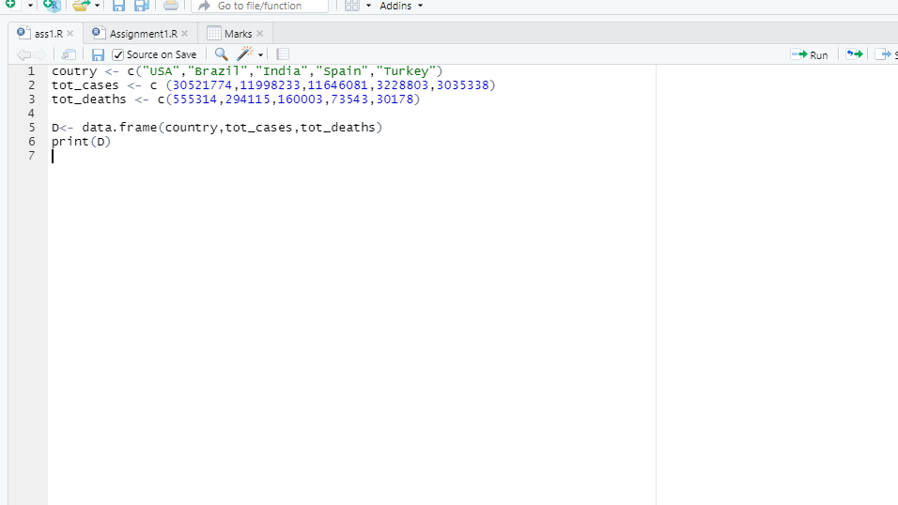

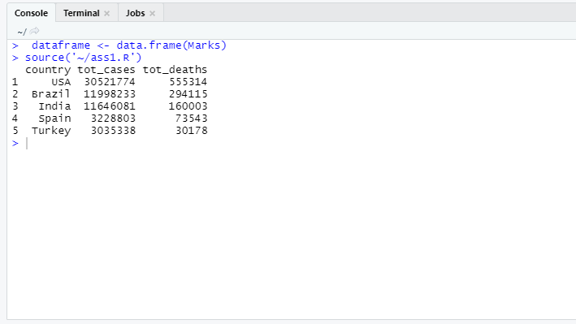

**Ques 8.** Please read the mtcars data set from R. It is an built-in data set.

Please check the structure of the data set. If required, please convert the data into their appropriate data types (character, logical, factor etc ). Save your results as a new data frame using a new name.

**Ans 8 .**

data(mtcars)

str(mtcars)

newmtcars <- within(mtcars,{

vs <- as.logical(vs)

am <- as.factor(am)

cyl <- as.logical(cyl)

gear <- ordered(gear)

carb <- as.factor(carb)

})

str(newmtcars)

newmtcars

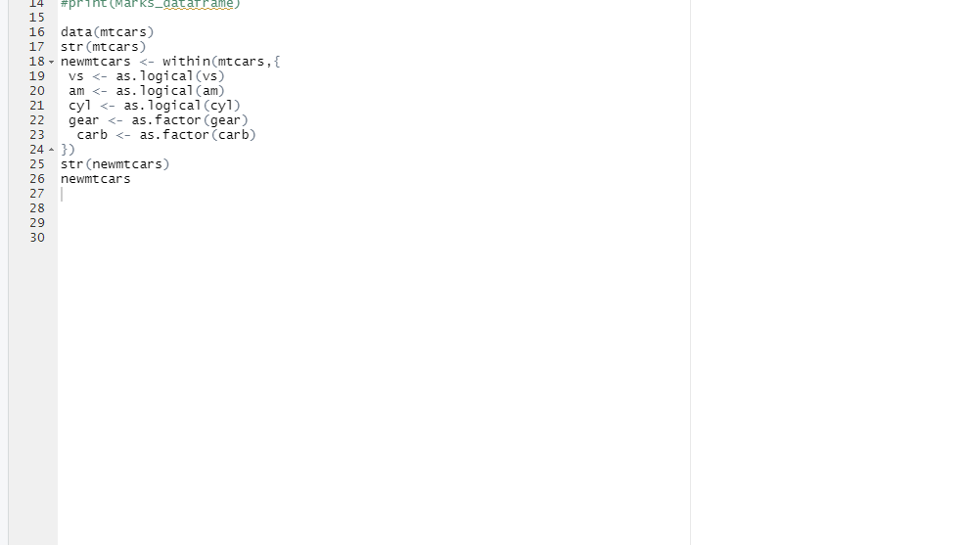

OUTPUT –

