ChatterBox – Full stack Web Application

Objectives :

* To build a personalized chat application managed by some people
* Personalized chat application for personal panel for chatting and adding a voice button to make it more user friendly.
* Built on My sql and PHP which gives seamless user experience.
* Password data is encrypted
* Status of active and non active is shown.

1. First to fall before creating this make sure you download the xampp server from the official link and you download it according to your operating system,

Link : <https://sourceforge.net/projects/xampp/>

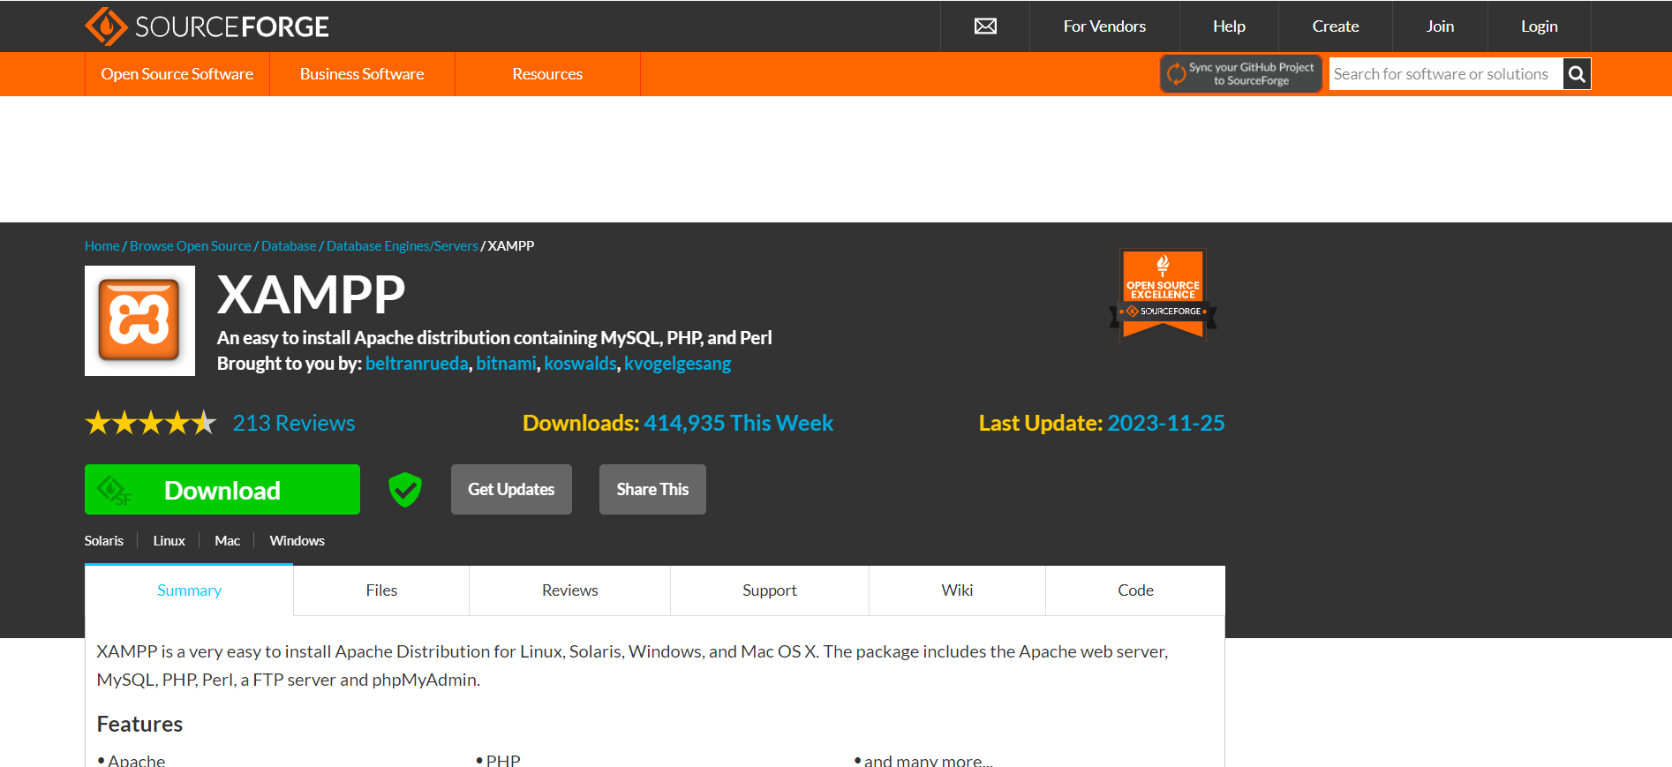

1. Next what we do is we will install it make sure you install the system in your C:Program Files so that it doesn’t cause error , if it says that you are already having a UAC(user account) the place it somewhere else you will have to modify some changes in your system.
2. After successfully installing your will see this

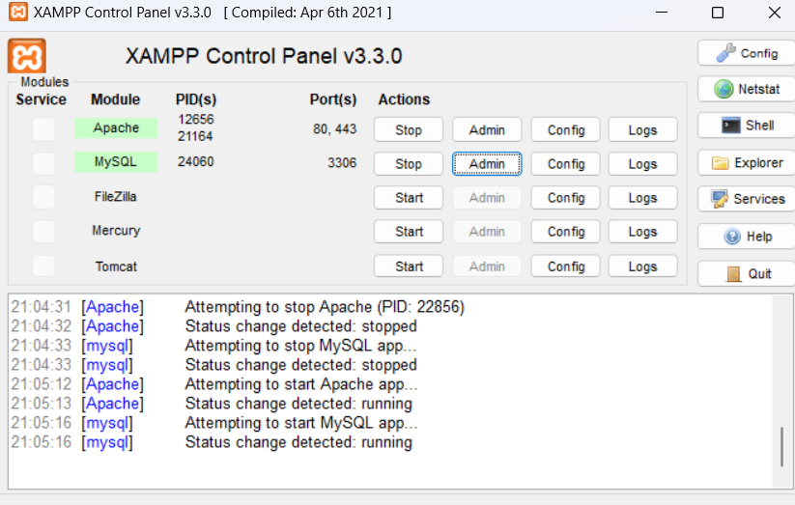

Start the Apache and MySQL and click on the admin part , if there is no error the it will take you to the myadmin page .

1. If you don’t want to click on the admin page then just what you can do is open your web browser and type “**localhost/phpMyAdmin**” and it will open up your database.
2. Next what you have to do is traverse to your Xampp folder where you have unpack your files or where you have installed your system , open that folder.
3. Open up , next after few folders you will see the whole lot of folders open the htdoc folder

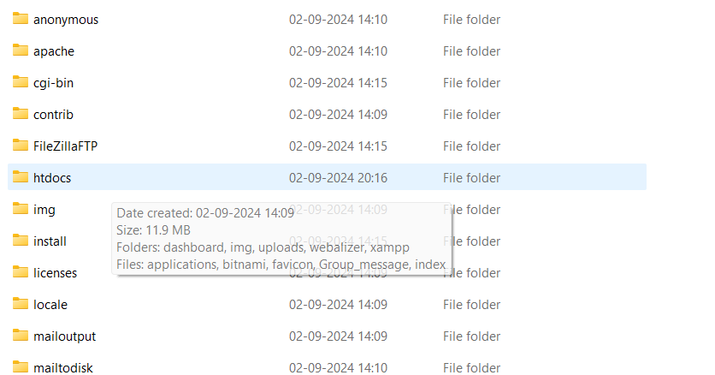

1. All the files that need a database must be created inside this htdocs folder , only and saved there , we will be having files like .php files inside the .php folder and moreover we will be having .js files for this we will be having javascript folder. This is what my file structure looks like moreover if we see that we have two folders more like one is the images and uploads folder, images will contain the profile image.
2. In the Chatapp.sql file in the folder you can find how I created the database.

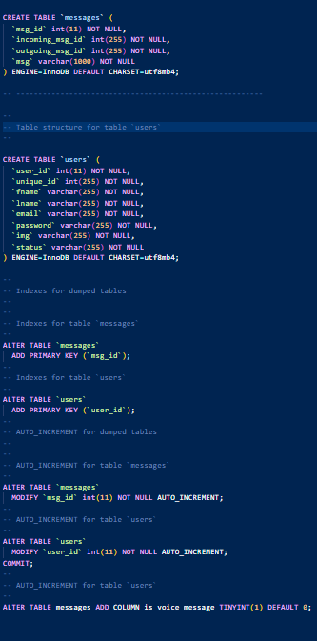

1. The Login page looks like and the sign up page looks like ,

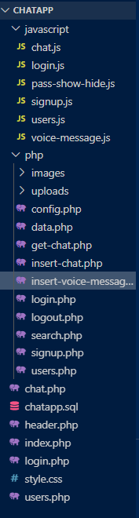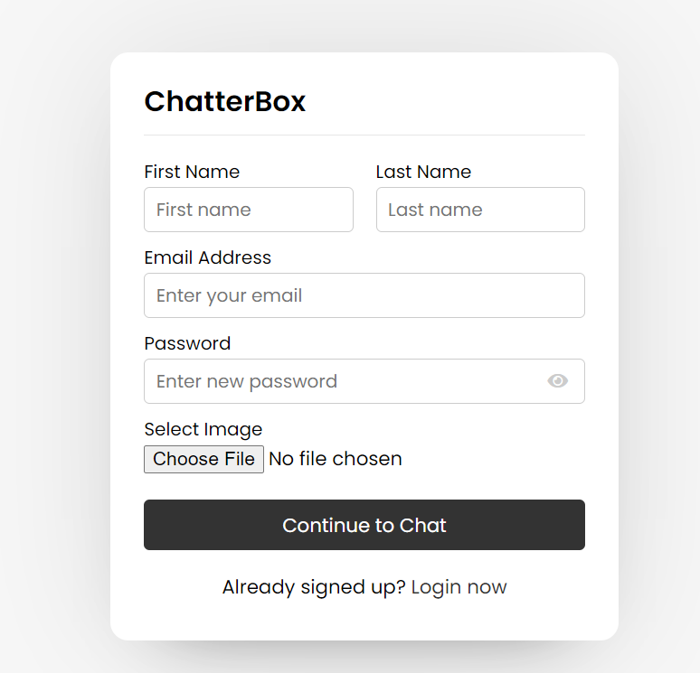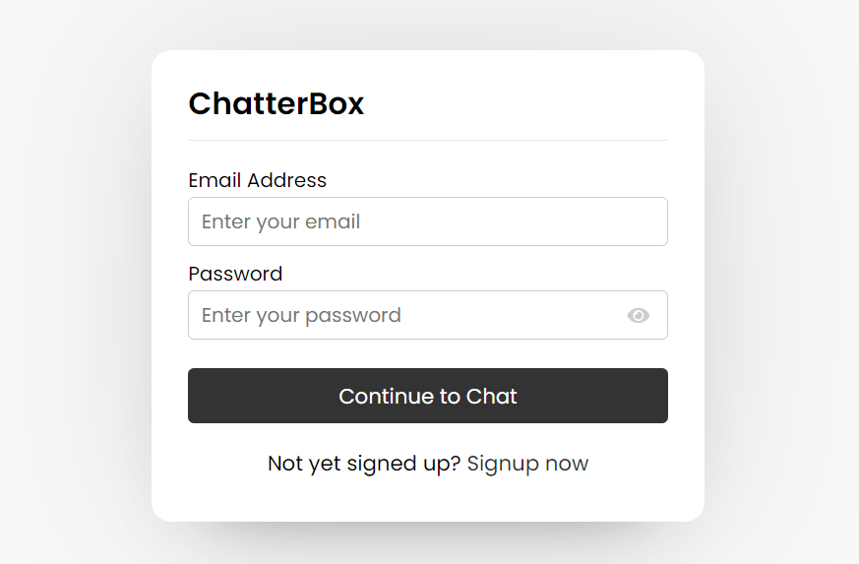

Now if we want to login just fill the form , as all the fields are mandatory to be field.

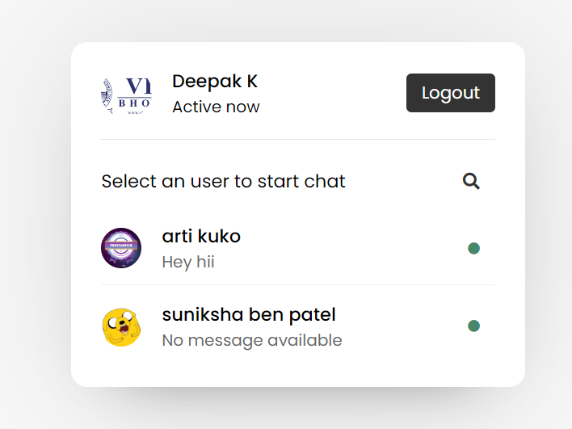

This is the user main page where the person can find the number of user logged in .

This is shown for the another person when no messages is sent yet from both the side ; also when the message is sent from both the side.

