Chrome – Gpt – Extension

Objective : Some of the objectives of building this extension are as follows:

1. **Enhance Search Experience:**

* Provide users with additional context, insights, and suggestions directly on Google Search results using AI-generated content.

1. **Content Generation:**

* Assist users in generating relevant content

1. It boost productivity
2. Instead of changing tabs 4-6 times you can simply take this extension pin it up and whatever page you serach for , what ever question you serach for it will give you a small summary on that.

Difficulties faced :

1. Too many requests which generated the result bit slower even though it was about to generate it after 5 seconds automatically by default , but it generated as per the traffic of the api request being made.
2. Also make sure the secret key which your are using is only copied once and if copied once then you forget it then you again have to revoke it and generate a new secret pin, which can generally lead to errors and handling out the requests.
3. Since the tokens provided for each api key is fixed so we should have to follow that much that it why we used only 7 minimum and you wont be charged for free api keys but you will be charged after the api key token has expired.
4. You can view your activity on Api dashboard since we saw that we made few msitakes and due to random calling it showed us error , in order to normalize the api again you have to re again try after 1-2 hours laters.

How to Build this Chrome Extension GPT:

1. Create a folder named chrome extension GPT
2. Then open the folder to any editor your have I have VS code so I used it
3. Now make two files manifest.json and content_script.js



Don’t worry if the manifest.json shows some errors it maybe due to some extensions being not working in VS code

1. Now go to your chrome go -> three button after the profile click -> extensions -> Manage Extensions and you will see your extensions page ,



Make sure the developer mode on the right is open and yes you are good to go.

1. Now click on the load unpacked option and traverse to your folder select your folder , but if it says error then , your have to use manifest.json code .
2. Write manifest.json code

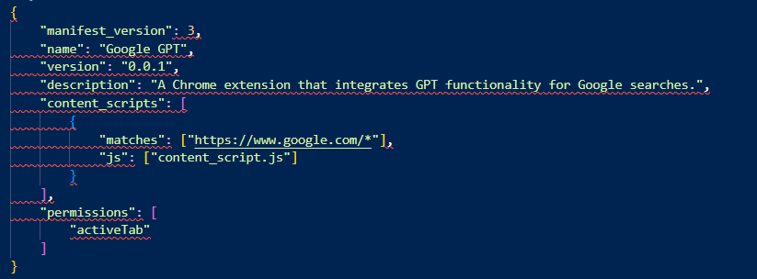

Now try to load you will be seeing your content is loaded successfully.

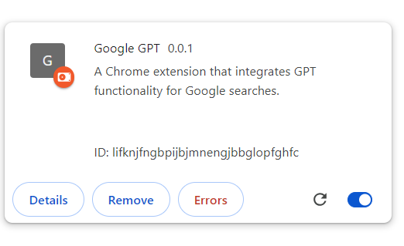

Kudos !!! for this achievements

1. Now open a new tab and serach for platform.openai.com/account
2. If the account is not created create it
3. If created use traverse to https://platform.openai.com/api-keys
4. You will find that your api key page is being loaded
5. Once you get it open it will look like

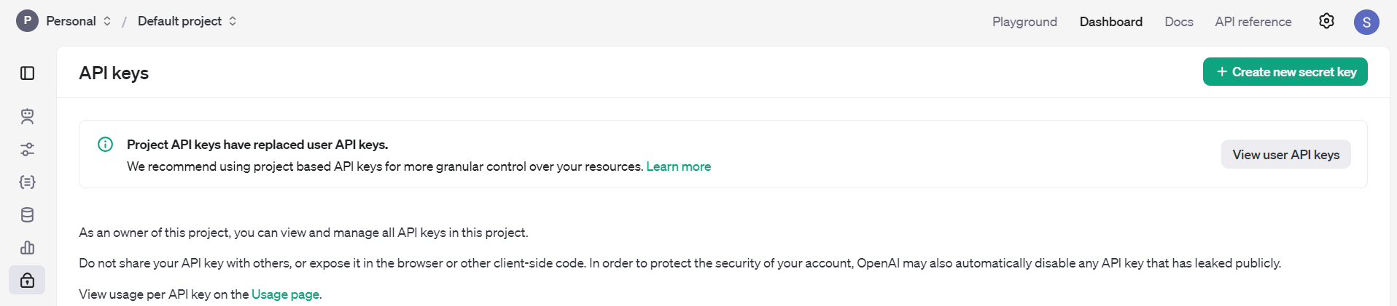

Now what you have to do is , click on new secret key generate it and save it somewhere as // comment cause you will be needing it , and if you don’t copy paste and save it somewhere you again have to revoke it and generate a new one which might cause errors.

1. In the content_script.js make sure you edit it the section

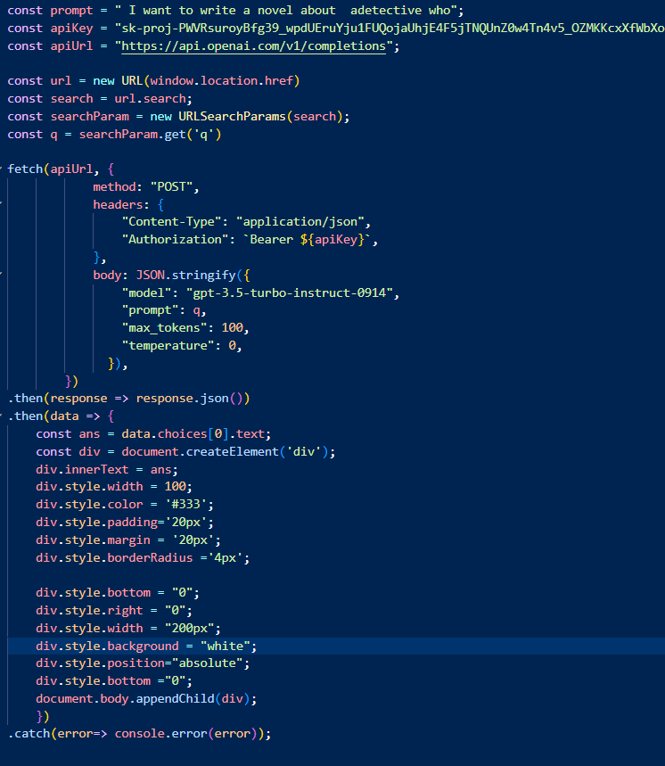

Add this code and at the apiKey add your api key which you copy pasted.

1. Now Right click and click on Inspect what you will see if if any issue then you will be seeing it if not it will work perfectly fine

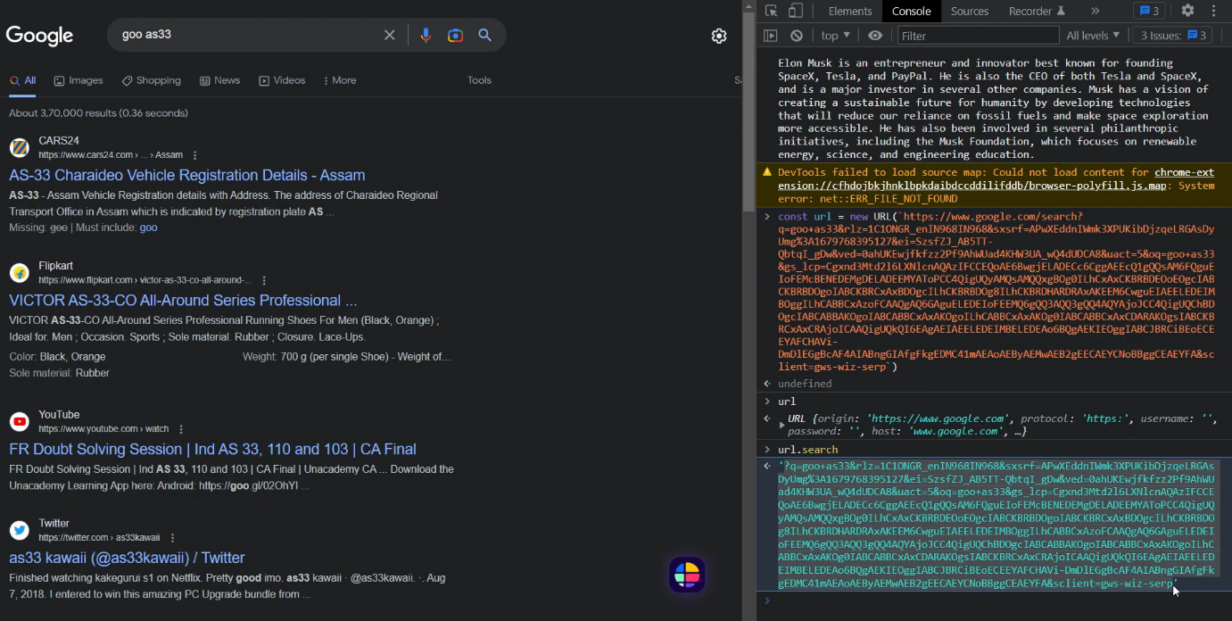

Okay I was just trying to test out some urls working perfectly fine or not.

1. Here is the result what I found 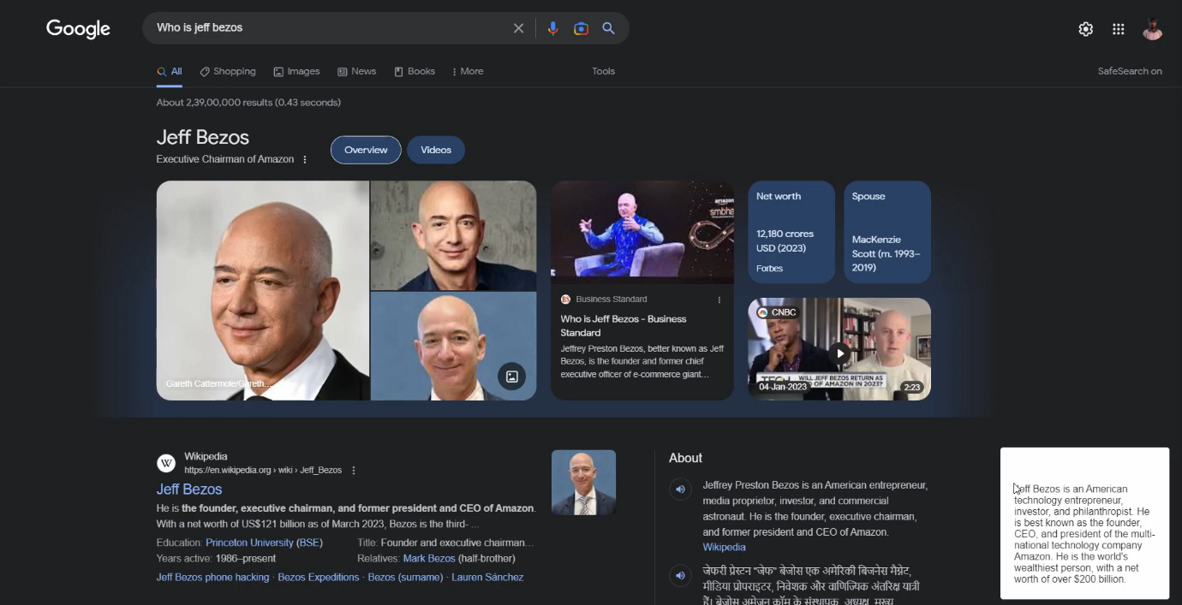
2. You can see at the bottom that it is completely working fine and we don’t need to add anything much on it.

--END--