# ML Model Deployment in the Local web Server Using Zomato Dataset.

GUIDED by : SMARTINTERNZ

DATA SCIENCE PROJECTS

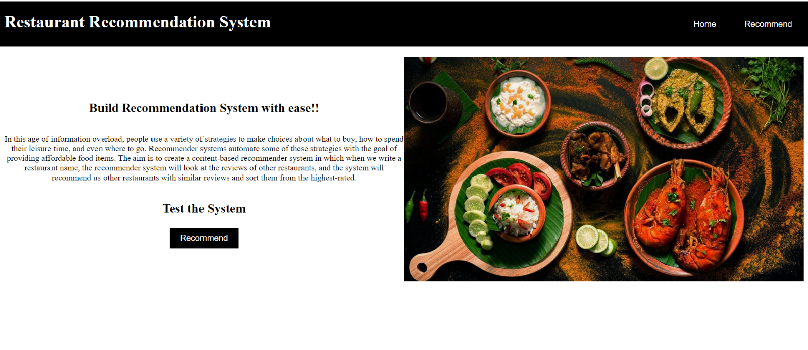

**Main Objective:**

The main agenda of this project is:

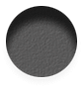 perform extensive Exploratory Data Analysis(EDA) on the Zomato Dataset provided by smartinternz the link is : <https://www.kaggle.com/datasets/himanshupoddar/zomato-bangalore-restaurants/code>

* Build an appropriate Machine Learning Model , a flask application and deploy it in web server , so as we give a restaurant name it should provide me top 10 recommended restuarnts with high mean rating out of 5 , and their cost accordingly in thousands.

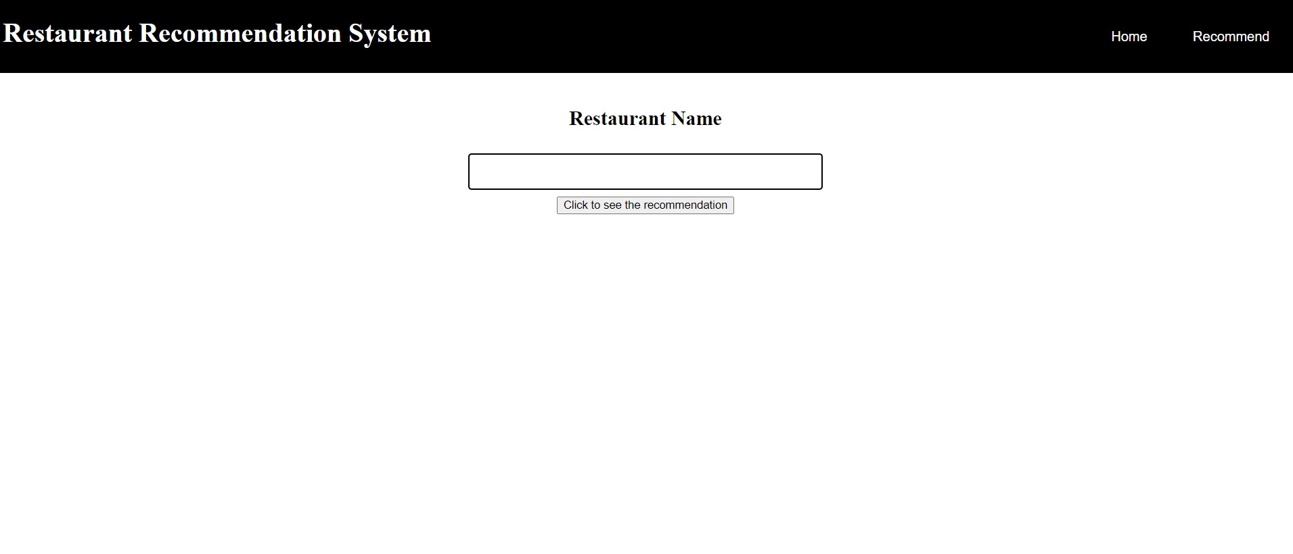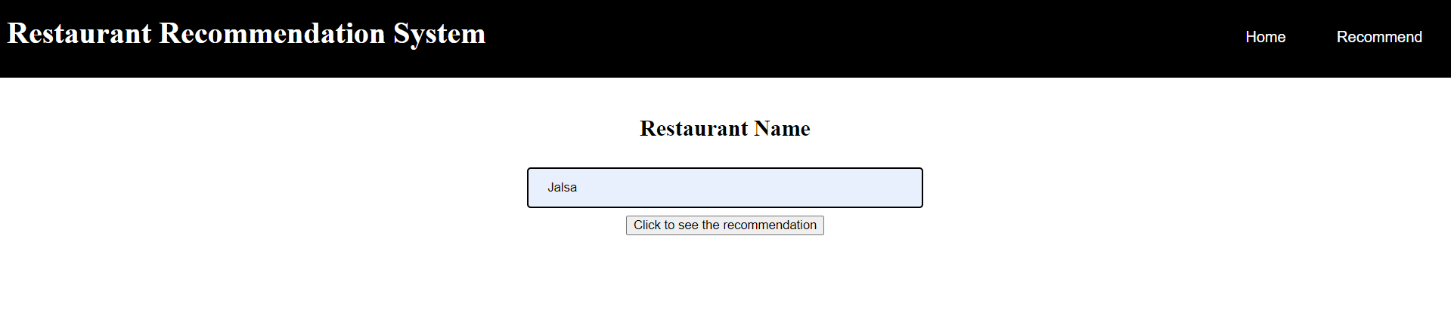

* DEPLOY the Machine learning model via Flask that can be used to make live predictions of restaurants ratings .

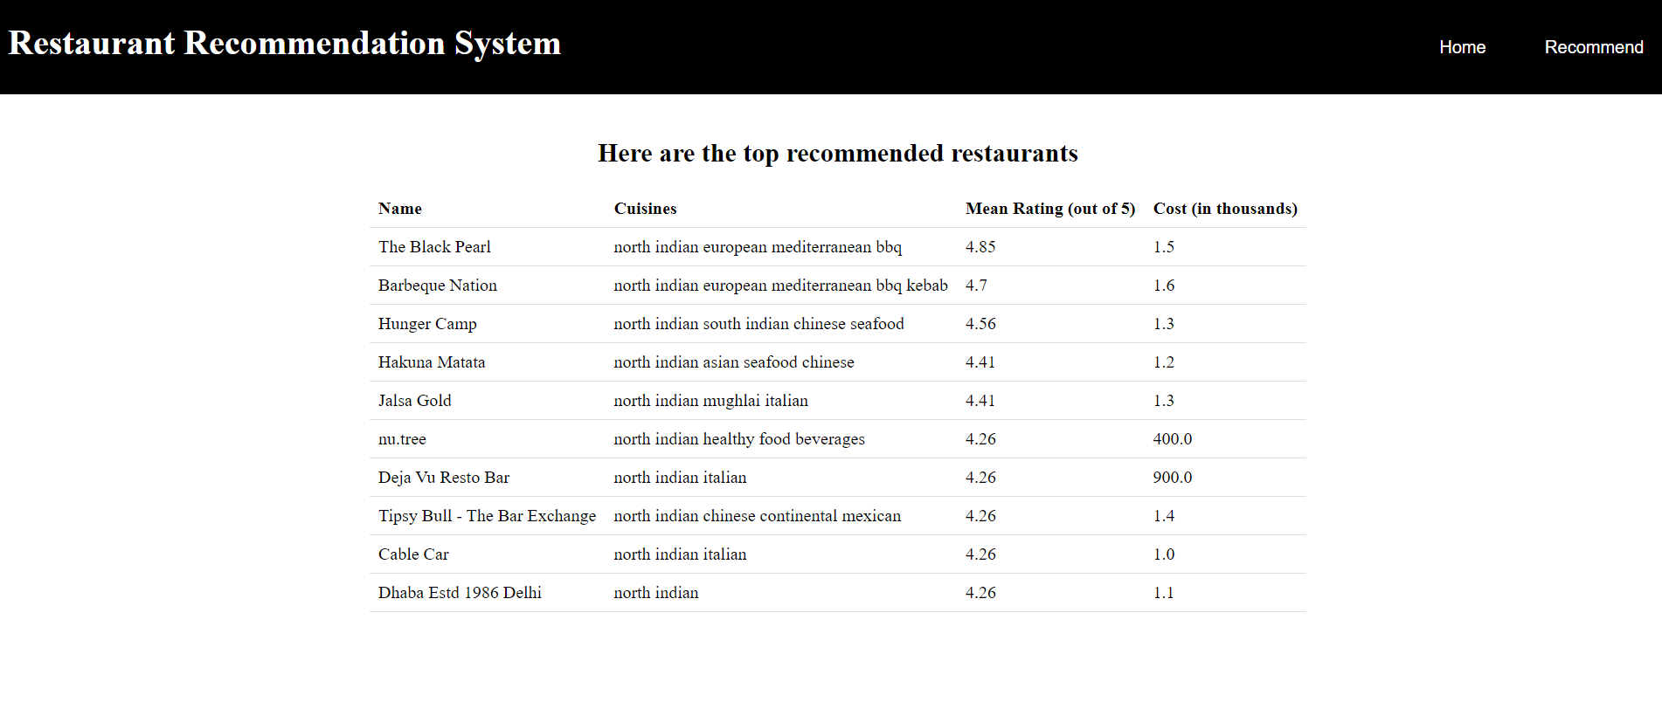

**STEPS:**

**A. EDA and Model Building Part**

1. Load the dataset and perform the necessary EDA in your Jupyter notebook or google colab , I choose the google collab to perform the operations.
2. Build your Machine learning algorithm I used a recommend (“restaurant_name”) in the google collab and then made app1.py file , the file consists of routing method , calling it with all the HTML files that is stored in the templates folder for further assistance and being called in the app1.py file which is my **Flask application.**

**B. Deployment Part**

1. In this project we will be using “VSCODE” and “Command Line Prompt” however, feel free to use any IDE that you are conformable with (e.g you can use Google collab editor to achieve the same)

NOTE: There several ways of using Flask to deploy your application including creating a virtual environment, which we will see in subsequent projects. In this project we will do it right from our base environment

1. Install your Vs code and make sure you have a pre installed python in your device , if not then first install python and then install vs code.

Download VSCode IDE : https://code.visualstudio.com/

1. Setting up your VSCOde
   * Create a new folder in your system and give it your preferred name (e.g. Resturant_Recommendation_System )
   * Open your VSCODE IDE and click on file—>open—>{select the folder you created}

OR

Simply right click selecting the folder if you installed VSCODE in the correct way then you might see the vscode option when you right click and so traverse it .

#photo

1. Set up Your base environment like first open your cmd by searching it and then navigate to the folder until you reach the flask folder using **cd flask.**
   * Input the necessary libraries like pip install seaborn , pip install pandas as the error you get you will need to install the necessary libraries in your command prompt. Check the directory using **dir** in command prompt , if it contains requirements.txt file or not , if it does’nt then check if .env file is present or not, if not then perform the following operations.
     + - * Pip install -r requirements.txt
         * .env\scripts\activate
         * set FLASK_APP = app1.py #since we have our flask app in app1.py so we renamed it as app1.py make changes accordingly.
         * Flask run #for running the applying then we will get the server code 127.0.0.1:5000 copy this and add this to your web browser and then you will find that your flask app is running well .
   * You can work with your base environment if you have the required libraries installed

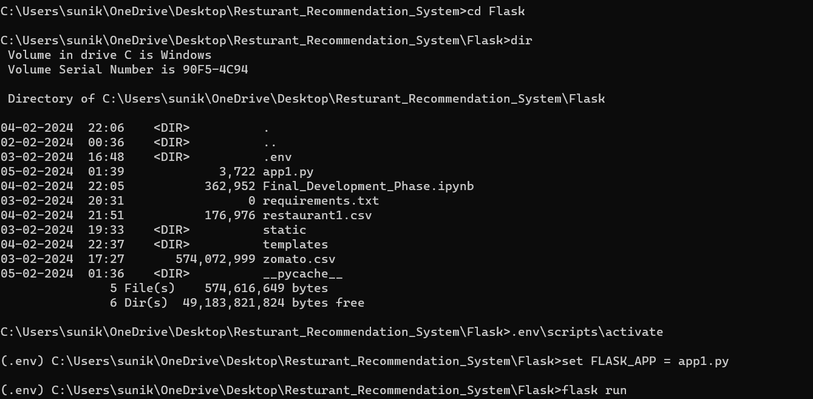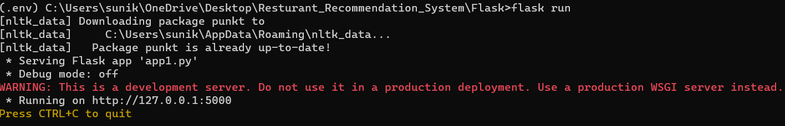

1. Specifically, install Flask:

Use: pip install flask

1. Files you will need:
   * App1.py file
   * .csv file , one which the original Zomato.dataset and another which is the resturant1.csv which contains only the limited columns to be displayed.
   * Templates folder which will contains , index.html, recommend.html , result.html files
   * Static folder which contains the .css file and the all the images like .jpeg

**File Descriptions**

**csv file:**

* Zomato.csv – it is the original dataset without being cleaned.
* restaurant1.csv – it is the cleaned dataset which contains only name , mean rating , cuisines , and cost.

**template folder:**

* The template folder contains the html files used in building our web app .
  + Index.html – it the first open up page when we run the model and contains a header and a press button for recommend.
  + recommend.html – it the next page connected to the index.html part when we click on the recommend button , this page contains a form where we have a text box in which we have to enter the restaurants name and click on the recommendations button.
  + result.html - It is the last page where we will get our output in this page we will see the recommended top 10 restaurants , with their names , mean ratings , cuisines and the cost.

**App.py:**

This contains the Flask API’s that receives restaurant details via a GUI/API calls, then make the prediction of restaurant ratings based on our model and returns the top 10 recommend restaurants with their mean ratings out of 5 and cuisine and the cost , like suppose we have a restaurant which is the north Indian then what will happen is the first keyword matching is north with other cuisines in the dataset will sort out the top 10 best recommended restaurant for north Indian food as this is helpful for the persons who are new in the city and are looking for the good restaurants for a particular cuisines.

**4. Creating your files**

1. Create a new python file and name it app1.py

{your home folder #named flask}—>New—>Python file

1. **Create a templates folder (for html)**

{your home folder #flask}—>New—>Directory(name it as templates) 🡪 file.html

1. **Create an HTML file:** templates—>New—>HTML file
2. **Static Folder**

**Create a static folder (for css)**

{your home folder #flask}—>New—>Directory(name it as static)

1. **Save a image file:** static—>New—>image.jpeg

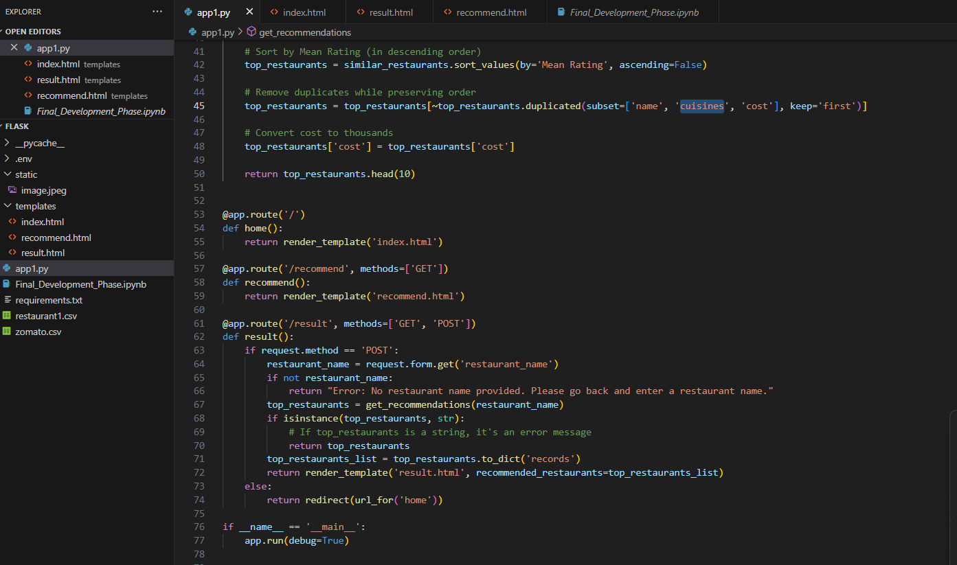

In the above image you can see how the files are arranged and how it looks like inside the flask folder.

1. Start creating the contents of each file following the video: