**PROJECT 6 : AI-DRIVEN EXPLORATION AND PREDICTION OF COMPANY REGISTRATION TRENDS**

**Phase 3: Development part 1**

#Import the libraries

import pandas as pd

import numpy as np

#Load the given dataset

df=pd.read_csv('D:\Data_Gov_Tamil_Nadu.csv')

df.head()

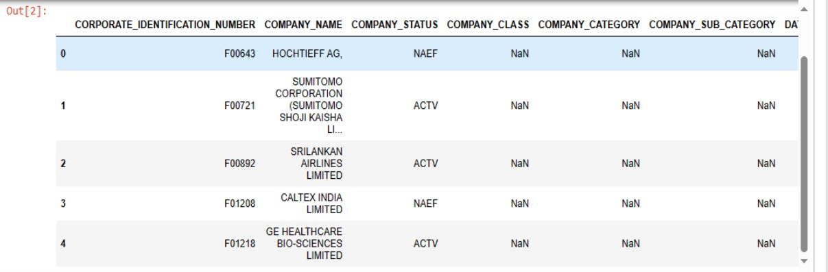

#Data preprocessing

#Check for missing values

df.isnull().sum()

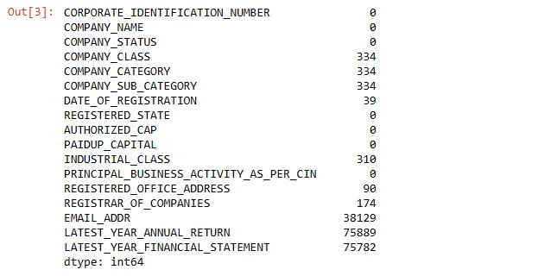

#Check for duplicate values

df.dropna(inplace=True)

#Remove the duplicate values

df.drop_duplicates(inplace=True)

#Again check the missing values are occur or not

df.isnull().sum()

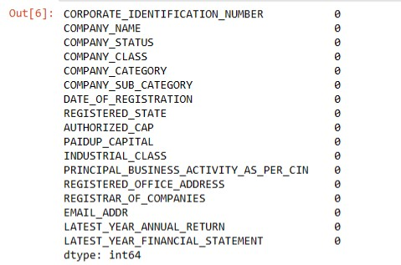

#Finally preprocessed data can be done successfully

df.head()

