iNeuBytes AI/ML INTERNSHIP
COMBINED INTERNSHIP PROJECT REPORT
CIFAR-10 CNN • SENTIMENT ANALYSIS • PERSONALIZED CHATBOT
Submitted by
SUNIL BHUKYA
Regd. No.: INBT021913
Course ID: AIINB20726
Department of Computer Science and Engineering
iNeuBytes
AI/ML Internship

CIFAR-10 IMAGE CLASSIFICATION USING A CONVOLUTIONAL NEURAL NETWORK
Baseline → Controlled Experiments → Final Model → Trade-off Analysis
Final Test Accuracy: 75.88%

Abstract
This project develops a Convolutional Neural Network (CNN) for image classification using the CIFAR-10 dataset. "
"The dataset contains 60,000 32×32 RGB images belonging to 10 classes. A baseline CNN was first trained and achieved "
"70.47% test accuracy. Controlled experiments were then performed using data augmentation, batch normalization, dropout, "
"learning-rate adjustment, and SAME padding. The best individual change was SAME padding, which achieved 74.69% test accuracy. "
"The final model combined SAME padding with batch normalization and achieved 75.88% test accuracy, an improvement of 5.41 "
"percentage points over the baseline. The study also evaluates precision, recall, F1-score, confusion matrices, parameter count, "
"training time, and the accuracy-versus-cost trade-off.

1. Introduction
Image classification is a core computer-vision task in which a model assigns an image to a predefined category. "
"Convolutional Neural Networks are effective for this task because they learn visual features such as edges, textures, shapes "
"and object parts directly from images. This project investigates how common CNN design and regularization techniques affect "
"CIFAR-10 classification performance.

2. Problem Statement
Develop a CNN-based classifier that can correctly classify CIFAR-10 images into 10 predefined categories, achieve at least "
"70% test accuracy, and systematically investigate architectural and training changes that improve generalization.

3. Objectives
- Build and evaluate a baseline CNN.
- Use a fixed train/validation split and reproducible seed.
- Study data augmentation, batch normalization, dropout, learning rate and SAME padding.
- Evaluate accuracy, precision, recall, F1-score and confusion matrices.
- Compare parameter count and training time against accuracy gains.
- Select and document the best-performing final model.

4. Dataset and Preprocessing
CIFAR-10 contains 60,000 32×32 RGB images across airplane, automobile, bird, cat, deer, dog, frog, horse, ship and truck. "
"The original 50,000 training images were split into 45,000 training and 5,000 validation images. The 10,000 test images were "
"kept separate for final evaluation. Pixel values were converted from 0–255 to 0–1 by dividing by 255.

5. Methodology
The workflow was: dataset loading → preprocessing → fixed train/validation split → baseline CNN → controlled experiments → "
"evaluation → model comparison → final model selection. The test set was reserved for final model evaluation.

6. Baseline CNN Architecture
The baseline uses three convolutional blocks with 64, 128 and 256 filters, each followed by max pooling. "
"The feature maps are flattened and passed to a 128-neuron dense layer and a 10-neuron softmax output layer.
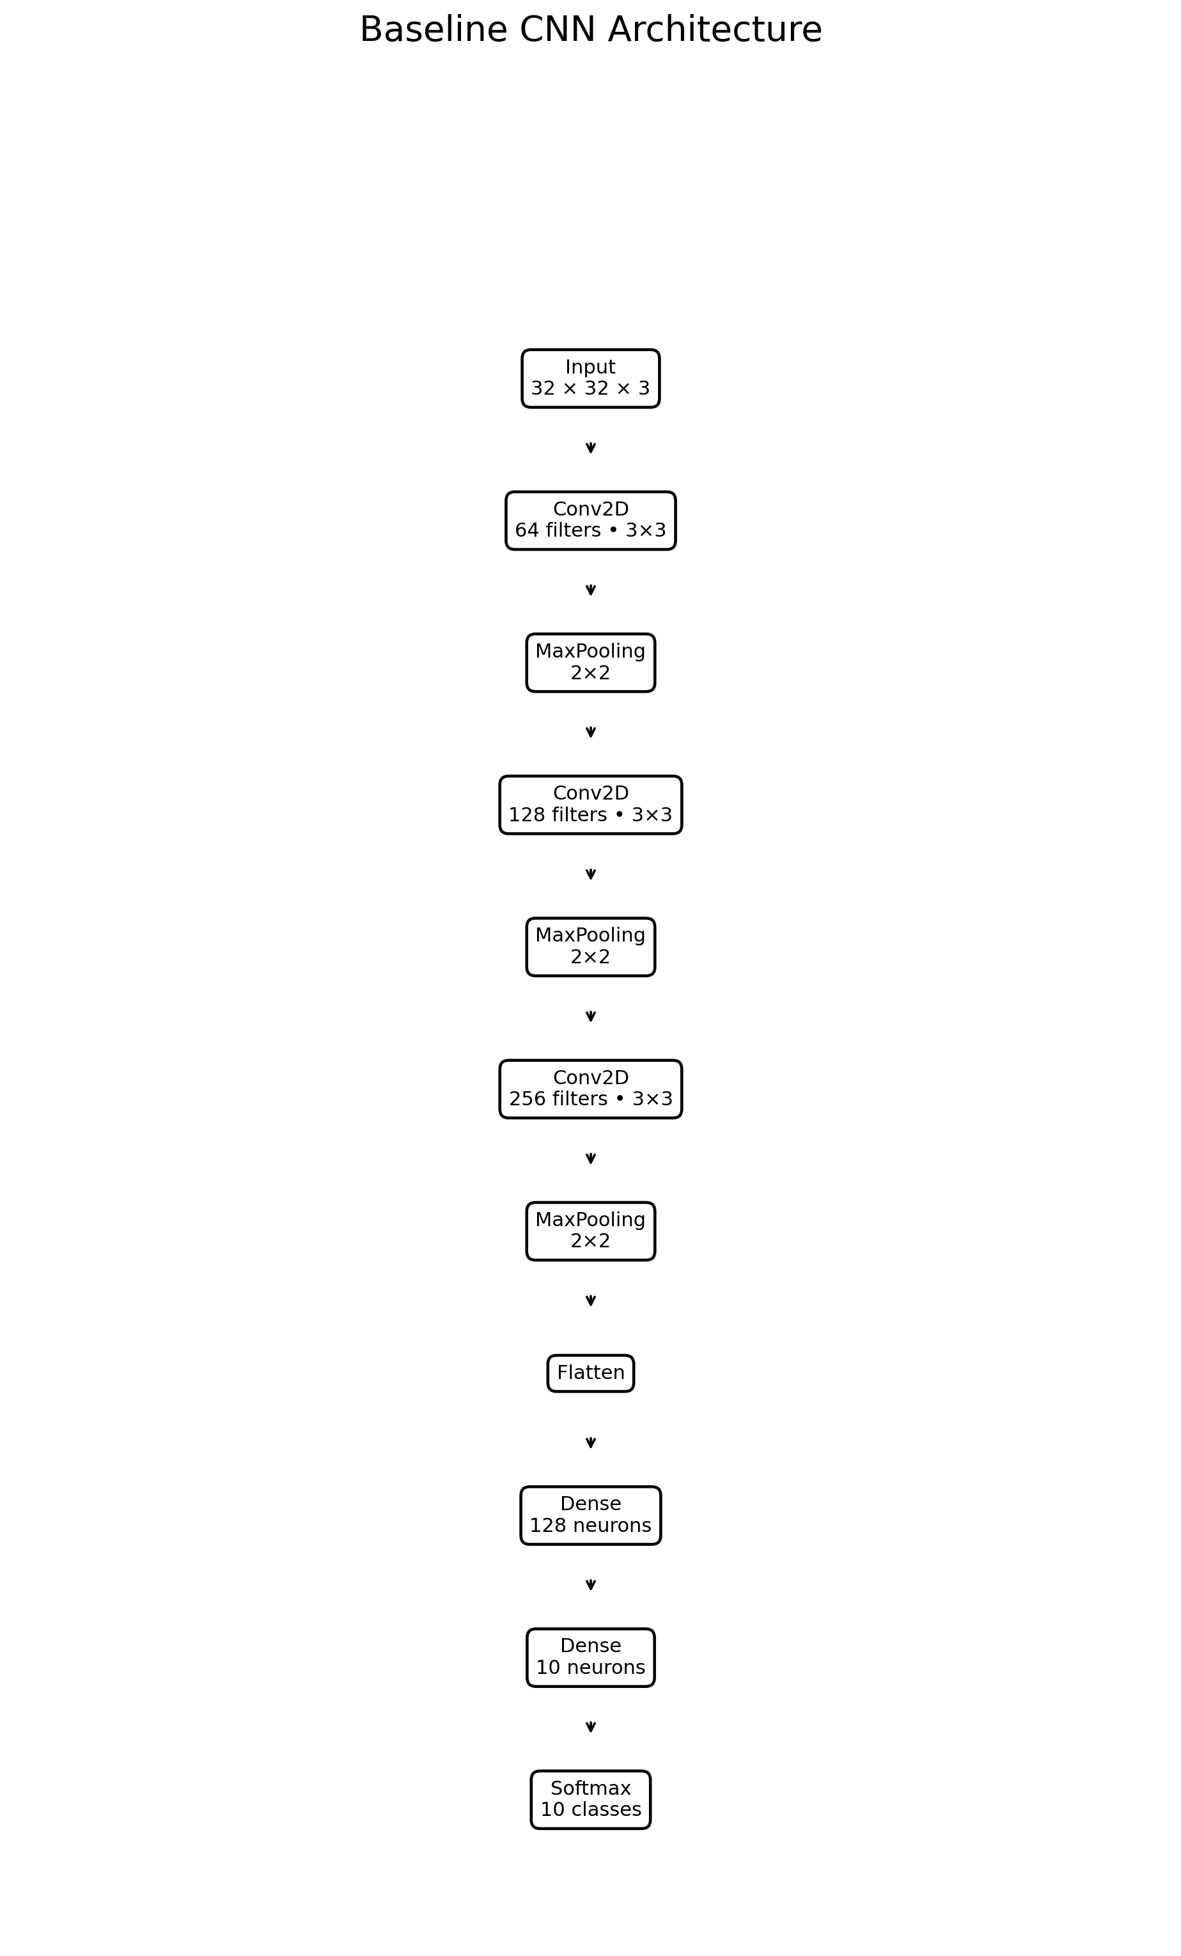

7. Final CNN Architecture
The final model uses the same general depth but changes the convolutional layers to SAME padding and adds batch normalization "
"and ReLU after each convolution. The model contains 898,314 total parameters, of which 897,418 are trainable and 896 are "
"non-trainable batch-normalization parameters.
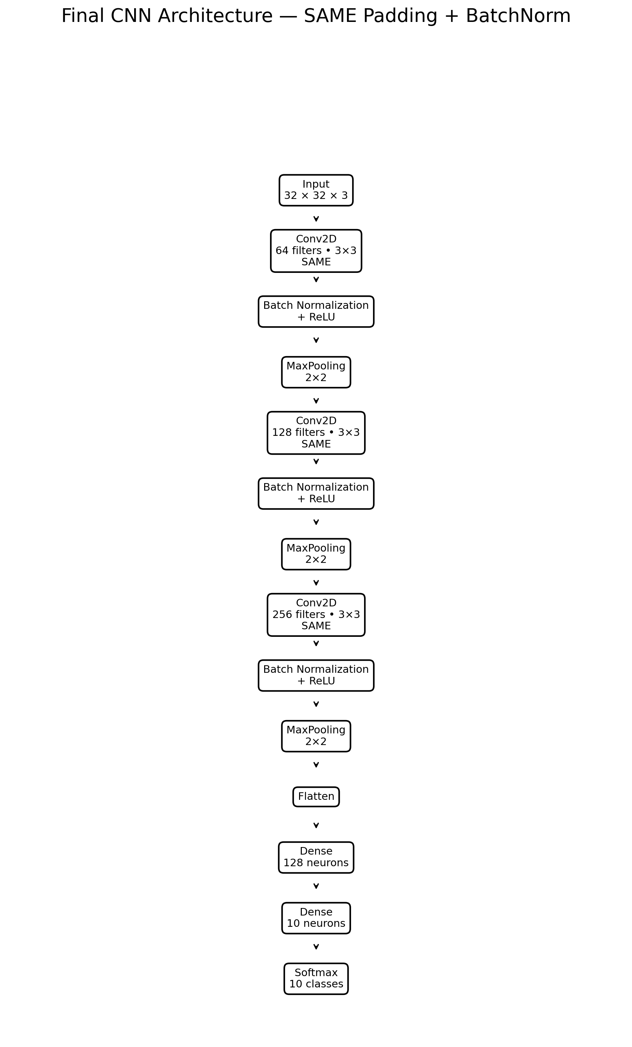

8. Controlled Experiments
Each experiment changed a specific part of the baseline or preceding design so that its effect could be measured. "
"The final candidate combined the two strongest architectural choices identified during experimentation.
Experiment | Parameters | Train Accuracy (%) | Validation Accuracy (%) | Train-Val Gap (pp) | Test Accuracy (%) | Test Loss | Training Time (s)
Baseline | 503,306 | 95.28 | 70.92 | 24.36 | 70.47 | 1.8802 | 98.26
Data Augmentation | 503,306 | 70.41 | 71.42 | -1.01 | 70.79 | 0.8609 | 157.29
Batch Normalization | 505,098 | 97.99 | 72.58 | 25.41 | 72.99 | 1.4866 | 120.76
Dropout | 503,306 | 87.28 | 72.62 | 14.66 | 72.51 | 1.1561 | 104.87
Learning Rate 0.0005 | 503,306 | 96.54 | 72.84 | 23.70 | 72.27 | 1.4439 | 100.58
Same Padding | 896,522 | 97.80 | 74.06 | 23.74 | 74.69 | 1.6522 | 116.89
Same Padding + BatchNorm | 898,314 | 97.79 | 76.12 | 21.67 | 75.88 | 1.2965 | 137.67

9. Performance Evaluation
The final evaluation uses accuracy, precision, recall and F1-score. The macro averages are reported so that all ten classes "
"contribute equally to the summary.
Model | Accuracy (%) | Precision (%) | Recall (%) | F1-Score (%)
Baseline CNN | 70.47 | 70.69 | 70.47 | 70.42
Final CNN | 75.88 | 77.15 | 75.88 | 75.47

10. Confusion Matrix Analysis
The confusion matrix identifies which classes are easiest and hardest to distinguish. The baseline's largest two-way confusion "
"was cat ↔ dog (293 combined mistakes). In the final model, cat ↔ dog remained the largest pair but decreased to 206 combined "
"mistakes. Other important final confusions were bird ↔ deer (144), airplane ↔ bird (136), bird ↔ cat (126), and bird ↔ dog (126).
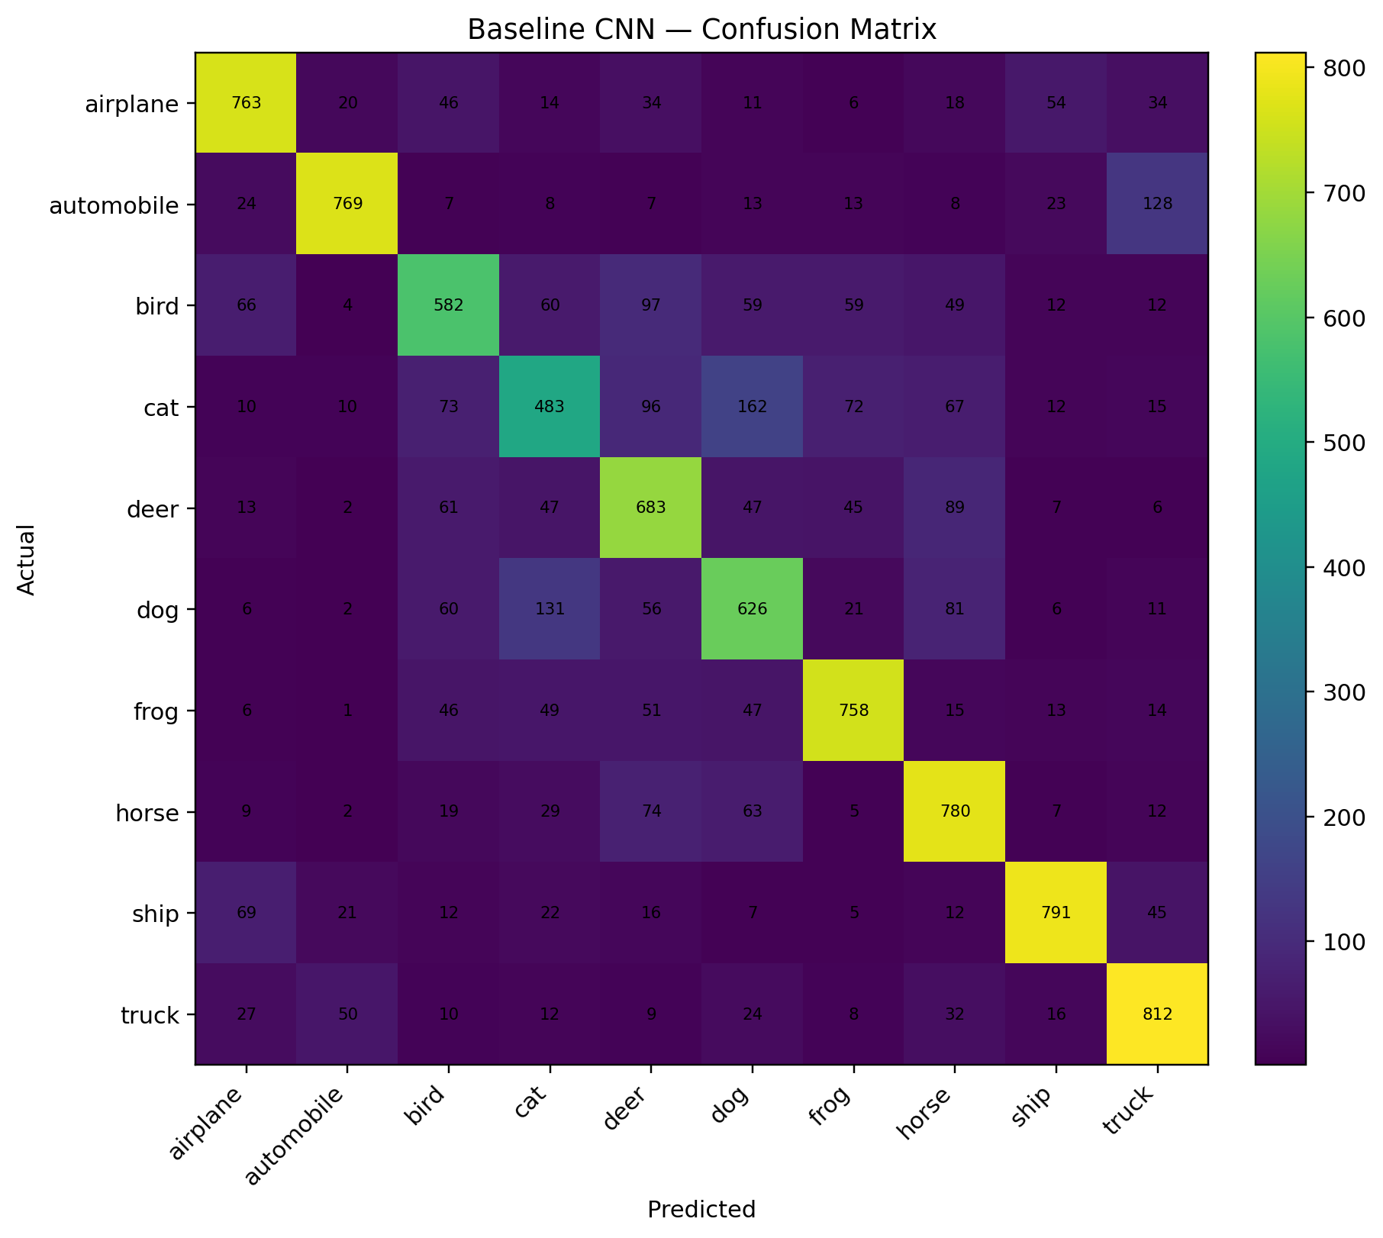
Figure: Baseline confusion matrix. The final confusion matrix is included in the project Drive as final_confusion_matrix.png.

11. Training and Validation Analysis
The baseline showed substantial overfitting: training accuracy reached 95.28% while validation accuracy was 70.92%. "
"The final model reached 97.79% training accuracy and 76.12% validation accuracy, reducing the train-validation gap from "
"24.36 percentage points to 21.67 percentage points. The gap is still present, but generalization improved.

12. Trade-off Analysis
The baseline uses 503,306 parameters and 98.26 seconds of training time. The final model uses 898,314 parameters and "
"137.67 seconds. Thus, the final model adds 395,008 parameters and 39.41 seconds of training time while improving test accuracy "
"by 5.41 percentage points. This corresponds to about 13.70 percentage points of accuracy gain per additional million parameters "
"and 8.24 percentage points per additional training minute. For this project, the accuracy improvement justifies the additional cost.
Metric | Value
Baseline accuracy | 70.47%
Final accuracy | 75.88%
Accuracy gain | +5.41 percentage points
Additional parameters | +395,008 (0.395M)
Additional training time | +39.41 seconds
Gain per extra million parameters | 13.70 percentage points/M
Gain per extra training minute | 8.24 percentage points/minute
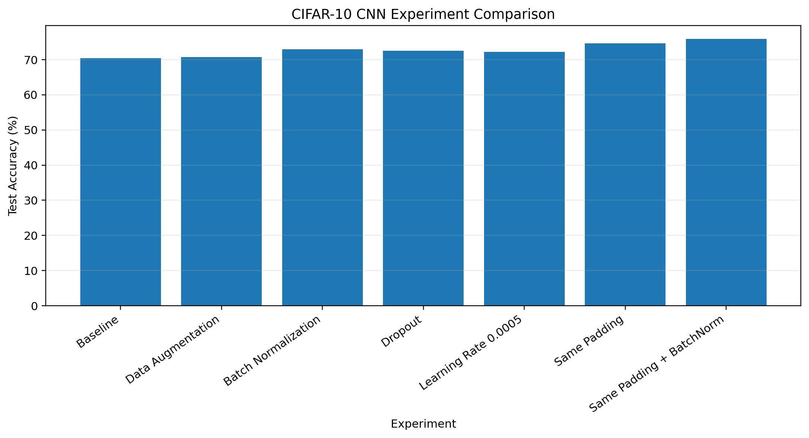

13. Explanation of Design Choices
Data augmentation: Test accuracy increased slightly to 70.79%. It was useful for reducing reliance on exact training examples, but the gain was small.
Batch normalization: Improved test accuracy to 72.99% and stabilized feature distributions during training.
Dropout: Reduced overfitting and achieved 72.51% test accuracy.
Learning rate 0.0005: Achieved 72.27%; changing the learning rate alone was less effective than the best architectural changes.
SAME padding: Improved test accuracy to 74.69%, suggesting that retaining spatial information was beneficial.
SAME padding + BatchNorm: Combined the strongest choices and achieved the best result of 75.88%.

14. Conclusion
The project successfully developed and evaluated a CNN for CIFAR-10 classification. The baseline achieved 70.47% test accuracy. "
"Systematic experiments showed that SAME padding and batch normalization were the most useful changes for this architecture. "
"The final combined model achieved 75.88% test accuracy, exceeding the 70% target by 5.88 percentage points and improving "
"5.41 percentage points over the baseline.

15. Future Scope
- Evaluate deeper architectures such as ResNet.
- Use stronger augmentation and regularization strategies.
- Apply learning-rate schedules and early stopping.
- Perform automated hyperparameter optimization.
- Investigate transfer learning and attention-based vision models.

16. Reproducibility
The project uses a fixed random seed and fixed train/validation split. The final model, histories, result files, tables and "
"figures are stored separately. requirements.txt and README.md are included with the deliverables.

TASK 2 — LSTM SENTIMENT CLASSIFICATION
Deep Learning Experiments, Evaluation and Overfitting Analysis

1. Objective
Task 2 evaluates LSTM-based neural sequence models for binary sentiment classification on the IMDB movie-review dataset. Multiple architectures and embedding choices were tested, with training and validation curves used to study generalization and overfitting.

2. Dataset and Preprocessing
The IMDB dataset contains 25,000 training reviews and 25,000 test reviews. The 25,000 training reviews were divided into 20,000 training and 5,000 validation samples. The test set remained separate. Reviews were reconstructed from integer sequences and cleaned before modelling. The final data retained balanced positive and negative sentiment classes.

3. LSTM Experiments
- Baseline LSTM
- LSTM + Dropout
- LSTM 128
- Stacked LSTM
- GloVe LSTM
- Additional saved early-stopping and bidirectional variants

4. Results by Model
- Baseline LSTM: 83.66% validation accuracy at epoch 9.
- LSTM + Dropout: 84.34% validation accuracy at epoch 7.
- Stacked LSTM: 85.56% validation accuracy at epoch 13.
- GloVe LSTM: 65.68% validation accuracy at epoch 1; 65.69% test accuracy.

5. Best LSTM Configuration
- Embedding dimension: 64
- LSTM layer 1: 64 units
- LSTM layer 2: 64 units
- Dropout: 0.5
- Output: Sigmoid
- Total parameters: 1,346,113
Best validation accuracy: 85.56%. Test accuracy: 84.77%. Precision: 82.96%. Recall: 87.51%. F1-score: 85.17%.

6. Training Curves
Baseline LSTM — Accuracy
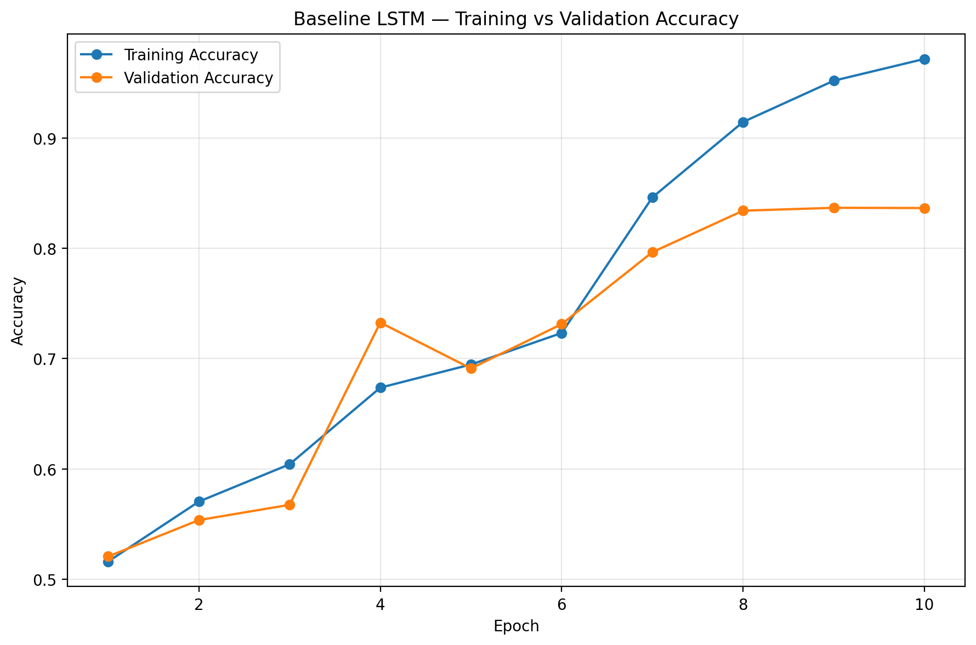
Baseline LSTM — Loss
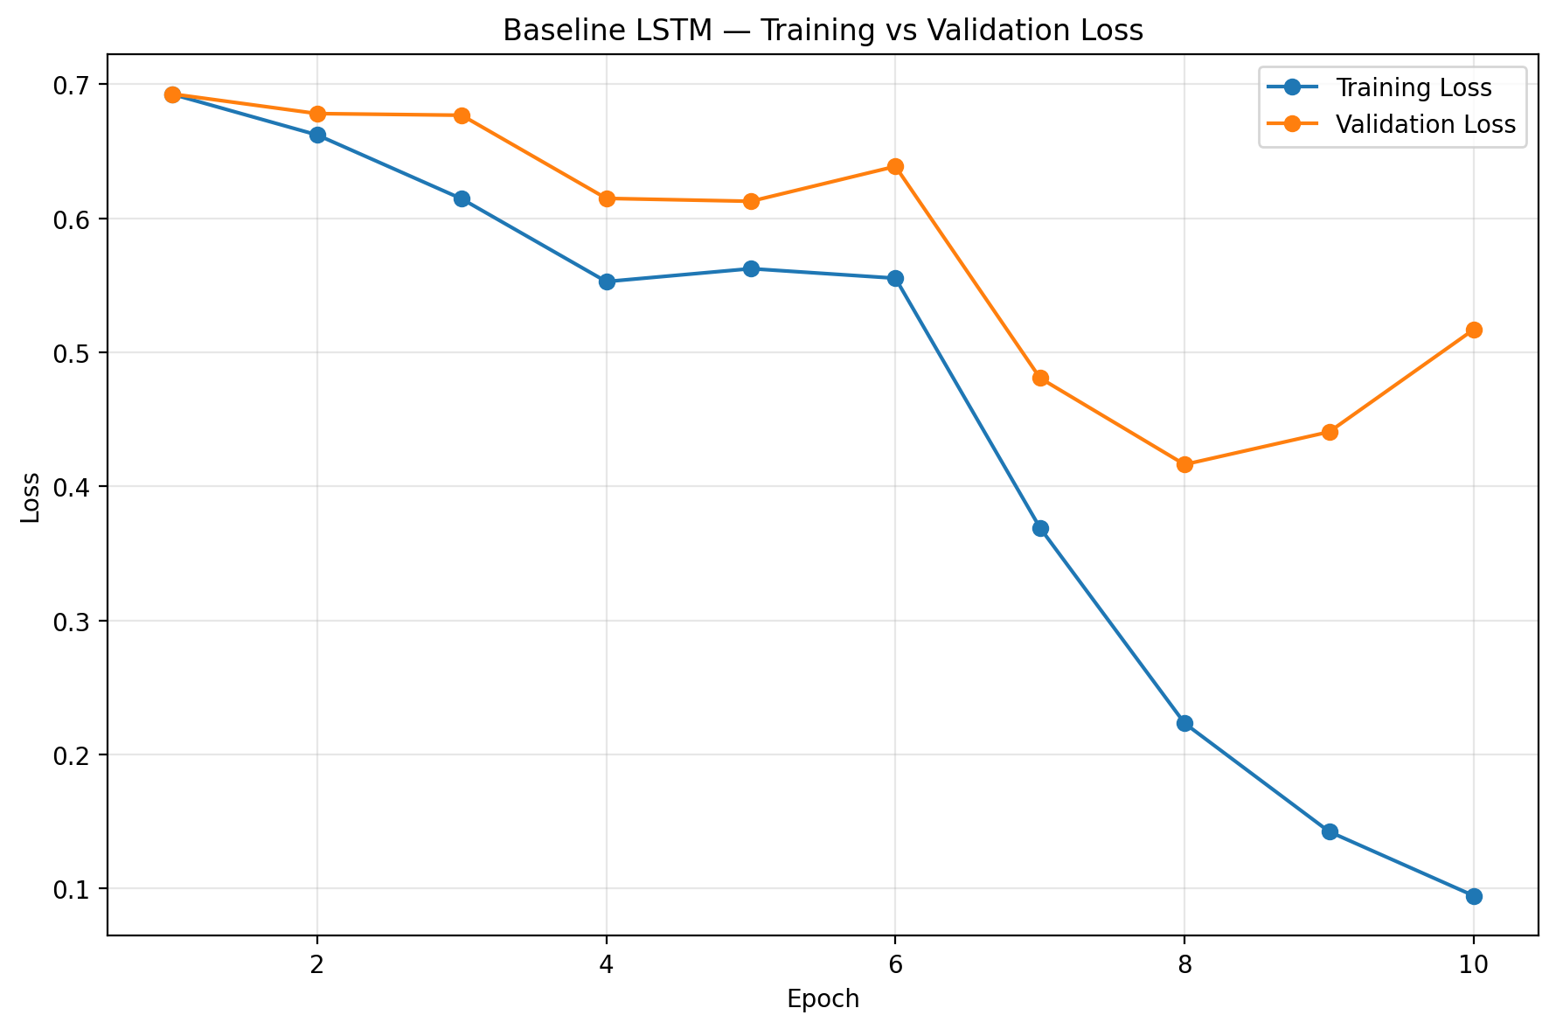
LSTM + Dropout — Accuracy
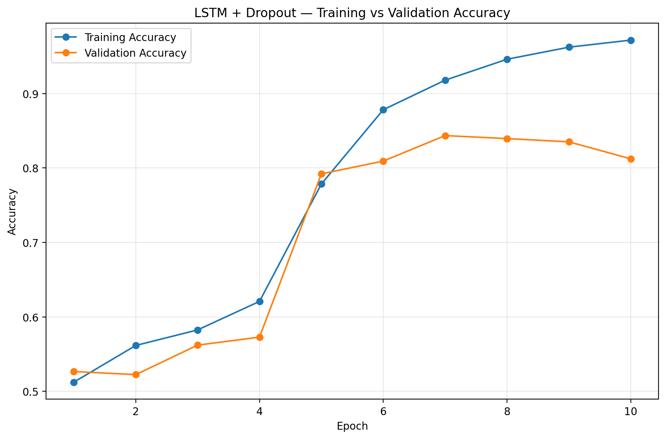
LSTM + Dropout — Loss
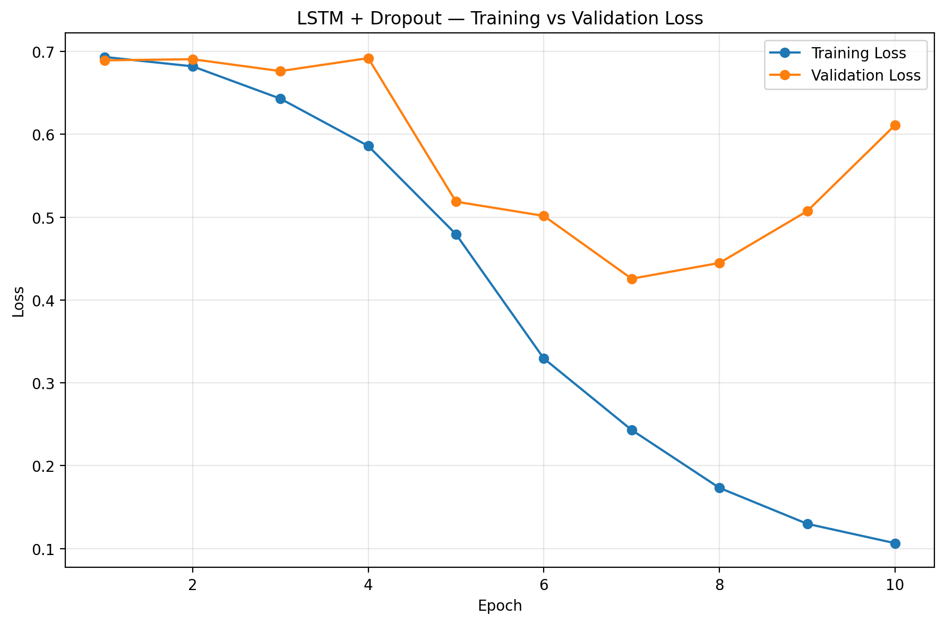
Stacked LSTM — Accuracy
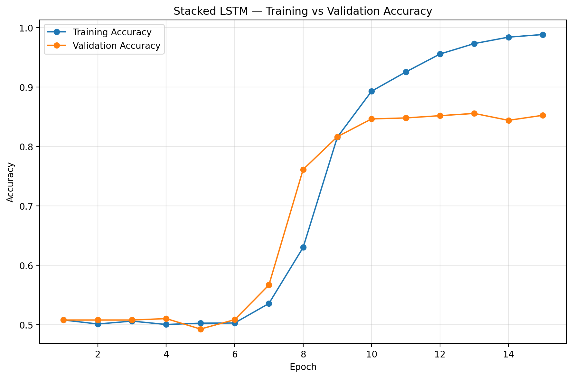
Stacked LSTM — Loss
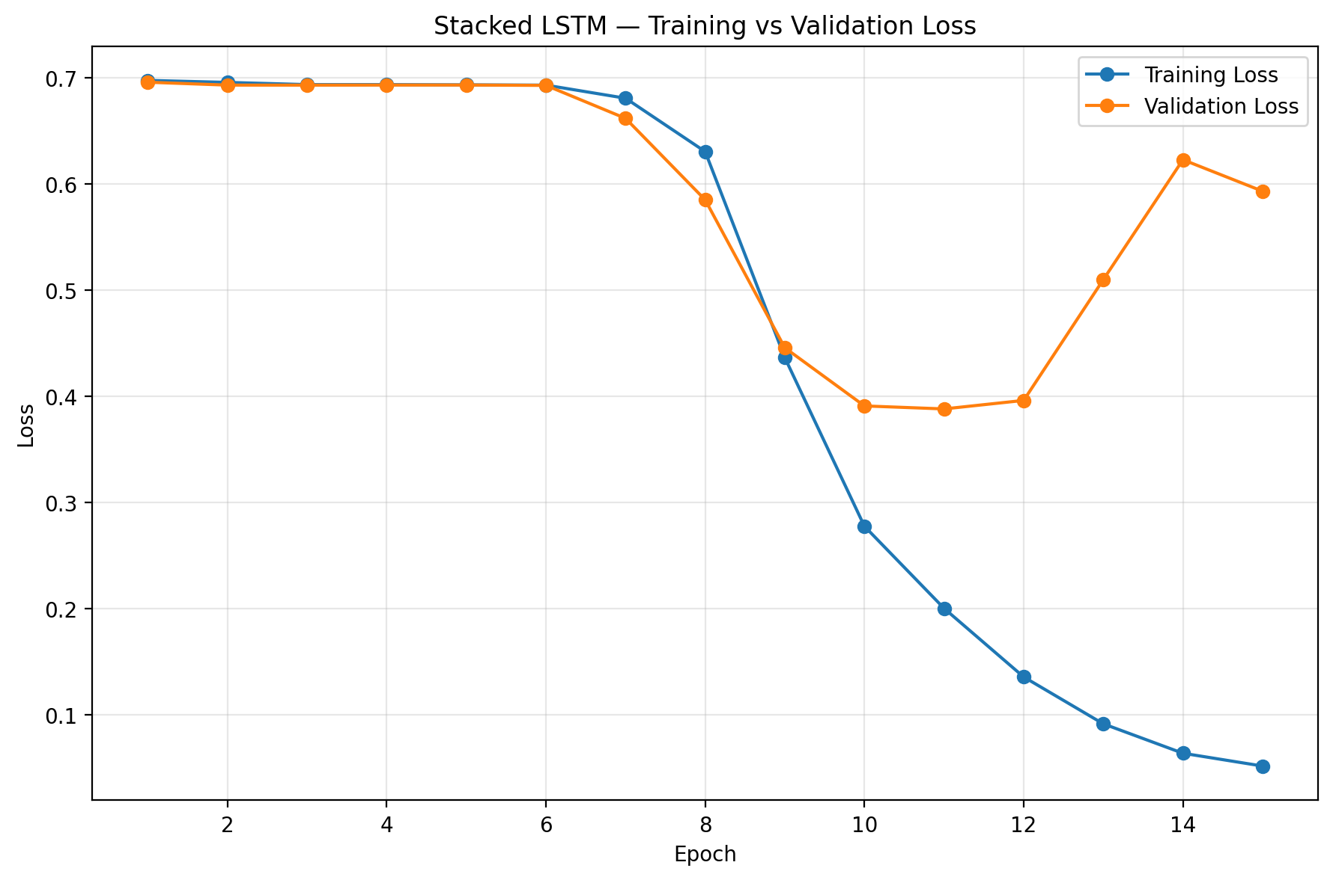
LSTM 128 — Accuracy
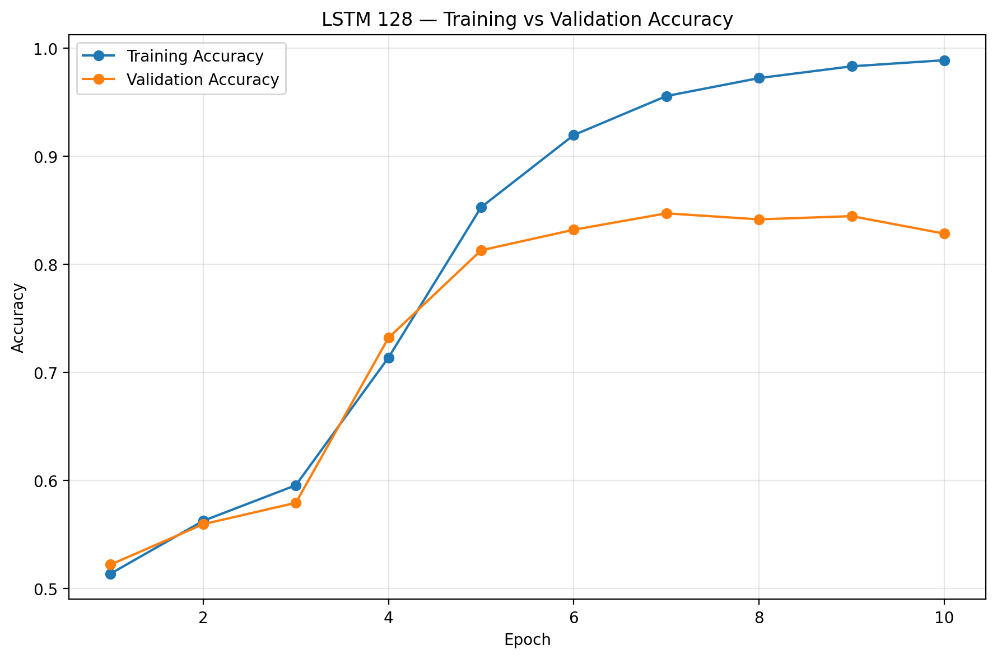
LSTM 128 — Loss
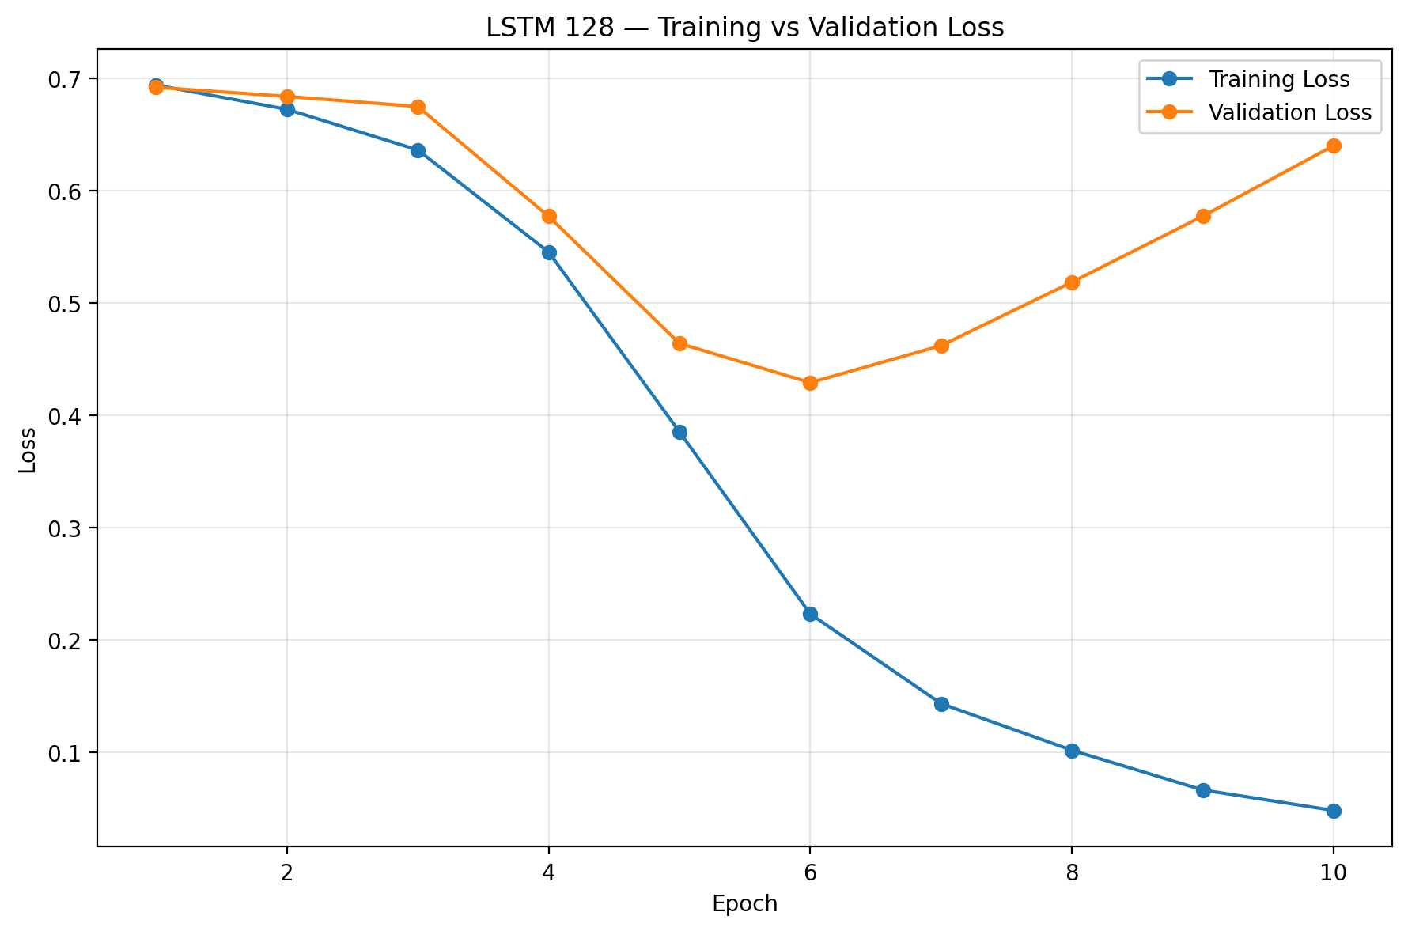
GloVe LSTM — Accuracy
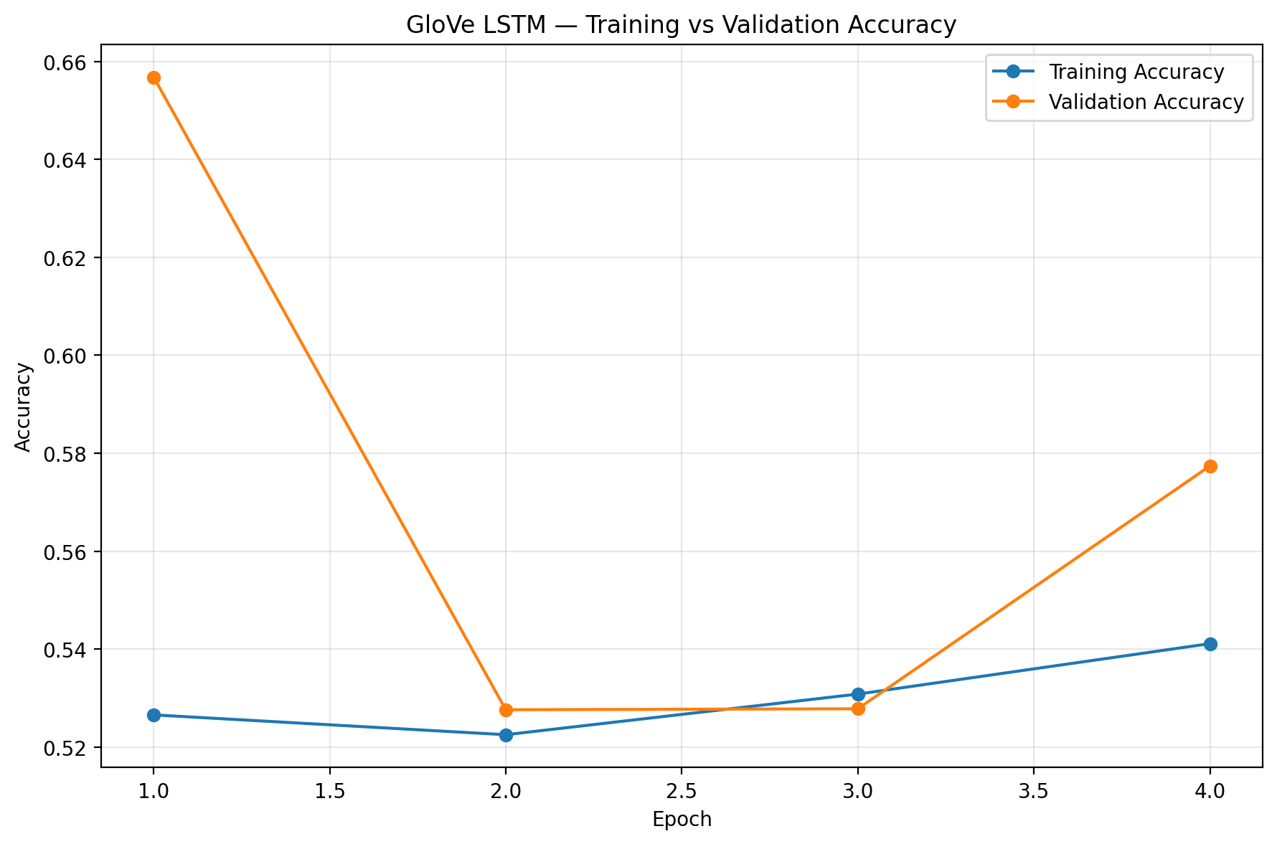
GloVe LSTM — Loss
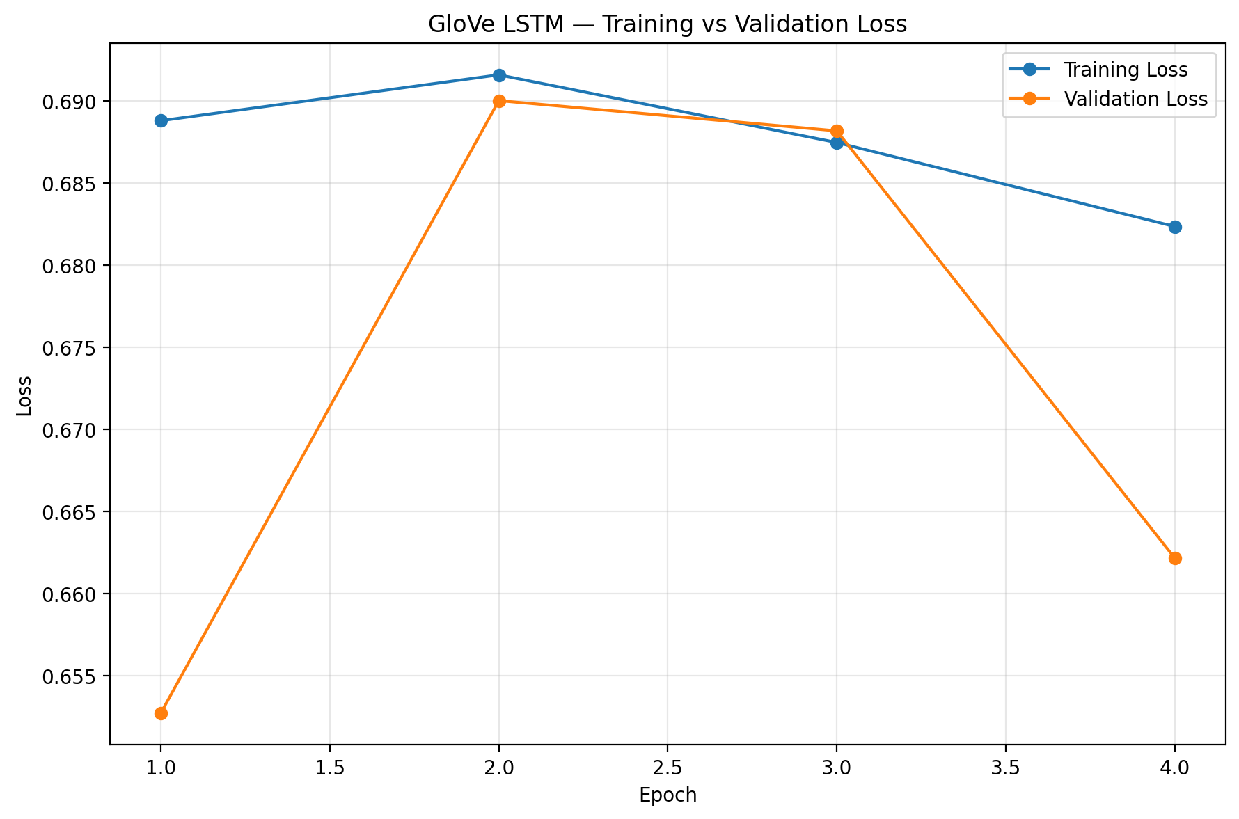

7. Overfitting Analysis
Baseline: possible overfitting around epoch 10; final train accuracy 97.15%, validation 83.64%, gap 13.52 points. LSTM + Dropout: possible overfitting around epoch 8; final train 97.17%, validation 81.22%, gap 15.94 points. Stacked LSTM: possible overfitting around epoch 14; final train 98.85%, validation 85.24%, gap 13.61 points. GloVe LSTM: no clear single overfitting point detected automatically.

8. Final Confusion Matrix
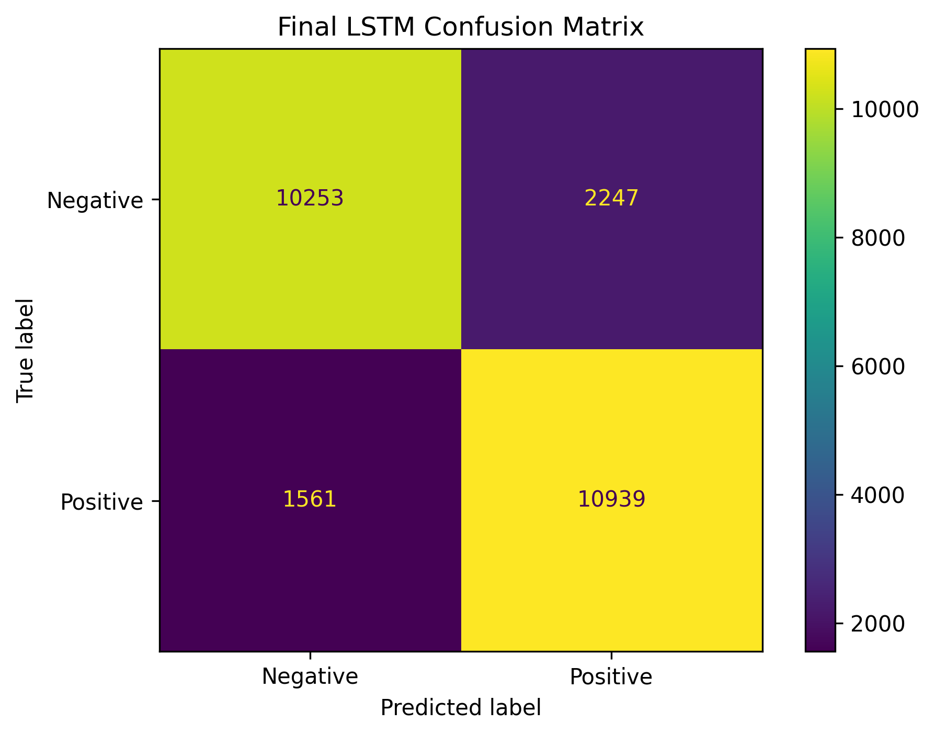
TN = 10,253; FP = 2,247; FN = 1,561; TP = 10,939.

9. GloVe Experiment
The GloVe experiment used 100-dimensional pretrained embeddings, 64 LSTM units, dropout 0.5, and non-trainable embedding weights. Vocabulary coverage was 95.65%. Best validation accuracy was 65.68%, test accuracy 65.69%, and training time 22.21 seconds.

10. Classical ML vs LSTM
Metric | Classical ML | LSTM
Accuracy | 88.75% | 84.77%
Precision | 88.33% | 82.96%
Recall | 89.30% | 87.51%
F1-Score | 88.81% | 85.17%
The classical model was 3.98 percentage points higher in accuracy.

11. Complexity and Training Time
- Classical ML: 30,001 parameters; 1.11 seconds training time.
- LSTM: 1,346,113 parameters; 122.90 seconds training time.

12. Conclusion
Stacked LSTM was the strongest LSTM configuration, reaching 85.56% validation accuracy and 84.77% test accuracy. The experiments demonstrate the effect of stacking, dropout, hidden-unit size and pretrained embeddings. On this dataset, however, the classical TF-IDF approach remained more accurate and substantially lighter.

PERSONALIZED CHATBOT
A Hybrid TF-IDF + MiniLM Retrieval-Based Chatbot
MAJOR PROJECT REPORT
Department of Computer Science and Engineering
Project Documentation and Final Demonstration Report

Parameter | Value
Project Title | Personalized Chatbot
Project Type | Major Project
Core Approach | Hybrid TF-IDF + MiniLM retrieval
Backend | Python Flask
Frontend | HTML, CSS, JavaScript
API Testing | Postman
MiniLM Dimension | 384
Training Examples | 276,753

Table of Contents
- Abstract
- Introduction
- Problem Statement
- Objectives
- Existing System
- Proposed System
- System Requirements
- System Architecture
- Dataset and Knowledge Base
- Data Processing
- TF-IDF Retrieval
- MiniLM Semantic Retrieval
- Hybrid Retrieval
- Candidate Retrieval and Confidence Handling
- Backend Implementation
- Frontend Implementation
- API and Postman Testing
- Evaluation and Validation
- Deployment
- Results
- Advantages
- Limitations
- Future Scope
- Conclusion
- References / Project Artifacts
- Appendix

1. Abstract
This project presents a personalized retrieval-based chatbot that combines TF-IDF and MiniLM semantic retrieval. The system searches a large question–answer knowledge base containing 276,753 training examples and selects a relevant stored response. TF-IDF provides lexical matching based on important words, while MiniLM provides semantic similarity using 384-dimensional embeddings. The two signals are combined using a weighted hybrid score with TF-IDF weight 0.3 and MiniLM weight 0.7. A confidence-based fallback mechanism prevents the system from returning a weak match when the retrieved result is not sufficiently relevant. The chatbot is implemented using Python and Flask, with an HTML/CSS/JavaScript frontend. The API was tested using Postman and the final system was demonstrated through a temporary public Cloudflare Quick Tunnel.

2. Introduction
Chatbots are software systems that interact with users through natural-language questions. A retrieval-based chatbot selects an answer from a predefined knowledge base instead of generating a new response from a language model. This project improves retrieval quality by combining two complementary techniques: TF-IDF for lexical matching and MiniLM for semantic matching.
The final system provides a browser-based interface, a Flask backend, a retrieval engine, confidence-based rejection, and API testing support. The project was also prepared as a GitHub repository and demonstrated through a temporary public tunnel.

3. Problem Statement
Traditional keyword-based retrieval can fail when users express the same idea using different words. A semantic-only method can also benefit from an additional lexical signal. The project therefore addresses the problem of selecting relevant responses from a large knowledge base while reducing unreliable matches.

4. Objectives
- Build a personalized retrieval-based chatbot.
- Process a large question–answer knowledge base.
- Implement TF-IDF retrieval for lexical matching.
- Implement MiniLM semantic retrieval.
- Combine both retrieval signals using weighted hybrid scoring.
- Introduce confidence-based fallback behavior.
- Develop a Flask backend and browser frontend.
- Test the API independently using Postman.
- Validate relevant retrieval and rejection of problematic questions.
- Prepare the project for GitHub and public demonstration.

5. Existing System
A conventional keyword-based chatbot generally searches for overlapping terms between a user's question and stored questions. This can work well when wording is similar, but it may fail when users use paraphrases or semantically related words. Another limitation is that an unrelated question can receive an incorrect nearest result if no confidence mechanism is used.

6. Proposed System
The proposed system uses a hybrid retrieval architecture:
User Question
|
+-------------------+
| |
TF-IDF MiniLM
| |
Lexical Score Semantic Score
| |
+---------+---------+
|
Hybrid Score
|
Confidence Check
/ \
Answer Fallback
The final configuration gives 30% weight to TF-IDF and 70% weight to MiniLM, allowing both lexical evidence and semantic meaning to contribute to the final result.

7. System Requirements

7.1 Software Requirements
- Python
- Flask and flask-cors
- NumPy and SciPy
- Scikit-learn
- Joblib
- PyTorch
- Sentence Transformers
- Hugging Face Hub libraries
- HTML, CSS and JavaScript
- Postman for API testing

7.2 Execution Environment
- CPU-based inference is supported.
- The final local model artifacts require approximately 1.3 GB of storage.
- The demonstrated local environment successfully ran the application in CPU mode.

8. System Architecture
Browser Frontend
|
| HTTP request
v
Flask Backend / API
|
v
Hybrid Retrieval Engine
| |
v v
TF-IDF MiniLM
| |
+-------> Hybrid Score
|
Confidence Check
/ \
Answer Fallback
The frontend sends a user message to the Flask backend. The backend retrieves candidates, computes lexical and semantic signals, combines them using the final configuration, applies confidence handling, and returns the selected response.

9. Dataset and Knowledge Base
- Training examples: 276,753.
- The system is retrieval-based and uses stored responses.
- The final model artifacts include TF-IDF and MiniLM retrieval representations.
- The semantic embedding dimension is 384.
The large knowledge base provides broad coverage for supported topics. The chatbot is designed to reject questions for which it cannot find a sufficiently relevant response.

10. Data Processing
Raw Question–Answer Data
|
v
Question / Response Alignment
|
+-------------------+
| |
v v
TF-IDF Matrix MiniLM Embeddings
| |
+---------+---------+
|
Retrieval Indexes
The project includes alignment checks between retrieval representations and response data. The final artifacts were verified before deployment.

11. TF-IDF Retrieval
TF-IDF stands for Term Frequency–Inverse Document Frequency. It assigns importance to words based on their occurrence in a text and their distribution across the collection. It provides a useful lexical signal for matching questions that share important terms.
Final TF-IDF weight: 0.3.

12. MiniLM Semantic Retrieval
MiniLM is a lightweight Transformer-based model used to generate semantic embeddings. Each question is represented using a 384-dimensional vector. Semantic similarity helps connect questions with similar meaning even when wording differs.
Final MiniLM weight: 0.7.

13. Hybrid Retrieval
The final hybrid score is represented as:
Hybrid Score = (0.3 × TF-IDF Score) + (0.7 × MiniLM Score)
The MiniLM component has the larger weight because semantic similarity is important for recognizing paraphrases, while TF-IDF provides an additional lexical matching signal.

14. Candidate Retrieval and Confidence Handling
The final configuration uses a candidate count of 100. After candidate retrieval, the system selects the strongest hybrid match. A confidence-based mechanism determines whether the result is sufficiently relevant. If confidence is not sufficient, the system returns a fallback message rather than an unrelated stored response.
Sufficient confidence -> Return retrieved answer
Low confidence -> Return fallback message

15. Backend Implementation
The backend is implemented with Flask. It loads the validated retrieval artifacts, receives user requests, performs hybrid retrieval, applies confidence handling, and returns the result.
- Flask web server
- REST-style chatbot endpoint
- Hybrid TF-IDF + MiniLM retrieval
- Confidence-based fallback
- CORS support for frontend/API communication

16. Frontend Implementation
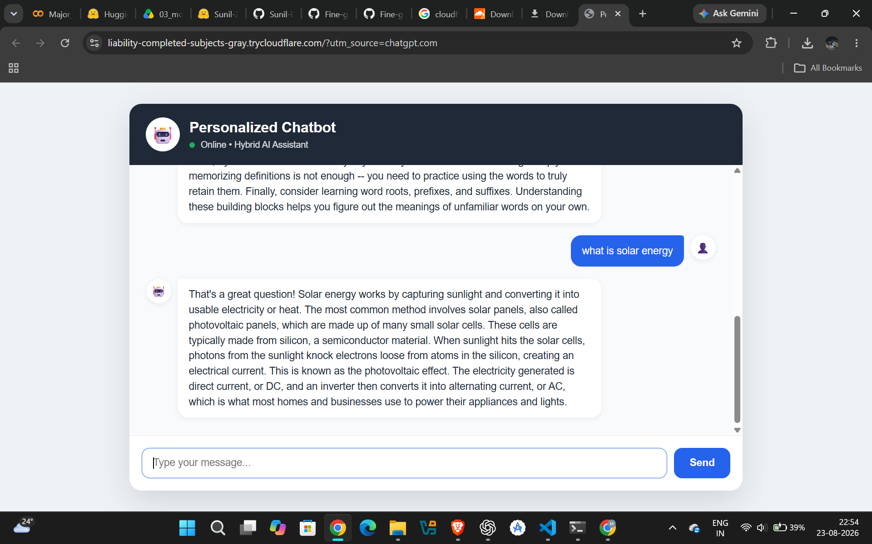
Figure 16.1: Live Personalized Chatbot web interface.
The frontend is implemented using HTML, CSS and JavaScript. It provides a simple chat interface where users enter questions and view returned responses.
- Chat header and online status
- User message area
- Chatbot response area
- Message input field
- Send button
- JavaScript-based API communication

17. API and Postman Testing
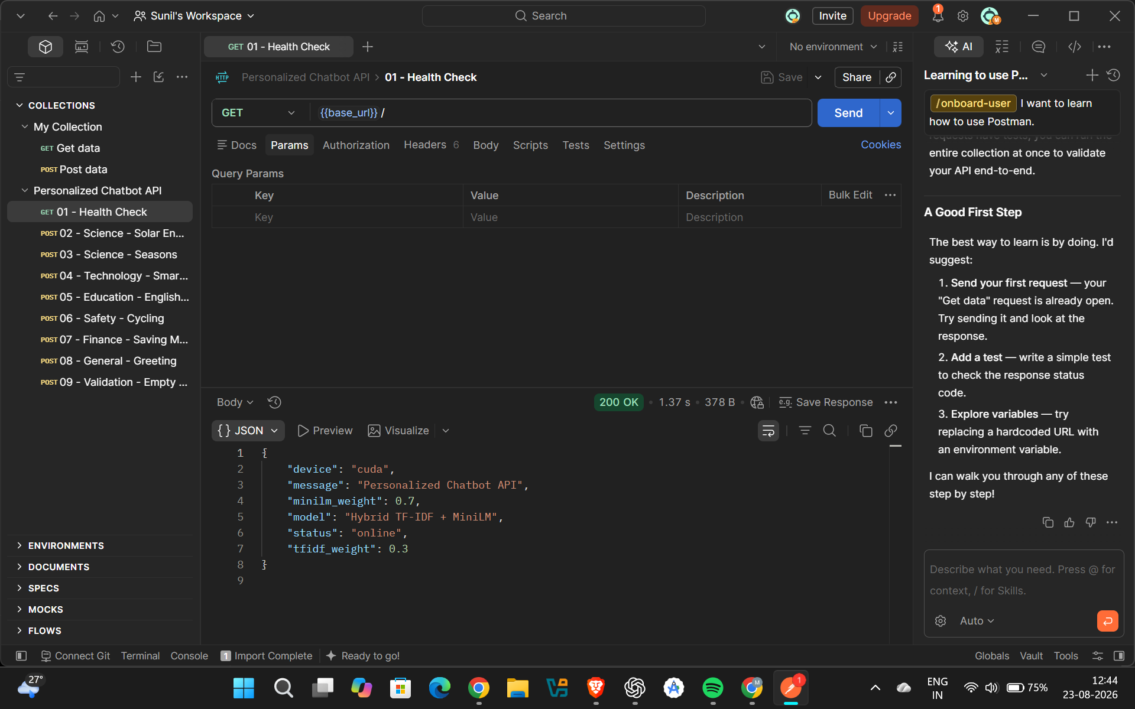
Figure 17.1: Postman API health-check response.
Postman was used to test the backend independently of the browser interface. The health-check endpoint returned HTTP 200 OK and reported the Hybrid TF-IDF + MiniLM configuration.
Example request
POST /respond
{
"message": "What is solar energy?"
}
The project package also contains the Postman collection and API test report.

18. Evaluation and Validation

18.1 Final Configuration
Parameter | Value
Model | Hybrid TF-IDF + MiniLM
TF-IDF weight | 0.3
MiniLM weight | 0.7
Candidate count | 100
MiniLM dimension | 384
Training examples | 276,753

18.2 Retrieval Validation
- Relevant questions matched: 6/6.
- Problematic questions rejected: 4/4.
- The validation confirms both relevant retrieval and rejection behavior.

19. Deployment
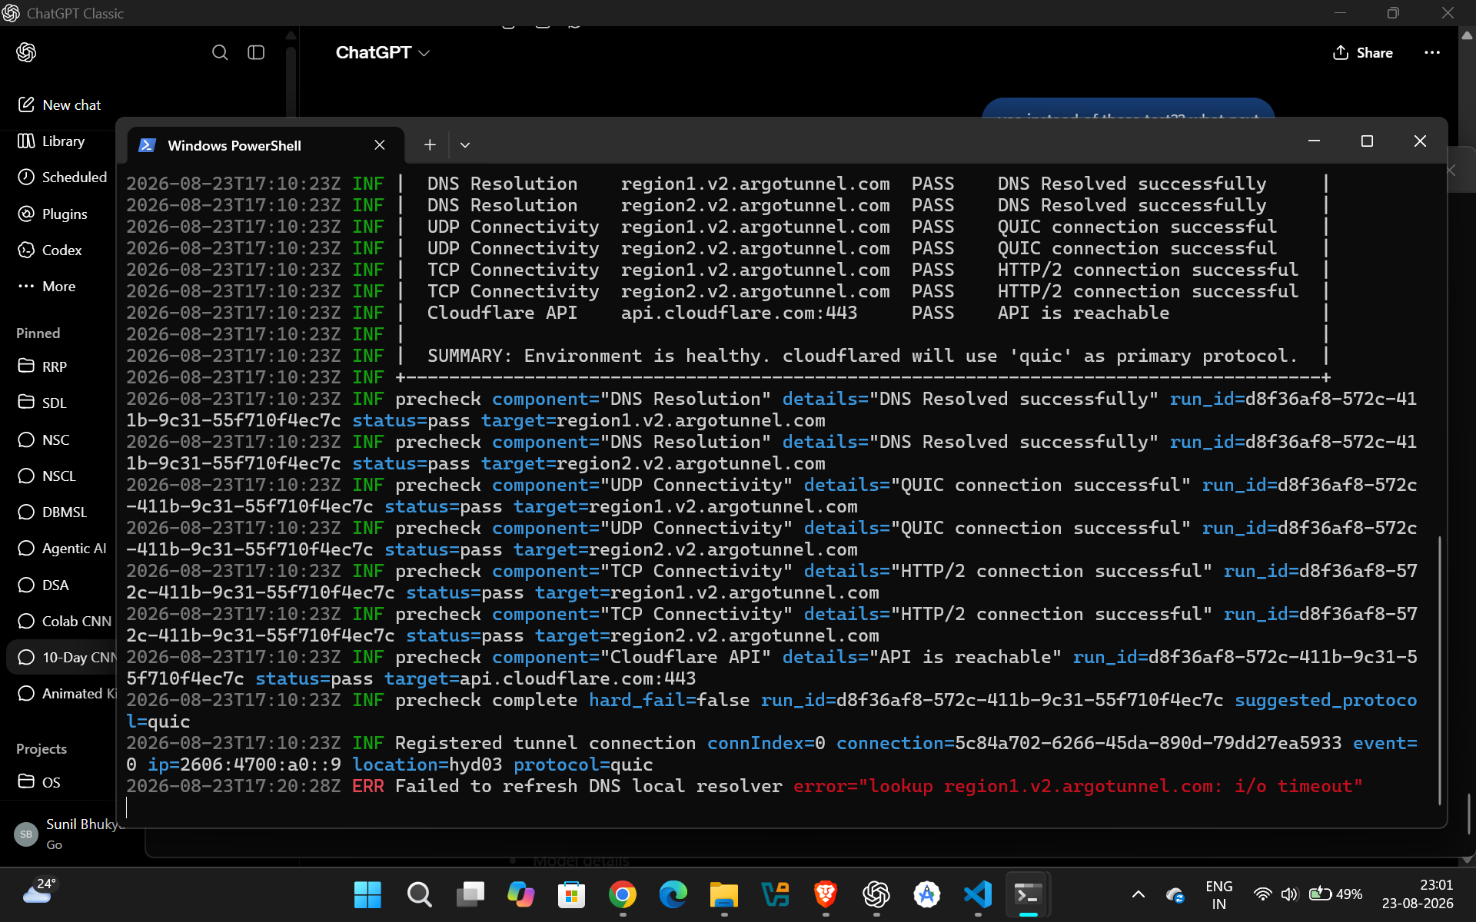
Figure 19.1: Cloudflare Quick Tunnel exposing the local Flask service.
The final application was first verified locally using Flask. A Cloudflare Quick Tunnel was then used to expose the local Flask service through a temporary public URL for demonstration.
Internet User
|
Public Quick Tunnel URL
|
Cloudflare Tunnel
|
Local Flask Server
|
Hybrid Retrieval Model
The public demonstration uses a temporary Quick Tunnel and depends on the local Flask server and tunnel process remaining active. It should therefore be described as a demonstration deployment rather than permanent production hosting.

20. Results

Figure 20.1: Successful chatbot response during live demonstration.
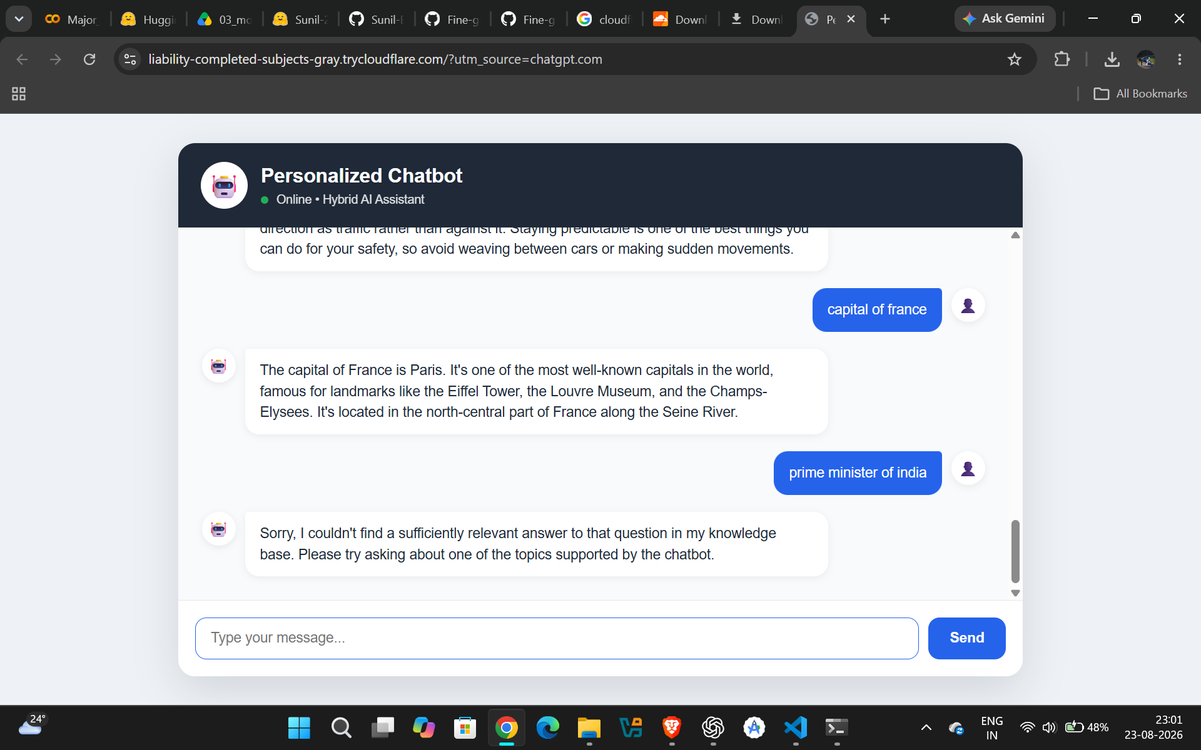
Figure 20.2: Low-confidence question handled with a fallback response.
- Final backend syntax validation passed.
- Final model artifacts were verified.
- Frontend files were verified.
- Postman API testing was completed.
- Relevant retrieval validation achieved 6/6 matches.
- Problematic question validation achieved 4/4 rejections.
- The chatbot was successfully run locally.
- The chatbot was successfully accessed through a public demonstration URL.

21. Advantages
- Combines lexical and semantic retrieval.
- Uses a large knowledge base.
- Includes confidence-based rejection.
- Provides a simple browser interface.
- Provides a separate API for testing and integration.
- Can run on CPU in the demonstrated environment.
- Includes GitHub-ready project files and reports.

22. Limitations
- The chatbot depends on the coverage of its knowledge base.
- It is not intended to answer arbitrary questions outside the supported knowledge base.
- CPU inference can be slower than GPU inference.
- The public Quick Tunnel is temporary and depends on the local machine remaining online.
- The current system is retrieval-based rather than a fully generative conversational model.

23. Future Scope
- Expand the knowledge base with more diverse topics.
- Improve semantic retrieval and ranking.
- Use persistent cloud hosting for a permanent deployment.
- Add GPU acceleration where available.
- Add conversation history and session-level personalization.
- Add multilingual support.
- Add voice input/output.
- Improve monitoring and production-level reliability.

24. Conclusion
The project successfully developed and demonstrated a personalized retrieval-based chatbot using a hybrid TF-IDF and MiniLM architecture. The final system combines lexical and semantic signals, uses confidence-based fallback behavior, and provides both a Flask API and web interface. The system was validated using retrieval tests and API testing, and it was successfully demonstrated through a temporary public deployment.

25. References / Project Artifacts
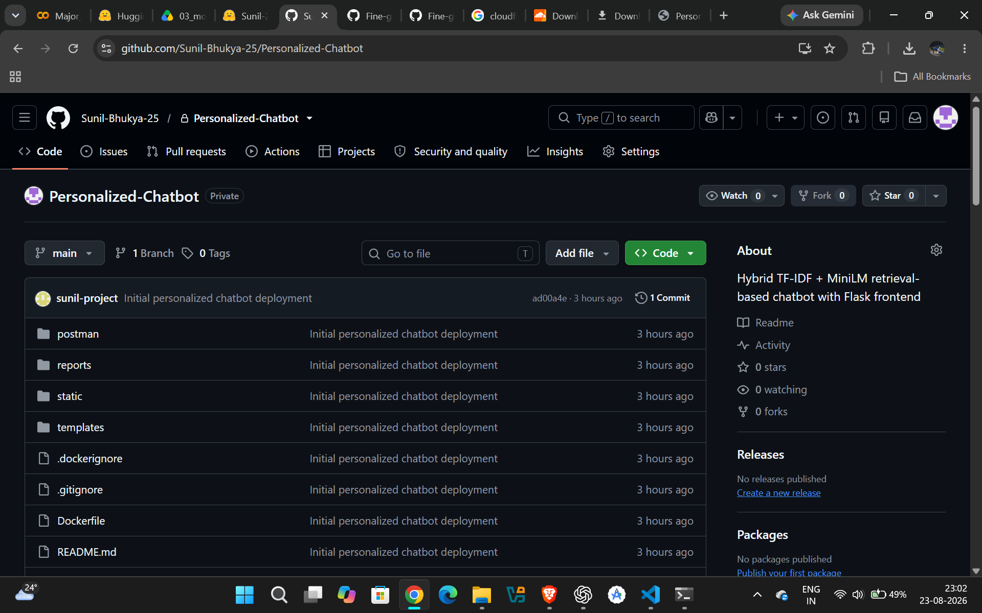
Figure 25.1: GitHub repository containing the project source and deployment files.
- Project source code: GitHub repository — Sunil-Bhukya-25/Personalized-Chatbot.
- Postman API collection and test report included in the project package.
- Final hybrid evaluation reports included in the project package.
- Final model artifacts stored separately from the GitHub deployment package.
- Cloudflare Quick Tunnel used only for temporary public demonstration.

26. Appendix

A. Final Project Structure
Personalized-Chatbot/
├── app.py
├── requirements.txt
├── Dockerfile
├── README.md
├── postman/
├── reports/
├── static/
│ ├── script.js
│ └── style.css
└── templates/
└── index.html

B. Final Model Artifacts
- tfidf_vectorizer.pkl
- tfidf_train_matrix.npz
- semantic_train_embeddings_fixed.npy
- semantic_train_indices_fixed.npy
- semantic_train_responses_fixed.json
- semantic_embedding_config_fixed.json

C. Final Demonstration Evidence
- Live chatbot screenshot
- Successful response screenshot
- Low-confidence/rejected response screenshot
- Flask server screenshot
- Cloudflare Tunnel screenshot
- GitHub repository screenshot
- Postman API screenshot

