MLOps Assignment 01 – Heart Disease Prediction Report

Heart Disease Prediction – MLOps Pipeline
MLOps Assignment 01 | BITS Pilani – AIMLCZG523
Student: Sunil Kumar | ID: 2024ac05659

Table of Contents
- Project Overview
- Setup & Installation Instructions
- Dataset & EDA Findings
- Feature Engineering & Modelling Choices
- Experiment Tracking Summary (MLflow)
- Model Packaging & Reproducibility
- API Design
- System Architecture Diagram
- CI/CD Pipeline
- Containerisation & Deployment
- Monitoring & Logging
- Repository Link

1. Project Overview
This project implements an end-to-end MLOps pipeline for binary classification of heart disease using the UCI Heart Disease Dataset. The pipeline covers every stage of the ML lifecycle: data acquisition, exploratory data analysis, preprocessing, model training with hyperparameter tuning, experiment tracking (MLflow), model packaging, REST API serving (FastAPI), containerisation (Docker), Kubernetes deployment, CI/CD automation (GitHub Actions), and production monitoring (Prometheus + Grafana).

Objectives
- Build a reproducible, production-grade ML pipeline following MLOps best practices.
- Train and compare four classifiers; select the best by ROC-AUC.
- Expose the model via a versioned REST API with health checks and Prometheus metrics.
- Automate the entire workflow with GitHub Actions CI/CD.
- Deploy to Kubernetes with liveness/readiness probes and resource limits.

Tech Stack
Category | Tools / Libraries
Language | Python 3.11
ML / Data | scikit-learn 1.5.0, XGBoost 2.0.3, pandas 2.2.2, numpy 1.26.4
Experiment Tracking | MLflow 2.13.2
API | FastAPI 0.111.0, Uvicorn 0.30.1, Pydantic 2.7.2
Testing | pytest 8.2.2, pytest-cov 5.0.0, httpx 0.27.0
Containers | Docker, Docker Compose
Orchestration | Kubernetes (Minikube / cloud K8s)
Monitoring | Prometheus 0.20.0, Grafana
CI/CD | GitHub Actions
Linting | flake8 7.0.0

2. Setup & Installation Instructions

Prerequisites
- Python 3.11+
- Docker & Docker Compose
- kubectl + Minikube (optional, for Kubernetes deployment)
- Git

Step-by-step Installation
1. Clone the repository
git clone https://github.com/Sunil-Kumar-2024ac05659/MLOps-Assign-1.git
cd MLOps-Assign-1
2. Create a virtual environment and install dependencies
python -m venv .venv
source .venv/bin/activate # Windows: .venv\Scripts\activate
pip install -r requirements.txt
3. Download the dataset
python data/download_data.py
# Saves: data/raw/heart_disease.csv (303 rows, 14 columns)
4. Train models
python src/train.py
# Trains 4 models, logs to MLflow, saves best_model.joblib
5. Launch MLflow UI
mlflow ui --port 5000
# Open: http://localhost:5000
6. Run the REST API
uvicorn api.main:app --reload --port 8000
# Swagger docs: http://localhost:8000/docs
7. Run tests
pytest tests/ -v --cov=src --cov=api

3. Dataset & EDA Findings

Dataset Summary
Property | Value
Source | UCI Machine Learning Repository – Heart Disease (ID: 45)
Total records | 303
Total columns | 14 (13 features + 1 target)
Target column | target – binarised: 0 = No Disease, 1 = Disease
Class balance | ~54% Disease (164), ~46% No Disease (139)
Missing values | Present in ca and thal columns (~1%)

Feature Description
Feature | Type | Description
age | Numerical | Age in years
trestbps | Numerical | Resting blood pressure (mm Hg)
chol | Numerical | Serum cholesterol (mg/dl)
thalach | Numerical | Maximum heart rate achieved
oldpeak | Numerical | ST depression induced by exercise
sex | Categorical | Sex (1=male, 0=female)
cp | Categorical | Chest pain type (0–3)
fbs | Categorical | Fasting blood sugar > 120 mg/dl
restecg | Categorical | Resting ECG results (0–2)
exang | Categorical | Exercise-induced angina (1=yes)
slope | Categorical | Slope of peak exercise ST segment
ca | Categorical | Number of major vessels coloured (0–3)
thal | Categorical | Thalassemia type

Key EDA Findings
- thalach (max heart rate) shows the strongest negative correlation with disease — patients with disease tend to have lower max heart rates.
- oldpeak (ST depression) shows positive correlation with disease presence.
- cp (chest pain type) is highly discriminative — type 0 (typical angina) strongly associated with disease.
- exang (exercise-induced angina) is a strong categorical predictor.
- chol shows weak correlation with the target, suggesting limited predictive power as a standalone feature.
- Class balance is near 54/46 — no resampling required; stratified splits used.
- Age distribution is right-skewed; older patients appear at higher risk.

EDA Visualisations

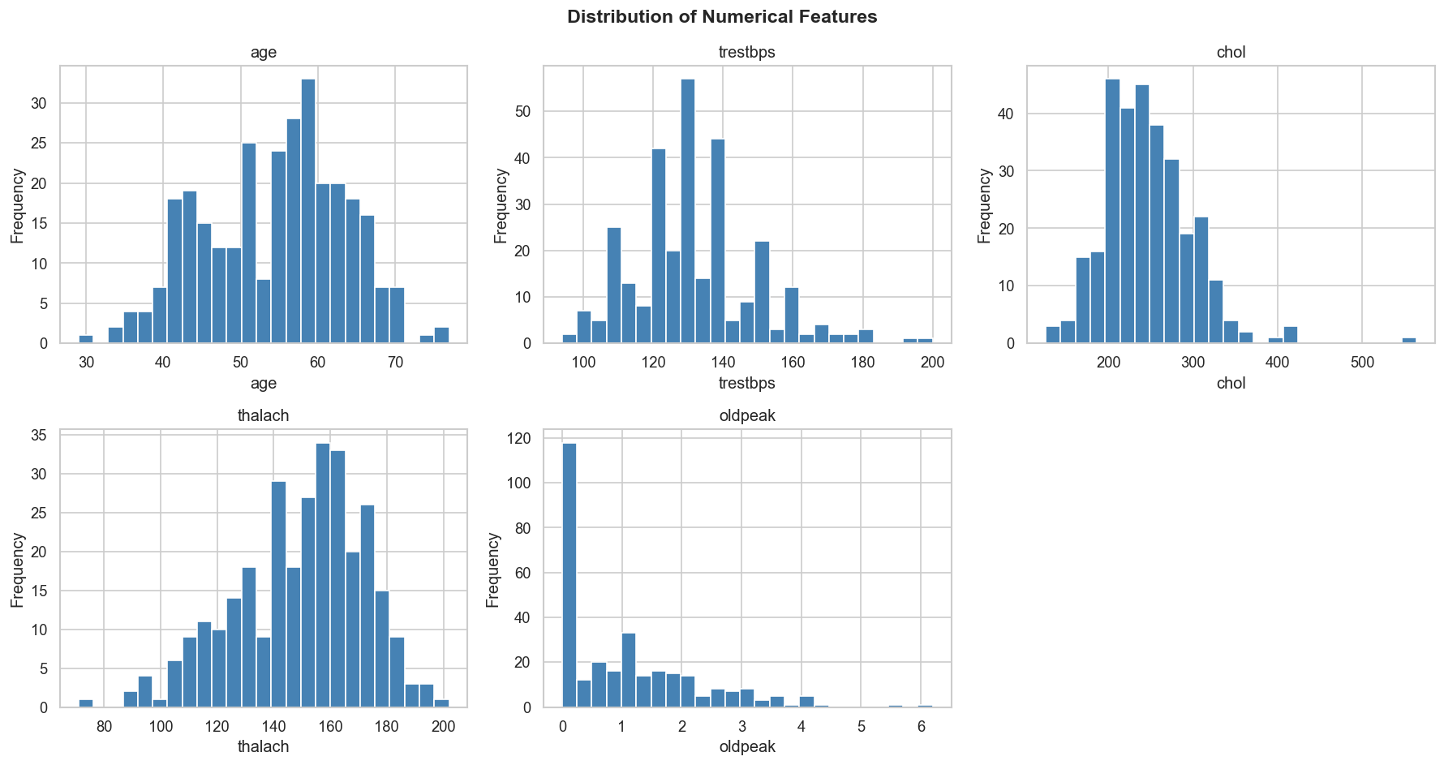
Figure 1: Distribution of Numerical Features (Histograms)

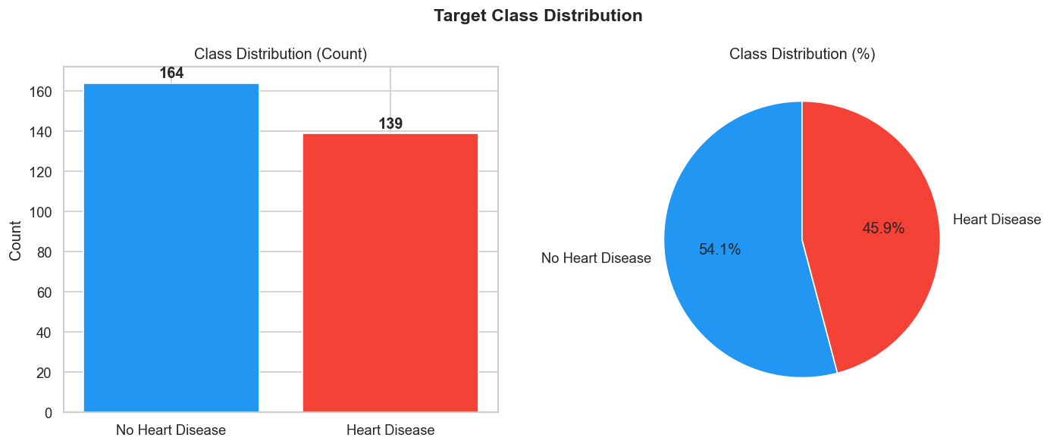
Figure 2: Target Class Distribution

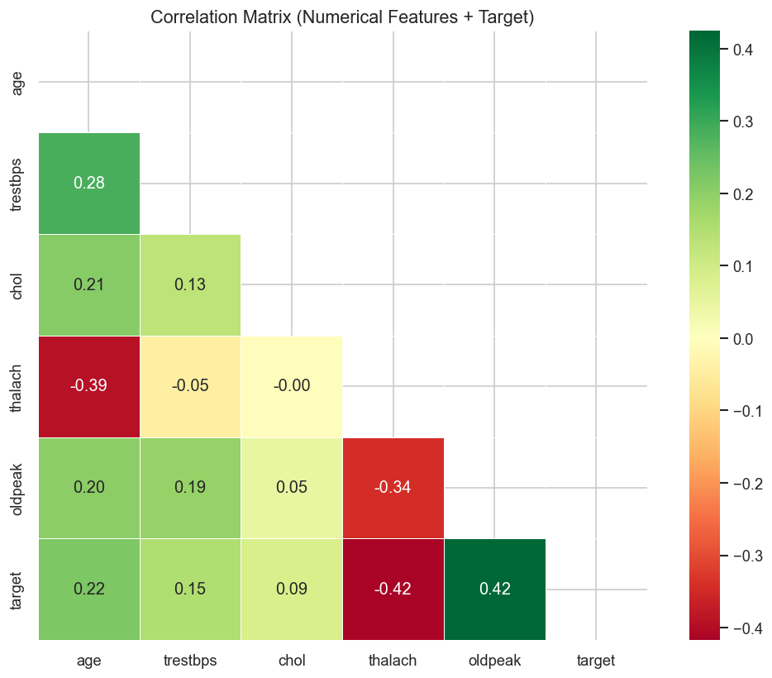
Figure 3: Correlation Matrix – Numerical Features vs Target

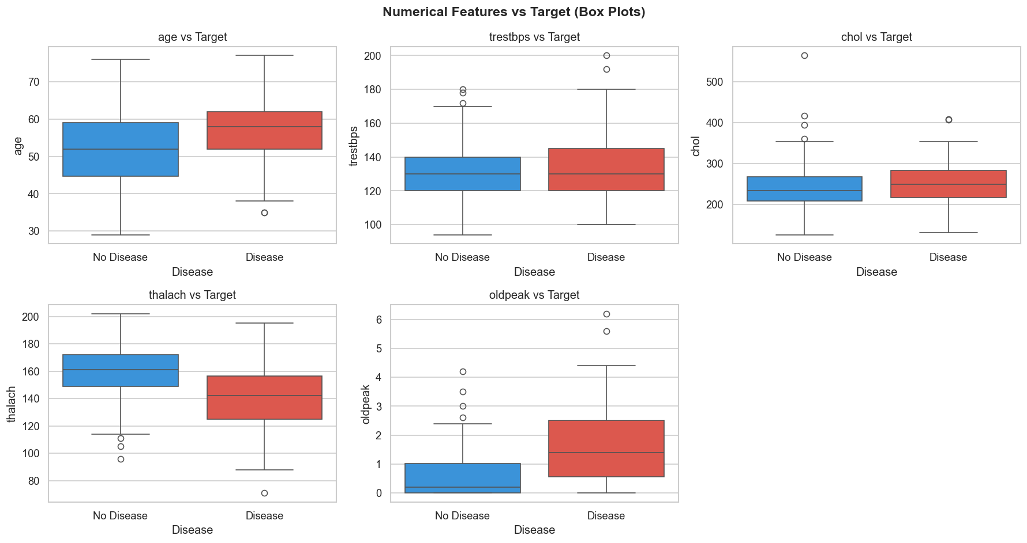
Figure 4: Numerical Features vs Target (Box Plots)

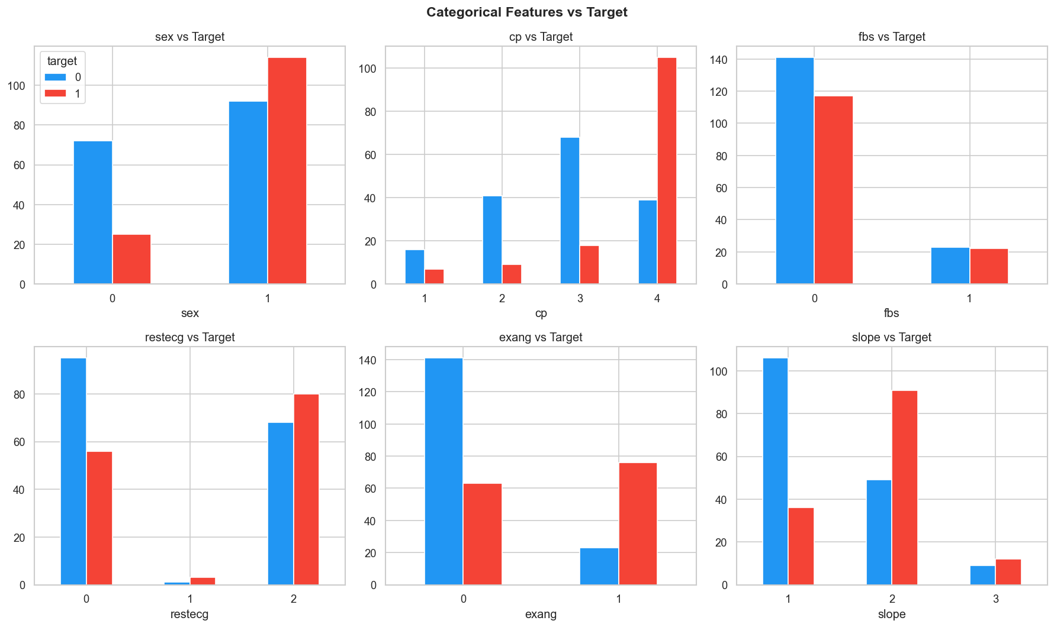
Figure 5: Categorical Features vs Target

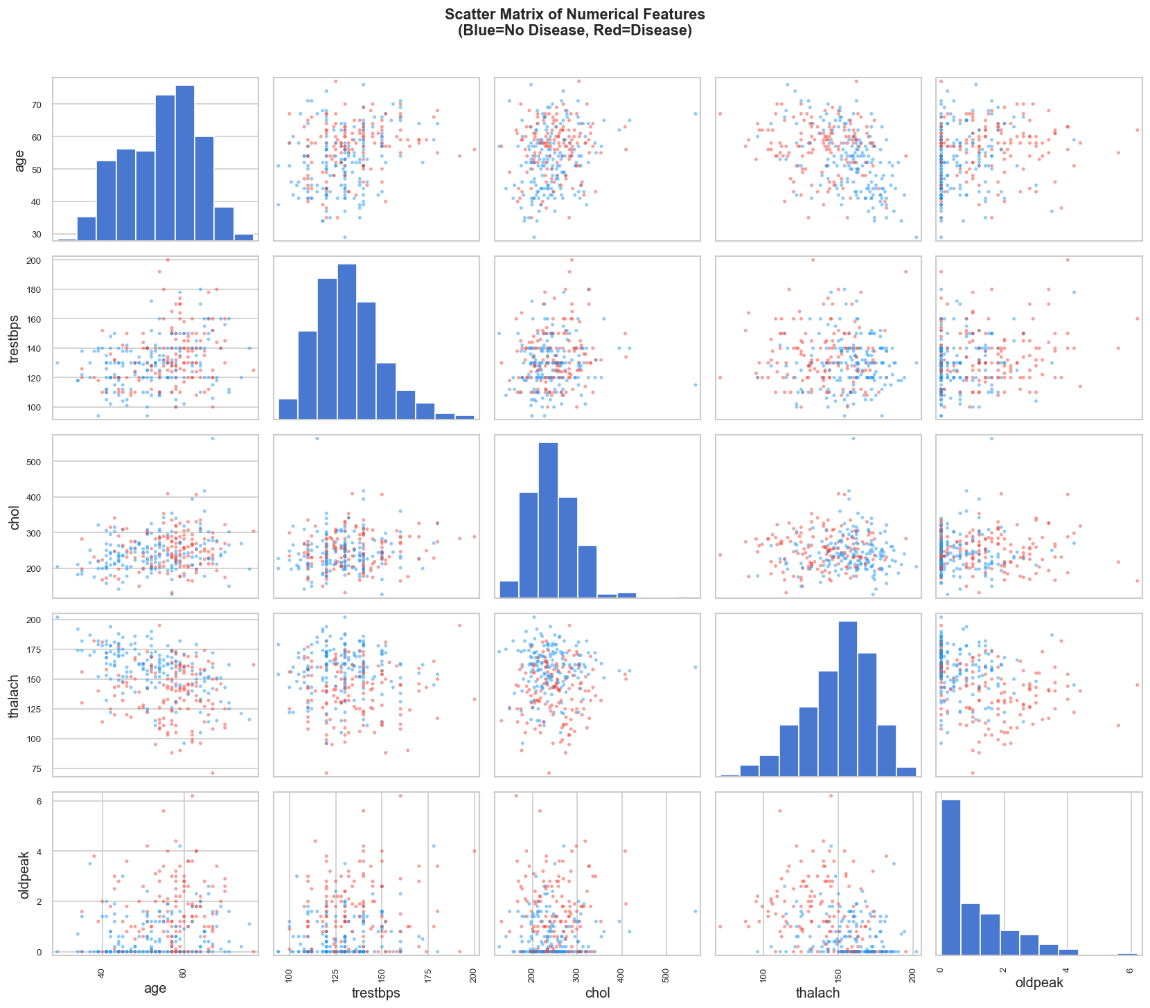
Figure 6: Scatter Matrix of Numerical Features

4. Feature Engineering & Modelling Choices

Preprocessing Pipeline
A scikit-learn ColumnTransformer is used to handle numerical and categorical features independently, inside a full Pipeline to prevent data leakage.
Step | Numerical Features | Categorical Features
Imputation | Mean imputation (SimpleImputer(strategy="mean")) | Most-frequent imputation
Scaling / Encoding | StandardScaler (zero mean, unit variance) | OneHotEncoder (handle_unknown="ignore")

Train / Test Split
- Split ratio: 75% train / 25% test
- Stratified on target class to preserve class balance in both sets
- Random state: 7
- Training samples: 227 | Test samples: 76

Models Trained
Model | Hyperparameter Grid | Notes
Logistic Regression | C: [0.001, 0.01, 0.1, 1.0, 5.0]  solver: [lbfgs, saga]  penalty: [l2]  max_iter: 2000 | Interpretable baseline; fast convergence
Random Forest | n_estimators: [150, 300]  max_depth: [None, 8, 15]  min_samples_split: [2, 4]  max_features: [sqrt, log2] | Ensemble; robust to outliers and feature scale
XGBoost | n_estimators: [150, 300]  max_depth: [3, 6, 9]  learning_rate: [0.01, 0.05, 0.1]  subsample: [0.8, 1.0] | Gradient boosting; regularisation via subsample
Gradient Boosting | n_estimators: [100, 200]  max_depth: [3, 5]  learning_rate: [0.05, 0.1, 0.2]  min_samples_split: [2, 5] | Scikit-learn native boosting; additional comparison model

Cross-Validation Strategy
10-fold Stratified K-Fold cross-validation (random_state=7) with GridSearchCV optimising for roc_auc. After tuning, a second cross_validate call on the best estimator records mean ± std for accuracy, F1, and ROC-AUC on the training set.

Model Comparison – Test Set Results
Model | Accuracy | Precision | Recall | F1 | ROC-AUC
Logistic Regression ✓ | 0.9211 | 0.9394 | 0.8857 | 0.9118 | 0.9554
Random Forest | 0.8684 | 0.8378 | 0.8857 | 0.8611 | 0.9526
XGBoost | 0.8553 | 0.8750 | 0.8000 | 0.8358 | 0.9449
Gradient Boosting | 0.7500 | 0.7353 | 0.7143 | 0.7246 | 0.8523
✓ Best model: Logistic Regression selected by highest ROC-AUC (0.9554).
0.9211
Accuracy
0.9394
Precision
0.8857
Recall
0.9118
F1 Score
0.9554
ROC-AUC

Best Model – Classification Report
precision recall f1-score support
No Disease 0.91 0.95 0.93 41
Disease 0.94 0.89 0.91 35
accuracy 0.92 76
macro avg 0.92 0.92 0.92 76
weighted avg 0.92 0.92 0.92 76
Best params: {'C': 0.1, 'penalty': 'l2', 'solver': 'lbfgs'}

5. Experiment Tracking Summary (MLflow)
MLflow is used for full experiment tracking. Every GridSearchCV run is wrapped in mlflow.start_run(). The following are recorded automatically:
- Parameters: best hyperparameters from grid search (e.g. C, solver, n_estimators, max_depth, learning_rate)
- Metrics: CV mean/std for accuracy, precision, recall, F1, ROC-AUC; test-set values for all five metrics
- Artifacts: confusion matrix PNG, ROC curve PNG, feature importance PNG, serialised sklearn pipeline
- Tags: model_name tag on each run for easy filtering

Experiment Configuration
Setting | Value
Experiment name | heart-disease-classifier
Tracking URI | Local filesystem (mlruns/)
CV folds | 10-fold Stratified K-Fold
Scoring metric | roc_auc
Total runs | 4 (one per model)

Launching MLflow UI
mlflow ui --port 5000
# Navigate to: http://localhost:5000
# Experiment: heart-disease-classifier
The MLflow UI provides a side-by-side comparison of all four runs, sortable by any metric. Artifact viewers allow inspection of plots and the serialised model directly in the browser.

6. Model Packaging & Reproducibility

Model Serialisation
The best pipeline (preprocessor + classifier) is serialised with joblib to models/best_model.joblib. The full sklearn Pipeline object is saved, which means the same preprocessing steps used at training time are automatically applied at inference — preventing any train/serve skew.

Model Metadata
A models/model_metadata.json file is written alongside the model:
{
"model_name": "LogisticRegression",
"metrics": {
"accuracy": 0.9211,
"precision": 0.9394,
"recall": 0.8857,
"f1": 0.9118,
"roc_auc": 0.9554
},
"num_features": ["age", "trestbps", "chol", "thalach", "oldpeak"],
"cat_features": ["sex", "cp", "fbs", "restecg", "exang", "slope", "ca", "thal"]
}

Reproducibility Measures
- All random states fixed: RANDOM_STATE = 7
- Pinned dependency versions in requirements.txt
- Deterministic data split via train_test_split(..., random_state=7, stratify=y)
- Pipeline includes preprocessor + model in a single joblib artifact
- MLflow logs every run's parameters, metrics, and artifacts for full audit trail
- Model also registered via mlflow.sklearn.log_model() for MLflow Model Registry compatibility

7. API Design
The model is served via a FastAPI application (api/main.py). The model pipeline is loaded once at startup using FastAPI's lifespan context manager.

Endpoints
Method | Endpoint | Description
GET | /health | Liveness check; returns model load status
GET | /metrics | Prometheus metrics (text format)
POST | /predict | Single-record heart disease prediction
POST | /predict/batch | Batch prediction (list of patients)
GET | /docs | Auto-generated Swagger UI

Request Schema (POST /predict)
curl -X POST http://localhost:8000/predict \
-H "Content-Type: application/json" \
-d '{
"age": 63, "sex": 1, "cp": 3, "trestbps": 145, "chol": 233,
"fbs": 1, "restecg": 0, "thalach": 150, "exang": 0,
"oldpeak": 2.3, "slope": 0, "ca": 0, "thal": 1
}'

Response Schema
{
"prediction": 1,
"label": "Heart Disease",
"confidence": 0.8712,
"probabilities": {
"no_disease": 0.1288,
"disease": 0.8712
}
}

API Design Decisions
- Pydantic v2 validation ensures all input fields are typed and bounded before inference.
- 503 response when model is not loaded (e.g. missing best_model.joblib).
- Structured logging via Python's logging module with timestamp, level, and module prefix.
- Optional features (slope, ca, thal) allow partial inputs; pipeline imputer handles missing values at serve time.

8. System Architecture Diagram
┌─────────────────────────────────────────────────────────────────────┐
│ DATA LAYER │
│ UCI Repository ──► download_data.py ──► data/raw/heart_disease.csv │
└───────────────────────────────┬─────────────────────────────────────┘
│
▼
┌─────────────────────────────────────────────────────────────────────┐
│ TRAINING LAYER │
│ │
│ src/data_processing.py │
│ ColumnTransformer (mean imputer + StandardScaler + OneHotEncoder)│
│ │ │
│ src/train.py ▼ │
│ GridSearchCV (10-fold StratifiedKFold, scoring=roc_auc) │
│ ├── LogisticRegression ◄── Best: ROC-AUC 0.9554 │
│ ├── RandomForest │
│ ├── XGBoost │
│ └── GradientBoosting │
│ │ │
│ MLflow Tracking ──► mlruns/ │
│ joblib.dump ──► models/best_model.joblib │
└───────────────────────────────┬─────────────────────────────────────┘
│
▼
┌─────────────────────────────────────────────────────────────────────┐
│ SERVING LAYER │
│ │
│ api/main.py (FastAPI + Uvicorn) │
│ GET /health ──► liveness check │
│ POST /predict ──► single inference │
│ POST /predict/batch ──► batch inference │
│ GET /metrics ──► Prometheus scrape endpoint │
└───────────────────────────────┬─────────────────────────────────────┘
│
┌───────────┴───────────┐
│ │
▼ ▼
┌─────────────────┐ ┌──────────────────────┐
│ MONITORING │ │ CONTAINERISATION │
│ │ │ │
│ Prometheus │ │ Dockerfile │
│ (port 9090) │ │ docker-compose.yml │
│ │ │ │ k8s/deployment.yaml │
│ ▼ │ │ k8s/service.yaml │
│ Grafana │ │ replicas: 2 │
│ (port 3000) │ └──────────────────────┘
└─────────────────┘
│
▼
┌─────────────────────┐
│ CI/CD LAYER │
│ GitHub Actions │
│ lint → test → │
│ train → docker │
└─────────────────────┘

9. CI/CD Pipeline
The CI/CD pipeline is defined in .github/workflows/ci-cd.yml and triggers on every push or pull request to main / develop.

Pipeline Stages
Stage | Tool | What it does
1. Lint | flake8 | Static analysis on src/, api/, tests/. Max line length 120. Fails fast before tests run.
2. Test | pytest + pytest-cov | Unit and integration tests with coverage report (XML + terminal). Uploads coverage.xml as artifact. Needs lint to pass.
3. Train | python src/train.py | Downloads dataset, trains all 4 models, logs to MLflow. Uploads best_model.joblib, model_metadata.json, and mlruns/ as artifacts. Needs tests to pass.
4. Docker Build & Test | Docker CLI + curl | Builds Docker image, runs container, waits for /health readiness, tests /predict endpoint. Collects logs on failure. Needs training to pass.

Pipeline YAML (key excerpt)
on:
push:
branches: [main, develop]
pull_request:
branches: [main]
jobs:
lint → test → train → docker-build # sequential dependency chain
# Stage 3: Train
- name: Download dataset
run: python data/download_data.py
- name: Train models
run: python src/train.py
- name: Upload trained model artifact
uses: actions/upload-artifact@v4
with:
name: trained-model
path: |
models/best_model.joblib
models/model_metadata.json

10. Containerisation & Deployment

Docker
Base image: python:3.11-slim. Layers are ordered for cache efficiency (dependencies installed before source copy).
# Build
docker build -t heart-disease-api:latest .
# Run standalone
docker run -p 8000:8000 heart-disease-api:latest
# Full stack (API + Prometheus + Grafana)
docker-compose up --build
Service | Port | Description
heart-disease-api | 8000 | FastAPI prediction service
prometheus | 9090 | Metrics collection; retention 7 days
grafana | 3000 | Dashboard; default password: admin

Kubernetes Deployment
Deployment manifest (k8s/deployment.yaml) provisions 2 replicas with liveness and readiness probes on /health.
# Start Minikube
minikube start
# Build image inside Minikube
eval $(minikube docker-env)
docker build -t heart-disease-api:latest .
# Deploy
kubectl apply -f k8s/deployment.yaml
kubectl apply -f k8s/service.yaml
# Get URL
minikube service heart-disease-api-service --url

Kubernetes Resource Limits
 | Memory | CPU
Requests | 256 Mi | 250m
Limits | 512 Mi | 500m

Probe Configuration
- Liveness probe: GET /health, initial delay 15s, period 20s
- Readiness probe: GET /health, initial delay 5s, period 10s

11. Monitoring & Logging

Prometheus Metrics
Three custom metrics are exposed at GET /metrics (scraped by Prometheus every 15s):
Metric Name | Type | Labels | Description
api_requests_total | Counter | endpoint, method, status | Total API requests by endpoint, method, and HTTP status
api_request_latency_seconds | Histogram | endpoint | Request latency in seconds per endpoint
predictions_total | Counter | label | Total predictions made, broken down by "Heart Disease" / "No Heart Disease"

Prometheus Scrape Config
global:
scrape_interval: 15s
scrape_configs:
- job_name: "heart-disease-api"
static_configs:
- targets: ["api:8000"]
metrics_path: /metrics

Grafana
Grafana is included in the Docker Compose stack, accessible at http://localhost:3000. Add Prometheus as a data source (http://prometheus:9090) and build dashboards from the three metric series above. Useful panels:
- Request rate per endpoint (rate of api_requests_total)
- P95/P99 latency histogram (from api_request_latency_seconds)
- Prediction class distribution over time (predictions_total)
- Error rate (status=5xx / total requests)

Application Logging
Python's standard logging module is configured at INFO level with the format timestamp | LEVEL | module | message. Key events logged:
- Model load at startup (path + success/failure)
- Each prediction (label + confidence)
- Batch prediction summary (record count)
- Prediction errors (exception message)
- API shutdown

12. Repository Link
GitHub Repository: https://github.com/Sunil-Kumar-2024ac05659/MLOps-Assign-1

Repository Structure
MLOps-Assign-1/
├── data/
│ ├── download_data.py # UCI dataset download script
│ └── raw/heart_disease.csv # 303 rows, 14 columns
├── src/
│ ├── data_processing.py # ColumnTransformer preprocessing pipeline
│ ├── train.py # 4-model training + MLflow tracking
│ └── inference.py # load_model() + predict() utilities
├── api/
│ └── main.py # FastAPI app with Prometheus metrics
├── tests/
│ ├── conftest.py
│ ├── test_data_processing.py
│ ├── test_inference.py
│ └── test_api.py
├── notebooks/
│ ├── 01_eda.ipynb # EDA with correlation, boxplots, distributions
│ └── 02_model_training.ipynb # Training walkthrough with MLflow
├── models/
│ ├── best_model.joblib # Serialised best pipeline
│ ├── model_metadata.json # Metrics + feature schema
│ └── tmp_plots/ # Confusion matrices, ROC curves, feature importances
├── k8s/
│ ├── deployment.yaml # 2 replicas, probes, resource limits
│ └── service.yaml
├── monitoring/
│ └── prometheus.yml # Scrape config
├── .github/workflows/
│ └── ci-cd.yml # lint → test → train → docker pipeline
├── Dockerfile # python:3.11-slim, HEALTHCHECK
├── docker-compose.yml # API + Prometheus + Grafana
└── requirements.txt # Pinned dependencies

MLOps Assignment 01 | BITS Pilani AIMLCZG523 | Sunil Kumar (2024ac05659)

