IEEE-IGNITE Hackathon 2026 | Problem SKIT002
MuleWatch
Demonstration Guide

AI-based detection of suspicious financial advertisements: posts that sell or rent bank accounts, ATM, debit and credit cards, current and savings accounts, and "full kits" used as money-mule accounts.
Event | IEEE-IGNITE Hackathon, 14–15 October 2026
Institute | Swami Keshvanand Institute of Technology (SKIT), Jaipur
Source code | https://github.com/vikashdhankar/mulewatch
Command center | http://localhost:8000 (presenter's laptop)
Public demo forum | http://103.155.85.18:8100 (Charcha)

Contents
1. What you are demonstrating The system, the two apps, how each expected outcome is covered
2. Links, logins and ports Every URL, account and token you need
3. One-time setup Laptop install, .env, forum on the CyberPanel server, Telegram, extension
4. Activation checklist What to run 30 minutes before presenting, and how to verify
5. Demo script Seven steps with what to do, what to say and what judges see
6. Copy-paste posts Ready-made posts for judges to submit live
7. Backup plan and troubleshooting Offline mode and fixes for common problems
8. Likely questions from judges Short answers
9. Command reference All commands on one page

1. What you are demonstrating
MuleWatch is a real-time monitoring and investigation system. It crawls public platforms every 3 seconds, reads every new post (including the text inside images), scores how likely it is to be selling or renting banking credentials, links posts that come from the same seller network, and alerts the investigator within seconds. Each case comes with highlighted evidence and a downloadable PDF evidence report.
For the demo, the system watches Charcha, a public Reddit-style community forum we built and seeded with 50 realistic posts. Judges can open the forum on their own phones, log in, and post anything. MuleWatch catches mule-account ads as they are posted.

1.1 The two applications
Application | Purpose | Where it runs | Address
MuleWatch command center | Crawler, AI detection engine, investigation dashboard | Presenter's laptop | http://localhost:8000
Charcha forum | Public community forum used as the live target. Login, posting with text, links and images, comments, votes | CyberPanel server (port 8100) | http://103.155.85.18:8100
Charcha forum (backup) | Same forum running on the laptop if the server or internet fails | Presenter's laptop | http://localhost:8100

1.2 How each expected outcome is covered
Expected outcome (problem statement) | What MuleWatch does | Where to show it
Collect or process publicly available advertisement data | Live crawler every 3 s reads every new post and every new comment from the schema.org JSON-LD that real forums publish, and downloads attached images. Any single link (post, ad, Telegram post, web page, image) can be checked on demand or watched every minute. Telegram public-channel crawler and a Chrome extension as extra inputs. | Monitored sources; Live intercepts; Check a post > Link
Identify suspicious keywords, images, phone numbers, URLs and payment details | English, Hindi and Hinglish lexicon with obfuscation handling (acc0unt, a.t.m); phone numbers in any format; UPI IDs; Telegram/WhatsApp links; IFSC; card numbers (masked); crypto wallets; prices. OCR reads text inside images. | Case page: highlighted text, Identifiers, Text read from the image
Classify advertisements based on risk indicators | Hybrid score 0–100 from rule engine + multilingual text model + image cues (+ optional Claude). Levels Low / Medium / High / Critical; categories Mule Account Sale, Account-Holder Recruitment, Card Sale, KYC Fraud. | Risk badge and score meter; Why it was flagged; score breakdown
Detect repeated or coordinated advertisements | Near-duplicate text (MinHash), reposted or edited images (perceptual hash), shared phone/UPI/Telegram/wallet. Linked posts form seller rings and get a risk boost. | Seller rings panel; Seller network graph; Linked posts
Provide evidence / context supporting a suspicious classification | Highlighted words and identifiers, OCR text, per-component scores, linked posts with the reason for each link, SHA-256 evidence hash, PDF evidence report. | Case page; Evidence report (PDF)
Generate alerts and an investigation dashboard | Real-time alert toast with sound, optional Telegram push to phone, a Telegram citizen reporting bot whose reports become cases, case management with verdicts, watchlist, takedown request to the platform. | Command center; Cases; Watchlist; Request takedown

2. Links, logins and ports
What | Value | Notes
Command center | http://localhost:8000 | Open on the projector laptop. If port 8000 is busy, run.sh prints the port it used (e.g. 8001)
Public forum | http://103.155.85.18:8100 | Judges open this on their phones
Backup forum | http://localhost:8100 | Started with ./run.sh --local-forum
Backup forum for phones on the same Wi-Fi | http://<laptop-IP>:8100 | Find the IP with hostname -I
API documentation | http://localhost:8000/docs | Interactive API (FastAPI)
GitHub repository | https://github.com/vikashdhankar/mulewatch | Code, README, tests
Forum demo login | demo / demo123 | Presenter account
Forum judge logins | judge1, judge2, judge3 / demo123 | Hand these to judges
Seeded forum users | <username> / charcha123 | e.g. rohit_traders / charcha123
Moderation (takedown) token | skit-cybercell-2026 | Must match on server and laptop .env
Ports | 8000 (command center), 8100 (forum) | Open 8100 on the server firewall

Keep these three tabs open on the presenter laptop
1. http://localhost:8000 (command center, sound on)
2. http://103.155.85.18:8100 (the forum, logged in as demo)
3. The GitHub repo, in case a judge asks about the code

3. One-time setup (do this before the event)
You need this only once. After that, use the activation checklist in section 4 every time you present.

3.1 Presenter laptop (Ubuntu)
Install system packages, download the code and start it once to install everything:
# system packages (Python virtualenv + OCR with Hindi)
sudo apt update
sudo apt install -y git python3-venv tesseract-ocr tesseract-ocr-hin

# get the code (if an old ~/Projects/mulewatch exists, move it aside first)
cd ~/Projects
[ -d mulewatch ] && mv mulewatch mulewatch_old
git clone https://github.com/vikashdhankar/mulewatch
cd mulewatch

# first start: creates .venv, installs packages, opens on :8000
./run.sh

The first start takes 1–2 minutes. When you see MuleWatch command center: http://localhost:8000, open that address. Stop it with Ctrl+C.
If GitHub asks for a password, the repository is private: enter your GitHub username and a personal access token (GitHub > Settings > Developer settings > Personal access tokens), or run gh auth login first.

3.2 Configure .env on the laptop
The first run creates .env from .env.example. Check these lines (open with nano .env):
FORUM_URL=http://103.155.85.18:8100
FORUM_MOD_TOKEN=skit-cybercell-2026
CRAWL_INTERVAL=3

# optional (section 3.4)
TELEGRAM_BOT_TOKEN=
TELEGRAM_CHAT_ID=

# optional AI analyst on the Check a post page
ANTHROPIC_API_KEY=

3.3 Forum on the CyberPanel server (103.155.85.18)
The forum runs as its own service on port 8100, so it does not touch the websites CyberPanel serves on ports 80 and 443.

a) Copy the forum to the server (run on the laptop)
cd ~/Projects
scp -r mulewatch/forum mulewatch/deploy root@103.155.85.18:/opt/charcha-src/

b) Install and start it (run on the server)
ssh root@103.155.85.18
sudo FORUM_MOD_TOKEN=skit-cybercell-2026 bash /opt/charcha-src/deploy/setup-forum-server.sh

The script installs Python packages into /opt/charcha/venv, seeds the 50 posts and their comments, creates a systemd service called charcha, and tries to open port 8100 in firewalld, ufw or CSF. It ends with a line starting with Charcha is running.

c) Open port 8100
- CyberPanel: Security > Firewall > add rule: name charcha, protocol TCP, port 8100 > Add.
- If your hosting provider has its own firewall or security group, allow TCP 8100 there too.

d) Verify from the laptop
curl -I http://103.155.85.18:8100 # expect: HTTP/1.1 200 OK

Then open http://103.155.85.18:8100 on your phone using mobile data (not the campus Wi-Fi), to be sure it is reachable from outside.

3.4 Telegram bot: citizen reporting and phone alerts
One Telegram bot does two jobs: anyone can forward a suspicious message, link or screenshot to it and get an instant verdict (each report becomes a case on the command center), and it can push Critical alerts to your phone.
- In Telegram, open @BotFather and send /newbot. Name: MuleWatch Report. Username: something ending in bot, e.g. SKITMuleWatchBot (MuleWatchBot may already be taken). Copy the token it gives you.
- Optional: in @BotFather send /setdescription and paste: Forward a suspicious message, link or screenshot about bank accounts or ATM cards for sale and get an instant check.
- Put the token in .env as TELEGRAM_BOT_TOKEN=... and restart ./run.sh.
- Open Monitored sources: the Citizen reporting bot panel should say Online and show a QR code. The same QR appears on the command center for judges to scan.
- For Critical alerts on your phone: in Monitored sources, the bot panel shows Phone alerts: send /alerts 123456. Send exactly that message to your bot from your phone. The bot replies Linked and alerts start arriving. Send /alerts off to stop. (No chat ID needed.)
The bot runs from the laptop (no public address needed). Only one copy of MuleWatch can use a bot token at a time; if the panel says Not connected with a Conflict error, close the other copy.
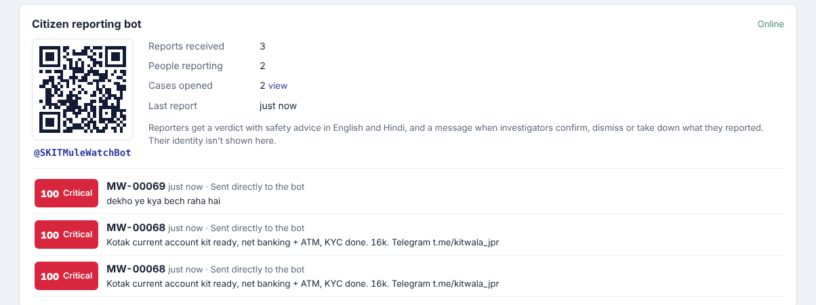
Citizen reporting bot panel: QR code, report counts and the latest reports

3.5 Optional: Chrome extension
- Open chrome://extensions and turn on Developer mode.
- Click Load unpacked and choose the folder ~/Projects/mulewatch/extension.
- On any website, select text or right-click an image and choose Check selected text with MuleWatch. The verdict appears as a notification and a badge, and the case is saved in the command center.

4. Activation checklist (30 minutes before presenting)
Follow these in order. Each command is safe to repeat.

4.1 Reset the forum to the original 50 posts (server)
This removes test posts and takedown flags from your rehearsal.
ssh root@103.155.85.18
sudo RESEED=1 FORUM_MOD_TOKEN=skit-cybercell-2026 bash /opt/charcha-src/deploy/setup-forum-server.sh

4.2 Start the command center with a clean slate (laptop)
cd ~/Projects/mulewatch
git pull # get the latest fixes
./run.sh --reset # clears old cases, crawls the forum again

Leave this terminal open. Within about a minute the command center shows the full forum scanned.

4.3 Verify before judges arrive
Check | Expected | If not
Top bar of http://localhost:8000 | Green dot, Monitoring 1 source, last crawl just now | See troubleshooting: source unreachable
Command center numbers | 67 posts and comments scanned, 18 critical, 1 high, 4 seller rings | Wait one minute; if the scanned count is above 67, reset the forum (4.1)
Monitored sources > Detection engine | Image text reading: Tesseract ready | sudo apt install tesseract-ocr tesseract-ocr-hin, restart
Sound button (top right) | Click it so it reads Sound on. You hear a short chime. | Unmute the laptop; browsers need one click before playing sound
Projector | Browser zoom 110–125% so the back row can read | Ctrl + plus
Judges' phones | http://103.155.85.18:8100 opens; logged in as judge1, judge2 | Use the backup plan in section 7

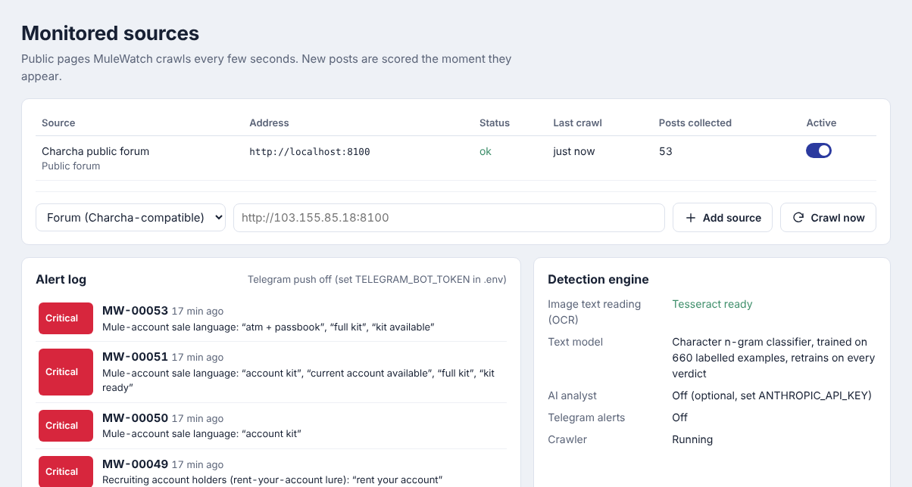
Monitored sources page: crawler status, alert log and detection engine status
Do a 30-second rehearsal
From your phone, post one test ad from section 6, watch the alert appear on the laptop, then reset the forum again (4.1) and restart with ./run.sh --reset so the judges start from a clean 50-post state.

5. Demo script (about 5 minutes)
Steps 7 and 8 are optional if time is short. Timings are approximate. Each step lists what to do, a suggested line to say, and what the judges will see.

Step 1. Set the scene (30 s)
Do | Show the Command center at http://localhost:8000. Point at the numbers, the Live intercepts feed and the Seller rings panel.
Say | "Money-mule accounts are bought and rented openly on social media. MuleWatch watches public platforms in real time. It has already scanned 50 posts and 17 comments on this forum, flagged 19 of them, and found 4 seller networks, without a single false alarm on the 48 normal ones. It even caught sellers hiding their ads in the comments of ordinary posts."
Judges see | Dashboard with 67 scanned, 18 critical, 1 high, 4 rings; red Critical rows in the live feed, some tagged comment.

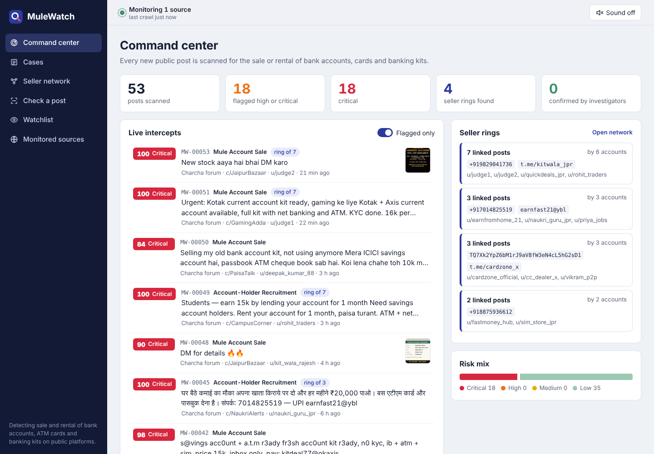
Command center: live intercepts, seller rings and risk mix

Step 2. A judge posts a mule ad live (60 s)
Do | Hand a judge a phone with http://103.155.85.18:8100 open and logged in as judge1.  Ask them to tap Create post, choose c/GamingAdda, and paste the text of sample A from section 6, then tap Post.
Say | "Please post this like a seller would. Watch the screen."
Judges see | Within about 3 seconds a red Critical alert slides in at the top right with a chime, and the post appears at the top of the feed tagged ring of 6: it reused the Telegram handle of an existing seller network.

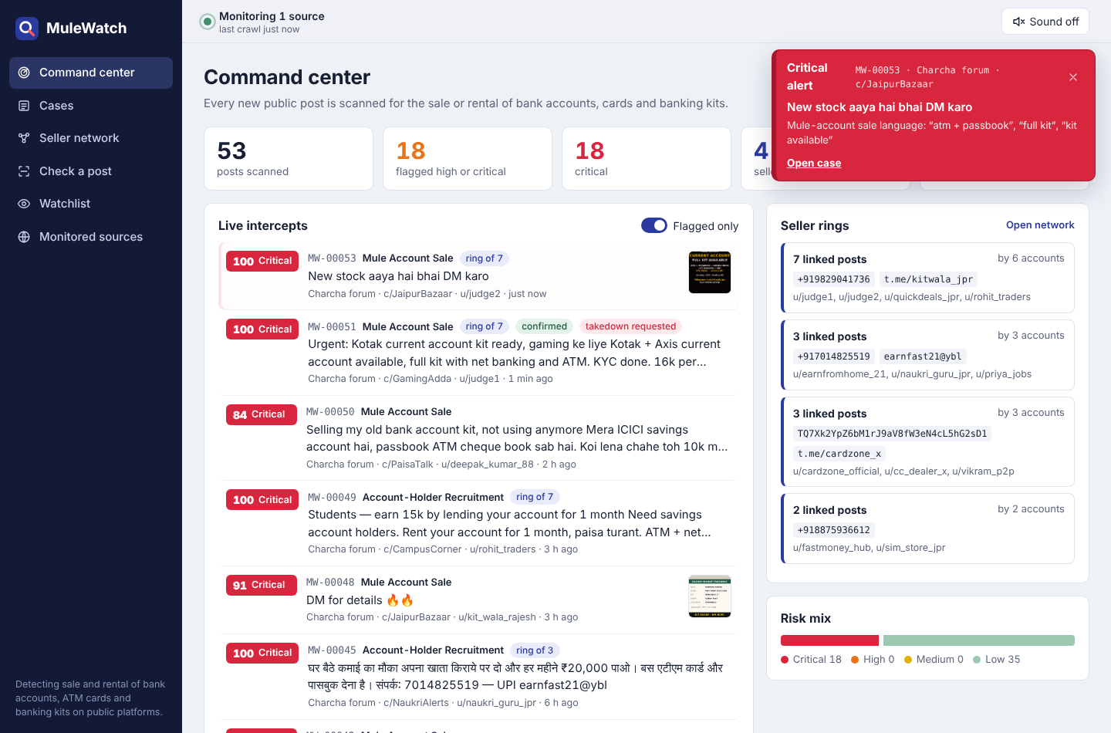
A Critical alert arriving in real time while the judge's post appears in the feed

Step 3. A harmless post stays quiet (30 s)
Do | Ask a second judge (judge2) to post sample B from section 6, an ordinary sale with a phone number.
Say | "Phone numbers and prices alone don't make something suspicious. The system looks for the combination of banking instruments, sale or rent intent, and evasion cues."
Judges see | The post shows up in the feed only when Flagged only is switched off, marked Low. No alert.

Step 3b. A scam hidden in a comment (30 s)
Do | Ask the judge to open any ordinary post (for example the wallet post) and add the comment from sample I in section 6.
Say | "Sellers know feeds are watched, so they hide in the comments of harmless posts. MuleWatch reads every comment too."
Judges see | A High alert within a few seconds, tagged comment, with the reason Easy-money lure. Request takedown hides just that comment on the forum.

Step 4. Open the case and explain the evidence (60 s)
Do | Click Open case on the alert (or the post in the feed).  Point at the highlighted words, the identifiers, Text read from the image, Why it was flagged and the score breakdown.
Say | "Every flag is explainable. Red is sale language, orange is evasion cues like KYC done, blue are identifiers. Here the image was read by OCR, so even image-only ads are caught. The score combines rules, a multilingual text model and image analysis."
Judges see | Score meter, colour-coded highlights, OCR text, reasons list and component scores. Linked posts on the right with why each one is linked.

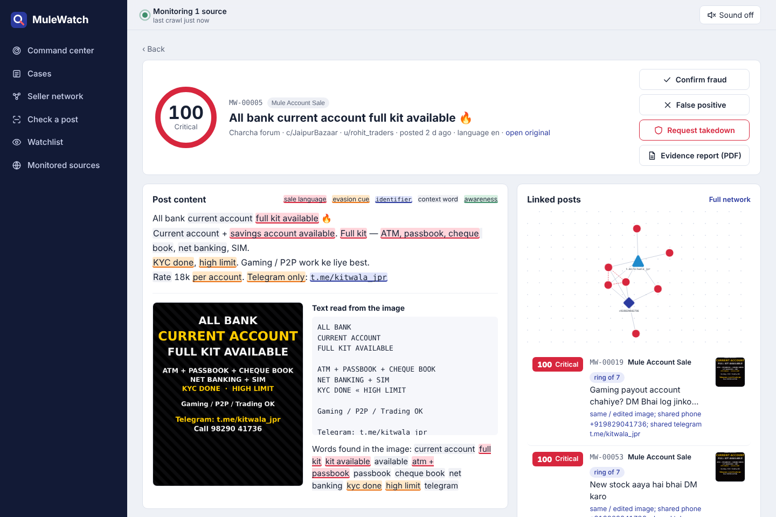
Case view: highlighted evidence, OCR text from the poster, linked posts

Step 5. Show the seller network (45 s)
Do | Click Full network (or the Seller network menu). Click the Telegram triangle or phone diamond.
Say | "Six different accounts, one seller. They share a phone number and a Telegram handle, and two of them posted the same poster with a different crop and tint. MuleWatch links them automatically, so police can go after the network, not one post."
Judges see | Graph: red posts connected to shared identifiers; dashed red lines for reposted images or copied text. Clicking a node shows every post that used it.

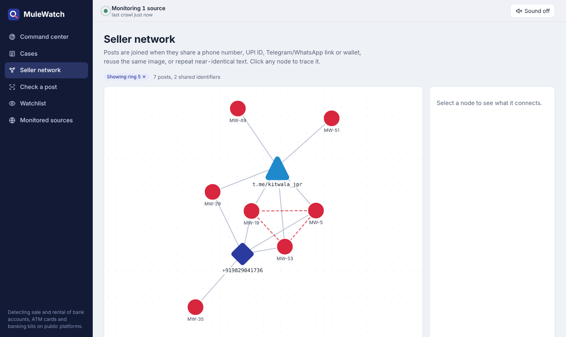
One seller ring: posts linked through a shared phone number, Telegram handle and reposted poster

Step 6. Take action: takedown and evidence report (45 s)
Do | Back on the case, click Request takedown. Refresh the post on the judge's phone.  Click Evidence report (PDF) and scroll through it.  Optionally click Confirm fraud.
Say | "The investigator can ask the platform to take the post down; the forum immediately shows a Cyber Cell review notice. The PDF is ready to attach to an NCRP complaint, with a SHA-256 hash so the evidence can be shown to be unaltered."
Judges see | On the phone the post is greyed out with a red under review by the Cyber Cell banner. The PDF opens with case details, highlighted text, identifiers, linked posts and the hash.

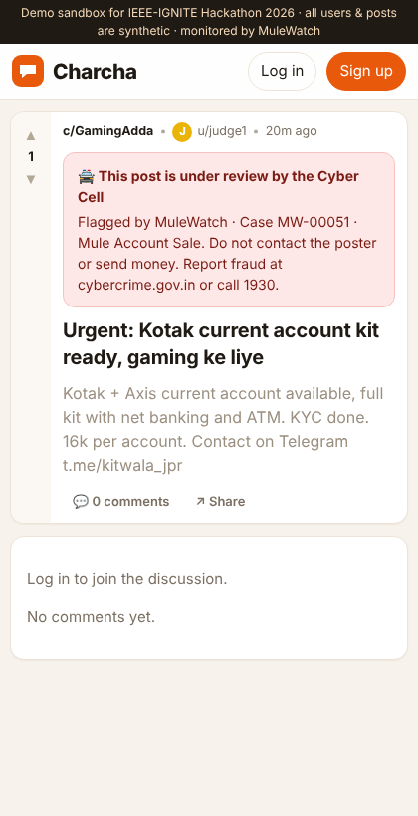
The forum post after Request takedown

Step 6b. Citizens report through Telegram (45 s)
Do | Point at the QR code on the command center. Ask a judge to scan it, press Start, and forward or paste sample J from section 6 (or forward any message from a Telegram channel).  Show the case appear on the command center tagged reported by 1 citizen. Click Confirm fraud.
Say | "Investigators can't watch everything, but citizens see these ads every day. Anyone can forward one to our bot and get an answer in seconds, in English and Hindi. Every report becomes a case here, identical reports are grouped, and when we act, the reporter is told."
Judges see | The judge's phone gets a verdict with reasons and safety advice within a few seconds; after Confirm fraud it gets a second message: investigators have confirmed it as fraud.

Step 7. Check any link (30 s, optional)
Do | Open Check a post, keep the Link tab, paste a link and click Check post. Good choices: a forum post link such as http://103.155.85.18:8100/p/5, a public Telegram post (t.me/channel/123), or any public ad page.  Optionally right-click a link on any website and choose Check this link with MuleWatch (Chrome extension).
Say | "Investigators don't only watch feeds; they get tip-offs. Paste any link and MuleWatch reads the page, its preview data and its pictures, and tells you in seconds whether it's selling accounts, and whether it's linked to a known seller."
Judges see | A note saying where the content was read from, the verdict and score, "linked to N other posts" when it shares a phone, UPI or Telegram handle with a known ring, and the same evidence view as a case.

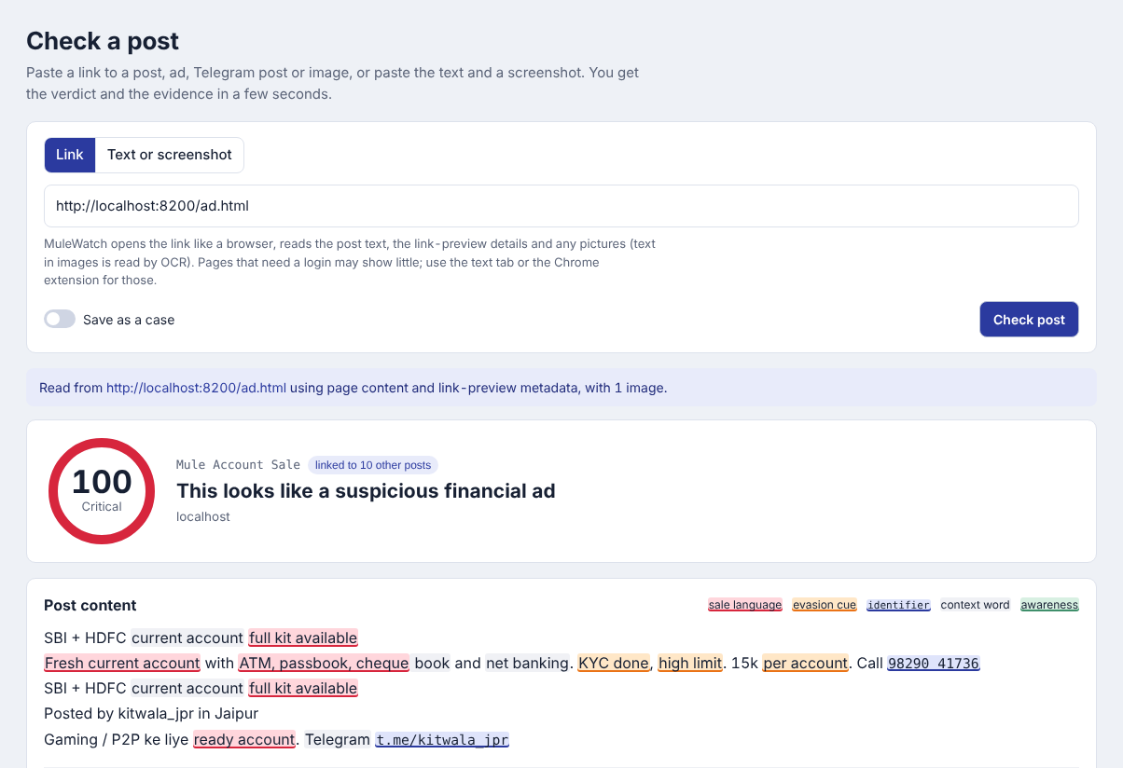
Checking a single link: content read from the page and its image, scored and linked to a known ring

Step 8. Tricky cases and learning (30 s, if time allows)
Do | In Cases, search Never sell and open the PSA post; search debit card and open the student's post.  On any borderline case, click False positive.
Say | "An awareness post that uses every keyword stays Low, and a student showing off a new debit card isn't a seller. When an investigator marks a mistake, the model retrains and rescores everything instantly."
Judges see | Both tricky posts are Low with an explanation. After False positive, a message confirms the model learned and the scores update.

6. Copy-paste posts for the live demo
Save these on the judges' phones (for example in a WhatsApp chat to yourself) so they can paste them quickly.
 | Community | Title | Text | Expected result
A | c/GamingAdda | Urgent: Kotak current account kit ready | Kotak + Axis current account available, full kit with net banking and ATM. KYC done. 16k per account. Contact on Telegram t.me/kitwala_jpr | Critical, joins the kitwala ring
B | c/JaipurBazaar | Selling my cycle | Hero Sprint cycle, 1 year old, ₹3,000. Call 9876512345 | Low, no alert
C | c/CampusCorner | Part time income for students | Apna bank account kiraye pe do, har mahine 25k milega. Sirf gaming transactions. WhatsApp 70148 25519 | Critical, joins the rent-your-account ring
D | c/PaisaTalk | खाता उपलब्ध | करंट अकाउंट उपलब्ध, पूरा किट मिलेगा — एटीएम पासबुक चेकबुक। संपर्क 9876501234 | Critical (Hindi)
E | c/JaipurBazaar | s@vings acc0unt r3ady | fr3sh acc0unt kit, a.t.m + ib, n0 kyc. inbox only | Critical (obfuscated spelling)
F | c/JaipurBazaar | New stock aaya hai | DM karo. Attach image kit_poster_repost.jpg (forum/seed/images on the laptop; copy it to the phone first) | Critical from the image alone; same-poster link
I | A comment under any post | (comment) | Contact 7678246551 to earn money | High, tagged comment; Request takedown hides only the comment
J | Telegram bot (scan the QR) | (message to the bot) | Bhai apna khata kiraye pe do, har mahine 25k. Sirf gaming. WhatsApp 70148 25519 | Very likely a scam, linked to the rent-your-account ring; case tagged reported by 1 citizen
H | Check a post > Link | (any link) | http://103.155.85.18:8100/p/5 or a public t.me/channel/123 post or any public ad page | Score and evidence for that page; linked to a ring if it shares identifiers
G | c/PaisaTalk | Beware of account rental scams | Never sell or rent your bank account. It makes you a money mule. Report to 1930. | Low (awareness)

Watchlist moment (optional)
Open Watchlist, add phone 9876512345 with note "tip from informant". The harmless cycle post (sample B) immediately becomes Critical with reason Watchlist hit. Remove it afterwards.

7. Backup plan and troubleshooting

7.1 If the server or venue internet fails
Run everything on the laptop. Judges on the same Wi-Fi can still post from their phones.
# stop the running command center with Ctrl+C, then:
cd ~/Projects/mulewatch
./run.sh --local-forum --reset

# give judges this address (laptop IP on the same Wi-Fi):
hostname -I # e.g. 192.168.1.23 -> http://192.168.1.23:8100
sudo ufw allow 8100/tcp # only if Ubuntu's firewall is on

If phones can't reach the laptop (campus Wi-Fi often isolates devices), present from the laptop alone: open http://localhost:8100 in a second browser window, log in as judge1 and post from there while the judges watch the command center.

7.2 Common problems
Symptom | Cause | Fix
./run.sh: No such file or directory | Not inside the cloned folder, or an old folder with the same name | cd ~/Projects/mulewatch and check ls run.sh; if missing, move the folder aside and clone again (3.1)
ensurepip is not available or venv error | python3-venv not installed | sudo apt install -y python3-venv, then rm -rf .venv and run again
Top bar says Source unreachable | Laptop can't reach the forum | curl -I http://103.155.85.18:8100; check port 8100 in CyberPanel firewall; on server systemctl status charcha; or use 7.1
No alert sound | Browser blocked audio | Click Sound off so it becomes Sound on; unmute laptop
Image posts show no OCR text | Tesseract missing | sudo apt install tesseract-ocr tesseract-ocr-hin, restart run.sh
Request takedown fails | Token mismatch | Same FORUM_MOD_TOKEN in laptop .env and server service; re-run setup script with the token
Posts scanned higher than 50 before demo | Test posts from rehearsal | Reset forum (4.1) and ./run.sh --reset
Command center opened on 8001, not 8000 | Another program on the laptop already uses port 8000; run.sh picks the next free port | Use the address run.sh prints, or choose one: ./run.sh --port 8010
Old MuleWatch still running in another terminal | A previous run.sh was not stopped | Press Ctrl+C in that terminal, or fuser -k 8000/tcp 8100/tcp
Link check says login required, or shows little text | Facebook, Instagram and WhatsApp hide posts from logged-out visitors | Open the post in Chrome and use the extension's Check this page, or paste the text and a screenshot
Link check refuses a local address | Links into private networks are blocked for safety (only the demo forum is allowed) | Use the public address of the page
Bot panel says Not connected | No internet, wrong token, or another copy of MuleWatch uses the same token | Check the token in .env; close other copies; the bot reconnects by itself
Bot doesn't reply | Message sent in a group, or the laptop is offline | Message the bot directly (private chat); check the panel shows Online
Request takedown says the post is no longer on the forum | The forum was reset after this case was captured | Expected; take down a post that exists on the forum now
Forum page error after server reboot | Service stopped | sudo systemctl restart charcha; logs: journalctl -u charcha -n 50

8. Likely questions from judges
How accurate is it?
On the 50 forum posts and 17 comments, which the model never saw during training (19 mule, card or easy-money items, 48 normal or tricky), it caught all 19 with no false alarms. Run python training/evaluate.py in backend/ to reproduce. It is a small synthetic set, so we treat it as a sanity check; the feedback loop is how accuracy improves with real cases.
Is this just keyword matching?
No. Rules are one of three signals. A character n-gram model handles Hinglish spelling variants and obfuscation; OCR covers images; ring detection adds network evidence. Awareness posts that contain every keyword stay Low because context lowers risk.
How would it work on real platforms?
The collectors are pluggable. The forum crawler reads standard schema.org structured data that most forums publish; the Telegram collector reads public channel previews without login; the Chrome extension lets an investigator send anything they see. Platform APIs or trust-and-safety feeds can be added as new sources.
Why character n-grams instead of a large model?
It runs offline on a laptop in milliseconds, retrains instantly from investigator feedback, and handles Hindi, Hinglish and leetspeak without a tokenizer. An optional Claude second opinion can be switched on with an API key.
What about privacy and misuse?
Only publicly available content is collected. Card numbers are masked. Scores are leads for a human investigator, not automatic punishment; every case has a verdict step and an evidence trail.
How does it detect coordination?
Three independent links: near-identical text (MinHash), the same image even if cropped or recoloured (perceptual hash), and shared identifiers such as phone, UPI, Telegram or wallet. Connected posts form a ring, and ring membership raises the score.
Can it scale?
Each post is analysed in milliseconds. SQLite and a single process are enough for the demo; the same code runs on PostgreSQL with a task queue for production volumes.

9. Command reference
Task | Command | Where
Start command center | ./run.sh | Laptop, in ~/Projects/mulewatch
Start on a specific port | ./run.sh --port 8010 | Laptop
Check a link from the terminal | curl -X POST localhost:8000/api/analyze/url -H 'Content-Type: application/json' -d '{"url":"https://t.me/channel/123","save":false}' | Laptop
Start with clean cases | ./run.sh --reset | Laptop
Start with local backup forum | ./run.sh --local-forum | Laptop
Update code | git pull | Laptop
Run tests | cd backend && ../.venv/bin/python -m pytest -q | Laptop
Accuracy on forum posts | cd backend && ../.venv/bin/python training/evaluate.py | Laptop
Reseed local forum | cd forum && ../.venv/bin/python seed_forum.py | Laptop
Copy forum to server | scp -r mulewatch/forum mulewatch/deploy root@103.155.85.18:/opt/charcha-src/ | Laptop
Install / update forum | sudo FORUM_MOD_TOKEN=skit-cybercell-2026 bash /opt/charcha-src/deploy/setup-forum-server.sh | Server
Reset forum to 50 posts | sudo RESEED=1 FORUM_MOD_TOKEN=skit-cybercell-2026 bash /opt/charcha-src/deploy/setup-forum-server.sh | Server
Forum status / restart | systemctl status charcha / sudo systemctl restart charcha | Server
Forum logs | journalctl -u charcha -f | Server
Bot status | curl localhost:8000/api/bot | Laptop
Check forum from laptop | curl -I http://103.155.85.18:8100 | Laptop
Free busy ports | fuser -k 8000/tcp 8100/tcp | Laptop

All users, phone numbers, handles and banks in the demo data are fictional. The forum is marked as a sandbox and blocks search engines.

