COVER LETTER

In Jio Platforms, we were developing new technologies as well as patent them, I have mentioned one patent in my resume. Recently, we were granted one more patent “METHOD AND SYSTEM FOR REAL-TIME ANALYSIS OF KEY PERFORMANCE INDICATORS (KPIS) DEVIATIONS”. This patent aims to resolve the network backlogs and bottlenecks using real-time network data calculated as KPI in the product designed by me and my team. We leveraged big data computation using spark to generate our data samples and train an LLM Model for forecasting the KPI trends in future. It immensely helped with network capacity planning.

Patent1:

METHOD AND SYSTEM FOR REAL-TIME ANALYSIS OF KEY PERFORMANCE INDICATORS (KPIS) DEVIATIONS

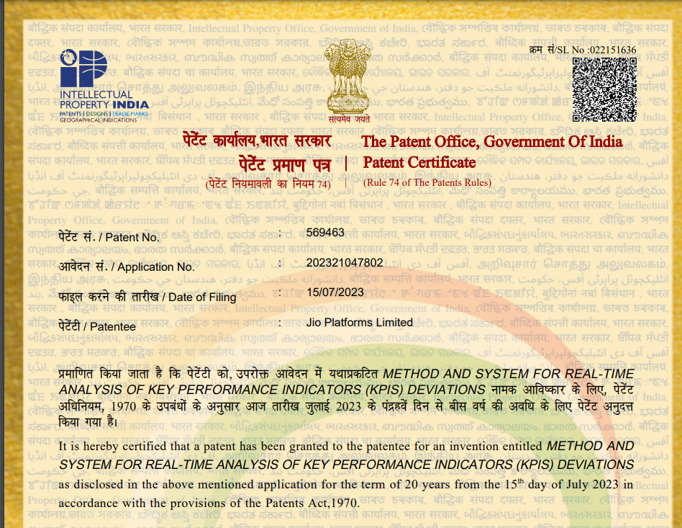

Patent2:

METHOD AND SYSTEM OF DETECTING ANOMALY IN A NETWORK

