PXO: Poly-XTAL operations V10.00. Free MATLAB codebase to generate and analyse complex 2D poly-crystalline grain structures

**DEVELOPER’S MANUAL V1.0**

Sunil Anandatheertha1

1PhD student, Faculty of Engineering and Computing, Coventry University, Coventry CV1 5FB, UK

**Author contributions**

|  |  |
| --- | --- |
| Sunil Anandatheertha | Conceptualization, Software development and maintenance, documentation and manuscript preparation |

**Table of Contents**

1.1. Data structure 1

1.2. PXO Structure 4

## Data structure

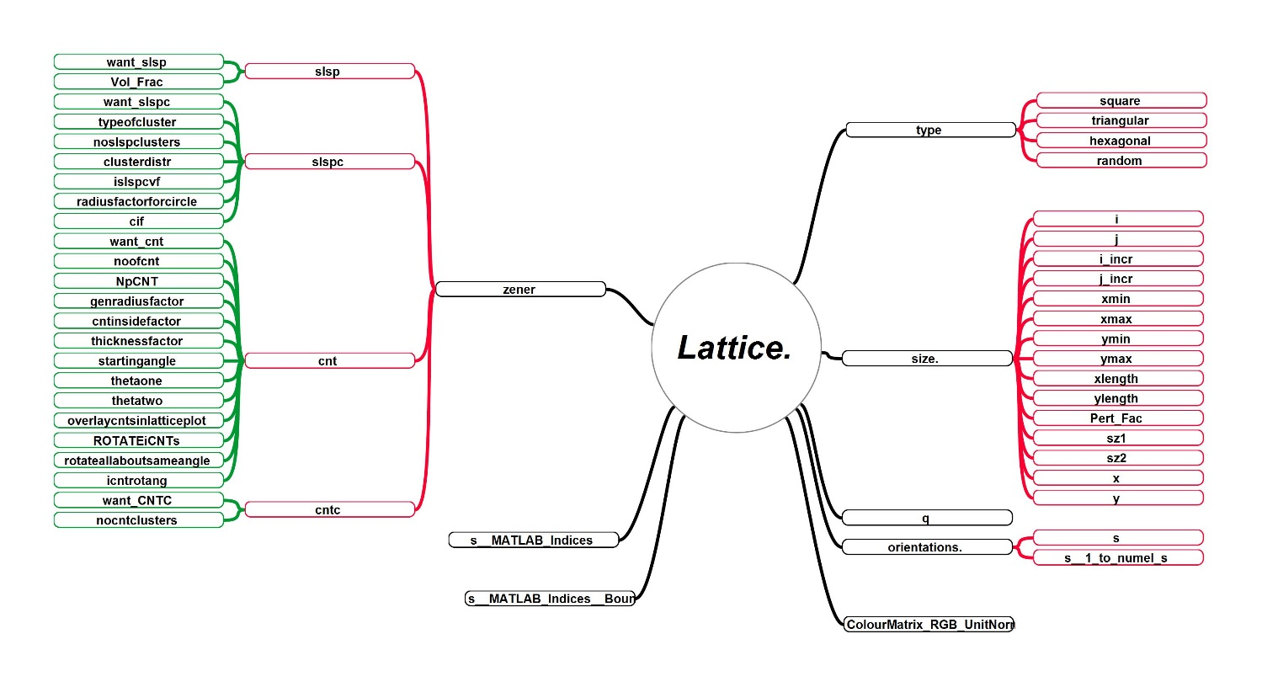

Figure 12: “Lattice” data structure

The structure **Lattice** is declared a global variable and is shown in the above figure stores user primary and secondary information about the lattice. Its level 1 sub-structures include type, size, q, orientations, Zener, s__MATLAB_Indices, S__MATLAB_Indices__Bounds and ColourMatrix_RGB_UnitNorm.

* “**type**” indicates the underlying lattice type. Its sub-structures are self-explanatory. The number of nearest neighbours to be considered in calculating is provided under the root structure “MC_Param”.
* “**size**” indicates the details of the grid. ‘i’ and ‘j’ are . WRITE HERE. ‘**x**’ and ‘**y**’ are the coordinates of the grid points and the ‘Pert_Fac’ controls the random perturbation introduced to ‘x’ and ‘y’.
* “**q**” is the total number of unique (states)/(configuration)/(crystal orientation) of the system.
* “**orientations**” is the grid of unique **q** value at each grid point. ‘**s**’ is the state matrix and ‘**s__1_to_numel_s**’ is the matrix having MATLAB’s indices of **s** (SEE IF THIS IS CORRECT).
* “**ColourMatrix_RGB_UnitNorm**” is a ‘**q** X 3’ vector storing normalized components of colour vectors r[0:255], g[0:255] and b[0:255]. Unit-normalization is done by 255. This is a random distribution with each colour associated to every unique value in “**orientations**”.
* “**s__MATLAB_Indices**” EXPLAIN HERE
* “**s_MATLAB_Indices__Bounds**” EXPLAIN HERE
* “**zener**” stores information of 2nd phase particles. Its substructures include “**slsp**”, “**slspc**”, “**cnt**” and “**cntc**”. They stand for “**s**ingle **l**attice **s**ite **p**articles”, “**s**ingle **l**attice **s**ite **p**article **c**lusters”, “**c**arbon **n**anotube **t**ype particles” and “**c**arbon **n**anotube **t**ype particle **c**lusters” respectively.

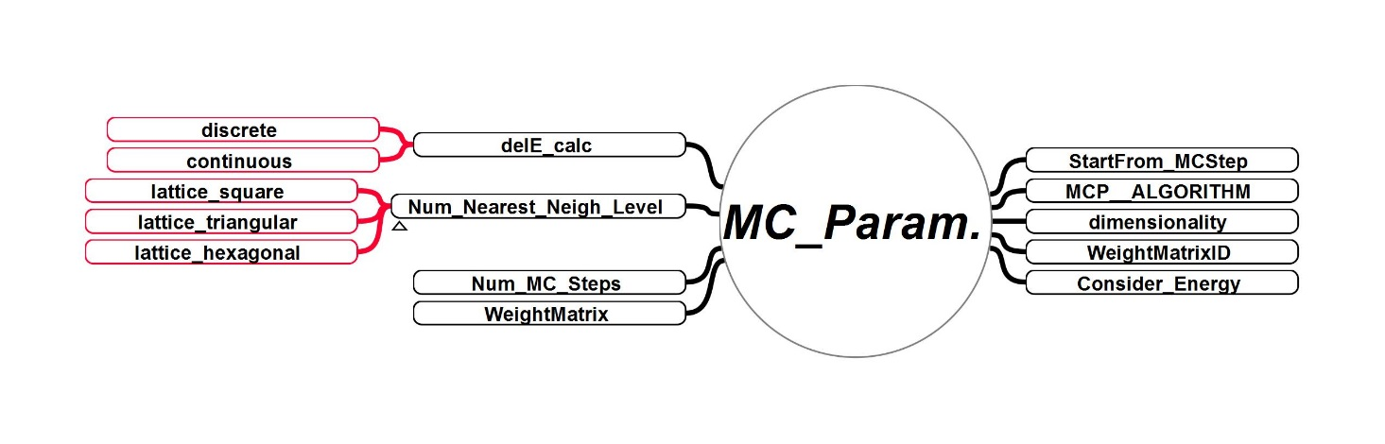

Figure 13: “MC_Param” data structure

The structure **MC_Param** is declared a global variable and is shown in the above figure. It stores user input information about the Monte-Carlo technique. Its level 1 and level 2 sub-structures are shown. Discrete and continuous sampling can be carried out and these are included in delE_calc. Square, triangular and hexagonal lattice can be chosen over the underlying square, triangular and hexagonal grid respectively. The number of Monte-Carlo steps over the entire domain is entered in “Num_MC_Steps”. The nth step to continue an ended simulation is entered in “StartFrom_MCStep”. Algorithm to be used is entered in “MCP_ALPGORITHM”. The number of dimensions of the domain is entered in “dimensionality”. The “WeightMatrixID” contains ID of the stored WeightMatrix WM applicable in KWF1A1, KWF1B1, KWF1B2, KWF1B3, KWF1C1, KWF1C2 and KWF1C3. Consider_Energy = 1 will save the Hamiltonian , else it won’t be.

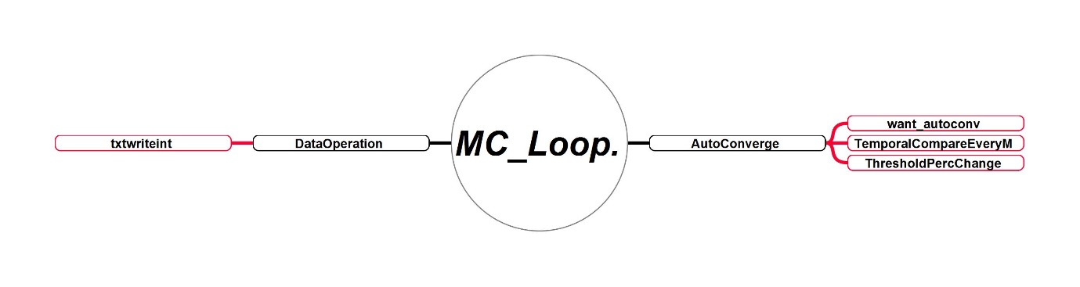

Figure 14: “MC_Loop” data structure

The structure “**MC_Loop**” is used to controls the evolutionary behaviour of energy calculation using the AutoConverge option while decides whether to end the energy calculations if becomes asymptotic with , which is decided by the Threshold Minimum Percentage Change specified in “ThresholdPercChange”. Sub-structures in “DataOperation” controls the data read and write operations.

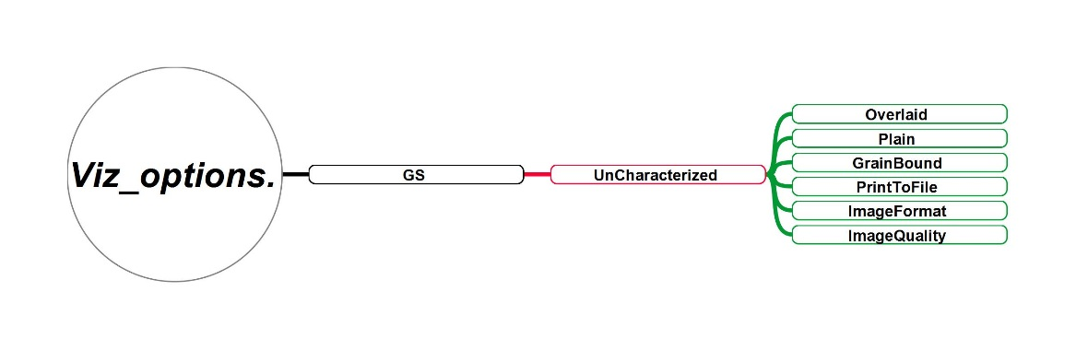

Figure 15: “Vis_options” data structure

The structure is designed to store all visualization options and parameters. The grain structure parameters “GS” currently contain only those parameters needed in the visualization of uncharacterized grain structure. Overlaid = 1 overlays the grain boundary on the coloured markers at the pixels, Plain = 1 plots lattice site orientations using coloured square markers, GrainBound = 1 plots the grain boundaries using black colour filled quares. PrintToFile controls whether the plot is exported to image file in the format specified in ImageFormat, with a quality specified by ImageQuality.

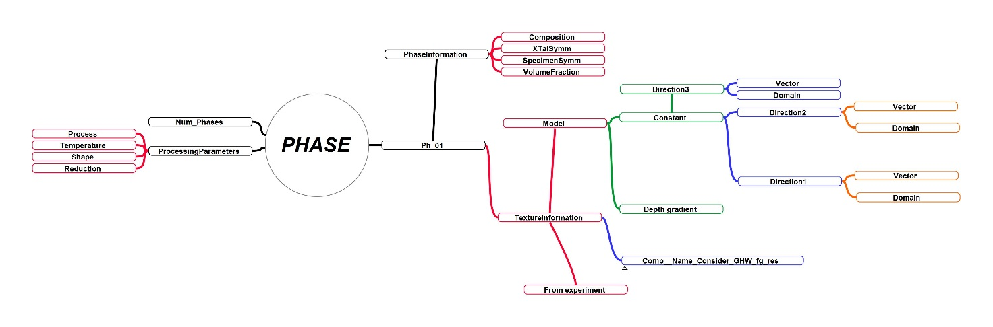

Figure 16: “PHASE” data structure

Each phase is stored under Ph_N, where N is the Nth phase. Input the number of phases to be used in the simulations in Num_Phases. Processingparameters is used to store the important parameters of processes such as rolling, extrusion, forging, etc. Ph_01 has two sub-structures as shown in the figure. The 1st is PhaseInformation which contain some basic information about the phases such as its compositional details, orientation parameters and volume fraction. The 2nd is the important TextureInformation used to generate crystallographic texture. depth gradient. Its sub-structure “Model”, “Comp__Name_Consider_GHW_fg_res” and “From_experiment” tell Poly-XTAL Operations, which texture model should be considered to make the synthetic texture; actual texture construction/re-construction parameters such as Gaussian Half Width; and parameters to import and use the real world texture respectively.

## PXO Structure



Figure 17: Data flow and structure in “Characterize_Grain_Structure_2D”



Figure 18: Data flow and structure in “Initialize__MCSolver_DATA”



Figure 19: Data flow and structure in “Minimize_Del_H_2D”