DESIGN DOCUMENTS
PotatoCare Disease Detection System
This document includes System Architecture, High-Level Design, Low-Level Design, Flowcharts, Wireframes, and Database Schema reflecting the actual implementation of our PotatoCare project.

4.1 System Architecture
The architecture below represents how the PotatoCare system works in real time using FastAPI backend, HTML/JS frontend, and a TensorFlow CNN model.
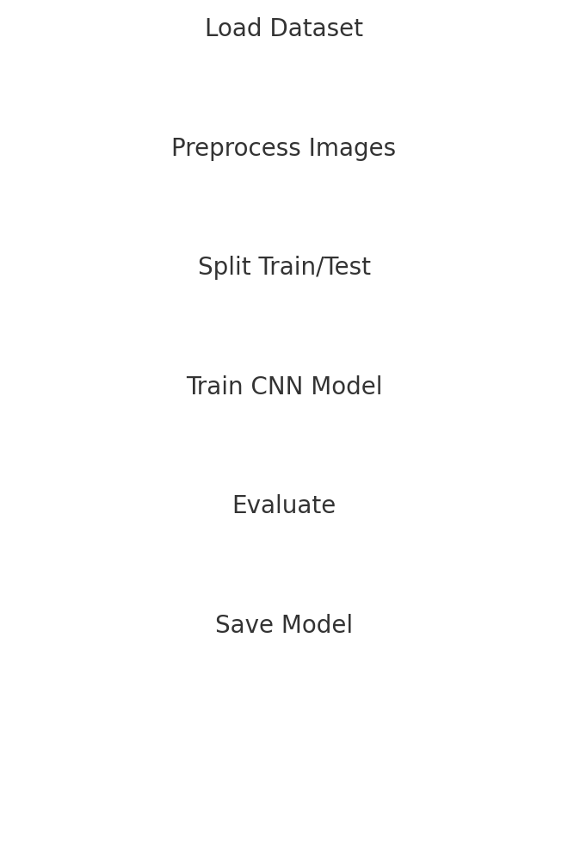
The workflow:
User → Frontend → FastAPI Backend → CNN Model → JSON Response → UI Display

4.2 High Level Design (HLD)
1. Model Training Module – Trains CNN using potato dataset and saves model as 'potato_model.h5'.
2. Backend Module – FastAPI handles /predict request and model inference.
3. Frontend Module – HTML/JS UI for uploading images and viewing predictions.
4. API Communication Module – Uses Fetch API (POST) to send image and receive JSON data.
5. Optional Database Module – Stores prediction history & remedy details.

4.3Wireframes (UI Mockups)
Upload Screen (UI):
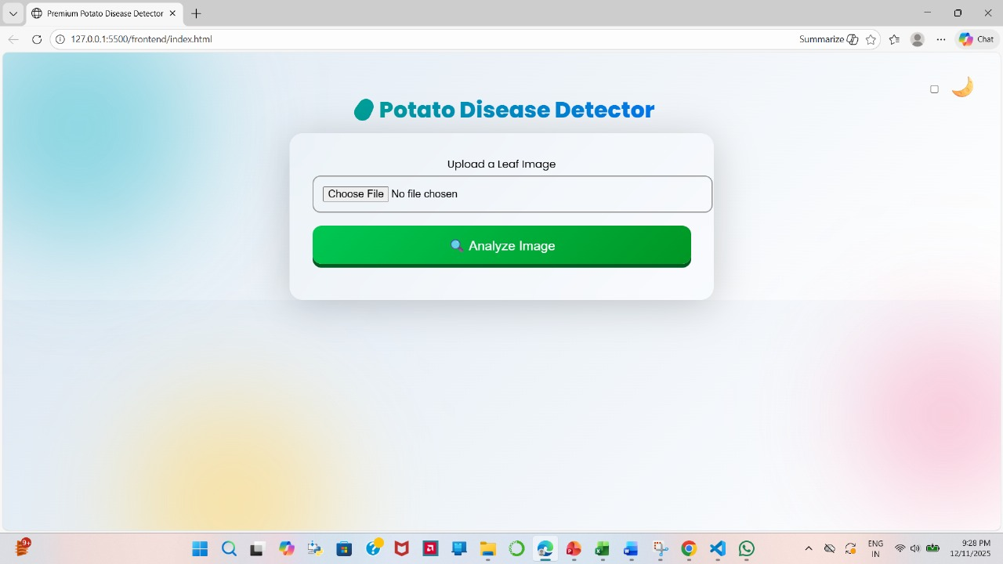

Prediction Screen (UI):
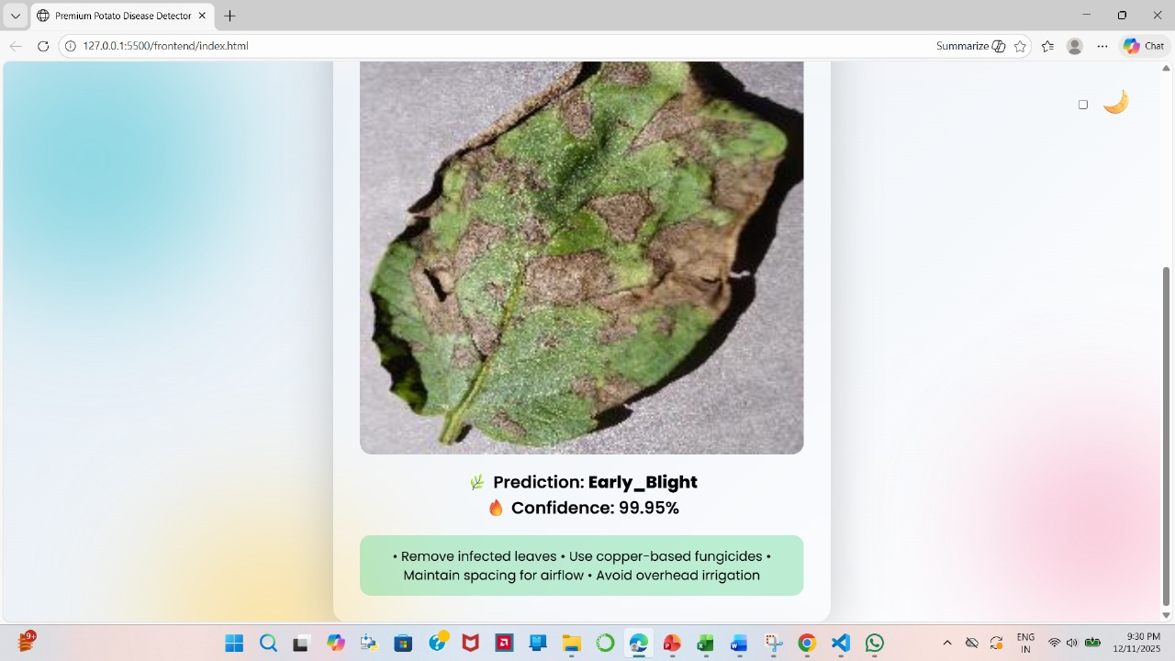

4.4 Low Level Design (LLD)
Backend Prediction Flow:
• Receive uploaded image
• Convert + resize (224×224)
• Normalize pixel values
• Run model.predict()
• Convert index → disease name
• Return JSON
Frontend Flow:
• User chooses leaf image
• JavaScript sends POST to /predict
• Response JSON displayed on screen

4.5Flowcharts
A. Training Flowchart
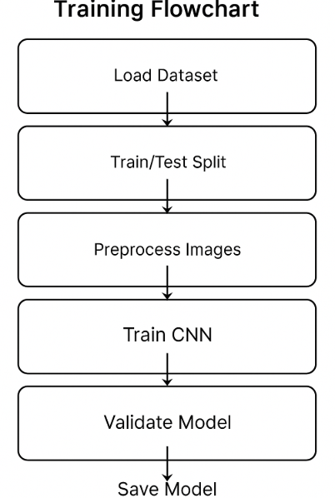
B. Prediction Flowchart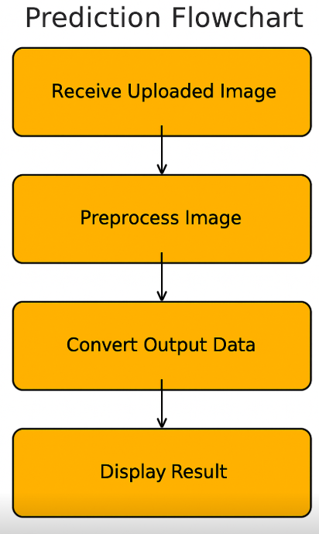rt

