Landslide Analysis and Detection using ML

Introduction:

Landslides are a type of "mass wasting," which denotes any down-slope movement of soil and rock under the direct influence of gravity.

The term "landslide" encompasses five modes of slope movement: falls, topples, slides, spreads, and flows. Landslide is a natural calamity which has devastating effects that can lead to multiple deaths and loss of property. Thus, landslide detection is of substantial importance in reducing the catastrophic effects of landslides.

We have developed a model using machine-learning which helps in analyzing the trigger elements which causes landslide.

Our project presents an approach to use the publicly available open source data by developing a model and detecting the region of landslides.

We preprocessed and cleaned the data by one hot encoding and label encoding to convert the labels into numeric-form.

**MODELS:**

**In our project, We have developed two machine learning model that is random forest and decision tree.**

**The aim or abstract of this project is to predict the landslide cause through the feature variables for the model such as Countryname, longitude, latitude, death counts, injury counts, landslide size, etc.**

**Decision tree:**

**In decision tree model, we have got an accuracy of 67 %**

**Random forest:**

**In random forest model, we have got an accuracy of 77.46 %. So we assume the prediction of this model is more accurate as compared to decision tree.**

**FINDINGS :**

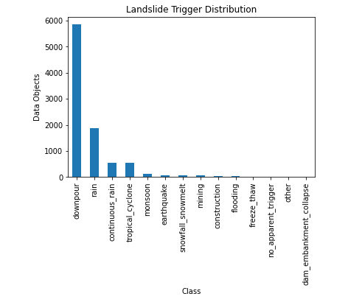

**The above graph demonstrates the landslide cause and its count. As per the graph, the major cause of landslide as analyzed from the data is due to downpour followed by rain. Other causes can also be visualized such as continuous rain, earthquake, snowfall_snow melt , etc.**

This study presents an approach to use

publicly available satellite data and open-source software to automate a land-

slide detection process called the Sudden Landslide Identiﬁcation Product

(SLIP). SLIP utilizes optical data from the Landsat-8 Operational Land Imager

sensor, elevation data from the Shuttle Radar Topography Mission, and pre-

cipitation data from the Global Precipitation Measurement mission to create

a reproducible and spatially customizable landslide identiﬁcation product. Th