Assignment 0: OpenCV and Chroma Keying

Assignment: 0
Gundapu Sunil
2018701022

2.1 Video ↔ Images

Write a program to convert a given video to its constituent images.

- Description

In this problem, mainly 4 steps involved. First step is load the video file using cv2.VideoCapture() object. Read the loaded video frame by frame. Iterate a loop till end of the video, in each iteration read a frame in video and append a name to each frame. Finally write each frame into specified folder using cv2.imwrite() object. Release VideoCapture object and exit from window, destroy all windows.

- Challenges and Learnings

At the time of appending names to each frame, need to take care. And mainly I recognized one point is that, OpenCV doesn’t actually care what the true FPS of the video is. The goal, in the case of OpenCV, is to read and process the frames as fast as possible. If we want to the frames at a constant rate we’ll need to insert time.sleep().

Write a program that will merge a set of images in a folder into a single video.

- Description

The first step is to open the directory and take the image names which are present in specified folder, into a list and sort out them. Initialize the cv2.VideoWriter() object. This object will take four parameters. (output_filename, fourcc, fps, size_of_frame and isColor). output_filename takes the output file name, fourcc takes the video codec or video format like XVID, MJPG, fps means frames per second, size_of_frame will takes the (height, width) of the frame and isColor for frame color eithe gray or color. After that read each image, store the each image pixel(RGB) values into array. According to pixel values, write each frame to a video file using cv2.VideoWriter.write(). Finally, Release the VideoWriter and destroy all windows.

- Challenges and Learnings

While appending the images to list, it will take in random order so need to sort out all the frames. While passing the parameters to the VideoWriter() object, need to careful. FOURCC is a 4-byte video codec and it’s platform dependent. For different platforms, different codecs are there. And the duration of a video depends on FPS(Frames per Second). If we give small fps the video duration is high and vice- versa. According to our convenience, we need to adjust the fps. The np.shape of I mage will give (height, width, channel), but here will pass size = (width, height) so need to check while passing the size.

Code Snippet of 2.1

import cv2, os
import numpy as np
from os.path import isfile, join
try:
if not os.path.exists('Frames'):
os.makedirs('Frames')
except OSError:
print ('Getting problem while creating folder')

def SplitVideobyFrame():
out = cv2.VideoCapture('example.mp4')
frame_count = 1
while(True):
retur, frame = out.read()
file_name = './Frames/frame' + str(frame_count) + '.jpg'
if(frame_count<=100):
cv2.imwrite(file_name, frame)
print (file_name + ' ...Created')
frame_count += 1

else:
break

out.release()
cv2.destroyAllWindows()

def ImagestoVideo():
path = './Frames/'
frame_array = []
files = []
for f in os.listdir(path):
if isfile(join(path, f)):
files.append(f)

files.sort(key = lambda x: int(x[5:-4]))

for i in range(len(files)):
filename = path+files[i]
img = cv2.imread(filename)
frame_array.append(img)

out = cv2.VideoWriter('output_video.avi',cv2.VideoWriter_fourcc('X', 'V', 'I', 'D'), 10.0, (img.shape[1], img.shape[0]))

for i in range(len(frame_array)):
out.write(frame_array[i])
print("output video stored")
out.release()
cv2.destroyAllWindows()

SplitVideobyFrame()
ImagestoVideo()

- Output (Google Drive Link):
https://drive.google.com/openid=1Tq_tFXPNGerrWsUYt4TokyaBy7lHKFqI

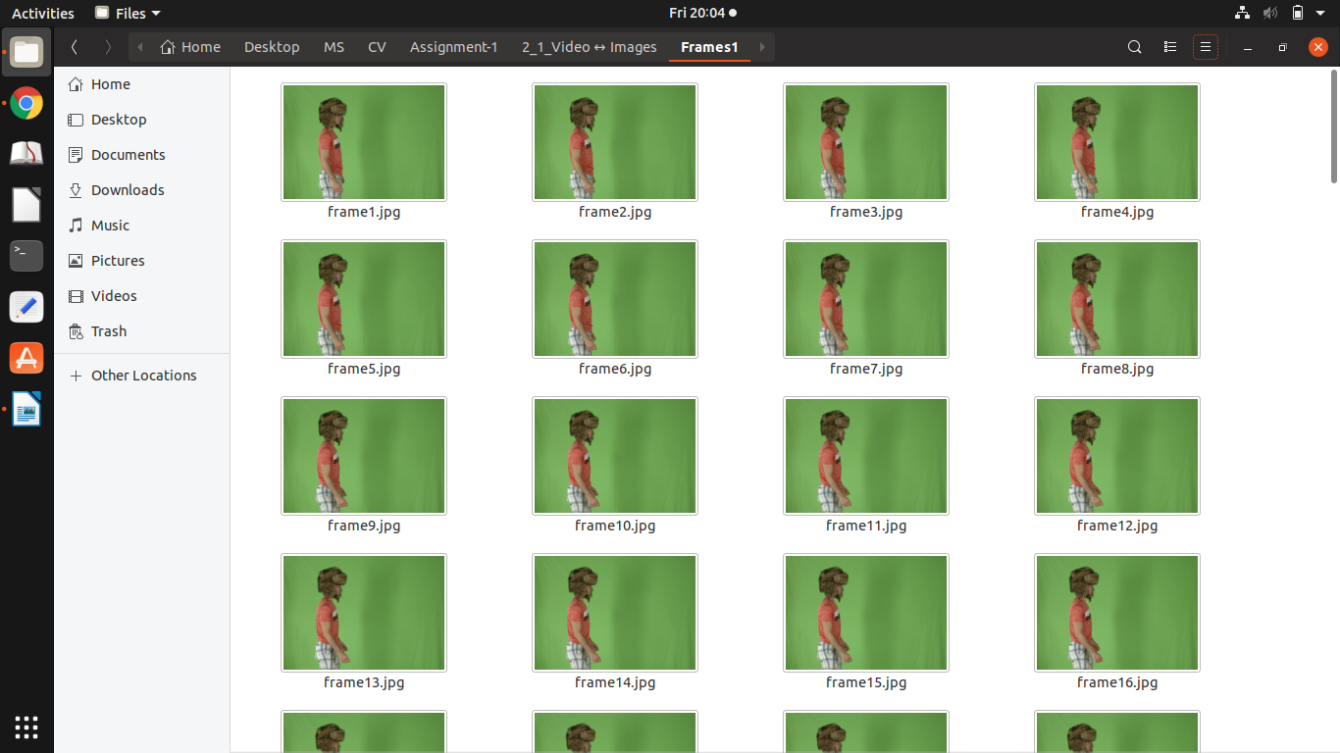

2.2 Capturing Images

Learn how to capture frames from a webcam connected to computer and save them as images in a folder.

- Description:

In this problem we will capture a video, process it and write to a folder frame by frame. It’s also same like extracting frames from a video but the difference is here we pass the webcam value, there will pass the path of video. Initially we creates a camera object of type openCV video capture, using the first camera in the list of cameras connected to the computer. 0 or -1 for first camera (most of the cases). After this read webcam video frame by frame, and store it in particular folder. To stop the webcam video will use cv2.waitKey(), It’s a keyboard binding function. The function waits for specified milliseconds for any keyboard event.

- Challenges and Learnings

Sometimes, may not have initialized the camera object. At that time snippet throwing an error. For this problem need to check whether camera is initialized or not by using cam.isOpened(). If it shows false need initialize by using cam.Open(). Need to take care while passing the value of camera.

- Code Snippet of 2.2

import cv2,os

try:
if not os.path.exists('Frames'): # Creating frames folder if it's not exist
os.makedirs('Frames')

except OSError:
print ('Getting problem while creating folder')

out = cv2.VideoCapture(-1) # Opening WebCam
frames_count = 1

while(True):
retur, frame = out.read()
cv2.imshow('frame',frame)
if retur:
file_name = './Frames/frame' + str(frames_count) + '.jpg'
print (file_name + 'Created')
cv2.imshow('image', frame)
cv2.imwrite(file_name, frame) # Write to folder
frames_count += 1
if cv2.waitKey(1) & 0xFF == ord('s'): # Press ‘s’to save and exit
break
else:
break

out.release()
cv2.destroyAllWindows()

- Output (Google Drive Link):
https://drive.google.com/open?id=1-BJR9NDVHr-8YvLT6dm5KXFnrv-xN2Hx

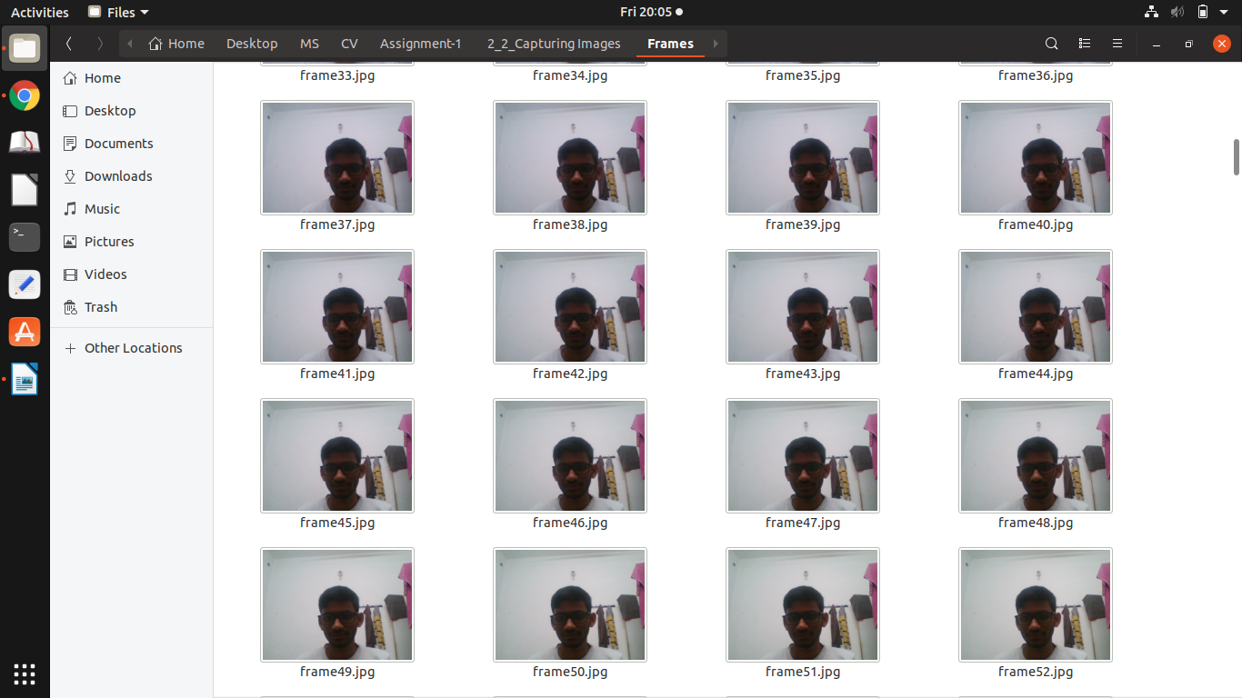

2.3 Chroma Keying

Create an interesting composite of two videos using this technique

- Description

Initially load and read both two videos frame by frame and store all frames of each individual video into separate folders. Append frames to two lists and sort out them. To create an composite of two videos using "No Blue" solution which is in reference document. According to this solution will restrict the foreground objects with no blue and background color totally blue.
So,
c_{o} = [R_{o} G_{o} 0], and c_{k} = [0 0 B_{k}], then
c_{f} = c_{o} + (1 − α_{o}) c_{k} = [R_{o} G_{o} (1 − α_{o})B_{k}]
B_{f} = (1 − α_{o})B_{k} equation for α_{o} gives solution
C_{o} = [R_{f} G_{f} 0 1-(B_{f} / B_{k})]

- Challenges and Learnings

The color of the chroma screen bounces on the foreground object. Because of this some objects edges lost. And all the frames in both videos should in same dimension, otherwise will get IndexError.

- Code Snippet of 2.3

import cv2
import os
from os.path import isfile, join
import numpy as np

def SplitVideobyFrame():
out = cv2.VideoCapture('forground_video.mp4')
frame_count = 1
while(True):
retur, frame = out.read()
file_name = './Foregound_Images/frame' + str(frame_count) + '.jpg'
if(frame_count<=300):
cv2.imwrite(file_name, frame)
print (file_name + ' ...Created')
frame_count += 1
else:
break

out1 = cv2.VideoCapture('background_video.mp4')
frame_count = 1
while(True):
retur, frame2 = out.read()
file_name = './Backgound_Images/frame' + str(frame_count) + '.jpg'
if(frame_count<=300):
cv2.imwrite(file_name, frame2)
print (file_name + ' ...Created')
frame_count += 1
else:
break

out.release()
cv2.destroyAllWindows()

dir_path1 = 'Foregound_Images'
dir_path2 = 'Backgound_Images

def Creating_Video():
images1 = []
images2 = []
new_images=[]
new_frames=[]
frames_arr=[]
for img in os.listdir(dir_path1):
if isfile(join(dir_path1, img)):
images1.append(img)

for img in os.listdir(dir_path2):
if isfile(join(dir_path2, img)):
images2.append(img)

images1.sort(key = lambda x: int(x[5:-4]))
images2.sort(key = lambda x: int(x[5:-4]))

image_path = os.path.join(dir_path1, images1[0])
frame = cv2.imread(image_path)
height, width, channels = frame.shape

out = cv2.VideoWriter('output1.avi', cv2.VideoWriter_fourcc(*'mp4v'), 25.0, (width, height))

for i in range(len(images1)):
image_path = os.path.join(dir_path1, images1[i])
frame = cv2.imread(image_path,cv2.IMREAD_COLOR)
image_path2 = os.path.join(dir_path2, images2[i])
frame2 = cv2.imread(image_path2,cv2.IMREAD_COLOR)
height, width, channels = frame.shape
for i in range(frame.shape[0]):
for j in range(frame.shape[1]):
temp=frame[i,j,:]
alpha=(((temp[0]/255.0) +(temp[2]/255.0))-(temp[1]/255.0))
if(alpha<=0):
new_frames.append(frame2[i,j,:])
else:
new_frames.append(frame[i,j,:])
frames_arr.append(new_frames)
frames_arr=np.array(frames_arr)
out.write(frames_arr)
out.release()
cv2.destroyAllWindows()
print("The output video is {}".format(output))

Creating_Video()

- Output:
https://drive.google.com/open?id=1me8Oynxg5fRWeKmMKuFSWPmHal8PYr3G





