1. Unable to go to home page when we click on Company Logo(“Lambda Software Innovations”) from other sections
2. Open <http://www.lambdainnov.com/> in a browser
3. Click on any link in the Mega navigation. Ex: ‘About’
4. Click on company Logo – “Lambda Software Innovations” which is on top left of the page.
5. Verify page redirection.

Actual:

It is not redirecting to Home screen but it changing the URL as <http://www.lambdainnov.com/#Home>

Expected:

It should redirect to Home screen

1. Works and Contacts sections are not fit into the window.
2. Open <http://www.lambdainnov.com/> in a browser
3. Click on ‘Works’ and ‘Contact’ links in the Mega navigation.
4. Verify content and alignment.

Actual:

The bottom content in these sections is not fit in the window.

Expected:

The content should be fit in the window as like in other sections

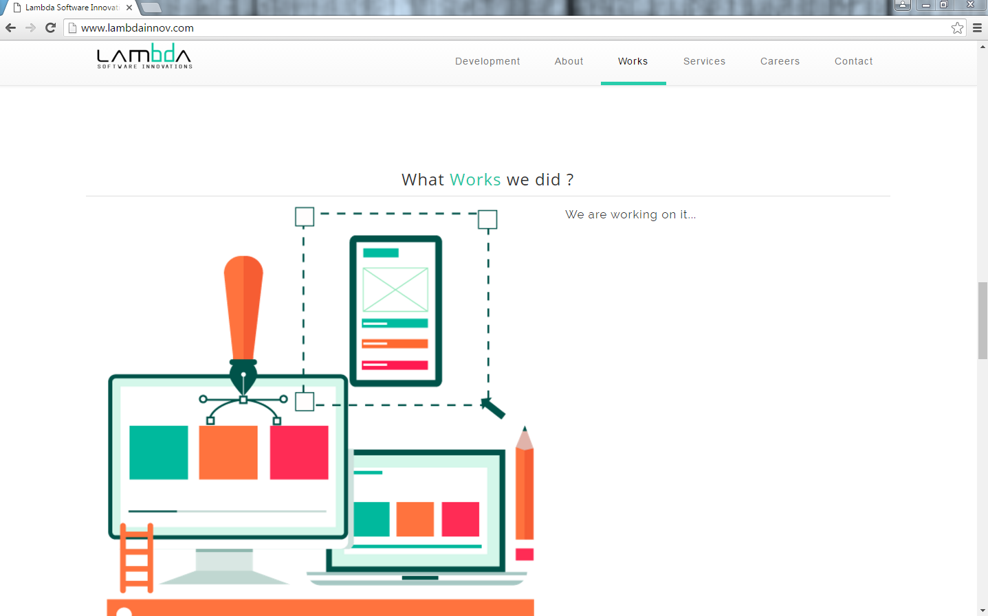

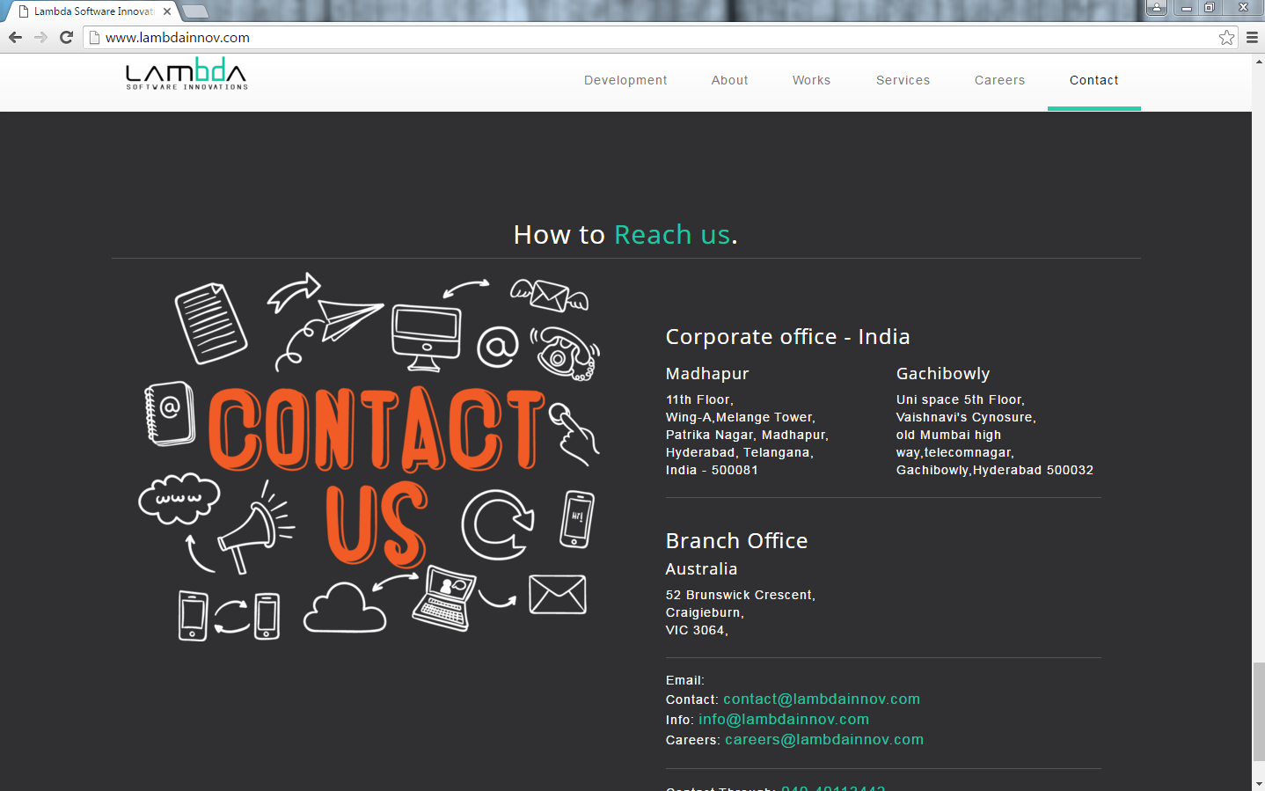

1. Font size and alignment is not consistent in Development section

**1.**Research

**2.** Implement

### ****3.****Development

Font should be same as above two

1. When we click on Facebook and Twitter image links in the Contact section, our company Facebook and Twitter pages are replacing our company portal instead of opening them in a new tabs.

If it is expected behavior, when we click on Twitter image link it will open our company twitter page and when we click on back button still twitter browser title image is displaying as our company portal browser title image.

