Welcome BANDI SUNIL REDDY from Building Web Applications in PHP

Your current grade on this assignment is: 100%

**Exploring the HyperText Transfer Protocol**

You are to retrieve the following document in a browser tab with "Developer Mode" enabled so you can examine the HTTP Response headers. You may need to open the URL in a new tab, turn on developer mode, and then press refresh to get the proper data.

* <http://data.pr4e.org/intro-short.txt>

Enter the header values in each of the fields below and press "Submit".

Top of Form

Last-Modified:  
  
ETag:  
  
Content-Length:  
  
Cache-Control:  
  
Content-Type:  
  


Bottom of Form

**Note:** If you look at the headers and not all of the headers are present, it may be that your browser is caching the request. Look for the [HTTP Response Code](https://en.wikipedia.org/wiki/List_of_HTTP_status_codes) in the developer console. Normally you should see a "200" code indicating a normal document retrieval. If you see a "304" status code, it means that your browser is likely using a cached copy of the file.

To convince your browser to actually retrieve the document, clear your browser cache and re-retrieve the document, or add a key-value pair to the URL like:

<http://data.pr4e.org/intro-short.txt?x=12345>

And then retrieve that URL. To force a fresh retrieval, simply change the value for x= to any new value and re-retrieve the page until you get a 200 status code.

[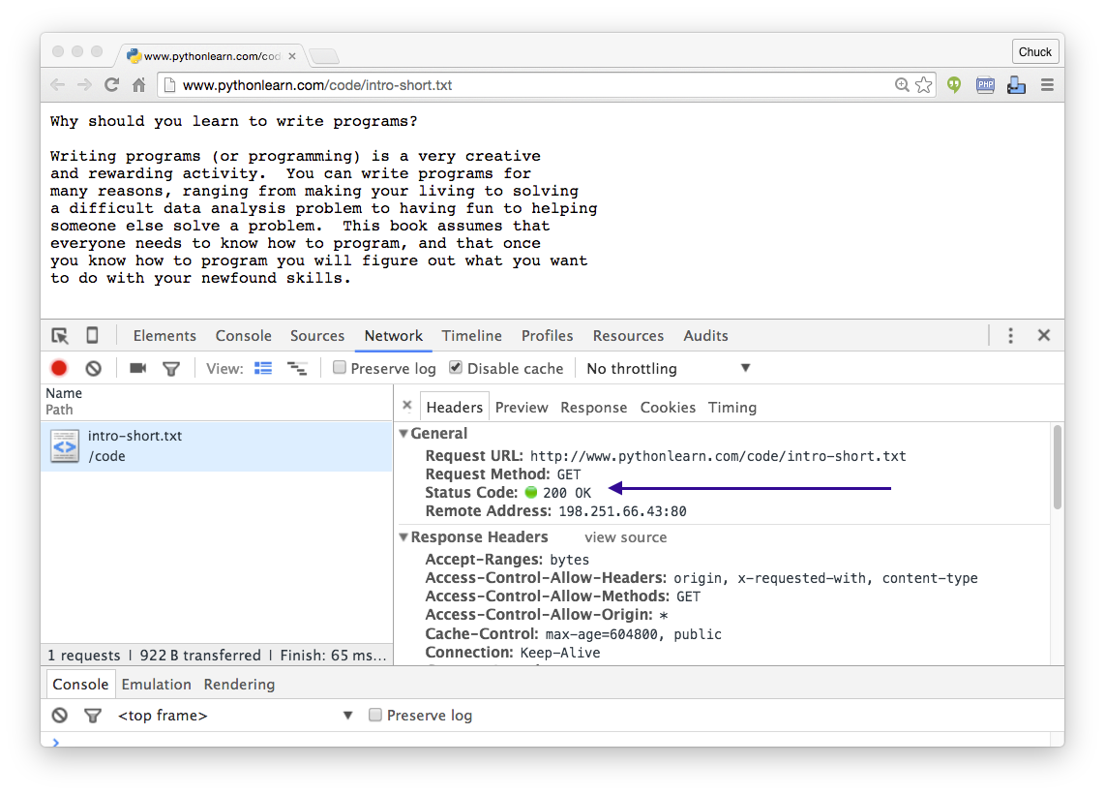](https://www.wa4e.com/tools/autograder/http_headers-01.png?PHPSESSID=3707f2b02dc39a3e6aaf67857b1bea74)

