MnS – Shadow project – Assignment for UX resources

**Personal Details Form** – create a page using the coding standards, styles, architecture of the current application of MnS. It should have the following features/functionalities.

**Imp**: Page should be AA level accessible. Validate HTML/CSS using w3 validators. Validate JS using JS Lint.

1. A form as shown in the **Figure 1**.

**Fields**:

First Name (Input text)

Last Name (Input text)

Add Address (Button)

Zip Code (Input text)

Find Address (Button)

Submit (Button)

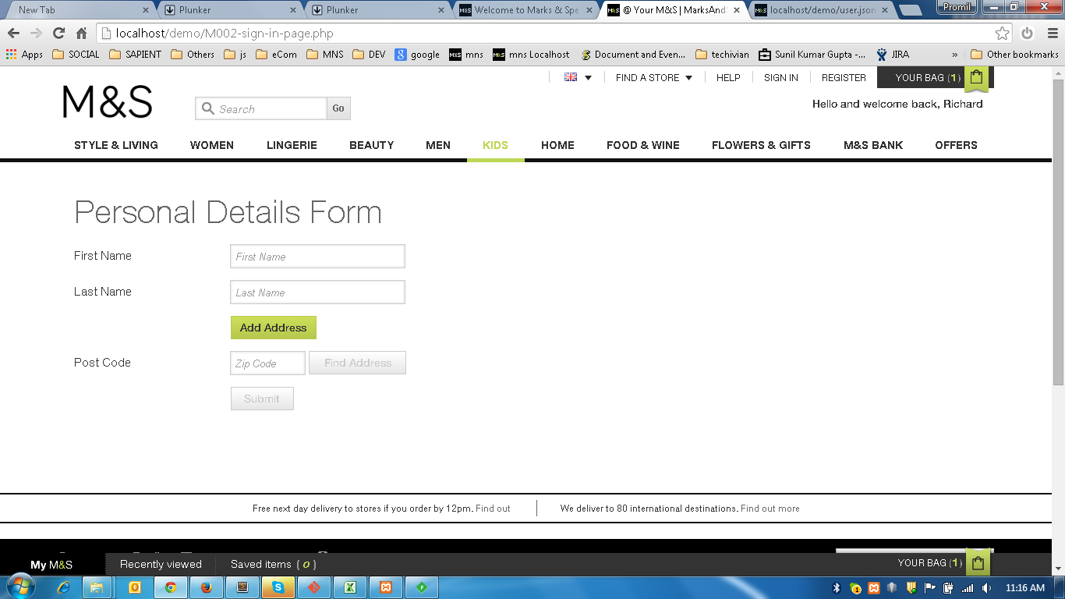

Figure 1

1. Apply validation check on each of the fields as shown in **Figure 2.1**. Refer live site to understand functioanlity.

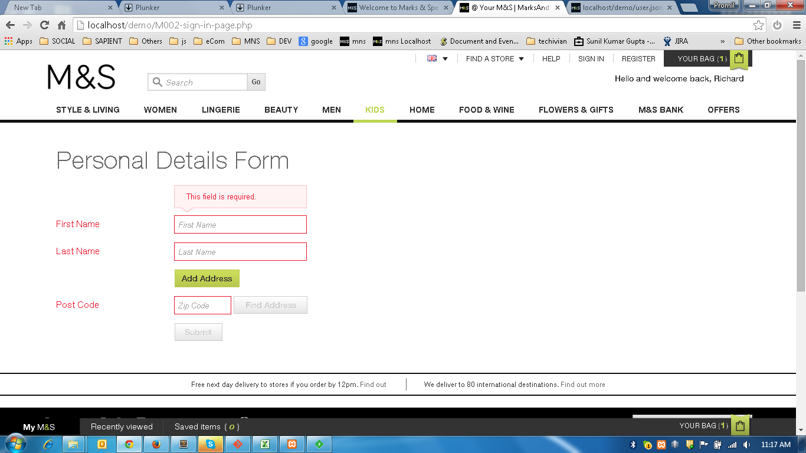

Figure 2

1. Clicking on **Add Address** button, a popup will be displayed with following fields:

Address (Input text)

City (Input text)

Country (Input text)

Save (Button)

Cancel (Button)

Clicking on **Cancel** and **X** button will hide the popup.

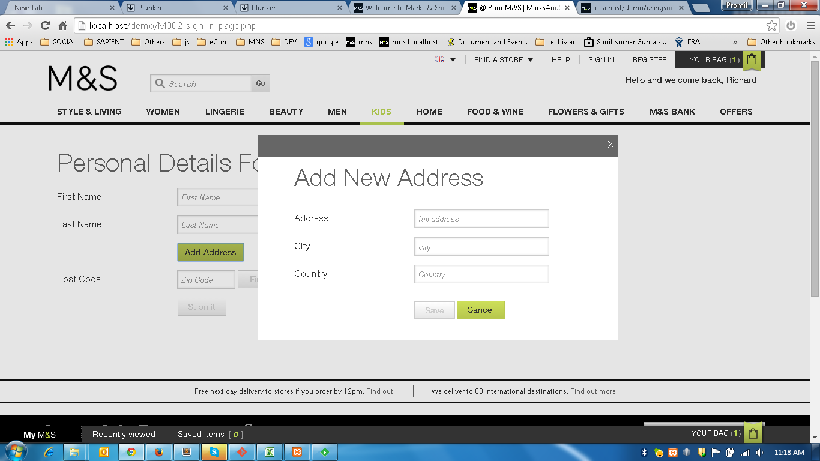

Figure 3

1. Field validations are expected as mentioned earlier.

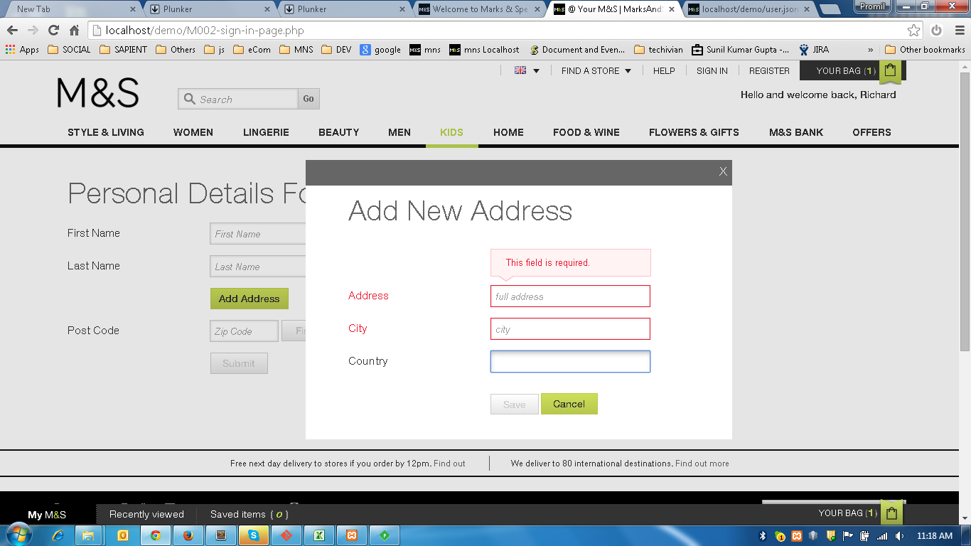

Figure 4

1. Save Address – Clicking on **Save** button will show three more fields with same label and data as it was there in popup window. Also **Clear Address** and **Edit Address** buttons will appear.

**Clear Address** - Clicking this button will clear the current address displayed – **Figure 5**

**Edit Address** **-** Clicking this button will open popup window pre-populated with current address and title of the popup will be **Edit Address** – **Figure 6**

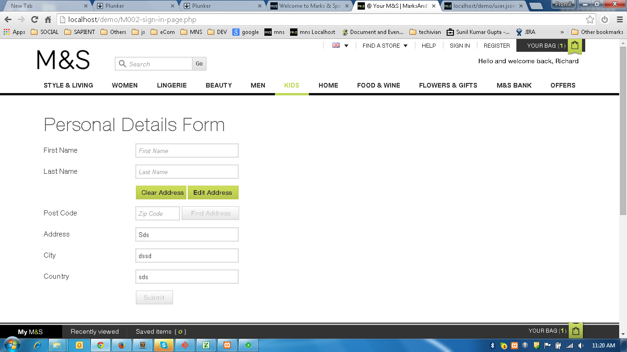

Figure 5

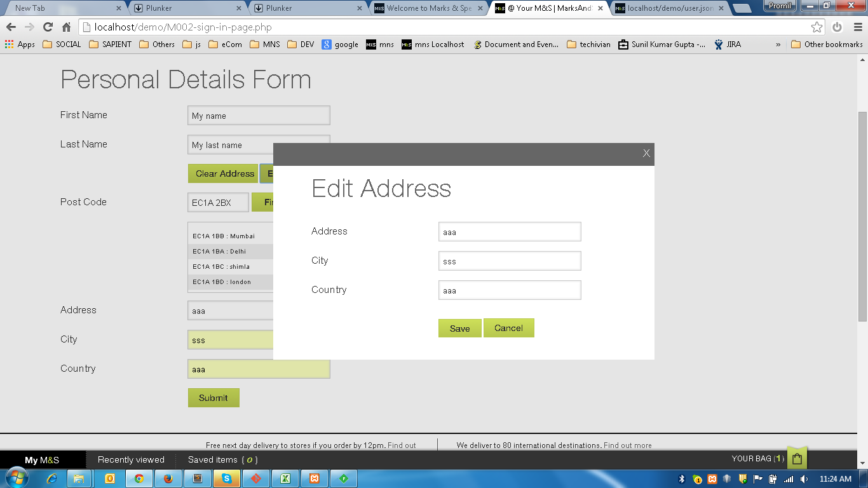

Figure 6

1. Post Code validation – Use the regular expression already in use for post code validation. Talk to your mentor regarding this.

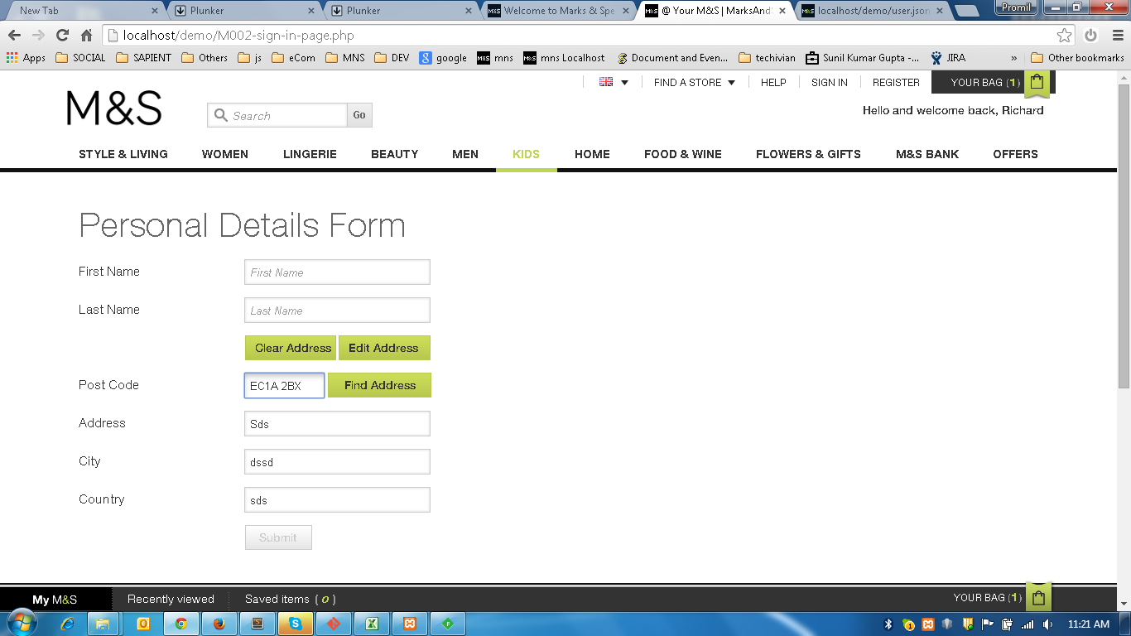

Figure 7

1. Clicking **Find Address** button will load a JSON file of addresses and those addresses will be displayed below the **Post Code** field. It should be a in ul-li format inside a scrollpane.

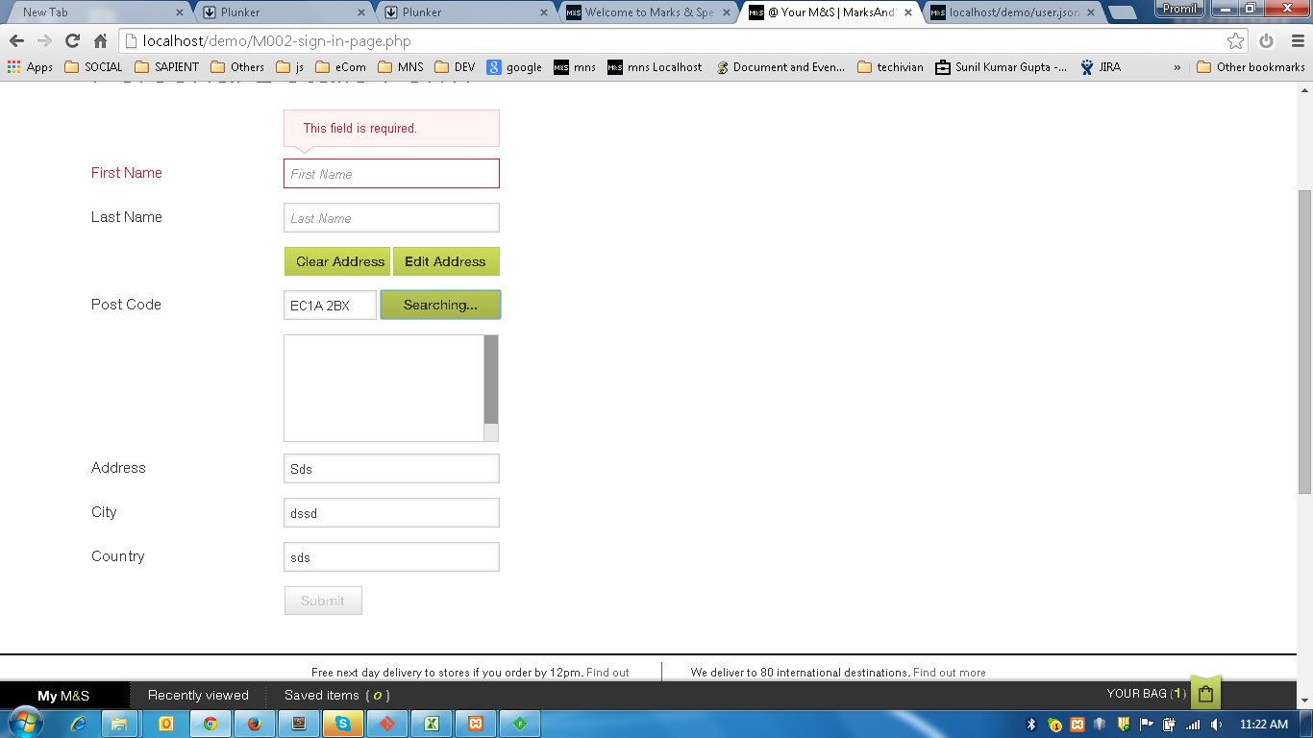

Figure 8

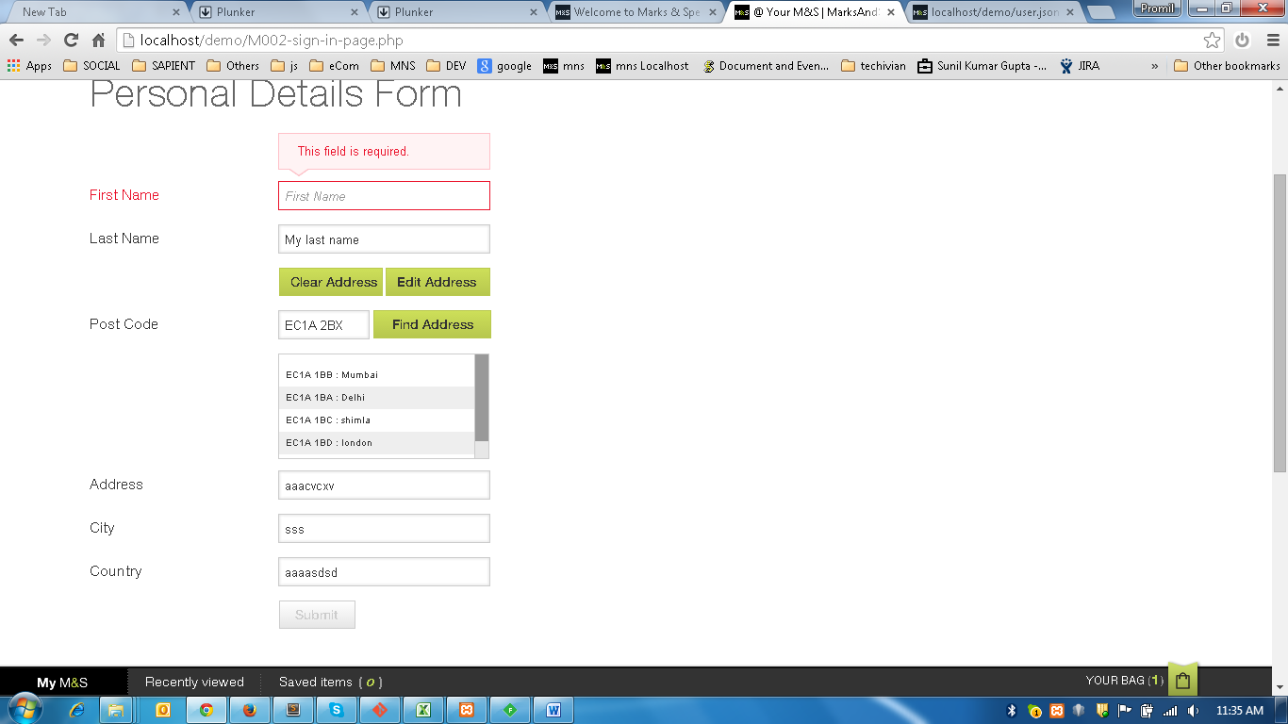

Figure 9