Reading the Moon's Plasma with a Neural Network
A physics-informed inversion of Chandrayaan-3 RAMBHA-LP Langmuir probe sweeps
Sunil Kumar
M.Tech Computer Science, IIIT Hyderabad
Independent Study · Supervisor: Dr. Rama Chandra Pillutla

Abstract
The RAMBHA-LP Langmuir probe on the Chandrayaan-3 Vikram lander recorded current–voltage sweeps of the near-surface plasma near the lunar south pole between 24 August and 3 September 2023. Electron density, electron temperature and plasma potential are usually obtained from such sweeps by piecewise line fitting, which fails on 44% of the 29,862 sweeps in the public archive. This study trains a physics-informed neural network on 40,000 synthetic sweeps generated with an orbital-motion-limited probe model, using a loss that also requires the predicted parameters to reconstruct the input curve. Applied to the archive, the network recovers 8,343 of the 13,266 sweeps rejected by the classical fit, raising usable coverage from 55.6% to 83.5%. Since no ground truth exists on the Moon, the results are validated against an independent classical fit (1.1% median density difference over 16,596 sweeps), by comparing the rising and falling halves of each sweep (2.6% density disagreement over 12,418 pairs), through a blind reconstruction of the density trend across the mission, and against values published by the instrument team. Removing the physics term improves accuracy on simulated data but loses about ten percentage points of real-data recovery. A two-population extension, tested against a single-population control, finds no evidence for a second electron population, and the averaged-sweep slope diagnostic used to infer such populations is shown to be unreliable when sweep temperatures vary. Electron temperature accuracy, about 20%, is limited by the forward model near the plasma potential rather than by the network.

1. Introduction
The Moon has no global magnetic field and only a tenuous exosphere, so its sunlit surface is exposed directly to solar ultraviolet radiation and the solar wind. Photoemission from the regolith charges the dayside surface positively and fills the region just above it with a photoelectron sheath, whose structure controls surface charging and the levitation of fine dust (Poppe & Horányi 2010). The electron density, electron temperature and plasma potential of this near-surface layer therefore matter both for understanding the surface–plasma interaction and for the electrical environment in which landers and surface instruments operate. Measurements made from the surface itself have, however, been rare.
Chandrayaan-3 provided a new opportunity. Its Vikram lander touched down near the lunar south pole on 23 August 2023 and carried RAMBHA-LP (Radio Anatomy of Moon Bound Hypersensitive ionosphere and Atmosphere - Langmuir Probe), a spherical probe mounted on a boom above the lander deck. From these measurements Manju et al. (2025) reported electron densities of 380–600 cm⁻³ and electron temperatures of 3,000–8,000 K near the landing site, the first in situ near-surface plasma measurements from the south polar region. A second study used the lander's hop experiment on 2 September 2023 and reported a fall in mean density from about 478 cm⁻³ before the hop to about 26 cm⁻³ during and immediately after it (Manju et al. 2026). The sweep data are publicly released through the ISRO Science Data Archive (ISRO PRADAN), which makes an independent re-analysis of the full archive possible.
A Langmuir probe infers plasma parameters from the current it collects while its bias voltage is swept. The theory goes back to Mott-Smith & Langmuir (1926), whose orbital-motion-limited (OML) description remains the basis for analysing small spherical and cylindrical probes (Hutchinson 2002). Below the plasma potential the electron current rises exponentially with a slope set by the electron temperature; above it the current grows more slowly as the collecting sheath expands, and its level scales with the electron density. Probes of this kind have flown widely. The Langmuir Probe and Waves instrument on MAVEN measures electron density and temperature in the Martian ionosphere (Ergun et al. 2015), and probe sweeps on Rosetta were used to quantify photoelectron emission and track the solar ultraviolet flux at comet 67P (Johansson et al. 2017).
The usual analysis fits straight lines to the logarithm of the current in the electron retardation region and to the saturation region, and reads the three parameters from those fits (Hutchinson 2002). It works well on clean, well-sampled sweeps, but the result depends on where the fitting windows are placed, and it becomes unreliable when the curve is noisy, poorly sampled in the exponential part, or modified by photoemission from the probe and its support (Johansson et al. 2017). On RAMBHA-LP, the classical fit fails on 44% of the sweeps (Section 1.1), so a large part of a dataset that cannot be repeated is at present unused.
Machine-learning regression offers another route. Instead of fitting selected parts of the curve, a model trained on many examples maps the whole sweep to plasma parameters. Liu et al. (2023) trained radial basis function and neural network regressors on synthetic probe currents from three-dimensional kinetic simulations and applied them to multi-needle Langmuir probe data from the NorSat-1 satellite, showing that simulation-trained inference can be used on flight data. For the Moon the main difficulty is that no independent measurement of the near-surface plasma exists, so training labels can only come from a physical model. Physics-informed neural networks address part of this problem by adding the governing equations to the training loss, so that predictions must also be consistent with the physics (Raissi et al. 2019). Monte-Carlo dropout can attach an uncertainty to each prediction at little extra cost (Gal & Ghahramani 2016), which is valuable when results cannot be checked against a known answer.
This study applies these ideas to the RAMBHA-LP archive. A physics-informed neural network is trained only on synthetic sweeps from an OML forward model and is then used to invert the real sweeps, including those that the classical fit rejects. Because there is no ground truth, as much weight is given to validation as to the inversion itself: agreement with the classical method, consistency between the rising and falling halves of each sweep, a blind check against the mission timeline, and comparison with published values. The same framework is then used to test whether the near-surface plasma contains a second, hotter electron population, and to find out what limits the accuracy of the electron temperature on this instrument.

1.1 Why the standard method struggles
Applied to this archive, the classical fit succeeds on 16,596 of 29,862 sweeps (55.6%). Table 1 lists the main reasons for failure; a further 136 sweeps fail for smaller reasons.
Table 1. Reasons the classical fit failed, with the number of sweeps affected.
Why the fit failed | Sweeps | What it means
Flat top has the wrong slope | 2,369 | noise swamps the saturation region
Too few points in the steep region | 2,347 | the exponential is too narrow to fit
Fit quality below threshold (R² under 0.90) | 4,945 | curve shape does not match the model
Plasma potential outside the sweep range | 3,469 | the fitted curve does not behave like the model

Discarding 44% of a dataset that cannot be repeated is the problem this study addresses.

1.2 Objectives
The objectives of this study are:
- To recover electron density, electron temperature and plasma potential from RAMBHA-LP sweeps that the classical fit cannot process, and so increase the usable fraction of the archive.
- To validate the recovered parameters without ground truth, using an independent method, the instrument's own repeated measurements and published results.
- To measure, rather than assume, how the physics-informed loss term affects performance on simulated and on real data.
- To test, with appropriate controls, whether the archive requires a second electron population.
- To identify the factor that limits electron temperature accuracy for this instrument.

2. Data and methodology

2.1 Instrument and data
The data were obtained from the ISRO Science Data Archive, PRADAN, operated by the Indian Space Science Data Centre (ISRO PRADAN). RAMBHA-LP products are distributed in the Planetary Data System version 4 (PDS4) format at three processing levels, labelled raw, rawA and rawB. The raw level holds only the bias voltage and the probe output voltage, which must be converted to current using the instrument's resistor and gain tables. In rawA (Level-0A) this conversion has been done and the current is given in amperes. In rawB (Level-0B) a photoemission current, estimated with the method of Johansson et al. (2017), has also been subtracted. This study uses rawB because it is the archive's calibrated, photoemission-corrected product and needs no further gain conversion. Within each file the difference between rawA and rawB is a constant offset, which the baseline subtraction described in Section 2.2 removes, so the choice of level does not change the curve shape that the network sees.
The release used is LTA_RAMBHA-LP_August2024_final, and its rawB level contains 144 science (sweep) files with their ops files. The science files hold the probe current, and the ops files record the commanded sweep sequence, including the number of samples in each sweep. Together they cover 24 August to 3 September 2023. In sweep mode the probe bias was stepped from −12 V to +12 V in 0.1 V steps and back again. The current was recorded on two ADC channels, with three probe resistor settings available in the front end.
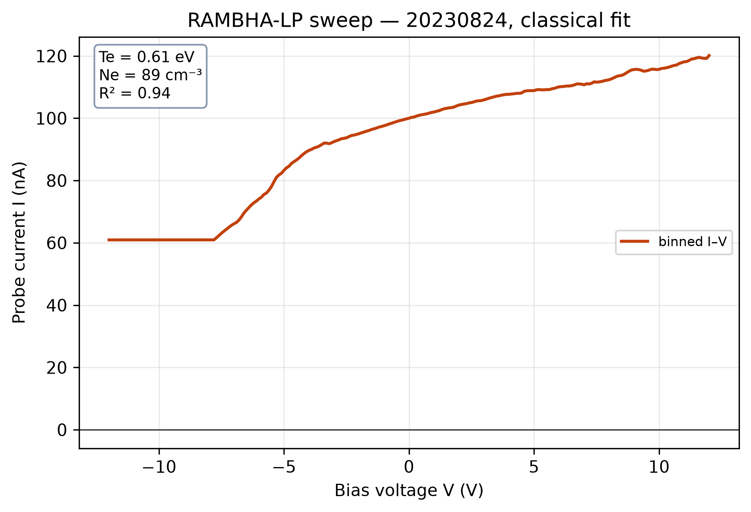
Figure 1. One real RAMBHA-LP sweep from 24 August 2023: binned probe current against bias voltage. The flat floor on the left, the steep rise and the slower climb on the right are the parts of the curve that the three plasma parameters are read from.

2.2 Preprocessing
Each science file was paired with its ops file, and the ops sample counts were used to cut the continuous science record into individual commanded sweeps. A commanded sweep is a triangle in which the bias rises from −12 V to +12 V and then returns. Each triangle was split into its rising and falling halves, which were treated as separate sweeps. This turned 14,931 commanded sweeps into 29,862 sweeps and also provides the paired measurements used for the self-consistency test in Section 3.2.2.
Within each half, the samples recorded at each voltage step were averaged, which reduces random noise without changing the shape of the curve. The averaged curves were resampled onto a common grid of 240 voltage points, so that every sweep has the same length as the network input. All sweeps were then brought to a common orientation and the ion-current baseline was subtracted. Finally, the currents were expressed on one fixed current scale for the whole archive rather than normalised sweep by sweep, so that the absolute current level, which carries the density information, is preserved.

2.3 Physics model and synthetic training data
No independent measurement of the near-surface plasma exists, so the network cannot be trained on measured labels. Labelled examples were instead generated with a physics model that predicts the current curve for a given plasma. The network therefore learns to invert the model rather than the plasma itself, and any error in the model passes into its results. This limitation recurs in Section 3.3.
The forward model follows orbital-motion-limited probe theory for a sphere (Mott-Smith & Langmuir 1926). The electron current at the plasma potential is
$I_{e0}=e N_{e} A \sqrt{\frac{e T_{e}}{2πm_{e}}}, A=4πr^{2}$ (1)
where e is the electron charge, Ne the electron density, Te the electron temperature in eV, me the electron mass and r = 2.5 cm the probe radius. Below the plasma potential Vp the current falls off exponentially, and above it the current grows with a sheath-expansion exponent α, set to 0.40 from fits to real sweeps:
$I_{e}\left(V\right)=I_{e0} exp​\left(\frac{V−V_{p}}{T_{e}}\right), V<V_{p}$ (2)
$I_{e}\left(V\right)=I_{e0}{\left(1+\frac{V−V_{p}}{T_{e}}\right)}^{α}, V≥V_{p}$ (3)
The synthetic data consist of 40,000 training sweeps and a separate test set of 4,000 sweeps. For each sweep, the electron density, electron temperature and plasma potential were drawn at random from 2–1,000 cm⁻³, 0.05–2 eV and −12 to +6 V respectively, and Equations 1–3 were used to compute the current on the same 240-point voltage grid as the real data. The temperature was drawn uniformly across its range; as Section 3.3.3 shows, this places a large share of the examples at temperatures above those observed at the landing site. To make the synthetic curves resemble the real ones, random noise and a linear baseline tilt were added to each curve, with amplitudes measured from the real sweeps.

2.4 Physics-informed network
The network is trained on two requirements: its three outputs must match the known values, and feeding them back through the physics model must reproduce the input curve. This follows the physics-informed approach of Raissi et al. (2019).
The training loss combines a supervised term and a physics term:
$L=w_{s} L_{sup}+w_{p} L_{phys}$ (4)
where the first term scores the predicted parameters against the known labels, the second scores how well the parameters rebuild the input curve through Equations 2 and 3, and the weights are 1 and 0.5.
The network is a fully connected multilayer perceptron with an input of 240 current values, three hidden layers of 256, 256 and 128 units, and an output layer of three values, giving 160,771 trainable parameters. The outputs are log₁₀ Ne, Te and Vp; density is predicted on a logarithmic scale because it spans almost three orders of magnitude in the training set. The network was trained for 250 epochs with the loss of Equation 4. Dropout is kept active at prediction time, and each sweep is passed through the network 50 times; the mean of these outputs is taken as the estimate and their standard deviation as its uncertainty (Gal & Ghahramani 2016). A real sweep that the classical method could not fit is counted as recovered only if four conditions hold: the predicted density lies between 1 and 100,000 cm⁻³, the predicted temperature lies between 0.03 and 5 eV, the curve rebuilt from the predicted parameters reproduces the baseline-subtracted sweep with R² of at least 0.90 (the same threshold used for the classical fit), and the Monte-Carlo dropout spread of log₁₀ Ne is below 0.5 dex. In practice the R² condition decides the outcome: all 13,266 classical failures pass the density and uncertainty conditions, 13,261 pass the temperature condition, and 8,343 pass the R² test.
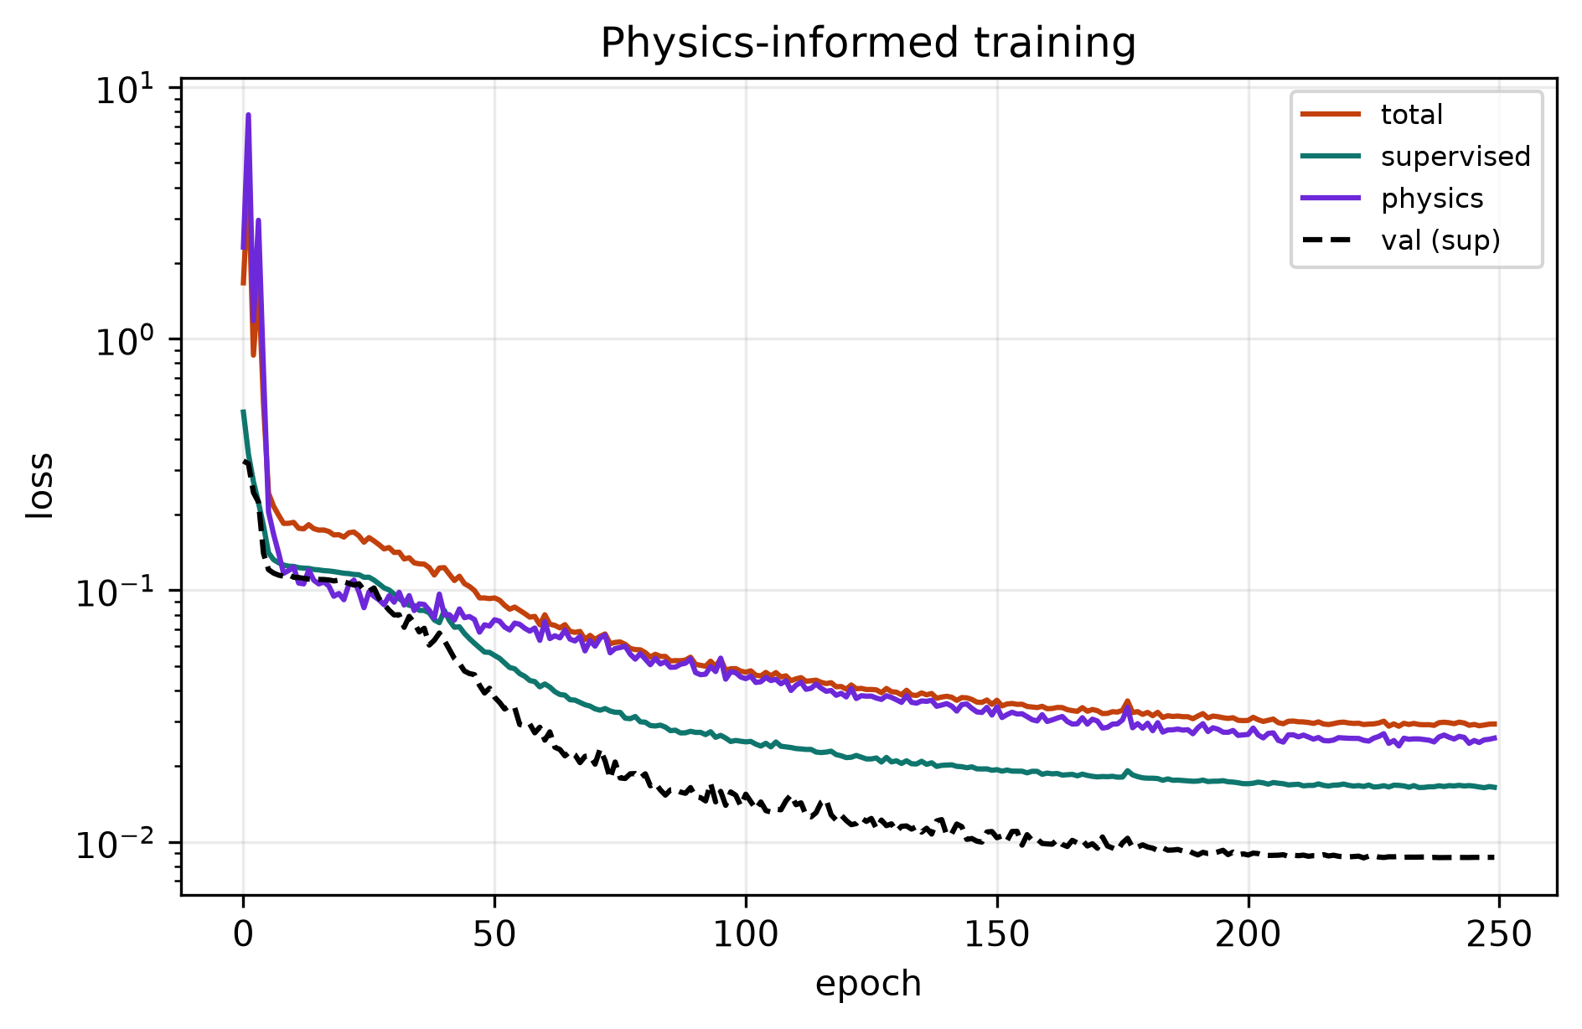
Figure 2. Training the network. The supervised loss scores the predicted numbers against the known answer, the physics loss scores how well those numbers rebuild the curve, and the dashed line is the supervised loss on held-out simulated sweeps.

2.5 Validation strategy
Since there is no ground truth, every check in this report is one of the three kinds listed in Table 2. The working practices behind these checks are described in Supplementary Appendix B.
Table 2. The three kinds of check used to validate results without ground truth.
Kind of check | What it does
Compare to an independent method | Run the classical fit on the same sweeps. It shares no code with the network, so agreement is meaningful.
Compare repeated measurements | Each commanded sweep goes up and then back down, giving two independent looks at the same plasma seconds apart. Their disagreement gives an error estimate independent of the model.
Build a control | Generate what the measurement would look like if the effect under test were absent, and compare.

3. Results and discussion

3.1 Coverage and accuracy

3.1.1 Usable fraction of the archive
Table 3. Usable sweeps from the classical method and the network.
 | Sweeps | Share
Total sweeps | 29,862 | 100%
Classical method succeeds | 16,596 | 55.6%
Classical fails - the network's target | 13,266 | 44.4%
…recovered by the network | 8,343 | 62.9% of them
Total usable after both methods | 24,939 | 83.5%

The network does not replace the classical method - where the classical fit works, the two agree closely. It extends coverage into sweeps the fitting approach cannot handle.
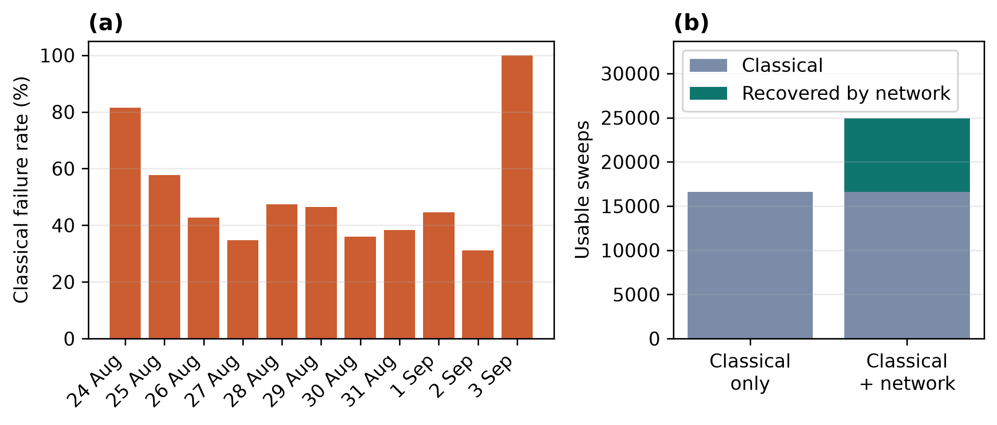
Figure 3. (a) Share of sweeps on which the classical fitting method fails, by day; overall it fails on 44% of the 29,862 sweeps, and on every sweep of 3 September. (b) Usable sweeps with the classical method alone and with the network added: the network recovers 8,343 of the 13,266 classical failures, taking the usable total from 16,596 to 24,939.

3.1.2 Accuracy on simulated sweeps
Table 4 gives the error on 4,000 simulated sweeps that were not used in training.
Table 4. Network error on 4,000 held-out simulated sweeps.
Quantity | Typical error | Note
Electron density | 0.021 dex | about 5%
Electron temperature | 0.078 eV | about 20% at our typical 0.4 eV
Plasma potential | 0.141 V | about a seventh of a volt

These values are a best case: they show that the network can invert the physics model, not that it can invert real data, which Section 3.2 tests.
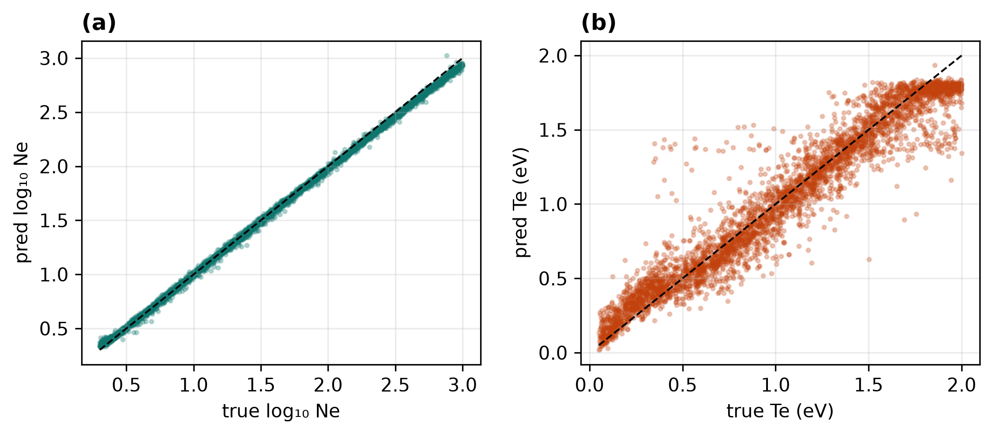
Figure 4. Network prediction against the known true value on 4,000 held-out simulated sweeps for (a) density and (b) temperature. Density is recovered almost exactly; temperature is noisier and flattens near the top of the training range, around 1.8 eV.

3.1.3 Calibration of the error bars
Every recovered value comes with an error bar from Monte-Carlo dropout (Gal & Ghahramani 2016): the network is run 50 times with random parts switched off, and the spread of its answers is the error bar. We checked those error bars against the known truth on the 4,000 simulated test sweeps. A well-calibrated error bar contains the true value about 68% of the time at one sigma and 95% at two sigma.
Density came out at 99.4% within one sigma, plasma potential at 96.7%, and temperature at 63.8% (88.8% within two sigma). So the density and plasma-potential error bars are about three times wider than they need to be, which is conservative. The temperature error bars are about the right size, but miss a little more often than they should in the tails.
On the real archive there is no truth, but the two halves of each commanded sweep should differ by no more than their combined error bars. They do: 99.8% of 12,418 pairs fall within one sigma. This checks repeatability rather than accuracy, but it confirms the bars are not too narrow.

3.2 Validation on the real archive

3.2.1 Agreement with the classical method
Table 5 compares the two methods on the 16,596 real sweeps where both work.
Table 5. Agreement between the network and the classical fit on the 16,596 sweeps both methods fit.
Quantity | Median difference | Note
Electron density | −0.0048 dex | about 1.1%
Electron temperature | +0.027 eV | about 7% of the typical 0.4 eV

Agreement of about 1% in density over 16,596 real sweeps, between a network trained only on simulated data and an independent curve-fitting procedure, is the strongest evidence in this report that the network is not responding to an artefact of the preprocessing.

3.2.2 Consistency between the two halves of each sweep
Every commanded sweep is a triangle: the voltage goes up and then comes back down. The two halves are separate measurements of the same plasma a few seconds apart, so they should agree (Table 6).
Table 6. Agreement between the up and down halves of each commanded sweep.
Quantity | Value | Note
Pairs compared | 12,418 | both halves recovered
Median density disagreement | 0.0110 dex | 2.6%
Systematic offset, down minus up | −0.0019 dex | 0.4%, no directional bias
Correlation between halves | 0.995 | log₁₀ density

This 2.6% is the precision to quote with densities from this archive. It comes from repeated measurement rather than from a model.

3.2.3 Blind test against the mission timeline
The network sees only a current curve and is never told the date, the time or the solar geometry. A model that had learned a quirk of the dataset would have no reason to follow the mission timeline. Table 7 shows that the recovered densities do.
Table 7. Median recovered density per day.
Date (2023) | Density (cm⁻³) | Date (2023) | Density (cm⁻³)
24 August | 246 | 30 August | 493
25 August | 326 | 31 August | 482
26 August | 369 | 1 September | 488
27 August | 444 | 2 September | 456
28 August | 468 | 3 September * | 100
29 August | 478

Density rises smoothly until about 29 August and then levels off near 480 cm⁻³; the rank correlation between date and density is 0.78. (* 3 September is the terminator session; only 3 of its 408 sweeps were recovered, far too few to draw anything from, and it is excluded from the statistic.)
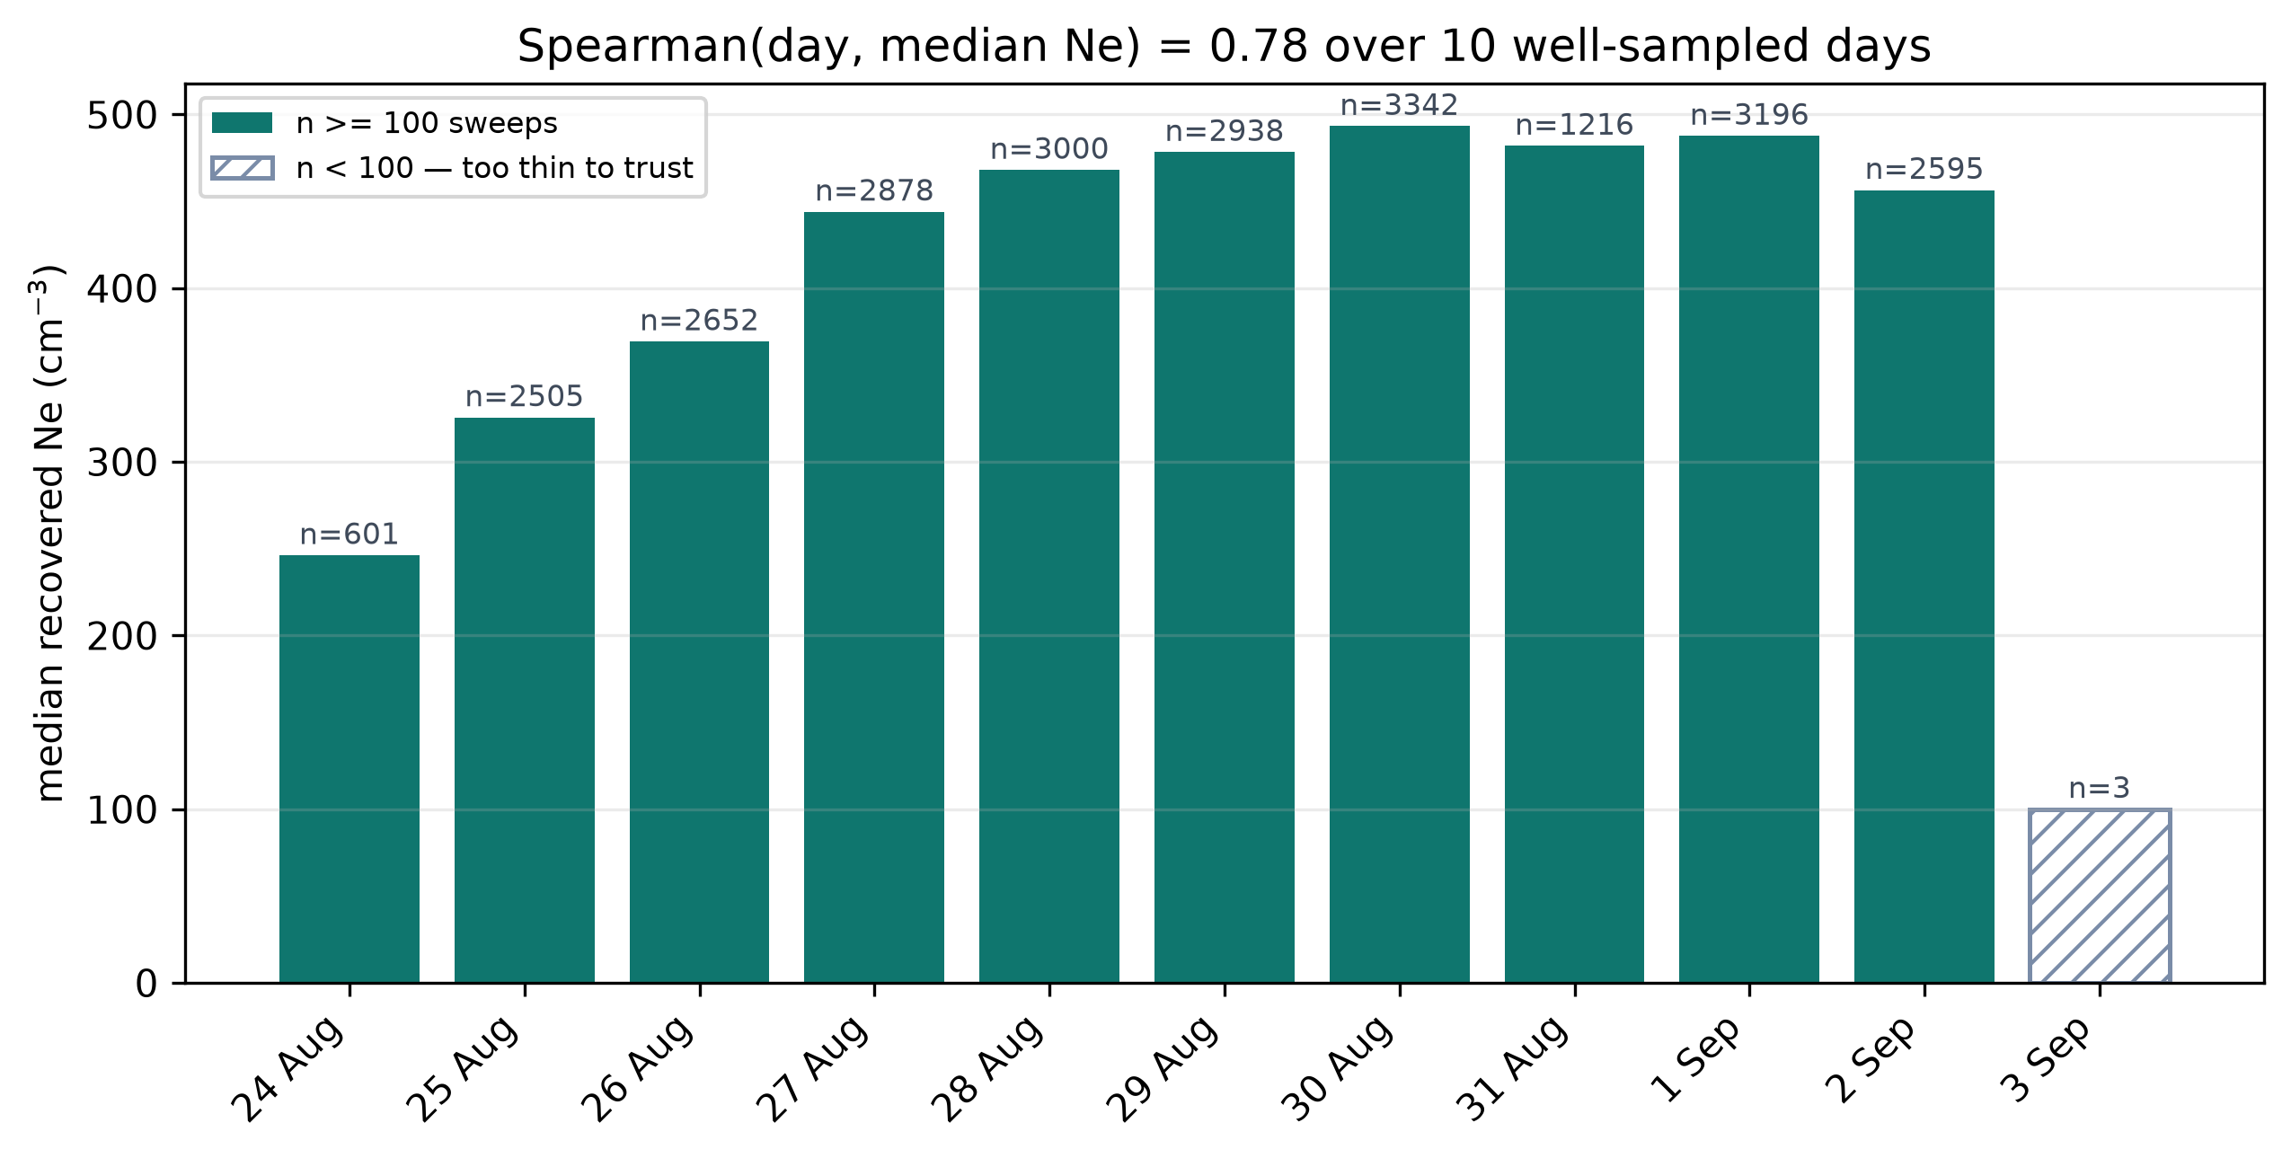
Figure 5. Median recovered density per day. The network is never told the date. 3 September (hatched) has only 3 recovered sweeps and is left out of the trend.

3.2.4 Comparison with the published analysis
The instrument team published their own analysis of this data (Manju et al. 2025), reporting mean daytime densities of 380–600 cm⁻³ and temperatures of 3,000–8,000 K. The median temperature of sweeps passing the network's acceptance test (0.36 eV, about 4,200 K) lies inside that range, although about 30% of those sweeps fall outside it (25% below 3,000 K and 4% above 8,000 K). The daily median densities lie inside the published range from 27 August onwards (Table 7); the first three days are lower, as discussed in Section 3.4. For 2 September the network returns 456 cm⁻³ against a published 478, and a plasma potential of −3.7 V against a published −3.9 V, where the classical fit gives −3.9 V (Manju et al. 2026).

3.3 Experiments
This section reports four further tests, including those that contradicted our initial expectations.

3.3.1 Effect of the physics term
The question. Physics-informed networks are usually evaluated on problems with a known solution (Raissi et al. 2019). Because we had an independent method and a self-consistency check, we could also measure the effect of the physics term on real data. We retrained the network four times with the physics requirement weighted differently, from full strength down to switched off.
Table 8. Effect of the physics-loss weight on simulated and real-data performance.
Physics weight | Simulated accuracy | Real self-consistency | Real sweeps recovered
0.5 (what we use) | 0.078 eV | 0.0108 dex | 62.7%
0.25 | 0.065 eV | 0.0114 dex | 60.5%
0.1 | 0.058 eV | 0.0112 dex | 58.8%
0.0 (switched off) | 0.055 eV | 0.0143 dex | 52.6%

Result. Switching the physics term off improves the network on simulated data, with temperature error falling from 0.078 to 0.055 eV, but worsens it on the real archive: recovery falls by ten percentage points, about 1,350 real sweeps, and self-consistency degrades by a third.
Judged on simulated accuracy alone, the physics term would have been removed, at a cost of about 1,350 real measurements. The term exists to help the network cope with the gap between simulation and reality, which a test run entirely in simulation cannot see.
We also measured how small a difference this comparison can resolve. Retraining with different random starting points gives roughly 250 sweeps of scatter, so a difference below about 2 percentage points is not measurable. The 0.5-versus-0.0 gap is more than five times that; the 0.5-versus-0.25 gap is not resolvable, so the weight was kept at 0.5. The 62.7% for weight 0.5 in Table 8 comes from this retraining series; the final network in Table 3 recovers 62.9%, a difference well inside that scatter.

3.3.2 Testing for a second electron population
The question. A second, hotter electron population was physically plausible at this site, because sunlight releases photoelectrons from the surface (Poppe & Horányi 2010) and from the lander itself. We are not aware of a machine-learning Langmuir inversion that separates two populations, so we built one and tested the idea directly.
We extended the network from three outputs to five.
A five-output model will always report some second population, so the test is whether it does so when none exists. We trained it on data containing two populations and then applied it to curves built with only one.
The first version reported a hot population of 8.9% of the density on curves that had none. The cause was the training data: the hot population's size was drawn from a range that never included zero, so the network had never seen an example with no hot population.
Making 35% of the training examples single-population brought the false rate down to 1.7%, and only then was the model applied to real data.
The earlier evidence for two populations in this archive came from a common diagnostic: averaging many sweeps and examining how the slope varies across the curve. A single population gives a constant slope, and an early version of this analysis showed about a five-fold variation in local temperature. Its code was not saved and the records of its values disagree, so that figure cannot be reproduced; a rerunnable diagnostic gives local temperatures of 0.44–0.70 eV on the averaged archive.
A varying slope is not decisive. Each sweep has its own temperature, and an average of curves that fall off at different rates does not fall off at a single rate: it bends, even when every individual sweep has one population.
The effect is large here. Classical-fit temperatures run from 0.24 to 1.56 eV (1st to 99th percentile), and the deep part of an averaged curve is dominated by its hottest members: the hottest 10% of sweeps contribute 65% of the signal in the region where the inference is made.
We built a control by giving each sweep a single population at its own measured temperature and averaging the results identically. It produces a graded slope with no second population present: local temperature falls from 0.77 eV at 1.9 V below the plasma potential to 0.42 eV at 0.3 V.
With that control in place we tested the archive three separate ways, and none supports a second population:
- Against the matched control, the region where a hot population would dominate shows no consistent excess: at 1.9 and 1.5 V below the plasma potential it is positive on only 3 and 2 of the 9 days with enough sweeps to compare. Closer to the plasma potential the real curves are flatter than the control, on 9 of 9 days at 0.3 V, which Section 3.3.3 attributes to the forward model rather than to a hot population.
- A per-sweep test avoids averaging by measuring the slope in two voltage windows of the same sweep, which must agree for a single population. On simulated data it detects a hot population of 5% of the density every time.
- On real sweeps that test gives 35.7% against a control's 34.7%, a difference of 0.9 sigma, which is not significant.
Splitting that result by probe channel showed the two channels disagreeing at 11 sigma, in opposite directions, so the small overall difference was two opposing effects cancelling.
This also argues against a second population. A real population in the plasma would affect both channels in the same way, so a signal that reverses sign between them points to the instrument.
Conclusion. This archive does not require a second electron population, which agrees with the published analysis of the same data. An earlier draft of this project claimed otherwise, with specific numbers; those are withdrawn and listed in Supplementary Appendix A.

3.3.3 Limits on temperature accuracy
The question. Density is recovered to about 5% and plasma potential to about 0.14 V, but temperature error stays near 20%. We examined whether this is a fundamental limit of the instrument or could be reduced.
Table 9 sets this against the MAVEN Langmuir probe.
Table 9. Electron temperature accuracy reported for MAVEN and for this work.
Mission / study | Temperature error | What kind of number
MAVEN at Mars (Ergun et al. 2015) | better than 20% | stated for most conditions
This work | 20–25% | simulation plus real repeatability

An error near 20% is comparable with the figure stated for MAVEN, although that is an absolute accuracy, whereas ours comes from simulation and repeatability (Section 3.4).
A Fisher-information calculation for this measurement (450 cm⁻³, 0.4 eV, quiet-channel noise) gives a Cramér–Rao bound of about 1.5% on temperature. The achieved error is about 13 times larger, so noise is not the limit.
The same calculation shows why. Temperature and plasma potential are 92% correlated: a slightly hotter plasma and a slight voltage shift bend the curve in nearly the same way. Not knowing the plasma potential inflates the achievable temperature error by a factor of about 2.5.
The training distribution also contributed. The network's absolute error was roughly constant across the temperature range (0.05–0.09 eV in every bin), and 41% of the training examples were hotter than 1.2 eV, a regime rarely seen in this archive, while only 10% were in the range it mostly occupies.
Training on the logarithm of temperature and narrowing the training range to realistic values gave 22.3% before and 20.2% after, over three runs each. The 1.5 sigma difference is not significant, although results became more stable between runs.
A more effective change removes the voltage from the problem before the network sees the curve. The curve is shifted so that zero sits at the plasma potential and divided by the current there so that density cancels, and its logarithm is taken. The slope of the result is set by the temperature alone.
Table 10. Temperature error on simulated sweeps with and without the plasma-potential-aligned refinement.
Configuration | Temperature error | Spread over 3 runs
As built (raw curve) | 22.3% | ± 1.3%
Aligned, using the true voltage (ceiling) | 11.7% | ± 2.6%
Aligned, using the predicted voltage | 12.2% | ± 0.2%

The error nearly halved, a difference of about 13 sigma over three independent runs in the 0.30–0.50 eV band, with every row at the full training budget (20,000 sweeps, 90 epochs). Using a predicted voltage instead of the true one costs little.
The change was then tested on real data. Following Section 3.3.1, it was not adopted on the strength of a simulated result; instead we measured whether the two halves of the same real sweep agreed better, a repeatability test that needs no ground truth. Table 11 gives the result, and the change fails it. The baseline in Table 11 is the final trained network rather than the three-run average of Table 10, so the simulated gain is smaller there: 0.075 to 0.049 eV, or 18.2% to 11.8% within the temperature range the archive mostly occupies.
Table 11. The temperature refinement on simulated and real data.
 | As built | With the fix
Simulated accuracy | 0.075 eV | 0.049 eV (better)
Real repeatability | 0.0076 eV | 0.0101 eV (32% worse)
Offset vs classical method | −0.003 eV | −0.048 eV (bias appeared)

The test itself is sound. A model predicting the same temperature for every sweep would score perfect repeatability while being useless, but this one's answers span 0.12 to 0.58 eV across the archive, and it is 13 times more repeatable than the classical fit.
We first suspected the region where the fix reads the temperature, near the plasma potential, where the real curves depart from the physics model on 9 of 9 days. Moving the reading window deeper made every measure worse, including the simulated accuracy, which rules this explanation out.
The current falls exponentially below the plasma potential. Just below it there is plenty of signal, but that is where the physics model is wrong; deeper down the model holds, but the current has dropped to 0.15% of its peak, below the noise floor on every channel.
The temperature information and the model's error therefore occupy the same part of the curve, and no window has one without the other.
Conclusion. Temperature accuracy here is limited by how well our physics model describes the curve near the plasma potential - not by the network. Further changes to the network are unlikely to improve it. Fixing that part of the physics model is the prerequisite, and it is the clearest piece of future work.

3.3.4 Per-sweep scatter
The per-sweep test in Section 3.3.2 produced something unrelated to electron populations. Real sweeps scatter about 3.6 times more than our noise model predicts. The scatter is symmetric, so it is not a bias, but we cannot account for it. The same excess scatter appears independently when the up and down halves of each sweep are compared.
The practical consequence is that a single sweep's temperature is much less repeatable than a simulated accuracy figure suggests, and should always be quoted with that scatter. Whether it comes from the baseline subtraction, from the plasma genuinely changing during a sweep, or from something the physics model omits, we could not determine.

3.4 Discussion
The recovered values broadly agree with the published analysis of the same instrument (Section 3.2.4). The exception is density on the first three days (246–369 cm⁻³), which is below the published 380–600 cm⁻³. On those days the network's median plasma potential is also far more negative (−8.2 to −4.4 V). Both analyses start from the same photoemission correction, which the archive applies with the method of Johansson et al. (2017), so this step is unlikely to explain the difference on its own, and the cause was not established here. Manju et al. (2026) also report densities of about 1,100 cm⁻³ near the terminator after the hop, but this could not be tested here because only 3 of the 408 sweeps from 3 September were recovered.
The accuracy figures should be read with their source in mind. The temperature error of about 20% on simulated data is similar to the better-than-20% stated for MAVEN in most conditions (Ergun et al. 2015), but that is an absolute accuracy, whereas the figures in this report come from simulation and from repeatability. The 2.6% disagreement between sweep halves is the most direct error estimate available for density, but it measures precision, not absolute accuracy.
The close agreement with the classical fit shows that the network is not simply reproducing artefacts of preprocessing. It does not remove errors that the two methods share, however. Both rely on the OML picture with a fixed sheath-expansion exponent. Liu et al. (2023) found that assuming the standard OML exponent for their needle probes overestimated density by a factor of about three. A shared error of this kind would move both methods together and would not appear in any of the consistency checks used here.
The physics-term experiment (Section 3.3.1) has a practical lesson for physics-informed machine learning. Physics-informed networks are usually judged by their accuracy on problems where the exact solution is known (Raissi et al. 2019). Here, accuracy on simulated sweeps pointed one way and recovery on real sweeps the other. When the physics term is meant to help the model cope with the gap between simulation and reality, it needs to be judged on real data.
For the two-population test, the physical expectation came from photoemission. A sunlit surface produces a photoelectron sheath (Poppe & Horányi 2010), and the lander and probe add photoelectrons of their own, so a warmer secondary population near the probe was plausible. The controlled tests in Section 3.3.2 do not support it, which is consistent with the published single-population analysis (Manju et al. 2025). The wider point is about method: when sweeps with different temperatures are averaged, the averaged curve shows a changing slope like that of a two-population plasma. Any claim of multiple populations based on averaged sweeps therefore needs a matched single-population control.
Finally, the temperature experiments show where further progress has to come from. The part of the curve that carries most of the temperature information, just below the plasma potential, is also where the forward model departs from the real sweeps. Better network design cannot get around this; a better description of the current near the plasma potential, including a variable sheath exponent and an explicit photoemission term, is needed first.

4. Limitations and future scope

4.1 Limitations
- We cannot check our absolute accuracy. There is no second instrument on the lander and no lunar equivalent of ground radar. Everything in this report is consistency, not verified accuracy.
- The physics model assumes a fixed value for how the collecting region grows with voltage. A study of cylindrical needle probes shows that this matters: assuming the standard value overestimated density by a factor of about three (Liu et al. 2023). This is the largest known systematic remaining.
- Photoemission from the probe and lander is not part of the forward model. The rawB product already has a photoemission current removed, estimated with the method of Johansson et al. 2017 as in the published analysis (Manju et al. 2025), and any remaining constant is absorbed by the baseline subtraction. Photoemission that changes with time is not corrected.
- A channel-dependent effect distorts the curve near the plasma potential. The two probe channels disagree at 11 sigma while returning almost identical density and temperature. We do not know its cause, and it limits how far any shape-based conclusion can be pushed.
- The 3 September terminator session is still almost entirely unrecovered - 3 sweeps of 408.
- The hop itself could not be tested. The project plan included a blind test on the lander's 2 September hop, where the instrument team report density falling from about 478 to 26 cm⁻³ (Manju et al. 2026). During the hop the probe was in a fixed-voltage mode and recorded no sweeps at all, so there is nothing for any sweep-based method to analyse.
- We tried pre-training on simulated Mars-like data before fine-tuning on lunar data. It made the model about fifteen times worse and was abandoned. We report this as a negative result about this particular attempt, not as a general claim: both datasets came from the same physics model, so the pre-training carried no new physics, only a prior centred two to three orders of magnitude away in density.

4.2 Future scope
Table 12. Future work, with the reason for each item.
Task | Why
Fix the physics model near the plasma potential | Currently limits temperature accuracy (Section 3.3.3)
Let the sheath-growth exponent vary per sweep | Shown to matter for cylindrical probes (Liu et al. 2023); largest known systematic
Add photoemission as a fitted term | It is present physically and absent from the model
Identify the channel-dependent effect | Unexplained, and it bounds shape-based conclusions

5. Conclusions
This study shows that a neural network trained only on simulated sweeps can invert real RAMBHA-LP Langmuir probe measurements from the lunar surface. On the 16,596 sweeps that the classical fit can also handle, the two methods agree to about 1% in density, and the network recovers 8,343 of the 13,266 sweeps that the classical fit rejects, raising the usable part of the archive from 56% to 84%. The rising and falling halves of each sweep agree to 2.6% in density, the daily medians follow the increase in density across the mission without the model being given the date, and the values for 2 September are close to those published by the instrument team.
The physics-informed loss term lowers accuracy on simulated data, with a temperature error of 0.078 eV against 0.055 eV without it, but recovers about ten percentage points more real sweeps. Judged on simulated accuracy alone, it would have been removed. Choices that are meant to close the gap between simulation and reality must therefore be tested on real data.
A two-population version of the network, checked against a single-population control, finds no evidence that the archive requires a second electron population. The remaining signal reverses sign between the two probe channels, which points to an instrumental cause. The local slope of an averaged sweep is not, on its own, evidence for multiple populations, because a spread of single-population temperatures also gives a graded pattern; in this archive the hottest 10% of sweeps supply 65% of the signal in the region used for that inference.
Electron temperature remains the least certain quantity, at about 20% on simulated data. An input aligned to the plasma potential reduces this error by between a third and a half in simulation but makes the real repeatability 32% worse, because the region of the curve that carries the temperature information is also where the forward model departs from the data. Improving the physics model near the plasma potential is therefore the next step, before any further change to the network.

Acknowledgements
The RAMBHA-LP data used in this work were provided by the Indian Space Research Organisation through the ISRO Science Data Archive (PRADAN), operated by the Indian Space Science Data Centre (ISSDC). The RAMBHA-LP instrument was built and operated by the Space Physics Laboratory, Vikram Sarabhai Space Centre. The author thanks Dr. Rama Chandra Pillutla, Lab for Spatial Informatics, IIIT Hyderabad, for supervising this independent study and for his guidance throughout the work.

References
Ergun, R. E., Morooka, M. W., Andersson, L. A., et al. (2015). Dayside electron temperature and density profiles at Mars: First results from the MAVEN Langmuir probe and waves instrument. Geophysical Research Letters, 42(21), 8846–8853. https://doi.org/10.1002/2015GL065280
Gal, Y., & Ghahramani, Z. (2016). Dropout as a Bayesian approximation: Representing model uncertainty in deep learning. Proceedings of the 33rd International Conference on Machine Learning, PMLR 48, 1050–1059. https://proceedings.mlr.press/v48/gal16.html
Hutchinson, I. H. (2002). Principles of Plasma Diagnostics (2nd ed.). Cambridge University Press. https://doi.org/10.1017/CBO9780511613630
ISRO Science Data Archive (PRADAN). Chandrayaan-3 RAMBHA-LP PDS4 data archive, release LTA_RAMBHA-LP_August2024_final. Indian Space Science Data Centre. https://pradan.issdc.gov.in/ch3/ (accessed 2026)
Johansson, F. L., Odelstad, E., Paulsson, J. J. P., et al. (2017). Rosetta photoelectron emission and solar ultraviolet flux at comet 67P. Monthly Notices of the Royal Astronomical Society, 469(Suppl. 2), S626–S635. https://doi.org/10.1093/mnras/stx2369
Liu, G., Marholm, S., Eklund, A. J., Clausen, L., & Marchand, R. (2023). m-NLP inference models using simulation and regression techniques. Journal of Geophysical Research: Space Physics, 128(2), e2022JA030835. https://doi.org/10.1029/2022JA030835
Manju, G., Pant, T. K., Mridula, N., et al. (2025). In situ ionospheric observations near lunar south pole by the Langmuir Probe on Chandrayaan-3 lander. Monthly Notices of the Royal Astronomical Society, 542(4), 2647–2656. https://doi.org/10.1093/mnras/staf1276
Manju, G., Pant, T. K., Mridula, N., et al. (2026). Langmuir probe-based lunar near-surface plasma measurements associated with the unique hop test of Chandrayaan 3 lander: observations and model simulations. Monthly Notices of the Royal Astronomical Society, 546(4), stag077. https://doi.org/10.1093/mnras/stag077
Mott-Smith, H. M., & Langmuir, I. (1926). The theory of collectors in gaseous discharges. Physical Review, 28(4), 727–763. https://doi.org/10.1103/PhysRev.28.727
Poppe, A., & Horányi, M. (2010). Simulations of the photoelectron sheath and dust levitation on the lunar surface. Journal of Geophysical Research: Space Physics, 115, A08106. https://doi.org/10.1029/2010JA015286
Raissi, M., Perdikaris, P., & Karniadakis, G. E. (2019). Physics-informed neural networks: A deep learning framework for solving forward and inverse problems involving nonlinear partial differential equations. Journal of Computational Physics, 378, 686–707. https://doi.org/10.1016/j.jcp.2018.10.045

