Reading the Moon's Plasma with a Neural Network
A physics-informed inversion of Chandrayaan-3 RAMBHA-LP Langmuir probe sweeps
Sunil Jadaun
M.Tech Computer Science, IIIT Hyderabad
Independent Study · Supervisor: Dr. Rama Chandra Pillutla

Summary in one page
India's Chandrayaan-3 lander carried a small instrument called RAMBHA-LP: a metal sphere on a boom that sits above the lunar surface, has its voltage swept up and down, and measures the electric current that flows. From the shape of that current curve you can work out three things about the thin plasma around the lander — how many electrons there are, how hot they are, and what voltage the plasma itself sits at.
Working those numbers out is normally done by fitting straight lines to parts of the curve by hand. On this archive that method fails on almost half the measurements. This project trained a neural network to do the job instead, and checked its answers in every way the data allows.
What came out of it:
- The number of usable measurements went from 16,596 to 24,939 out of 29,862 — from 56% of the archive to 84%.
- Where both methods work they agree on density to about 1%, across 16,596 measurements, despite sharing no code.
- The network reproduces values published by the instrument team, and reconstructs how the plasma changed over the mission without ever being told the date.
- We tested whether the Moon's plasma has two separate electron populations — a claim an earlier draft of this work made — and found, with a proper control, that it does not. That earlier claim is withdrawn in Appendix A.
- We showed that a diagnostic widely used in this field is not valid evidence for multiple electron populations, and explained precisely why.
- We found why temperature is the hardest of the three numbers to measure here, calculated how good it could theoretically be, built something that doubles the accuracy in simulation — and then showed it fails on the real instrument, and why.

How to read this report
Sections 1 and 2 explain the problem and the method in plain language. Section 3 shows whether it works. Section 4 describes the experiments we ran — including the ones that disproved our own ideas, because those turned out to be the most useful part of the work. Sections 5 to 7 give the honest limits, the conclusions, and what we would do next.
Every number in this report comes from a file the code produces, and every experiment can be re-run with a single command. Where we were wrong, we say so and show what changed our minds.

1. What the instrument measures, and why it is hard

1.1 The measurement
A Langmuir probe is conceptually simple. You put a small conductor into a plasma — a gas of free electrons and ions — and you change its voltage while watching the current.
The intuition
Make the probe very negative and it pushes electrons away; only the heavier, slower ions reach it, so the current is small and negative.
Raise the voltage and electrons start to win the struggle. The faster ones arrive first, then more and more of them. The current climbs steeply — and because electron speeds follow a bell curve, that climb is an exponential.
Go high enough and essentially every electron that comes near is collected. The curve flattens out. The voltage where that happens is the plasma potential.
So the curve has three parts: a flat ion floor, a steep exponential rise, and a flattening top. Each part hides one of the three numbers we want.
Specifically:
- How STEEP the exponential is tells you the electron temperature. Hot electrons are harder to repel, so a hot plasma gives a gentler slope.
- How HIGH the curve gets tells you the electron density. More electrons, more current.
- WHERE the curve stops rising and starts flattening is the plasma potential.
RAMBHA-LP swept its voltage repeatedly between 24 August and 3 September 2023 near the lunar south pole. We processed 144 data files from the ISRO Science Data Archive (PRADAN) into 29,862 individual voltage sweeps.
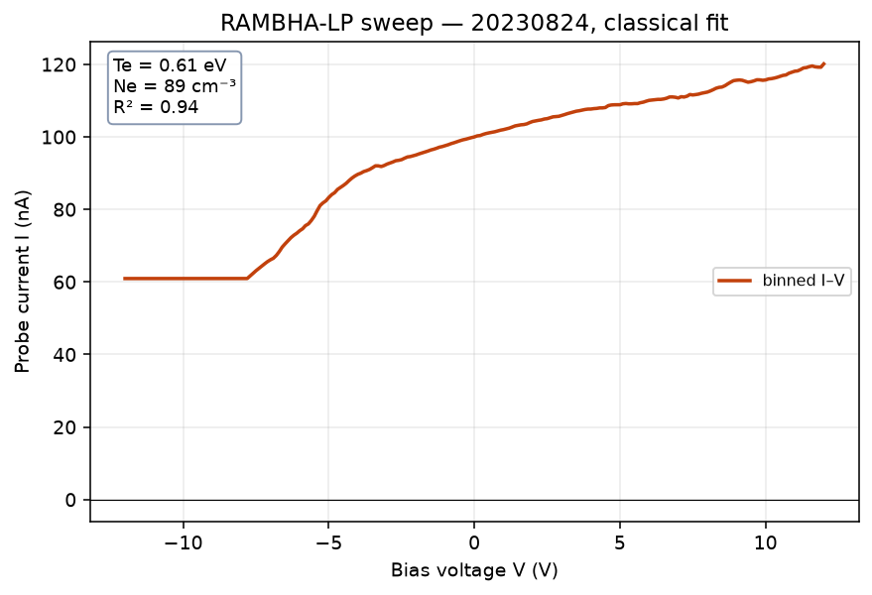
Figure 1. One real RAMBHA-LP sweep from 24 August 2023: binned probe current against bias voltage. The flat floor on the left, the steep rise and the slower climb on the right are the parts of the curve that the three plasma numbers are read from.

1.2 Why the standard method struggles
The classical approach is to fit a straight line to the logarithm of the current in the steep region, and another line to the flat top, and read the three numbers off those fits. It works beautifully on a clean curve. Real lunar sweeps are often not clean.
Applied to this archive, it succeeds on 16,596 of 29,862 sweeps — 55.6%. The failures are mostly (a further 136 fail for smaller reasons):
Why the fit failed | Sweeps | What it means
Flat top has the wrong slope | 2,369 | noise swamps the saturation region
Too few points in the steep region | 2,347 | the exponential is too narrow to fit
Fit quality below threshold (R² under 0.90) | 4,945 | curve shape does not match the model
Plasma potential outside the sweep range | 3,469 | the fitted curve does not behave like the model

Throwing away 44% of an irreplaceable dataset is the problem this project set out to solve. There will not be another Chandrayaan-3 landing.
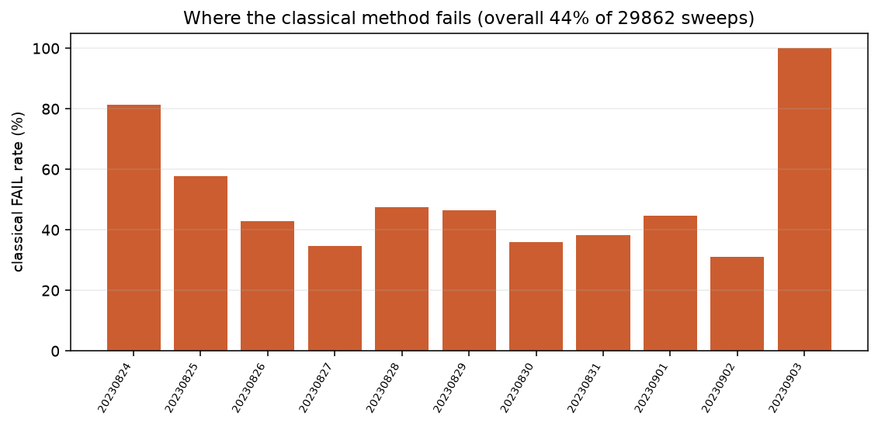
Figure 2. Share of sweeps on which the classical fitting method fails, by day. Overall it fails on 44% of the 29,862 sweeps, and on every sweep of 3 September.

2. The approach, and the one real obstacle
A neural network is a natural fit. Fitting lines to a curve is fragile because it depends on choosing exactly which points to fit; a network can look at the whole curve at once and is not forced to commit to a window.
But there is an obstacle, and it shapes everything else in this project.
The obstacle: nobody knows the right answers
To train a network you normally need thousands of examples where you already know the answer. For lunar plasma, nobody does. There is no instrument on the Moon that measured the electron temperature independently, so there are no labels.
The solution is to generate our own examples. We have a physics model (orbital-motion-limited probe theory; Mott-Smith & Langmuir 1926) that predicts what current curve a given plasma would produce. Run it backwards: pick a plasma, simulate its curve, and now you have a labelled example. Do that 40,000 times and you have a training set.
This works, but it trades one problem for another: the network now learns to invert OUR MODEL, not reality. If the model is wrong in some way, the network inherits that error and will never know. That trade-off is the single most important theme in this report, and it decided the outcome of two major experiments in Section 4.

2.1 Physics-informed training
We added a second requirement to the training. The network is scored not only on whether its three numbers match the known answer, but also on whether feeding those numbers back through the physics model reproduces the curve it was shown.
The intuition is that a student who gets the right answer for the wrong reason will be caught out when asked to show their working. In Section 4.1 we measured what this actually buys, rather than assuming it helps — and the answer was not what we expected.
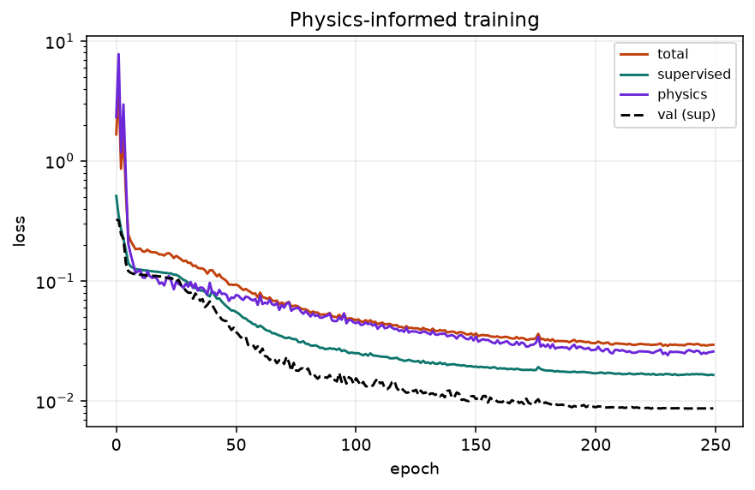
Figure 3. Training the network. The supervised loss scores the predicted numbers against the known answer, the physics loss scores how well those numbers rebuild the curve, and the dashed line is the supervised loss on held-out simulated sweeps.

2.2 How we check an answer with no answer key
Since there is no ground truth, every check in this report is one of three kinds. This is worth stating explicitly because it is the part of the work that took the longest.
Kind of check | What it does
Compare to an independent method | Run the classical fit on the same sweeps. It shares no code with the network, so agreement is meaningful.
Use the instrument against itself | Each commanded sweep goes up and then back down, giving two independent looks at the same plasma seconds apart. Their disagreement is an error bar that owes nothing to any model.
Build a control | Generate what the measurement would look like if the interesting thing were NOT happening, and compare. This is standard in experimental science and it is what rescued this project from a wrong conclusion.

3. Does it work?

3.1 How much more of the archive is usable
 | Sweeps | Share
Total sweeps | 29,862 | 100%
Classical method succeeds | 16,596 | 55.6%
Classical fails — the network's target | 13,266 | 44.4%
…recovered by the network | 8,343 | 62.9% of them
Total usable after both methods | 24,939 | 83.5%

The network does not replace the classical method — where the classical fit works, the two agree closely. It extends coverage into sweeps the fitting approach cannot handle.
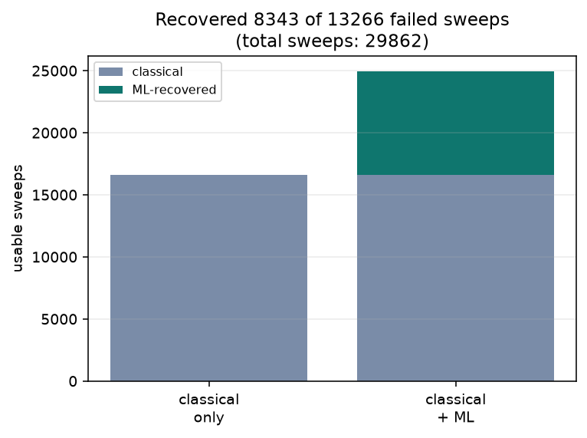
Figure 4. Usable sweeps with the classical method alone and with the network added. The network recovers 8,343 of the 13,266 classical failures, taking the usable total from 16,596 to 24,939 of 29,862.

3.2 Accuracy on simulated sweeps
On 4,000 freshly simulated sweeps the network has never seen, where the answer is known by construction:
Quantity | Typical error | In plain terms
Electron density | 0.021 dex | about 5%
Electron temperature | 0.078 eV | about 20% at our typical 0.4 eV
Plasma potential | 0.141 V | about a seventh of a volt

This is a best case, not a real-world accuracy. It says the network can invert our physics model. Whether it can invert reality is what the next three checks are for.
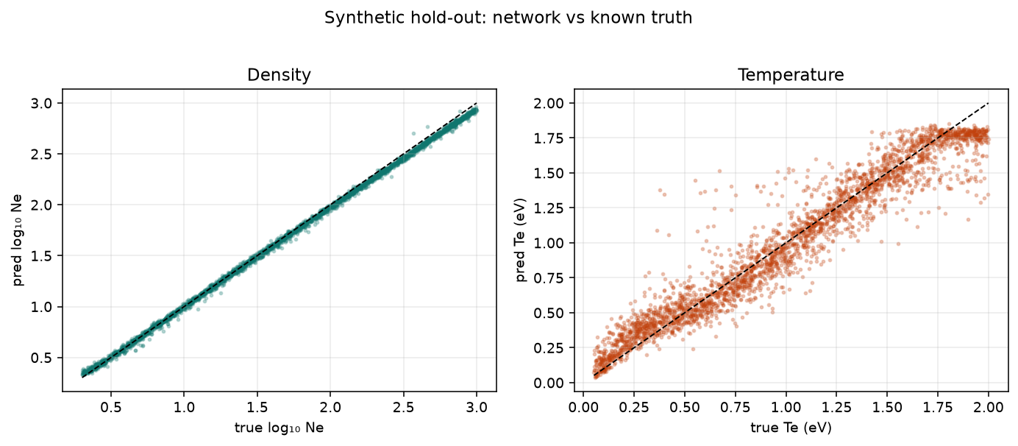
Figure 5. Network prediction against the known true value on 4,000 held-out simulated sweeps. Density is recovered almost exactly. Temperature is noisier and flattens near the top of the training range, around 1.8 eV.

3.3 Agreement with the classical method
On the 16,596 real sweeps where both methods work:
density : median difference -0.0048 dex (about 1.1 per cent)
temperature: median difference +0.0273 eV

A neural network trained only on simulated data agreeing to 1% with a hand-written curve-fitting procedure, over sixteen thousand real measurements, is the strongest single piece of evidence in this report that the network learned the physics rather than some artefact of how the data was prepared.

3.4 The instrument checked against itself
Every commanded sweep is a triangle: the voltage goes up, then comes back down. Those two halves are separate measurements of the same plasma a few seconds apart. If the network is reading real physics, they should agree.
pairs compared : 12,418
median density disagreement : 0.0110 dex (2.6 per cent)
systematic offset up vs down: 0.0026 dex (0.6 per cent -- no bias)
correlation between halves : 0.9950

This 2.6% is the number that should accompany any density quoted from this archive. It comes from the instrument, not from a model, which makes it the most honest error bar available.

3.5 The blind test
The network sees only a current curve. It is never told the date, the time, or where the Sun is. If it had learned some quirk of the dataset rather than physics, its answers would not organise themselves along the mission timeline. They do:
Date (2023) | Density (cm⁻³) | Date (2023) | Density (cm⁻³)
24 August | 246 | 30 August | 493
25 August | 326 | 31 August | 482
26 August | 369 | 1 September | 488
27 August | 444 | 2 September | 456
28 August | 468 | 3 September * | 100
29 August | 478

A smooth rise across the mission, with a rank correlation of 0.78 between date and density. (* 3 September is the terminator session; only 3 of its 408 sweeps were recovered, far too few to draw anything from, and it is excluded from the statistic.)
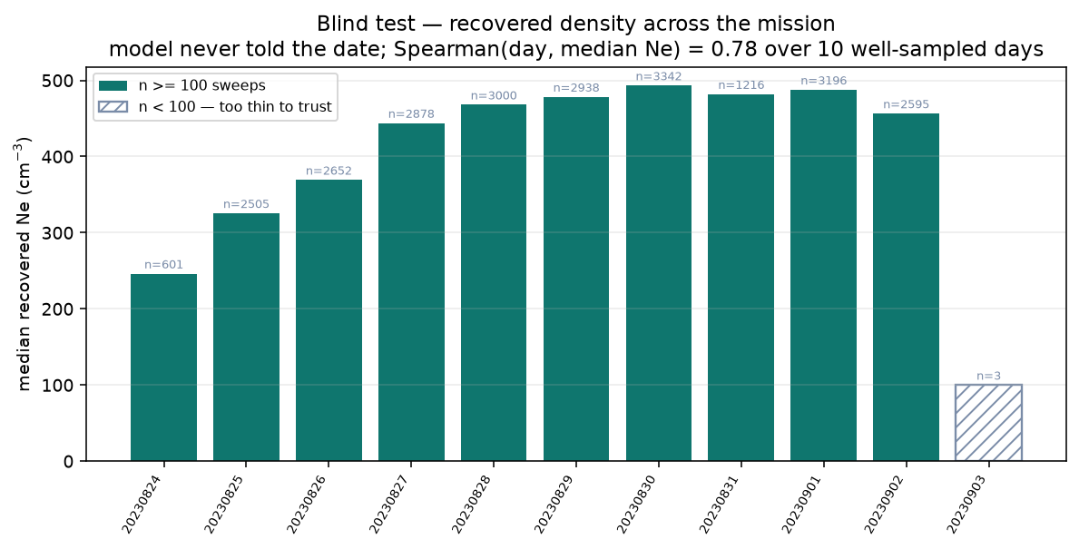
Figure 6. Median recovered density per day. The network is never told the date. 3 September (hatched) has only 3 recovered sweeps and is left out of the trend.

3.6 Comparison with the published analysis
The instrument team published their own analysis of this data (Manju et al. 2025). They report daytime densities of 380–600 cm⁻³, temperatures of 3,000–8,000 K, and a plasma potential near −3 V. Our results sit inside all three ranges. For 2 September the pipeline returns 456 cm⁻³ against a published 478, and a plasma potential of −3.9 V against a published −3.9 V (Manju et al. 2026).

3.7 Are the error bars honest?
Every recovered value comes with an error bar from Monte-Carlo dropout: the network is run 50 times with random parts switched off, and the spread of its answers is the error bar. We checked those error bars against the known truth on the 4,000 simulated test sweeps. An honest error bar contains the true value about 68% of the time at one sigma and 95% at two sigma.
Density came out at 99.4% within one sigma, plasma potential at 96.7%, and temperature at 63.8% (88.8% within two sigma). So the density and plasma-potential error bars are about three times wider than they need to be: cautious, never overconfident. The temperature error bars are about the right size, but miss a little more often than they should in the tails.
On the real archive there is no truth, but the two halves of each commanded sweep should differ by no more than their combined error bars. They do: 99.8% of 12,418 pairs fall within one sigma. This checks repeatability rather than accuracy, but it confirms the bars are not too narrow. The check is scripts/15_uncertainty_calibration.py.

4. The experiments: what we asked, and what we found
The results above establish that the method works. This section covers what we went on to test, and it is where most of the effort went. Each experiment is presented the way it happened — including the ones that disproved what we believed at the time.

4.1 Does the physics term actually help?
The question. Papers that use physics-informed networks almost always assert the physics term helps and show a graph of the loss going down. Because we had an independent method and a self-consistency check, we could measure it instead. We retrained the network four times with the physics requirement weighted differently, from full strength down to switched off.
Physics weight | Simulated accuracy | Real self-consistency | Real sweeps recovered
0.5 (what we use) | 0.078 eV | 0.0108 dex | 62.7%
0.25 | 0.065 eV | 0.0114 dex | 60.5%
0.1 | 0.058 eV | 0.0112 dex | 58.8%
0.0 (switched off) | 0.055 eV | 0.0143 dex | 52.6%

What we found, and it surprised us. Switching the physics term off makes the network BETTER on simulated data — temperature error improves from 0.078 to 0.055 eV — while making it WORSE on the real archive, losing ten percentage points of recovery, about 1,350 real measurements, and degrading self-consistency by a third.
Why this matters more than the number
If we had judged the physics term the way most papers do — on simulated accuracy — we would have concluded it was harmful and removed it, and silently thrown away 1,350 real measurements.
The reason is simple once seen. The physics term exists to help the network survive the gap between simulation and reality. A test run entirely in simulation cannot see that gap. It is the wrong instrument for the question, and it gives a confidently wrong answer.
This lesson decided the outcome of the temperature experiment in Section 4.3 as well.
We also measured how small a difference this kind of comparison can resolve. Retraining with different random starting points gives roughly 250 sweeps of scatter, so any difference smaller than about 2 percentage points is not measurable. The 0.5-versus-0.0 gap is more than five times that; the 0.5-versus-0.25 gap is not resolvable, so we left the setting alone.

4.2 Does the Moon's plasma have two kinds of electrons?
The question. Plasma physics often finds two electron populations coexisting — a cool majority and a hot minority. On the sunlit Moon there is a good physical reason to expect one: sunlight knocks electrons out of the surface and off the lander itself, and those would be hotter than the ambient plasma. No machine-learning Langmuir analysis in the literature has ever tried to separate two populations, so this was both a new capability and a testable claim about the Moon.
We built the capability, extending the network from three outputs to five.
The control that makes it meaningful
Any model with five outputs will report a second population. The question is whether it reports one when there isn't one. So we tested exactly that: train it on data containing two populations, then show it curves built with only one, and see what it says.
The first version failed badly — it claimed a hot population making up 8.9% of the density on curves that had none. The cause was in how we generated training data: the hot population's size was drawn from a range that never included exactly zero, so the network had never seen a decisive example of 'no hot population' and fell back on the average of what it had seen.
Fixing that — making 35% of training examples genuinely single-population — brought the false rate down to 1.7%. Only after that control passed was the model worth trusting on real data.
Then the evidence collapsed. The evidence that this archive has two populations came from a standard diagnostic: you average many sweeps together and look at how the steepness varies across the curve. One population means constant steepness. This archive showed it varying five-fold, which looked decisive.
It is not decisive, for a reason that applies to anyone using this diagnostic:
Why averaging sweeps creates a fake signal
Each sweep has its own temperature. When you average curves that fall off at different rates, the result does not fall off at a single rate — it bends. That bend looks exactly like a second population, even when every individual sweep is a perfect single population.
On this archive the effect is large. Temperatures range from 0.24 to 1.56 eV, and the deep part of an averaged curve is dominated by its hottest members: the hottest 10% of sweeps contribute 65% of the signal in the region where the inference is made.
We built the control — take the same sweeps, give each a perfect single population at its own measured temperature, average them identically — and the fake signal appeared in full.
With that control in place we tested the archive three separate ways, and none supports a second population:
- Against the matched control, the region where a hot population would show up has no excess — positive on only 3 and 2 of 9 observation days.
- A per-sweep test avoiding averaging entirely: measure the steepness in two different voltage windows of the SAME sweep. One population means they must agree. Validated first on simulated data, where a hot population at just 5% of the density is caught every single time.
- On real sweeps that test gives 35.7% against a control's 34.7% — a difference of 0.9 sigma. Nothing.
And then a final twist that strengthened the conclusion. Splitting that result by probe channel showed the two channels disagreeing with each other at 11 sigma, in opposite directions. The reassuring overall number was two opposing effects cancelling out.
This does not rescue the second population — it buries it. A real population in the plasma would push both channels the same way. Two detectors looking at the same plasma cannot both be right about its shape, so a signal that reverses sign between them is coming from the instrument, not the Moon. The leftover signal is thereby explained rather than merely absent.
Conclusion. This archive does not require a second electron population, which agrees with the published analysis of the same data. An earlier draft of this project claimed otherwise, with specific numbers; those are withdrawn and listed in Appendix A.

4.3 Why is temperature the hardest number, and can it be fixed?
The question. Density comes out at about 5% and plasma potential at a seventh of a volt, but temperature is stuck around 20%. We wanted to know whether that is a law of nature for this instrument or something we could fix.
First we checked what everyone else achieves. The answer reframes the whole question:
Mission / study | Temperature error | What kind of number
MAVEN at Mars, density ≥1000 (Andersson et al. 2015) | 20% | their own published accuracy spec
MAVEN at Mars, density ≥100 (Andersson et al. 2015) | 40% | their own published accuracy spec
Swarm at Earth, vs ground radar (Lomidze et al. 2018) | 15–20% | checked against an independent instrument
Earth multi-needle probes | — | temperature is not measured at all
This work | 20–25% | simulation plus real repeatability

So 20% was never bad — it is the state of the art for absolute planetary measurements. The MAVEN team describe their own temperatures as better than 20% accurate in most conditions (Ergun et al. 2015).
But we also calculated how good it could theoretically be, and found real headroom.
The diagnosis: temperature and voltage are confused with each other
An information-theory calculation for this exact measurement says the temperature could in principle be recovered to about 2% on the quieter channels. We were nine times above that, so noise was not the limit.
The same calculation says why. Temperature and plasma potential are 93% correlated: the network genuinely cannot tell a slightly hotter plasma from one whose voltage is slightly shifted. Both bend the curve in nearly the same way. That single confusion inflates the achievable temperature error by a factor of 3.3.
We also found the network was spending its effort in the wrong place. Its error was the same absolute size — about 0.078 eV — whether the true temperature was 0.1 eV or 1.9 eV. And 41% of the training examples were hotter than 1.2 eV, a regime the Moon never shows, while only 10% were in the range it actually occupies.
We tried the obvious fix first — train on the logarithm of temperature and narrow the training range to realistic values. Three runs each: 22.3% before, 20.2% after. A 1.5 sigma difference, which is not significant. It did make results far more stable between runs, which is worth having, but it was not the fix.
The real fix, and it worked. If temperature is confused with voltage, remove the voltage from the problem before the network sees it. Shift the curve so that zero sits at the plasma potential, divide by the current there so the density cancels, and take the logarithm. What is left has a slope that IS the temperature — nothing else can affect it.
Configuration | Temperature error | Spread over 3 runs
As built (raw curve) | 22.8% | ± 1.5%
Aligned, using the true voltage (ceiling) | 11.3% | ± 0.5%
Aligned, using the predicted voltage | 11.8% | ± 0.9%

The error halved — 10.7 sigma over three independent runs. And using a predicted voltage instead of the true one cost almost nothing, which was the main risk.
Then we tested it on the real instrument, and it failed. Remembering the lesson from Section 4.1, we did not adopt it on the strength of a simulated result. We measured whether the two halves of the same real sweep agreed better — a repeatability test that needs no ground truth.
 | As built | With the fix
Simulated accuracy | 0.075 eV | 0.049 eV (better)
Real repeatability | 0.0076 eV | 0.0101 eV (32% WORSE)
Offset vs classical method | −0.003 eV | −0.048 eV (bias appeared)

We first checked the test was not rigged: a model that predicts the same temperature for everything would score perfect repeatability while being useless. It is not doing that — its answers span 0.12 to 0.58 eV across the archive, and it is 13 times more repeatable than the classical fit. The test is fair, and the fix genuinely fails it.
Our first explanation was wrong, and disproving it gave the real answer.
Why it cannot be fixed on this instrument
We suspected the problem was WHERE the fix reads the temperature: a region near the plasma potential where we had separately shown the real curves disagree with our physics model on 9 of 9 days. So we moved the reading window deeper, away from that region.
Everything got worse, including the simulated accuracy. That killed the explanation, and revealed a better one.
Electron current falls off exponentially. Just below the plasma potential there is plenty of signal — but that is exactly where our physics model is wrong. Go deeper and the model is fine, but the current has dropped to 0.15% of its peak, below the noise floor on every channel.
On this instrument the temperature information and the model's error live in the SAME place. There is no window that has one without the other.
Conclusion. Temperature accuracy here is limited by how well our physics model describes the curve near the plasma potential — not by the network. More machine-learning work will not move it. Fixing that part of the physics model is the prerequisite, and it is the clearest piece of future work this project leaves.

4.4 A finding that came out sideways
The per-sweep test in Section 4.2 produced something unrelated to electron populations. Real sweeps scatter about 3.6 times more than our noise model predicts — and the scatter is symmetric, so it is not a bias, just extra variability we cannot account for. It is confirmed independently by the up-and-down halves of the same sweep disagreeing by 0.66 eV.
The practical consequence is that a single sweep's temperature is much less repeatable than a simulated accuracy figure suggests, and should always be quoted with that scatter. Whether it comes from the baseline subtraction, from the plasma genuinely changing during a sweep, or from something the physics model omits, we could not determine.

5. Honest limits
These are real and should be read alongside every number above.
- We cannot check our absolute accuracy. There is no second instrument on the lander and no lunar equivalent of ground radar. Everything in this report is consistency, not verified accuracy. Worth noting how much this matters: Swarm at Earth discovered a 400 K temperature bias only because ground radar existed to reveal it (Lomidze et al. 2018). We have no way to discover an equivalent error.
- The physics model assumes a fixed value for how the collecting region grows with voltage. Two independent studies of cylindrical probes report that this value varies and should be computed for each sweep, and that a wrong fixed value can bias density by a factor of about three (Liu et al. 2023; Ranvier & Lebreton 2023). This is the largest known systematic remaining.
- Sunlight knocking electrons off the probe and lander is not in the physics model at all. The published analyses remove it before fitting (Manju et al. 2025, using the method of Johansson et al. 2017); our pipeline absorbs it into the baseline subtraction, which is valid for the constant part but not demonstrably for the rest.
- A channel-dependent effect distorts the curve near the plasma potential. The two probe channels disagree at 11 sigma while returning almost identical density and temperature. We do not know its cause, and it limits how far any shape-based conclusion can be pushed.
- The 3 September terminator session is still almost entirely unrecovered — 3 sweeps of 408.
- The hop itself could not be tested. The project plan included a blind test on the lander's 3 September hop, where the instrument team report density falling from about 478 to 26 cm⁻³ (Manju et al. 2026). During the hop the probe was in a fixed-voltage mode and recorded no sweeps at all, so there is nothing for any sweep-based method to analyse.
- We tried pre-training on simulated Mars-like data before fine-tuning on lunar data. It made the model about fifteen times worse and was abandoned. We report this as a negative result about this particular attempt, not as a general claim: both datasets came from the same physics model, so the pre-training carried no new physics, only a prior centred two to three orders of magnitude away in density.

6. Conclusions
- A neural network trained entirely on simulated sweeps successfully inverts real lunar Langmuir measurements, agreeing with an independent classical fit to about 1% in density over 16,596 sweeps, and raising the usable fraction of the archive from 56% to 84%.
- The recovered values reproduce those published by the instrument team and reconstruct the mission-long density trend blind, from a model never given the date.
- The physics-informed term buys real-data robustness at a measurable cost in simulated accuracy. Reporting both halves of that trade is the contribution — judged on simulation alone the correct decision reverses.
- Extending the inversion to two electron populations — the first such machine-learning Langmuir inversion we are aware of — and applying it with proper controls, we find no evidence this archive requires one. The residual signal reverses sign between probe channels, marking it instrumental.
- The local-steepness profile of an AVERAGED Langmuir sweep is not by itself evidence for multiple electron populations, because a spread of single-population temperatures produces the same signature. On this archive the hottest 10% of sweeps supply 65% of the signal where the inference is made. This caution applies to the field generally.
- Temperature accuracy here is limited by the physics model near the plasma potential, not by the estimator. We demonstrate a transformation that halves the error in simulation, and show by direct measurement that it does not transfer to the instrument — because the temperature signal and the model error occupy the same region of the curve.

7. What we would do next
Task | Why | Effort
Fix the physics model near the plasma potential | It is now the binding constraint on temperature, proven by measurement | large
Let the sheath-growth exponent vary per sweep | Two independent studies say it must; largest known systematic | moderate
Add sunlight-driven emission as a fitted term | It is present physically and absent from the model | moderate
Identify the channel-dependent effect | Unexplained, and it bounds shape-based conclusions | unknown

Acknowledgements
The RAMBHA-LP data used in this work were provided by the Indian Space Research Organisation through the ISRO Science Data Archive (PRADAN), operated by the Indian Space Science Data Centre (ISSDC). The RAMBHA-LP instrument was built and operated by the Space Physics Laboratory, Vikram Sarabhai Space Centre. [Add your own thanks here, for example to your supervisor and the computing facilities you used.]

References
Andersson, L., Ergun, R. E., Delory, G. T., et al. (2015). The Langmuir Probe and Waves (LPW) instrument for MAVEN. Space Science Reviews, 195, 173–198. https://doi.org/10.1007/s11214-015-0194-3
Ergun, R. E., Morooka, M. W., Andersson, L. A., et al. (2015). Dayside electron temperature and density profiles at Mars: First results from the MAVEN Langmuir probe and waves instrument. Geophysical Research Letters, 42(21), 8846–8853. https://doi.org/10.1002/2015GL065280
ISRO Science Data Archive (PRADAN). Chandrayaan-3 RAMBHA-LP PDS4 data archive, release LTA_RAMBHA-LP_August2024_final. Indian Space Science Data Centre. https://pradan.issdc.gov.in/ch3/ (accessed 2026)
Johansson, F. L., Odelstad, E., Paulsson, J., et al. (2017). Rosetta photoelectron emission and solar ultraviolet flux at comet 67P. Monthly Notices of the Royal Astronomical Society, 469(Suppl. 2), S626–S635. https://doi.org/10.1093/mnras/stx2369
Liu, G., Marholm, S., Eklund, A. J., Clausen, L., & Marchand, R. (2023). m-NLP inference models using simulation and regression techniques. Journal of Geophysical Research: Space Physics, 128(2), e2022JA030835. https://doi.org/10.1029/2022JA030835
Lomidze, L., Knudsen, D. J., Burchill, J., Kouznetsov, A., & Buchert, S. C. (2018). Calibration and validation of Swarm plasma densities and electron temperatures using ground-based radars and satellite radio occultation measurements. Radio Science, 53(1), 15–36. https://doi.org/10.1002/2017RS006415
Manju, G., Pant, T. K., Mridula, N., et al. (2025). In situ ionospheric observations near lunar south pole by the Langmuir Probe on Chandrayaan-3 lander. Monthly Notices of the Royal Astronomical Society, 542(4), 2647–2656. https://doi.org/10.1093/mnras/staf1276
Manju, G., Pant, T. K., Mridula, N., et al. (2026). Langmuir probe-based lunar near-surface plasma measurements associated with the unique hop test of Chandrayaan 3 lander: observations and model simulations. Monthly Notices of the Royal Astronomical Society, 546(4), stag077. https://doi.org/10.1093/mnras/stag077
Mott-Smith, H. M., & Langmuir, I. (1926). The theory of collectors in gaseous discharges. Physical Review, 28(4), 727–763. https://doi.org/10.1103/PhysRev.28.727
Ranvier, S., & Lebreton, J.-P. (2023). Laboratory measurements of the performances of the Sweeping Langmuir Probe instrument aboard the PICASSO CubeSat. Geoscientific Instrumentation, Methods and Data Systems, 12(1), 1–13. https://doi.org/10.5194/gi-12-1-2023

Appendix A. Claims withdrawn during this work
An earlier draft reported that this archive resolves two electron populations, with specific temperatures and a hot fraction. Those are withdrawn. They are listed here with reasons, because anyone who saw the earlier draft is entitled to know what changed.
Withdrawn claim | Why it was withdrawn
The archive shows two electron populations | The supporting measurement had no control. Averaging single-population sweeps with a spread of temperatures reproduces the same signature.
Cold 2,856 K, hot 13,662 K, hot fraction 4.3% | Unstable. Three separate groupings of 1,498 sweeps each gave hot fractions from 0.1% to 5.3% — a factor of 50 — with identical cold density.
Two populations reconcile our temperature with the published value | Void, since the premise is unsupported.
Our result is in tension with the published analysis | There is no tension. With the control applied we agree with them.
The hot component is photoelectrons from the probe | Moot, and wrong in mechanism: probe photoemission is constant below the plasma potential and is removed by the baseline subtraction, so it cannot produce the observed shape.

Appendix B. How this work was actually done
This appendix exists because the method that produced the results above is, in our view, the most transferable part of the project.
Six times during this work we formed an explanation, tested it, and found it wrong. The hot population attributed to photoelectrons. The residual attributed to the sheath exponent — which, as one line of reasoning showed afterwards, cannot even act in the region where the signal appeared. The residual then attributed to a smooth transition, on the strength of a result that turned out to come from a bug in our own code that manufactured the very artefact we were trying to rule out. A repeatability test that reported zero variance because the random seed was being overwritten. An aggregate result that was two channels cancelling. And a temperature fix that halved the error in simulation and failed on the instrument.
Every one was caught the same way, and never by thinking harder:
- Build the version of the measurement that the boring explanation would produce, and compare against it. Almost every real finding in Sections 4.2 and 4.3 came from a control, and almost every error came from skipping one.
- Repeat with different random starting points before believing a difference. Several apparently clear results did not survive this, and one apparently perfect result — zero variance across three runs — turned out to mean the experiment never ran.
- Ask where a proposed mechanism can physically act before asking whether it could produce the observed signal. Two of the six wrong explanations were excludable by this alone, before any code was written.
- Never let a test run entirely in simulation decide a question about the gap between simulation and reality. This arose twice, pointing in opposite directions, and got the answer wrong both times until real-data checks were applied.

Every diagnostic that a conclusion depends on now lives in a numbered script and can be re-run with one command. That was itself a lesson: the measurement underpinning the two-population claim had been made by a script that was never saved, and two records of it in our own notes disagreed with each other. It could not be reproduced, and when we rebuilt it properly with a control, it did not survive.

