**RESUME**

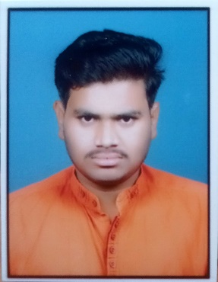**Jadhav Sunil Dnyaneshwar.**

**Email id :-** [suniljadhav8306@gmail.com](mailto:suniljadhav8306@gmail.com)

**Contact :-** 7083509380.

**Qualification :-** B.Tech in Civil Engineering.

**CAREER OBJECTIVE**

I am looking for the challenging and growth – oriented career with the progress of an organization that could utilize my skill at better extent and provide me a platform to develop and acquire skills and I like to give my small contribution for growth of our country.

**ACADEMIC**

|  |  |  |  |
| --- | --- | --- | --- |
| **QUALIFICATION** | **INSTITUTE/BOARD** | **PASSING YEAR** | **%AGE/CGPA** |
| S.S.C | LATUR | 2018 | 66.80 % |
| H.S.C | LATUR | 2018 | 53.40% |
| B.Tech in Civil Engg | DBATU | 2024 | 8.3 |

**TECHNICAL SKILLS (COMPUTER) OTHER SKILLS**

* JAVA FULLSTACK DISCIPLINED
* AUTOCAD HARD WORKING
* WORD HONEST
* EXCEL WORK COMPLETE IN TIME
* POWER POINT

**PERSONAL DETAILS**

**Name :-** Jadhav Sunil Dnyaneshwar.

**Date of birth :-** 27th October 2001 .

**Father Name :-**  Jadhav Dnyaneshwar Purbhaji.

**Sex :-** Male

**Marital Status :-** Unmarried

**Nationality :-** Indian

**Languages known :-** Marathi, Hindi, English.

**Address :-** At Zari post Vishnupuri Tq. Loha Dist.Nanded.

**DECLARATION**

I assure that above mentioned particular are true & correct to the best of my knowledge.

**Jadhav Sunil Dnyaneshwar**

**Date:- Place:-** Nanded.