**what is MySQL?**

MySQL is a relational database management system(RDMS) developed by oracle that is based on structured query language(SQL).

**what is database?**

a database is an organized collection of structured information or data.

**what is DBMS ?**

database management system (DBMS) are software system used to store , retrieve and run queries on data.

**Types of DBMS ?**

DBMS

|

**Relational(SQL)** **Non-relational (No-SQL)**

**what is Relational Database ?**

a relational database is a collection of data items with pre-defined relationships between them, stored in the from of table, rows and columns.

**list of SQL Databases :**

* MySQL
* MariaDB
* Oracle
* PostgreSQL
* MSSQL

**what is a database Table ?**

Database table is a collection of rows and columns that contains relational data.

|  |  |  |  |
| --- | --- | --- | --- |
| I d | Name | Email | DOB |
| 1 | Ramesh | [ramesh@gmail.com](mailto:ramesh@gmail.com) | `10-01-1999 |
| 2 | John | [john@gmail.com](mailto:john@gmail.com) | 05-02-1997 |
| 3 | Reena | [reena@gmail.com](mailto:reena@gmail.com) | 15-05-1997 |

**Categories of Datatypes**

1. **String**
2. **Numeric**
3. **Date & Time**
4. **String Datatypes**

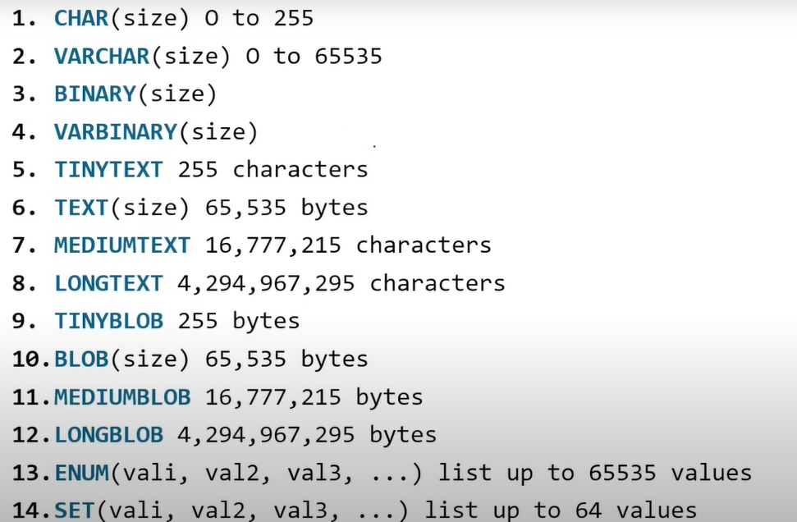

1. **Number Data Types**

1. **Date Data Types**

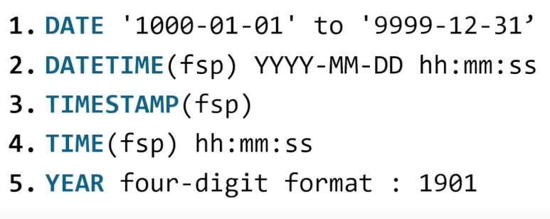

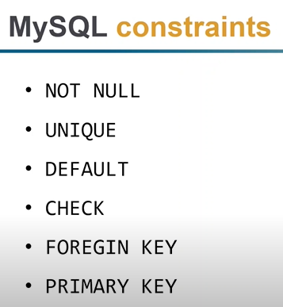

AND operator

OR operator

NOT operator

IN operator

**LIKE operator :**

**while cards**

* **%**
* **_**

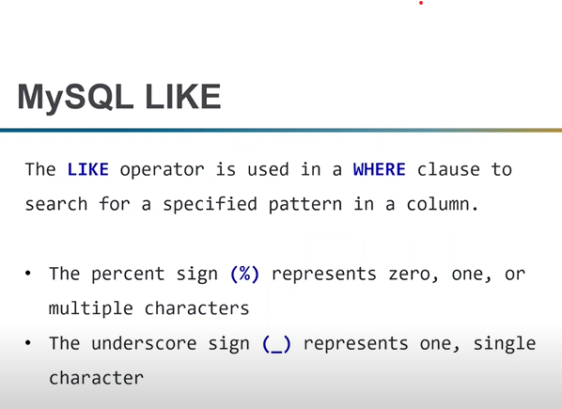

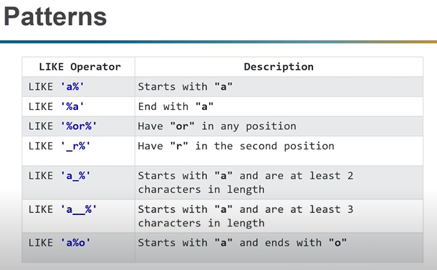

Between and not Between

ORDER BY

DISTINCT

IS NULL

IS NOT NULL

MYSQL Aggregate Function :

* Count()
* Sum()
* Min()
* Max()
* Avg()

UPDATE

## Syntex: update table_name

## set field1 = new-value1,

## field2 = new-value2 [where clause]

DELETE

Syntes:

DELETE FROM table_name [where clause]

Commit and Rollback

Primary key :

* Primary key aways contains unique data
* It cannot be null
* There must be a single primary key

Foreign key :

The foreign key is used to link two tables.

A foreign key in one table (child table) is used to point PRIMRY KEY in another table(parent table)

JOINS :

INNER JOIN

LEFT JOIN - return all records from left table and the attached record the right table.

RIGHT JOIN - returns all records from the right table and the matched records from the left table.

CROSS JOIN

SUB QUERY

Exists

Not Exists

GROUP BY and HAVING CLAUSE