**Tableau**

**Line chart**

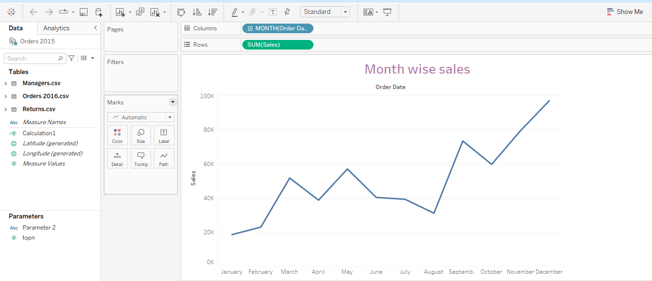

**Bar chart**

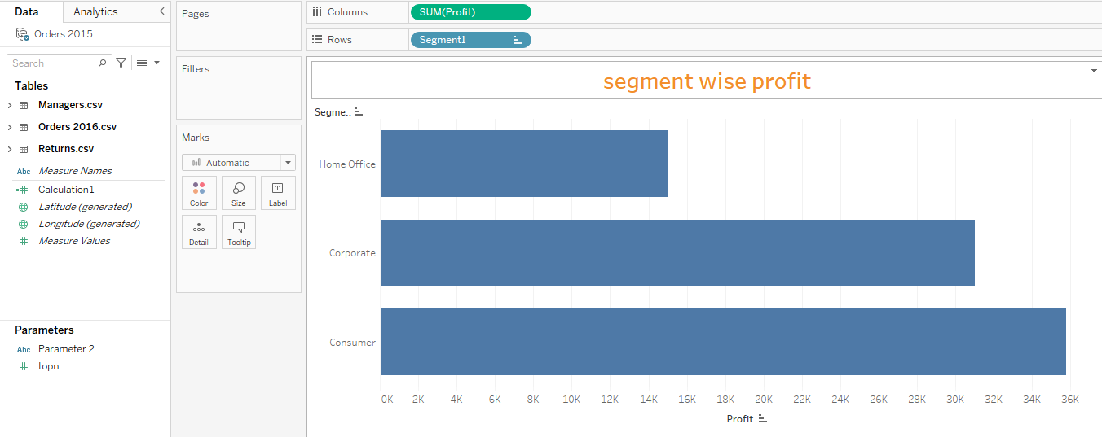

**Pie chart**

**Map visual**

**Scatter chart**

**Group**

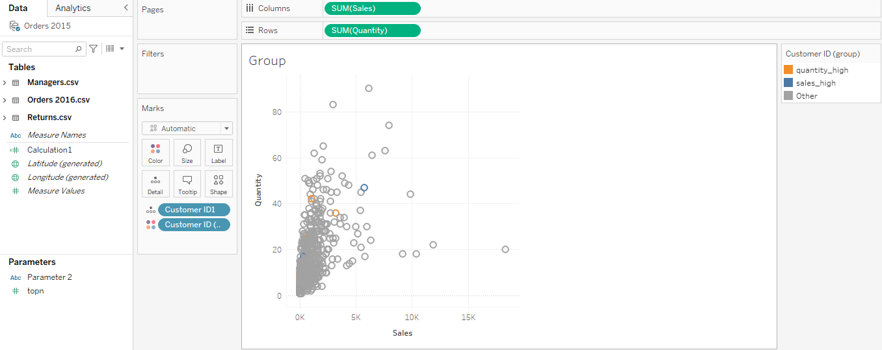

**Heatmap**



**Treemap**

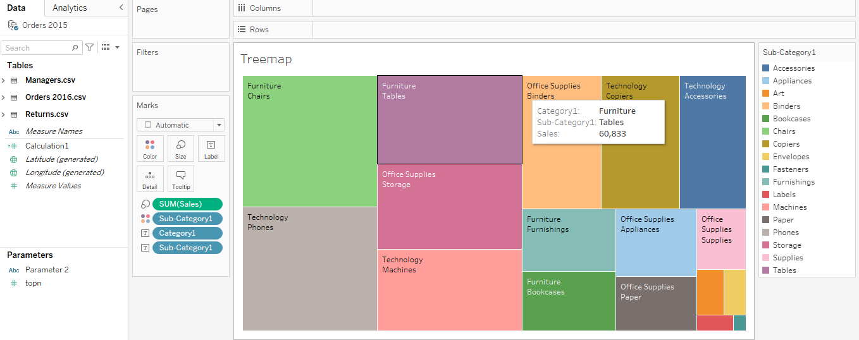

**Bubble chart**

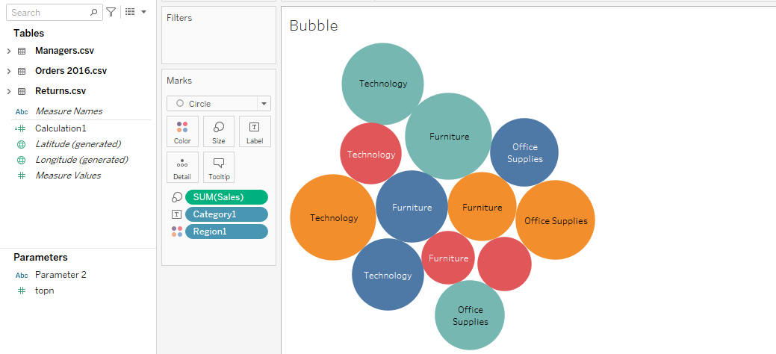

**Word clod**

