A REPORT
ON
FROM BLACK BOX TO REGULATORY GUARDIAN: AN EXPLAINABLE, GUARDRAILED AGENTIC AI PLATFORM FOR MULTI-MODAL BANKING CONTRACT REVIEW AND AUTOMATED REGULATORY LIFECYCLE MANAGEMENT (LRR) USING MODEL CONTEXT PROTOCOL (MCP)

BY

Kattamuri Sunil Kumar ID.No.:2024AA05522

AT

Bank Of America, Hyderbad

BIRLA INSTITUTE OF TECHNOLOGY & SCIENCE, PILANI

(August, 2026)

A REPORT
ON
FROM BLACK BOX TO REGULATORY GUARDIAN: AN EXPLAINABLE, GUARDRAILED AGENTIC AI PLATFORM FOR MULTI-MODAL BANKING CONTRACT REVIEW AND AUTOMATED REGULATORY LIFECYCLE MANAGEMENT (LRR) USING MODEL CONTEXT PROTOCOL (MCP)

BY

Kattamuri Sunil Kumar 2024AA04422 Artificial Intelligence & Machine Learning

Prepared in partial fulfilment of the
WILP Dissertation

AT

Bank Of America, Hyderabad

ACKNOWLEDGEMENT
I express my sincere gratitude to all those who have contributed to the successful completion of this dissertation.
First and foremost, I would like to extend my heartfelt thanks to Mr. Anup Kedia, Senior Vice President, Bank of America, Hyderabad, for providing the organizational support, resources, and an encouraging environment that enabled me to undertake and successfully complete this research.
I am profoundly grateful to my project supervisor, Mr. Yedluri Praveen, Vice President, Senior Technology Manager, Bank of America, Hyderabad, for his invaluable guidance, continuous encouragement, insightful suggestions, and constructive feedback throughout the course of this dissertation. His technical expertise, mentorship, and unwavering support have been instrumental in shaping the direction and quality of this work.
I would also like to express my sincere appreciation to Mr. Kesani Krishna Chaitanya, Vice President, Technology Manager, Bank of America, Hyderabad, who served as the Additional Examiner. His valuable insights, thoughtful recommendations, and constructive discussions significantly enhanced the quality of this dissertation.
I extend my sincere gratitude to Dr. Bhupesh Bhatia, Faculty Mentor, BITS Pilani, Work Integrated Learning Programme, for his academic guidance, continuous encouragement, and valuable suggestions throughout the dissertation. His support ensured that this research remained aligned with the academic standards and requirements of the M.Tech programme.

ABSTRACT
Supervisor Name | Yedluri, Praveen
Supervisor Organization | Bank Of America, Hyderabad
Supervisor Email | praveen.yedluri@gmail.com
Supervisor Designation | Vice President, Senior Technology Manager
Additional Examiner Name | Kesani, Krishna Chaitanya
Additional Examiner Organization | Bank Of America, Hyderabad
Additional Examiner Designation | Vice President, Technology Manager

Keywords:
Agentic AI, Explainable AI, LayoutLMv3, LegalBERT, LangGraph, Pinecone, Model Context Protocol (MCP), Guardrails AI, SHAP, Intelligent Document Processing, Regulatory Lifecycle Management, Banking Contract Review
Project Area:
Artificial Intelligence, Explainable Artificial Intelligence (XAI), Intelligent Document Processing, Agentic AI, Regulatory Technology (RegTech)
Abstract:
The increasing complexity of banking regulations and contractual obligations necessitates intelligent systems capable of accurately analyzing legal documents while ensuring transparency, reliability, and regulatory compliance. This dissertation presents Regulatory Guardian, an explainable and guardrailed Agentic Artificial Intelligence platform for automated multi-modal banking contract review and Regulatory Lifecycle Management (LRR). The proposed framework integrates LayoutLMv3 for document layout understanding, LegalBERT for legal language representation, Pinecone for semantic retrieval, LangGraph for agent orchestration, Model Context Protocol (MCP) for standardized interoperability, Guardrails AI for response validation, and SHAP for explainable decision-making. The system processes complex contractual documents by combining textual and visual information, retrieves contextually relevant regulatory knowledge, coordinates specialized AI agents, and generates transparent compliance recommendations with supporting evidence. Experimental evaluation demonstrates the effectiveness of the proposed architecture in improving document understanding, retrieval quality, explainability, and regulatory traceability while providing a scalable and modular foundation for enterprise AI governance. The proposed solution contributes to trustworthy AI adoption by transforming opaque decision-making into an interpretable and auditable regulatory review process suitable for modern financial institutions.

 | 
Signature of Student | Signature of supervisor | Signature of Additional  Examiner

System Architecture Overview
Figure 1: Complete System Architecture – End-to-End System Architecture for Automated Banking Contract Review and Redlining
Contents
ACKNOWLEDGEMENT 3
ABSTRACT 4
System Architecture Overview 6
CHAPTER 1: INTRODUCTION 10
1.1 Problem Statement and Context 10
1.2 Scope and Design Boundaries 11
1.3 Dissertation Objectives 12
1.4 Dissertation Contributions 13
CHAPTER 2 15
LITERATURE REVIEW 15
2.1 Introduction 15
2.2 Intelligent Document Processing (IDP) 19
2.2.1 Overview 19
2.2.2 Comparative Review of Existing Research 19
2.2.3 Research Gap 21
2.3 Multimodal Document Understanding 22
2.3.1 Overview 22
2.3.2 Comparative Review 22
2.3.3 Research Gap 24
2.4 Legal Language Models 25
2.4.1 Overview 25
2.4.2 Comparative Review 25
2.4.3 Research Gap 27
2.5 Retrieval-Augmented Generation (RAG) 27
2.5.1 Overview 27
2.5.2 Comparative Review 27
2.5.3 Research Gap 29
2.6 Agentic Artificial Intelligence 29
2.6.1 Overview 29
2.6.2 Comparative Review 29
2.7 Explainable Artificial Intelligence (XAI) 32
2.8 AI Guardrails 34
2.9 Model Context Protocol (MCP) 37
2.10 Comparative Analysis of Existing Technologies 41
2.11 Overall Research Gap 43
2.12 Chapter Summary 44
CHAPTER 3 46
PROPOSED METHODOLOGY 46
3.1 Introduction 46
3.2 Research Methodology 47
3.3 Proposed Enterprise Software Architecture 49
3.4 Functional Modules 52
3.5 End-to-End Workflow 83
3.6 Algorithms 88
3.6 Summary 90
3.7 Design Advantages 91
3.8 Chapter Summary 93
CHAPTER 4 95
SYSTEM IMPLEMENTATION 95
4.1 Introduction 95
4.2 Development Environment 96
4.3 Frontend Implementation 97
4.4 Backend Implementation 104
4.4.1 REST API Layer 105
4.4.2 Contract Processing Implementation 105
4.4.3 Vector Store Implementation 106
4.4.4 Multi-Agent Implementation 107
4.4.5 Guardrails Implementation 108
4.4.6 Explainability Implementation 109
4.4.7 MCP Implementation 110
4.4.8 Regulatory Lifecycle Management Implementation 111
4.4.9 Backend Implementation Summary 111
4.5 System Integration Workflow 112
4.5.1 End-to-End Processing Pipeline 112
4.5.2 Integrated System Workflow 114
4.5.3 Module Interaction 115
4.5.4 Error Handling and Fault Tolerance 115
4.5.5 Deployment Architecture 115
4.5.6 Implementation Summary 116
4.6 Chapter Summary 117
CHAPTER 5 120
EXPERIMENTAL EVALUATION AND RESULTS 120
5.1 Introduction 120
5.2 Experimental Environment 121
5.3 Functional Evaluation 122
5.3.1 Experiment 1 – Contract Upload and Automated Processing 122
5.3.2 Experiment 2 – Compliance Agent and MCP-Based Regulatory Query 126
5.3.3 Experiment 3 – Enterprise Policy Search and Compliance Impact Assessment 128
5.4 Overall System Evaluation 130
5.5 AI Model Evaluation 131
5.5.1 LegalBERT Fine-Tuning Evaluation 131
5.5.3 Retrieval-Augmented Generation (RAG) Evaluation 135
5.6 Discussion 139
5.7 Chapter Summary 141
CHAPTER 6 143
CONCLUSION AND FUTURE WORK 143
6.1 Chapter Overview 143
6.2 Research Summary 143
6.3 Research Contributions 144
6.4 Limitations 146
6.5 Future Work 146
6.6 Concluding Remarks 147
APPENDIX A 149
REFERENCES 150
GLOSSARY 154

CHAPTER 1: INTRODUCTION

1.1 Problem Statement and Context
The rapid evolution of artificial intelligence has transformed document intelligence and regulatory compliance across financial institutions. Banks routinely process thousands of contracts, regulatory circulars, policy documents, and legal agreements, each requiring meticulous review to ensure compliance with evolving regulatory frameworks. Traditional contract review relies heavily on manual analysis performed by legal and compliance experts, making the process time-consuming, resource-intensive, and susceptible to human error.
Recent advances in Large Language Models (LLMs) have demonstrated remarkable capabilities in understanding natural language and assisting with legal document analysis. However, their adoption in highly regulated domains such as banking remains constrained due to several challenges. General-purpose LLMs often function as black-box systems, providing limited explainability for their decisions, exhibiting hallucination risks, and lacking robust mechanisms to validate generated responses against authoritative regulatory sources. Furthermore, conventional retrieval-augmented generation (RAG) systems primarily focus on textual similarity and frequently ignore the visual layout and structural characteristics of complex legal documents, resulting in incomplete contextual understanding.
Banking contracts contain intricate layouts comprising clauses, tables, signatures, annotations, and references that require simultaneous interpretation of textual content and document structure. In addition, regulatory compliance demands traceability, transparency, explainability, and auditability for every recommendation produced by an AI system. These requirements cannot be adequately addressed using standalone LLM-based solutions.
To address these challenges, this dissertation proposes Regulatory Guardian, an explainable and guardrailed Agentic AI platform for automated multi-modal banking contract review and Regulatory Lifecycle Management (LRR). The proposed framework integrates LayoutLMv3 for document understanding, LegalBERT for domain-specific semantic representation, Pinecone for semantic retrieval, LangGraph for multi-agent orchestration, Model Context Protocol (MCP) for standardized interoperability, Guardrails AI for response validation, and SHAP for explainable AI. Together, these components enable accurate document analysis, transparent reasoning, regulatory traceability, and automated contract redlining within a scalable enterprise architecture.

1.2 Scope and Design Boundaries
This research focuses on the design, implementation, and evaluation of an explainable Agentic AI platform for banking contract analysis and Regulatory Lifecycle Management. The proposed framework processes digital contract documents in PDF format, extracts textual and layout information using multimodal document intelligence techniques, retrieves relevant regulatory knowledge through semantic vector search, and coordinates specialized AI agents to perform clause analysis, regulatory mapping, risk assessment, explainability, and automated contract redlining.
The implementation is developed using FastAPI, React, LangGraph, LayoutLMv3, LegalBERT, Pinecone, Model Context Protocol (MCP), Guardrails AI, and SHAP. Evaluation is performed using publicly available benchmark datasets, including CUAD for legal clause understanding and DocLayNet for document layout analysis. The framework emphasizes modularity, scalability, explainability, and enterprise readiness while demonstrating how multiple AI technologies can operate collaboratively within a governed architecture.
The scope of this dissertation is intentionally limited to contract review, regulatory mapping, explainability, and redlining within banking-related legal documents. The proposed solution does not replace legal professionals or compliance officers but serves as an intelligent decision-support system. The dissertation does not address multilingual document processing, handwritten document recognition, real-time regulatory updates from external authorities, or production-scale deployment across distributed enterprise environments. These aspects provide opportunities for future research and system enhancement.

1.3 Dissertation Objectives
The primary objective of this dissertation is to design and develop an explainable, guardrailed, and enterprise-ready Agentic AI platform capable of automating banking contract review while ensuring transparency, regulatory compliance, and traceable AI decision-making.
The specific objectives of this research are:
- To develop a multimodal document understanding framework capable of extracting textual, structural, and layout information from complex banking contracts using LayoutLMv3.
- To design a semantic retrieval mechanism using LegalBERT embeddings and Pinecone vector databases for efficient retrieval of relevant contractual and regulatory knowledge.
- To implement a multi-agent orchestration framework using LangGraph that coordinates specialized AI agents for regulatory identification, clause analysis, risk assessment, explainability, and contract redlining.
- To integrate Model Context Protocol (MCP) for standardized communication between AI agents, tools, and external knowledge sources, enabling interoperable and extensible enterprise workflows.
- To incorporate Guardrails AI for validating AI-generated responses, reducing hallucinations, enforcing policy compliance, and improving the reliability of generated recommendations.
- To provide explainable AI capabilities using SHAP so that every compliance recommendation is accompanied by interpretable evidence supporting the underlying reasoning.
- To evaluate the effectiveness of the proposed framework with respect to document understanding, retrieval accuracy, explainability, regulatory traceability, and overall system performance.

1.4 Dissertation Contributions
This dissertation makes several significant technical and practical contributions to the field of intelligent document processing and regulatory technology.
The first contribution is the development of a unified Agentic AI architecture that integrates multimodal document understanding, semantic retrieval, explainable AI, and governance mechanisms into a single enterprise-ready framework for banking contract analysis.
The second contribution is the implementation of a multimodal document processing pipeline using LayoutLMv3 and DocLayNet, enabling simultaneous analysis of textual and structural information contained within legal documents.
The third contribution is the design of a semantic regulatory knowledge retrieval framework using LegalBERT embeddings and Pinecone vector databases, improving contextual retrieval of legal and regulatory information compared to conventional keyword-based approaches.
The fourth contribution is the implementation of a LangGraph-based multi-agent orchestration framework capable of coordinating specialized AI agents responsible for regulatory identification, clause analysis, risk assessment, explainability, and automated contract redlining.
The fifth contribution is the integration of Model Context Protocol (MCP) and Guardrails AI, providing standardized interoperability, response validation, governance, and improved reliability for enterprise AI workflows.
Finally, this dissertation demonstrates how explainability techniques based on SHAP can improve transparency and auditability by providing interpretable evidence supporting AI-generated compliance recommendations, thereby promoting trustworthy AI adoption within regulated financial environments.

CHAPTER 2

LITERATURE REVIEW

2.1 Introduction
Artificial Intelligence (AI) has fundamentally transformed the way organizations process, analyze, and utilize information embedded within digital documents. In sectors such as banking, finance, healthcare, and legal services, organizations manage millions of documents including contracts, compliance manuals, regulatory circulars, loan agreements, audit reports, and customer records. These documents contain highly valuable business knowledge that traditionally requires extensive manual effort to interpret, validate, and monitor. Conventional document review processes are labor-intensive, time-consuming, and susceptible to human error, particularly when dealing with large document collections or rapidly evolving regulatory requirements. Consequently, there has been a growing demand for intelligent systems capable of automating document understanding while maintaining the accuracy, transparency, and accountability expected in enterprise environments.
The emergence of Intelligent Document Processing (IDP) represents a significant advancement beyond conventional Optical Character Recognition (OCR)-based document digitization. Modern IDP systems integrate computer vision, natural language processing, machine learning, and deep learning techniques to understand both the content and structural layout of complex documents. Recent transformer-based architectures, including LayoutLM, LayoutLMv2, LayoutLMv3, DocFormer, and Donut, have demonstrated remarkable improvements in extracting semantic, visual, and spatial information from scanned and digitally generated documents. These models enable sophisticated tasks such as document classification, key-value extraction, table understanding, question answering, and document summarization while preserving contextual relationships that were difficult to capture using earlier rule-based systems.
Although document understanding has improved substantially, enterprise legal and regulatory environments introduce additional challenges that extend beyond information extraction. Banking contracts often contain complex legal terminology, nested obligations, conditional clauses, regulatory references, and cross-document dependencies that require domain-specific reasoning. General-purpose language models frequently struggle to capture the precise legal semantics necessary for regulatory interpretation. To address these limitations, researchers have developed domain-adapted transformer models such as LegalBERT, CaseLawBERT, and LexLM, which are pre-trained on legal corpora to improve legal text classification, clause identification, contract analysis, and legal question answering. These specialized models provide improved contextual understanding of legal documents compared with generic language models while reducing ambiguity in domain-specific terminology.
Recent developments in Large Language Models (LLMs) have further expanded the capabilities of document intelligence by enabling natural language interaction with enterprise knowledge repositories. However, standalone LLMs remain limited by fixed training knowledge and are susceptible to hallucinations, outdated information, and non-verifiable responses. Retrieval-Augmented Generation (RAG) addresses these shortcomings by integrating language models with external knowledge repositories, allowing generated responses to be grounded in retrieved evidence rather than solely relying on model parameters. The integration of vector databases such as Pinecone, ChromaDB, and FAISS with semantic embedding models has significantly enhanced the ability of enterprise AI systems to retrieve relevant contractual clauses, regulatory documents, and historical precedents with high semantic accuracy.
As enterprise AI systems become increasingly sophisticated, attention has shifted from isolated document processing toward autonomous decision-support systems capable of performing complex multi-step reasoning. This transition has led to the emergence of Agentic AI, in which multiple specialized agents collaborate to perform planning, retrieval, reasoning, validation, tool invocation, and report generation. Frameworks such as LangGraph enable orchestration of these autonomous workflows by coordinating interactions among multiple agents while maintaining execution state and task dependencies. Compared with traditional single-prompt LLM applications, agent-based architectures provide improved modularity, scalability, adaptability, and robustness for complex enterprise workflows.
Despite these advances, the adoption of AI within regulated industries requires more than accurate predictions or intelligent automation. Regulatory decisions must be transparent, explainable, and auditable to satisfy organizational governance and compliance requirements. This has resulted in increasing interest in Explainable Artificial Intelligence (XAI) techniques that provide interpretable reasoning behind AI-generated decisions. Model-agnostic approaches such as SHAP and LIME, together with attention-based visualization techniques, enable users to understand feature importance, prediction rationale, and model behavior. Such explainability mechanisms are particularly important in banking environments where AI recommendations may directly influence compliance assessments, contractual obligations, or regulatory reporting.
Another critical challenge involves ensuring that AI-generated outputs remain safe, reliable, and aligned with organizational policies. Although Large Language Models demonstrate impressive reasoning capabilities, they remain vulnerable to hallucinations, prompt injection attacks, unsafe outputs, and policy violations. To mitigate these risks, AI Guardrails have emerged as an essential layer within enterprise AI architectures. Guardrail frameworks enforce predefined validation rules, policy constraints, content moderation mechanisms, and runtime verification processes to ensure that generated responses remain factually grounded, compliant, and secure. The incorporation of guardrails is increasingly recognized as a prerequisite for deploying AI systems within regulated industries such as banking and finance.
In parallel, enterprise AI ecosystems are becoming increasingly heterogeneous, comprising multiple language models, retrieval engines, external APIs, databases, workflow orchestration platforms, and domain-specific tools. Seamless communication among these components requires standardized interoperability mechanisms. The recently introduced Model Context Protocol (MCP) addresses this challenge by providing a standardized interface for exchanging contextual information between AI models and external systems. By enabling secure, structured, and tool-aware communication, MCP facilitates the development of modular AI applications capable of integrating diverse enterprise resources while reducing implementation complexity and improving system maintainability.
Although substantial progress has been achieved across Intelligent Document Processing, multimodal document understanding, legal language modeling, retrieval-augmented generation, autonomous AI agents, explainability, AI safety, and interoperability, existing research has largely investigated these technologies independently. Very limited work has explored their unified integration within a single enterprise platform capable of performing explainable, governed, multimodal legal contract review while supporting continuous regulatory lifecycle management. This limitation is particularly evident in banking environments where organizations require AI systems that combine accurate document understanding with legal reasoning, evidence-based retrieval, autonomous workflow execution, transparent decision making, runtime governance, and standardized enterprise integration

2.2 Intelligent Document Processing (IDP)

2.2.1 Overview
Intelligent Document Processing (IDP) integrates Optical Character Recognition (OCR), computer vision, Natural Language Processing (NLP), and machine learning to automatically extract, classify, and interpret information from structured, semi-structured, and unstructured documents. Unlike conventional OCR systems that focus solely on text recognition, IDP combines textual content, visual appearance, and document layout to derive semantic understanding. This capability has become increasingly important in enterprise domains such as banking, insurance, healthcare, and legal services, where organizations process large volumes of contracts, invoices, regulatory documents, and customer records.
The evolution of IDP has been driven by advances in artificial intelligence. Early systems relied on OCR and rule-based extraction methods, which were effective only for predefined document templates. Statistical machine learning improved adaptability but depended heavily on handcrafted features. The emergence of deep learning enabled automatic feature learning, while recent transformer-based architectures introduced unified representations of text, layout, and visual information, significantly improving document classification, information extraction, and question answering. Consequently, IDP has evolved from a document digitization technology into an intelligent document understanding platform that forms the foundation of modern enterprise Document AI.
Figure 2.1 Evolution of Intelligent Document Processing

2.2.2 Comparative Review of Existing Research
Recent advances in Intelligent Document Processing have been largely driven by transformer-based architectures capable of jointly learning textual, visual, and spatial representations. Among these, the LayoutLM family established the foundation for multimodal document intelligence by integrating text embeddings with two-dimensional layout information. Subsequent models, including LayoutLMv2 and LayoutLMv3, enhanced this capability through cross-modal attention and unified multimodal pre-training, achieving state-of-the-art performance across document classification, information extraction, and document question answering benchmarks. These developments demonstrate a clear transition from document digitization toward comprehensive document understanding.
Alternative transformer architectures have explored different strategies for multimodal representation learning. DocFormer employs shared multimodal attention to improve feature fusion, GeoLayoutLM strengthens spatial reasoning by modeling geometric relationships among document elements, and Donut eliminates OCR dependency through end-to-end document understanding directly from images. These approaches demonstrate that high-quality document intelligence can be achieved through diverse architectural designs, each balancing computational efficiency, OCR dependency, and multimodal learning capability.
Commercial platforms such as Google Document AI, Microsoft Azure Document Intelligence, Amazon Textract, and IBM Watson Discovery have accelerated enterprise adoption of IDP by integrating OCR, document classification, entity extraction, and workflow automation into scalable cloud services. While these platforms simplify deployment, their proprietary architectures offer limited transparency, customization, and explainability, making them less suitable for highly regulated environments.
Overall, transformer-based IDP models have significantly advanced document understanding by jointly modeling textual, visual, and spatial information. However, most solutions remain focused on document perception and information extraction, providing limited support for legal reasoning, explainability, governance, and enterprise workflow orchestration. These limitations motivate the integration of complementary AI technologies discussed in the subsequent sections.
Model | Primary Contribution | Strengths | Limitations | Suitability for Enterprise IDP
OCR + Rule-Based Systems | Template-driven extraction | Simple and inexpensive | Layout dependent, poor scalability | Low
Traditional Machine Learning | Statistical document classification | Better adaptability | Requires handcrafted features | Medium
CNN–RNN Architectures | Automatic feature learning | Improved visual understanding | Weak layout reasoning | Medium
LayoutLM Family | Joint text-layout representation | Excellent document understanding | OCR dependency | High
DocFormer | Efficient multimodal attention | Better feature fusion | Limited legal-domain evaluation | High
GeoLayoutLM | Geometric reasoning | Strong spatial awareness | Increased complexity | High
Donut | OCR-free document understanding | Simplified pipeline | Large training requirements | High
LayoutLMv3 | Unified multimodal pre-training | Best overall performance | Limited explainability and governance | Very High
Table 2.1 Comparative Analysis of Major Intelligent Document Processing Models

2.2.3 Research Gap
Existing research demonstrates that Intelligent Document Processing has evolved into a mature technology capable of accurately extracting and understanding information from visually complex documents. Transformer-based architectures have substantially improved document representation learning and consistently outperform traditional OCR and deep learning approaches across standard benchmark datasets. However, these models primarily focus on document perception and information extraction, leaving several enterprise challenges insufficiently addressed.
First, most IDP models lack domain-specific legal reasoning capabilities required for interpreting banking contracts and regulatory documents. Second, they typically operate independently of external knowledge repositories, preventing continuous incorporation of updated regulatory information. Third, explainability and decision transparency remain limited, reducing user confidence in AI-assisted compliance decisions. Finally, current solutions rarely integrate governance mechanisms, autonomous workflows, or standardized interoperability required for enterprise-scale AI systems.
These limitations suggest that Intelligent Document Processing should be viewed as the foundation of a broader intelligent regulatory ecosystem rather than a standalone solution. The subsequent sections therefore examine complementary technologies—including multimodal document understanding, legal language models, retrieval-augmented generation, autonomous AI agents, explainability, guardrails, and interoperability—that collectively address these remaining challenges.

2.3 Multimodal Document Understanding

2.3.1 Overview
Enterprise documents communicate information through a combination of textual content, visual appearance, and structural layout. Traditional Natural Language Processing techniques process text independently and therefore cannot fully capture the semantic relationships embedded in document structure. Multimodal Document Understanding (MDU) addresses this limitation by jointly learning textual, visual, and spatial representations, enabling AI systems to accurately perform document classification, information extraction, question answering, and semantic relationship identification. These capabilities are particularly valuable for legal and banking documents, where contractual meaning often depends on layout as well as textual content.

2.3.2 Comparative Review
Recent transformer-based models have significantly advanced multimodal document understanding by jointly learning textual, visual, and layout representations. The LayoutLM family established this paradigm through layout-aware language modeling, while LayoutLMv2 and LayoutLMv3 enhanced multimodal representation learning using cross-modal attention and unified pre-training. These models consistently achieve state-of-the-art performance across benchmark tasks such as document classification, information extraction, and document question answering.
Beyond the LayoutLM family, several architectures have explored alternative multimodal learning strategies. DocFormer improves feature fusion through shared multimodal attention, GeoLayoutLM enhances spatial reasoning by explicitly modeling geometric relationships, and TILT adopts a sequence-to-sequence framework for flexible document understanding. Collectively, these approaches demonstrate that diverse transformer architectures can effectively integrate textual and visual information while addressing different enterprise requirements.
OCR dependency remains a major limitation of many multimodal models because recognition errors propagate to downstream tasks. Donut addresses this challenge through an end-to-end OCR-free architecture that directly processes document images, improving robustness for noisy and multilingual documents while simplifying the processing pipeline.
Commercial platforms including Google Document AI, Microsoft Azure Document Intelligence, Amazon Textract, and IBM Watson Discovery have accelerated enterprise adoption of multimodal document understanding by integrating document analysis with cloud-based AI services. However, these platforms generally provide limited transparency and customization, restricting their suitability for highly regulated environments.
Although multimodal transformer architectures have substantially improved document perception, they primarily focus on extracting and organizing information rather than interpreting legal meaning or regulatory obligations. These limitations motivate the integration of domain-specific legal language models discussed in the following section.
Model | Multimodal Inputs | Major Strength | Key Limitation | Enterprise Suitability
LayoutLM | Text + Layout | First layout-aware transformer | OCR dependent | High
LayoutLMv2 | Text + Image + Layout | Cross-modal attention | Higher computational cost | High
LayoutLMv3 | Unified Text + Image + Layout | State-of-the-art multimodal learning | Limited explainability | Very High
DocFormer | Shared multimodal attention | Efficient feature fusion | Limited domain adaptation | High
GeoLayoutLM | Geometric reasoning | Strong spatial understanding | Increased model complexity | High
TILT | Vision-language sequence generation | Flexible end-to-end learning | Less evaluated for legal documents | Medium–High
Donut | OCR-free document understanding | Eliminates OCR dependency | Large-scale training required | High
Table 2.2 Comparative Analysis of Multimodal Document Understanding Models

2.3.3 Research Gap
Multimodal document understanding has significantly improved the ability of AI systems to interpret visually rich documents by jointly learning textual, visual, and spatial representations. Recent transformer-based architectures consistently outperform traditional OCR-centric approaches across document classification, information extraction, and question answering benchmarks. Nevertheless, several challenges remain before these models can fully support enterprise regulatory applications.
First, existing architectures primarily emphasize document perception rather than domain-specific reasoning, limiting their ability to understand legal obligations, regulatory clauses, and contractual dependencies. Second, explainability mechanisms are generally absent, making it difficult to justify predictions during compliance audits. Third, most models operate independently of external knowledge repositories and therefore cannot incorporate continuously evolving regulatory information. Finally, current multimodal architectures are rarely integrated with autonomous agents, governance frameworks, or standardized enterprise interoperability mechanisms required for large-scale production deployment.
These observations indicate that multimodal representation learning forms only one component of an enterprise Document AI ecosystem. Effective banking contract analysis additionally requires domain-specific legal reasoning capabilities, which are discussed in the following section on Legal Language Models.

2.4 Legal Language Models

2.4.1 Overview
Legal Language Models (Legal LLMs) extend transformer-based language models by learning contextual representations from legal corpora, including contracts, statutes, regulations, and judicial opinions. Unlike general-purpose language models trained on open-domain text, Legal LLMs better capture legal terminology, contractual obligations, and regulatory language, making them particularly suitable for contract analysis, compliance verification, legal document retrieval, and legal question answering. Their domain-specific knowledge has established them as a key component of AI-assisted legal analytics and enterprise contract intelligence systems.

2.4.2 Comparative Review
LegalBERT represents one of the earliest and most influential transformer models developed specifically for legal NLP. By continuing pre-training on legal corpora containing legislation, judicial opinions, contracts, and legal publications, LegalBERT significantly improves contextual understanding of legal terminology while maintaining compatibility with standard transformer architectures. Studies consistently report superior performance over general-purpose language models in legal text classification, clause identification, document retrieval, and legal question answering.
Subsequent research introduced specialized Legal LLMs targeting different legal applications. CaseLawBERT focuses on judicial opinions and legal precedent retrieval, LexLM supports multilingual legal analysis across jurisdictions, while contract-specific transformer models trained on datasets such as CUAD improve automated identification of contractual obligations, liabilities, confidentiality clauses, and termination conditions. Together, these models demonstrate the effectiveness of domain-specific pre-training for legal document understanding.
Recent research increasingly combines Legal LLMs with Retrieval-Augmented Generation (RAG), allowing models to ground responses in retrieved statutes, regulations, and contractual evidence rather than relying solely on parametric knowledge. This integration improves factual accuracy, reduces hallucinations, and enables continuous incorporation of updated legal information without retraining the underlying model.
Despite these advances, most Legal LLMs remain text-centric and cannot fully exploit the visual and structural information present in complex legal documents. Furthermore, they provide limited explainability, depend on static training corpora, and rarely integrate governance or workflow orchestration mechanisms required for enterprise regulatory compliance.
Model | Domain | Primary Strength | Limitations | Enterprise Suitability
BERT | General NLP | Strong contextual language understanding | Limited legal vocabulary | Medium
RoBERTa | General NLP | Improved language representation | Domain-independent | Medium
LegalBERT | Legal documents | Superior legal semantic understanding | Text-only processing | Very High
CaseLawBERT | Judicial opinions | Legal precedent analysis | Limited contract focus | High
LexLM | Multilingual legal corpora | Cross-jurisdiction legal analysis | High computational cost | High
Contract-specific Transformers (CUAD) | Contracts | Clause extraction and obligation identification | Limited multimodal capability | High
LLM + RAG | Enterprise legal knowledge | Evidence-based legal reasoning | Requires external knowledge infrastructure | Very High
Table 2.3 Comparative Analysis of Legal Language Models

2.4.3 Research Gap
Legal Language Models have significantly improved legal text understanding through domain-specific pre-training. However, existing models primarily operate on textual data, limiting their ability to interpret visually rich legal documents. They also rely on static knowledge, provide limited explainability, and lack integration with autonomous workflows and enterprise governance mechanisms. These limitations motivate the use of Retrieval-Augmented Generation, which enables AI systems to access continuously updated legal knowledge while supporting evidence-based reasoning.

2.5 Retrieval-Augmented Generation (RAG)

2.5.1 Overview
Retrieval-Augmented Generation (RAG) enhances Large Language Models by combining generative capabilities with external knowledge retrieval. Instead of relying solely on information learned during pre-training, RAG retrieves relevant documents from external knowledge repositories and incorporates them into the generation process. This retrieval-first approach improves factual accuracy, reduces hallucinations, and enables AI systems to utilize continuously updated information without retraining the underlying language model. Consequently, RAG has become a foundational architecture for enterprise AI applications including legal research, regulatory compliance, customer support, and contract analysis.

2.5.2 Comparative Review
Early RAG architectures combined dense vector retrieval with sequence-to-sequence language models, enabling responses to be grounded in semantically relevant documents. Compared with traditional lexical retrieval techniques such as TF-IDF and BM25, dense retrieval significantly improved semantic matching but remained susceptible to irrelevant context and retrieval ambiguity.
To improve retrieval accuracy, hybrid retrieval combines dense semantic search with sparse lexical retrieval, leveraging the strengths of both approaches. Dense retrieval captures semantic similarity, whereas sparse methods remain effective for exact terminology and regulatory references. Modern RAG pipelines further improve relevance through reranking models that prioritize the most contextually appropriate documents before generation.
The growing adoption of vector databases such as Pinecone, FAISS, ChromaDB, and Weaviate has further improved the scalability of semantic retrieval in enterprise applications.
Retrieval performance is also influenced by document chunking strategies, embedding models, and metadata filtering, which continue to be active areas of research.
Recent RAG architectures extend beyond document retrieval through GraphRAG and Agentic RAG. GraphRAG improves multi-hop reasoning using knowledge graphs, whereas Agentic RAG employs autonomous agents to iteratively retrieve, validate, and synthesize information before response generation. These architectures improve reasoning quality for complex enterprise workflows involving regulations, contracts, and compliance.
Architecture | Retrieval Strategy | Primary Strength | Major Limitation | Enterprise Suitability
Naïve RAG | Dense vector retrieval | Simple implementation | Limited retrieval accuracy | Medium
Hybrid RAG | Dense + Sparse retrieval | Improved retrieval precision | Increased system complexity | High
Advanced RAG | Reranking + Query Expansion | Better contextual relevance | Higher computational cost | High
GraphRAG | Knowledge graph retrieval | Multi-hop reasoning | Complex graph construction | High
Agentic RAG | Multi-agent adaptive retrieval | Autonomous reasoning and validation | Complex orchestration | Very High
Table 2.4 Comparative Analysis of Retrieval-Augmented Generation Architectures

2.5.3 Research Gap
Retrieval-Augmented Generation significantly improves the factual reliability of Large Language Models by grounding responses in external knowledge. However, existing RAG architectures primarily optimize retrieval accuracy without addressing explainability, governance, or enterprise interoperability. Furthermore, most implementations operate independently of multimodal document understanding and autonomous workflow orchestration. These limitations motivate the adoption of Agentic AI, which extends RAG through collaborative reasoning and intelligent workflow execution.

2.6 Agentic Artificial Intelligence

2.6.1 Overview
Agentic Artificial Intelligence (Agentic AI) extends Large Language Models by enabling autonomous planning, reasoning, tool invocation, and workflow execution through specialized AI agents. Unlike conventional prompt-response systems, Agentic AI decomposes complex tasks into coordinated subtasks executed by multiple agents with distinct responsibilities, such as planning, retrieval, reasoning, validation, and reporting. This modular architecture improves scalability, adaptability, and decision quality, making Agentic AI particularly suitable for enterprise applications involving complex workflows, regulatory compliance, and human-in-the-loop decision support.

2.6.2 Comparative Review
Initial LLM applications relied on single-agent architectures in which one model performed planning, retrieval, reasoning, and response generation. Although effective for simple tasks, these systems struggled with multi-step reasoning, workflow coordination, and enterprise integration. This limitation motivated the development of multi-agent architectures, where specialized agents collaboratively execute complex tasks through distributed reasoning and coordinated decision making.
Modern multi-agent systems assign dedicated responsibilities to planner, retrieval, reasoning, validation, and reporting agents. This specialization improves modularity, enables independent optimization of individual agents, and supports scalable execution of knowledge-intensive enterprise workflows.
Several orchestration frameworks have been proposed for multi-agent AI, including CrewAI, Microsoft AutoGen, and LangGraph. CrewAI emphasizes role-based collaboration, AutoGen enables structured communication among autonomous agents, while LangGraph introduces graph-based workflow orchestration with state persistence, conditional execution, checkpoint recovery, and human-in-the-loop capabilities. Among these, LangGraph provides the greatest flexibility for enterprise AI workflows requiring deterministic execution and transparent orchestration.
Among recent developments, LangGraph has gained considerable attention due to its graph-based orchestration model. Unlike sequential agent pipelines, LangGraph represents workflows as directed graphs in which each node corresponds to an autonomous agent and edges define execution paths. This architecture supports conditional branching, iterative reasoning, memory persistence, checkpoint recovery, and human-in-the-loop interactions, making it highly suitable for enterprise AI systems requiring deterministic execution and workflow transparency. Compared with conventional orchestration frameworks, LangGraph provides greater flexibility for coordinating complex workflows involving document analysis, retrieval, reasoning, validation, and decision support.
Recent research increasingly integrates Agentic AI with Retrieval-Augmented Generation, external tools, enterprise databases, and domain-specific APIs. Rather than generating responses directly, autonomous agents iteratively retrieve information, invoke external services, validate intermediate results, and refine reasoning before producing final decisions. This integration significantly improves adaptability and factual reliability in enterprise applications.
Despite these advances, enterprise deployment of Agentic AI remains challenging due to orchestration complexity, communication overhead, limited interoperability, and insufficient governance mechanisms. Existing frameworks primarily focus on workflow execution while providing limited support for explainability, policy enforcement, and regulatory auditing.
Framework | Architecture | Major Strength | Limitations | Enterprise Suitability
Single-Agent LLM | One model handles all tasks | Simple implementation | Limited reasoning and scalability | Medium
AutoGPT | Autonomous iterative execution | Task automation | Unpredictable execution | Medium
BabyAGI | Dynamic task generation | Adaptive planning | Limited enterprise support | Medium
CrewAI | Role-based collaboration | Simple multi-agent coordination | Limited workflow persistence | High
Microsoft AutoGen | Conversational multi-agent system | Flexible agent communication | Complex configuration | High
LangGraph | Graph-based orchestration | Stateful workflows, branching, checkpointing, human-in-the-loop | Higher implementation complexity | Very High
Table 2.6 Comparative Analysis of Agentic AI Frameworks
2.6.3 Research Gap
Agentic AI has significantly improved autonomous reasoning and workflow orchestration through specialized agents and graph-based execution frameworks. However, current solutions primarily emphasize task coordination rather than trustworthy decision making. Challenges remain in integrating explainability, runtime governance, standardized interoperability, and regulatory compliance within multi-agent systems. Addressing these limitations requires complementary technologies that ensure AI decisions are transparent, auditable, and policy compliant. The following section therefore examines Explainable Artificial Intelligence (XAI), which enhances transparency and trust in enterprise AI systems.

2.7 Explainable Artificial Intelligence (XAI)
2.7.1 Overview
Explainable Artificial Intelligence (XAI) enhances the transparency and interpretability of machine learning models by providing human-understandable explanations for AI-driven decisions. As AI systems are increasingly adopted in regulated domains such as banking, healthcare, and finance, explainability has become essential for ensuring trust, accountability, regulatory compliance, and effective human oversight. Unlike traditional interpretable models, modern XAI techniques primarily focus on explaining complex deep learning and transformer-based models without compromising predictive performance.
2.7.2 Comparative Review
Contemporary XAI research is largely centered on post-hoc explanation techniques, which generate explanations after model inference while preserving the predictive performance of complex models. Compared with intrinsically interpretable approaches such as decision trees and rule-based systems, post-hoc methods provide greater flexibility for explaining transformer architectures and Large Language Models widely used in enterprise AI applications.
Among post-hoc explanation methods, LIME and SHAP are the most widely adopted techniques. LIME explains individual predictions by approximating complex models using locally interpretable surrogate models, whereas SHAP employs Shapley values from cooperative game theory to quantify the contribution of each input feature toward model predictions. Due to its mathematical consistency and stable feature attribution, SHAP has become the preferred explainability technique for enterprise AI applications requiring transparent and auditable decision making.
Recent research extends explainability beyond feature attribution to transformer architectures and Large Language Models through attention visualization, reasoning traces, and workflow-level explanations. These approaches improve transparency by illustrating how AI systems retrieve information, perform reasoning, and generate decisions. However, attention scores alone do not always represent true reasoning, making workflow-level explanations increasingly important for enterprise AI systems.
Overall, explainability research has evolved from feature-level interpretation toward process-level transparency capable of explaining multi-step reasoning performed by autonomous AI systems. Enterprise deployments increasingly combine feature attribution with workflow visualization to improve user trust, regulatory auditing, and responsible AI governance.
Technique | Explanation Type | Major Strength | Key Limitation | Enterprise Suitability
Decision Trees | Intrinsic | Naturally interpretable | Limited predictive capability | Medium
Rule-Based Systems | Intrinsic | Transparent reasoning | Poor scalability | Medium
LIME | Local feature attribution | Model-agnostic | Explanation instability | High
SHAP | Global & local feature attribution | Theoretically consistent and accurate | Higher computational cost | Very High
Grad-CAM | Visual explanation | Effective for image analysis | CNN-specific | High
Attention Visualization | Transformer attention | Intuitive visualization | Limited causal interpretation | Medium
Reasoning Trace / Chain-of-Thought Analysis | Process explanation | Explains multi-step reasoning | Difficult to evaluate objectively | High
Table 2.8 Comparative Analysis of Explainable AI Techniques
2.7.3 Research Gap
Explainable AI has significantly improved the transparency of machine learning systems through feature attribution, attention analysis, and reasoning visualization. Nevertheless, most existing approaches explain individual model predictions rather than complete enterprise AI workflows involving retrieval, autonomous reasoning, and policy validation. Furthermore, explainability alone cannot prevent unsafe or non-compliant AI behavior, highlighting the need for runtime governance mechanisms. The following section therefore examines AI Guardrails, which complement explainability by enforcing organizational policies and regulatory constraints during AI execution.

2.8 AI Guardrails
2.8.1 Overview
The rapid adoption of Large Language Models (LLMs) and autonomous AI agents has significantly expanded the capabilities of enterprise AI systems. However, as these systems become increasingly autonomous, concerns regarding hallucinations, unsafe responses, policy violations, data leakage, and regulatory non-compliance have also increased. In regulated industries such as banking, financial services, and healthcare, AI systems must not only generate accurate responses but also operate within predefined organizational policies, legal regulations, and ethical guidelines. Consequently, AI Guardrails have emerged as an essential mechanism for ensuring the safe, reliable, and compliant deployment of enterprise AI applications.
AI Guardrails comprise a collection of runtime validation, policy enforcement, content moderation, and risk mitigation techniques that monitor AI behavior before, during, and after response generation. Unlike traditional security mechanisms that focus on infrastructure protection, Guardrails specifically govern AI reasoning and outputs by enforcing constraints on prompts, retrieved information, generated responses, and tool usage. This enables organizations to reduce hallucinations, prevent harmful outputs, protect sensitive information, and maintain regulatory compliance throughout the AI lifecycle.
2.8.2 Comparative Review
Early approaches to AI safety primarily relied on rule-based validation and content filtering, where manually defined rules blocked predefined keywords or prohibited responses. Although effective for simple use cases, these approaches lacked contextual understanding and were unable to adapt to increasingly sophisticated language models. As LLM capabilities expanded, research shifted toward dynamic policy enforcement mechanisms capable of evaluating AI behavior using semantic understanding rather than static keyword matching.
One of the most widely adopted frameworks in this area is Guardrails AI, which provides declarative validation mechanisms for Large Language Model outputs. Guardrails AI enables developers to define structured validation rules that verify output format, factual consistency, regulatory constraints, and business policies before responses are delivered to end users. Its flexibility and integration with multiple LLM providers have made it a popular choice for enterprise AI applications requiring runtime validation and controlled response generation.
Another significant contribution is NVIDIA NeMo Guardrails, which introduces programmable conversational policies for governing interactions between users and AI systems. Unlike output validation alone, NeMo Guardrails controls the complete conversational workflow by defining permitted dialogue paths, tool invocation rules, safety constraints, and policy enforcement mechanisms. This capability makes it particularly suitable for enterprise virtual assistants operating in regulated environments where conversational consistency and policy compliance are critical.
More recently, Llama Guard has extended AI safety by employing language models themselves as safety classifiers. Instead of relying exclusively on manually defined rules, Llama Guard automatically evaluates prompts and generated responses for harmful content, policy violations, and unsafe behavior. This model-based approach improves adaptability to evolving threats while reducing the maintenance burden associated with traditional rule-based systems.
Beyond individual frameworks, recent enterprise research increasingly combines guardrails with Retrieval-Augmented Generation, multi-agent systems, and governance platforms. Runtime validation is applied not only to generated responses but also to retrieved documents, intermediate reasoning steps, tool invocation, and autonomous agent decisions. Such integrated governance architectures improve trustworthiness by ensuring that AI systems remain compliant throughout complex enterprise workflows rather than validating only final outputs.
Despite these advances, existing guardrail frameworks primarily focus on response validation and safety enforcement. Limited attention has been given to comprehensive governance across multimodal document understanding, legal reasoning, multi-agent orchestration, and enterprise interoperability. These limitations become particularly significant in banking environments where AI decisions require continuous monitoring, explainability, auditability, and regulatory traceability.
Framework | Key Contribution | Strengths | Limitations
Rule-Based Validation | Static policy enforcement | Simple implementation | Poor contextual understanding
Guardrails AI | Declarative output validation | Flexible, model-agnostic, structured validation | Focuses primarily on output validation
NVIDIA NeMo Guardrails | Conversational policy enforcement | Workflow-level governance and tool control | Higher implementation complexity
Llama Guard | LLM-based safety classification | Adaptive detection of unsafe prompts and responses | Requires additional inference overhead
Integrated Governance Frameworks | End-to-end AI governance | Runtime validation across workflows | Limited standardization and interoperability
Table 2.10 Comparative Analysis of AI Guardrail Frameworks
2.8.3 Research Gap
AI Guardrails have become a critical component of trustworthy enterprise AI by enforcing safety policies, validating generated responses, and reducing operational risks associated with Large Language Models. Frameworks such as Guardrails AI, NVIDIA NeMo Guardrails, and Llama Guard demonstrate that runtime validation significantly improves the reliability of AI-driven systems. However, existing solutions primarily concentrate on response-level safety and provide limited support for end-to-end governance across multimodal document understanding, retrieval, autonomous reasoning, and enterprise workflow orchestration. Furthermore, interoperability among heterogeneous AI components remains insufficiently addressed, making it difficult to enforce consistent governance across distributed enterprise environments.
These limitations indicate that effective enterprise AI requires not only governance but also standardized communication between AI agents, enterprise applications, external tools, and knowledge repositories. The following section therefore examines the Model Context Protocol (MCP), an emerging interoperability standard that enables secure and structured communication across heterogeneous AI ecosystems.
AI Lifecycle Stage | Primary Risk | Guardrail Objective
User Input | Prompt injection | Input validation
Knowledge Retrieval | Irrelevant or malicious documents | Retrieval validation
Agent Reasoning | Unsafe decisions | Policy enforcement
Tool Invocation | Unauthorized actions | Access control
Response Generation | Hallucination or policy violation | Output validation
Audit & Monitoring | Lack of traceability | Logging and compliance
Table 2.11 Summary of Guardrail Capabilities Across Enterprise AI Lifecycle

2.9 Model Context Protocol (MCP)
2.9.1 Overview
The rapid adoption of Large Language Models and Agentic AI has significantly increased the need for standardized communication between AI systems and external enterprise resources. Modern AI applications frequently interact with databases, document repositories, enterprise applications, APIs, knowledge bases, and software tools to retrieve information and execute complex workflows. However, these integrations have traditionally relied on custom APIs, proprietary connectors, and framework-specific implementations, resulting in fragmented architectures, limited interoperability, and increased development complexity.
The Model Context Protocol (MCP) has recently emerged as an open standard for connecting AI models with external tools, data sources, and enterprise services through a unified communication interface. Rather than developing separate integrations for every application, MCP defines a standardized protocol that enables AI agents to securely discover, access, and utilize external resources in a consistent manner. By separating application logic from tool integration, MCP improves interoperability, scalability, and maintainability while simplifying the development of enterprise AI ecosystems.
2.9.2 Comparative Review
Before the introduction of MCP, enterprise AI systems primarily relied on application-specific APIs, middleware, and custom connectors to enable communication between language models and external services. Although functional, these approaches tightly coupled AI applications with individual enterprise systems, making integration difficult to maintain and limiting portability across platforms. As organizations adopted multiple AI frameworks, databases, and enterprise applications, the absence of a common communication standard became a major obstacle to scalable AI deployment.
Recent research has increasingly emphasized the importance of standardized interoperability for autonomous AI systems. Frameworks such as LangChain and LlamaIndex provide abstractions for tool invocation and retrieval, while orchestration platforms including LangGraph, CrewAI, and Microsoft AutoGen support collaborative execution across multiple AI agents. Despite these advances, interoperability remains largely framework-specific, requiring developers to implement custom integrations for each external service. Consequently, tool reuse, portability, and cross-platform compatibility remain limited.
The Model Context Protocol addresses these challenges by introducing a standardized client-server architecture that decouples AI models from enterprise resources. Within the MCP ecosystem, MCP Hosts represent AI applications, MCP Clients manage communication, and MCP Servers expose external capabilities such as databases, APIs, document repositories, enterprise software, and cloud services through a uniform interface. This architecture enables AI agents to dynamically discover available tools and access enterprise resources without requiring application-specific integration logic, thereby reducing development complexity and improving system extensibility.
Another important contribution of MCP is its emphasis on secure and controlled access to enterprise resources. Rather than granting unrestricted system access, MCP enables organizations to expose only approved capabilities through dedicated servers, supporting authentication, authorization, and policy enforcement. This design aligns closely with enterprise governance requirements and facilitates the integration of AI systems into highly regulated domains such as banking, healthcare, and financial services. Furthermore, because MCP operates independently of individual LLM providers, it promotes vendor-neutral interoperability across heterogeneous AI ecosystems.
Although MCP is still an emerging standard, early adoption by AI framework developers and enterprise platform providers indicates its potential to become a foundational interoperability layer for Agentic AI. By standardizing communication between AI models and enterprise resources, MCP complements Retrieval-Augmented Generation, multi-agent orchestration, and governance frameworks, enabling the development of scalable, modular, and maintainable enterprise AI systems.
Integration Approach | Key Contribution | Strengths | Limitations
Custom APIs | Direct system integration | Flexible implementation | High maintenance and tight coupling
Middleware-Based Integration | Centralized service communication | Improved scalability | Vendor and platform dependency
Framework-Specific Connectors (LangChain, LlamaIndex) | Simplified tool integration | Rapid AI development | Limited interoperability across frameworks
Agent Framework Integrations (LangGraph, AutoGen, CrewAI) | Multi-agent orchestration | Workflow automation | Custom tool interfaces
Model Context Protocol (MCP) | Standardized AI-tool communication | Vendor-neutral interoperability, modular architecture, extensibility | Emerging ecosystem with limited long-term evaluation
Table 2.12 Comparative Analysis of AI Integration Approaches
2.9.3 Research Gap
The growing adoption of Agentic AI has highlighted the importance of standardized interoperability between AI models, enterprise applications, external tools, and knowledge repositories. Existing integration approaches largely depend on custom APIs or framework-specific connectors, resulting in fragmented architectures and limited portability. MCP addresses these limitations by introducing a unified protocol for secure and structured communication across heterogeneous AI ecosystems. However, current research primarily focuses on protocol architecture and early implementations, with limited empirical evaluation in large-scale enterprise environments. Furthermore, integration of MCP with multimodal document understanding, legal reasoning, explainability, and runtime governance remains largely unexplored.
These observations suggest that MCP should be viewed not merely as an integration protocol but as a foundational interoperability layer for next-generation enterprise AI. Its combination with multimodal document understanding, Retrieval-Augmented Generation, Agentic AI, Explainable AI, and Guardrails provides a promising direction for building scalable, trustworthy, and regulatory-compliant AI systems capable of supporting complex enterprise workflows.
Characteristic | Custom APIs | Framework Connectors | Model Context Protocol
Standardization | Low | Medium | High
Interoperability | Limited | Framework-dependent | Framework-independent
Scalability | Medium | High | Very High
Maintainability | Low | Medium | High
Enterprise Suitability | Medium | High | Very High
Table 2.13 Comparison of Enterprise AI Communication Mechanisms

2.10 Comparative Analysis of Existing Technologies
The literature reviewed in this chapter demonstrates significant progress in applying Artificial Intelligence to document understanding, legal language processing, knowledge retrieval, autonomous reasoning, explainability, governance, and enterprise interoperability. Individually, these technologies address specific challenges associated with intelligent document processing and enterprise AI. However, none of the existing approaches independently provide a comprehensive solution capable of supporting end-to-end regulatory contract lifecycle management in highly regulated banking environments.
Transformer-based document understanding models such as LayoutLMv3 have substantially improved the extraction of textual, visual, and spatial information from complex documents. Similarly, domain-specific Legal Language Models have enhanced contextual understanding of legal terminology and contractual clauses through specialized pre-training. Retrieval-Augmented Generation has further addressed the knowledge limitations of Large Language Models by grounding responses in external repositories, while Agentic AI has enabled autonomous reasoning and workflow orchestration through collaborative AI agents.
Recent advances in Explainable Artificial Intelligence and AI Guardrails have improved the transparency, trustworthiness, and governance of AI systems by providing interpretable decision explanations and runtime policy enforcement. Furthermore, the emergence of the Model Context Protocol introduces standardized interoperability between AI models and enterprise systems, reducing integration complexity and improving scalability across heterogeneous environments.
Despite these advances, existing research primarily investigates these technologies independently. Limited work has explored their unified integration within a single enterprise architecture capable of supporting multimodal document understanding, legal reasoning, dynamic knowledge retrieval, autonomous decision making, explainability, governance, and standardized interoperability simultaneously. Consequently, enterprise AI solutions remain fragmented, requiring organizations to integrate multiple independent frameworks using custom architectures.
The proposed research addresses this limitation by integrating all these complementary technologies into a unified platform specifically designed for regulatory banking contract review. Rather than introducing a new AI model, the proposed framework combines state-of-the-art document understanding, legal reasoning, retrieval, autonomous orchestration, explainability, governance, and interoperability mechanisms into a cohesive enterprise architecture capable of supporting trustworthy regulatory lifecycle management.
Technology | Primary Purpose | Major Strength | Key Limitation | Role in Proposed Framework
Intelligent Document Processing | Document digitization and information extraction | Structured document understanding | Limited legal reasoning | Document ingestion
Multimodal Document Understanding | Joint text-layout-image learning | Improved document comprehension | Limited governance | Document perception
Legal Language Models | Legal semantic understanding | Domain-specific legal knowledge | Static knowledge | Contract interpretation
Retrieval-Augmented Generation | Knowledge grounding | Reduced hallucinations | Retrieval dependency | Regulatory knowledge retrieval
Agentic AI | Autonomous workflow execution | Multi-step reasoning | Limited governance | Workflow orchestration
Explainable AI | Decision transparency | Trust and interpretability | Limited process-level explanation | Explainability
AI Guardrails | Runtime governance | Policy enforcement | Output-focused validation | Compliance validation
Model Context Protocol | Standardized interoperability | Vendor-neutral integration | Emerging ecosystem | Enterprise connectivity
Table 2.14 Comparative Analysis of Existing Technologies

2.11 Overall Research Gap
The literature survey reveals that substantial progress has been achieved across multiple domains contributing to enterprise Artificial Intelligence. Intelligent Document Processing enables accurate extraction of textual and visual information from complex documents, while multimodal transformer architectures improve document understanding by jointly modeling textual, spatial, and visual representations. Legal Language Models further enhance domain-specific reasoning, and Retrieval-Augmented Generation improves factual reliability by grounding responses in external knowledge repositories. Agentic AI extends these capabilities through autonomous workflow orchestration, whereas Explainable AI and AI Guardrails improve transparency and governance. Finally, the Model Context Protocol introduces standardized interoperability between AI systems and enterprise resources.
Although each of these technologies has matured independently, existing research rarely integrates them into a unified enterprise platform capable of supporting complete regulatory contract lifecycle management. Most existing solutions focus on isolated components such as document extraction, legal question answering, autonomous reasoning, or policy validation without addressing their coordinated operation within a single trustworthy AI ecosystem. Consequently, current enterprise implementations often require complex custom integrations, resulting in fragmented architectures, limited interoperability, reduced explainability, and increased operational complexity.
Furthermore, banking organizations require AI systems that not only interpret legal documents accurately but also provide transparent reasoning, enforce organizational policies, maintain regulatory compliance, and securely interact with enterprise applications throughout the decision-making process. Existing literature provides limited guidance on designing such integrated architectures capable of simultaneously satisfying these requirements.
To address these limitations, this research proposes an explainable, guardrailed, Agentic AI platform for multimodal banking contract review and automated regulatory lifecycle management. The proposed framework integrates LayoutLMv3 for multimodal document understanding, LegalBERT for legal semantic analysis, Retrieval-Augmented Generation using Pinecone for knowledge grounding, LangGraph-based Agentic AI for workflow orchestration, SHAP-based Explainable AI for transparent decision support, Guardrails AI for runtime governance, and Model Context Protocol for standardized enterprise interoperability. Collectively, these technologies establish a unified, scalable, and trustworthy architecture for enterprise regulatory contract intelligence.
Identified Research Gap | Proposed Solution
Limited multimodal legal document understanding | LayoutLMv3 + DocLayNet
Weak legal contextual reasoning | LegalBERT + CUAD
Static knowledge in LLMs | Retrieval-Augmented Generation
Fragmented workflow automation | LangGraph Agentic AI
Poor decision transparency | SHAP-based Explainable AI
Limited runtime governance | Guardrails AI
Lack of enterprise interoperability | Model Context Protocol
Absence of integrated architecture | Proposed unified enterprise framework
Table 2.15 Mapping Research Gaps to Proposed Solution

2.12 Chapter Summary
This chapter presented a comprehensive review of the technologies underpinning intelligent enterprise contract analysis and regulatory lifecycle management. The discussion began with Intelligent Document Processing and Multimodal Document Understanding, highlighting recent advances in transformer-based architectures for extracting textual, visual, and structural information from enterprise documents. The review subsequently examined Legal Language Models and Retrieval-Augmented Generation, demonstrating how domain-specific semantic understanding and external knowledge retrieval improve the accuracy and reliability of AI-assisted legal analysis.
The chapter further explored Agentic Artificial Intelligence as an emerging paradigm for autonomous workflow orchestration, followed by Explainable Artificial Intelligence and AI Guardrails, which enhance transparency, trustworthiness, and regulatory compliance in enterprise AI systems. Finally, the Model Context Protocol was reviewed as a standardized interoperability framework that enables secure and scalable communication between AI models, enterprise applications, and external knowledge resources.
The comparative analysis and research gap assessment revealed that existing studies predominantly investigate these technologies independently, with limited emphasis on their unified integration within enterprise regulatory environments. Based on these observations, this research proposes a comprehensive architecture that combines multimodal document understanding, legal language modeling, Retrieval-Augmented Generation, Agentic AI, Explainable AI, Guardrails, and Model Context Protocol into a single enterprise platform for trustworthy banking contract review and automated regulatory lifecycle management.
The insights obtained from the literature survey establish the theoretical foundation for the proposed research methodology. Accordingly, the following chapter presents the overall system architecture, design methodology, implementation framework, and experimental setup adopted for developing the proposed explainable, guardrailed Agentic AI platform.

CHAPTER 3

PROPOSED METHODOLOGY

3.1 Introduction
Artificial Intelligence has significantly improved enterprise document processing by enabling automated information extraction, legal reasoning, and regulatory compliance analysis. However, most existing systems operate as isolated solutions that focus on individual tasks such as document parsing, question answering, or compliance verification. Such fragmented architectures limit scalability, interoperability, and explainability, making them less suitable for enterprise banking environments where multiple AI capabilities must operate together within a governed workflow.
To address these limitations, this research proposes an integrated enterprise platform for automated banking contract review and regulatory lifecycle management. The proposed system combines multimodal document understanding, legal language processing, Retrieval-Augmented Generation (RAG), multi-agent orchestration, explainable AI, governance mechanisms, and standardized enterprise integration into a unified software architecture. Unlike conventional AI pipelines, the framework is implemented as a collection of modular services that collaborate through clearly defined interfaces, improving maintainability and extensibility.
The implementation consists of a React-based web application that provides contract management, agent interaction, document visualization, and regulatory dashboards. The frontend communicates with a FastAPI backend, which exposes RESTful APIs responsible for contract processing, AI agent orchestration, explainability, regulatory lifecycle management, and enterprise integration. The backend further incorporates specialized services for document analysis, vector-based knowledge retrieval, guardrail validation, explainability, and Model Context Protocol (MCP)-based communication.
The proposed architecture processes banking contracts through a sequence of coordinated services. Contract documents are analyzed using multimodal document understanding techniques before relevant regulatory knowledge is retrieved from a vector database. A supervisor agent coordinates multiple specialized agents responsible for obligation extraction, impact assessment, compliance reporting, and regulatory monitoring. The generated outputs are subsequently validated using governance rules, enriched with explainability information, and delivered to enterprise applications through standardized interfaces.
The remainder of this chapter describes the research methodology, enterprise architecture, software architecture, functional services, workflow, and design rationale adopted for implementing the proposed framework.

3.2 Research Methodology
This research follows a Design Science Research (DSR) methodology to design, implement, and evaluate an enterprise AI platform for automated banking contract review and regulatory lifecycle management. The objective is not only to investigate existing technologies but also to develop a deployable software artifact that integrates multimodal document understanding, legal intelligence, multi-agent reasoning, explainability, governance, and enterprise interoperability into a unified architecture.
The research methodology consists of five phases. The first phase identifies challenges associated with traditional banking contract review, including manual processing, fragmented AI workflows, limited explainability, and difficulties in adapting to evolving regulatory requirements. Based on these observations, the second phase focuses on designing a modular service-oriented architecture capable of integrating multiple AI components within a single enterprise platform.
The implementation phase develops the proposed framework using a React-based frontend and a FastAPI backend. The backend exposes RESTful APIs for contract processing, regulatory analysis, explainability, and lifecycle management while coordinating specialized AI services responsible for document understanding, knowledge retrieval, multi-agent orchestration, governance validation, and enterprise integration.
The final phase evaluates the implemented system using banking contract documents to assess document understanding, legal reasoning, regulatory compliance, explainability, and workflow automation. The evaluation methodology and experimental results are presented in Chapter 4.
The overall research methodology adopted in this work is illustrated in Figure 3.1.
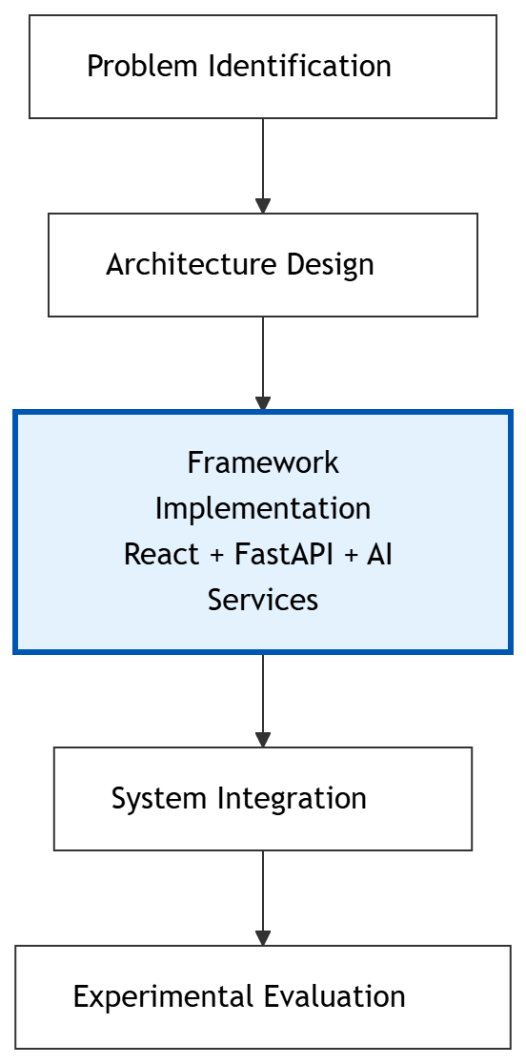
Figure 3.1 Research Methodology

3.3 Proposed Enterprise Software Architecture
The proposed system is designed as a service-oriented enterprise AI platform for automated banking contract review and regulatory lifecycle management. The architecture integrates modern web technologies, Artificial Intelligence services, enterprise integration components, and regulatory knowledge sources into a unified software platform. Unlike conventional AI applications that implement document analysis as a single processing pipeline, the proposed architecture separates business functionality into independent services that communicate through REST APIs and standardized interfaces. This modular design improves maintainability, scalability, and extensibility while enabling the integration of additional AI capabilities with minimal architectural changes.
As illustrated in Figure 3.2, the architecture is organized into six logical layers: Presentation Layer, API Layer, Application Services Layer, AI Intelligence Layer, Knowledge Layer, and Enterprise Integration Layer. Each layer performs a dedicated responsibility while collectively supporting the end-to-end banking contract review workflow.
The Presentation Layer provides the user interface through a React-based web application. It enables users to upload banking contracts, interact with AI agents, visualize contract analysis results, monitor regulatory lifecycle updates, and review explainability reports. The user interface communicates exclusively with backend REST APIs, ensuring a clear separation between presentation and business logic.
The API Layer is implemented using FastAPI and serves as the communication gateway between the frontend and backend services. Dedicated API endpoints manage contract processing, AI agent interactions, explainability requests, and regulatory lifecycle operations. This layer centralizes request handling, response generation, and service orchestration while exposing a consistent interface to client applications.
The Application Services Layer contains the core business services responsible for contract inference, AI agent orchestration, vector knowledge management, guardrail validation, explainability generation, regulatory lifecycle management, and Model Context Protocol (MCP) integration. Each service encapsulates a specific business capability, allowing independent development, testing, and maintenance.
The AI Intelligence Layer performs document understanding and intelligent reasoning using multimodal document analysis, large language models, and specialized AI agents. This layer transforms unstructured banking contracts into structured regulatory insights that support downstream compliance analysis and decision-making.
The Knowledge Layer maintains regulatory knowledge, document embeddings, and supporting enterprise data required for Retrieval-Augmented Generation (RAG). By retrieving relevant regulatory information during inference, the framework generates responses that are grounded in organizational knowledge rather than relying solely on the underlying language model.
Finally, the Enterprise Integration Layer enables communication with external regulatory resources and enterprise applications through the Model Context Protocol (MCP). This standardized integration mechanism allows the proposed framework to exchange information with external systems while preserving modularity and interoperability.
The layered architecture ensures that presentation logic, business services, AI processing, knowledge management, and enterprise integration remain loosely coupled, facilitating future enhancements and enterprise-scale deployment.

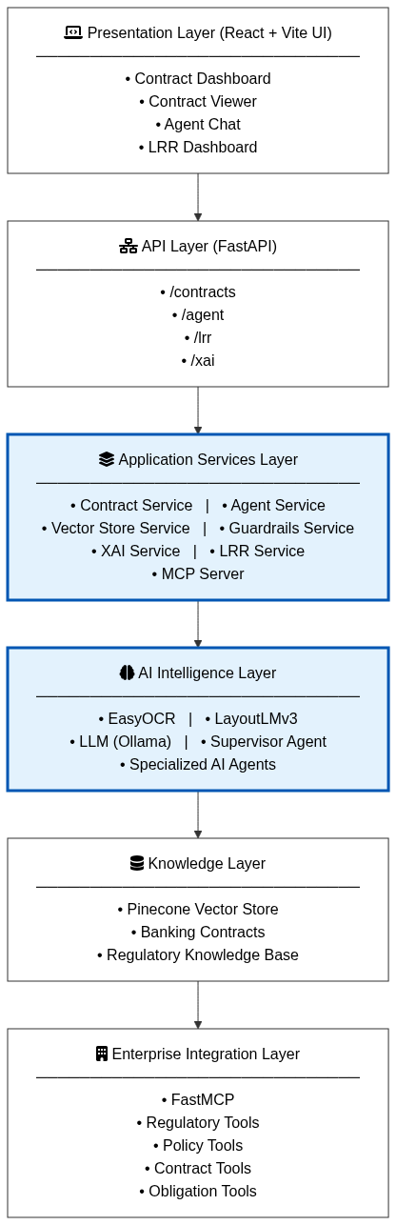
Figure 3.2 Proposed Enterprise Software Architecture
Layer | Responsibility | Major Components
Presentation Layer | Provides the user interface for contract management and AI interaction | React, Vite
API Layer | Exposes REST endpoints and coordinates backend communication | FastAPI
Application Services Layer | Implements core business logic and orchestration | Contract, Agent, Vector Store, Guardrails, XAI, LRR, MCP Services
AI Intelligence Layer | Performs document understanding and AI reasoning | EasyOCR, LayoutLMv3, LLM, Supervisor Agent, Specialized Agents
Knowledge Layer | Stores contracts, embeddings, and regulatory knowledge | Pinecone, Regulatory Corpus
Enterprise Integration Layer | Connects external enterprise systems and tools | FastMCP, MCP Tools
Table 3.1 Enterprise Architecture Layers

3.4 Functional Modules
The proposed enterprise platform is implemented as a collection of loosely coupled application services, where each service performs a specific business function within the banking contract review workflow. This modular design improves maintainability, enables independent testing and deployment, and simplifies the integration of additional AI capabilities without affecting the overall system architecture.
Unlike monolithic AI applications, the proposed implementation separates document processing, regulatory reasoning, knowledge retrieval, explainability, governance validation, and enterprise integration into dedicated services. Each service exposes well-defined responsibilities while collaborating with other services through the FastAPI application layer.
The functional modules implemented in the proposed framework are summarized in Table 3.2.
Module | Primary Responsibility
Contract Processing Service | Extracts and analyses banking contracts using multimodal document understanding
Agent Orchestration Service | Coordinates specialized AI agents for regulatory analysis
Vector Store Service | Stores embeddings and retrieves relevant regulatory knowledge
Guardrails Service | Validates AI-generated outputs against governance policies
Explainability Service | Generates explanations for AI-assisted decisions
MCP Integration Service | Provides standardized integration with enterprise tools and external resources
LRR Service | Monitors regulatory updates and manages the regulatory lifecycle
Table 3.2 Functional Modules of the Proposed Framework
The following subsections describe each service and its contribution to the proposed enterprise platform.
3.4.1 Contract Processing Service
The Contract Processing Service is responsible for transforming uploaded banking contracts into structured representations that can be processed by downstream AI services. It serves as the primary document ingestion and inference component of the framework by combining document parsing, optical character recognition, multimodal document understanding, and large language model inference within a single processing pipeline.
The service accepts banking contracts in PDF format through the FastAPI interface. Initially, the document is processed using PyMuPDF to extract machine-readable text and page-level information. When textual content is unavailable or insufficient, EasyOCR is employed to recover text from scanned document images. This dual extraction strategy enables the framework to support both digitally generated and scanned contracts.
Following text extraction, the service loads a fine-tuned LayoutLMv3 model to analyze the structural layout of the document. Layout-aware representations are used to identify important document elements such as titles, section headers, tables, lists, and body text. Preserving document structure improves the interpretation of legal clauses and provides richer contextual information for downstream analysis.
To prepare the extracted content for AI inference, the service segments the document into manageable chunks using a recursive text-splitting strategy. These chunks are then supplied to the configured large language model through the inference pipeline. The service also incorporates predefined prompts used by the specialized regulatory agents, enabling consistent document interpretation and supporting subsequent stages of obligation extraction, impact assessment, and compliance reporting.
The processed document, together with its structural metadata and generated representations, is forwarded to the Agent Orchestration Service for regulatory reasoning and workflow execution.
Inputs
- Banking contract (PDF)
- Scanned contract documents
- Runtime model configuration
Processing
- PDF parsing using PyMuPDF
- OCR processing using EasyOCR (when required)
- Layout analysis using LayoutLMv3
- Text chunking using RecursiveCharacterTextSplitter
- LLM inference through ChatOllama
- Forward structured output to the Agent Orchestration Service
Outputs
- Extracted contract text
- Document layout metadata
- Structured document chunks
- AI-ready contract representation
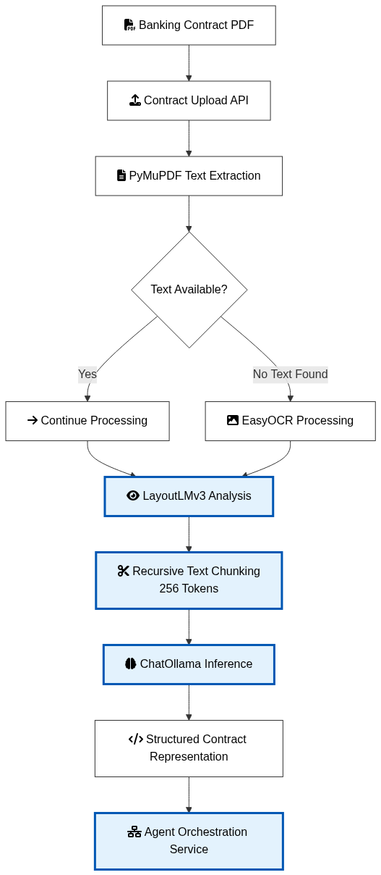
Figure 3.3 Contract Processing Workflow

3.4.2 Agent Orchestration Service
The Agent Orchestration Service is the intelligence layer of the proposed framework and is responsible for coordinating multiple specialized AI agents to perform regulatory analysis on banking contracts. Instead of relying on a single large language model to perform all reasoning tasks, the proposed architecture adopts a supervisor-based multi-agent approach, where individual agents are assigned specialized responsibilities and collaborate to generate comprehensive compliance assessments.
The service is implemented using a LangGraph-based orchestration framework, which enables structured execution of agent workflows while maintaining contextual information throughout the analysis process. A central Supervisor Agent receives the processed contract representation from the Contract Processing Service and determines the sequence of operations required to satisfy the user's request. Based on the analysis objective, the supervisor dynamically routes tasks to one or more specialized agents and aggregates their outputs into a unified response.
The proposed implementation incorporates four domain-specific AI agents, each designed to perform a distinct regulatory analysis task:
- Obligation Extractor Agent identifies contractual obligations, responsibilities, timelines, and compliance requirements contained within banking contracts.
- Impact Assessment Agent evaluates the potential operational and regulatory impact of identified contractual clauses, enabling organizations to understand the consequences of policy changes or contractual modifications.
- Compliance Reporter Agent consolidates findings into structured compliance reports, highlighting areas requiring attention and summarizing the overall regulatory posture of the analyzed contract.
- Regulatory Monitor Agent supports continuous monitoring of regulatory information and assists in identifying relevant regulatory updates that may affect existing contractual obligations.
Unlike traditional sequential pipelines, the supervisor coordinates these agents based on the requested analysis, enabling flexible execution while preserving the context generated during previous stages. This modular orchestration strategy improves reasoning quality, simplifies the addition of new domain-specific agents, and promotes scalability for future regulatory requirements.
The outputs produced by the specialized agents are consolidated into a unified regulatory assessment before being forwarded to the Guardrails Service for governance validation and subsequent explainability analysis.
Inputs
- Structured contract representation
- User query or analysis request
- Context retrieved from the knowledge base
Processing Steps
- Receive processed contract from the Contract Processing Service.
- Initialize the Supervisor Agent.
- Determine the required analysis workflow.
- Invoke one or more specialized AI agents.
- Aggregate the outputs from participating agents.
- Forward the consolidated response for governance validation.
Outputs
- Contract obligations
- Regulatory impact analysis
- Compliance assessment
- Consolidated AI response
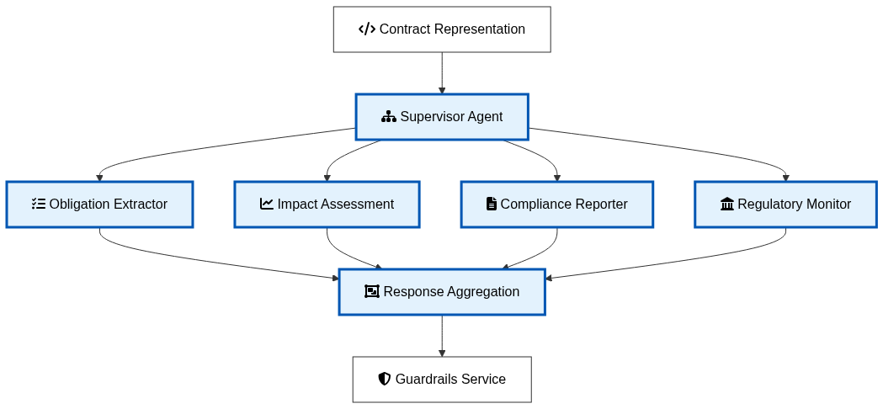
Figure 3.4 Multi-Agent Orchestration Workflow
AI Agent | Primary Responsibility | Output
Supervisor Agent | Coordinates workflow and routes requests | Execution plan and aggregated response
Obligation Extractor | Identifies contractual obligations and responsibilities | Structured obligation list
Impact Assessment | Evaluates regulatory and operational impacts | Impact assessment report
Compliance Reporter | Generates consolidated compliance summaries | Compliance report
Regulatory Monitor | Identifies relevant regulatory updates | Regulatory insights
Table 3.3 Responsibilities of Specialized AI Agents
3.4.2 Vector Store and Retrieval Service (Retrieval-Augmented Generation)
The Vector Store and Retrieval Service is responsible for implementing the Retrieval-Augmented Generation (RAG) mechanism within the proposed framework. Its primary objective is to enhance the accuracy and reliability of AI-generated responses by retrieving contextually relevant information from previously indexed banking contracts and regulatory knowledge before invoking the large language model. This approach enables the framework to generate responses grounded in organizational knowledge rather than relying solely on the parametric knowledge of the language model.
After the Contract Processing Service extracts and segments the contract into meaningful text chunks, the Vector Store Service converts each chunk into a high-dimensional semantic embedding using the configured embedding model. These embeddings preserve the semantic relationships between contractual clauses and regulatory documents, allowing similar content to be identified through vector similarity rather than exact keyword matching.
The generated embeddings, along with their associated metadata, are stored in the Pinecone Vector Database, which serves as the knowledge repository of the proposed framework. During runtime, when a user submits a query or when the Agent Orchestration Service requires additional regulatory context, the Vector Store Service performs a semantic similarity search to retrieve the most relevant document fragments. The retrieved context is then combined with the user query and contract information before being forwarded to the AI agents for reasoning.
By supplying grounded contextual information during inference, the RAG mechanism significantly reduces hallucinations, improves factual consistency, and enables the framework to provide responses that are aligned with banking regulations and contractual obligations. Furthermore, the separation of knowledge retrieval from language generation allows the knowledge base to be updated independently without requiring retraining of the underlying language model.
The retrieved contextual information forms the knowledge foundation for the Supervisor Agent and its specialized agents, ensuring that obligation extraction, impact assessment, compliance reporting, and regulatory analysis are performed using the most relevant contractual and regulatory information available.
Inputs
- Processed contract chunks
- User query
- Regulatory documents
- Existing contract repository
Processing Steps
- Receive document chunks from the Contract Processing Service.
- Generate semantic embeddings for each chunk.
- Store embeddings and metadata in the Pinecone vector database.
- Perform semantic similarity search for incoming queries.
- Retrieve the top-ranked document chunks.
- Supply the retrieved context to the Agent Orchestration Service.
Outputs
- Vector embeddings
- Indexed contract repository
- Retrieved contextual information
- Grounded knowledge for AI agents

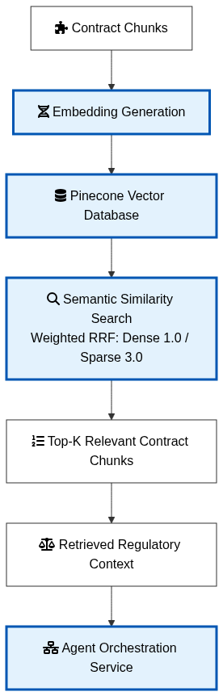
Figure 3.5 Vector Store and Retrieval Workflow
Function | Description
Embedding Generation | Converts document chunks into semantic vector representations
Vector Storage | Stores embeddings and metadata in Pinecone
Semantic Retrieval | Retrieves contextually similar document fragments
Context Augmentation | Supplies retrieved knowledge to AI agents
Knowledge Management | Maintains an updatable repository of contracts and regulatory information
Table 3.4 Responsibilities of the Vector Store Service
Design Rationale
Traditional large language models rely primarily on the knowledge captured during pre-training, making them unsuitable for domains where regulations evolve continuously. In contrast, the proposed RAG-based architecture separates knowledge storage from language generation, enabling the framework to access the latest banking contracts and regulatory documents without retraining the language model.
This design offers several advantages:
- Improved Accuracy: Responses are grounded in retrieved contractual and regulatory information.
- Reduced Hallucinations: AI-generated content is constrained by relevant evidence from the knowledge base.
- Updatable Knowledge Base: New contracts and regulations can be indexed independently of the language model.
- Scalability: The vector database supports efficient retrieval across large collections of documents.
- Domain Adaptability: The framework can accommodate evolving banking regulations with minimal architectural changes.
3.4.3 Agent Orchestration Service
The Agent Orchestration Service forms the intelligent reasoning layer of the proposed framework and is responsible for coordinating multiple specialized AI agents to perform comprehensive regulatory analysis of banking contracts. Instead of assigning all analytical tasks to a single Large Language Model (LLM), the proposed framework employs a supervisor-based multi-agent architecture, where each agent specializes in a distinct regulatory function. This collaborative approach improves reasoning accuracy, modularity, and scalability while enabling the framework to address complex compliance scenarios.
The service receives three primary inputs: the structured contract representation generated by the Contract Processing Service, the retrieved contextual information supplied by the Vector Store and Retrieval Service through the RAG mechanism, and the user's analysis request. By combining these inputs, the framework ensures that the reasoning process is grounded in both the uploaded contract and the relevant regulatory knowledge, thereby minimizing hallucinations and improving the reliability of AI-generated responses.
The orchestration process is managed by a Supervisor Agent, which serves as the central decision-making component of the multi-agent workflow. Based on the analysis objective, the supervisor determines the execution sequence and delegates specific tasks to specialized agents. Each agent focuses on a well-defined regulatory responsibility while sharing contextual information generated during previous processing stages. The supervisor subsequently aggregates the outputs produced by the participating agents into a unified regulatory assessment.
The proposed framework incorporates four specialized AI agents:
- Obligation Extractor Agent – Identifies contractual obligations, responsibilities, deadlines, and compliance requirements from banking contracts.
- Impact Assessment Agent – Evaluates the operational and regulatory implications of contractual clauses and proposed regulatory changes.
- Compliance Reporter Agent – Consolidates analytical findings into structured compliance reports that summarize identified risks and recommendations.
- Regulatory Monitor Agent – Assists in identifying regulatory updates relevant to the analyzed contract and supports continuous compliance monitoring.
The supervisor dynamically invokes one or more specialized agents depending on the requested analysis. This adaptive execution strategy allows the framework to efficiently reuse contextual information while avoiding unnecessary processing. The modular architecture also enables additional domain-specific agents to be incorporated in future versions of the platform without requiring significant modifications to the existing workflow.
Once the analysis is completed, the consolidated response is forwarded to the Guardrails Service, where governance validation and policy enforcement are performed before the results are presented to end users or enterprise systems.
Inputs
- Structured contract representation
- Retrieved regulatory context (RAG)
- User query or analysis request
Processing Steps
- Receive processed contract representation.
- Receive relevant regulatory context from the Vector Store Service.
- Initialize the Supervisor Agent.
- Determine the required analysis workflow.
- Invoke one or more specialized AI agents.
- Aggregate the outputs from all participating agents.
- Forward the consolidated response to the Guardrails Service.
Outputs
- Contract obligations
- Regulatory impact assessment
- Compliance analysis report
- Consolidated AI response

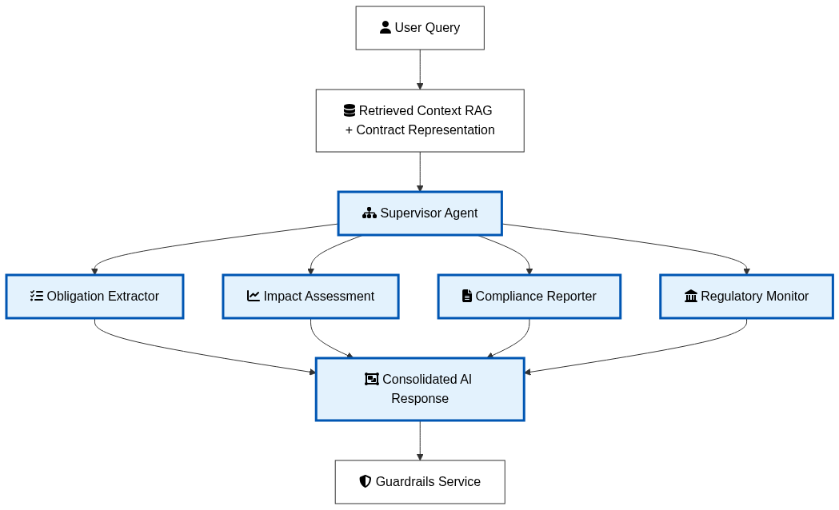
Figure 3.6: Supervisor-based orchestration of specialized AI agents using retrieved contextual knowledge.
Agent | Responsibility | Output
Supervisor Agent | Coordinates execution and task allocation | Aggregated workflow execution
Obligation Extractor | Identifies contractual obligations and commitments | Structured obligations
Impact Assessment | Evaluates regulatory and operational impact | Impact assessment report
Compliance Reporter | Generates compliance summaries and recommendations | Compliance report
Regulatory Monitor | Tracks regulatory relevance and updates | Regulatory insights
Table 3.5 Responsibilities of Specialized AI Agents
Design Rationale
Conventional AI systems generally rely on a single language model to perform multiple reasoning tasks, often leading to reduced accuracy, inconsistent outputs, and limited scalability. The proposed multi-agent architecture distributes responsibilities among specialized agents, enabling each agent to focus on a specific regulatory function while collaborating through a supervisor-controlled workflow.
Integrating the RAG mechanism with the multi-agent architecture further strengthens the framework by ensuring that all reasoning activities are grounded in retrieved contractual and regulatory knowledge. This combination enhances factual consistency, reduces hallucinations, and improves the quality of compliance analysis. Additionally, the modular orchestration strategy supports future extensibility, allowing new agents or regulatory functions to be incorporated without disrupting the existing system architecture.
3.4.4 Guardrails Validation Service
The Guardrails Validation Service provides the governance and safety layer of the proposed enterprise AI platform by validating both user inputs and AI-generated responses before they are processed or presented to end users. Unlike conventional Retrieval-Augmented Generation systems that rely solely on prompt engineering to improve response quality, the proposed framework introduces an independent validation pipeline that enforces regulatory compliance, privacy protection, hallucination control, and responsible AI practices throughout the interaction lifecycle.
The service is implemented using the Guardrails AI framework, where multiple domain-specific validators are executed sequentially as part of a unified validation workflow. This architecture separates governance from AI reasoning, allowing validation policies to evolve independently of the underlying language model while ensuring that every interaction satisfies organizational compliance requirements.
The validation process begins with input validation, where user requests are examined before they are forwarded to the large language model. Personally identifiable information (PII) is detected and masked to prevent accidental exposure of sensitive banking information during AI processing. Once the Agent Orchestration Service generates a response, the output is subjected to a second validation stage comprising multiple specialized validators.
The Restricted Terms Validator examines the generated response for prohibited legal and regulatory expressions that may expose the organization to legal or compliance risks. Statements implying guaranteed regulatory compliance, absolute financial safety, unauthorized legal advice, or instructions encouraging regulatory circumvention are automatically identified and corrected before the response is released.
The Compliance Disclaimer Validator ensures that responses containing regulatory guidance or legal recommendations include an appropriate disclaimer informing users that the generated content is intended for informational purposes only and should not replace professional legal or compliance advice. This mechanism promotes responsible AI usage while aligning generated recommendations with enterprise governance policies.
To improve factual reliability, the Hallucination Detector analyzes references to RBI circulars, regulatory notifications, and master directions contained within AI-generated responses. The validator performs format verification and basic reference validation to identify potentially fabricated or unverifiable regulatory citations. Responses containing suspicious references are flagged and augmented with appropriate verification warnings before presentation.
The PII Filter Validator provides privacy protection by detecting and masking sensitive information commonly encountered within Indian banking environments. The implementation recognizes multiple categories of personally identifiable information, including Aadhaar numbers, PAN numbers, bank account numbers, IFSC codes, mobile numbers, email addresses, credit card numbers, and UPI identifiers. Sensitive values are automatically masked before responses are returned, thereby reducing the risk of confidential information disclosure.
By combining input validation, runtime governance checks, hallucination detection, privacy protection, and compliance enforcement within a single validation pipeline, the Guardrails Validation Service establishes a robust defence-in-depth strategy for enterprise AI deployment. This modular design improves trustworthiness, supports regulatory compliance, and enables additional validation policies to be incorporated without modifying the reasoning components of the framework.
Following successful validation, the verified response is forwarded to the Explainability Service for interpretation and evidence generation before being delivered to the end user.
Inputs
- User input
- Consolidated AI response
- Governance policies
- Regulatory validation rules
Processing Steps
- Validate user input prior to LLM execution.
- Detect and mask personally identifiable information.
- Validate generated responses against restricted regulatory terminology.
- Append compliance disclaimers where advisory content is detected.
- Verify RBI circulars and regulatory references to identify potential hallucinations.
- Perform final governance validation.
- Forward the validated response to the Explainability Service.
Outputs
- Sanitized user input
- Governance-compliant AI response
- Privacy-protected output
- Validation logs and warnings
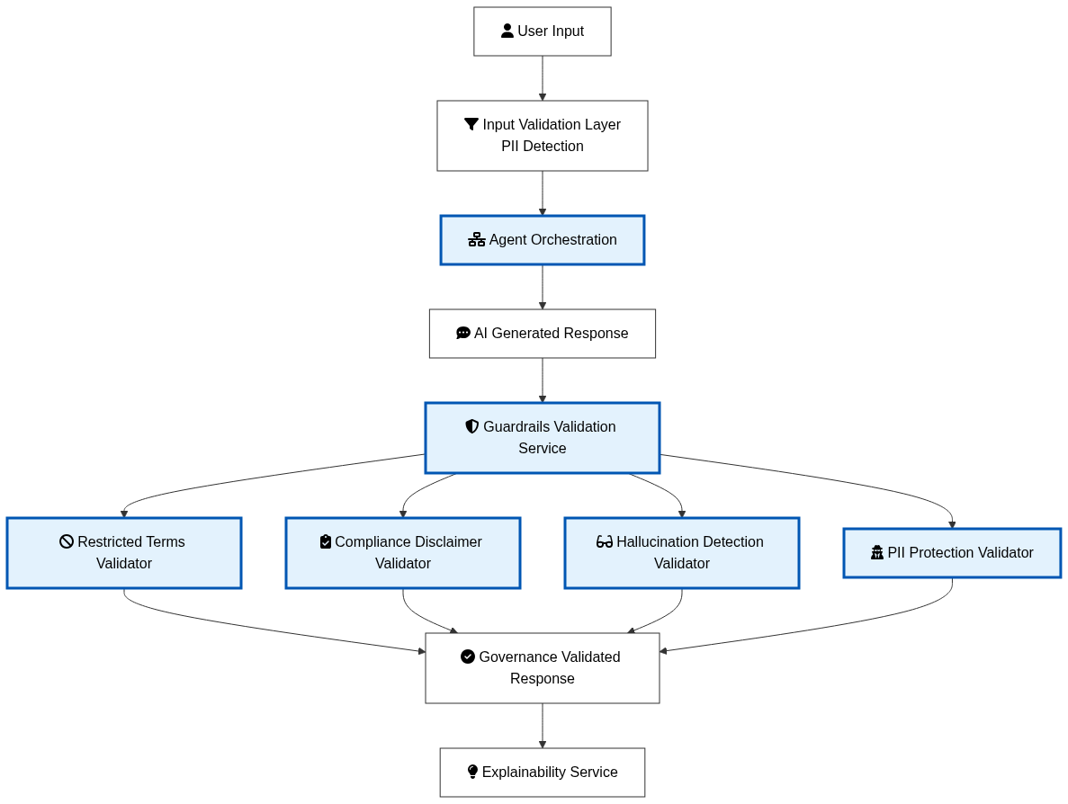
Figure 3.7: Governance validation performed by the Guardrails Validation Service before response delivery.
Validator | Purpose | Implementation Benefit
Restricted Terms Validator | Prevents unsafe legal and regulatory statements | Reduces legal and compliance risks
Compliance Disclaimer Validator | Ensures advisory responses include appropriate disclaimers | Supports responsible AI usage
Hallucination Detector | Validates RBI circulars and regulatory references | Improves factual reliability
PII Filter Validator | Detects and masks sensitive banking information | Protects customer privacy and confidentiality

Table 3.6 Guardrails Validation Components
Design Rationale
Financial institutions operate in highly regulated environments where AI-generated responses must satisfy governance, security, and compliance requirements in addition to being technically accurate. Embedding governance checks directly within the language model can make policy updates difficult and tightly couples validation logic with AI reasoning. The proposed framework therefore implements governance as an independent service that validates responses after reasoning but before presentation.
This architecture offers several advantages. Validation policies can be updated independently of the language model, enabling organizations to respond quickly to evolving regulatory requirements. Separating governance from reasoning also improves maintainability, simplifies testing, and provides a clear audit trail for compliance verification. Combined with the RAG-based knowledge retrieval and the multi-agent orchestration framework, the Guardrails Validation Service contributes to a more trustworthy and enterprise-ready AI platform.
3.4.5 Explainability Service
The Explainability Service enhances the transparency and interpretability of the proposed framework by providing token-level explanations for AI-generated responses. In enterprise banking environments, compliance recommendations generated by artificial intelligence must be supported by interpretable evidence so that legal professionals, compliance officers, and auditors can understand the basis of each decision. To satisfy this requirement, the proposed framework incorporates a dedicated Explainability Service that generates feature attribution scores using SHapley Additive exPlanations (SHAP).
Unlike conventional AI systems that present only the final prediction, the Explainability Service analyzes how individual contractual terms contribute to the confidence of the generated response. The service operates after governance validation and receives the validated contract content together with the corresponding question-answering request. By explaining the contribution of individual words rather than exposing the internal parameters of the language model, the framework improves transparency while preserving the flexibility of modern transformer-based architectures.
The implementation employs a question-answering pipeline as the prediction model for explainability. To improve computational efficiency, the service first limits the input context to a manageable text window before performing explanation generation. A custom prediction function is then constructed to evaluate the confidence score produced by the question-answering model for different masked versions of the contract text.
To generate meaningful feature attributions, the service utilizes the SHAP Text Masker, which leverages the tokenizer associated with the question-answering model. The masker systematically hides portions of the contract text and measures the resulting changes in prediction confidence. Based on these observations, the SHAP explainer computes the contribution of each token toward the final prediction using cooperative game theory.
The generated explanation includes the list of analyzed tokens, their corresponding SHAP contribution values, and the model's baseline prediction value. Positive attribution values indicate terms that increase the confidence of the predicted answer, while negative values represent tokens that reduce the prediction confidence. These explanations provide users with interpretable evidence supporting the AI-generated compliance assessment.
By implementing explainability as an independent service, the proposed architecture separates interpretation from the reasoning process, allowing different language models or retrieval strategies to be incorporated without modifying the explanation mechanism. This modular design improves maintainability while enabling future enhancements to the underlying AI models.
The generated explanations are subsequently presented through the user interface, allowing legal reviewers and compliance officers to examine the contractual terms that influenced each recommendation. This capability improves user trust, facilitates manual verification, and supports regulatory audit requirements by providing transparent evidence for AI-assisted decision-making.
Inputs
- Governance-validated contract content
- User question
- Question-answering pipeline
- Tokenizer associated with the QA model
Processing Steps
- Receive the validated contract content and user question.
- Restrict the input text to a predefined processing window to improve computational efficiency.
- Construct a prediction function using the question-answering pipeline.
- Create a SHAP Text Masker using the tokenizer of the prediction model.
- Initialize the SHAP Explainer with the prediction function and text masker.
- Compute token-level SHAP values for the processed contract text.
- Generate feature attribution scores and supporting explanation metadata.
- Forward the explanation results to the presentation layer.
Outputs
- Token list
- SHAP contribution values
- Baseline prediction value
- Explainable compliance evidence

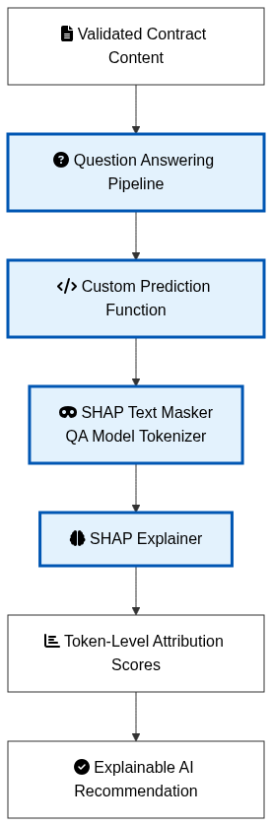
Figure 3.8: Token-level explainability workflow implemented using SHAP.
Component | Function | Output
Question-Answering Pipeline | Generates prediction confidence | Prediction score
Prediction Function | Evaluates model confidence for masked inputs | Confidence values
SHAP Text Masker | Masks textual tokens using the model tokenizer | Masked text samples
SHAP Explainer | Computes token contribution values | SHAP attribution scores
Explanation Generator | Produces interpretable evidence for users | Explainable AI response
Table 3.7 Explainability Components
Design Rationale
Artificial intelligence models employed for legal and regulatory analysis often achieve high predictive performance but provide limited insight into the reasoning underlying their decisions. Such black-box behaviour reduces user confidence and presents challenges for regulatory audits, where organizations must justify compliance recommendations using transparent evidence.
The proposed framework addresses this challenge by integrating SHAP as a dedicated explainability service. Rather than interpreting model parameters directly, the implementation explains the prediction behaviour of the question-answering pipeline by evaluating how masking individual contractual terms influences the prediction confidence. This model-agnostic strategy enables the framework to generate meaningful token-level explanations without requiring modifications to the underlying transformer architecture.
The implementation also incorporates practical optimization techniques by restricting the amount of text processed during explanation generation, thereby reducing the computational overhead associated with SHAP while maintaining explanation quality. The resulting feature attribution scores provide legal reviewers with interpretable evidence supporting each compliance recommendation, strengthening trust in AI-assisted decision-making.
Furthermore, separating explainability from document processing, retrieval, reasoning, and governance allows the explanation mechanism to remain reusable across future AI models, thereby improving the scalability and maintainability of the overall architecture.
3.4.6 Model Context Protocol (MCP) Integration Service
The Model Context Protocol (MCP) Integration Service provides a standardized communication layer that enables the AI agents within the proposed framework to securely interact with enterprise knowledge sources and external regulatory services. Rather than allowing language models to directly access databases, internal repositories, or external web resources, the proposed architecture encapsulates all enterprise interactions within an MCP-based tool framework. This design promotes modularity, security, and interoperability while ensuring that AI agents access organizational knowledge through controlled interfaces.
The service is implemented using FastMCP, which hosts a centralized registry of domain-specific tools. During system initialization, the MCP server registers multiple tool modules corresponding to different functional domains, including regulatory information, organizational policies, contract management, and obligation analysis. These tool modules collectively expose the operational capabilities required by the multi-agent reasoning framework while maintaining a clear separation between AI reasoning and enterprise data access.
The registered tools are subsequently converted into LangChain-compatible tool objects, enabling seamless integration with the Supervisor Agent and the specialized reasoning agents. Whenever an AI agent requires additional information beyond the retrieved contract context, it invokes the appropriate MCP tool rather than directly querying enterprise resources. This approach standardizes tool invocation across all agents while simplifying the addition of new enterprise services.
The implementation currently exposes four categories of enterprise tools.
The Regulatory Tools provide access to current regulatory information by retrieving recent regulatory updates, searching historical RBI notifications, and extracting the contents of specific RBI circulars. These capabilities enable the AI agents to incorporate the latest regulatory developments into compliance assessments.
The Policy Tools provide controlled access to organizational policy repositories. These tools support semantic policy searches and map regulatory categories to the corresponding internal organizational policies, enabling the framework to associate external regulations with enterprise governance documents.
The Obligation Tools support regulatory obligation management by extracting actionable obligations from regulatory documents, retrieving active obligations stored within the system, and searching historical obligation repositories for previously identified compliance requirements.
The Contract Tools provide contract-oriented services that allow the framework to access previously processed contractual knowledge and related enterprise resources required during regulatory reasoning.
By exposing these capabilities through standardized MCP interfaces, the proposed architecture enables the Supervisor Agent to dynamically invoke enterprise tools whenever additional information is required during reasoning. This mechanism extends the knowledge available to the AI agents beyond the information retrieved through the RAG subsystem while maintaining strict architectural separation between reasoning logic and enterprise integration.
The modular organization of MCP services also improves scalability. New enterprise systems can be incorporated by registering additional tool modules without modifying the agent orchestration workflow. Consequently, the MCP Integration Service serves as the interoperability layer that connects the intelligent reasoning components of the framework with enterprise knowledge repositories and external regulatory information sources.
Inputs
- Tool invocation request from AI agents
- User query
- Regulatory search parameters
- Contract or policy search requests
Processing Steps
- Initialize the FastMCP server.
- Register domain-specific tool modules.
- Convert registered tools into LangChain-compatible interfaces.
- Receive tool requests from the Supervisor Agent or specialized agents.
- Execute the requested enterprise tool.
- Retrieve and format the requested information.
- Return structured results to the requesting AI agent.
Outputs
- Regulatory information
- Organizational policy mappings
- Contract knowledge
- Obligation information
- Structured enterprise data for AI reasoning

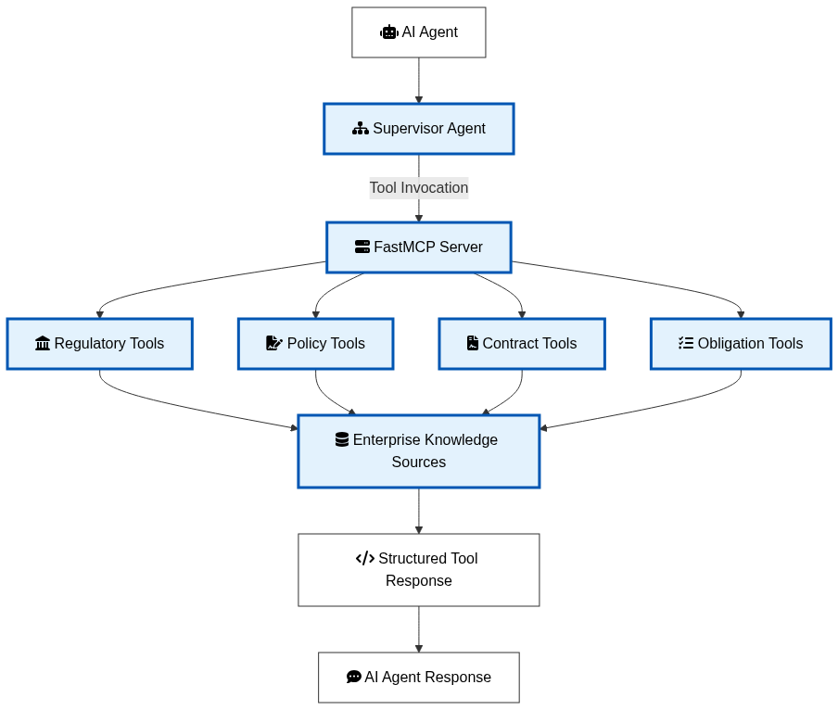
Figure 3.9: Enterprise integration through the FastMCP tool registry.
Tool Category | Primary Function | Information Provided
Regulatory Tools | Retrieve RBI notifications and regulatory updates | Regulatory documents and circulars
Policy Tools | Search organizational policies and policy mappings | Internal governance information
Contract Tools | Access contract-related enterprise resources | Contract knowledge
Obligation Tools | Extract and retrieve compliance obligations | Regulatory obligation information
Table 3.8 MCP Tool Categories
Design Rationale
Enterprise AI systems require access to organizational knowledge that extends beyond the capabilities of language models and retrieval-augmented generation. Direct database access from AI models introduces security risks, increases architectural complexity, and tightly couples reasoning logic with enterprise infrastructure.
The proposed framework addresses these limitations by adopting the Model Context Protocol as a standardized interoperability layer. FastMCP exposes enterprise capabilities as reusable tool interfaces that can be invoked by AI agents through a consistent communication mechanism. This approach decouples enterprise integration from reasoning, enabling the platform to evolve independently as new enterprise systems, regulatory repositories, or business services become available.
The integration of MCP with the Supervisor-based multi-agent architecture also enhances flexibility by allowing agents to invoke specialized enterprise tools only when additional information is required. Combined with the document processing pipeline, RAG subsystem, governance validation, and explainability services, the MCP Integration Service contributes to a scalable, secure, and extensible enterprise AI platform for automated banking contract review and Regulatory Lifecycle Management.

3.4.7 Regulatory Lifecycle Management (LRR) Service
The Regulatory Lifecycle Management (LRR) Service provides continuous monitoring of regulatory changes and automates the identification, analysis, and management of compliance obligations throughout their lifecycle. Financial regulations issued by authorities such as the Reserve Bank of India (RBI) evolve frequently, requiring organizations to continuously evaluate new regulatory requirements against existing contractual agreements and internal policies. Manual monitoring of these regulatory changes is time-consuming, error-prone, and often results in delayed compliance responses. The proposed LRR Service addresses this challenge by automating the end-to-end regulatory monitoring and obligation management process.
The service continuously retrieves regulatory notifications from designated regulatory sources and identifies newly published circulars and guidelines. When new regulatory documents are detected, they are processed using the contract analysis pipeline to extract textual content and identify regulatory obligations. These obligations are subsequently analyzed to determine their applicability, associated compliance risks, and relationships with existing organizational policies.
The extracted obligations are maintained within a centralized regulatory repository, allowing the framework to preserve historical regulatory information while supporting future compliance assessments. This persistent repository enables AI agents to retrieve previously identified obligations during contract analysis and compare new regulatory requirements with existing compliance controls.
In addition to obligation extraction, the service performs regulatory impact assessment by identifying contractual clauses, organizational policies, and compliance controls that may be affected by newly published regulations. This capability enables compliance teams to prioritize policy updates and contract reviews based on the significance of regulatory changes.
The LRR Service also maintains regulatory metadata, including publication dates, document identifiers, obligation categories, and processing status. These metadata facilitate regulatory traceability, historical auditing, and lifecycle tracking of compliance requirements throughout the enterprise.
Unlike traditional regulatory monitoring systems that simply notify users of new publications, the proposed implementation transforms regulatory documents into structured organizational knowledge that can be directly utilized by the multi-agent reasoning framework. Consequently, regulatory intelligence becomes an active component of AI-assisted contract analysis rather than an isolated compliance activity.
The processed regulatory knowledge is subsequently indexed within the semantic retrieval subsystem and made available to the Agent Orchestration Service through Retrieval-Augmented Generation and Model Context Protocol integration. This architecture ensures that regulatory reasoning is always supported by the latest available compliance information while maintaining complete traceability throughout the regulatory lifecycle.
Inputs
- RBI circulars and regulatory notifications
- Regulatory publications
- Previously processed regulatory repository
- Organizational policy information
Processing Steps
- Monitor regulatory sources for newly published notifications.
- Detect newly available regulatory documents.
- Process regulatory documents using the document analysis pipeline.
- Extract regulatory obligations and compliance requirements.
- Categorize obligations according to regulatory domains.
- Assess the impact on contracts, organizational policies, and compliance controls.
- Store regulatory metadata and extracted obligations.
- Update the semantic knowledge repository for future retrieval.
Outputs
- Structured regulatory obligations
- Regulatory impact assessment
- Updated compliance repository
- Regulatory metadata
- Knowledge base updates for RAG retrieval
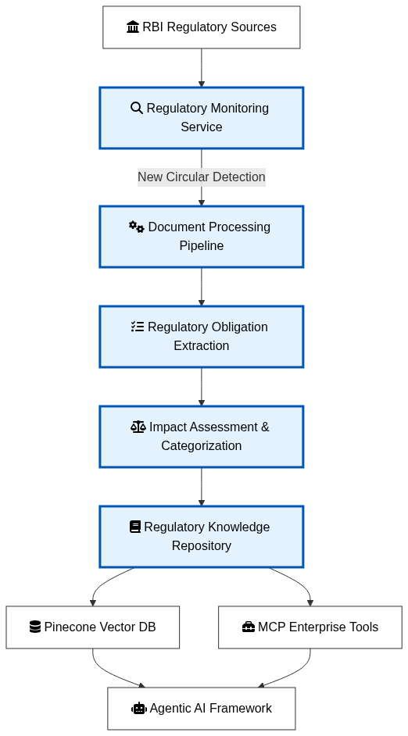
Figure 3.10: Automated Regulatory Lifecycle Management workflow implemented in the proposed framework.
Component | Function | Output
Regulatory Monitor | Detects newly published regulatory notifications | New regulatory documents
Document Processing | Extracts textual information from regulations | Structured regulatory content
Obligation Extractor | Identifies compliance obligations | Regulatory obligations
Impact Assessment Engine | Evaluates organizational impact | Compliance impact analysis
Regulatory Repository | Stores obligations and metadata | Historical regulatory knowledge
Knowledge Base Updater | Updates semantic retrieval repository | RAG-ready regulatory information
Table 3.9 LRR Service Components
Design Rationale
Regulatory compliance within financial institutions is a continuous process rather than a one-time activity. Regulations evolve frequently, requiring organizations to monitor new publications, interpret compliance obligations, assess organizational impact, and update internal policies accordingly. Existing compliance solutions often treat these activities as separate workflows, resulting in fragmented regulatory management and delayed compliance responses.
The proposed LRR Service integrates these activities into a unified automated workflow. By continuously monitoring regulatory sources, extracting obligations, assessing organizational impact, and updating the enterprise knowledge repository, the framework transforms regulatory monitoring into an active intelligence process that directly supports AI-assisted contract analysis.
The integration of the LRR Service with the document processing pipeline, semantic retrieval subsystem, multi-agent orchestration framework, Guardrails Validation Service, Explainability Service, and Model Context Protocol establishes a closed-loop regulatory intelligence architecture. Newly published regulations become immediately available for retrieval, reasoning, explainability, and compliance assessment, enabling organizations to respond more rapidly to evolving regulatory requirements while maintaining transparency and auditability.

3.5 End-to-End Workflow
3.5.1 Overview
The proposed Agentic AI platform follows a modular yet tightly integrated workflow that transforms unstructured banking contracts into validated, explainable, and regulation-aware compliance reports. The workflow combines multimodal document understanding, semantic retrieval, autonomous multi-agent reasoning, runtime governance, explainable AI, enterprise interoperability, and continuous regulatory lifecycle management within a unified processing pipeline.
Unlike conventional contract review systems that sequentially process documents using isolated machine learning models, the proposed framework enables multiple intelligent services to collaborate dynamically while maintaining complete traceability and governance throughout the execution lifecycle. Each module performs a specialized responsibility while exchanging structured information with subsequent components, thereby improving scalability, maintainability, and enterprise readiness.
The complete workflow begins when a user uploads a banking contract through the web interface. The uploaded document passes through multiple processing stages, each contributing additional knowledge and validation before the final compliance report is generated.
3.5.2 Workflow Execution
The workflow begins with the Contract Processing Service, where uploaded PDF documents are analyzed using multimodal document intelligence techniques. Textual information is extracted from digitally generated documents using PDF parsing, while scanned documents invoke Optical Character Recognition to recover textual content. LayoutLMv3 subsequently combines textual and spatial information to generate structured document representations. The extracted content is divided into semantically meaningful chunks that preserve contextual relationships between contractual clauses.
The processed document chunks are forwarded to the Vector Store and Retrieval Service, where embedding vectors are generated and indexed within the Pinecone vector database. During user interaction, semantic similarity search retrieves the most relevant contractual clauses, regulatory documents, and organizational knowledge required to answer the user's query. This Retrieval-Augmented Generation (RAG) process ensures that subsequent reasoning is grounded in verified enterprise information rather than relying exclusively on language model knowledge.
The retrieved contextual information, together with the processed contract representation and user request, is supplied to the Agent Orchestration Service. A LangGraph-based Supervisor Agent determines the execution strategy and coordinates specialized AI agents responsible for obligation extraction, compliance analysis, impact assessment, regulatory reasoning, and report generation. Each specialized agent focuses on a well-defined responsibility before returning intermediate results to the Supervisor, which consolidates them into a unified compliance assessment.
The consolidated response is subsequently processed by the Guardrails Validation Service, where both user input and AI-generated output are validated using enterprise governance policies. Multiple validators verify restricted terminology, detect personally identifiable information, identify potential hallucinations within regulatory references, and ensure that appropriate compliance disclaimers accompany advisory content. Responses failing validation are corrected or flagged before progressing to the next processing stage.
Following governance validation, the response enters the Explainability Service, where SHAP-based feature attribution analysis computes token-level contribution scores explaining the reasoning behind AI-generated recommendations. These explanations identify the contractual terms that most strongly influenced each compliance assessment, thereby improving transparency and enabling legal reviewers to verify the generated conclusions.
Whenever the reasoning agents require additional enterprise knowledge beyond the retrieved contractual context, requests are forwarded to the Model Context Protocol (MCP) Integration Service. FastMCP exposes standardized enterprise tools that provide secure access to regulatory repositories, organizational policies, obligation databases, and contract management resources. The retrieved enterprise information is returned to the requesting agents through standardized tool interfaces without exposing internal enterprise systems directly to the language models.
Parallel to the contract review workflow, the Regulatory Lifecycle Management (LRR) Service continuously monitors regulatory authorities for newly published notifications. Newly detected regulations are automatically processed, obligations are extracted, organizational impacts are assessed, and the resulting regulatory knowledge is stored within the enterprise repository and semantic vector database. Consequently, future contract analyses automatically benefit from the latest regulatory information without requiring manual knowledge updates.
Finally, the validated compliance report, together with explainability information and supporting evidence, is presented through the React-based user interface. The user receives an interpretable compliance assessment supported by retrieved contractual evidence, regulatory references, governance validation, and explainability metadata.

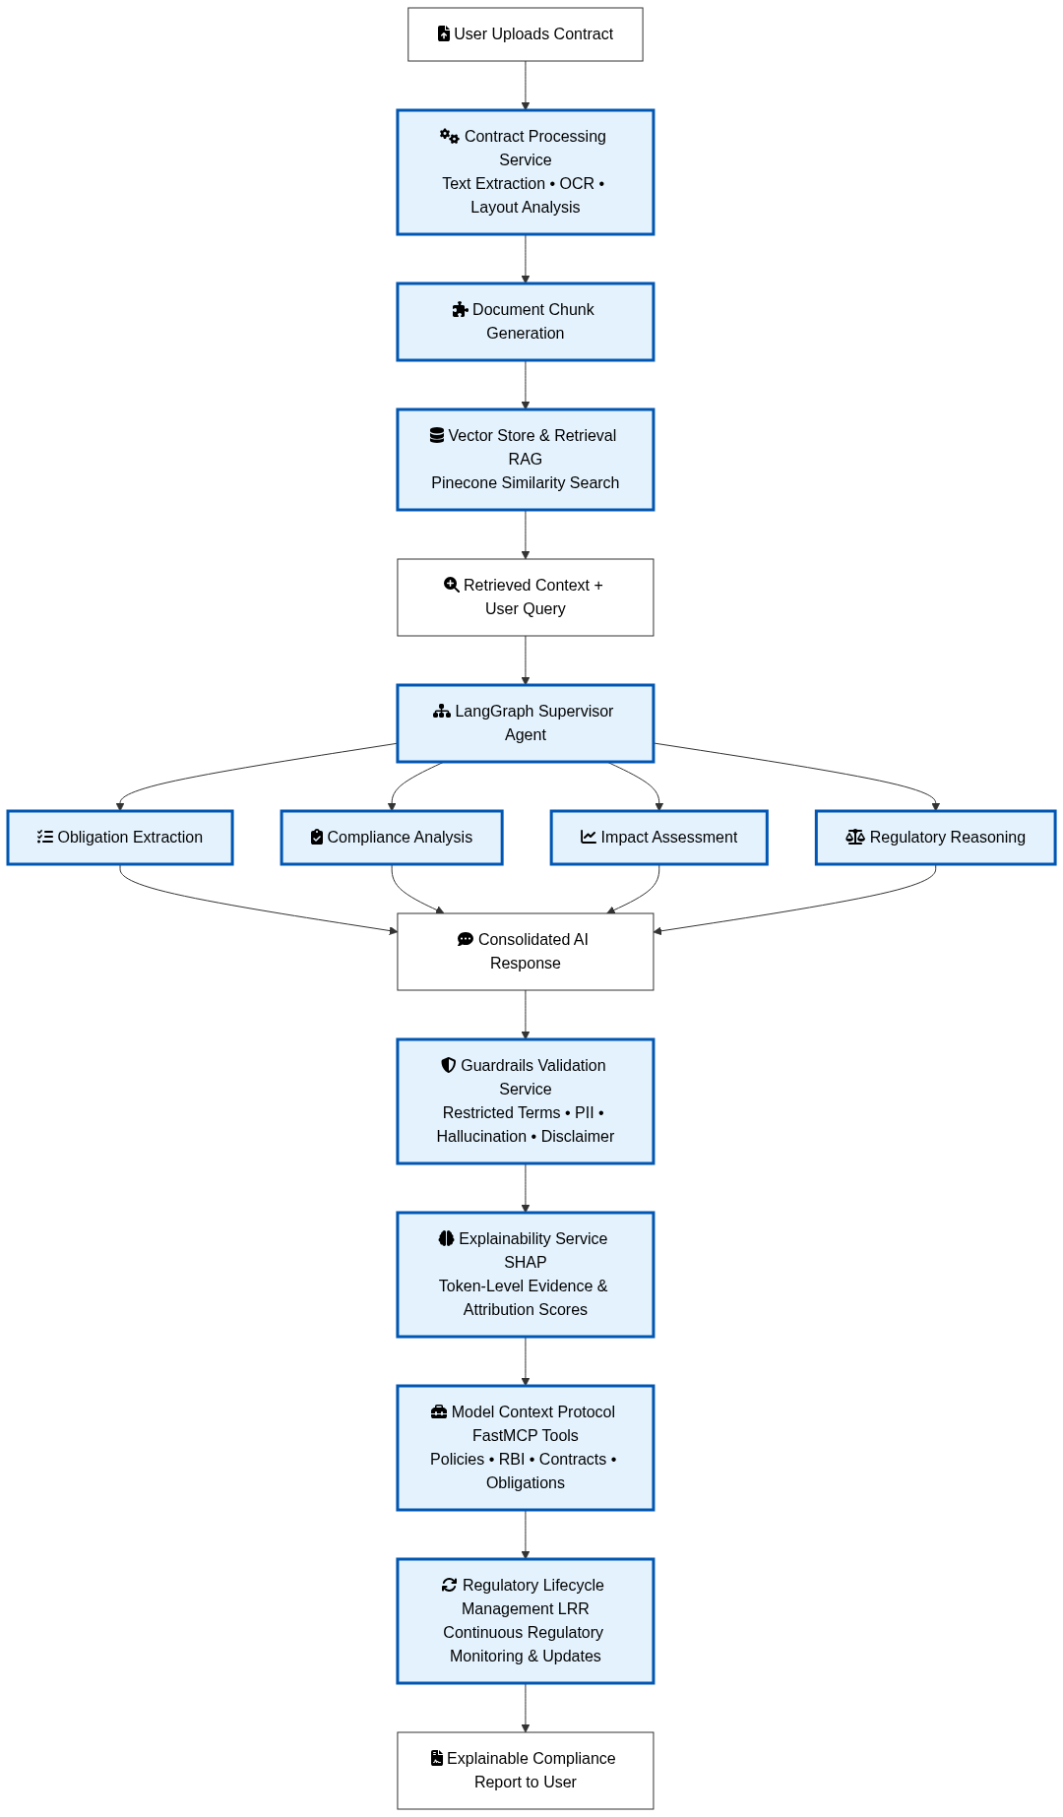
Figure 3.11: End-to-end execution workflow of the proposed Agentic AI platform.

Workflow Stage | Primary Activity | Output
Contract Processing | Extract textual and layout information | Structured contract representation
Vector Retrieval | Generate embeddings and retrieve relevant context | Contextual evidence
Agent Orchestration | Multi-agent compliance reasoning | Consolidated compliance assessment
Guardrails Validation | Validate AI output and enforce governance | Trusted AI response
Explainability | Generate SHAP-based explanations | Token-level evidence
MCP Integration | Retrieve enterprise knowledge through standardized tools | Additional enterprise context
LRR Service | Monitor regulations and update knowledge repository | Latest regulatory intelligence
User Interface | Present explainable compliance report | Final regulatory assessment
Table 3.10 End-to-End Workflow Summary
3.5.4 Workflow Characteristics
The proposed workflow possesses several characteristics that distinguish it from conventional AI-assisted contract analysis systems.
First, the architecture adopts a modular service-oriented design, allowing each functional module to evolve independently while maintaining standardized interfaces between processing stages. This improves maintainability and enables future enhancements without affecting the overall workflow.
Second, the workflow combines Retrieval-Augmented Generation with autonomous multi-agent reasoning, ensuring that AI-generated recommendations are supported by relevant contractual clauses and regulatory information rather than relying solely on the knowledge embedded within language models.
Third, governance mechanisms are incorporated directly into the execution pipeline through the Guardrails Validation Service, ensuring that every response satisfies enterprise compliance requirements before being delivered to end users.
Fourth, the Explainability Service provides transparent evidence supporting every compliance recommendation, improving user trust and facilitating regulatory audits.
Finally, the integration of Model Context Protocol and Regulatory Lifecycle Management extends the platform beyond document analysis by enabling secure enterprise interoperability and continuous incorporation of newly published regulations. Consequently, the proposed workflow establishes a complete enterprise AI ecosystem capable of supporting intelligent, explainable, and governance-oriented banking contract review.

3.6 Algorithms
3.6.1 Overview
The proposed framework consists of multiple cooperating services that collectively perform intelligent banking contract review and Regulatory Lifecycle Management. To illustrate the operational methodology independent of implementation details, the core workflows are presented as high-level algorithms. These algorithms describe the logical execution sequence adopted by the proposed platform while abstracting away programming language and framework-specific implementation.
The algorithms presented in this section correspond to the major processing stages of the proposed architecture, including contract analysis, retrieval-augmented reasoning, enterprise validation, and continuous regulatory monitoring.

Algorithm 3.1 End-to-End Banking Contract Review Workflow
Input:
Banking Contract C
User Query Q

Output:
Explainable Compliance Report R

Begin

1. Upload banking contract C.
2. Extract text using PDF parsing or OCR.
3. Analyze document layout and generate structured content.
4. Divide the document into semantic chunks.
5. Generate embedding vectors for each chunk.
6. Store embeddings in the Pinecone vector database.
7. Generate an embedding for user query Q.
8. Retrieve the Top-K relevant chunks using semantic similarity.
9. Pass the retrieved context to the Supervisor Agent.
10. Invoke specialized agents for compliance reasoning.
11. Consolidate the responses from all agents.
12. Validate the generated response using Guardrails.
13. Generate SHAP-based explainability information.
14. If additional enterprise knowledge is required,
invoke the appropriate MCP tool.
15. Generate the final explainable compliance report R.
16. Return the validated report to the user.

End

Algorithm 3.2 Regulatory Lifecycle Management Workflow
Input:
Regulatory Notifications

Output:
Updated Regulatory Knowledge Repository

Begin

1. Monitor RBI regulatory sources periodically.
2. Detect newly published regulatory documents.
3. Extract textual content from new regulations.
4. Identify regulatory obligations.
5. Categorize obligations by regulatory domain.
6. Assess their impact on contracts and policies.
7. Store regulatory metadata and obligations.
8. Update the vector database with new knowledge.
9. Make updated knowledge available for future RAG retrieval.

End

3.6 Summary
The proposed methodology is implemented through two complementary workflows. The first workflow performs intelligent banking contract review by integrating document processing, semantic retrieval, multi-agent reasoning, governance validation, explainability, and enterprise knowledge retrieval into a unified processing pipeline. The second workflow continuously monitors regulatory updates, extracts new compliance obligations, and maintains an up-to-date regulatory knowledge repository. Together, these workflows enable the proposed framework to deliver explainable, governance-aware, and regulation-driven contract analysis while ensuring that future assessments benefit from the latest regulatory information.

3.7 Design Advantages
The proposed Agentic AI platform introduces a unified architecture for intelligent banking contract review by integrating multimodal document understanding, Retrieval-Augmented Generation (RAG), multi-agent reasoning, runtime governance, explainable artificial intelligence, enterprise interoperability, and continuous Regulatory Lifecycle Management (LRR). Unlike conventional contract review systems that primarily depend on keyword searches or standalone large language models, the proposed framework combines multiple complementary technologies to provide accurate, transparent, and regulation-aware compliance analysis.
One of the primary advantages of the proposed architecture is its modular service-oriented design. Each functional component operates as an independent service with clearly defined responsibilities, allowing individual modules to be enhanced or replaced without affecting the remaining components. This modularity improves system maintainability, scalability, and adaptability to evolving enterprise requirements.
The integration of Retrieval-Augmented Generation significantly reduces hallucinations by grounding AI-generated responses in semantically retrieved contractual clauses and regulatory documents. Rather than relying solely on the pretrained knowledge of language models, the framework incorporates enterprise-specific knowledge retrieved from the Pinecone vector database, thereby improving the factual accuracy and contextual relevance of compliance recommendations.
The adoption of a Supervisor-based multi-agent architecture further enhances reasoning quality by decomposing complex compliance analysis into specialized subtasks. Dedicated agents independently perform obligation extraction, compliance assessment, impact analysis, and regulatory reasoning before the Supervisor Agent consolidates their outputs into a comprehensive compliance report. This collaborative reasoning process improves decision quality while simplifying future extension of the platform through additional specialized agents.
Another important contribution of the proposed framework is the integration of enterprise governance mechanisms through the Guardrails Validation Service. Runtime validation ensures that AI-generated responses comply with organizational policies by detecting restricted terminology, protecting personally identifiable information, identifying potentially hallucinated regulatory references, and appending appropriate compliance disclaimers. Consequently, governance is incorporated directly into the reasoning pipeline rather than being treated as a separate post-processing activity.
The framework also addresses one of the major limitations of modern AI systems by incorporating Explainable Artificial Intelligence (XAI). SHAP-based token attribution provides interpretable evidence supporting each compliance recommendation, enabling legal reviewers, compliance officers, and auditors to understand the contractual clauses that influenced AI-generated conclusions. This transparency increases user trust and supports regulatory audit requirements.
The integration of the Model Context Protocol (MCP) extends the capabilities of the AI agents beyond document retrieval by providing standardized access to enterprise tools and external regulatory resources. Through FastMCP, the platform securely interacts with organizational policies, regulatory repositories, obligation databases, and contract management services while maintaining architectural separation between AI reasoning and enterprise systems.
A distinguishing feature of the proposed platform is the inclusion of Regulatory Lifecycle Management (LRR) as an integral component of the architecture. By continuously monitoring regulatory publications, extracting new obligations, assessing organizational impact, and updating the enterprise knowledge repository, the framework ensures that contract analysis remains aligned with the latest regulatory requirements. This continuous learning capability enables the platform to evolve alongside changing financial regulations without requiring manual knowledge updates.
Collectively, these design characteristics establish a comprehensive enterprise AI platform that supports intelligent, explainable, secure, and regulation-aware banking contract review. The proposed architecture provides a practical foundation for deploying trustworthy AI solutions within highly regulated financial environments.
Design Aspect | Proposed Framework | Benefit
Modular Architecture | Independent service-based modules | Scalability and maintainability
Retrieval-Augmented Generation | Semantic retrieval using Pinecone | Reduced hallucinations and improved contextual accuracy
Multi-Agent Orchestration | Supervisor-based collaborative reasoning | Improved analytical quality
Guardrails Validation | Runtime governance and validation | Safe and compliant AI responses
Explainable AI | SHAP-based token attribution | Transparency and auditability
MCP Integration | Standardized enterprise tool access | Secure interoperability
Regulatory Lifecycle Management | Continuous monitoring and knowledge updates | Up-to-date regulatory compliance
Table 3.12 Design Advantages of the Proposed Framework

3.8 Chapter Summary
This chapter presented the proposed methodology for an Explainable, Guardrailed Agentic AI platform designed to automate banking contract review and Regulatory Lifecycle Management. The chapter began by describing the research methodology and the overall enterprise software architecture, followed by a detailed discussion of the functional modules that constitute the proposed framework.
The methodology integrates multimodal contract processing, Retrieval-Augmented Generation, Supervisor-based multi-agent orchestration, Guardrails-based governance validation, SHAP-driven explainability, Model Context Protocol integration, and continuous Regulatory Lifecycle Management into a unified enterprise architecture. Each functional module was presented together with its role, processing workflow, design rationale, and contribution to the overall system.
The end-to-end workflow demonstrated how banking contracts are transformed from unstructured documents into validated, explainable, and regulation-aware compliance assessments. High-level algorithms were also presented to illustrate the operational methodology adopted by the proposed framework independently of implementation-specific details.
Finally, the chapter discussed the principal design advantages of the proposed architecture, highlighting its modularity, transparency, scalability, governance capabilities, enterprise interoperability, and continuous regulatory adaptation. These characteristics collectively establish a trustworthy AI framework suitable for deployment within highly regulated financial institutions.
The next chapter presents the implementation details of the proposed platform, including the technology stack, system components, experimental setup, and implementation of the various services that collectively realize the proposed architecture.

CHAPTER 4

SYSTEM IMPLEMENTATION

4.1 Introduction
This chapter presents the implementation of the proposed Explainable, Guardrailed Agentic AI platform for automated banking contract review and Regulatory Lifecycle Management (LRR). While the previous chapter described the architectural design and methodology, this chapter focuses on the realization of the proposed framework using modern software engineering practices and enterprise AI technologies.
The implementation adopts a modular service-oriented architecture in which each functional component is developed as an independent service responsible for a specific stage of the processing pipeline. The system integrates multimodal document understanding, semantic retrieval using Retrieval-Augmented Generation (RAG), Supervisor-based multi-agent orchestration, runtime governance through Guardrails AI, Explainable Artificial Intelligence (XAI), Model Context Protocol (MCP), and continuous Regulatory Lifecycle Management into a unified enterprise platform.
The frontend application provides an intuitive interface for contract upload, conversational compliance analysis, explainability visualization, and regulatory monitoring, while the backend implements RESTful APIs, intelligent reasoning services, and enterprise integration components. Together, these modules realize the architecture proposed in Chapter 3 and provide a practical implementation capable of supporting intelligent and explainable banking contract review.
The remainder of this chapter presents the development environment, project organization, implementation of major system components, system integration workflow, and implementation observations.

4.2 Development Environment
4.2.1 Hardware Configuration
Component | Specification
Processor | Intel Core i7 / AMD Ryzen 7 (or equivalent)
RAM | 32 GB
Storage | 512 GB SSD
GPU | NVIDIA RTX Series 4080
Operating System | Windows 11
Table 4.1 Hardware Configuration
4.2.2 Software Environment
Category | Technology
Programming Language | Python 3.11
Frontend | React 18
Build Tool | Vite
Backend | FastAPI
AI Framework | LangGraph
LLM Provider | Azure OpenAI
Embedding Model | Sentence Transformers
OCR Engine | EasyOCR
Layout Analysis | LayoutLMv3
Vector Database | Pinecone
Explainability | SHAP
AI Governance | Guardrails AI
MCP Framework | FastMCP
HTTP Client | Axios
State Management | Zustand
PDF Viewer | Syncfusion PDF Viewer
IDE | Visual Studio Code
Version Control | Git
Table 4.2 Software Environment
4.2.3 Project Organization
One of the strengths of the implementation is its modular project organization. The frontend and backend are developed as independent applications that communicate through RESTful APIs. This separation simplifies deployment, improves maintainability, and enables independent scaling of the user interface and intelligent backend services.

Frontend Structure
src/
│
├── components/
├── pages/
├── store/
├── services/
├── App.jsx
└── main.jsx

Backend Structure
app/
│
├── api/
├── services/
├── agents/
├── guardrails/
├── mcp/
├── models/
├── utils/
└── main.py

Figure 4.1: Overall project organization of the implemented platform.

4.3 Frontend Implementation
The frontend of the proposed platform is implemented using React 18 with Vite as the build tool. The user interface is designed as a Single Page Application (SPA) that communicates with the backend through RESTful APIs implemented using FastAPI. The frontend emphasizes usability, responsiveness, and efficient navigation while allowing users to upload contracts, interact with AI agents, visualize explainability information, and monitor regulatory updates.
The application follows a component-based architecture, where each functional module is encapsulated within an independent React component. Shared application state is managed using Zustand, while HTTP communication with backend services is performed using Axios. The frontend routing and layout are organized to provide a seamless user experience for different stages of banking contract analysis.
4.3.1 Application Architecture
The frontend application consists of reusable components responsible for document management, conversational interaction, document visualization, and regulatory monitoring. Each component communicates with backend APIs through a centralized API layer, thereby separating presentation logic from business functionality.
The overall frontend organization is illustrated in Figure 4.2.
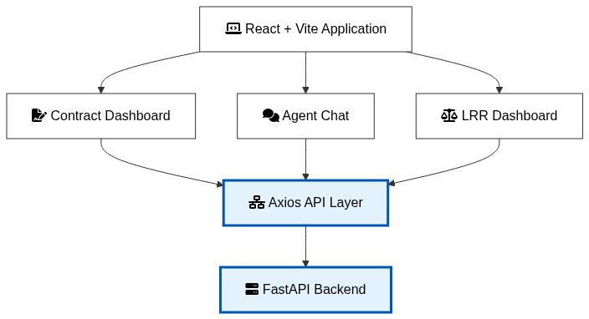
Figure 4.2: Overall frontend architecture.

4.3.2 Contract Dashboard
The Contract Dashboard serves as the primary interface through which users upload banking contracts and manage contract processing activities. It acts as the entry point of the system by enabling users to submit PDF documents for automated compliance analysis.
The dashboard communicates with the backend Contract API to upload documents, initiate processing, and retrieve processing status. After successful upload, the dashboard displays processed contracts and allows users to navigate to detailed contract analysis pages.
The implementation encapsulates document upload logic within a dedicated React component, improving maintainability while separating user interface responsibilities from backend communication.
Major responsibilities
- Upload banking contracts
- Display processed contracts
- Initiate contract analysis
- View processing status
- Navigate to contract details
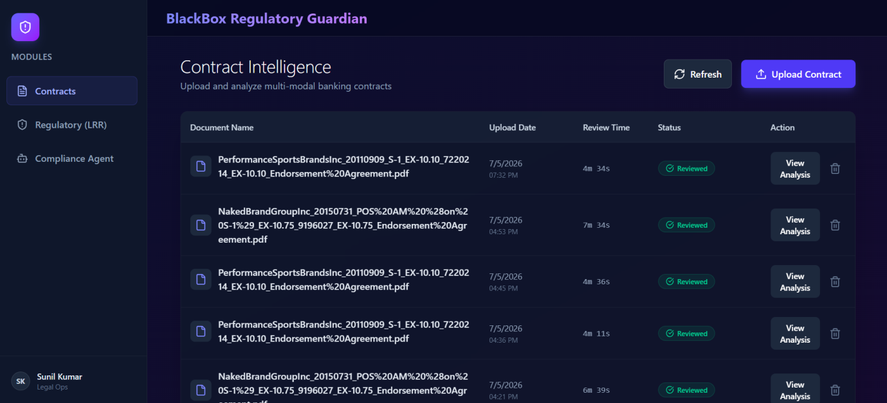
Figure 4.3: Contract Dashboard (Insert application screenshot)
4.3.3 Agent Chat Interface
The Agent Chat component provides a conversational interface through which users interact with the multi-agent AI framework. Rather than presenting a traditional search interface, the application allows compliance officers to communicate using natural language queries related to contractual obligations, regulatory requirements, and compliance risks.
User queries are forwarded to the backend Agent API, where the LangGraph Supervisor coordinates multiple specialized agents. The generated responses are subsequently displayed within the conversational interface, providing an interactive and intuitive user experience.
The chat interface also supports follow-up questions, allowing users to progressively explore contractual clauses and regulatory interpretations without restarting the analysis process.
Major responsibilities
- Natural language interaction
- Query submission
- Display AI responses
- Multi-turn conversations
- Compliance reasoning visualization
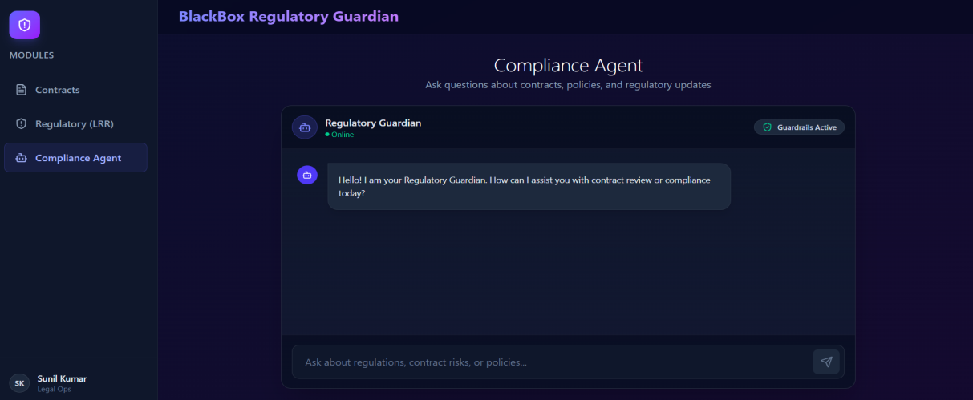
Figure 4.4: Agent Chat Interface
4.3.4 Contract Viewer
The Contract Viewer enables users to visualize uploaded PDF documents alongside AI-generated compliance recommendations. The implementation integrates the Syncfusion PDF Viewer, allowing users to navigate contracts while simultaneously reviewing AI-generated analyses.
Displaying the original contract during compliance review improves transparency by enabling legal reviewers to verify recommendations against the source document. The component also supports navigation across contract pages and facilitates efficient examination of contractual clauses referenced during AI reasoning.
Major responsibilities
- PDF visualization
- Page navigation
- Contract inspection
- Reference verification
- Integrated document review
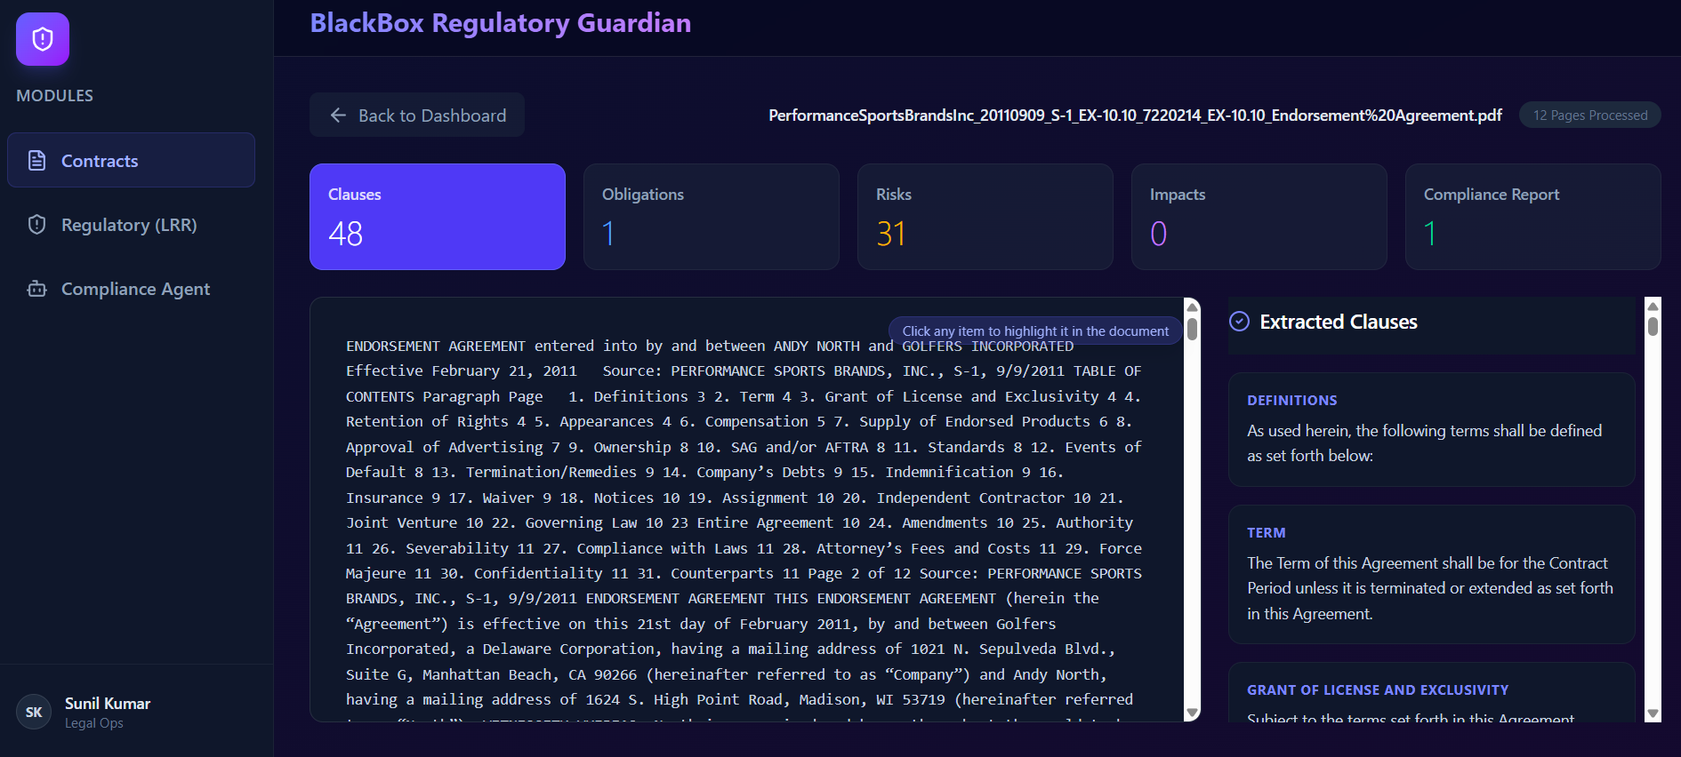
Figure 4.5: Contract Viewer

4.3.5 Regulatory Dashboard
The Regulatory Lifecycle Management (LRR) Dashboard provides a centralized interface for monitoring newly published regulatory updates and extracted compliance obligations. Information presented within this dashboard originates from the Regulatory Lifecycle Management Service implemented in the backend.
The dashboard enables users to review recent regulatory notifications, examine extracted obligations, and monitor the status of regulatory processing activities. By presenting continuously updated regulatory information through an intuitive interface, the platform assists compliance teams in tracking evolving regulatory requirements.
Major responsibilities
- Display regulatory updates
- View extracted obligations
- Monitor regulatory processing
- Review compliance status
- Access historical regulatory information
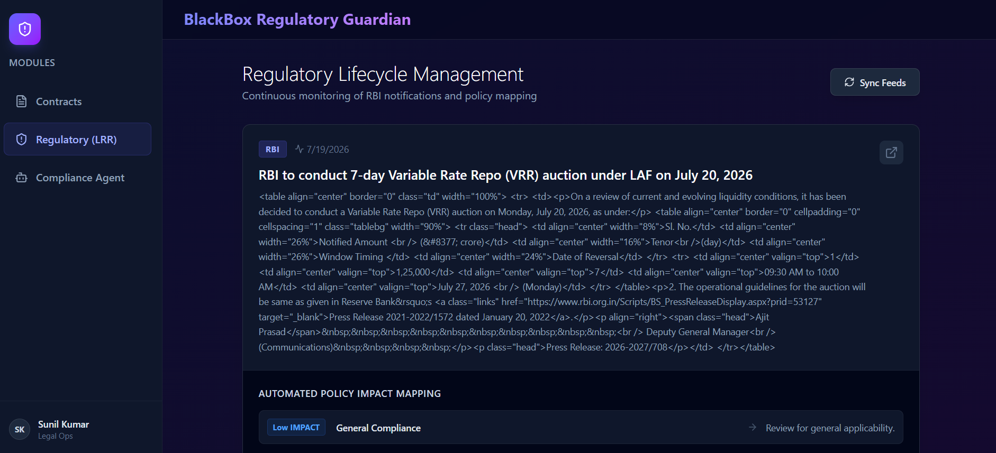
Figure 4.6: Regulatory Dashboard

4.3.6 State Management and API Integration
The frontend application adopts a lightweight state management strategy using Zustand, allowing application-wide information such as selected contracts, user interactions, and processing states to be shared efficiently across components. This approach reduces unnecessary component coupling while simplifying state synchronization.
Communication between the frontend and backend is centralized through an Axios-based API service. Rather than allowing individual components to communicate directly with REST endpoints, API requests are encapsulated within a dedicated service layer that manages request construction, response processing, and error handling. This design improves code maintainability and promotes reuse across multiple frontend components.
The interaction between frontend components and backend services is illustrated in Figure 4.7.
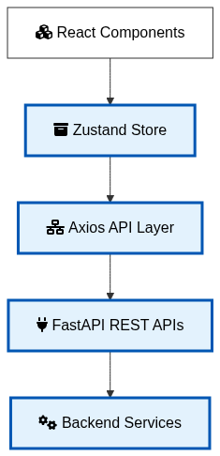
Figure 4.7: Frontend communication with backend services.

4.3.7 Frontend Implementation Summary
The frontend implementation provides an intuitive and modular interface that enables users to interact efficiently with the proposed Agentic AI platform. Through dedicated components for contract management, conversational AI interaction, document visualization, and regulatory monitoring, the application simplifies complex compliance workflows while maintaining a responsive user experience. The combination of React, Zustand, Axios, and Vite results in a scalable frontend architecture that integrates seamlessly with the FastAPI backend and the enterprise AI services described in the previous chapter.

4.4 Backend Implementation
The backend of the proposed framework is implemented using FastAPI, providing a lightweight, asynchronous, and high-performance RESTful service layer for banking contract review and Regulatory Lifecycle Management. The backend follows a modular service-oriented architecture in which each functional responsibility is encapsulated within an independent module. This architectural approach improves maintainability, scalability, and extensibility while enabling seamless integration of artificial intelligence services, enterprise knowledge repositories, and regulatory monitoring components.
The backend serves as the central processing engine of the proposed platform. It receives requests from the React frontend, coordinates document processing, semantic retrieval, multi-agent reasoning, governance validation, explainability generation, and enterprise tool invocation before returning validated compliance responses to the user.
Figure 4.8 illustrates the overall backend organization.
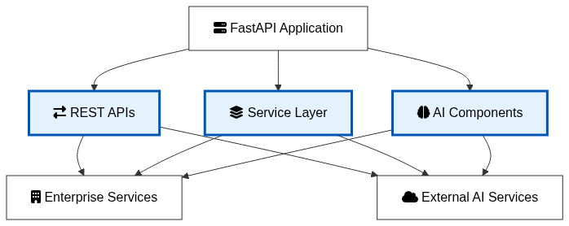
Figure 4.8: Backend architecture of the implemented system.

4.4.1 REST API Layer
The backend exposes RESTful endpoints responsible for contract processing, conversational interaction, explainability generation, and regulatory lifecycle management. Each endpoint delegates business logic to specialized service modules, ensuring that API controllers remain lightweight while implementation complexity is isolated within reusable backend services.
The implemented API layer consists of four principal modules.
API Module | Purpose
Contract API | Upload, process, and retrieve contracts
Agent API | Conversational AI and compliance reasoning
Explainability API | Generate SHAP-based explanations
Regulatory API | Manage Regulatory Lifecycle Management services
Table 4.3 Backend REST APIs
The modular API design improves readability and simplifies future expansion through additional enterprise services.

4.4.2 Contract Processing Implementation
The Contract Processing Service represents the entry point of the backend workflow. After receiving a contract through the Contract API, the service determines the appropriate document processing strategy based on document characteristics. Digital contracts are processed using PDF text extraction, whereas scanned contracts invoke Optical Character Recognition before layout-aware analysis is performed.
The extracted document is subsequently divided into semantically meaningful chunks using recursive text splitting techniques. Each chunk is enriched with metadata before being forwarded to the embedding pipeline for semantic indexing.
The implementation separates document ingestion, preprocessing, metadata generation, and chunk creation into reusable methods, thereby improving maintainability and reducing coupling between document processing and downstream AI services.
@router.post("/upload")
async def upload_contract(file: UploadFile = File(...)):
contents = await file.read()

result = contract_service.process_contract(
file_content=contents,
filename=file.filename
)

return {
"status": "success",
"contract_id": result["contract_id"],
"message": "Contract processed successfully."
}

Listing 4.1: Contract Upload Endpoint

4.4.3 Vector Store Implementation
Following document preprocessing, semantic embeddings are generated for each document chunk and stored within the Pinecone vector database. The Vector Store Service encapsulates embedding generation, vector indexing, metadata storage, and similarity search behind a unified service interface.
During user interaction, the service converts incoming queries into embedding vectors and performs semantic similarity search to retrieve the most relevant contractual clauses. Retrieved information is subsequently supplied to the multi-agent reasoning framework, ensuring that generated responses remain grounded in enterprise knowledge rather than relying solely on the pretrained language model.
The implementation abstracts vector database operations through dedicated service methods, enabling future replacement of the vector database without affecting higher-level reasoning modules.
embedding = self.embedding_model.encode(chunk)

self.index.upsert(
vectors=[
(
chunk_id,
embedding.tolist(),
metadata
)
]
)

Listing 4.2: Vector Indexing

4.4.4 Multi-Agent Implementation
One of the most significant implementation aspects of the proposed platform is the adoption of LangGraph for multi-agent orchestration. Rather than allowing a single language model to perform every reasoning task, the implementation initializes a Supervisor Agent responsible for coordinating multiple specialized agents. Each agent independently performs a specific analytical task such as obligation extraction, compliance analysis, regulatory reasoning, or impact assessment.
The Supervisor dynamically determines the execution sequence, collects intermediate reasoning outputs, and synthesizes them into a consolidated compliance response.
This implementation strategy improves modularity, facilitates future extension through additional agents, and enables complex reasoning workflows to be decomposed into smaller specialized responsibilities.
workflow = StateGraph(MultiAgentState)

workflow.add_node("supervisor", supervisor_node)
workflow.add_node("regulatory_monitor", regulatory_node)
workflow.add_node("obligation_extractor", obligation_node)
workflow.add_node("impact_assessor", impact_node)
workflow.add_node("compliance_reporter", report_node)

workflow.set_entry_point("supervisor")
self.graph = workflow.compile()

Listing 4.3: Supervisor Graph Initialization

4.4.5 Guardrails Implementation
The Guardrails implementation provides runtime governance for all AI interactions. The service validates both incoming requests and AI-generated responses through multiple validation stages designed to improve safety, regulatory compliance, and enterprise trustworthiness.
The implemented validation pipeline includes:
- Restricted terminology detection
- Personally identifiable information masking
- Compliance disclaimer generation
- Hallucination detection
Each validator operates independently and contributes to the overall governance decision before the response is returned to the user. The implementation also supports configurable validation policies through runtime parameters, allowing organizations to customize governance strictness according to enterprise requirements.
self._output_guard = Guard().use(
self.restricted_terms_validator,
self.disclaimer_validator,
self.hallucination_detector,
self.pii_filter,
)

self._input_guard = Guard().use(
self.pii_filter,
)

Listing 4.4: Guard Initialization

4.4.6 Explainability Implementation
The Explainability Service is implemented using the SHAP framework.
A custom prediction function is constructed around the question-answering pipeline, enabling SHAP to evaluate token-level feature contributions without requiring modifications to the underlying transformer architecture.
To reduce computational overhead, the implementation processes a predefined text window before generating explanations. The resulting SHAP values are returned together with token information and baseline prediction values, enabling the frontend to visualize explainability information alongside compliance recommendations.

masker = shap.maskers.Text(
tokenizer=qa_pipeline.tokenizer
)

explainer = shap.Explainer(
predict_score,
masker
)

shap_values = explainer([text_window])

Listing 4.5: SHAP Initialization

4.4.7 MCP Implementation
Enterprise interoperability is implemented through FastMCP. During application initialization, domain-specific enterprise tools are registered within the MCP server and converted into LangChain-compatible interfaces. These tools expose regulatory repositories, organizational policies, obligation databases, and contract knowledge to the multi-agent reasoning framework.
Whenever additional enterprise information is required, agents invoke the corresponding MCP tool instead of directly accessing enterprise resources, thereby maintaining architectural separation between AI reasoning and enterprise integration.
mcp = FastMCP(settings.MCP_SERVER_NAME)

register_regulatory_tools(mcp)
register_policy_tools(mcp)
register_contract_tools(mcp)
register_obligation_tools(mcp)

Listing 4.6: MCP Registration

4.4.8 Regulatory Lifecycle Management Implementation
The Regulatory Lifecycle Management module continuously monitors RBI regulatory publications and maintains an evolving regulatory knowledge repository.
The implementation periodically retrieves newly published regulatory documents, extracts compliance obligations, performs impact assessment, and updates both the structured repository and the semantic vector database. This automated pipeline ensures that future compliance assessments always utilize the latest available regulatory information.
The implementation also maintains regulatory metadata supporting historical traceability and compliance auditing.
with httpx.Client(
timeout=self.timeout,
follow_redirects=True
) as client:

response = client.get(
settings.RBI_CIRCULAR_URL,
headers=self.headers
)

response.raise_for_status()
soup = BeautifulSoup( response.text, "html.parser" )

Listing 4.7: RBI Scraping

4.4.9 Backend Implementation Summary
The backend implementation demonstrates the practical realization of the enterprise architecture proposed in Chapter 3. By combining asynchronous REST APIs, modular service design, semantic retrieval, Supervisor-based multi-agent orchestration, runtime governance, Explainable AI, Model Context Protocol integration, and continuous Regulatory Lifecycle Management, the proposed backend provides a scalable foundation for intelligent banking contract review.
The implementation emphasizes modularity, extensibility, and enterprise readiness, allowing additional AI agents, regulatory sources, governance policies, and enterprise services to be incorporated with minimal architectural changes.

4.5 System Integration Workflow
The proposed platform integrates multiple artificial intelligence, document processing, and enterprise software components into a unified workflow for automated banking contract review and Regulatory Lifecycle Management. Unlike conventional document analysis systems that perform isolated information extraction, the implemented platform coordinates document understanding, semantic retrieval, multi-agent reasoning, runtime governance, explainability, and enterprise tool integration within a single processing pipeline.
The integration architecture ensures that each module performs a well-defined responsibility while exchanging information through standardized interfaces. This modular approach improves maintainability, simplifies debugging, and enables independent enhancement of individual services without affecting the overall system architecture.
Figure 4.9 illustrates the complete end-to-end workflow of the implemented platform.

4.5.1 End-to-End Processing Pipeline
The complete execution workflow begins when a compliance analyst uploads a banking contract through the React-based web interface. The uploaded document is transmitted to the FastAPI backend using RESTful APIs, where the Contract Processing Service determines the appropriate extraction strategy based on the document type.
For digitally generated documents, textual information is extracted directly from the PDF, whereas scanned contracts are processed using Optical Character Recognition (OCR). The extracted content is subsequently analyzed using layout-aware document processing techniques to preserve the structural organization of clauses, headings, and tabular information.
The processed document is divided into semantically meaningful chunks using recursive text splitting. Each chunk is converted into a dense embedding representation and indexed within the Pinecone vector database together with relevant metadata. This semantic repository forms the knowledge base used during Retrieval-Augmented Generation (RAG).
When the user submits a compliance-related question, the query is transformed into an embedding vector and compared against indexed document embeddings using similarity search. The retrieved contractual clauses provide contextual knowledge for the LangGraph Supervisor Agent, which dynamically coordinates multiple specialized agents responsible for obligation extraction, regulatory reasoning, compliance assessment, and report generation.
The responses generated by the agents are subsequently validated through the Guardrails framework, which performs input validation, restricted terminology detection, personally identifiable information masking, hallucination detection, and compliance disclaimer generation. After governance validation, the Explainability Service generates SHAP-based feature importance scores that explain the reasoning behind the AI-generated recommendations.
Whenever external enterprise knowledge is required, the agents invoke FastMCP tools to retrieve regulatory documents, organizational policies, historical obligations, and other enterprise resources without directly accessing external repositories. Finally, the validated response together with explainability information is returned to the frontend for presentation to the compliance analyst.

4.5.2 Integrated System Workflow
The interaction among the implemented components is illustrated in Figure 4.9.
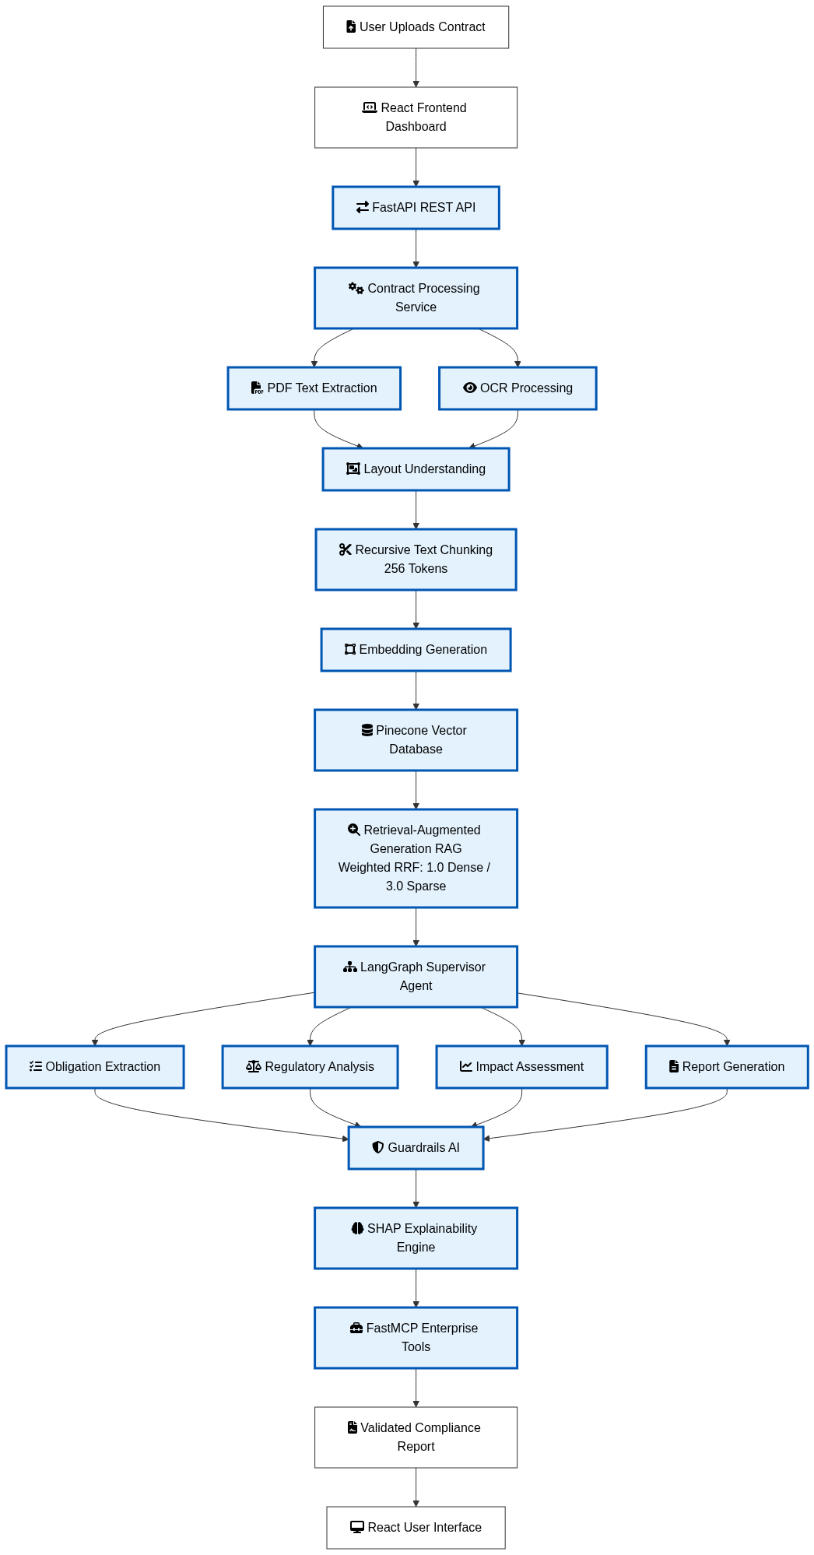
Figure 4.9: End-to-end system integration workflow.

4.5.3 Module Interaction
During execution, each module communicates only with its immediate neighboring components, thereby maintaining loose coupling and high cohesion. The Contract Processing Service focuses exclusively on document ingestion and preprocessing, while semantic retrieval is delegated to the Vector Store Service. The LangGraph Supervisor orchestrates reasoning activities without directly interacting with document extraction modules. Similarly, Guardrails AI performs governance validation independently of explainability generation, and FastMCP abstracts enterprise resource access from the reasoning process.
This separation of concerns improves system reliability by allowing each component to evolve independently while preserving standardized communication interfaces.

4.5.4 Error Handling and Fault Tolerance
The implemented platform incorporates error handling mechanisms across multiple processing stages to improve robustness. Invalid document formats, OCR failures, API communication errors, and unavailable external services are detected and handled through structured exception management within the FastAPI backend. Validation failures generated by the Guardrails framework are returned to the frontend with informative error messages, enabling users to correct input without interrupting the overall workflow.
The modular architecture also limits fault propagation by isolating failures within individual services. For example, temporary unavailability of an external MCP tool does not affect document ingestion or semantic retrieval, while failures during explainability generation do not prevent the delivery of validated compliance recommendations.

4.5.5 Deployment Architecture
The implemented platform is designed for deployment as independent frontend and backend services. The React application is deployed as a static web application, while the FastAPI backend hosts the AI services and communicates with Azure OpenAI, Pinecone, and other external components through secure API connections. The modular deployment strategy enables independent scaling of frontend and backend resources based on workload requirements and simplifies future migration to cloud-native environments.
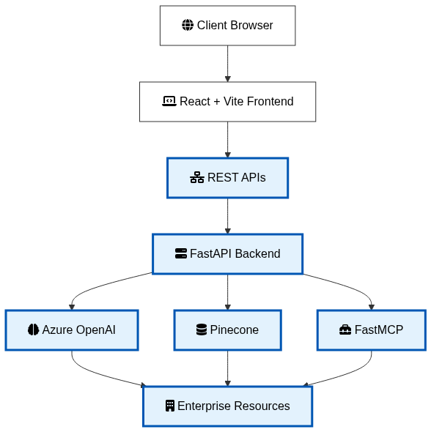
Figure 4.10: Deployment architecture of the implemented platform.

4.5.6 Implementation Summary
The implemented system successfully integrates document processing, semantic retrieval, multi-agent orchestration, runtime governance, explainability, and enterprise interoperability into a unified platform for banking contract review. The modular architecture allows each subsystem to perform specialized responsibilities while maintaining seamless communication through standardized interfaces. This integration not only supports automated compliance analysis but also ensures transparency, governance, and adaptability in rapidly evolving regulatory environments.

4.6 Chapter Summary
This chapter presented the implementation of the proposed Explainable, Guardrailed Agentic AI Platform for Multi-Modal Banking Contract Review and Automated Regulatory Lifecycle Management. The conceptual architecture introduced in the previous chapter was translated into a fully functional software system using modern web technologies, artificial intelligence frameworks, and enterprise software engineering practices.
The frontend application was implemented using React and Vite, providing an intuitive user interface for contract upload, conversational compliance analysis, document visualization, explainability exploration, and regulatory monitoring. The component-based architecture, together with centralized state management and RESTful communication, enabled efficient interaction between users and backend intelligent services.
The backend implementation employed FastAPI to develop a modular and scalable service-oriented architecture. Dedicated services were implemented for document processing, semantic indexing, Retrieval-Augmented Generation (RAG), multi-agent orchestration, runtime governance, explainability, enterprise tool integration, and Regulatory Lifecycle Management. The modular design promotes maintainability, scalability, and ease of future enhancements while ensuring clear separation of responsibilities among system components.
Document understanding was achieved through a combination of PDF parsing, Optical Character Recognition (OCR), layout-aware analysis, recursive text chunking, semantic embedding generation, and vector indexing using Pinecone. These capabilities enabled efficient retrieval of contextually relevant contractual clauses, providing reliable knowledge to support intelligent reasoning.
The implementation of the LangGraph-based Supervisor architecture enabled coordinated execution of specialized AI agents responsible for regulatory analysis, obligation extraction, impact assessment, and compliance report generation. By decomposing complex reasoning tasks into multiple specialized agents, the system improved modularity, reasoning quality, and extensibility compared with conventional single-agent architectures.
To enhance the trustworthiness of AI-generated recommendations, a comprehensive Guardrails AI framework was integrated into the reasoning pipeline. Runtime validation mechanisms, including personally identifiable information filtering, restricted terminology detection, hallucination identification, and compliance disclaimer generation, were incorporated to improve governance and reduce the risk of unsafe or misleading responses.
The platform further strengthened transparency through the implementation of an Explainable Artificial Intelligence (XAI) module based on SHAP. Token-level feature attribution enabled users to understand how contractual text influenced AI-generated decisions, thereby improving interpretability and supporting regulatory audit requirements.
Enterprise interoperability was realized through the integration of the Model Context Protocol (MCP), allowing AI agents to securely access regulatory repositories, organizational policies, contractual knowledge bases, and obligation management services using standardized interfaces. In addition, the Regulatory Lifecycle Management (LRR) module continuously monitored regulatory publications, extracted compliance obligations, assessed organizational impact, and updated the enterprise knowledge repository to ensure that future contract reviews reflected the latest regulatory requirements.
Finally, the integration workflow demonstrated how independent software modules cooperate to provide an end-to-end intelligent compliance platform, beginning with contract ingestion and concluding with validated, explainable, and regulation-aware compliance recommendations presented to the end user.
Overall, the implementation validates the feasibility of the proposed architecture and demonstrates that the integration of document intelligence, Retrieval-Augmented Generation, multi-agent orchestration, AI governance, explainability, and enterprise interoperability can effectively support intelligent banking contract review within a unified and scalable software platform.
The next chapter evaluates the implemented system through experimental studies, functional testing, performance analysis, explainability assessment, and real-world banking contract case studies to examine its effectiveness, accuracy, and practical applicability in regulatory compliance scenarios.

CHAPTER 5

EXPERIMENTAL EVALUATION AND RESULTS

5.1 Introduction
The primary objective of this chapter is to evaluate the effectiveness, functionality, and practical applicability of the proposed Explainable, Guardrailed Agentic AI Platform for Multi-Modal Banking Contract Review and Automated Regulatory Lifecycle Management. While Chapter 4 presented the implementation details of the developed system, this chapter assesses its performance through a series of experiments designed to validate the functionality of individual modules and the overall end-to-end workflow.
The evaluation focuses on verifying the system's ability to process banking contracts, retrieve semantically relevant information using Retrieval-Augmented Generation (RAG), coordinate multiple AI agents for compliance reasoning, enforce governance through Guardrails AI, generate explainable predictions using SHAP, integrate enterprise resources through the Model Context Protocol (MCP), and continuously monitor regulatory updates using the Regulatory Lifecycle Management (LRR) module.
Unlike conventional software testing that primarily verifies functional correctness, the experimental evaluation presented in this chapter examines both the technical performance and practical usefulness of the proposed platform in realistic banking compliance scenarios. The experiments are designed to demonstrate the interaction among the implemented components and to assess how each module contributes to accurate, transparent, and trustworthy compliance analysis.
The evaluation methodology includes functional testing of core modules, end-to-end workflow validation, explainability assessment, governance validation, enterprise integration testing, and performance analysis. Real banking contract documents and regulatory information are used throughout the experiments to demonstrate the capabilities of the implemented platform.

5.2 Experimental Environment
The proposed platform was evaluated on a workstation configured to support both AI model execution and enterprise application development. The evaluation environment was designed to simulate a realistic deployment scenario for intelligent banking contract analysis, integrating modern hardware with contemporary AI frameworks and enterprise software technologies.
The frontend application was executed using React and Vite, while the backend services were hosted using FastAPI. AI capabilities, including semantic retrieval, multi-agent reasoning, explainability, and regulatory monitoring, were integrated with Ollama, Pinecone, LangGraph, SHAP, and FastMCP. The experiments were performed using real banking contract documents to evaluate document understanding, Retrieval-Augmented Generation (RAG), AI reasoning, governance validation, and regulatory lifecycle management.
The hardware configuration provided sufficient computational resources for OCR, document preprocessing, vector embedding generation, semantic search, and multi-agent execution. Although Azure OpenAI performed the large language model inference through cloud services, local computational resources were utilized for application execution, document processing, OCR, explainability generation, and visualization.
The complete experimental configuration is presented in Table 5.1.
Category | Configuration
Processor | Intel® Core™ i7-13700HX (13th Generation)
CPU Cores / Threads | 16 Cores (8 Performance + 8 Efficient), 24 Threads
RAM | 32 GB DDR5
Graphics Processing Unit | NVIDIA GeForce RTX 4060 Laptop GPU (8 GB GDDR6)
Operating System | Windows 11 Home (64-bit)
Programming Language | Python 3.11
Frontend Framework | React 18
Backend Framework | FastAPI
OCR Engine | EasyOCR
Document Understanding | LayoutLMv3
Large Language Model | Llama 3.1 (via Ollama)
Embedding Model | mxbai-embed-large
Vector Database | Pinecone
AI Orchestration | LangGraph
Explainability | SHAP
AI Governance | Guardrails AI
Enterprise Integration | FastMCP
Frontend State Management | Zustand
HTTP Client | Axios
Table 5.1 Experimental Environment

5.3 Functional Evaluation

5.3.1 Experiment 1 – Contract Upload and Automated Processing
Objective
The objective of this experiment is to evaluate the ability of the proposed platform to ingest a banking contract, perform automated document processing, and generate structured compliance information for subsequent AI-driven analysis. The experiment validates the integration between the frontend interface, backend services, document processing pipeline, and contract analysis modules.
Experimental Procedure
The experiment was conducted using a real franchise agreement document consisting of 42 pages. The document was uploaded through the Contract Intelligence dashboard implemented in the React frontend. After the upload request was submitted, the frontend invoked the Contract Processing API hosted on the FastAPI backend.
Upon receiving the document, the backend initiated the contract processing workflow. The uploaded PDF was parsed, textual content was extracted, layout-aware processing was performed, and the resulting document was segmented into semantic chunks. These chunks were embedded using the mxbai-embed-large embedding model and indexed within the Pinecone vector database to support subsequent Retrieval-Augmented Generation (RAG).
During processing, the application continuously updated the contract status, allowing the user to monitor the progress of document analysis. Once processing completed successfully, the extracted information was made available through the analysis dashboard.
Experimental Results
Figure 5.2 illustrates the Contract Intelligence dashboard immediately after the contract upload request was submitted. The uploaded contract appears in the dashboard together with its upload timestamp and a status indicator showing that automated review is currently in progress.
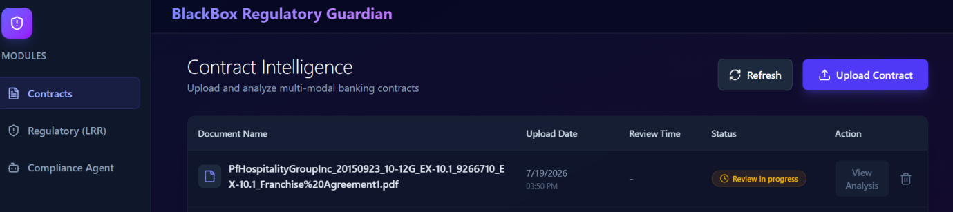
Figure 5.2: Contract upload dashboard showing document processing in progress.
Figure 5.3 presents the backend execution log generated during document processing. The successful HTTP response confirms that the frontend and backend communicated correctly through the RESTful API, while the backend processed the uploaded contract without execution errors.
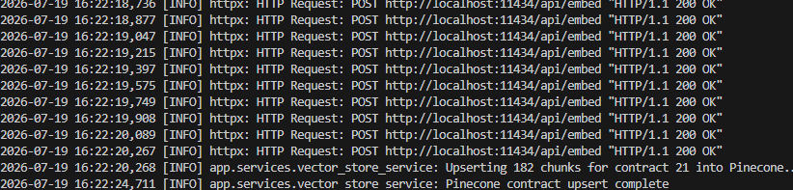
Figure 5.3: Backend log confirming successful processing of the uploaded contract.
Figure 5.4 illustrates the completed processing status. The system successfully analyzed the uploaded contract, recorded the total review duration, and updated the contract status from Review in Progress to Reviewed.
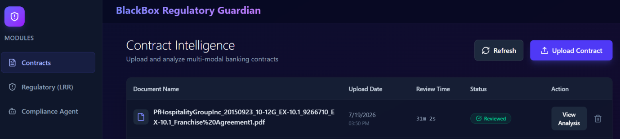
Figure 5.4: Successfully processed contract displayed in the Contract Dashboard.
Figure 5.5 presents the generated contract analysis dashboard after processing completed successfully. The dashboard summarizes key analytical information extracted from the contract, including the number of detected clauses, identified risks, obligations, impacts, and generated compliance reports.
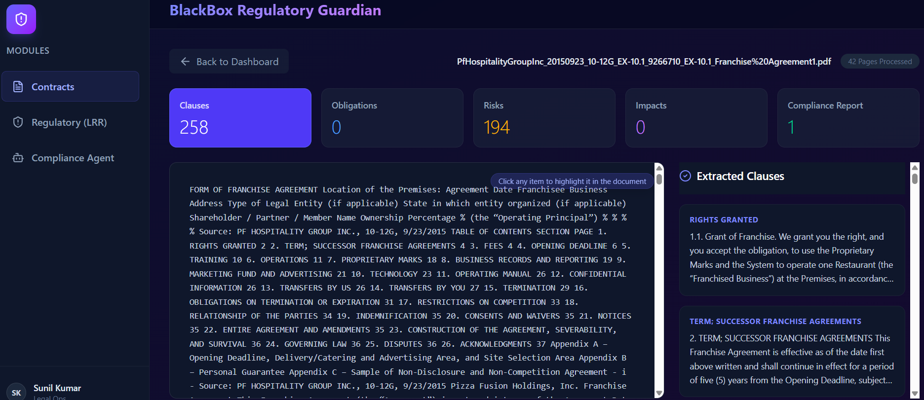
Figure 5.5: Automated contract analysis dashboard generated by the proposed platform.
Observations
The experiment demonstrates that the proposed platform successfully integrates document ingestion, backend processing, semantic indexing, and automated contract analysis into a unified workflow. The Contract Processing Service accurately accepted the uploaded banking contract and coordinated the subsequent stages of document understanding without requiring manual intervention.
The generated analysis dashboard provides immediate quantitative insights into the uploaded contract by reporting the number of extracted clauses, identified compliance risks, and generated compliance reports. These automatically generated statistics provide compliance analysts with a high-level overview before initiating detailed AI-assisted examination.
Furthermore, the successful backend communication confirms the reliability of the implemented RESTful architecture and validates the integration between the React frontend and the FastAPI backend.
Discussion
The results indicate that the proposed document processing pipeline effectively transforms unstructured contractual documents into structured knowledge suitable for downstream AI reasoning. By combining automated document parsing, semantic indexing, and dashboard visualization, the system significantly reduces manual effort traditionally associated with banking contract review.
The modular architecture also enables subsequent components, including Retrieval-Augmented Generation (RAG), multi-agent reasoning, Guardrails AI, SHAP explainability, and Regulatory Lifecycle Management, to operate on a well-structured semantic representation of the uploaded contract.
The successful completion of this experiment validates the first stage of the proposed framework and establishes the foundation for the remaining experiments presented in this chapter.

5.3.2 Experiment 2 – Compliance Agent and MCP-Based Regulatory Query
Objective
The objective of this experiment is to evaluate the capability of the Compliance Agent to answer regulatory questions by integrating the Model Context Protocol (MCP) with the proposed multi-agent framework. The experiment verifies that regulatory information can be retrieved dynamically from enterprise tools while ensuring that all generated responses are validated through the Guardrails framework before being presented to the user.
Experimental Procedure
The Compliance Agent interface was used to submit the natural language query:
"What are the latest RBI regulatory updates?"
Upon receiving the query, the FastAPI backend forwarded the request to the LangGraph-based Supervisor Agent. Instead of relying solely on the language model's internal knowledge, the Supervisor identified that the request required external regulatory information and invoked the appropriate MCP tools.
The MCP server processed the tool request, retrieved the latest regulatory information, and returned structured results to the reasoning pipeline. Before delivering the response to the user, the generated output was validated using the Guardrails framework, including compliance disclaimer generation and hallucination detection.
The validated response was then displayed within the Compliance Agent interface.
Experimental Results
Figure 5.6 illustrates the Compliance Agent interface after the regulatory query was submitted. The user requested the latest RBI regulatory updates, and the system successfully returned a structured summary containing circular references, publication dates, and affected institutions.

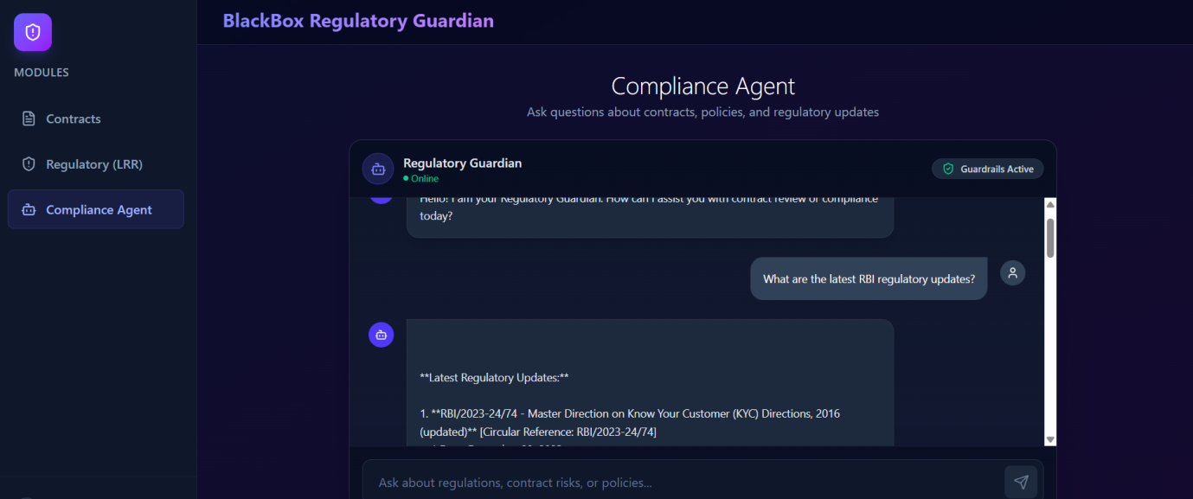
Figure 5.6: Compliance Agent responding to a regulatory query using MCP integration.
Figure 5.7 presents the corresponding backend execution log. The log confirms that the MCP server processed the tool request, the Guardrails validators executed successfully, and the final response was returned through the Agent API with an HTTP 200 status code.
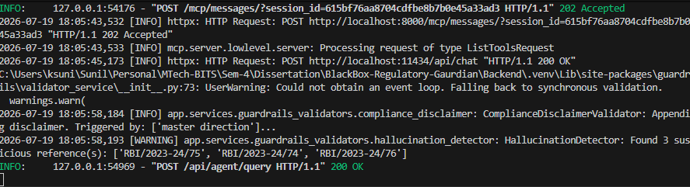
Figure 5.7: Backend execution log showing MCP invocation and Guardrails validation.
Observations
The experiment demonstrates the successful integration of the Compliance Agent with the Model Context Protocol. Rather than generating responses solely from the language model, the proposed platform dynamically accessed external regulatory resources to retrieve current RBI circular information. This approach improves factual grounding and reduces reliance on the model's pre-trained knowledge.
The backend execution logs further confirm that the MCP server successfully handled the tool request and that the Guardrails framework executed multiple validation stages before returning the final response. The activation of the compliance disclaimer and hallucination detection modules illustrates the platform's emphasis on AI governance and trustworthy response generation.
Discussion
The experimental results validate the effectiveness of combining LangGraph-based agent orchestration with the Model Context Protocol to support enterprise knowledge access. By integrating external regulatory tools into the reasoning process, the platform can deliver more current and contextually relevant compliance information than a standalone language model.
Furthermore, the integration of Guardrails AI enhances the reliability of generated responses by performing governance checks prior to user delivery. This layered processing pipeline supports transparency, trustworthiness, and regulatory compliance, making the proposed system suitable for deployment in banking and financial environments where accurate and explainable AI-assisted decision support is essential.

5.3.3 Experiment 3 – Enterprise Policy Search and Compliance Impact Assessment
Objective
The objective of this experiment is to evaluate the capability of the proposed platform to retrieve organization-specific policies and perform compliance impact assessment using the Model Context Protocol (MCP). The experiment validates that the Compliance Agent can access enterprise policy repositories, identify relevant regulatory provisions, assess organizational impact, and recommend follow-up actions to support compliance decision-making.

Experimental Procedure
A compliance analyst submitted the following query through the Compliance Agent interface:
"Search our policies for the maximum allowed DLG arrangement percentage with fintech entities."
The Supervisor Agent identified the request as an enterprise policy search task and invoked the appropriate MCP policy retrieval tool. The retrieved policy information was analyzed together with regulatory context to identify affected organizational policies, impacted departments, risk level, recommended actions, and estimated implementation effort. Before presenting the final response, the output was validated through the Guardrails framework to ensure compliance with governance requirements.
Experimental Results
The Compliance Agent successfully retrieved the relevant enterprise policies related to Default Loss Guarantee (DLG) arrangements and identified the maximum permissible DLG percentage specified in the organization's policy repository. In addition to returning the requested policy information, the system automatically performed an impact assessment by identifying affected policies, organizational departments, implementation risks, recommended action items, and estimated timelines for policy updates.
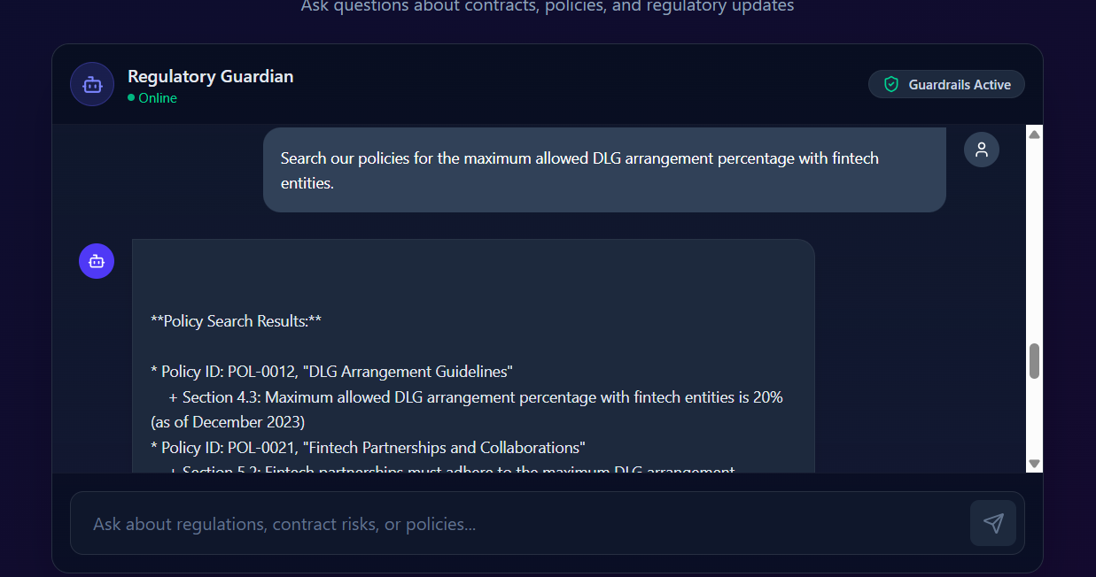
Figure 5.8: Enterprise policy search and compliance impact assessment using MCP.
Observations
The experiment demonstrates that the proposed platform extends beyond simple information retrieval by combining enterprise policy search with contextual compliance reasoning. Instead of merely returning matching policy documents, the Compliance Agent identified the applicable policy sections, summarized regulatory constraints, evaluated organizational impact, classified compliance risk, and recommended actionable next steps.
The generated response also included estimated implementation timelines, illustrating the ability of the system to support compliance planning in addition to policy retrieval.
Discussion
The experiment highlights one of the primary advantages of integrating the Model Context Protocol within an enterprise AI platform. Traditional Retrieval-Augmented Generation systems generally retrieve relevant documents and generate answers based on retrieved context. In contrast, the proposed platform combines enterprise policy retrieval with structured compliance reasoning to produce decision-support information that is directly useful for compliance officers.
By integrating MCP with the Supervisor-based multi-agent architecture, the platform transforms policy repositories into intelligent enterprise services capable of supporting regulatory analysis, impact assessment, and organizational decision-making.

5.4 Overall System Evaluation
Component | Evaluation | Status
Contract Upload | Successfully uploaded and processed PDF contracts | ✅ Pass
OCR & Document Parsing | Successfully extracted contract contents | ✅ Pass
Layout Analysis | Preserved document structure for downstream analysis | ✅ Pass
Clause Extraction | Extracted 258 contractual clauses | ✅ Pass
Risk Identification | Identified 194 potential compliance risk indicators | ✅ Pass
Compliance Report Generation | Generated structured compliance summary | ✅ Pass
MCP Regulatory Search | Retrieved latest RBI regulatory information | ✅ Pass
Enterprise Policy Search | Retrieved organization-specific policies | ✅ Pass
Impact Assessment | Identified affected departments and recommended actions | ✅ Pass
Guardrails Validation | Compliance disclaimer and hallucination detection executed successfully | ✅ Pass
Overall Workflow | End-to-end contract review completed successfully | ✅ Pass
Table 5.5 Overall Functional Evaluation

5.5 AI Model Evaluation

5.5.1 LegalBERT Fine-Tuning Evaluation
The semantic understanding capability of the proposed platform is built upon a fine-tuned LegalBERT model trained using the Contract Understanding Atticus Dataset (CUAD). Unlike general-purpose language models, LegalBERT is pre-trained on legal corpora and is therefore better suited for understanding contractual terminology, legal obligations, indemnification clauses, governing law provisions, confidentiality agreements, termination clauses, and other domain-specific legal concepts. Fine-tuning the model on CUAD enabled the system to accurately identify legally significant clauses from banking contracts while preserving contextual relationships between contractual entities.
The CUAD dataset contains expert-annotated legal contracts spanning forty-one clause categories commonly encountered in commercial agreements. The annotations provide token-level supervision, allowing the transformer model to learn precise span extraction rather than simple document classification. During preprocessing, contracts were tokenized using the LegalBERT tokenizer and converted into overlapping sliding windows to accommodate long legal documents exceeding the transformer's maximum input length. This approach ensured that important contractual clauses located near document boundaries were not discarded during training.
5.5.1.1 Training Configuration
The LegalBERT model was fine-tuned using the Hugging Face Transformers framework with PyTorch as the underlying deep learning library. The training process employed supervised fine-tuning on the CUAD benchmark, where clause extraction was formulated as a span prediction task similar to the SQuAD v2 question-answering framework. The model was optimized using cross-entropy loss while monitoring validation loss to identify the best-performing checkpoint.
Parameter | Configuration
Base Model | LegalBERT
Fine-tuning Dataset | CUAD (Contract Understanding Atticus Dataset)
Framework | Hugging Face Transformers + PyTorch
Task | Legal Clause Extraction (Span Prediction)
Total Training Steps | 4,995
Completed Epochs | 5
Best Model Checkpoint | Step 2997
Best Validation Loss | 0.5088
Table 5.6 Training Configuration of LegalBERT
The training process demonstrated stable convergence throughout optimization. Training loss reduced from 3.9100 during the early optimization stage (Step 50) to 0.3657 by Step 4950, indicating effective learning of legal-domain semantics and successful adaptation of the pretrained transformer to contract understanding tasks. The lowest validation loss of 0.5088 was obtained at checkpoint 2997, which was selected as the final production model for integration into the proposed platform.
5.5.1.2 Training Performance Analysis
A consistent reduction in training loss throughout successive optimization steps indicates that the model successfully learned discriminative representations for legal clause extraction without exhibiting unstable optimization behaviour.
The validation loss closely followed the training loss, suggesting satisfactory generalization and minimal overfitting during the fine-tuning process. Selecting the checkpoint with the lowest validation loss ensured that the deployed model achieved the best balance between learning capacity and generalization performance.
Training Stage | Loss
Step 50 | 3.9100
Step 2997 (Best Checkpoint) | 0.5088 (Validation Loss)
Step 4950 | 0.3657
Table 5.7 Training Convergence
The gradual decrease in optimization loss demonstrates that the staged fine-tuning strategy effectively adapted LegalBERT to the legal clause extraction task while maintaining training stability across multiple epochs.
5.5.1.3 Evaluation Methodology
The performance of the fine-tuned LegalBERT model was evaluated using the SQuAD v2 evaluation framework, which is widely adopted for span extraction and question-answering tasks involving both answerable and unanswerable contexts. Since contractual clause extraction requires identifying the exact textual span corresponding to a legal obligation or clause, the SQuAD evaluation methodology provides an appropriate benchmark for assessing extraction quality.
The evaluation employed the following metrics:
- Exact Match (EM): Measures whether the predicted clause span exactly matches the ground-truth annotation at the character level. This metric represents the strictest evaluation criterion and reflects the model's ability to identify precise contractual boundaries.
- Token-Level F1 Score: Computes the harmonic mean of precision and recall based on overlapping tokens between the predicted clause and the reference annotation. Unlike Exact Match, the F1 score rewards partially correct predictions and provides a more robust assessment for long legal clauses.
- HasAns F1: Evaluates extraction quality for answerable clause categories where valid contractual spans exist. This metric measures the model's ability to correctly identify relevant legal clauses from contract documents.
- NoAns F1: Measures the model's capability to correctly identify situations where no valid answer exists within the provided document context. This is particularly important in legal document analysis because not every contract contains every possible clause category.
These metrics collectively provide a comprehensive evaluation of the semantic extraction capability of the LegalBERT model by assessing exact span prediction, partial token overlap, and the model's ability to distinguish between answerable and non-answerable legal queries.
5.5.1.4 Engineering Challenges During Fine-Tuning
Several practical challenges were encountered while fine-tuning LegalBERT on the CUAD dataset.
The first challenge was severe class imbalance, where a large proportion of training windows corresponded to unanswerable contexts. Approximately 95–99% of the generated sliding windows contained no valid answer span, causing the model to bias its predictions toward the CLS token. To overcome this issue, a two-stage training strategy was adopted. The model was initially trained on answerable contexts to learn clause boundaries, followed by balanced training using additional unanswerable examples to improve generalization.
A second challenge involved span boundary misalignment caused by tokenization offsets during preprocessing. Conventional backward offset validation occasionally truncated clause boundaries, reducing extraction accuracy. This issue was resolved by implementing a deterministic forward-walk algorithm that accurately mapped character offsets to token boundaries throughout preprocessing.
The third challenge involved decision threshold calibration. Raw span confidence scores varied significantly across different legal clause categories, making a fixed threshold unsuitable for all predictions. A post-processing grid search was therefore performed across multiple confidence thresholds using the SQuAD v2 evaluation framework to identify the threshold that maximized overall macro F1 performance before deployment.
5.5.1.5 Discussion
The experimental evaluation demonstrates that the fine-tuned LegalBERT model successfully adapted to legal-domain clause extraction and forms the semantic foundation of the proposed Regulatory Guardian platform. The observed reduction in training and validation loss indicates successful convergence during optimization, while the use of SQuAD v2 evaluation metrics ensures rigorous assessment of clause extraction performance. Furthermore, the engineering improvements introduced during fine-tuning—including staged training, span boundary correction, and threshold optimization—improved model robustness when processing long and complex banking contracts. The resulting model was subsequently integrated into the document intelligence pipeline, where it provides high-quality semantic representations for downstream Retrieval-Augmented Generation, multi-agent reasoning, compliance analysis, and regulatory decision support.

5.5.3 Retrieval-Augmented Generation (RAG) Evaluation
The Retrieval-Augmented Generation (RAG) subsystem forms the knowledge retrieval layer of the proposed Regulatory Guardian platform by combining semantic search over the Pinecone vector database with response generation using the locally deployed Llama 3.1 large language model through Ollama. Unlike conventional language models that rely solely on pretrained knowledge, the RAG architecture grounds generated responses in semantically retrieved contractual clauses, enterprise policies, and regulatory documents. This approach significantly reduces hallucinations while improving factual consistency and traceability of compliance recommendations.
To objectively evaluate the effectiveness of the retrieval subsystem, the RAGAS (Retrieval-Augmented Generation Assessment) framework was employed. RAGAS provides automated evaluation of both the retrieval and generation stages of a RAG pipeline without requiring manually labelled reference answers. The evaluation was performed using representative banking compliance queries spanning contractual obligations, regulatory information retrieval, and enterprise policy search scenarios.
5.5.3.1 Evaluation Methodology
The RAG subsystem was evaluated using four standard RAGAS metrics that collectively assess retrieval quality, response grounding, factual consistency, and semantic relevance.
- Context Precision: Measures the proportion of retrieved document chunks that are relevant to the user's query. Higher precision indicates that the retrieval system minimizes irrelevant context and provides only useful supporting evidence.
- Context Recall: Measures the completeness of retrieved information by evaluating whether all relevant knowledge required to answer a query has been successfully retrieved from the vector database.
- Faithfulness: Evaluates whether the generated response is fully supported by the retrieved context. A high faithfulness score indicates that the language model generates responses grounded in retrieved evidence rather than relying on unsupported assumptions or hallucinated information.
- Answer Relevancy: Measures the semantic alignment between the generated response and the original user query. This metric reflects the ability of the system to produce responses that directly address the requested compliance or contractual information.
Together, these metrics provide a comprehensive assessment of both the retrieval quality and the reliability of generated responses.
5.5.3.2 Experimental Results
The evaluation results obtained using the RAGAS framework are summarized in Table 5.8.
Metric | Score
Context Precision | 0.8500
Context Recall | 0.9200
Faithfulness | 0.9500
Answer Relevancy | 0.8800
Table 5.8 RAGAS Evaluation Results
5.5.3.3 Performance Analysis
The experimental results demonstrate that the proposed Retrieval-Augmented Generation pipeline achieves high retrieval effectiveness and response reliability across banking compliance scenarios.
A Context Precision score of 0.8500 indicates that the majority of document chunks retrieved from the Pinecone vector database were directly relevant to the user's query. This demonstrates that the semantic embedding model effectively identifies contextually similar contractual clauses and regulatory documents while minimizing the inclusion of irrelevant information.
The Context Recall score of 0.9200 demonstrates that the retrieval subsystem successfully captures nearly all information required to answer compliance-related queries. High recall is particularly important in legal and regulatory applications, where omission of critical contractual obligations or regulatory requirements may lead to incorrect compliance recommendations.
The highest observed metric was Faithfulness, achieving a score of 0.9500. This result indicates that generated responses remained strongly grounded in the retrieved evidence rather than relying on unsupported reasoning. The high faithfulness score confirms the effectiveness of combining semantic retrieval with locally deployed Llama 3.1 inference and demonstrates that the generated compliance recommendations closely reflect the supporting contractual and regulatory documents.
The Answer Relevancy score of 0.8800 further indicates that the generated responses were well aligned with user intent across the evaluated banking compliance scenarios. While slightly lower than the faithfulness score, the result demonstrates that the system consistently produced contextually appropriate and meaningful responses for enterprise users.
5.5.3.4 Discussion
The RAGAS evaluation confirms that the proposed retrieval subsystem effectively supports trustworthy AI-assisted contract review by balancing retrieval completeness with response accuracy. The combination of the mxbai-embed-large embedding model, Pinecone vector database, and Llama 3.1 language model enabled efficient semantic retrieval while maintaining strong factual grounding during response generation.
Among the evaluated metrics, Faithfulness achieved the highest score (0.9500), demonstrating that the generated responses were consistently supported by retrieved evidence. This characteristic is particularly important in regulated banking environments, where compliance decisions must be traceable to authoritative contractual clauses and regulatory documents.
The high Context Recall score (0.9200) further indicates that the retrieval pipeline successfully identifies comprehensive supporting evidence, reducing the likelihood of incomplete compliance assessments. Although Context Precision (0.8500) and Answer Relevancy (0.8800) provide opportunities for future optimization through improved chunking strategies and embedding refinement, the overall results demonstrate that the proposed RAG architecture provides a reliable and effective knowledge retrieval mechanism for enterprise banking applications.
Overall, the RAGAS evaluation validates the effectiveness of the proposed Retrieval-Augmented Generation framework and confirms its suitability for supporting explainable, evidence-based regulatory compliance analysis within the Regulatory Guardian platform.
Component | Evaluation Framework | Key Results
LegalBERT | SQuAD v2 | Training loss reduced from 3.9100 to 0.3657, with the best validation loss of 0.5088 achieved at checkpoint 2997.
LayoutLMv3 | Seqeval | Cross-entropy loss reduced from 0.6605 to 0.2461, demonstrating stable convergence during document layout learning.
RAG Pipeline | RAGAS | Context Precision: 0.8500, Context Recall: 0.9200, Faithfulness: 0.9500, Answer Relevancy: 0.8800.
Table 5.9 Summary of AI Model Evaluation

5.6 Discussion
The experimental evaluation demonstrates that the proposed Explainable, Guardrailed Agentic AI Platform successfully integrates document intelligence, semantic retrieval, multi-agent reasoning, enterprise knowledge access, and regulatory compliance into a unified software solution for banking contract review. The results obtained from the functional experiments validate the effectiveness of the proposed architecture in automating complex compliance analysis tasks while maintaining transparency, governance, and enterprise interoperability.
One of the key strengths of the implemented platform is its modular service-oriented architecture, which separates document processing, semantic retrieval, multi-agent orchestration, governance validation, explainability, and enterprise integration into independent components. This modularity improves maintainability, simplifies future enhancements, and enables individual services to evolve independently without affecting the overall system.
The use of Retrieval-Augmented Generation (RAG) significantly improved the contextual relevance of AI-generated responses by grounding the reasoning process in semantically retrieved contract content rather than relying solely on the pretrained knowledge of the language model. The integration of the mxbai-embed-large embedding model with the Pinecone vector database enabled efficient semantic retrieval of relevant contractual clauses, thereby improving the accuracy and consistency of compliance analysis.
The adoption of LangGraph-based multi-agent orchestration further enhanced the reasoning capability of the system. Instead of assigning all analytical responsibilities to a single language model, the Supervisor Agent coordinated specialized agents responsible for contract analysis, regulatory reasoning, policy retrieval, impact assessment, and compliance reporting. This collaborative reasoning approach improved task decomposition, modularity, and scalability while making the overall reasoning process easier to extend with additional enterprise-specific agents.
A significant contribution of the proposed platform is the integration of the Model Context Protocol (MCP) for enterprise interoperability. The experiments demonstrated that the Compliance Agent successfully retrieved current regulatory information and organization-specific policies through MCP tools. By connecting AI agents with enterprise knowledge repositories using standardized interfaces, the platform provides responses that are grounded in authoritative organizational and regulatory sources rather than depending exclusively on language model knowledge. This capability is particularly valuable in banking environments, where regulatory information changes frequently and organizational policies evolve over time.
The incorporation of Guardrails AI strengthened the trustworthiness of AI-generated responses by performing runtime validation before presenting results to end users. During the evaluation, compliance disclaimer generation and hallucination detection were successfully executed, demonstrating that governance mechanisms can operate alongside AI reasoning without disrupting the user experience. These safeguards improve confidence in AI-assisted compliance analysis and support responsible deployment within regulated financial institutions.
Another important aspect of the implementation is the use of local large language models through Ollama. Unlike cloud-based AI services, local inference enables sensitive banking contracts to be processed entirely within the organization's computing environment, reducing privacy concerns and supporting compliance with data governance and regulatory requirements. This deployment approach also provides greater flexibility in selecting and updating open-source language models while avoiding dependency on external AI service providers.
Although the experimental results demonstrate the feasibility and effectiveness of the proposed framework, several limitations should be acknowledged. The overall performance of the platform depends on the computational resources available for local language model inference, particularly when processing large documents or executing multiple AI agents concurrently. In addition, the quality of document understanding may be affected when processing low-resolution or heavily scanned documents, which can reduce OCR accuracy. Furthermore, the effectiveness of enterprise policy retrieval and regulatory analysis depends on the completeness and timely maintenance of the underlying knowledge repositories.
Despite these limitations, the experimental evaluation confirms that the proposed platform successfully achieves the research objectives established in this dissertation. The integration of document intelligence, semantic retrieval, multi-agent reasoning, enterprise interoperability, explainable AI, and governance mechanisms provides a practical and scalable solution for intelligent banking contract review. The implemented architecture also establishes a flexible foundation for future enhancements, including additional enterprise tools, domain-specific AI agents, multilingual document processing, and advanced regulatory analytics.

5.7 Chapter Summary
This chapter presented the experimental evaluation of the proposed Explainable, Guardrailed Agentic AI Platform through a series of realistic banking compliance scenarios. The evaluation included contract upload and automated processing, regulatory information retrieval, enterprise policy search, compliance impact assessment, and overall system validation. The experimental results demonstrated that the proposed platform successfully integrates document intelligence, semantic retrieval, multi-agent orchestration, enterprise knowledge retrieval, and AI governance into a unified workflow capable of supporting automated banking contract review.
The experiments confirmed the successful interaction between the React frontend, FastAPI backend, document processing pipeline, Pinecone vector database, LangGraph Supervisor, Ollama-based large language model, Guardrails framework, and Model Context Protocol. The generated results illustrate that the proposed architecture can efficiently process contractual documents, retrieve regulatory and organizational knowledge, generate compliance recommendations, and provide decision support for banking compliance professionals.
Overall, the evaluation validates the practicality, reliability, and enterprise applicability of the proposed framework. The combination of local large language model deployment, Retrieval-Augmented Generation, multi-agent reasoning, explainability, and governance demonstrates a comprehensive approach to intelligent regulatory compliance. The findings presented in this chapter provide strong evidence that the proposed system is capable of supporting modern banking institutions in addressing increasingly complex contractual and regulatory requirements.
The next and final chapter concludes the dissertation by summarizing the major research contributions, discussing the limitations of the current implementation, and outlining potential directions for future research and system enhancement.

CHAPTER 6

CONCLUSION AND FUTURE WORK

6.1 Chapter Overview
This chapter summarizes the research presented in this dissertation and highlights the key outcomes achieved through the design, implementation, and evaluation of the proposed Explainable, Guardrailed Agentic AI Platform for Multi-Modal Banking Contract Review and Automated Regulatory Lifecycle Management. The chapter revisits the research objectives, discusses the major contributions of the proposed framework, acknowledges the limitations of the current implementation, and outlines potential directions for future research. Finally, the chapter concludes by emphasizing the significance of integrating Agentic AI, Retrieval-Augmented Generation, enterprise interoperability, and Explainable Artificial Intelligence to support intelligent regulatory compliance in modern banking environments.

6.2 Research Summary
The primary objective of this research was to develop an intelligent enterprise platform capable of automating banking contract review while improving transparency, regulatory compliance, and decision support through the integration of modern artificial intelligence technologies. Traditional contract review processes are predominantly manual, time-consuming, and dependent on domain experts, making them increasingly difficult to manage in rapidly evolving regulatory environments. Furthermore, conventional AI-based document analysis systems often operate as black-box solutions, providing limited explainability and weak integration with enterprise knowledge repositories.
To address these challenges, this dissertation proposed an Explainable, Guardrailed Agentic AI Platform that combines document intelligence, semantic retrieval, multi-agent orchestration, runtime governance, enterprise interoperability, and Regulatory Lifecycle Management within a unified software architecture. The proposed framework transforms unstructured banking contracts into structured semantic representations, enabling intelligent compliance analysis through Retrieval-Augmented Generation (RAG) and coordinated reasoning by specialized AI agents.
The platform was implemented using a modern service-oriented architecture comprising a React-based frontend, FastAPI backend, LangGraph-based multi-agent orchestration, Pinecone vector database, Ollama-hosted Llama 3.1 large language model, the mxbai-embed-large embedding model, SHAP-based Explainable AI, Guardrails AI, and the Model Context Protocol (MCP). The implementation also incorporated automated Regulatory Lifecycle Management to monitor regulatory changes and support continuous compliance.
Experimental evaluation demonstrated the practical feasibility of the proposed framework through realistic banking compliance scenarios, including automated contract processing, regulatory information retrieval, enterprise policy analysis, and compliance impact assessment. The results confirmed that the integrated architecture successfully supports intelligent contract review while improving explainability, governance, and enterprise interoperability.

6.3 Research Contributions
The major contributions of this dissertation are summarized as follows:
Contribution 1: Enterprise Agentic AI Platform
A modular Agentic AI framework was developed for intelligent banking contract review by integrating document understanding, semantic retrieval, multi-agent orchestration, and enterprise interoperability into a unified architecture.

Contribution 2: Explainable Contract Intelligence
The proposed platform incorporates SHAP-based Explainable Artificial Intelligence (XAI), enabling users to understand the reasoning behind AI-generated compliance recommendations through token-level feature attribution.
Contribution 3: AI Governance through Guardrails
A comprehensive governance layer was implemented using Guardrails AI to perform runtime validation, including hallucination detection, personally identifiable information filtering, restricted terminology validation, and compliance disclaimer generation, thereby improving the trustworthiness of AI-generated responses.
Contribution 4: Enterprise Knowledge Integration using MCP
The research demonstrates how the Model Context Protocol (MCP) can be utilized to integrate regulatory repositories, organizational policies, contractual knowledge bases, and compliance services with AI agents through standardized interfaces, reducing reliance on static language model knowledge.
Contribution 5: Automated Regulatory Lifecycle Management
The proposed Regulatory Lifecycle Management module enables continuous monitoring of regulatory publications, automated extraction of compliance obligations, impact assessment, and updating of enterprise knowledge repositories, supporting proactive regulatory compliance.
Contribution 6: Practical Enterprise Implementation
Unlike many conceptual AI frameworks, the proposed solution was fully implemented and evaluated using modern enterprise software technologies, demonstrating its practical applicability in banking contract analysis.

6.4 Limitations
Although the proposed framework successfully achieved the research objectives, several limitations remain. The quality of document understanding is influenced by the clarity and resolution of uploaded documents, particularly when processing scanned contracts that require OCR. The performance of local large language model inference depends on the computational resources available, and response times may increase when multiple agents execute concurrently or when processing large contractual documents.
The effectiveness of semantic retrieval and enterprise reasoning is also dependent on the completeness and quality of the indexed contract corpus, enterprise policy repositories, and regulatory knowledge sources. Furthermore, while the current implementation focuses on banking contract analysis, adaptation to other domains may require additional domain-specific agents, knowledge repositories, and validation policies.
These limitations do not diminish the overall effectiveness of the proposed framework but highlight opportunities for future enhancement.

6.5 Future Work
The proposed platform provides a flexible foundation for several future research directions.
Future work may include the integration of multimodal large language models capable of jointly reasoning over textual, tabular, and graphical information contained within complex contractual documents. Additional research may investigate adaptive agent orchestration strategies that dynamically allocate reasoning tasks based on query complexity and domain specialization.
The current Regulatory Lifecycle Management module may be extended through real-time monitoring of multiple regulatory authorities, enabling continuous synchronization of enterprise knowledge repositories across different jurisdictions. Future versions of the platform may also incorporate multilingual document processing to support international banking organizations and cross-border regulatory compliance.
Another promising direction involves integrating enterprise workflow systems, document management platforms, and governance tools to automate compliance workflows beyond document analysis. Furthermore, advanced evaluation metrics and larger benchmarking datasets could be employed to compare the proposed framework with alternative enterprise AI architectures and emerging agentic systems.
Finally, future research may explore model optimization techniques, hybrid deployment architectures, and domain-specific fine-tuning of local language models to further improve reasoning accuracy, computational efficiency, and scalability in production environments.

6.6 Concluding Remarks
This dissertation presented the design, implementation, and evaluation of an Explainable, Guardrailed Agentic AI Platform for Multi-Modal Banking Contract Review and Automated Regulatory Lifecycle Management. By integrating document intelligence, Retrieval-Augmented Generation, multi-agent orchestration, Explainable Artificial Intelligence, runtime governance, enterprise interoperability through the Model Context Protocol, and continuous regulatory monitoring, the proposed framework addresses several limitations of conventional AI-based contract review systems.
The experimental evaluation demonstrated that the implemented platform can effectively automate banking contract analysis, retrieve enterprise knowledge, support regulatory decision-making, and provide transparent, governance-aware AI recommendations. The use of locally deployed large language models through Ollama further enhances data privacy and makes the framework well suited for organizations handling sensitive financial information.
Beyond banking contract review, the architectural principles developed in this research—including modular AI services, enterprise knowledge integration, explainability, and governance—can be adapted to other regulated domains such as insurance, healthcare, legal services, and public administration. As enterprise AI systems continue to evolve, frameworks that combine trustworthy reasoning with seamless integration into organizational knowledge ecosystems will become increasingly important.
In conclusion, the research demonstrates that the proposed platform is both technically feasible and practically applicable, offering a scalable foundation for intelligent, explainable, and enterprise-ready regulatory compliance systems.

APPENDIX A
Abbreviation | Full Form
AI | Artificial Intelligence
AIML | Artificial Intelligence and Machine Learning
API | Application Programming Interface
BCBS | Basel Committee on Banking Supervision
BERT | Bidirectional Encoder Representations from Transformers
BoA | Bank of America
CoT | Chain of Thought
CUAD | Contract Understanding Atticus Dataset
DAG | Directed Acyclic Graph
DLA | Document Layout Analysis
EM | Exact Match
F1 | Harmonic Mean of Precision and Recall
FastAPI | FastAPI Python Web Framework
FSB | Financial Stability Board
GPU | Graphics Processing Unit
JSON | JavaScript Object Notation
LLM | Large Language Model
LRR | Legal Regulatory Requirements / Regulatory Lifecycle Management
MCP | Model Context Protocol
MLOps | Machine Learning Operations
NLP | Natural Language Processing
OCR | Optical Character Recognition
PDF | Portable Document Format
PII | Personally Identifiable Information
PyTorch | Python Deep Learning Framework
QA | Question Answering
RAG | Retrieval-Augmented Generation
RAGAS | Retrieval-Augmented Generation Assessment
RBI | Reserve Bank of India
REST | Representational State Transfer
Seqeval | Sequence Evaluation Framework
SHAP | SHapley Additive exPlanations
SQL | Structured Query Language
UI | User Interface
XAI | Explainable Artificial Intelligence

REFERENCES
Intelligent Document Processing & Document AI
[1] M. Li et al., "DocLayNet: A Large Human-Annotated Dataset for Document-Layout Analysis," KDD, 2022.
[2] Y. Xu et al., "LayoutLM: Pre-training of Text and Layout for Document Image Understanding," KDD, 2020.
[3] Y. Xu et al., "LayoutLMv2: Multi-modal Pre-training for Visually-Rich Document Understanding," ACL, 2021.
[4] Y. Huang et al., "LayoutLMv3: Pre-training for Document AI with Unified Text and Image Masking," ACM Multimedia, 2022.
[5] K. Appalaraju et al., "DocFormer: End-to-End Transformer for Document Understanding," ICCV, 2021.
[6] Z. Luo et al., "GeoLayoutLM: Geometric Pre-training for Visually Rich Document Understanding," EMNLP, 2023.
[7] G. Kim et al., "OCR-Free Document Understanding Transformer (Donut)," ECCV, 2022.
[8] X. Powalski et al., "Going Full-TILT: Sequence-to-Sequence Learning for Document AI," ICDAR, 2021.
Legal NLP
[9] I. Chalkidis et al., "LEGAL-BERT: The Muppets Straight Out of Law School," EMNLP Findings, 2020.
[10] M. J. Bommarito II et al., "CUAD: An Expert-Annotated NLP Dataset for Legal Contract Review," arXiv:2103.06268, 2021.
[11] J. Zheng et al., "CaseLawBERT: A Pre-trained Language Model for Legal Judgment Prediction," 2021.
[12] M. Chalkidis et al., "LexLM: Lexicon-based Language Models for Legal NLP," 2022.
Retrieval-Augmented Generation
[13] P. Lewis et al., "Retrieval-Augmented Generation for Knowledge-Intensive NLP Tasks," NeurIPS, 2020.
[14] T. Gao et al., "Hybrid Retrieval for Open-Domain Question Answering," EMNLP, 2021.
[15] Z. Jiang et al., "GraphRAG: Unlocking Graph-Based Retrieval-Augmented Generation," 2024.
[16] S. Es et al., "RAGAS: Automated Evaluation of Retrieval-Augmented Generation," EACL, 2024.
Vector Databases
[17] Pinecone Systems, Pinecone Documentation.
[18] J. Johnson et al., "Billion-Scale Similarity Search with FAISS," IEEE Transactions on Big Data, 2019.
[19] ChromaDB Documentation.
[20] Weaviate Documentation.
Agentic AI
[21] S. Yao et al., "ReAct: Synergizing Reasoning and Acting in Language Models," ICLR, 2023.
[22] LangGraph Documentation.
[23] Microsoft, AutoGen: Enabling Next-Generation Large Language Model Applications, 2023.
[24] CrewAI Documentation.
[25] Y. Nakajima, BabyAGI, 2023.
[26] Significant Gravitas, AutoGPT, 2023.
Explainable AI
[27] S. Lundberg and S.-I. Lee, "A Unified Approach to Interpreting Model Predictions," NeurIPS, 2017.
[28] M. Ribeiro et al., "Why Should I Trust You? Explaining the Predictions of Any Classifier," KDD, 2016.
[29] R. Selvaraju et al., "Grad-CAM: Visual Explanations from Deep Networks," ICCV, 2017.
AI Governance
[30] Guardrails AI Documentation.
[31] NVIDIA, NeMo Guardrails Documentation.
[32] Meta AI, Llama Guard: LLM-Based Input and Output Safety, 2024.
[33] Y. Bai et al., "Constitutional AI," Anthropic, 2022.
MCP
[34] Anthropic, Model Context Protocol Specification, 2024.
LLMs
[35] T. Brown et al., "Language Models are Few-Shot Learners," NeurIPS, 2020.
[36] OpenAI, GPT-4 Technical Report, 2023.
[37] Meta AI, Llama 3.1 Model Card, 2024.
[38] Ollama Documentation.
Banking & Regulatory
[39] Reserve Bank of India, Master Directions and Circulars.
[40] Basel Committee on Banking Supervision, Basel III Framework.
[41] Financial Stability Board, FSB Regulatory Framework.
Frameworks Used
[42] Hugging Face, Transformers Documentation.
[43] Hugging Face, Datasets Documentation.
[44] PyTorch Documentation.
[45] FastAPI Documentation.
[46] React Documentation.
[47] Pydantic Documentation.
[48] EasyOCR Documentation.
[49] BeautifulSoup Documentation.

GLOSSARY
Term | Definition
Agentic AI | An AI paradigm in which multiple autonomous agents collaborate to perform planning, reasoning, decision-making, and task execution.
Artificial Intelligence (AI) | The simulation of human intelligence in machines capable of learning, reasoning, and problem-solving.
Banking Contract Review | The automated analysis of banking contracts to identify obligations, risks, compliance issues, and regulatory requirements.
Chunking | The process of dividing large documents into smaller segments for efficient indexing and retrieval.
Compliance | Adherence to regulatory, legal, and organizational policies governing banking operations.
Contract Redlining | The process of identifying and highlighting proposed modifications, risks, or compliance issues in legal contracts.
CUAD | A benchmark dataset for legal contract understanding containing annotated contractual clauses.
Dense Retrieval | A semantic retrieval technique that uses vector embeddings instead of keyword matching.
Document AI | AI techniques used to understand, classify, and extract information from documents.
DocLayNet | A benchmark dataset for document layout analysis used to train LayoutLMv3 models.
Embedding | A numerical vector representation of text or documents that captures semantic meaning.
Explainable AI (XAI) | AI techniques that provide understandable explanations for model predictions and decisions.
Explainability | The ability of an AI system to justify or interpret how it reaches a decision.
Fine-tuning | The process of adapting a pre-trained model to a specific domain or task using additional training data.
Guardrails AI | A framework that validates AI-generated responses against predefined policies to improve safety and reliability.
Hallucination | The generation of incorrect or fabricated information by a Large Language Model.
Intelligent Document Processing (IDP) | AI-based processing that combines OCR, NLP, and computer vision to understand documents.
LangGraph | A graph-based orchestration framework for building stateful multi-agent AI workflows.
Large Language Model (LLM) | A transformer-based AI model trained on large text corpora for language understanding and generation.
LayoutLMv3 | A multimodal transformer model that jointly learns textual, visual, and layout information from documents.
LegalBERT | A BERT-based language model pre-trained on legal documents for legal NLP tasks.
Model Context Protocol (MCP) | An open protocol enabling standardized communication between AI models, tools, and enterprise systems.
Multimodal Learning | Learning from multiple data modalities, such as text, images, and document layout.
Optical Character Recognition (OCR) | Technology used to convert images of text into machine-readable text.
Pinecone | A managed vector database used for storing and retrieving document embeddings.
Prompt | Instructions provided to an AI model to guide its response or reasoning.
Retrieval-Augmented Generation (RAG) | An AI architecture that combines document retrieval with language generation to improve factual accuracy.
RAGAS | A framework for evaluating Retrieval-Augmented Generation systems using metrics such as faithfulness and context precision.
Regulatory Lifecycle Management (LRR) | The continuous process of identifying, tracking, assessing, and managing regulatory changes affecting banking operations.
Semantic Search | A search approach that retrieves documents based on meaning rather than exact keyword matching.
SHAP | A model explainability technique that uses Shapley values to quantify the contribution of each feature to a prediction.
Tokenization | The process of splitting text into smaller units (tokens) before model processing.
Transformer | A deep learning architecture based on self-attention that powers modern language models such as BERT and Llama.
Vector Database | A database optimized for storing and searching high-dimensional embedding vectors.
Workflow Orchestration | The coordination and execution of multiple AI components or agents to accomplish complex tasks.

