**CC2**

**Code:**

package com.cc.Test;

import org.testng.annotations.Test;

import io.github.bonigarcia.wdm.WebDriverManager;

import org.testng.annotations.BeforeMethod;

import org.openqa.selenium.By;

import org.openqa.selenium.WebDriver;

import org.openqa.selenium.chrome.ChromeDriver;

import org.openqa.selenium.chrome.ChromeOptions;

import org.testng.Assert;

import org.testng.annotations.AfterMethod;

public class Yatra {

WebDriver driver;

*@Test*

public void partA() throws InterruptedException {

driver.get("https://www.yatra.com/");

driver.findElement(By.*xpath*("//*[@id=\"BE_flight_form_wrapper\"]/div[1]/div[1]/ul[1]/li[2]/a")).click();

driver.findElement(By.*id*("BE_flight_origin_city")).click();

Thread.*sleep*(2000);

driver.findElement(By.*xpath*("//*[@id=\"BE_flight_form_wrapper\"]/div[1]/div[2]/ul/li[1]/ul/li[1]/div/div/ul/div/div/div/li[4]")).click();

Thread.*sleep*(2000);

driver.findElement(By.*xpath*("//*[@id=\"BE_flight_form_wrapper\"]/div[1]/div[2]/ul/li[1]/ul/li[3]/div/div/ul/div/div/div/li[6]/div[1]/p[1]")).click();

driver.findElement(By.*id*("BE_flight_origin_date")).click();

Thread.*sleep*(2000);

driver.findElement(By.*id*("07/05/2023")).click();

Thread.*sleep*(1500);

driver.findElement(By.*id*("09/05/2023")).click();

Thread.*sleep*(1500);

driver.findElement(By.*xpath*("//*[@id=\"BE_flight_paxInfoBox\"]/span")).click();

Thread.*sleep*(1000);

driver.findElement(By.*xpath*("//*[@id=\"BE_flight_passengerBox\"]/div[1]/div[2]/div/div/span[2]")).click();

Thread.*sleep*(1000);

driver.findElement(By.*xpath*("//*[@id=\"special_student_offer\"]/a/i")).click();

Thread.*sleep*(3000);

driver.findElement(By.*xpath*("//*[@id=\"BE_flight_flsearch_btn\"]")).click();

String actual=driver.findElement(By.*xpath*("//*[@id=\"BE_flight_flsearch_btn\"]")).getText();

String expected="Access Denied";

Assert.*assertEquals*(actual,expected);

}

*@BeforeMethod*

public void beforeMethod() {

WebDriverManager.*chromedriver*().setup();

ChromeOptions co=new ChromeOptions();

co.addArguments("--remote-allow-origins=*");

driver = new ChromeDriver(co);

driver.manage().window().maximize();

}

*@AfterMethod*

public void afterMethod() {

// driver.close();

}

}

**CONSOLE:**

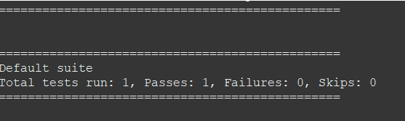

**TESTNG REPORT**

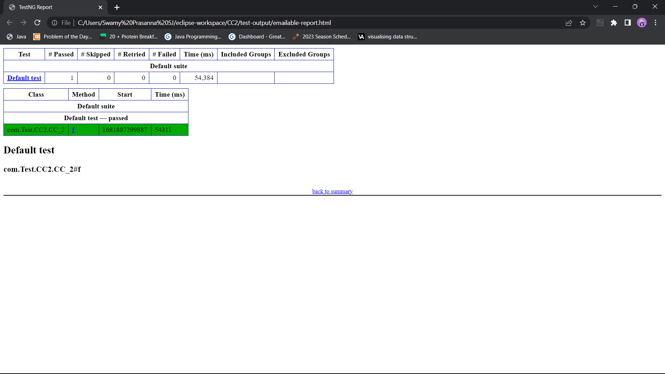

**ACCESS DENIED:**

