# DAY-5

#1

package com.Test.Testing.Day5;

import java.awt.Desktop.Action;

import java.util.List;

import org.openqa.selenium.By;

import org.openqa.selenium.WebDriver;

import org.openqa.selenium.WebElement;

import org.openqa.selenium.chrome.ChromeDriver;

import org.openqa.selenium.chrome.ChromeOptions;

import org.openqa.selenium.interactions.Actions;

import io.github.bonigarcia.wdm.WebDriverManager;

public class Day_5_1 {

public static void main( String[] args )throws InterruptedException{

ChromeOptions co=new ChromeOptions();

co.addArguments("--remote-allow-origins=*");

WebDriverManager.chromedriver().setup();

WebDriver d=new ChromeDriver(co);

d.get("https://demoqa.com/droppable/");

d.manage().window().maximize();

WebElement fromElement =d.findElement(By.xpath("//*[@id=\"draggable\"]") );

WebElement toElement = d.findElement(By.xpath("//*[@id=\"droppable\"]"));

Actions act=new Actions(d);

act.dragAndDropBy(fromElement,270, 70).build().perform();

d.close();

}

}

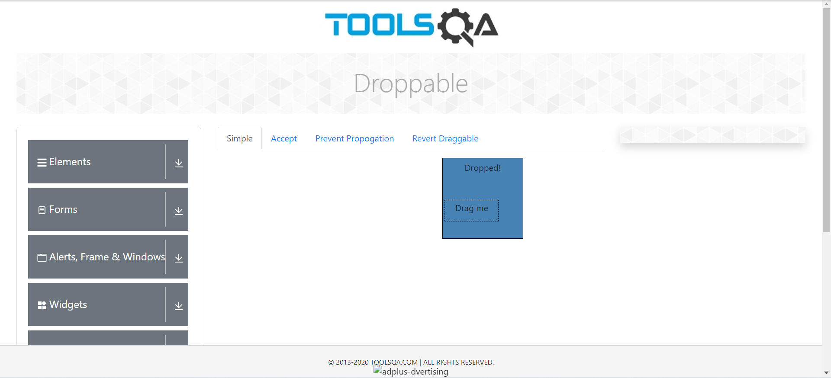

#2

**import** org.openqa.selenium.interactions.Actions;

**import** io.github.bonigarcia.wdm.WebDriverManager;

**public** **class** Day_5_2 {

**public** **static** **void** main(String[] args) {

WebDriverManager.*chromedriver*().setup();

ChromeOptions co=**new** ChromeOptions();

co.addArguments ("--remote-allow-origins=*");

WebDriver driver=**new** ChromeDriver (co);

//open link and maximize

driver.get("https://jqueryui.com/droppable/");

driver.manage().window().maximize();

driver.switchTo().frame (0);

WebElement drag=driver.findElement(By.*id*("draggable"));

WebElement drop=driver.findElement(By.*id*("droppable"));

Actions a=**new** Actions (driver);

a.dragAndDrop (drag, drop).build() .perform();

// **TODO** Auto-generated method stub

}

}

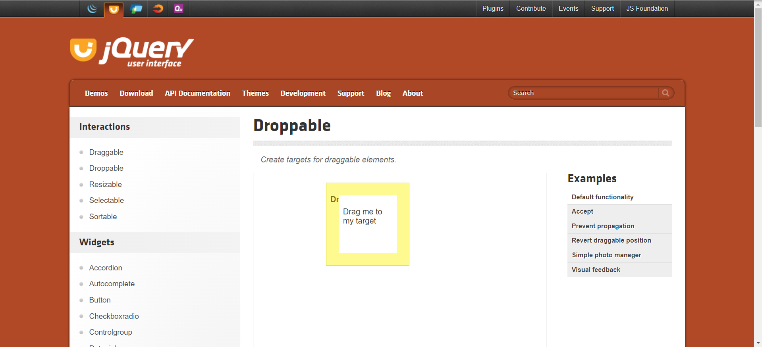

#3

**package** com.Test.Testing.Day5;

**import** java.lang.Thread;

**import** org.openqa.selenium.Alert;

**import** org.openqa.selenium.By;

**import** org.openqa.selenium.WebDriver;

**import** org.openqa.selenium.WebElement;

**import** org.openqa.selenium.chrome.ChromeDriver;

**import** org.openqa.selenium.chrome.ChromeOptions;

**import** io.github.bonigarcia.wdm.WebDriverManager;

**public** **class** Day_5_3 {

**public** **static** **void** main(String[] args) {

// **TODO** Auto-generated method stub

WebDriverManager.*chromedriver*().setup(); ChromeOptions co=**new** ChromeOptions();

co.addArguments ("--remote-allow-origins=*");

WebDriver driver=**new** ChromeDriver (co);

//open link and maximize

driver.get("https://demo.guru99.com/test/delete_customer.php");

WebElement txtBox1=driver.findElement(By.*name* ("cusid"));

txtBox1.sendKeys ("401");

WebElement submitBtn=driver.findElement(By.*name* ("submit"));

submitBtn.click();

Alert alertl=driver.switchTo() .alert();

**try** {

Thread.*sleep*(3000);

} **catch** (InterruptedException e) {

e.printStackTrace();

}

alertl.dismiss();

txtBox1.clear();

txtBox1.sendKeys("402");

submitBtn.click();

Alert alert2=driver.switchTo() .alert();

alert2.accept();

//to get value from alert and print in console

Alert alert3=driver.switchTo() .alert();

String txt=alert3.getText();

alert3.accept();

System.***out***.println(txt);

}

}

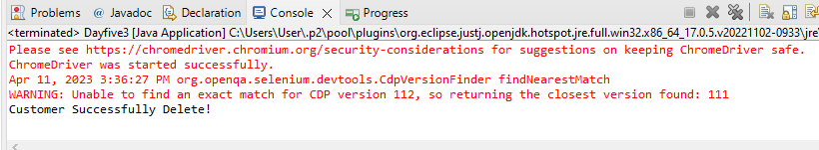

#4

**package** com.Test.Testing.Day5;

**import** org.openqa.selenium.By;

**import** org.openqa.selenium.WebDriver;

**import** org.openqa.selenium.chrome.ChromeDriver;

**import** org.openqa.selenium.chrome.ChromeOptions;

**import** io.github.bonigarcia.wdm.WebDriverManager;

**public** **class** Day_5_4 {

**public** **static** **void** main(String[] args)**throws** InterruptedException {

WebDriverManager.*chromedriver*().setup();

ChromeOptions co=**new** ChromeOptions();

co.addArguments ("--remote-allow-origins=*");

WebDriver d=**new** ChromeDriver (co);

d.get("https://www.abhibus.com/bus-ticket-booking");

d.manage().window().maximize();

d.findElement(By.*xpath*("//*[@id=\"source\"]")).sendKeys("Coimbatore");

d.findElement(By.*xpath*("//*[@id=\"destination\"]")).sendKeys("Chennai");

Thread.*sleep*(5000);

d.findElement(By.*xpath*("//*[@id=\"datepicker1\"]")).click();

d.findElement(By.*xpath*("//*[@id=\"ui-datepicker-div\"]/div[2]/table/tbody/tr[4]/td[1]/a")).click();

}

}

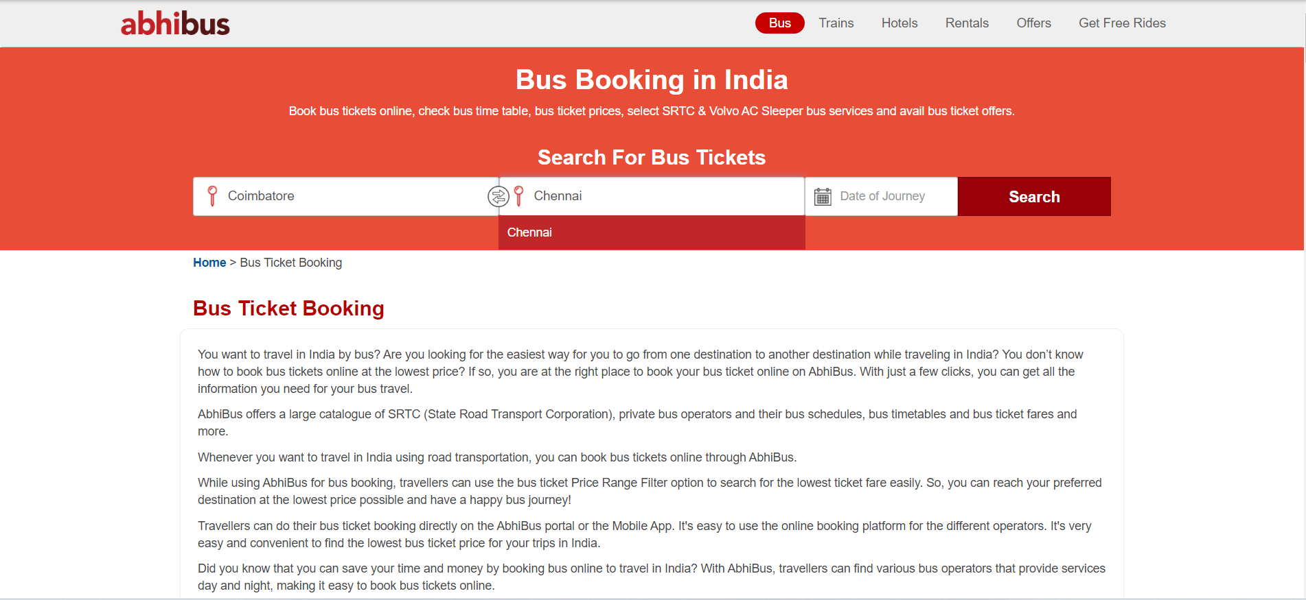

#5

**package** com.Test.Testing.Day5;

**import** org.openqa.selenium.By;

**import** org.openqa.selenium.Keys;

**import** org.openqa.selenium.WebDriver;

**import** org.openqa.selenium.WebElement;

**import** org.openqa.selenium.WindowType;

**import** org.openqa.selenium.chrome.ChromeDriver;

**import** org.openqa.selenium.chrome.ChromeOptions;

**import** io.github.bonigarcia.wdm.WebDriverManager;

**public** **class** Day_5_5 {

**public** **static** **void** main(String[] args)**throws** InterruptedException {

ChromeOptions co=**new** ChromeOptions();

co.addArguments ("--remote-allow-origins=*");

WebDriver driver=**new** ChromeDriver (co);

//open link and maximize

driver.get("https://www.google.com");

driver.manage() .window () .maximize();

driver.findElement(By.*name* ("q")).sendKeys ("Apple");

driver.findElement(By.*name* ("q")).sendKeys (Keys.***ENTER***);

System.***out***.println(driver.getWindowHandle());

System.***out***.println(driver.getTitle());

driver.switchTo().newWindow (WindowType.***TAB***);

driver.get("https://google.com");

driver.manage() .window () .maximize();

driver.findElement(By.*name* ("q")).sendKeys ("Selenium");

driver.findElement(By.*name* ("q")).sendKeys (Keys.***ENTER***);

System.***out***.print ("\n"+driver.getWindowHandle());

System.***out***.println("\n"+driver.getTitle());

driver.switchTo() .newWindow (WindowType. ***TAB***);

driver.get("https://google.com"); driver.manage() .window () .maximize();

driver.findElement(By.*name* ("q")).sendKeys ("Cucumber");

driver.findElement(By.*name* ("q")).sendKeys (Keys.***ENTER***);

System.***out***.print ("\n"+driver.getWindowHandle());

System.***out***.println("\n"+driver.getTitle());

}

}

