
CSA15 Cloud Computing and Big Data Analytics
CO1 AT2 - Digital Concept Map and Service Model Matrix
Individual Student Submission Template

Student and Faculty Details
Student Name | Sunil Kumar I S | Register Number | 192324155
Class / Section |  | Slot | C
Course Code | CSA1517 | Course Title | Cloud Computing
Capstone Title | Internship Progress and Risk Monitoring System
Submission Date
Faculty Name | DR RAJESH BABU | Employee ID
Department

Assessment Brief
Course Outcome | CO1 - Explain the evolution, architecture, characteristics, service models, and emerging paradigms of cloud computing.
Assessment Type | Individual concept mapping, service-model responsibility analysis, and capstone-cloud interpretation.
Assessment Focus | Each map must show key nodes, link labels, relationship meaning, and a logical hierarchy. The response must connect cloud fundamentals to the student's own perception of the capstone title.
Submission Mode | Editable DOCX + exported diagram evidence + GitHub repository link submitted in Google Classroom.
Permitted Tools | draw.io / diagrams.net, Lucidchart, Miro, Canva, PowerPoint, Google Drawings, or equivalent diagramming tool.
Individual Rule | Every student must submit their own concept map, matrix, capstone-cloud mapping, and reflection. The capstone title may be shared by a team, but the assessment answer must not be common.
Total Marks | 100 marks

Code of Conduct and Student Assurance
Academic Integrity Statement
This assessment must be completed individually. Students may discuss the capstone domain with their team, but the concept map, service model matrix, explanations, GitHub evidence, and reflection submitted here must be individually prepared.
Student Assurance | I confirm that this submission represents my own understanding of CO1 concepts and my individual interpretation of the selected capstone title.
Tool Use | I have used digital tools only for diagram preparation, organization, and presentation. I have not copied another student's diagram, matrix, or explanation.
Evidence | I have uploaded the required files to my GitHub repository and submitted the repository link / evidence link through Google Classroom.
Student Signature
Date

Procedure for Preparing the Digital Concept Map
Use the following procedure to prepare the diagram and upload evidence. Students who already know another diagramming tool may use it, but the exported evidence and source file must still be submitted.
- Open https://app.diagrams.net/ or the desktop version of draw.io / diagrams.net.
- Choose Device, Google Drive, or OneDrive as the save location according to availability.
- Create a blank diagram and name the file as CSA15_CO1_AT2_RegisterNumber_Concept_Map.drawio.
- Place the capstone title at the center or as a clearly visible anchor node.
- Add major cloud nodes: cloud definition, cloud evolution, cloud architecture, service models, deployment models, virtualization, web services, SOAP, REST, APIs, elasticity, scalability, resource pooling, measured service, and emerging paradigms.
- Connect nodes with labeled arrows such as uses, depends on, enables, scales through, communicates through, belongs to, supports, provides, consumes, or controls.
- Use colors meaningfully: one color for service models, one for cloud characteristics, one for API/web-service concepts, and one for capstone-specific elements.
- Export the final diagram as PNG or PDF. Keep the editable .drawio source file also.
- Paste the exported diagram image or screenshot in this DOCX under Task 1.
- Upload the DOCX, exported PNG/PDF, and .drawio file to GitHub, then submit the GitHub link in Google Classroom.

GitHub Submission Procedure
Step | Required Action | Expected Evidence
1 | Create or use your individual GitHub account. | GitHub profile link.
2 | Create a repository named CSA15-CO-Assessments-RegisterNumber or use the repository instructed by faculty. | Repository URL.
3 | Create a folder named CO1_AT2 inside the repository. | Folder visible in repository.
4 | Upload this completed DOCX, exported diagram PNG/PDF, and editable .drawio source file. | At least three evidence files uploaded.
5 | Add a short README.md explaining the capstone title and files submitted. | README visible in the AT2 folder.
6 | Submit the GitHub folder link in Google Classroom. | GCR submission with repository/folder link.

Assessment Questions and Student Response Sections
Important
The capstone project may be developed by a team, but every response below must be written from the individual student's own perspective. Do not submit a common team answer.

Task 1 - Digital Cloud Concept Map
Create one integrated digital concept map for CO1. The map must show key nodes, link labels, relationship meaning, and a logical hierarchy. It must also connect the concepts to your selected capstone title from your individual perspective.
Mandatory Concept Group | Minimum Concepts / Nodes to Include
Cloud Fundamentals | Definition, characteristics, benefits, limitations, on-demand access, measured service.
Cloud Evolution and Drivers | Hardware evolution, internet software evolution, distributed systems, cost economics, mobility, remote access, big data growth.
Architecture and Deployment | Front-end, back-end, network layer, data center, management software, public/private/hybrid/community cloud.
Service Models and Responsibility | IaaS, PaaS, SaaS, XaaS, provider responsibility, user responsibility, shared responsibility.
Virtualization and Web/API Layer | Virtual machine, hypervisor, abstraction, resource pooling, multi-tenancy, web services, SOAP, REST, API request/response.
Capstone Connection | Your capstone users, app/module, cloud backend, database/storage, dashboard/analytics, scalability and elasticity idea.
Paste exported concept map image / screenshot here. Resize neatly within this white space.
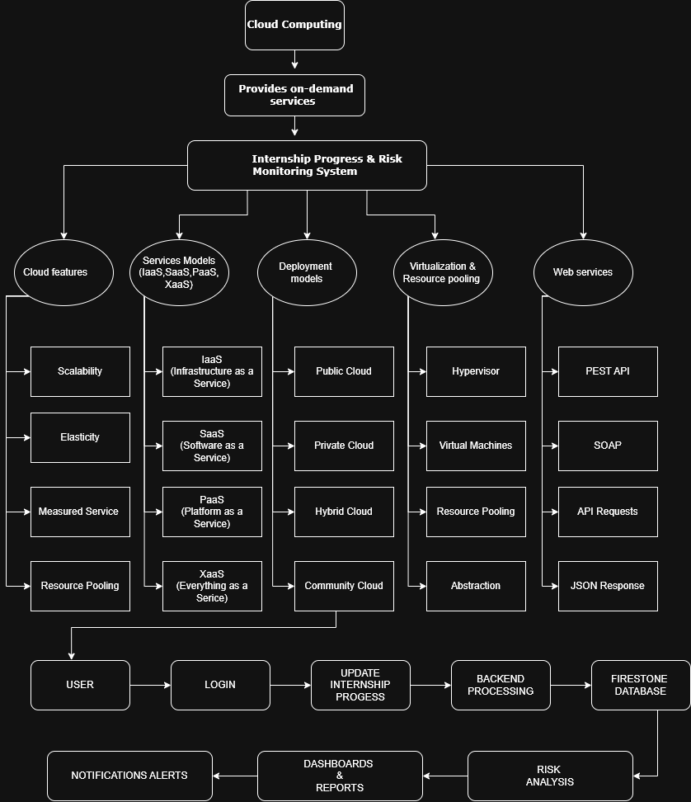
Brief explanation of your concept map: explain the most important nodes, link labels, hierarchy, and capstone connection.
The concept map explains how cloud computing supports the Internship Progress & Risk Monitoring System. Cloud computing provides on-demand services such as scalability, elasticity, measured service, and resource pooling. The project uses service models including IaaS, PaaS, SaaS, and XaaS to manage infrastructure, application development, software services, and notifications. A public cloud platform such as Firebase is used for hosting, authentication, database storage, and file storage. Virtualization enables efficient resource allocation using virtual machines and cloud servers, while REST APIs allow communication between the frontend and backend. The system allows students, mentors, and coordinators to monitor internship progress, identify risks, generate reports, and send notification alerts through cloud-based services.

Task 2 - Service Model Matrix
Complete the matrices by making technical decisions for your capstone project. Select only the rows that are relevant to your capstone design. If a row is not used, write a short technical reason instead of leaving it blank.
Your answer should show how responsibility shifts between cloud provider and student development team, and how the chosen services support the capstone workflow, API design, storage, security, scalability, and evidence submission.

Task 2A - Service Model Responsibility Matrix
Service Model | Capstone Role / Module | Provider Responsibility | Student Responsibility | Evidence to Submit
IaaS | Virtual Server & Storage | Provides virtual machines, networking, storage, backups | Configure server and deploy application | VM/Cloud configuration screenshot
PaaS | Backend Development | Provides runtime, database, deployment platform | Develop APIs, backend logic, testing | Backend code & deployment screenshot
SaaS | GitHub, Google Drive | Provides software applications and collaboration tools | Upload reports, manage project files | GitHub repository link
XaaS / Specialized Service | Notification Service | Email/SMS notification service | Configure internship reminders and alerts | Notification settings screenshot

Task 2B - Capstone Cloud Service Decision Matrix
Cloud Layer / Function | Selected Tool or Service | Data / Resource Handled | API or Integration Path | Security / Scaling Note
Client access and UI | React.js / HTML, CSS | Student, Mentor, Coordinator Interface | REST API | HTTPS communication
API / backend logic | Node.js + Express | Internship progress processing | REST API | JWT Authentication
Authentication and identity | Firebase Authentication | User login credentials | Firebase Auth API | Secure role-based login
Database / structured records | Firebase Fire store | Student details, internship progress, risk records | Firestore API | Automatic cloud scaling
File / object storage | Firebase Storage | Reports, certificates, documents | Firebase Storage API | Secure file access
Monitoring / logs / usage metrics | Firebase Analytics | User activity and application logs | Analytics API | Performance monitoring
Analytics / reporting output | Power BI / Dashboard | Internship reports and progress analytics | Dashboard API | Real-time analytics
Technical justification: Explain why the selected cloud service pattern fits your capstone project's users, data, API flow, scalability, and security needs.
The Internship Progress & Risk Monitoring System requires a secure, scalable, and reliable cloud platform to manage internship records and monitor student performance. Firebase provides authentication, cloud storage, and a NoSQL database for storing internship data. REST APIs enable communication between the frontend and backend services. Cloud-based analytics help identify students at risk by monitoring deadlines, progress updates, and completion status. Automatic cloud scaling ensures smooth performance even when many users access the system simultaneously. This architecture improves security, availability, and overall efficiency.

Task 3 - Capstone Cloud Flow Mapping
Study the sample architecture-flow template below. Redraw it in draw.io / diagrams.net using your own capstone architecture. Replace every generic label with your actual user role, screen, API endpoint, backend logic, cloud storage, analytics output, security control, and scalability or elasticity decision.
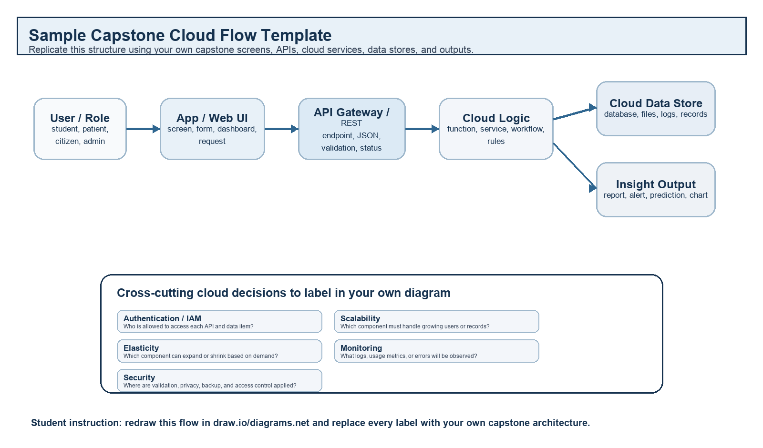
Student Drawing Requirement
Do not copy the sample as it is. Use it as a layout model, then create your own capstone-specific flow diagram with meaningful labels, arrows, data movement, API names, and cloud service choices.
Flow Component | Student Entry
User role and action | Student logs in, updates internship progress, uploads weekly report. Mentor reviews progress and Coordinator monitors overall internship status.
Frontend / app screen | Login Page → Dashboard → Internship Progress Form → Risk Monitoring Dashboard → Reports Page
API endpoint and method | POST /api/login (User Login), POST /api/progress/update (Update Progress), GET /api/risk (Fetch Risk Status), GET /api/report (Generate Report)
Backend processing rule | Verify user authentication, validate submitted data, update internship progress, calculate risk level based on deadlines and completion percentage, and generate dashboard statistics.
Cloud database / storage operation | Store user details, internship progress, reports, and risk data in Firebase Firestore. Store uploaded reports and certificates in Firebase Storage.
Response, alert, report, or dashboard output | Display updated progress dashboard, internship completion percentage, risk level (Low/Medium/High), mentor feedback, and send email/notification alerts for pending tasks.
Security, scalability, and elasticity labels added in diagram | Security: Firebase Authentication, HTTPS, Role-Based Access Control (RBAC). Scalability: Auto-scaling cloud resources for multiple users. Elasticity: Resources automatically increase during heavy usage and decrease during low usage.
Paste your redrawn capstone cloud-flow diagram here.

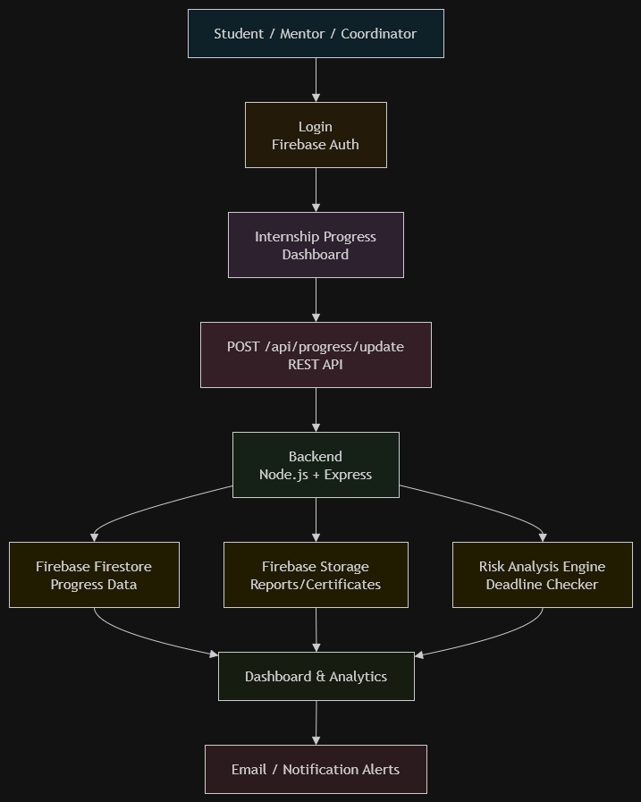

Brief explanation: explain one complete request-response path from user action to cloud response.
A student logs into the application using Firebase Authentication. After successful authentication, the student updates internship progress through the web interface. The frontend sends the information to the backend using REST APIs. The backend validates the request and stores the data in Firebase Firestore. The system analyzes the progress and identifies potential risks such as delayed submissions or incomplete tasks. The processed information is displayed on dashboards for mentors and coordinators. Email and notification services send reminders and alerts to students when necessary. Cloud computing ensures secure storage, scalability, and high availability throughout the workflow.

Task 4 - Individual Reflection
Answer the following from your own perspective. Avoid team-common wording.
1. What is the strongest cloud concept represented in your capstone project?
The strongest cloud concept represented in my capstone project is scalability. The system can efficiently support a large number of students, mentors, and coordinators without affecting application performance. Cloud resources automatically handle increasing workloads, making the application reliable and efficient.

2. Where will elasticity or scalability become important in your capstone product?
Elasticity and scalability become important when many users access the system simultaneously, especially during internship report submissions, mentor evaluations, and progress updates. Cloud resources automatically increase or decrease based on user demand, ensuring uninterrupted service.

3. Which API or web-service idea is most relevant to your project and why?
REST API is the most relevant web-service technology for this project because it enables secure communication between the frontend and backend. It is used for user authentication, updating internship progress, retrieving reports, and managing database operations efficiently.

4. What did you personally understand better after preparing this concept map and matrix?
After preparing the concept map and service model matrix, I gained a better understanding of cloud computing concepts such as IaaS, PaaS, SaaS, virtualization, REST APIs, scalability, and cloud deployment. I also learned how these technologies work together to build a secure, reliable, and scalable cloud-based application for internship progress monitoring.

Evaluation Rubric - 100 Marks
Criteria | Marks | Expected Standard
Concept identification | 20 | Major CO1 concepts are accurately identified: cloud fundamentals, characteristics, evolution, service models, deployment models, virtualization, web services, SOAP/REST, APIs, elasticity, and scalability.
Relationship mapping | 20 | Links between concepts are accurate, meaningful, and labeled. The map should explain how concepts depend on, enable, consume, provide, scale, or control one another.
Hierarchy and organization | 15 | Concepts are arranged in a logical hierarchy with clear grouping, readable flow, and no disconnected keyword clusters.
Technical relevance | 15 | The map strongly reflects cloud course content and avoids decorative or generic non-technical content.
Service model matrix | 15 | IaaS, PaaS, SaaS, and XaaS are compared with provider responsibility, user responsibility, examples, capstone usage, and risks or limitations.
Capstone alignment and individual reflection | 10 | The student's own capstone interpretation is visible in the concept map, flow mapping, justification, and reflection. Team-common answers are avoided.
Visual clarity and digital evidence | 5 | Diagram is neat, readable, exported properly, and supported with GitHub evidence including source and exported files.

Faculty Evaluation Record
Evaluator Name |  | Marks Awarded
Observation |  | Signature

