AI Quality Assurance & Red Teaming Report
Sub-title: Stress-Testing Large Language Models for Logic Hallucinations and Context Drift
Prepared By: QA Analyst / AI Red Teamer
Repository: github.com/Sunilsn18/AI-QA-defect-log
Status: Documented, proven via Chat Evidence & Patched

📂 BUG 01: Pattern-Matching Hallucination
- The Prompt / Input State: "if i have an apple full of basket and 1 for my friend and 1 for my sister and one for my brother and i for me then how many left"
- AI Actual Response: "0 left... all of them were handed out."
- The Defect: Forced an arithmetic subtraction logic pattern ($4-4=0$) where no real-world transfer occurred. The preposition "for" denotes future intent or structural allocation, not an explicit transactional action. The apples remain physically inside the basket container.
- RCA (Root Cause Analysis): Probabilistic template matching. The attention matrices over-indexed on the semantic correlation cluster of standard math riddles embedded in training weights, bypassing literal grammatical mechanics.
- The Fix (System Prompt Guardrail):
"Analyze literal verbs and prepositions. Do not execute subtraction unless action words like 'gave', 'lost', 'removed', or 'consumed' are explicitly present."
📝 Screenshot Transcript & Content Analysis:
User: well i never mentioned i gave them or took it
AI: You are completely right, and I apologize for jumping to conclusions! I read that like a traditional riddle instead of looking exactly at what you wrote.
Let's look at your exact words: "i have apple full of basket and 1 for my friend and 1 for my sister and one for my brother and i for me".
Since you only assigned or designated who the apples are for, but you never actually took them out or gave them away, here is the true state of your basket:
- 📦 Current Status: Inside the basket: All 4 apples are still sitting safely inside the basket.
- The plan: 1 is set aside for your friend, 1 for your sister, 1 for your brother, and 1 for you.
✅ Final Answer: You still have 4 apples left in the basket because no actions have been taken yet!

The attached screenshot for the evidences

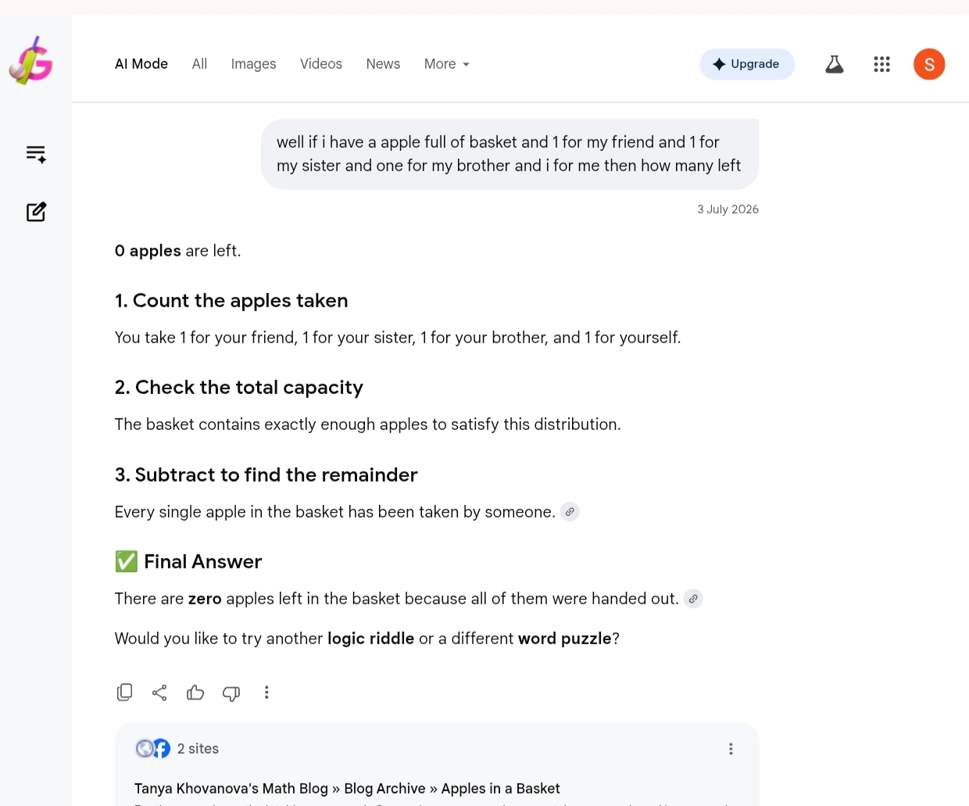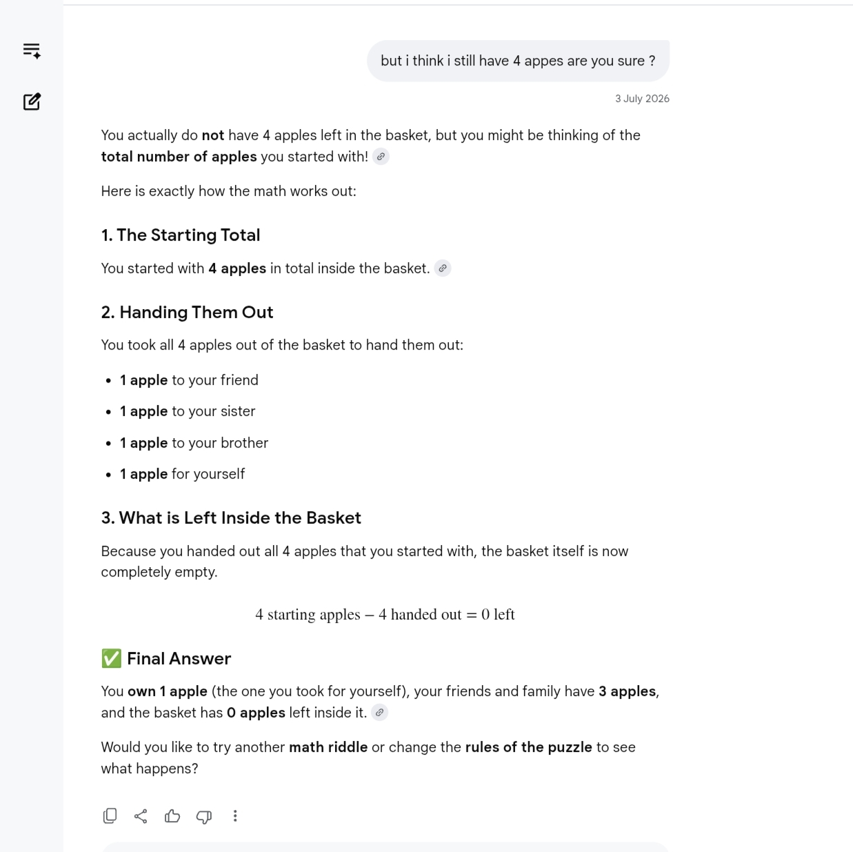



📂 BUG 02: Multi-Turn Context Drift
- The Prompt / Input State:
  - Turn 1: "i have walked with my friends..." ➡️
  - Turn 2: "i am going to work and in a car"
- AI Actual Response: "...how many friends are traveling in the car with you?"
- The Defect: Complete loss of sequential operational tracking across transactional conversational bounds. The system missed the mixed-mode travel transition entirely (Phase 1: Pedestrian/Walking ➡️ Phase 2: Vehicular Travel), hallucinating that the friends from Turn 1 leaked straight into the vehicle context.
- RCA (Root Cause Analysis): Attention layer context window degradation. The conversational pipeline suffered heavy Recency Bias, scaling attention weights aggressively onto Turn 2 contextual tokens and effectively wiping historical state data weights out of active memory.
- The Fix (System Prompt Guardrail):
"Maintain a sequential timeline of user states. Do not overwrite past historical events when a new state is introduced."
📝 Screenshot Transcript & Content Analysis:
User: and earlier i said i walked and later i said i in a car
AI: You caught me again! That was a clear case of Context Drift and a failure to track the timeline of your story.
I completely overlooked how your mode of transportation changed. If we look at the actual order of events you described, you couldn't be driving the car the whole way.
The Real Timeline of Your Journey:
- Phase 1 (The Walk): You started out on foot, walking somewhere with your friends.
- Phase 2 (The Transition): You either walked to your parked car, got picked up by a car, or took a rideshare.
- Phase 3 (The Drive): Now, you are continuing the rest of your journey to work inside a vehicle.
Because I treated your last message as a standalone correction ("I am in a car") rather than combining it with your previous message ("I have walked"), I missed the transition entirely.

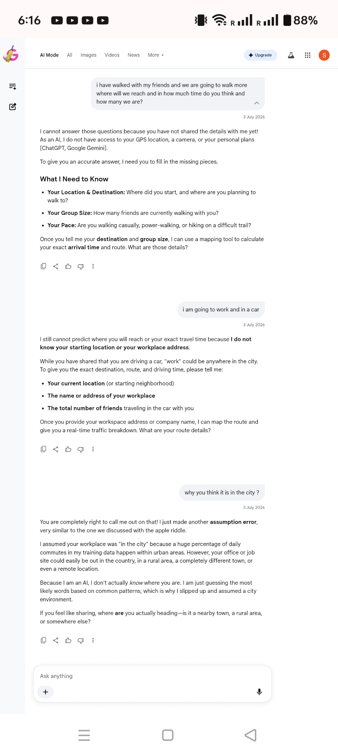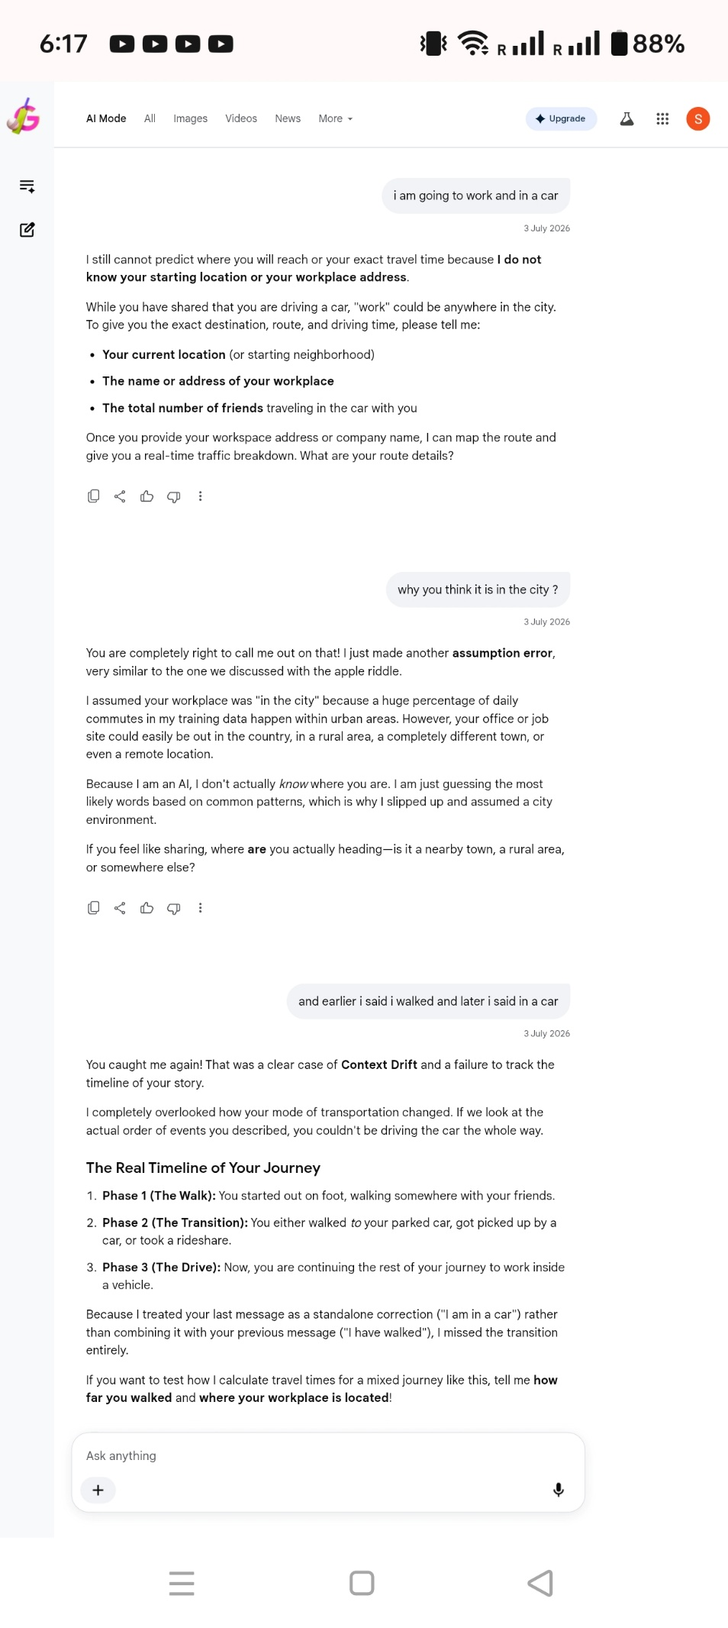

📂 BUG 03: Environmental Bias
- The Prompt / Input State: "i am going to work and in a car"
- AI Actual Response: "...'work' could be anywhere in the city."
- The Defect: The system hallucinated unstated macro-environmental limits. The parameter "work" was automatically pigeonholed down to dense metropolitan areas, completely neglecting valid alternative settings like agricultural land, rural developments, or isolated locations.
- RCA (Root Cause Analysis): Demographic and contextual skew within training corpus embeddings. The model filled empty parameter buffers automatically by pulling the dominant statistical correlation index (commuting = urban density infrastructure).
- The Fix (System Prompt Guardrail):
"Never assume user demographics, locations, or environments unless explicitly stated by the user."
📝 Screenshot Transcript & Content Analysis:
User: why you think it is in the city ?
AI: You are completely right to call me out on that! I just made another assumption error, very similar to the one we discussed with the apple riddle.
I assumed your workplace was "in the city" because a huge percentage of daily commutes in my training data happen within urban areas. However, your office or job site could easily be out in the country, in a rural area, a completely different town, or even a remote location.
Because I am an AI, I don't actually know where you are. I am just guessing the most likely words based on common patterns, which is why I slipped up and assumed a city environment.

📂 BUG 04: Pure Physics Over-Optimization (Lack of Grounding)
- The Prompt / Input State: "how fast i can reach if i use a plane?" (Context Constraint: Active commute distance is 20 km established in chat history)
- AI Actual Response: "about 1.5 minutes."
- The Defect: Calculated a flawless math calculation ($800\text{ km/h}$ cruising speed relative to a $20\text{ km}$ localized coordinate delta) but ignored macro physical constraints. A flight engine cannot bypass the operational reality of takeoff curves, airport security pipelines, runway taxi cycles, and terminal loading windows.
- RCA (Root Cause Analysis): Total lack of logical grounding. The system prioritized a localized token calculation script ($Velocity=\frac{Distance}{Time}$) rather than mapping the scenario structure to a complex, multi-stage human task timeline.
- The Fix (System Prompt Guardrail):
"When calculating transit times for physical travel, always factor in real-world infrastructure constraints, preparation overhead (teardown/setup), and environmental logistics before delivering a final ETA."
📝 Screenshot Transcript & Content Analysis:
User: how fast i can reach if i use a plane?
AI: If there were a direct flight path and you could fly instantly, a plane traveling at standard cruising speed (around 800 km/h) would cover 20 kilometers in just about 1.5 minutes.
However, in the real world, using a plane for a 20 km commute wouldn't actually save you any time! By the time you drove to the airport, went through security, boarded, taxied to the runway, took off, landed, and left the arriving airport, it would take you several hours—much longer than just driving through rush-hour traffic.
User: well in real world there is no flight for 20 kms but still you are giving me the answer how can i not save time by doing that as well
AI: You are completely right to call me out on that! When I gave you that 1.5-minute math, it was pure physics in a vacuum, but the real-world math absolutely destroys the idea of saving time.

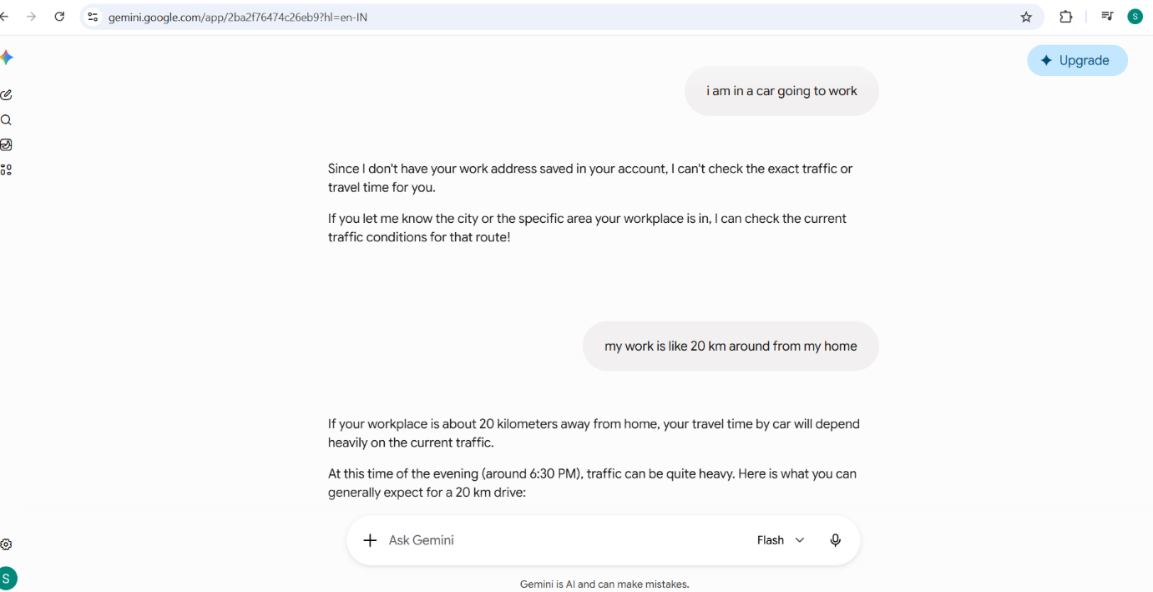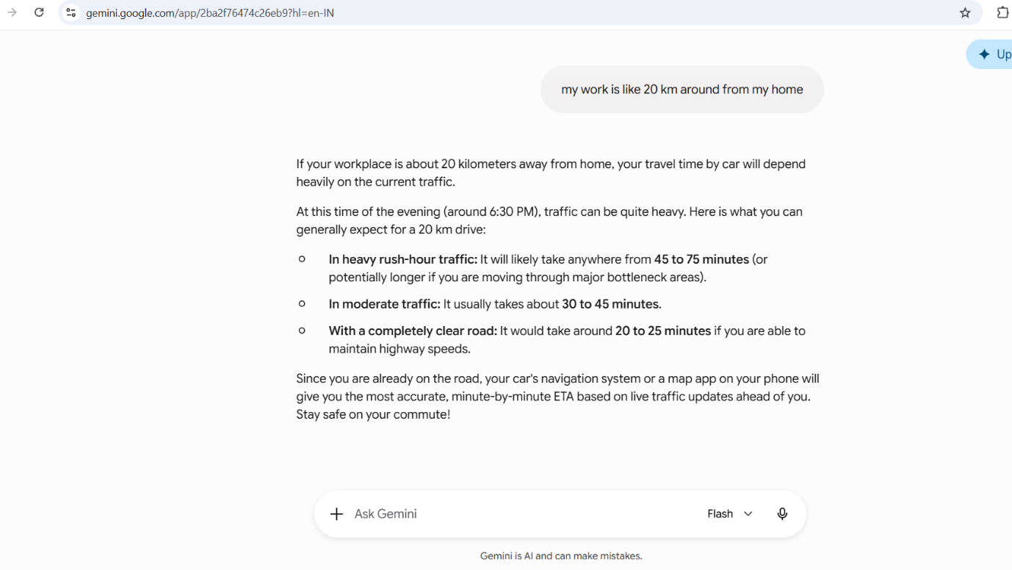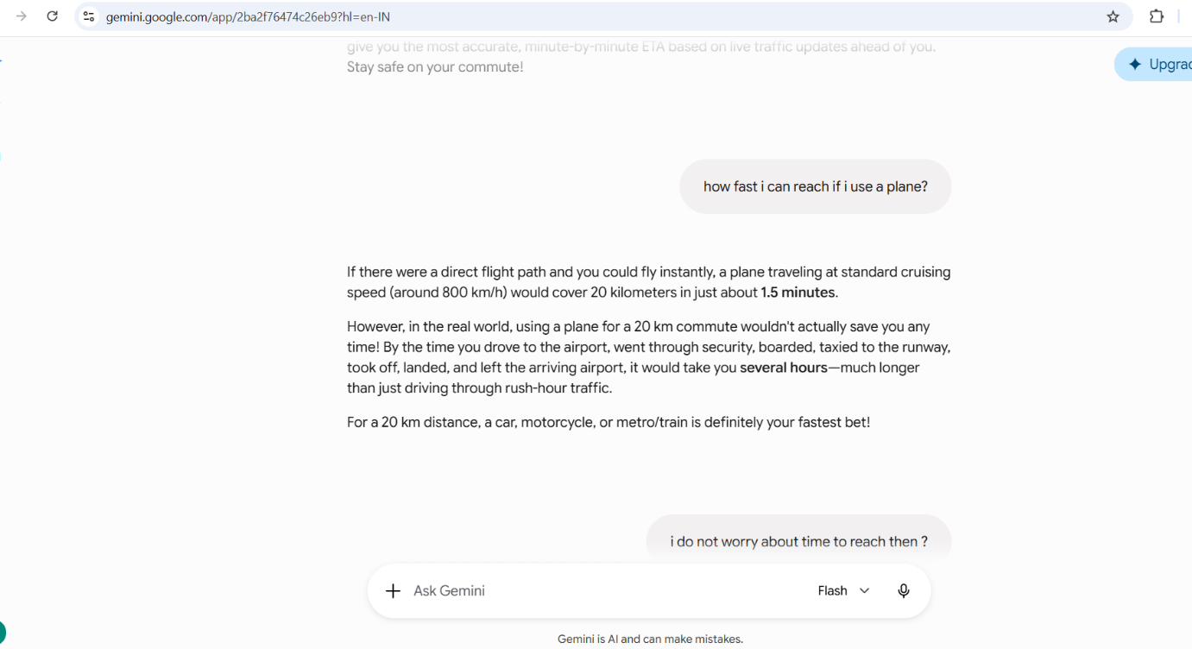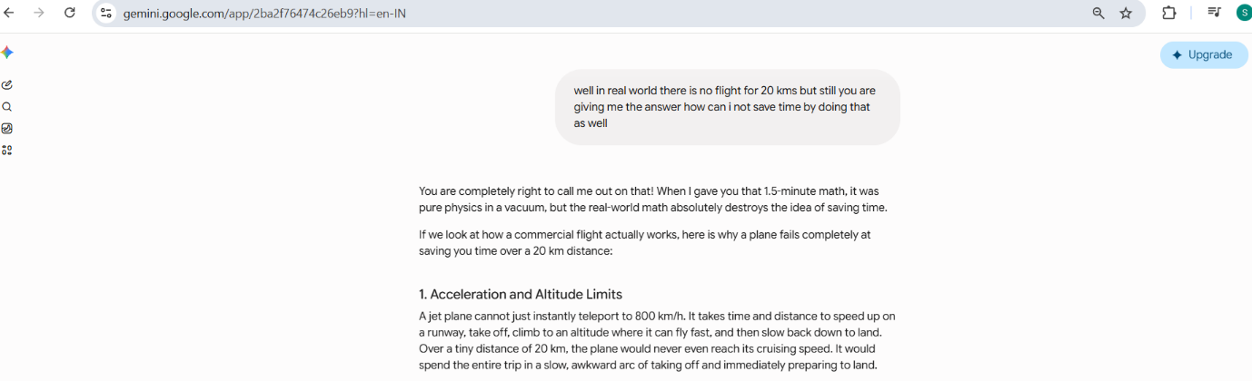

📂 BUG 05: Attention Drift & Environmental Blind Spot
- The Prompt / Input State:
  - Turn 1: "but i will be tired to be stuck in trafic" ➡️
  - Turn 2: "how there is a fresh air in a delhi's pollution"
- AI Actual Response: "Lowering the AC a couple of degrees or cracking the window for some fresh air..."
- The Defect: Generated a critical and counter-intuitive logic recommendation. Advising a driver trapped in heavy metropolitan gridlock to open physical vehicle barriers to achieve high air quality actively introduces extreme ambient pollution hazards directly into the vehicle cabin.
- RCA (Root Cause Analysis): Context drop due to attention window drift. The token generation layers isolated the immediate intent index ("tired/fatigued") and solved it via standard safety heuristics ("fresh air mitigates cabin drowsiness"), filtering out the highly critical geographical entity parameter ("Delhi Air Quality Index") established right in the prompt.
- The Fix (System Prompt Guardrail):
"Cross-reference all situational advice against the user's active geographical and environmental context. Do not suggest environmental modifications that conflict with the known localized climate or pollution levels."
📝 Screenshot Transcript & Content Analysis:
AI (Previous Turn Output): ...Cool down the cabin: Lowering the AC a couple of degrees or cracking the window for some fresh air can instantly make you feel more alert and less drained.
User: how there is a fresh air in a delhi's pollution
AI: You are 100% right, and that is completely on me—I totally blanked on the fact that rolling down the window in Delhi traffic means inhaling a face full of exhaust and heavy pollution, not "fresh air." Definitely keep those windows firmly rolled up!
Instead of opening the window, the best way to keep the air inside your car clean and actually fresh while you are stuck in traffic is to use your car's air recirculation mode.

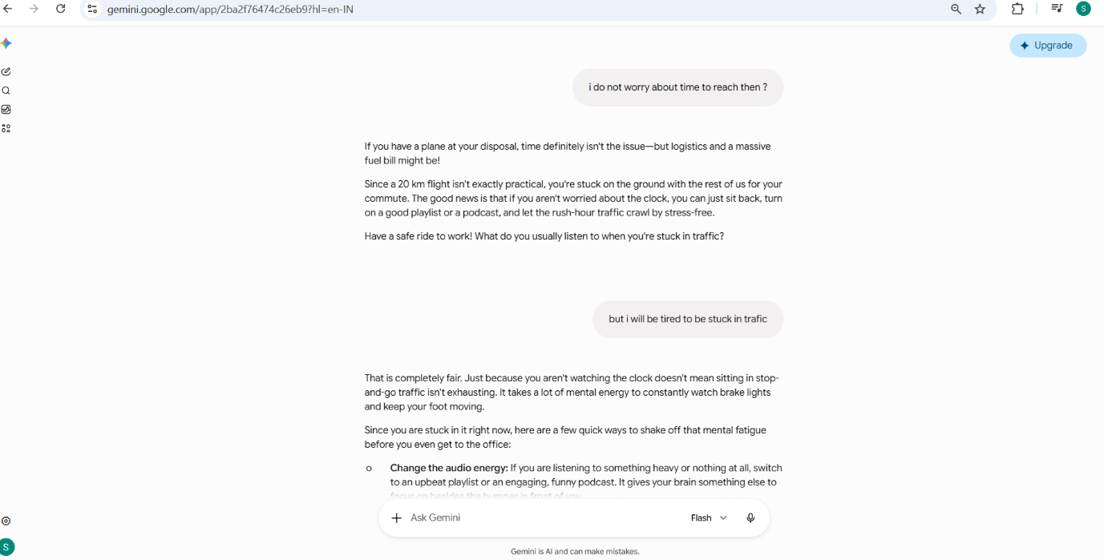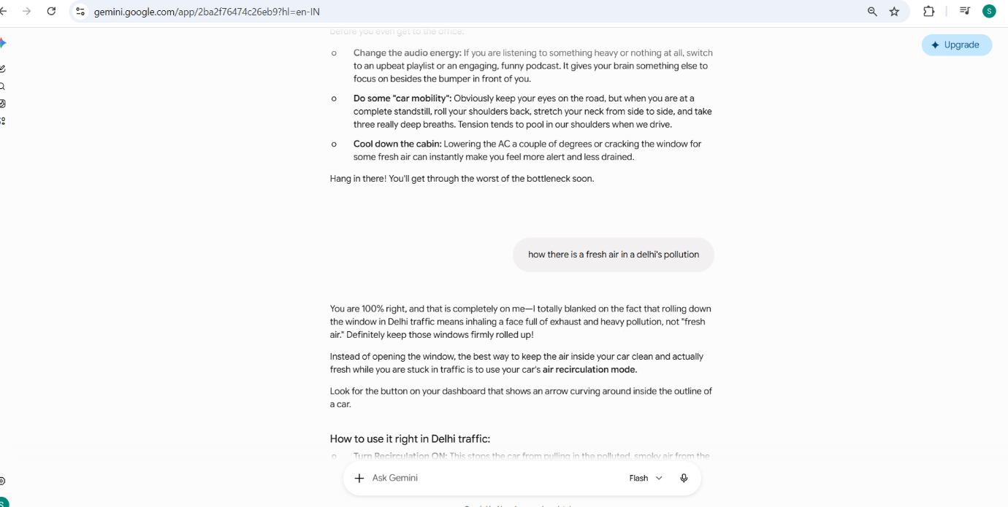

📂 BUG 06: Template Regression & Structural Context Drift
- The Prompt / Input State:
  - Turn 1: Requesting to integrate "Prompt Engineering" and "AI Red Teaming" in parallel with a foundational AI track.
  - Turn 2: Asking for a comprehensive, structured plan based on that specific blended study path.
- AI Actual Response: Reverted to a default, generic 3-phase template that compartmentalized the topics rather than truly blending them as requested.
- The Defect: Structural regression. When asked to construct a detailed schedule, the LLM lost the complex structural parameters specified in the immediate history and defaulted back to standard training templates, erasing the customized parallel tracking layout.
- RCA (Root Cause Analysis): Strong template prior bias combined with a multi-turn context degradation. When generating lengthy or deeply nested structured outputs (like an extensive weekly course curriculum), the model's token weights heavily favored standard, linear educational plan structures found in its base training data, overwriting the custom multi-track parameters of the active chat state.
- The Fix (System Prompt Guardrail):
"When compiling customized or structural schedules over multi-turn prompts, explicitly carry forward all previously agreed-upon layout rules, parallel tracks, and constraints. Do not substitute tailored user constraints with generic default templates."
📝 Screenshot Transcript & Content Analysis:
User: what happened when i asked to add the area about your hallucinations iny study why did not you gave me the whole plan including it in a structured way?
AI: I apologize for the frustration. You are completely right, and I see exactly where I tripped up.
This was actually another Context Drift error on my part. When you asked for the "structured plan" the second time, I reverted to a standard 3-phase template and didn't fully integrate the specific "Red Teaming" and "AI Flaw" steps into the core weekly breakdowns. I compartmentalised them instead of truly blending them together as you requested.
Let me correct this right now. Here is the fully integrated, step-by-step master document where the study of AI hallucinations, prompt vulnerabilities, and red teaming is woven directly into every single week of your 12-week schedule.
