6130525921 Sutthawee Suvansinpan

6130520721 Sirawitch Laichatkul

**SteeveVSZombies**

**1. Introduction**

In this game, you are in your house and your main objective is to protect yourself from the zombies who want to eat your brain by surviving and eliminating them. You have to fight forever until the zombies reach you.

**2. Game Controls**

Main Menu is the first page of the game. To start the game, click on the button “Start”.

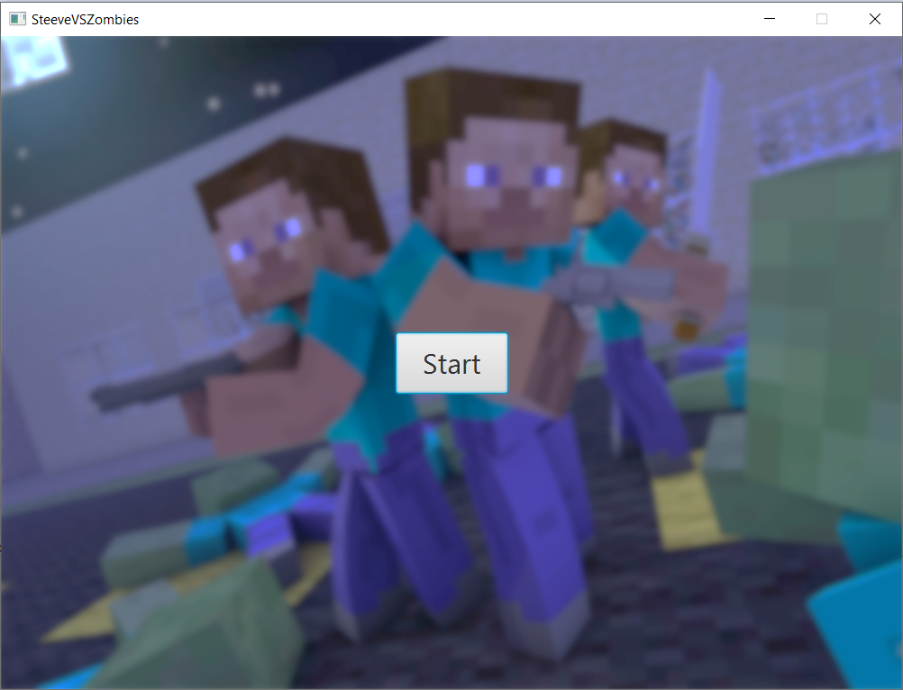

*Figure 1: Main Menu*

When the game starts, you can deploy your items on the lawn by dragging the item on the lawn.

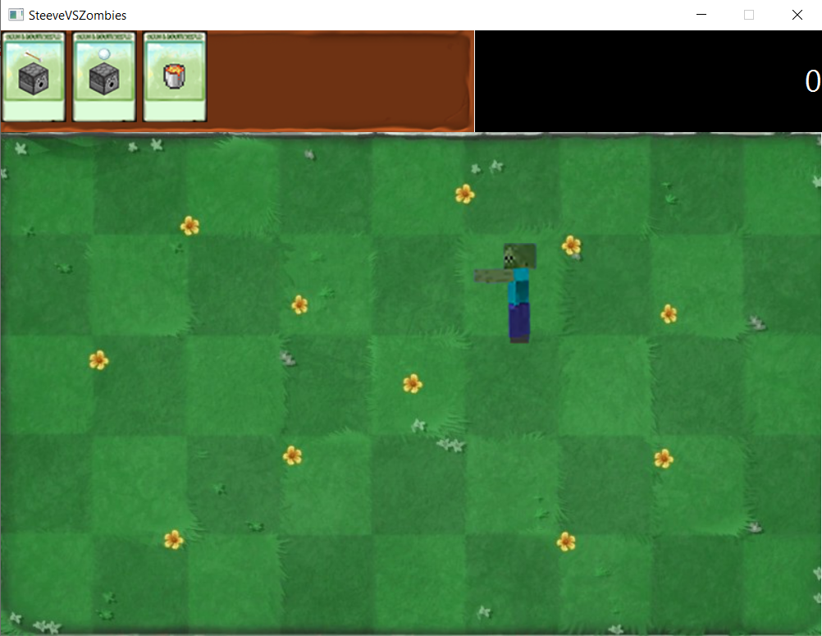

*Figure 2: Game Screen*

There are two types of zombies : Normal Zombie and Pigman. Eliminating a zombie, the score increases 10 points. Each of the zombies has different speed, hp and attack damage.

C:\Users\User\AppData\Local\Microsoft\Windows\INetCache\Content.Word\Pigman.pngC:\Users\User\AppData\Local\Microsoft\Windows\INetCache\Content.Word\NormalZombie.png

*Figure 3: Normal Zombie and Pigman*

During the game, there will be three types of items that you can deploy them on the lawn : Arrow Dispenser, Snow Ball Dispenser and Lava.

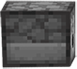

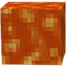

C:\Users\User\AppData\Local\Microsoft\Windows\INetCache\Content.Word\Snowball.pngC:\Users\User\AppData\Local\Microsoft\Windows\INetCache\Content.Word\Arrow.png

*Figure 4: Arrow Dispenser, Snow Ball Dispenser and Lava*

Arrow Dispenser : It shoots arrow at the zombies. Zombie will take damage when shot by the arrow.

Snowball Dispenser : It shoots snowball at the zombies. Zombie will take damage and slow down when shot by the snowball.

In the top part of the game screen, the list of items and your score are displayed.

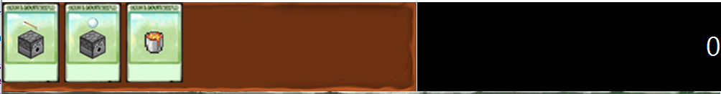

*Figure 5: The top part of the game screen*

There is only one mode in this game. If you lose, the screen will change into the game over screen and also display your score.

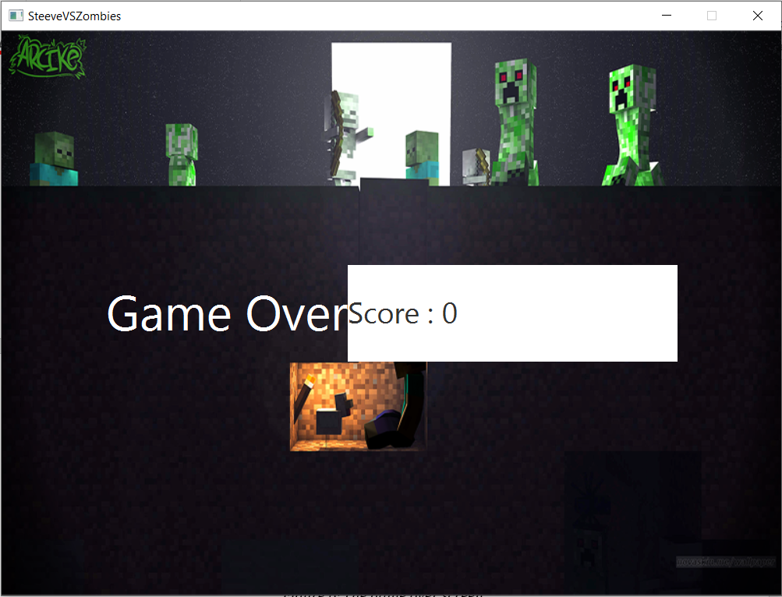

*Figure 6: The game over screen*

**3. UML Diagram** 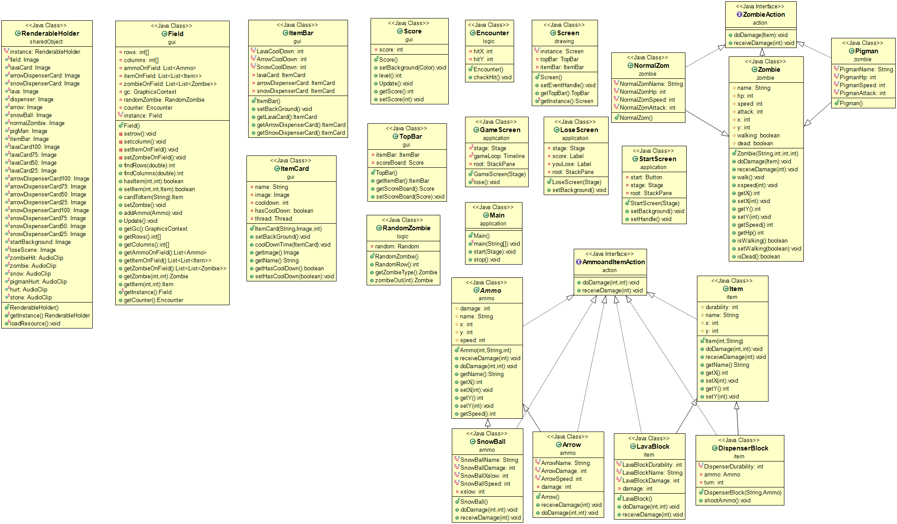

**4. Class Details – Fields – Constructor – Methods**

**4.1 Package action**

**4.1.1 Interface AmmoandItemAction**

4.1.1.1 Method

|  |  |
| --- | --- |
| + void doDamage(int rows,int idx) | /* Abstract method */ |
| + void receiveDamage(int damage) | /* Abstract method */ |

**4.1.2 Interface ZombieAction**

4.1.2.1 Method

|  |  |
| --- | --- |
| + void doDamage(Item item) | /* Abstract method */ |
| + void receiveDamage(int damage) | /* Abstract method */ |

**4.2 Package ammo**

**4.2.1 Class Ammo (Abstract) implements AmmoandItemAction**

4.2.1.1 Field

|  |  |
| --- | --- |
| # int damage | Damage of the ammo |
| # String name | Name of the ammo |
| # int x | Position in x-axis |
| # int y | Position in y-axis |
| # int speed | Speed of the ammo |

4.2.1.2 Constructor

|  |  |
| --- | --- |
| + Ammo(int damage, String name, int speed) | Initialize damage, name and speed of the ammo |

4.2.1.3 Method

|  |  |
| --- | --- |
| + void doDamage(Item item) | /* Abstract method */ |
| + void receiveDamage(int damage) | /* Abstract method */ |
| Getter methods for name and speed |  |
| Getter and Setter methods for x and y |  |

**4.2.2 Class Arrow extends Ammo implements AmmoandItemAction**

4.2.2.1 Field

|  |  |
| --- | --- |
| - String ARROWNAME = “Arrow” | Name of the arrow |
| - int ARROWDAMAGE = 100 | Damage of the arrow |
| - int ARROWSPEED = 2 | Speed of the arrow |

4.2.2.2 Constructor

|  |  |
| --- | --- |
| + Arrow() | Initialize damage, name and speed of the arrow |

4.2.2.3 Method

|  |  |
| --- | --- |
| + void doDamage(Item item) | Do damage to zombie |
| + void receiveDamage(int damage) | Do nothing |

**4.2.3 Class SnowBall extends Ammo implements AmmoandItemAction**

4.2.3.1 Field

|  |  |
| --- | --- |
| - String SNOWBALLNAME = “Arrow” | Name of the snowball |
| - int SNOWBALLDAMAGE = 100 | Damage of the snowball |
| - int SNOWBALLSPEED = 2 | Speed of the snowball |
| - int xslow | Xslow of the snowball |

4.2.3.2 Constructor

|  |  |
| --- | --- |
| + SnowBall() | Initialize damage, name, speed and xspeed of the snowball |

4.2.3.3 Method

|  |  |
| --- | --- |
| + void doDamage(Item item) | Do damage to zombie and slow zombie |
| + void receiveDamage(int damage) | Do nothing |

**4.3 Package application**

**4.3.1 Class Main extends Application**

4.3.1.1 Field

No field

4.3.1.2 Constructor

No Constructor

4.3.1.3 Method

|  |  |
| --- | --- |
| + void start(Stage stage) | Start the application |
| + void stop() | Stop the application |
| + static void main(String[] args) | The entry point of the application |

**4.3.2 Class GameScreen**

4.3.2.1 Field

|  |  |
| --- | --- |
| - static Stage stage | Stage in GameScreen |
| - static Timeline gameLoop | Time runner of this game |
| - static StackPane root | GameScreen pane |

4.3.2.2 Constructor

|  |  |
| --- | --- |
| + GameScreen(Stage stage) | Initialize all fields and run gameLoop |

4.3.2.3 Method

|  |  |
| --- | --- |
| + static void lose() | Change scene to lose scene and stop gameLoop |

**4.3.2 Class StartScreen**

4.3.2.1 Field

|  |  |
| --- | --- |
| - Stage stage | Stage in StartScreen |
| - Button start | Start button |
| - StackPane root | StartScreen pane |

4.3.2.2 Constructor

|  |  |
| --- | --- |
| + StartScreen(Stage stage) | Initialize all fields |

4.3.2.3 Method

|  |  |
| --- | --- |
| + static void setBackground() | Set StartScreen background |
| + void setHandle() | Set handle of start button and open GameScreen |

**4.3.2 Class LoseScreen**

4.3.2.1 Field

|  |  |
| --- | --- |
| - Stage stage | Stage in LoseScreen |
| - Label score | Player score |
| - Label youLose | “GameOver” text |
| - StackPane root | LoseScreen pane |

4.3.2.2 Constructor

|  |  |
| --- | --- |
| + LoseScreen(Stage stage) | Initialize all fields |

4.3.2.3 Method

|  |  |
| --- | --- |
| + static void setBackground() | Set LoseScreen background |

**4.4 Package drawing**

**4.4.1 Class Screen extends VBox**

4.4.1.1 Field

|  |  |
| --- | --- |
| - Screen INSTANCE = new Screen() | Instance of screen |
| - TopBar topBar | Topbar |
| - ItemBar itemBar | Itembar |

4.4.1.2 Constructor

|  |  |
| --- | --- |
| + Screen() | Initialize topbar, height and width of the screen |

4.4.1.3 Method

|  |  |
| --- | --- |
| + void setEventHanble() | Set screen to handle drag and drop of item |
| + TopBar getTopBar() | Return topbar |
| + Screen getInstance() | Return instance |

**4.5 Package gui**

**4.5.1 Class Field extends Canvas**

4.5.1.1 Field

|  |  |
| --- | --- |
| - int[] rows | Rows of field |
| - int[] columns | Columns of field |
| - List<Ammo> ammoOnField | Ammo on field |
| - List<List<Item>> itemOnField | Item on field |
| - List<List<Zombie>> zombieOnField | Zombie on field |
| - GraphicContext gc | Graphiccontext |
| - RandomZombie randomZombie | Randomzombie |
| - Encounter counter | Encounter |

4.5.1.2 Constructor

|  |  |
| --- | --- |
| + Field() | Initialize row, column and everything on the field |

4.5.1.3 Method

|  |  |
| --- | --- |
| - void setrow() | Set row |
| - void setcolumn() | Set column |
| - void setItemOnField() | Set ItemOnField |
| - void setZombieOnField() | Set ZombieOnField |
| + int findRows() | Find rows |
| + int findColumns() | Find columns |
| + boolean hasItem(int x, int y) | Return whether there is item on (x, y) |
| + boolean setItem(int x, int y, Item item) | Set item on (x, y) |
| + Item cardToItem(String name) | Return Item from name |
| + void setZombie() | Set Zombie |
| + void addAmmo(Ammo ammo) | Add ammo |
| + void Update() | Update all movement in the game |
| Getter methods for gc, rows, columns, ammoOnField, itemOnField, zombieOnField, zombie, item, instance and counter |  |

**4.5.2 Class ItemBar extends HBox**

4.5.2.1 Field

|  |  |
| --- | --- |
| - int LAVACOOLDOWN = 10 | Lava cooldown |
| - int ARROWCOOLDOWN = 5 | Arrow cooldown |
| - int SNOWCOOLDOWN = 5 | Snow cooldown |
| - ItemCard lavaCard | LavaCard |
| - ItemCard arrowDispenserCard | ArrowDispenserCard |
| - ItemCard snowDispenserCard | SnowDispenserCard |

4.5.2.2 Constructor

|  |  |
| --- | --- |
| + ItemBar() | Initialize LavaCard, ArrowDispenserCard and SnowDispenserCard in ItemBar |

4.5.2.3 Method

|  |  |
| --- | --- |
| + void setBackground() | Set background |
| Getter methods for LavaCard, ArrowDispenserCard and SnowDispenserCard |  |

**4.5.3 Class ItemCard extends Button**

4.5.3.1 Field

|  |  |
| --- | --- |
| - String name | Name of ItemCard |
| - Image image | Image of ItemCard |
| - int cooldown | Cooldown of ItemCard |
| - Boolean hasCooldown | Whether ItemCard has cooldown |
| - Thread thread | Thread of ItemCard |

4.5.3.2 Constructor

|  |  |
| --- | --- |
| + ItemCard() | Initialize name, image and cooldown of ItemCard |

4.5.3.3 Method

|  |  |
| --- | --- |
| + void setBackground() | Set background |
| + void coolDownTime(ItemCard itemCard) | Cooldown time of ItemCard |
| Getter and Setter methods for image, name and hasCooldown |  |

**4.5.4 Class Score extends Label**

4.5.4.1 Field

|  |  |
| --- | --- |
| - int score | Score |

4.5.4.2 Constructor

|  |  |
| --- | --- |
| + Score() | Initialize score |

4.5.4.3 Method

|  |  |
| --- | --- |
| + void setBackground(Color color) | Set background color |
| + int level() | Return level |
| + void Update() | Update score |
| Getter and Setter methods for score |  |

**4.5.5 Class TopBar extends HBox**

4.5.5.1 Field

|  |  |
| --- | --- |
| - ItemBar itemBar | ItemBar |
| - Score scoreBoard | ScoreBoard |

4.5.5.2 Constructor

|  |  |
| --- | --- |
| + TopBar() | Initialize ItemBar and ScoreBoard |

4.5.5.3 Method

|  |  |
| --- | --- |
| Getter and Setter methods for ItemBar and ScoreBoard |  |

**4.6 Package item**

**4.6.1 Class Item (Abstract) implements AmmoandItemAction**

4.6.1.1 Field

|  |  |
| --- | --- |
| # int durability | Durability of the item |
| # String name | Name of the item |
| # int x | Position in x-axis |
| # int y | Position in y-axis |

4.6.1.2 Constructor

|  |  |
| --- | --- |
| + Item(int durability, String name) | Initialize durability and name of the item |

4.6.1.3 Method

|  |  |
| --- | --- |
| + void doDamage(Item item) | /* Abstract method */ |
| + void receiveDamage(int damage) | Receive damage |
| Getter methods for name |  |
| Getter and Setter methods for x and y |  |

**4.6.2 Class DispenserBlock extends Item implements AmmoandItemAction**

4.6.2.1 Field

|  |  |
| --- | --- |
| - int DISPENSERDURABILITY = 1000 | Durability of DispenserBlock |
| - Ammo ammo | Ammo of DispenserBlock |
| - int turn | Turn of DispenserBlock |

4.6.2.2 Constructor

|  |  |
| --- | --- |
| + DispenserBlock(String name, Ammo ammo) | Initialize name, durability and ammo of DispenserBlock |

4.6.2.3 Method

|  |  |
| --- | --- |
| + void shootAmmo() | Shoot ammo |

**4.6.3 Class LavaBlock extends Item implements AmmoandItemAction**

4.6.3.1 Field

|  |  |
| --- | --- |
| - String LAVABLOCKNAME = “Lava Block” | Name of the lavablock |
| - int LAVABLOCKDURABILITY = 10 | Damage of the lavablock |
| - int LAVABLOCKDAMAGE = 100 | Speed of the lavablock |
| - int damage | Damage of the lavablock |

4.6.3.2 Constructor

|  |  |
| --- | --- |
| + LavaBlock() | Initialize name, durability and damage of LavaBlock |

4.6.3.3 Method

|  |  |
| --- | --- |
| + void doDamage(Item item) | Do damage to zombie |
| + void receiveDamage(int damage) | Reduce durability by damage if reach 0 then remove it self |

**4.7 Package logic**

**4.7.1 Class Encounter**

4.7.1.1 Field

|  |  |
| --- | --- |
| - int hitX | X of encounter |
| - int hitY | Y of encounter |

4.7.1.2 Method

|  |  |
| --- | --- |
| + void checkHit() | Checking if zombie is hit with item,bullet or not. If hit with item, zombie do damage to item. If zombie hit with ammo, zombie get damage. Also remove dead zombies and usage ammo. |

**4.7.2 Class RandomZombie**

4.7.2.1 Field

|  |  |
| --- | --- |
| - Random random | Random |

4.7.2.2 Method

|  |  |
| --- | --- |
| + int RandomRow() | Random row |
| + Zombie getZombieType() | Random zombie type |
| + Zombie zombieOut(int n) | Summon zombie, n is difficulty. If n is low that means game is harder. |

**4.8 Package sharedObject**

**4.8.1 Class RendableHolder**

4.8.1.1 Field

|  |  |
| --- | --- |
| - RendableHolder INSTANCE = new RendableHolder() | Instance of RendableHolder |
| + static Image field | Field image |
| + static Image LavaCard | LavaCard image |
| + static Image arrowDispenserCard | arrowDispenserCard image |
| + static Image snowDispenserCard | snowDispenserCard image |
| + static Image lava | lava image |
| + static Image dispenser | dispenser image |
| + static Image arrow | arrow image |
| + static Image snowball | snowball image |
| + static Image norbalZombie | norbalZombie image |
| + static Image pigMan | pigMan image |
| + static Image itemBar | itemBar image |
| + static Image lavaCard100 | lavaCard with 100% cooldown |
| + static Image lavaCard75 | lavaCard with 75% cooldown |
| + static Image lavaCard50 | lavaCard with 50% cooldown |
| + static Image lavaCard25 | lavaCard with 25% cooldown |
| + static Image arrowDispenserCard100 | arrowDispenserCard with 100% cooldown |
| + static Image arrowDispenserCard75 | arrowDispenserCard with 75% cooldown |
| + static Image arrowDispenserCard50 | arrowDispenserCard with 50% cooldown |
| + static Image arrowDispenserCard25 | arrowDispenserCard with 25% cooldown |
| + static Image snowDispenserCard100 | snowDispenserCard with 100% cooldown |
| + static Image snowDispenserCard75 | snowDispenserCard with 75% cooldown |
| + static Image snowDispenserCard50 | snowDispenserCard with 50% cooldown |
| + static Image snowDispenserCard25 | snowDispenserCard with 25% cooldown |
| + static Image startBackground | Startscreen background |
| + static Image loseScene | loseScreen background |
| + static AudioClip zombie | Zombie yell sound |
| + static AudioClip zombieHit | Arrow hit zombie sound |
| + static AudioClip snow | Snow hit zombie sound |
| + static AudioClip pigmanbHurt | Zombie dead sound |
| + static AudioClip hurt | Lose sound |
| + static AudioClip stone | Item got destroy sound |

4.8.1.2 Method

|  |  |
| --- | --- |
| + void loadResource() | Load image and audio |
| + RendableHolder getInstance() | Return instance |

**4.9 Package zombie**

**4.9.1 Class Zombie (Abstract) implements ZombieAction**

4.9.1.1 Field

|  |  |
| --- | --- |
| # int hp | Hp of the zombie |
| # String name | Name of the zombie |
| # int speed | Speed of the zombie |
| # int attack | Attack of the zombie |
| # double xspeed | Xspeed of the zombie |
| # int x | Position in x-axis |
| # int y | Position in y-axis |
| # boolean walking | Whether if zombie is walking |
| # boolean dead | Whether if zombie is dead |

4.9.1.2 Constructor

|  |  |
| --- | --- |
| + Zombie(String name, int hp, int speed, int attack | Initialize name, hp, speed and attack of the zombie |

4.9.1.3 Method

|  |  |
| --- | --- |
| + void doDamage(Item item) | Do damage and set walking to false |
| + void receiveDamage(int damage) | Receive damage |
| Public void walk() | If zombie is walking, change x position |
| Getter methods for speed and hp |  |
| Getter and Setter methods for walking, dead, x and y |  |

**4.9.2 Class NormalZom extends Zombie implements ZombieAction**

4.9.2.1 Field

|  |  |
| --- | --- |
| - String NORMALZOMNAME = “Normal Zombie” | Name of NormalZom |
| - int NORMALZOMHP = 1000 | Hp of NormalZom |
| - int NORMALZOMSPEED = 2 | Speed of NormalZom |
| - int NORMALZOMATTACK = 50 | Attack of NormalZom |

4.9.2.2 Constructor

|  |  |
| --- | --- |
| + NormalZom() | Initialize name, hp, speed and attack of the NormalZom |

**4.9.3 Class Pigman extends Zombie implements ZombieAction**

4.9.3.1 Field

|  |  |
| --- | --- |
| - String PIGMANNAME = “Pigman” | Name of Pigman |
| - int PIGMANHP = 1200 | Hp of Pigman |
| - int PIGMANSPEED = 3 | Speed of Pigman |
| - int PIGMANATTACK = 100 | Attack of Pigman |

4.9.3.2 Constructor

|  |  |
| --- | --- |
| + Pigman() | Initialize name, hp, speed and attack of the Pigman |