Class Test Questions (25 Marks)

# Please write your answer in a neat & proper way (preferably in yellow color font.)

Q1. Which one is ordered collection of multi-typed object?

1. List
2. Dictionary
3. Sets

Q2. Is tuple mutable?

1. Yes
2. No

Q3. Is String mutable?

1. Yes
2. No

Q4. What will be the output of below code:

St=” Hello world”

St [0] =”H”

print (St)

1. “Hello World”
2. “HHello World”
3. Error
4. “hello world”

Q5. What will be the output for below code:

X=10

Y=20

Z=5

print (X<Y<Z, X>Y<Z, X<Y>Z)

1. False, False, False
2. True, False, True
3. False, True, False
4. False, False, True

Q6. What is the Output of below code:

print (38/4, 38//4)

Q7. Question 10:

What is the output ?

print(38//4, -38//4)

Q8. What is the output of following code?

X = 0.1 + 0.1 + 0.1 - 0.3

print(X)

1. Non Zero Value
2. Zero Value

Q9. What is the value of following print statement?

from decimal import Decimal

print(Decimal('0.1') + Decimal('0.1') + Decimal('0.1') - Decimal('0.3'))

1. Zero Value
2. Non-Zero Value

Q10. What is the output of following python code ?

L = [10,20,30,40,50,20.4, "Hello Python"]

print(L[3], L[1:4])

Q11. What is the output of following print command?

L = [10,20,30.4, "Hello World", 100]

print([L]*2)

Q12. What is the output of following print command?

L = [10,20,30.4, "Hello World", 100]

print(L*2)

Q13. What is the output of below code:

D = {'a':1, 'b':3, 'c':4}

D[0]

Q14. What will be the output?

setA = set("hello")

print(setA)

1. {‘h’, ‘o’, ‘l’, ‘e’}
2. {‘h’, ‘o’, ‘l’, ‘l’, ‘e’}
3. {‘h’, ‘e’, ‘l’, ‘l’, ‘o’}
4. {‘h’, ‘o’, ‘l’, ‘e’, ‘l’}

Q15. What is the output of following code?

a=10

b=10

c=20

d=20

print(a==b<c==d)

1. True
2. False

Q16. What is the output of following code?

L = [10,20,30,40,50,20,30,40]

S = list(set(L))

print (S)

1. [10,20,30,40,50,20,30,40]
2. {10,20,30,40,50,20,30,40}
3. [40,10,50,20,30]
4. {40,10,50,20,30}

Q17. What will be the output?

X = 10

X= 10.4

X = "Hello World"

type(X)

1. Int
2. Float
3. Str

Q18. How many rows & columns does an array with shape (6,3) have?

Q19. Which array method will modify the shape of an array to specified dimension?

Q20. What will be the output of np.linespace(0,20,5)? (attach a screenshot)

Q21. What does np.array([3,4,5]).sum() return?

Q22. What is the output of following code?

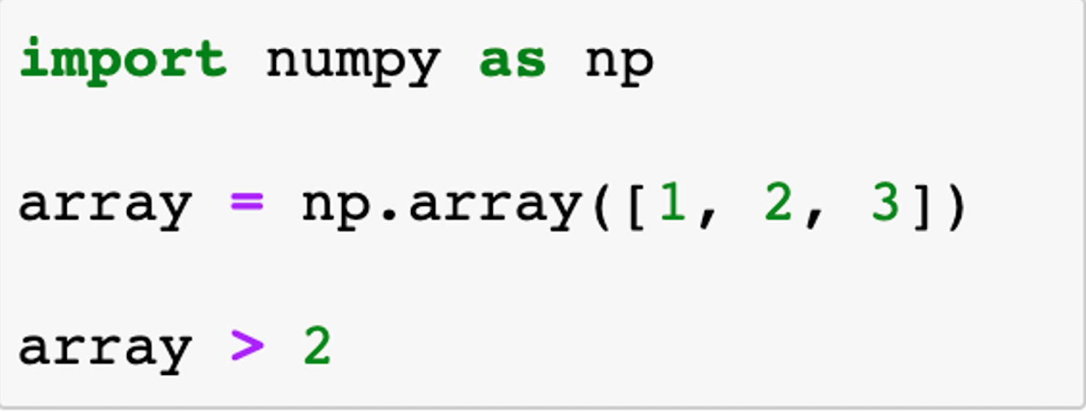

Q23. How many elements will be in the array returned by the following code?

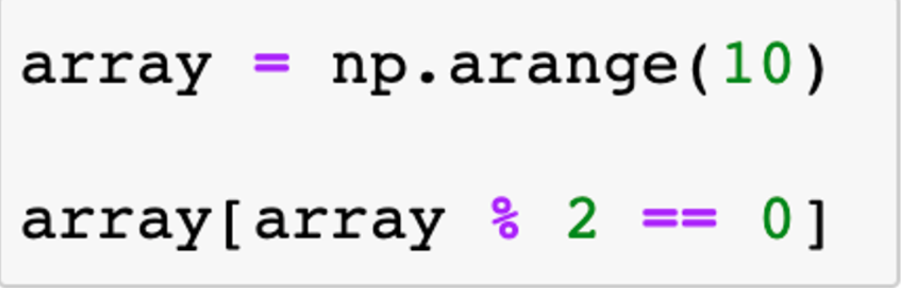

Q24. Which index value will return the last element in an 1D array?

Q25. Which Numpy function returns an array with values based on the results of logical test?

Q26. Which function will create an array out of a Python list?

Q27. Which function in Numpy will give me 16 random numbers between 2 & 202

Q28. What is the default series index?

Q29. What is the difference between.loc & .iloc?

Q30. Which of the following will return True if “hello” is found in a row of text?

* + 1. Series.str.contains(“hello”)
    2. Series.contains(“hello”)
    3. Series.str.search(“hello”)
    4. Series.search(“hello”)

Q31. Which method will produce the output seen here when called on the series “state”?

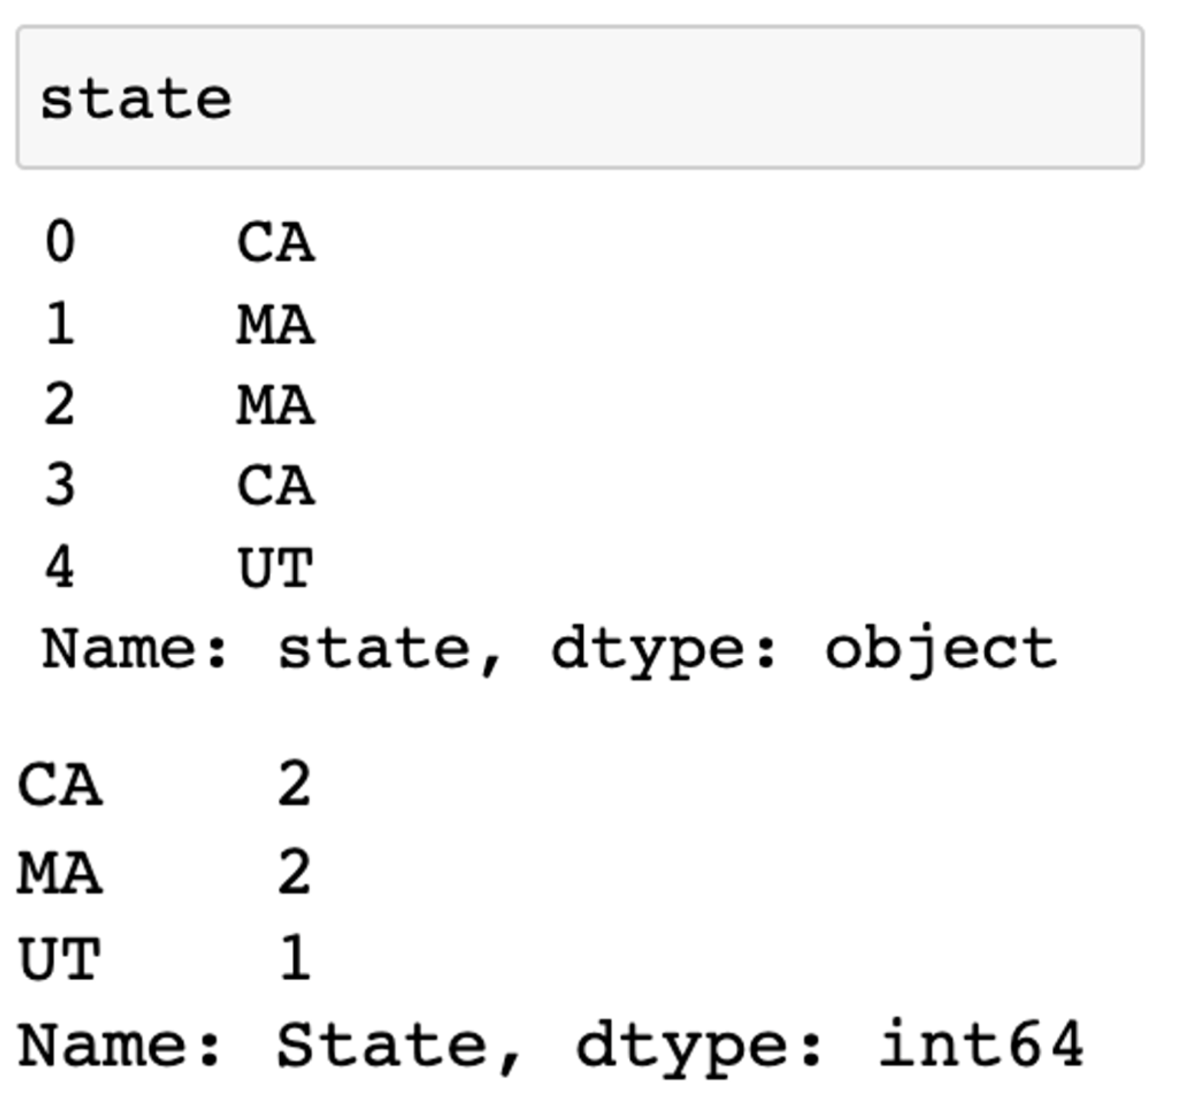

Q32. Which aggregation function will give me index value of maximum & minimum value in integer series?

Q33. What function does “!=” do while filtering?

Q34. What function does “~.isin()” do while filtering?

Q35. What is the difference between unique, nunique & value counts?

Q36. Where do we apply .split() function?

Q37. What will be the output of below codes? (attach screenshot)

X=pd.DataFrame([[10,20,30,40],[1,np.nan,3,4],[np.nan,np.nan,np.nan,np.nan]])

print(X.dropna())

Q38. What will be the output of below codes? (attach screenshot)

X = pd.DataFrame([[10,20,30,40],[10,20,30,40],[10,20,30,40], [100,200,300,400], [200,300,400,500,]])

print(X.duplicated())

Q39. What is the difference between dropping data 'in place' vs. dropping data 'not in place'?

Q40. How many rows will return below code?  
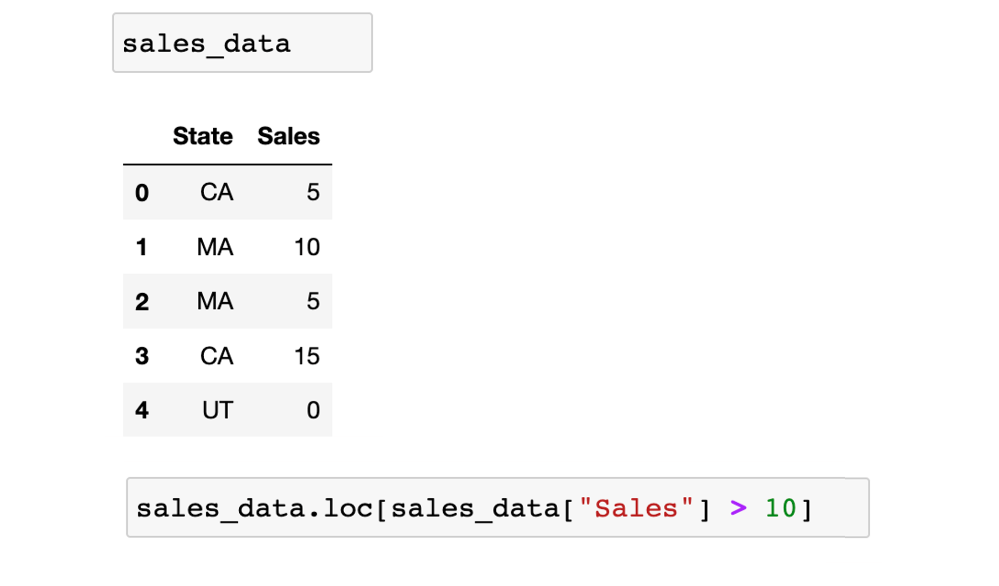

Q41. Which function will give me below output?  
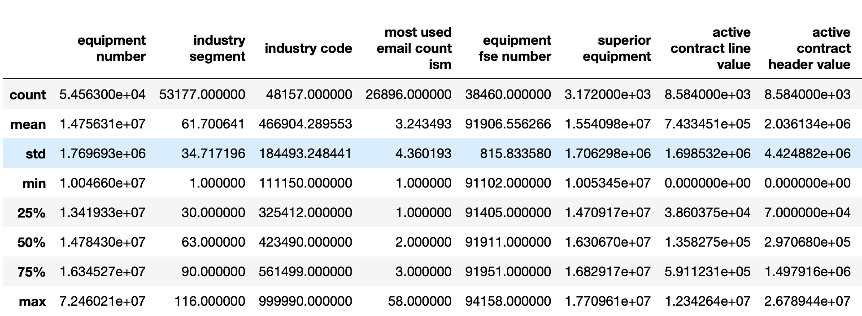

Q42. Which function will remove FTR & HTGS columns in below screenshot?

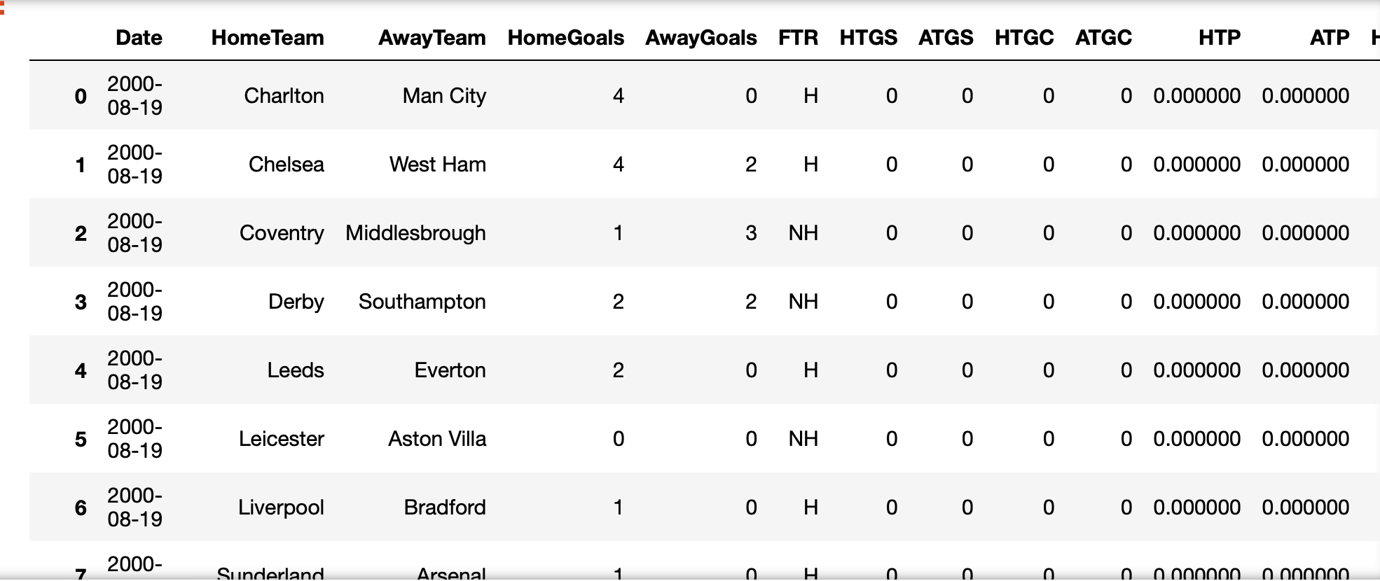

Q43. How to make all the column names in upper case for below dataframe?

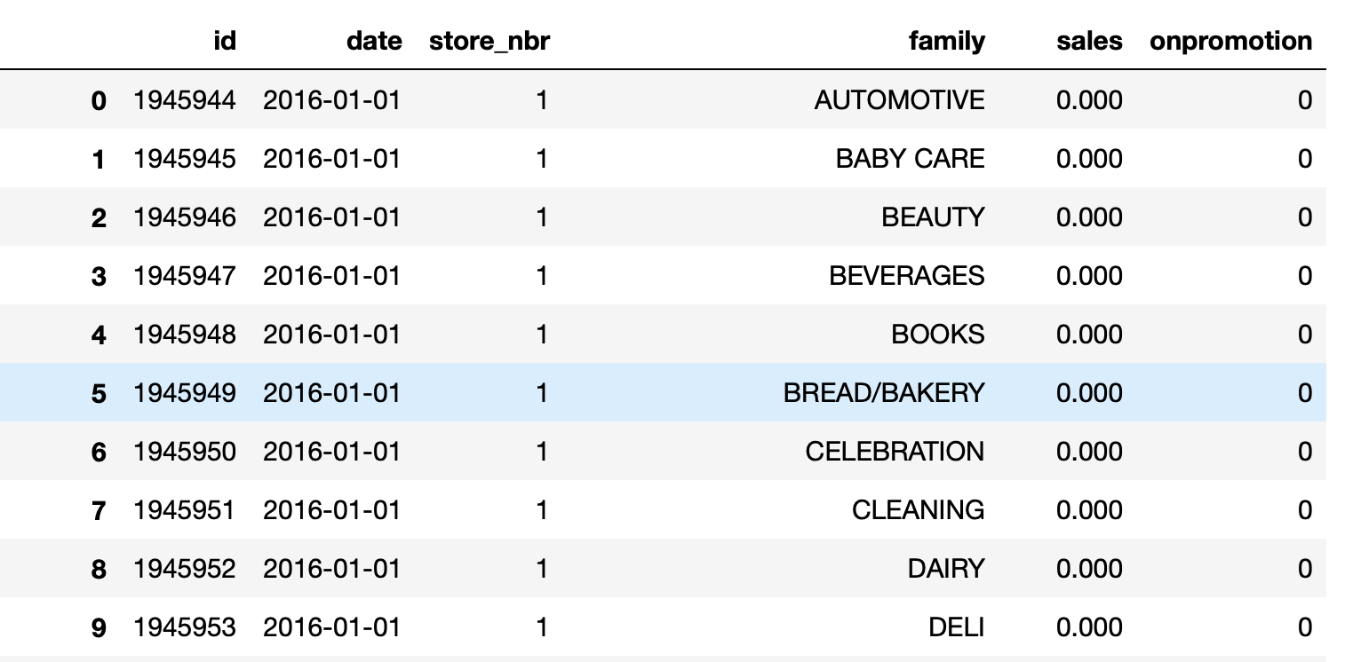

Q44. Which function will give me below output?

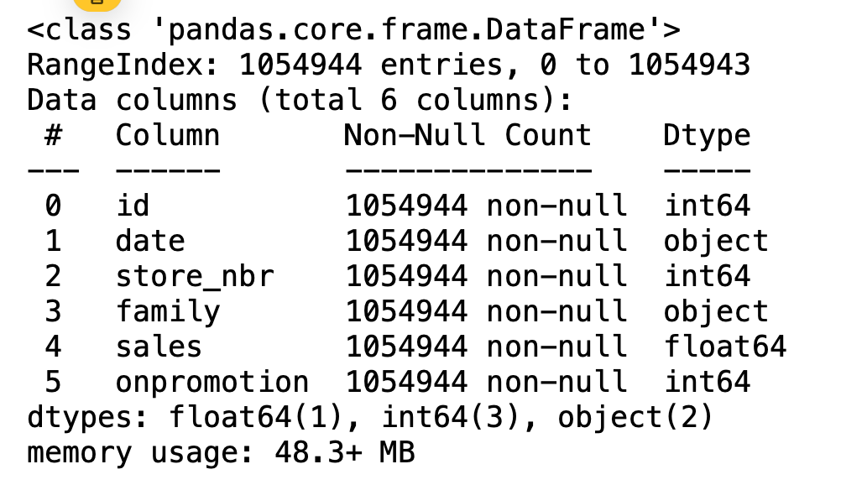

Q45. How to know number of null values for all the columns?

Q46. What’s the difference between pandas series, pandas dataframe & numpy 2d array?

Q47. Which method allows us to aggregate a DataFrame by a specific column or columns?

1. .aggregate()
2. .agg()
3. .groupby()
4. .groups()

Q48. How many rows will be in the dataframe returned by the following aggregation?

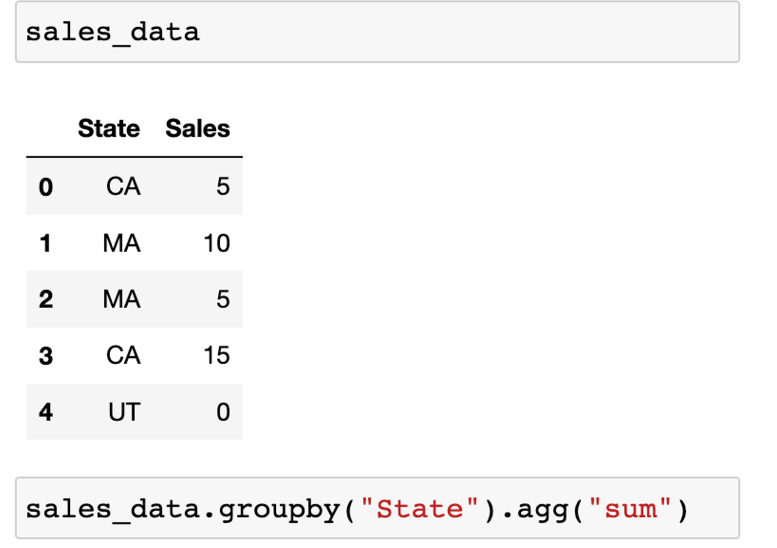

Q49. Which method allows us to perform aggregation while keeping rows intact?

1. .rowagg()
2. .transfer()
3. .nogroup()
4. .transform()

Q50. Which of the following method will extract month from datetime column?

1. df[“column”].dt.month
2. df[“column”].month
3. df[“column”].to_month
4. month(df[“column”])