# Basics of Python

Q1. Which one is ordered collection of multi-typed object?

1. List
2. Dictionary
3. Sets

Q2. Is tuple mutable?

1. Yes
2. No

Q3. Is String mutable?

1. Yes
2. No

Q4. What is the output of below code:

D = {'a':1, 'b':3, 'c':4}

D[0]

1. “a”
2. 1
3. “a”:1
4. Error

Q5. What will be the output?

setA = set("hello")

print(setA)

1. {‘h’, ‘o’, ‘l’, ‘e’}
2. {‘h’, ‘o’, ‘l’, ‘l’, ‘e’}
3. {‘h’, ‘e’, ‘l’, ‘l’, ‘o’}
4. {‘h’, ‘o’, ‘l’, ‘e’, ‘l’}

Q6. What will be the output?

X = 10  
X= 10.4  
X = "Hello World"

type(X)

1. Int
2. Float
3. Str

# Pandas

Q7. What is the default series index?

Q8. Write & explain any 5 functions of data pre-processing?

Q9. Which of the following will return True if “hello” is found in a row of text?

1. Series.str.contains(“hello”)
2. Series.contains(“hello”)
3. Series.str.search(“hello”)
4. Series.search(“hello”)

Q10. Which method will produce the output seen here when called on the series “state”?

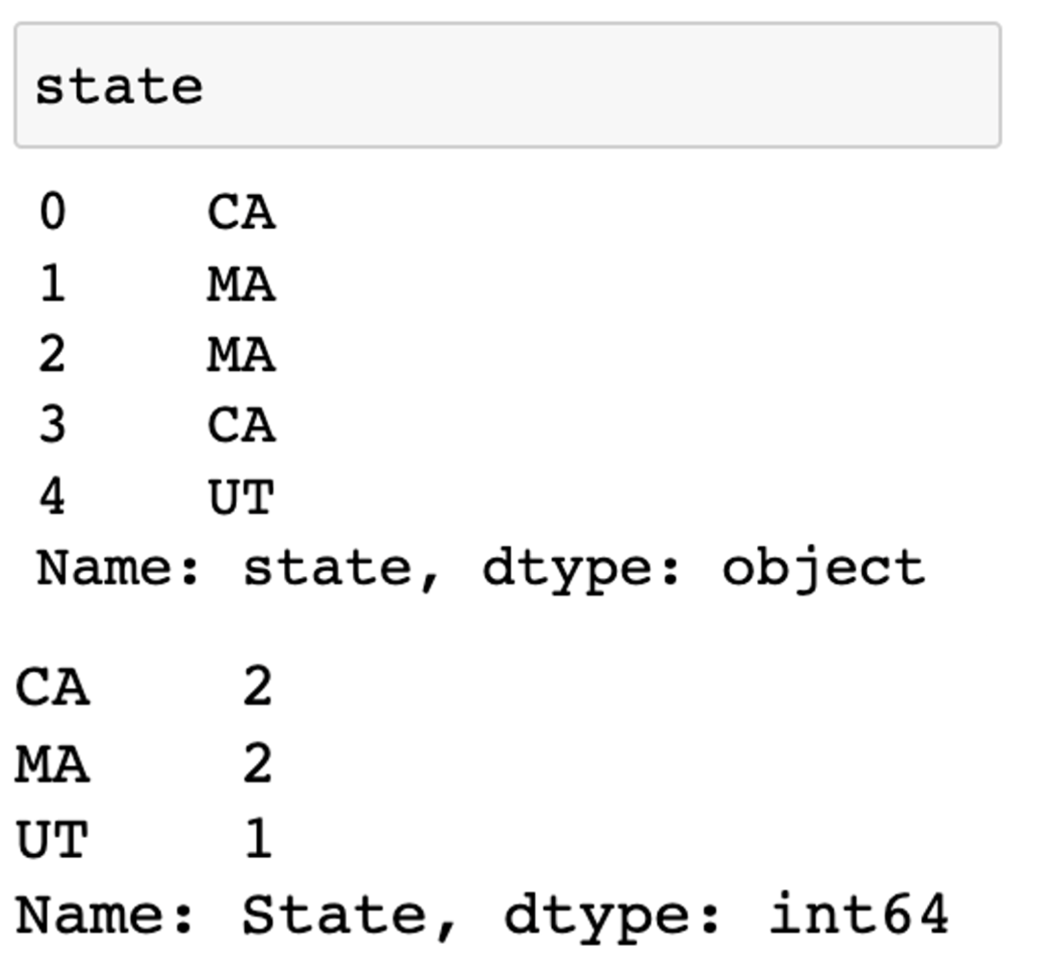

Q11. Which aggregation function will give me index value of maximum & minimum value in integer series?

Q12. What function does “!=” do while filtering?

Q13. What function does “~.isin()” do while filtering?

Q14. What is the difference between unique, nunique & value counts?

Q15. Where do we apply .split() function?

Q16. What is the difference between dropping data 'in place' vs. dropping data 'not in place'?

Q17. How many rows will return below code?

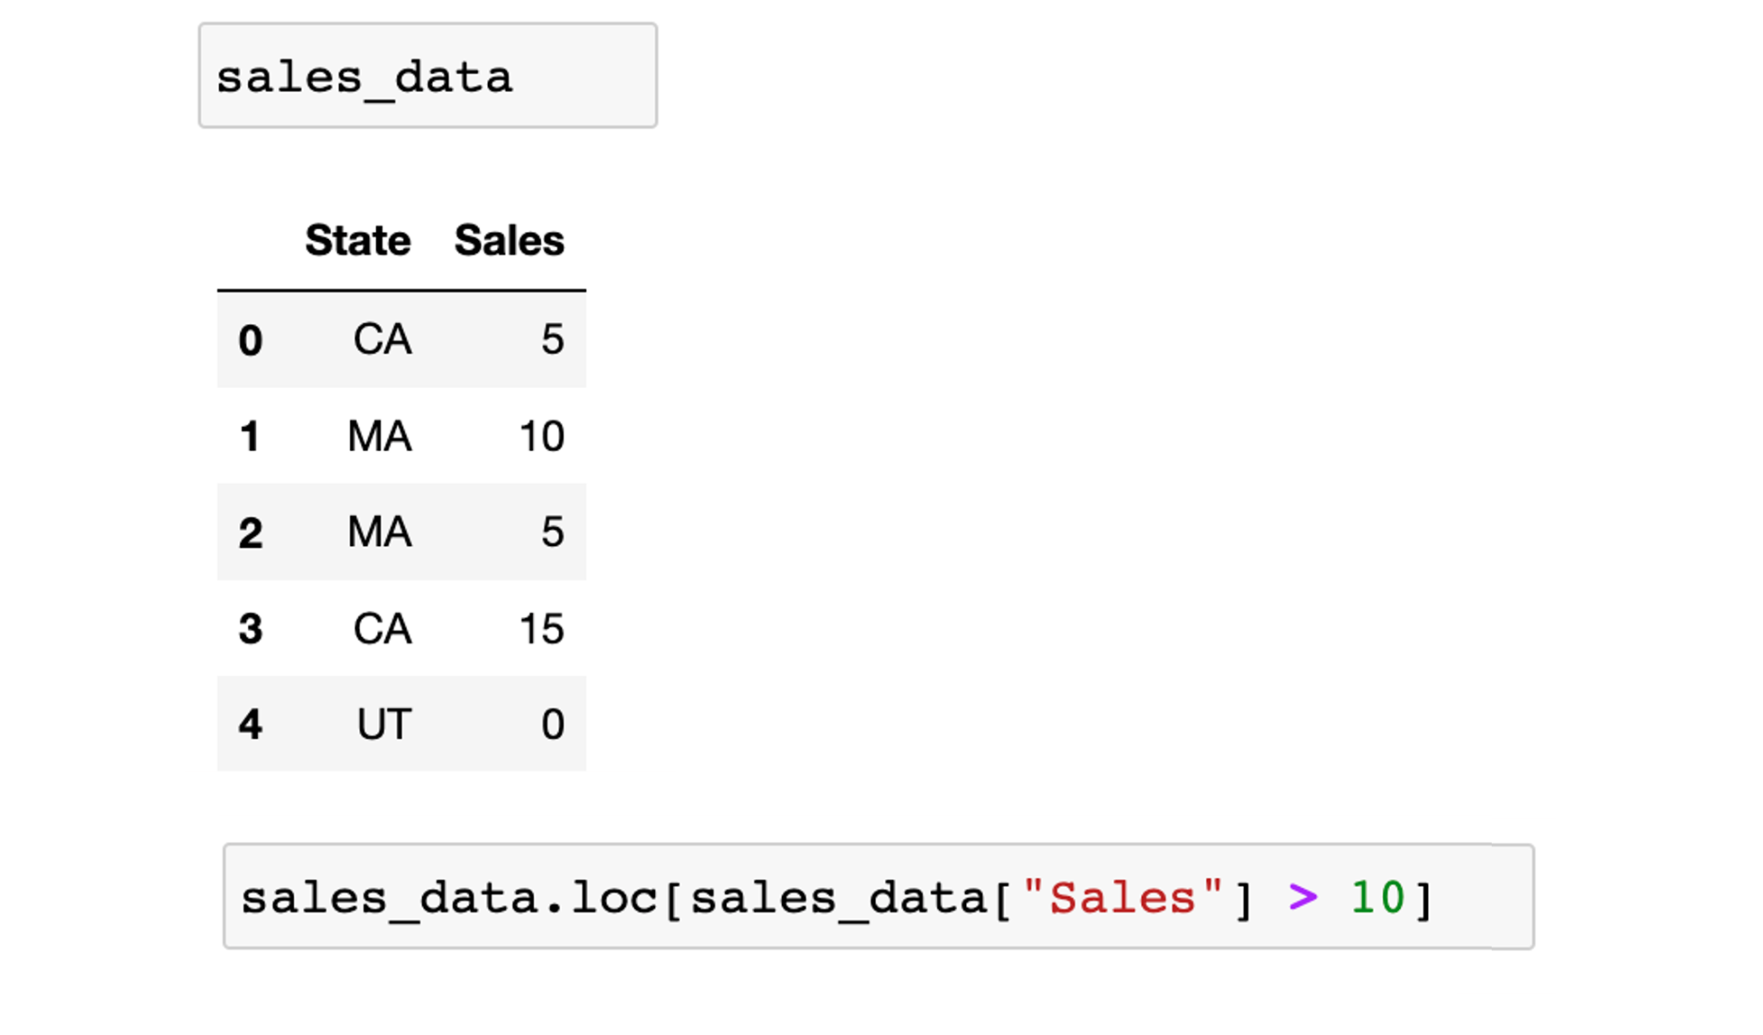

Q18. Which function will give me below output?

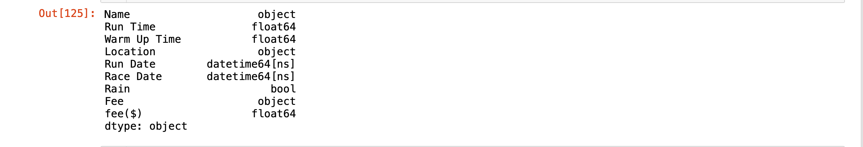

Q19. Which function will give me below output?

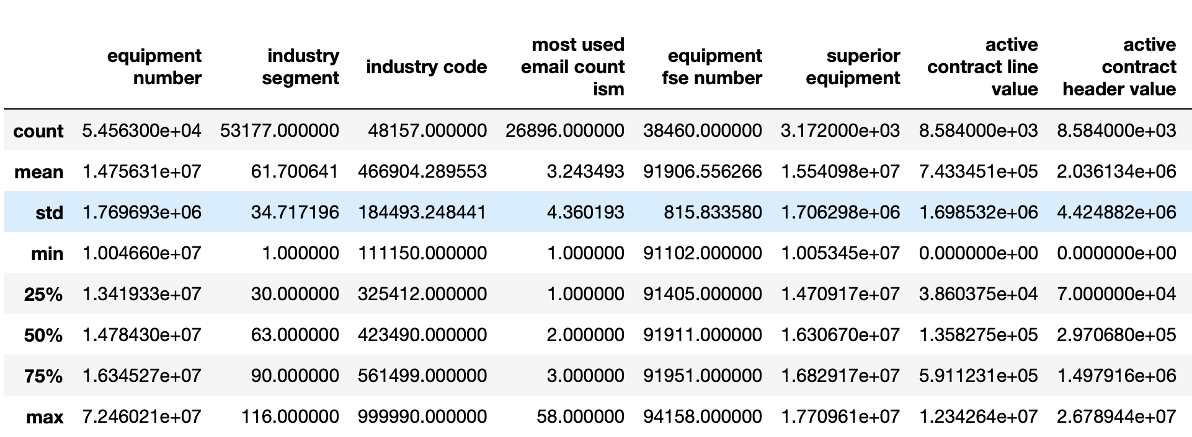

Q20. Which function will remove FTR & HTGS columns?

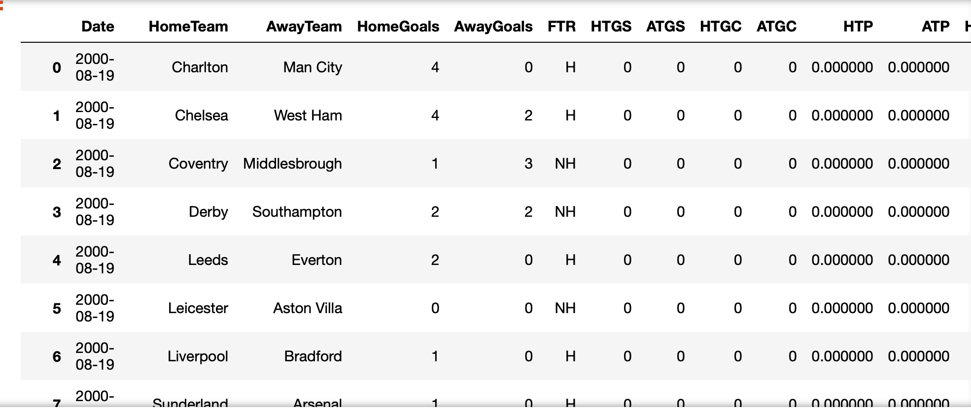

Q21. Which function will make all the columns in upper case for below dataframe?

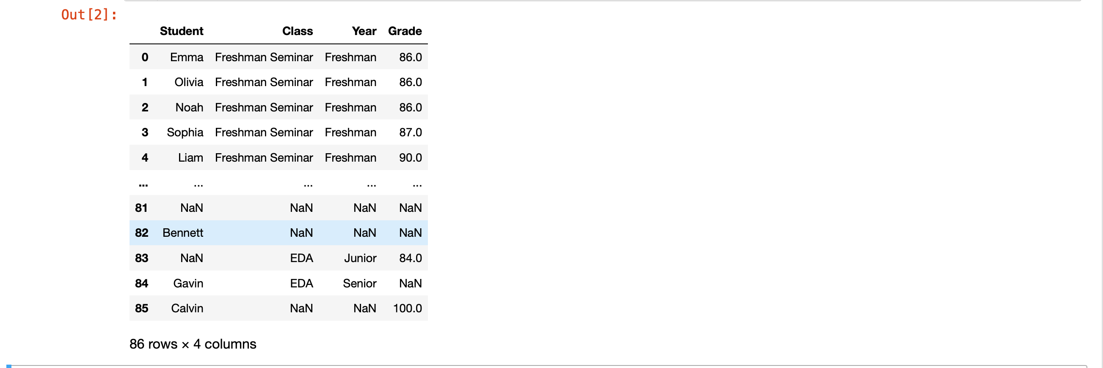

Q22. Which function will give me below output?

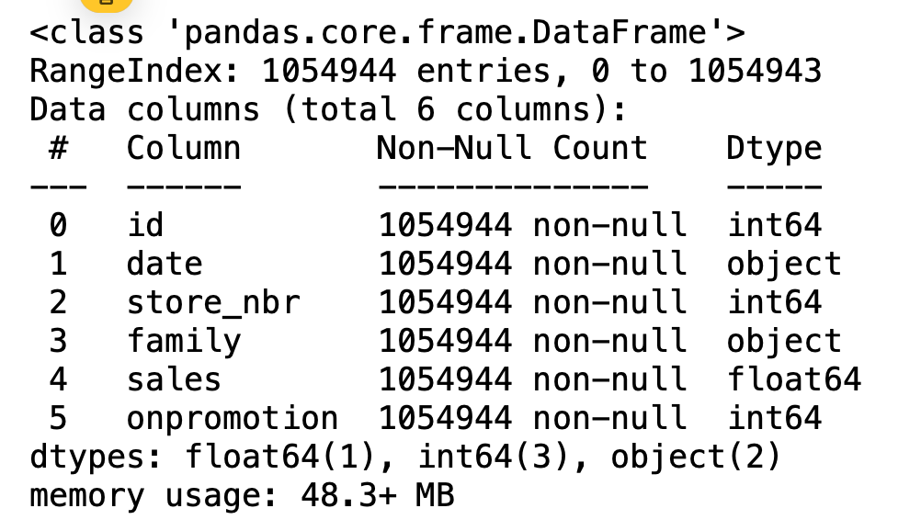

Q23. How to know number of null values for all the columns?

Q24. Write any 4 ways to deal with null values?

Q25. What’s the difference between pandas series, pandas dataframe & numpy 2d array?