# **Dry and Wet Waste Segregation**

**A PROJECT REPORT**

***Submitted by***

**Sunita Devi or 23MCC20094**

***Submitted to***

**Mr. Sachin Chawla**

***in partial fulfillment for the award of the degree of***

# **MASTER OF COMPUTER APPLICATIONS**



**University Institute of Computing**

**Chandigarh University**

**April 2025**

**Table of Contents**

**Dry and Wet Waste Segregation** 1

**MASTER OF COMPUTER APPLICATIONS** 1

Abstract 3

CHAPTER.1 4

Introduction 4

CHAPTER 3 5

Survey Report 5

CHAPTER 4. 6

Hardware Requirements (with Explanation) 6

4.4 Servo Motor (SG90) 8

Chapter 5. 9

Software Requirement 9

5.1 Arduino IDE (Integrated Development Environment) 9

Purpose: 9

Libraries Used in Your Project 9

Chapter 6. Block Diagram 11

🔄 Flow of Process (Left-side Arrows): 11

Right-side Ovals (Peripheral Components): 11

7. Flowchart 12

CHAPTER 8. Result 13

Working Model and Hardware Assembly 15

CHAPTER 9. Future Scope 16

# **Abstract**

This project introduces an innovative and automated smart waste segregation system designed to differentiate between wet and dry household waste. The primary objective is to simplify and enhance the waste management process at the source, thereby promoting environmental sustainability and reducing the burden on manual labor. The system employs a combination of sensors and actuators, including an ultrasonic sensor, a soil moisture sensor, a servo motor, and an LCD display, all integrated through an Arduino microcontroller.

The ultrasonic sensor first detects the presence of waste as it is placed near the segregation unit. Upon detection, the waste is analyzed by the soil moisture sensor, which measures the moisture content to determine whether the waste is wet (organic/biodegradable) or dry (inorganic/recyclable). Based on the sensor readings, the Arduino processes the input and commands the servo motor to rotate in the appropriate direction, allowing the waste to be deposited into the correct bin. Simultaneously, an LCD screen provides real-time feedback by displaying system status, sensor data, and waste type classification.

This intelligent system eliminates the need for manual segregation, which is often unhygienic and inefficient, especially in households and small communities. By automating the classification process, the system encourages responsible waste disposal practices and supports the efficient recycling and composting of waste materials. The compact design and use of affordable components make this solution scalable and suitable for both urban and rural deployment. Through this project, we aim to contribute towards cleaner surroundings, improved waste handling, and a step forward in achieving sustainable development goals.

Moreover, the system serves as a foundational model that can be further developed or scaled to accommodate additional types of waste (e.g., metallic, hazardous, or e-waste) using advanced sensors and machine learning algorithms. It lays the groundwork for smarter, technology-driven waste management infrastructures and contributes meaningfully to the objectives of sustainable development—such as reducing landfill dependency, improving recycling rates, and conserving natural resources.

Through this project, we strive to demonstrate how small-scale innovations in waste management can have a far-reaching impact on environmental health and community well-being. By bridging the gap between technology and everyday environmental challenges, this project represents a significant step forward in achieving long-term sustainability goals and fostering a cleaner, greener future.

# **Introduction**

The rapid growth in population, urbanization, and consumerism has led to a significant rise in the generation of household waste. This increase in waste production poses serious challenges for municipal waste management authorities, especially when it comes to the effective segregation and treatment of solid waste. Proper segregation at the source is a critical step in ensuring that recyclable materials are not contaminated, organic waste is composted appropriately, and non-recyclable waste is disposed of in an environmentally friendly manner.

However, in most households and small communities, segregation of waste is still carried out manually, which is not only inefficient but also unhygienic and labor-intensive. Manual segregation often leads to errors, where wet and dry waste are mixed, making it difficult to recycle or process the waste further. This improper handling and mixing of waste results in increased landfill use, greenhouse gas emissions, and environmental pollution.

To tackle these challenges, the proposed smart waste segregation system aims to automate the initial segregation process using affordable and easily available electronic components. The system is built around an Arduino microcontroller and utilizes an ultrasonic sensor to detect the presence of waste, a soil moisture sensor to analyze its composition, a servo motor to direct it to the appropriate bin, and an LCD to display system status and real-time data. The integration of these components allows the system to classify waste into wet and dry categories without human intervention.

The core objective of this project is to develop a low-cost, efficient, and user-friendly solution for household waste management that not only reduces the burden on municipal systems but also promotes responsible waste disposal habits among individuals. By automating segregation at the source, this system can significantly improve the efficiency of downstream processes such as recycling, composting, and waste treatment. Moreover, this project supports the broader vision of smart cities and sustainable living by leveraging technology to solve one of the most pressing environmental issues of our time. The system’s design emphasizes cost-effectiveness, portability, and ease of integration. It uses readily available electronic components such as sensors, a microcontroller, and actuators, making the technology accessible even to low-income or resource-constrained areas. Its compact size and modular nature allow it to be installed in various settings—ranging from residential buildings and apartment complexes to schools, offices, and rural homes—without the need for significant structural changes.

The heart of this system is an Arduino microcontroller, which processes the data from the sensors and controls the servo motor based on predefined logic.

In addition to promoting cleanliness and hygiene, this system encourages environmentally responsible behavior and aids in the efficient processing of waste by downstream recycling and composting facilities. It serves as a stepping stone toward smarter cities and aligns with national and global initiatives focused on sustainable development, clean technology, and resource conservation.

By introducing automation into the segregation process, this project aims to revolutionize how everyday waste is handled at the grassroots level. It holds the potential to transform waste management into a more intelligent, hygienic, and eco-friendly practice, ultimately contributing to a healthier environment and more sustainable future.

# **Survey Report**

Various waste segregation systems have been developed in recent years. Some employ image processing or machine learning, which, while accurate, are expensive and complex for small-scale applications. Simpler systems using sensors are affordable and practical for home and educational use. From our research, sensor-based segregation using Arduino is effective for classifying common household waste with minimal hardware.

In recent years, the growing concern over improper waste disposal and its impact on the environment has led to the development of various smart waste segregation systems. Several research studies and prototype implementations have explored different techniques and technologies to automate the segregation process and improve the efficiency of waste management at both community and household levels.

One common approach involves the use of image processing and machine learning algorithms to identify and classify waste. These systems typically use cameras to capture images of waste items and employ trained models to determine their type—such as plastic, metal, organic, or paper. As a result, such systems are generally more suitable for large-scale industrial or municipal applications rather than domestic environments.

On the other hand, sensor-based systems provide a more practical and cost-effective alternative for small-scale implementations such as homes, schools, and community centers. These systems typically rely on a combination of sensors—like infrared, capacitive, ultrasonic, and moisture sensors—to detect physical and chemical properties of waste materials.

During our research, we reviewed a variety of existing sensor-based segregation models, many of which use microcontrollers like Arduino or Raspberry Pi as the control unit. Arduino-based systems, in particular, have gained popularity due to their affordability, ease of use, and support for multiple sensor modules. Projects documented in open-source communities and academic papers show successful segregation of household waste using combinations of moisture sensors to detect wetness, metal detectors for metallic objects, and proximity sensors for automatic bin activation.

Our analysis revealed that for common domestic waste segregation—especially for the basic wet and dry classification—sensor-based systems provide a reliable and economical solution. Combining these with a servo motor for bin control and an LCD for real-time display results in a system that is both functional and user-friendly.

In conclusion, while advanced technologies offer sophisticated waste classification, they often exceed the needs and budgets of household users. For small-scale, community-level, or educational implementations, Arduino-powered, sensor-based waste segregation systems strike an ideal balance between functionality, simplicity, and cost-efficiency. Our project builds upon these findings to create a smart, compact, and effective solution that meets the basic segregation needs of everyday users.

**Hardware Requirements** (with Explanation)

**Arduino UNO** 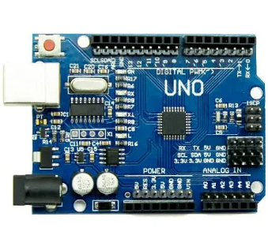  
The Arduino UNO is an open-source microcontroller development board based on the ATmega328P microchip. It features 14 digital input/output pins (of which 6 can be used as PWM outputs), 6 analog inputs, a 16 MHz quartz crystal, a USB connection, a power jack, and a reset button. It is one of the most widely used boards in embedded electronics due to its simplicity, flexibility, and strong community support.

Why we use it?

In this project, the Arduino UNO serves as the central control unit or the brain of the smart waste segregation system. It plays a critical role in:

Reading data from sensors (ultrasonic and soil moisture sensors)

Making logical decisions based on sensor input (e.g., determining the type of waste)

Controlling the servo motor to direct waste into the appropriate bin

Sending real-time output to the LCD display for user feedback

Its ability to handle multiple I/O operations, easy coding with the Arduino IDE, and compatibility with a wide range of sensors and modules make it an ideal choice for this application.

* Integration with the system:  
  The Arduino UNO is the hub to which all the components are connected:
* The ultrasonic sensor is connected to the digital pins to detect the presence and distance of waste.
* The soil moisture sensor is connected to the analog input pins to measure the moisture content in the waste.
* The servo motor is connected to a digital PWM pin, which receives signals to rotate to the desired angle depending on the waste type.
* The LCD display is connected via digital pins (or I2C if using an I2C module) to display sensor values, waste classification status, and system alerts.
* With its compact size and ability to process inputs and control outputs in real time, the Arduino UNO enables seamless coordination of all hardware elements, making the entire waste segregation system functional and efficient.

4.2. **Ultrasonic Sensor (HC-SR04)**

The HC-SR04 Ultrasonic Sensor is an electronic device that measures distance by using ultrasonic sound waves. It consists of two main components: a transmitter (Trig) that emits high-frequency sound waves and a receiver (Echo) that detects the reflected wave. It can measure distances ranging from 2 cm to 400 cm with good accuracy.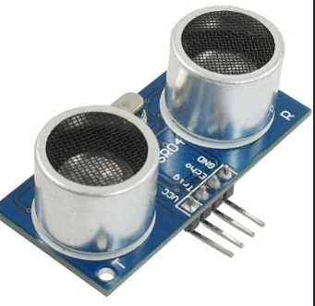Why we use it?  
In this project, the ultrasonic sensor is used to detect the presence of waste by calculating the distance between the sensor and the incoming object. When waste is dropped or placed in front of the system, the sensor recognizes it by detecting a reduction in distance from its baseline (empty bin distance). This triggers the waste classification process.

* + How it works with Arduino:  
    The ultrasonic sensor is connected to two digital pins of the Arduino:
  + 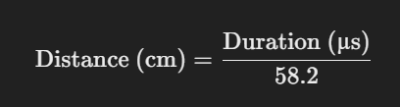Trig Pin – Arduino sends a short 10-microsecond HIGH pulse to this pin to trigger the sound wave.Echo Pin – The sensor receives the reflected sound wave and sends back a pulse to the Echo pin.  
    The Arduino measures the duration of this returned pulse, which is directly proportional to the distance of the object. Using the speed of sound, the Arduino calculates the distance with the following formula:
* If the calculated distance falls below a predefined threshold (e.g., 10 cm), the Arduino interprets it as waste detected and initiates the next step—moisture detection.
* Integration in the system:  
  The sensor is placed above the input chute or entry point of the waste segregation system. It serves as the triggering mechanism that starts the entire classification and binning sequence.

4.3 **Soil Moisture Sensor**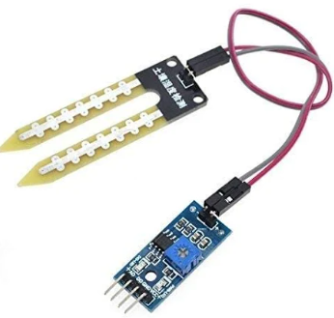

What is it?  
The Soil Moisture Sensor is an analog sensor designed to measure the moisture content in a material. Originally intended for agricultural applications, it determines how much water is present by measuring the resistance between two probes inserted into the substance. The wetter the material, the lower the resistance and higher the output signal.

Why we use it?  
In the context of this waste segregation system, the soil moisture sensor is used to differentiate between wet and dry waste. Wet waste (such as food scraps, fruits, or vegetable peels) contains a significant amount of moisture, whereas dry waste (like plastic, paper, and metal) does not. By reading the moisture level of the waste material, the system can classify it accurately and efficiently without human intervention.

Integration with Arduino:

Higher values (close to 1023) indicate dry waste. Lower values (closer to 0) indicate wet waste. A threshold value is predefined (e.g., 500) to distinguish between wet and dry types. If the analog reading is below the threshold, the waste is classified as wet; if it is above, it is considered dry. System Role:  
After the ultrasonic sensor detects an object, the soil moisture sensor takes a reading from the waste material. Based on this data, the Arduino triggers the servo motor to rotate toward the appropriate bin, ensuring correct classification.

### 4.4 **Servo Motor (SG90)**

* **What is it?** A small motor that can rotate between 0° and 180°.
* **Why we use it?** To physically direct waste to wet or dry bins.
* **Connection:** Controlled using a PWM pin from the Arduino (typically pin 9).

4.5 **16x2 I2C LCD**

* **What is it?** A 16-column, 2-row display with an I2C adapter.
* **Why we use it?** Displays messages like "Waste Detected", "Type: Wet" or "Type: Dry".
* **Integration:** Only two wires (SDA and SCL) connected to A4 and A5 on Arduino make it simple to use.

4.6 **Jumper Wires and Breadboard**

**Purpose:** Used to make temporary connections between components without soldering.

# **Software Requirement**

### 5.1 **Arduino IDE (Integrated Development Environment)**

### **Purpose:**

The **Arduino IDE** is a software platform used for programming Arduino microcontrollers. It allows you to:

* **Write** the code (called a sketch).
* **Verify/Compile** the code to check for errors.
* **Upload** the code to the Arduino board via USB.

#### **Key Features:**

* Simple editor with syntax highlighting.
* One-click Verify and Upload buttons.
* Serial Monitor for debugging sensor outputs.
* Supports multiple boards (like Uno, Mega, Nano).
* Open-source and beginner-friendly.

### **Libraries Used in Your Project**

#### 5.2. **LiquidCrystal_I2C.h**

##### **Purpose:**

This library is used to interface with **LCDs** (like 16x2 or 20x4) that are connected via **I2C module** instead of the standard 16-pin parallel interface. The I2C module uses only **two wires (SDA & SCL)**, saving Arduino pins.

##### **What It Does:**

* Initializes the LCD screen.
* Displays messages (like "System Ready...", sensor values, etc.).
* Positions text on specific rows and columns.

##### **Common Functions:**

lcd.begin(16, 2); // Set LCD size

lcd.setCursor(0, 0); // Set cursor to column 0, row 0

lcd.print("Hello World"); // Print message

lcd.clear(); // Clear screen

#### 5.3 **Servo.h**

#### **Purpose:**

This library is used to control **servo motors**, which are essential for moving parts like the waste bin divider in your project. **What It Does:**

* Sends PWM signals to the servo motor.
* Sets the angle of rotation (like 0°, 90°, 180°).
* Allows smooth and accurate movement.

##### **Common Functions:**

Servo myservo; // Create a servo object

myservo.attach(9); // Attach to pin 9

myservo.write(90); // Rotate to 90 degrees

In your project:

* If waste is **wet**, the servo turns to the **wet bin** side.
* If **dry**, it turns to the **dry bin** side.
* After 3 seconds, it resets to **90°** (neutral position).

# **Block Diagram**

This block diagram visually represents the **waste segregation process** using your Arduino-based system. Here's a step-by-step explanation of each part:

### 🔄 **Flow of Process (Left-side Arrows):**

1. **Waste**
   * Waste is introduced into the system.
2. **Ultrasonic Sensor**
   * Detects the presence of waste (typically by sensing distance).
   * **Also triggers the Soil Moisture Sensor** to start measuring moisture content of the waste.
3. **Arduino UNO**
   * Acts as the central controller.
   * It receives data from the ultrasonic sensor and soil moisture sensor.
   * Processes the data to decide how to act (e.g., whether the waste is wet or dry).
4. **Servo Motor**
   * Controlled by Arduino.
   * It positions the waste accordingly by rotating toward the **wet bin** or **dry bin**.
5. **Move to Dry/Wet Bin**
   * The waste is finally sorted based on its moisture level.

### **Right-side Ovals (Peripheral Components):**

* **[Soil Moisture]**
  + Activated by the ultrasonic sensor or Arduino UNO.
  + Measures if the waste is wet or dry.
* **LCD Display**
  + Displays system status or results (e.g., "Dry Waste Detected", "Moving to Wet Bin", etc.).
  + Helps users monitor the operation in real-time.

# **Flowchart**

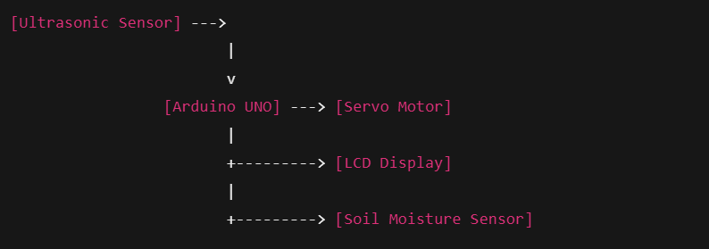

The flowchart you've provided describes the sequence of operations in your waste segregation system involving an Arduino UNO and several sensors. Here’s a breakdown of the flow:

1. Ultrasonic Sensor: This is the starting point of the process. The sensor is likely measuring distance or detecting obstacles to determine the presence of waste.
2. Arduino UNO: The input from the ultrasonic sensor is fed to the Arduino UNO, which processes the data and controls the other components based on the sensor readings.
3. Servo Motor: Depending on the input from the ultrasonic sensor, the Arduino UNO controls the servo motor. This could be for sorting or positioning the waste.
4. LCD Display: Simultaneously, the system shows relevant information (perhaps status or data from the sensors) on an LCD display. This provides visual feedback to the user.
5. Soil Moisture Sensor: The soil moisture sensor is another component of your system. Based on its reading, the Arduino UNO may take actions, such as separating the wet waste from the dry waste.

# **Result**

The system successfully detects the presence of waste using the ultrasonic sensor. Once detected, it reads the moisture content to classify the waste. The servo motor directs the waste to either the wet or dry bin based on the reading. The LCD provides real-time feedback. The system operates accurately within the set range and effectively performs automatic segregation.

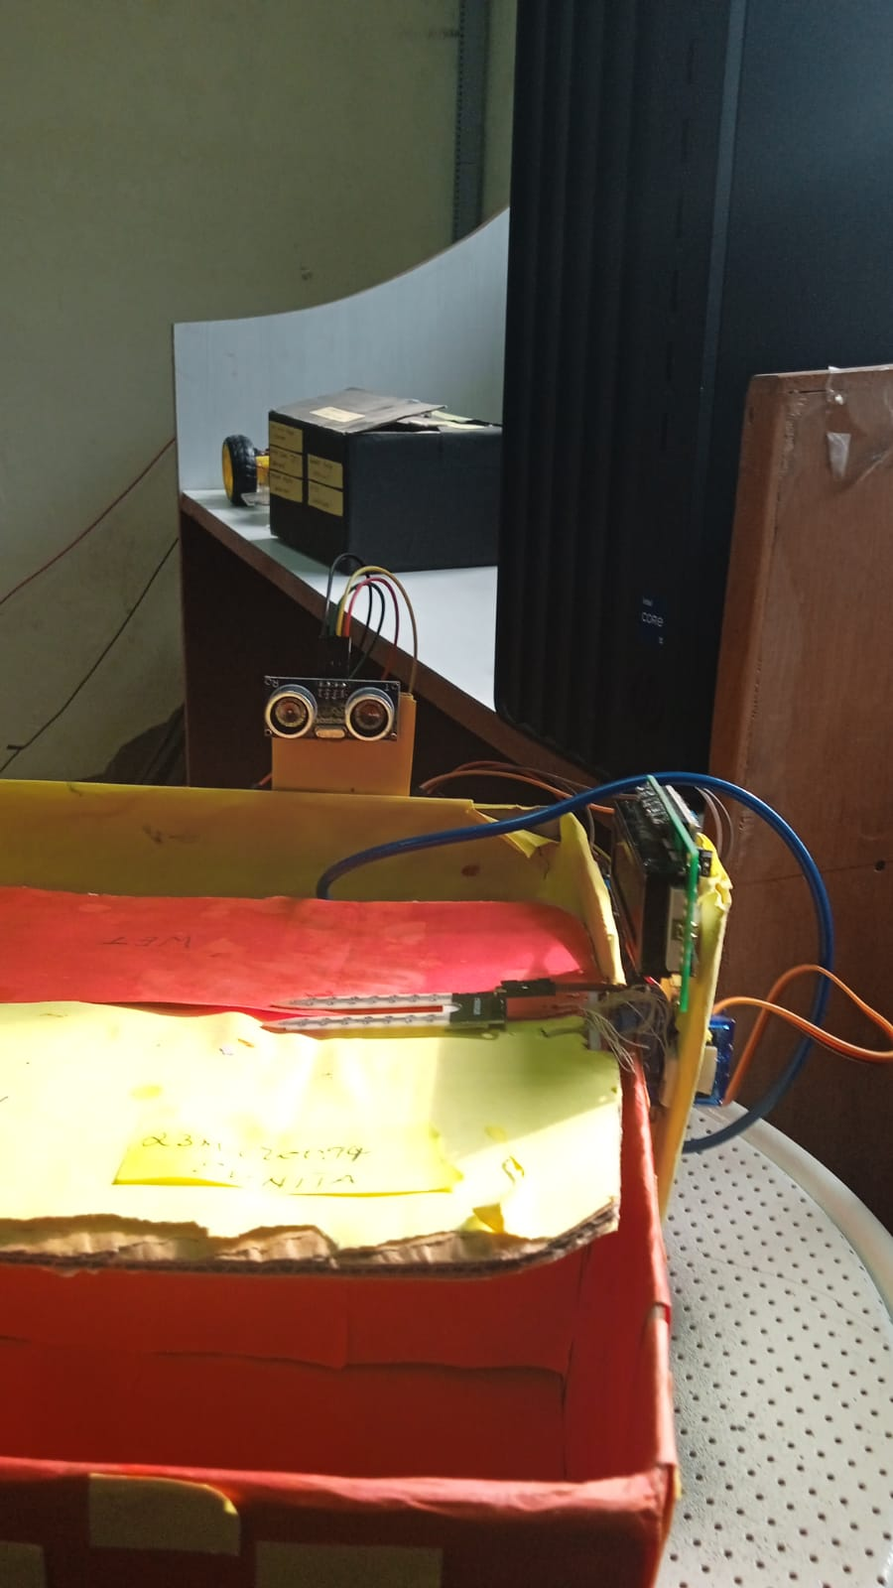81. Circuit Diagram

**Fig. 1.** Prototype of wet and dry waste segregation system showing compartments, ultrasonic sensor, LCD module, and servo-actuated flap.

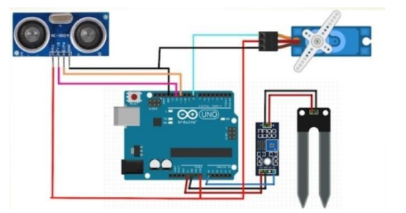

Additionally, waste segregation is vital for public health, particularly in the separation of hazardous and non-hazardous waste. Health-related issues may arise when waste is discarded without proper segregation, with various illnesses linked to the presence of non-biodegradable and toxic waste.

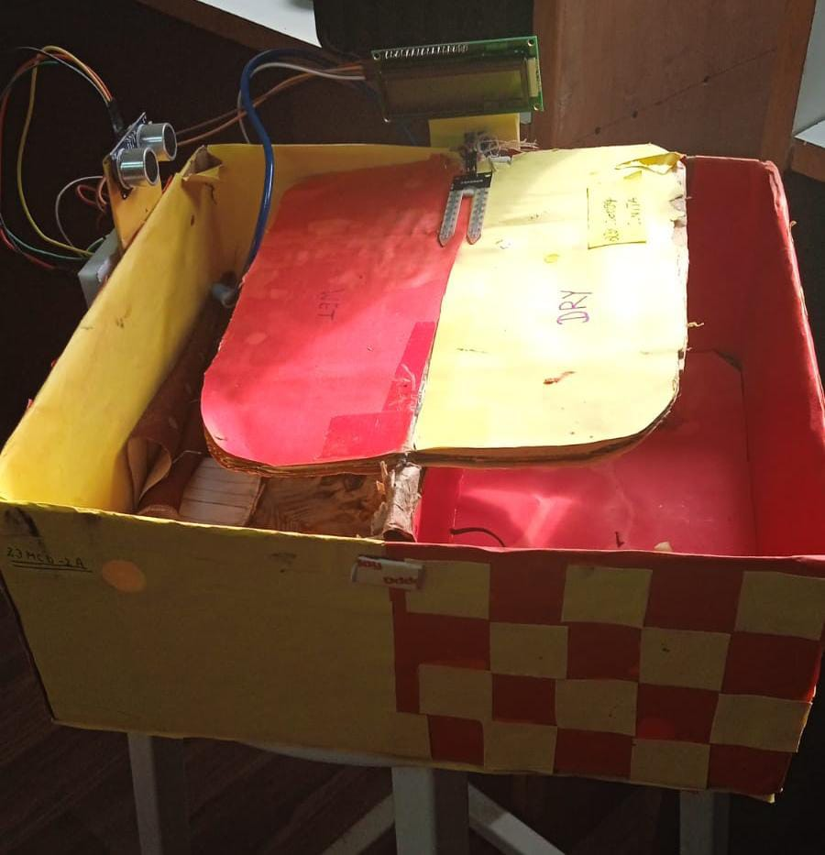 The process involves a plank where a moisture sensor detects the wet or dry nature of an object placed on it. Based on this determination, a servo motor directs the waste into the corresponding bins. Subsequently, an ultrasonic sensor gauges the distance from the bin's surface to the garbage. When the bin reaches full capacity, a signal is sent to the Arduino Uno, which, in turn, communicates with the computer. The process pauses until the bin is emptied

Waste segregation plays a crucial role in enhancing the reuse, recycling, and recovery of waste, thereby improving the overall recycling process. The practice ensures that only degradable wastes are disposed of in the natural environment, leading to a reduction in overall pollution. The efficient use and preservation of resources for future generations are promoted through waste segregation.

Introducing this system at a local level, such as in residential areas, educational institutions, etc., can alleviate the burden on local authorities. The automated waste segregator represents a small yet significant stride toward establishing an efficient and cost-effective waste collection system, minimizing human intervention and eliminating potential hazards to human life. The incorporation of a conveyor belt enhances the system's accuracy, cost efficiency, and ease of installation, making it suitable for domestic use.

The segregation of various wastes at the household level also contributes to time savings. During the implementation of our system, challenges were encountered, including issues with the sensing range of the inductive proximity sensor and the accuracy of the moisture sensor, among others. Despite these challenges, modifications were applied to enhance the system's reliability, although perfection was not entirely achieved.

The advantages of reducing human time and effort, promoting health and sanitation, protecting the environment, and ensuring cleaner garbage disposal are integral to the implementation of this system.

### **Working Model and Hardware Assembly**

The prototype model of the proposed system for wet and dry waste segregation is illustrated in Fig. 1. It consists of an enclosed dual-compartment box made from cardboard, divided into two sections labeled "WET" and "DRY" respectively. The model integrates various sensors and actuators connected to a central microcontroller unit (Arduino Uno), ensuring real-time identification and segregation of household waste.

#### A. **Ultrasonic Sensor (HC-SR04)**

Mounted on the upper left side of the model, the ultrasonic sensor functions as a proximity detector. When waste is brought near the opening, the sensor calculates the distance of the object using ultrasonic waves, thereby triggering the system to prepare for classification.

#### B. **Soil Moisture Sensor**

Located centrally just above the flap, the soil moisture sensor plays a pivotal role in determining the type of waste. When the waste comes in contact with this sensor, it measures the moisture content. A high moisture level indicates wet waste (e.g., food scraps), while a low reading classifies it as dry waste (e.g., paper, plastic).

#### C. **Servo Motor and Flap Mechanism**

The decision based on sensor data is processed by the Arduino, which then controls a servo motor attached to a movable flap. This flap rotates either left or right, directing the waste into the appropriate compartment. This mechanism ensures accurate segregation with minimal mechanical delay.

#### D. **LCD Display Unit**

An LCD module is attached to the front top of the system to display real-time system status. It communicates the waste classification result ("Wet Waste Detected" or "Dry Waste Detected") to the user, thereby enhancing transparency and usability.

#### E. **Power and Connectivity**

The entire system is powered using a standard 5V power supply. All components are interconnected via jumper wires. The compact design ensures modularity and ease of maintenance or upgrades.

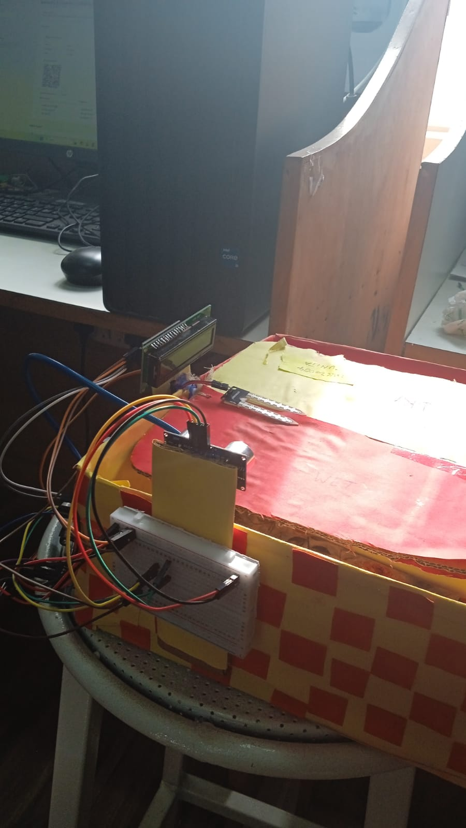

# **Future Scope**

The proposed waste segregation system serves as a foundational model for efficient and automated waste management. In the future, this system can be integrated with IoT platforms to enable remote monitoring of bin status, usage patterns, and maintenance alerts. Solar power can be incorporated to make the system more sustainable and suitable for deployment in remote or rural areas. Additionally, by utilizing machine learning and image recognition, the system can be enhanced to identify various types of waste such as hazardous, recyclable, or organic materials with higher accuracy. A mobile application interface may also be introduced to provide real-time notifications to users regarding bin capacity and collection schedules, improving user engagement and waste disposal practices. Further advancements could include automated lid mechanisms, waste compaction features, and smart notification systems using GSM or Wi-Fi modules to alert municipal authorities when bins reach full capacity. These improvements will not only enhance operational efficiency but also contribute to cleaner and smarter urban environments.

The prototype model developed for wet and dry waste segregation using Arduino-based sensors offers a promising starting point for addressing the growing need for automated waste management systems. Looking ahead, the project holds significant potential for scalability and integration with advanced technologies. By incorporating Internet of Things (IoT) capabilities, the system can be upgraded to enable real-time data monitoring, remote access, and cloud-based analytics. This would allow municipal bodies and sanitation workers to track bin fill levels, predict collection requirements, and optimize route planning for waste collection vehicles, thereby reducing fuel consumption and operational costs. Moreover, the system can be powered through renewable energy sources such as solar panels, promoting sustainability and enabling deployment in remote or off-grid locations. Machine learning algorithms can be integrated to train the system for more accurate classification of complex waste types such as hazardous materials, recyclables, and biodegradable waste, surpassing the binary wet-dry categorization. Enhancements such as voice alerts, multilingual LCD interfaces, and app-based dashboards can significantly improve usability and accessibility for users across diverse demographics. Additionally, the structure can be made weather-resistant and more robust, making it suitable for outdoor installation in public places like parks, marketplaces, and educational institutions. With the addition of GSM or Wi-Fi modules, automated notification systems can be implemented to send alerts to waste management authorities when bins are full or malfunctioning, reducing manual inspection and response times. The implementation of robotic arms or conveyor systems may further automate the sorting and disposal process, especially in large-scale applications like industrial waste processing units or smart cities. These developments could collectively lead to a smarter, cleaner, and more efficient urban environment, aligning with the goals of sustainable development and smart infrastructure initiatives.