1. Create a custom pipe for employee grades. ( Refer the image )

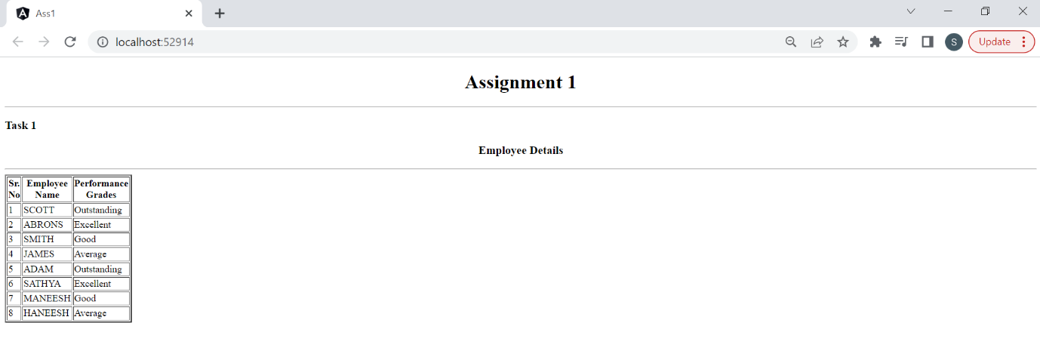

2. Update the Employees component to implement the same functionality using Buttons for each department. (Refer the image)

4. Update the filter pipe to dynamically passing prop and value so that we can filter the data based on given property and value.

Sample Usage:

\*ngFor="let item of empsArray | filter : 'deptno' : '10'

\*ngFor="let item of empsArray | filter : 'job' : 'Manager'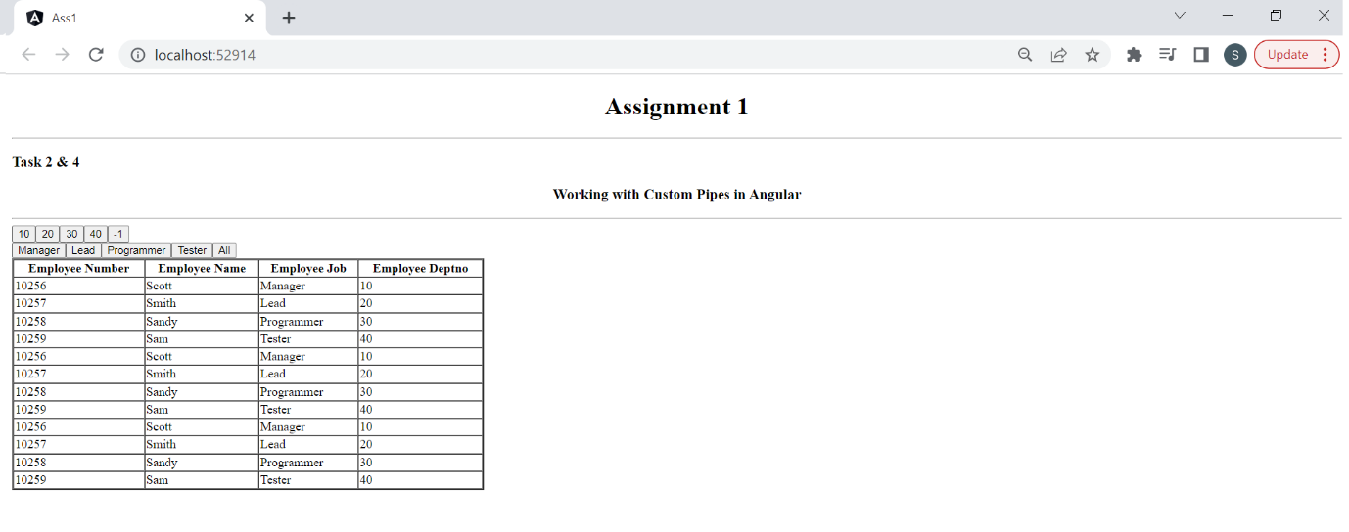

3. Create Angular component to process users data using slice pipe.

Loading the items based on the user interaction.

a. Display users details in cards format.

b. By default only four records should display.

c. Add a button "Load More" that will keep on increase number of records. 4 --> 8 --> 12 ---> 16 .................

d. Once it reach to end, make the button invisible.

